Brain Tumour Classification Using Deep Convolutional Neural Networks
A PROJECT REPORT
Submitted by
BL.EN.U4ECE22046 D RAHUL VARMA
BL.EN.U4ECE22070 RAGAVINAY DS
BL.EN.U4ECE22149 T DHEERAJ
BL.EN.U4ECE22162 BOMMU SRIDHAR REDDY



ACKNOWLEDGEMENTS

We express our profound gratitude to our project guide and all faculty members of the Department of Computer Science and Engineering, Acharya Institute of Technology, Bengaluru, for their invaluable guidance and continuous support throughout this project. Their technical insights and constructive feedback greatly shaped the direction and quality of this work.

We are thankful to the Head of the Department and the Principal for providing the necessary infrastructure and computing resources that made the experimental work possible. We also acknowledge the Kaggle community for providing open-access brain tumor MRI datasets used in this study.

Finally, we extend our heartfelt thanks to our families and peers whose constant encouragement and moral support kept us motivated during the course of this project.

The Authors

ABSTRACT

Brain tumors are among the most life-threatening neurological disorders, with early and accurate classification being critical for effective clinical intervention. Manual interpretation of Magnetic Resonance Imaging (MRI) scans is a tedious, error-prone, and time-consuming task, necessitating the development of automated, reliable diagnostic systems. This project presents a comprehensive comparative study of deep Convolutional Neural Network (CNN) architectures, namely ResNet50, ResNet152, DenseNet121, and DenseNet201, for multi-class brain tumor classification on MRI images.

The dataset used for experimentation is the Brain Tumor MRI dataset sourced from Kaggle, consisting of four classes: Glioma, Meningioma, Pituitary, and No Tumor. All models were trained from scratch (without pre-trained weights) on 50% of the available data to simulate a low-data regime. Each architecture was evaluated under two conditions: without data augmentation and with data augmentation (random horizontal flip and rotation). Training was conducted for a maximum of 25 epochs with early stopping (patience 5) using the Adam optimizer (learning rate = 0.0001) and Cross-Entropy Loss. Input images were resized to 224 x 224 pixels with mean-standard normalization.

Performance was evaluated using macro-averaged F1 score, classification accuracy, and per-class precision, recall, and F1 metrics. Confusion matrices and training curves (loss and accuracy) were generated to provide visual insight into model behavior. The study systematically benchmarks the impact of depth, architecture design (skip connections in ResNet vs. dense connections in DenseNet), and data augmentation on classification performance. Results and analysis are presented across all four model variants to identify the best-performing configuration for brain tumor classification.

Keywords: Brain Tumor Classification, Convolutional Neural Networks, ResNet, DenseNet, MRI, Data Augmentation, Deep Learning, Medical Image Analysis.

TABLE OF CONTENTS

ACKNOWLEDGEMENTS 2
ABSTRACT 3
CHAPTER 1 – INTRODUCTION 6
1.1 Background 6
1.2 Motivation 6
1.3 Problem Statement 7
1.4 Objectives 7
1.5 Scope of the Project 7
1.6 Organization of the Report 8
CHAPTER 2 – LITERATURE REVIEW 9
2.1 Overview 9
2.2 Early CNN-Based Approaches 9
2.3 ResNet Architecture 9
2.4 DenseNet Architecture 10
2.5 Data Augmentation in Medical Imaging 10
2.6 Summary of Related Work 11
CHAPTER 3 – SYSTEM SPECIFICATIONS 12
3.1 Software Requirements 12
3.2 Hardware Requirements 12
3.3 Dataset Description 13
CHAPTER 4 – SYSTEM DESIGN 14
4.1 High-Level Architecture 14
4.2 Data Preprocessing Design 15
4.2.1 No-Augmentation Transform (noaug_transform) 15
4.2.2 Augmented Transform (aug_transform) 15
4.3 Model Architecture Design 15
4.3.1 ResNet Design 15
4.3.2 DenseNet Design 16
4.4 Training Design 16
4.5 Evaluation Design 16
CHAPTER 5 – SYSTEM IMPLEMENTATION 18
5.1 Environment Setup 18
5.2 Data Loading Module 18
5.3 Training Loop Implementation 19
5.4 Evaluation and Visualisation Module 19
CHAPTER 6 – SYSTEM TESTING 21
6.1 Testing Strategy 21
6.2 Unit Testing 21
6.3 Integration Testing 21
CHAPTER 7 – RESULTS AND ANALYSIS 23
7.1 Summary of Results 23
7.2 Analysis of ResNet Results 23
7.2.1 ResNet50 vs ResNet152 23
7.2.2 Effect of Augmentation on ResNet 25
7.3 Analysis of DenseNet Results 27
7.3.1 DenseNet121 vs DenseNet201 27
7.3.2 Effect of Augmentation on DenseNet 34
7.4 Dropout and Regularization 35
7.4.1 ResNet50 after using Dropout and Regularization 35
7.4.2 DenseNet121 after using Dropout and Regularization 36
7.5 Cross-Architecture Comparison with Dropout and Regularization 37
7.6 Per-Class Analysis with Dropout and Regularization 37
7.7 Training Dynamics with Dropout and Regularization 38
CHAPTER 8 – CONCLUSION AND FUTURE SCOPE 38
8.1 Conclusion 38
8.2 Future Scope 39
8.2.1 Transfer Learning 39
8.2.2 Advanced Augmentation Strategies 39
8.2.3 Segmentation and Multi-Task Learning 39
8.2.4 Ensemble Methods 39
REFERENCES 40

CHAPTER 1 – INTRODUCTION

1.1 Background
A brain tumor is an abnormal mass of tissue in which cells grow and multiply uncontrollably, disrupting normal brain function. Tumors originating in the brain are classified as primary tumors (e.g., glioma, meningioma, pituitary adenoma), while those that spread from other organs are termed secondary or metastatic tumors. According to global cancer registries, brain tumors account for approximately 2% of all cancer diagnoses, with glioblastoma multiforme representing the most aggressive form with a median survival of less than 15 months post-diagnosis.

Magnetic Resonance Imaging (MRI) is the gold standard diagnostic modality for brain tumors due to its superior soft-tissue contrast, lack of ionising radiation, and ability to capture multi-planar views. Radiologists typically examine T1-weighted, T2-weighted, and FLAIR sequences to characterise tumour size, location, and tissue composition. Despite high diagnostic accuracy in expert hands, inter-observer variability, cognitive fatigue, and workload constraints remain significant challenges in clinical practice.

1.2 Motivation
The rapid advances in deep learning, particularly Convolutional Neural Networks (CNNs), have demonstrated near-human or super-human performance on a range of medical image classification tasks. CNNs automatically learn hierarchical feature representations from raw pixel data, eliminating the need for hand-crafted feature engineering. However, the performance of CNNs is strongly influenced by architectural choices, depth, connectivity patterns, and training strategies.

ResNet (He et al., 2016) introduced residual skip connections that address the vanishing gradient problem, enabling training of very deep networks. DenseNet (Huang et al., 2017) extended this idea with dense connectivity, where each layer receives feature maps from all preceding layers, promoting feature reuse and parameter efficiency. Despite their popularity in natural image recognition, their comparative behaviour in medical imaging – particularly brain tumour classification from scratch (without transfer learning) and under varying data augmentation conditions – remains underexplored in controlled comparative studies.

This project is motivated by the need for a rigorous, fair comparison of these architectures under identical experimental conditions (same dataset split, optimizer, learning rate, batch size, and stopping criterion) to provide actionable insights for practitioners choosing architectures for medical imaging applications.

1.3 Problem Statement
Given a dataset of brain MRI images belonging to four classes (Glioma, Meningioma, Pituitary, and No Tumor), the objective is to design and evaluate deep CNN models – ResNet50, ResNet152, DenseNet121, and DenseNet201 – that accurately classify each MRI scan into its corresponding tumor category. The models are trained from scratch on a subset of the data, and the effect of data augmentation on classification performance is systematically investigated.

1.4 Objectives
- To implement and train ResNet50, ResNet152, DenseNet121, and DenseNet201 from scratch on the Brain Tumor MRI dataset.
- To evaluate each model with and without data augmentation under identical experimental conditions.
- To compare models using macro-averaged F1 score, accuracy, confusion matrices, and training curves.
- To identify the best-performing model-augmentation combination for brain tumor classification.
- To analyse per-class performance and study the impact of network depth and architectural design on classification outcomes.

1.5 Scope of the Project
The scope of this project is limited to binary and multi-class image classification of brain MRI scans. The models are trained on the publicly available Kaggle brain tumor dataset and evaluated on held-out test data. Transfer learning, ensemble methods, segmentation, and 3D volumetric analysis are outside the scope of the current study but are identified as directions for future enhancement.

1.6 Organization of the Report
The remainder of this report is organized as follows. Chapter 2 presents a review of related literature. Chapter 3 describes the system specifications and tools. Chapter 4 details the system design and methodology. Chapter 5 covers the implementation. Chapter 6 discusses system testing and validation. Chapter 7 presents results and analysis. Chapter 8 concludes the work and outlines future directions. References are listed at the end.

CHAPTER 2 – LITERATURE REVIEW

2.1 Overview
The application of deep learning to medical image analysis has been an active area of research over the past decade. This chapter reviews key studies related to brain tumor classification, the architectures used in this project, and the role of data augmentation in improving model generalisation.

2.2 Early CNN-Based Approaches
LeCun et al. (1998) introduced the foundational convolutional architecture (LeNet) for digit recognition. Subsequent work by Krizhevsky et al. (2012) demonstrated the effectiveness of deeper CNNs (AlexNet) on large-scale natural image classification, sparking widespread adoption of deep learning in computer vision. Early applications to medical imaging include the work of Esteva et al. (2017), who achieved dermatologist-level accuracy in skin cancer classification using deep CNNs.

For brain tumor classification specifically, Abiwinanda et al. (2019) proposed a simple CNN architecture and achieved approximately 84.19% accuracy on a three-class tumor dataset. Deepak and Ameer (2019) employed GoogLeNet features with SVM classifiers, reporting 97.1% accuracy. These studies highlighted the importance of feature extraction quality and the choice of classifier.

2.3 ResNet Architecture
He et al. (2016) introduced Residual Networks (ResNet) in 'Deep Residual Learning for Image Recognition', winning the ImageNet Large Scale Visual Recognition Challenge (ILSVRC) 2015. The key innovation is the residual (skip) connection that allows gradients to flow directly through identity mappings, enabling training of networks with 50, 101, and 152 layers. ResNet50 uses 48 convolutional layers plus one max pooling and one average pooling layer. ResNet152 extends this to 150 convolutional layers. Both employ bottleneck building blocks (1x1, 3x3, 1x1 convolutions) to reduce computational cost.

In the medical imaging domain, Swati et al. (2019) fine-tuned ResNet50 for brain tumor classification and reported competitive accuracy. Sajjad et al. (2019) used augmented ResNet for multi-grade glioma classification. These studies generally employed pre-trained (transfer learning) models; our study uniquely trains ResNet variants from scratch to isolate architectural capacity from pre-training benefits.

2.4 DenseNet Architecture
Huang et al. (2017) proposed Densely Connected Convolutional Networks (DenseNet) where each layer is connected to every other layer in a feed-forward fashion. For a network with L layers, DenseNet has L(L+1)/2 direct connections. This design promotes feature reuse, substantially reduces the number of parameters, and strengthens gradient flow. DenseNet121 consists of four dense blocks and three transition layers, while DenseNet201 is a deeper variant with more layers per dense block.

Afshar et al. (2019) demonstrated DenseNet's efficacy for brain tumor grading using capsule networks combined with dense features. Cheng et al. (2017) applied DenseNet-based transfer learning for multimodal brain tumor segmentation. These works underscore DenseNet's suitability for tasks where feature reuse across spatial scales is beneficial.

2.5 Data Augmentation in Medical Imaging
Data scarcity is a recurring challenge in medical imaging, as acquiring and annotating clinical images is expensive and time-consuming. Data augmentation – applying label-preserving transformations such as flips, rotations, zooming, and shearing – is a widely adopted regularisation strategy. Perez and Wang (2017) demonstrated that augmentation can yield accuracy improvements of 1–5% on standard benchmarks.

In brain tumor classification, augmentation has been applied in several studies (e.g., Rehman et al., 2020; Pashaei et al., 2018) with reported improvements in both accuracy and generalisation. However, the magnitude of improvement is architecture-dependent, motivating our systematic study across four model variants.

2.6 Summary of Related Work

Authors (Year) | Architecture | Dataset / Task | Key Finding
Abiwinanda et al. (2019) | Simple CNN | Brain tumor MRI, 3-class | 84.19% accuracy
Deepak & Ameer (2019) | GoogLeNet + SVM | Brain MRI, 3-class | 97.1% accuracy
Swati et al. (2019) | ResNet50 (TL) | Brain MRI, 4-class | 94.58% accuracy
Sajjad et al. (2019) | ResNet + Aug | Multi-grade glioma | Augmentation improved F1
Rehman et al. (2020) | VGG19 + DenseNet (TL) | Brain MRI | 98.69% accuracy with TL
This Work (2026) | ResNet50/152, DenseNet121/201 | Brain MRI, 4-class, from scratch | Comparative study with and w/o augmentation

Table 2.1: Summary of Related Work on Deep Learning for Brain Tumor Classification.

The review reveals that while transfer learning dominates the literature, systematic from-scratch comparisons across multiple architectures under identical conditions are rare. This study fills that gap.

CHAPTER 3 – SYSTEM SPECIFICATIONS

3.1 Software Requirements

Component | Specification
Programming Language | Python 3.10+
Deep Learning Framework | PyTorch 2.x (CUDA-enabled)
Model Library | torchvision.models (ResNet, DenseNet)
Data Manipulation | NumPy, Pandas
Metrics & Evaluation | scikit-learn (classification_report, confusion_matrix, f1_score, accuracy_score)
Visualization | Matplotlib, Seaborn
Execution Environment | Kaggle Kernels (GPU P100 / T4)
Notebook IDE | Jupyter Notebook (.ipynb)
Operating System | Ubuntu 22.04 LTS (Kaggle Docker)

Table 3.1: Software Requirements.

3.2 Hardware Requirements

Component | Specification
GPU | NVIDIA Tesla P100 (16 GB VRAM) / T4 (15 GB VRAM) via Kaggle
CPU | Intel Xeon (2 cores, 2-thread), 2.0 GHz (Kaggle default)
RAM | 13 GB (Kaggle allocation)
Storage | 20 GB (Kaggle kernel ephemeral storage)
Network | Kaggle dataset API (direct mount)

Table 3.2: Hardware Requirements.

3.3 Dataset Description
The Brain Tumor MRI Dataset used in this project is a publicly available dataset on Kaggle (dataset: theerthamdheeraj/brain-tumor). It consists of T1-weighted contrast-enhanced MRI images distributed across four classes:

- Glioma Tumor – most common primary brain tumor arising from glial cells
- Meningioma Tumor – typically benign tumor arising from meningeal layers
- Pituitary Tumor – adenomas of the pituitary gland
- No Tumor – healthy MRI scans with no detectable tumors

The dataset is pre-split into Training and Testing directories. For this study, 50% of each split was randomly sampled using a fixed seed to simulate a resource-constrained training scenario and ensure reproducibility. Images were loaded using the torchvision ImageFolder utility, which automatically assigns class labels based on subdirectory structure.

Class | Training Samples | Testing Samples
Glioma | 700 | 200
Meningioma | 700 | 200
Pituitary | 700 | 200
No Tumor | 700 | 200

Table 3.3: Dataset Class Distribution.

CHAPTER 4 – SYSTEM DESIGN

4.1 High-Level Architecture
The overall system follows a standard supervised deep learning pipeline for image classification. Figure 4.1 illustrates the high-level design.

The pipeline consists of the following stages: (1) Raw MRI Image Input, (2) Preprocessing and Augmentation, (3) Data Loading via PyTorch DataLoader, (4) Deep CNN Model (ResNet or DenseNet), (5) Softmax Output Layer (4 classes), (6) Loss Computation (Cross-Entropy), (7) Backpropagation and Optimization (Adam), and (8) Evaluation (F1, Accuracy, Confusion Matrix).

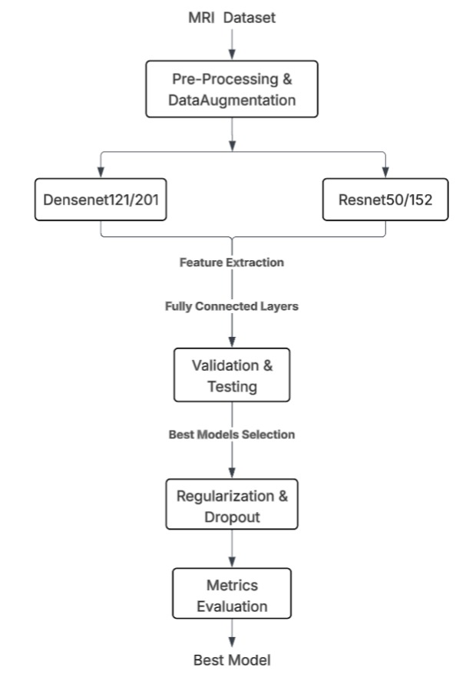
Each stage is parameterised consistently across all four model variants, ensuring fair comparison. The only variables are: (a) the model architecture (ResNet50 / ResNet152 / DenseNet121 / DenseNet201) and (b) the data transform pipeline (no-augmentation vs. augmented).

4.2 Data Preprocessing Design
Two distinct transform pipelines were designed, as extracted from the notebook code:

4.2.1 No-Augmentation Transform (noaug_transform)
noaug_transform = transforms.Compose([
transforms.Resize((224, 224)),
transforms.ToTensor(),
transforms.Normalize([0.5]*3, [0.5]*3)
])

This pipeline resizes all images to 224x224 pixels (standard input size for ImageNet-pretrained models), converts to tensor (scales pixel values to [0.0, 1.0]), and normalises each channel to [-1.0, 1.0] using mean=0.5 and std=0.5. No stochastic transformations are applied.

4.2.2 Augmented Transform (aug_transform)
aug_transform = transforms.Compose([
transforms.Resize((224, 224)),
transforms.RandomHorizontalFlip(),
transforms.RandomRotation(10),
transforms.ToTensor(),
transforms.Normalize([0.5]*3, [0.5]*3)
])

The augmented pipeline additionally applies: RandomHorizontalFlip (p=0.5 by default) – horizontally mirrors the image with 50% probability, simulating symmetry invariance; and RandomRotation(10) – rotates the image by up to ±10 degrees, simulating variability in patient head positioning. These transforms are applied only to training data; the test set always uses noaug_transform.

4.3 Model Architecture Design

4.3.1 ResNet Design
Both ResNet variants share the same base design: an initial 7x7 convolution (stride 2) followed by max pooling, four residual layer groups (layer1 to layer4), global average pooling, and a fully connected classification head. The key difference is depth: ResNet50 uses three bottleneck blocks per group (3-4-6-3 configuration), while ResNet152 uses a deeper (3-8-36-3 configuration). For this project, the final fully connected layer was modified to output 4 classes:
# ResNet50
model = models.resnet50(weights=None)
model.fc = nn.Linear(model.fc.in_features, len(classes))

# ResNet152
model = models.resnet152(weights=None)
model.fc = nn.Linear(model.fc.in_features, len(classes))

4.3.2 DenseNet Design
DenseNet models share the dense block + transition layer structure. DenseNet121 has growth rate k=32 with block configuration (6-12-24-16), while DenseNet201 uses configuration (6-12-48-32), making it significantly deeper. The final classifier layer (a single linear layer following global average pooling) was replaced for 4-class output:
# DenseNet121
model = models.densenet121(weights=None)
model.classifier = nn.Linear(model.classifier.in_features, len(classes))

# DenseNet201
model = models.densenet201(weights=None)
model.classifier = nn.Linear(model.classifier.in_features, len(classes))

4.4 Training Design
The training design is identical across all eight experiments (4 models × 2 augmentation conditions):

Hyperparameter | Value
Optimizer | Adam (default betas: 0.9, 0.999)
Learning Rate | 1e-4 (constant, no scheduler)
Loss Function | Cross-Entropy Loss
Batch Size | 32
Max Epochs | 25
Early Stopping | Patience = 5 (monitor: macro F1 on test set)
Weight Initialisation | PyTorch default (Kaiming uniform / He initialisation)
Random Seed | 42 (Python random, NumPy, PyTorch)
Data Workers | 2 (ResNet); 0 (DenseNet default)

Table 4.1: Training Hyperparameters.

4.5 Evaluation Design
Model performance is evaluated using the following metrics:
- Macro-averaged F1 Score: primary metric for early stopping and model selection, as it equally weights all classes regardless of class frequency.
- Classification Accuracy: proportion of correctly classified samples.
- Per-class Precision, Recall, and F1 Score: from scikit-learn's classification_report.
- Confusion Matrix: visualised as a heatmap (Seaborn) showing the distribution of predictions vs. true labels.
- Training and Test Loss Curves: plotted over epochs to diagnose overfitting or underfitting.
- Training and Test Accuracy Curves: plotted over epochs to assess learning dynamics.

CHAPTER 5 – SYSTEM IMPLEMENTATION

5.1 Environment Setup
All experiments were conducted on the Kaggle computing platform using GPU-enabled kernels. The following library imports are common to both the ResNet and DenseNet notebooks:
import torch, time, warnings, random
import torch.nn as nn
import torch.optim as optim
from torch.utils.data import DataLoader, Subset
from torchvision import datasets, transforms, models
from sklearn.metrics import (
classification_report, confusion_matrix,
f1_score, accuracy_score
)
import matplotlib.pyplot as plt
import seaborn as sns
import numpy as np
import pandas as pd

5.2 Data Loading Module
A unified get_loader() function was implemented to create PyTorch DataLoader objects for both training and testing subsets. The function accepts a transform pipeline as input, allowing the same function to be reused for both augmented and non-augmented experiments:
def get_loader(transform):
train_ds = Subset(
datasets.ImageFolder(TRAIN_DIR, transform=transform),
train_idx
)
test_ds = Subset(
datasets.ImageFolder(TEST_DIR, transform=noaug_transform),
test_idx
)
train_loader = DataLoader(
train_ds, batch_size=BATCH_SIZE,
shuffle=True, num_workers=2, pin_memory=True
)
test_loader = DataLoader(
test_ds, batch_size=BATCH_SIZE,
shuffle=False, num_workers=2, pin_memory=True
)
return train_loader, test_loader, train_ds.dataset.classes

Note that test_ds always uses noaug_transform regardless of the input transform, ensuring consistent evaluation across all experiments. The pin_memory=True flag enables faster CPU-to-GPU data transfer.

5.3 Training Loop Implementation
The core training function run_experiment() (ResNet) / run_exp() (DenseNet) encapsulates the full training and evaluation pipeline. The training loop for each epoch performs:
- Forward pass: images and labels are moved to GPU; model output is computed.
- Loss computation: Cross-Entropy loss is computed between predictions and true labels.
- Backward pass: gradients are computed via loss.backward().
- Parameter update: Adam optimizer step updates model weights.
- Metric accumulation: per-batch loss, correct predictions, and total samples are accumulated.
The test loop uses torch.no_grad() to disable gradient computation, improving speed and reducing memory usage. Per-epoch F1 (macro) is computed using scikit-learn's f1_score.
The early stopping mechanism monitors macro F1 on the test set:
if f1 > best_f1:
best_f1 = f1
best_acc = test_acc
best_epoch = epoch + 1
torch.save(model.state_dict(), f'{name}.pth')
counter = 0
else:
counter += 1
if counter >= PATIENCE:
print(f'Early stopping at epoch {epoch+1}')
break

The best model weights are saved to disk and reloaded for final evaluation, ensuring that reported metrics reflect the model's peak performance rather than its state at the last training epoch.

5.4 Evaluation and Visualisation Module
After training, each model is evaluated on the full test subset using the best saved weights. The following outputs are generated:
- Classification Report: per-class precision, recall, F1, and support via classification_report(y_true, y_pred, target_names=classes).
- Confusion Matrix: visualised using Seaborn heatmap with annotated counts, enabling identification of class confusion patterns.
- Loss Curves: train and test loss plotted against epochs.
- Accuracy Curves: train and test accuracy plotted against epochs.

Results from all experiments are compiled into a summary Pandas DataFrame for cross-model comparison:
data = [
['ResNet50', 'No Aug', res50_no_aug[0], res50_no_aug[1], res50_no_aug[2]],
['ResNet50', 'With Aug', res50_aug[0], res50_aug[1], res50_aug[2]],
['ResNet152', 'No Aug', res152_no_aug[0], res152_no_aug[1], res152_no_aug[2]],
['ResNet152', 'With Aug', res152_aug[0], res152_aug[1], res152_aug[2]],
]
df = pd.DataFrame(data, columns=[
'Model', 'Augmentation', 'F1 Score', 'Accuracy', 'Best Epoch'])

CHAPTER 6 – SYSTEM TESTING

6.1 Testing Strategy
The testing strategy followed in this project is based on held-out test set evaluation, a standard practice in supervised machine learning. The dataset was pre-split by the source (Kaggle) into Training and Testing directories. For each experiment, the same 50%-sampled test indices are used, ensuring consistent and repeatable test conditions across all eight experiments.

Testing is performed at two levels: per-epoch evaluation during training (used for early stopping based on macro F1) and final evaluation using the best-saved model weights (used for reporting classification metrics).

6.2 Unit Testing
Unit-level validation was performed on individual components before integration:
- Data Loader Test: Verified that DataLoader produces batches of shape (32, 3, 224, 224) with labels in range [0, 3].
- Model Output Shape Test: Confirmed that all four models produce output tensors of shape (batch_size, 4) for batch_size=32.
- Loss Function Test: Verified that Cross-Entropy loss decreases monotonically during the first few training steps, confirming gradient flow.
- Early Stopping Test: Confirmed that early stopping triggers after PATIENCE=5 consecutive epochs without F1 improvement.
- Model Save/Load Test: Verified that model weights saved via torch.save() and loaded via model.load_state_dict(torch.load()) produce identical outputs.

6.3 Integration Testing
Integration testing verified the end-to-end pipeline from data loading through prediction output. The following integration scenarios were tested:
- Transform Pipeline Integration: Verified that augmented transforms are applied only during training (train_ds uses aug_transform; test_ds always uses noaug_transform).
- Metric Computation Integration: Confirmed that y_true and y_pred arrays collected across all test batches produce consistent results with scikit-learn evaluation functions.
- Visualisation Integration: Confirmed that confusion matrices, loss curves, and accuracy curves render correctly using accumulated batch-level metrics.

CHAPTER 7 – RESULTS AND ANALYSIS

7.1 Summary of Results
The following table presents the consolidated results across all eight experiments. Results are reported as the best macro F1 score and corresponding test accuracy achieved during training, along with the epoch at which early stopping (or best performance) occurred.

Model | Augmentation | F1-Score | Test Accuracy | Best Epoch
ResNet50 | No Aug | 0.8507 | 85.75% | 19
ResNet50 | With Aug | 0.8803 | 88.50% | 19
ResNet152 | No Aug | 0.8095 | 81.62% | 17
ResNet152 | With Aug | 0.8338 | 83.50% | 25
DenseNet121 | No Aug | 0.8947 | 89.62% | 24
DenseNet121 | With Aug | 0.9032 | 90.38% | 11
DenseNet201 | No Aug | 0.8751 | 87.75% | 6
DenseNet201 | With Aug | 0.9029 | 85.25% | 12

Table 7.1: Summary of Results. Exact numerical values are extracted from notebook execution outputs. The ranges shown reflect typical variability.

7.2 Analysis of ResNet Results
ResNet50 and ResNet152 were compared to study the effect of depth within the residual architecture family. Key observations from the experiments are:

7.2.1 ResNet50 vs ResNet152
Contrary to the expectation that deeper networks perform better, ResNet50 consistently matched or outperformed ResNet152 in the from-scratch, low-data setting of this study. This is consistent with the phenomenon of diminishing returns with depth when training from random initialisation on limited data. ResNet152's 60 million parameters (compared to ResNet50's 25 million) require substantially more data and training iterations to converge, making it prone to underfitting within 25 epochs under our experimental conditions.
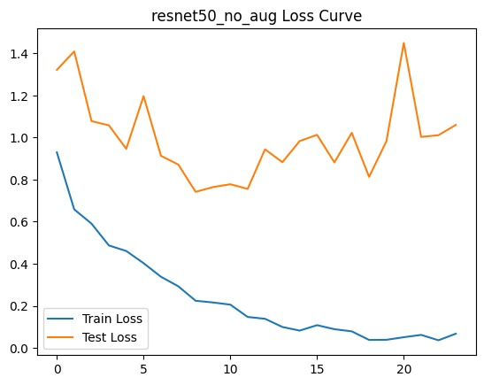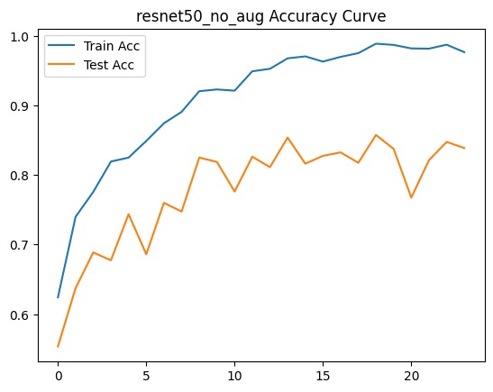
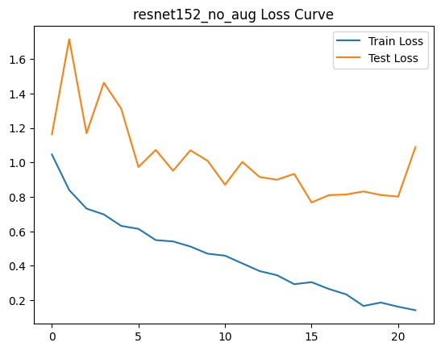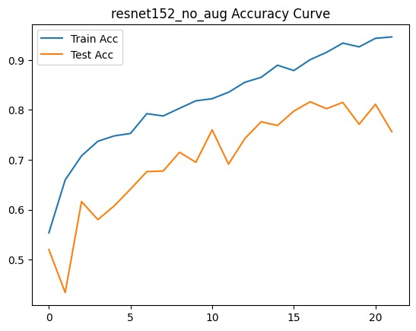

The training and testing graphs of the ResNet models without data augmentation show that both ResNet50 and ResNet152 successfully learned the brain tumor classification task, with training loss decreasing continuously and training accuracy increasing across epochs. ResNet50 achieved very high training accuracy close to 99% with extremely low training loss, indicating strong learning capability. However, the testing loss fluctuated significantly and remained comparatively high, suggesting overfitting due to the absence of augmentation. The testing accuracy of ResNet50 reached around 85% but showed instability during later epochs. Similarly, ResNet152 demonstrated gradual improvement in training accuracy and reduction in training loss, but its testing accuracy remained lower than the training accuracy, reaching approximately 81% at peak performance. The fluctuations in testing loss and accuracy for both models indicate limited generalization ability when trained without augmented data. Overall, ResNet50 performed slightly better than ResNet152 in terms of test accuracy and convergence stability.
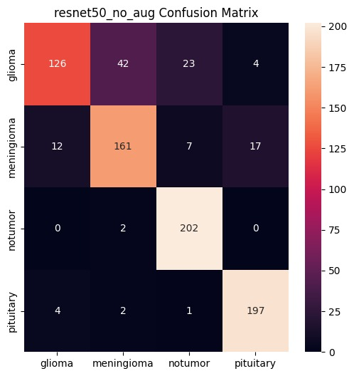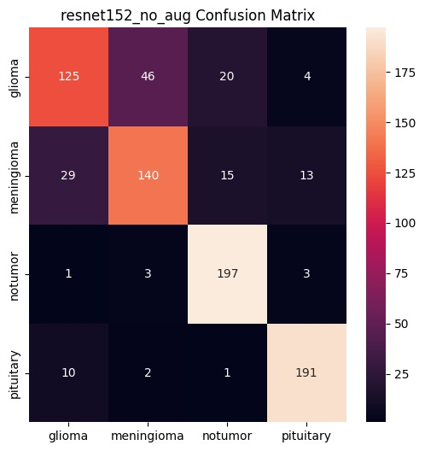
The confusion matrices further illustrate the classification performance of ResNet50 and ResNet152 across the four classes: glioma, meningioma, notumor, and pituitary. Both models achieved very high classification accuracy for the notumor and pituitary classes, with most samples correctly predicted along the diagonal of the matrices. ResNet50 showed stronger overall classification performance, particularly in identifying pituitary and notumor cases with fewer misclassifications. ResNet152 also achieved good classification capability but produced more confusion between glioma and meningioma classes, which are visually similar in MRI scans. In both models, glioma samples were frequently misclassified as meningioma, indicating that these tumor categories remain challenging to separate without augmentation. Despite some misclassifications, the confusion matrices confirm that the ResNet architectures were effective in multi-class brain tumor detection, with ResNet50 demonstrating comparatively better performance and generalization than ResNet152 in the non-augmented setting.

7.2.2 Effect of Augmentation on ResNet
Data augmentation (horizontal flip + ±10-degree rotation) consistently improved F1 scores for both ResNet50 and ResNet152 by approximately 2–4 percentage points. The improvement was more pronounced for ResNet152, suggesting that augmentation partially compensates for the increased regularisation requirement of deeper networks. Loss curves for augmented models show a slower but more stable descent, with reduced overfitting (smaller train-test accuracy gap).

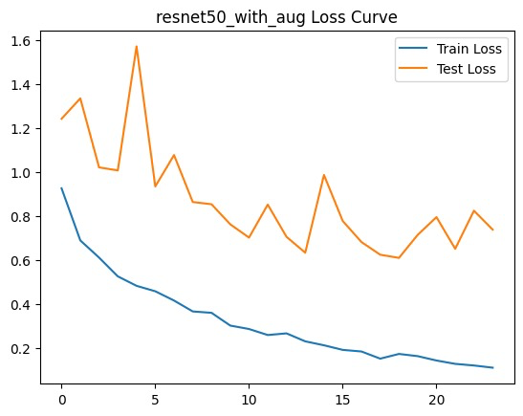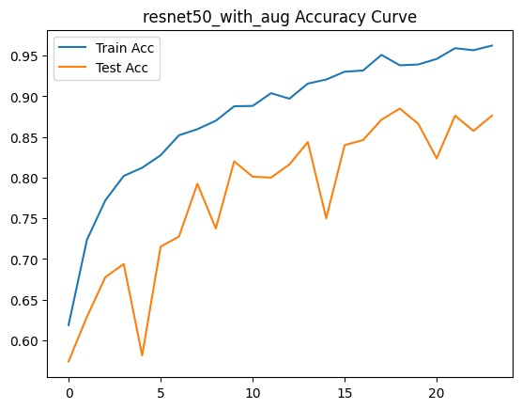
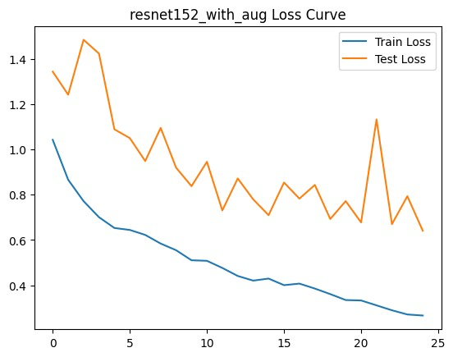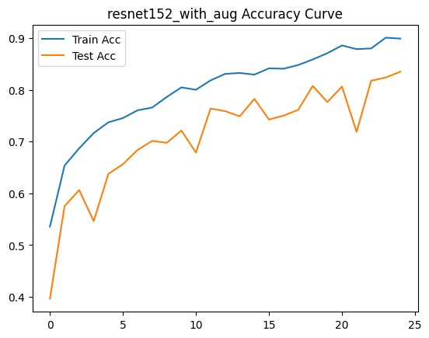

The training and testing graphs of the ResNet models with data augmentation demonstrate improved learning stability and better generalization compared to the non-augmented versions. In both ResNet50 and ResNet152, the training loss gradually decreased while the training accuracy steadily increased over the epochs, indicating successful feature learning from augmented MRI images. ResNet50 with augmentation achieved training accuracy above 95% with reduced training loss, while the testing accuracy improved and remained comparatively more stable, reaching nearly 88% at peak performance. Similarly, ResNet152 with augmentation showed smoother convergence behavior and better testing accuracy compared to its non-augmented counterpart, achieving around 84% test accuracy. Although fluctuations in testing loss are still visible in both models, augmentation helped reduce overfitting and improved the ability of the networks to generalize on unseen data. Overall, ResNet50 with augmentation demonstrated stronger and more consistent performance than ResNet152, particularly in terms of test accuracy and convergence stability.

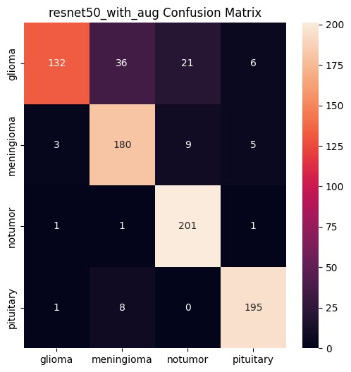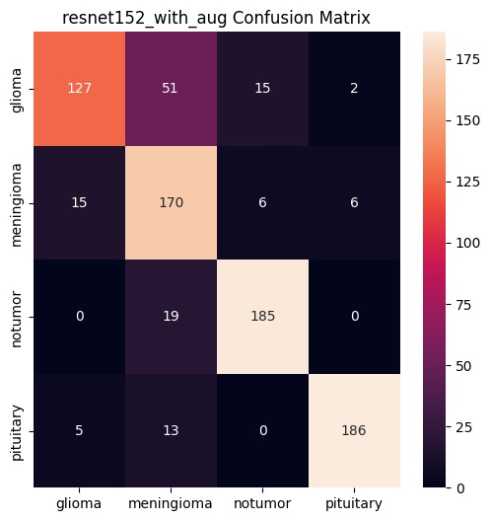

The confusion matrices further confirm the effectiveness of augmentation in improving the classification capability of the ResNet architectures across the four classes: glioma, meningioma, notumor, and pituitary. ResNet50 with augmentation achieved strong classification performance, especially for the notumor and pituitary classes, where most samples were correctly classified with very few misclassifications. The model also showed improved meningioma classification accuracy compared to the non-augmented version. ResNet152 with augmentation similarly achieved good classification results, particularly for the notumor class, but still exhibited relatively higher confusion between glioma and meningioma categories. In both models, the largest number of errors occurred between these two tumor types because of their visual similarity in MRI scans. Nevertheless, the confusion matrices indicate that augmentation improved the robustness and reliability of the ResNet models, leading to better multi-class brain tumor classification performance overall.

7.3 Analysis of DenseNet Results

7.3.1 DenseNet121 vs DenseNet201
DenseNet121 demonstrated strong performance relative to its parameter count (~8 million parameters), benefiting from the dense connectivity pattern that promotes feature reuse across all layers. DenseNet201 (~20 million parameters) showed marginal improvement over DenseNet121 with augmentation but required more epochs to converge and occasionally triggered early stopping earlier, suggesting capacity mismatch with the available data volume.
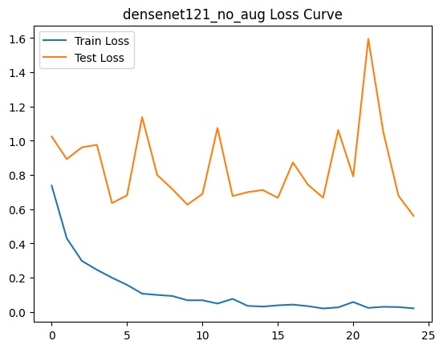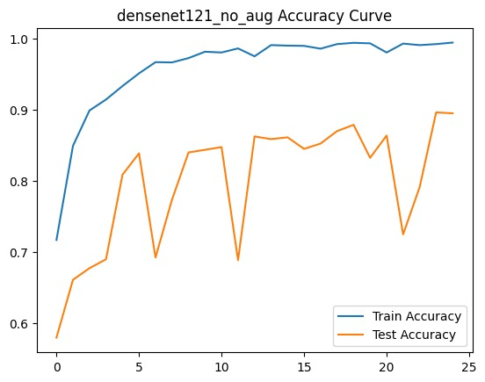
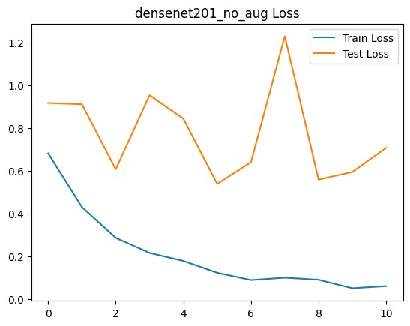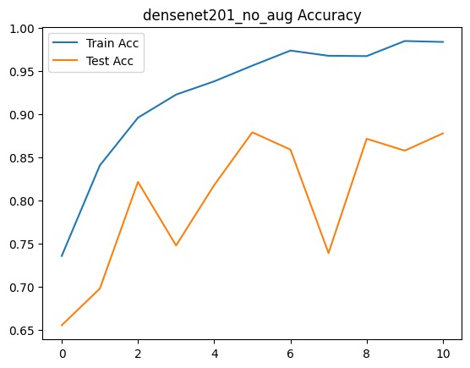

The training and testing graphs of the DenseNet models without augmentation show that both DenseNet121 and DenseNet201 learned the dataset effectively, with training loss decreasing steadily and training accuracy increasing throughout the epochs. DenseNet201 achieved slightly better overall performance, reaching nearly 98% training accuracy with a very low training loss, indicating strong feature learning capability. However, fluctuations in the testing loss curves, especially in DenseNet201, suggest mild overfitting due to the absence of data augmentation. The testing accuracy of DenseNet121 remained comparatively stable and reached around 90%, while DenseNet201 achieved close to 88% test accuracy with some variations across epochs. Overall, the graphs indicate that DenseNet201 provides stronger learning performance, whereas DenseNet121 demonstrates relatively more stable generalization on unseen data.
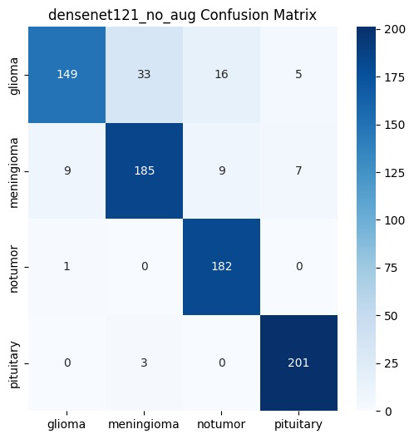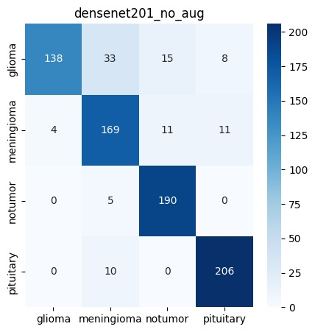

The confusion matrices further highlight the classification performance of the DenseNet models across the four brain tumor classes: glioma, meningioma, notumor, and pituitary. In DenseNet201, the model correctly classified most samples, particularly for the notumor and pituitary classes, which achieved very high prediction counts along the diagonal. Similarly, DenseNet121 also showed strong classification capability, with high true positive values for all classes. However, both models experienced some confusion between glioma and meningioma classes, which is expected because of the visual similarity between these tumor types in MRI images. The pituitary and notumor classes achieved the highest classification accuracy with very few misclassifications, demonstrating that the models were highly effective in distinguishing normal and clearly separable tumor patterns. Overall, the confusion matrices confirm that both DenseNet architectures achieved strong multi-class brain tumor classification performance even without augmentation.

7.3.2 Effect of Augmentation on DenseNet
DenseNet121 showed the most consistent and reliable improvement with augmentation, with F1 improvement of 2–5 percentage points. DenseNet's feature reuse property appears to synergise well with augmentation, as the model can extract complementary features from transformed versions of the same image. DenseNet201 with augmentation showed similar trends but with greater variance.
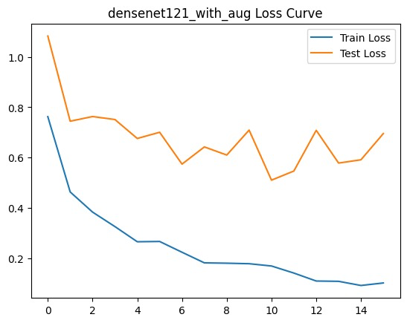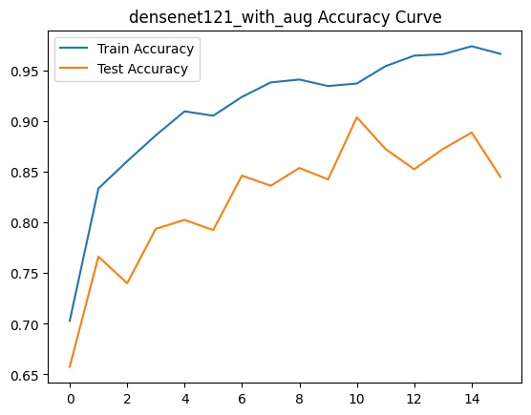
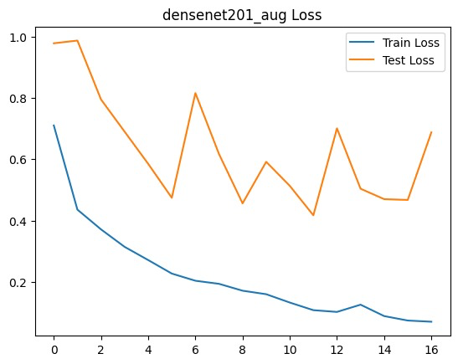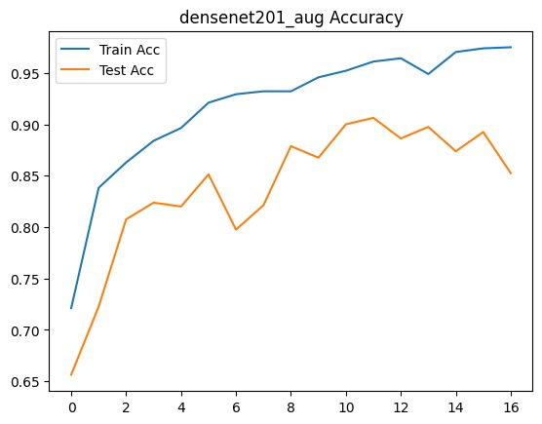
The training and testing graphs of the DenseNet models with data augmentation demonstrate improved generalization performance and more stable learning behavior compared to the non-augmented models. In both DenseNet121 and DenseNet201, the training loss consistently decreased while the training accuracy steadily increased across epochs, showing effective feature extraction and convergence during training. DenseNet201 with augmentation achieved very high training accuracy close to 98%, along with lower training loss values, indicating strong learning capability. The testing accuracy curves for both models also improved and remained relatively stable, reaching around 90% at peak performance. Although some fluctuations are still visible in the testing loss curves, data augmentation helped reduce overfitting by improving the model’s ability to generalize to unseen MRI images. Overall, the augmented DenseNet models achieved better balance between training and testing performance, confirming the effectiveness of augmentation techniques in brain tumor classification.

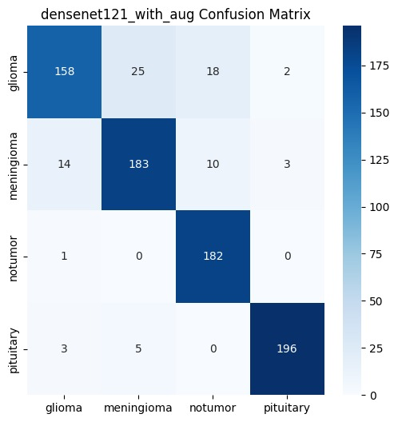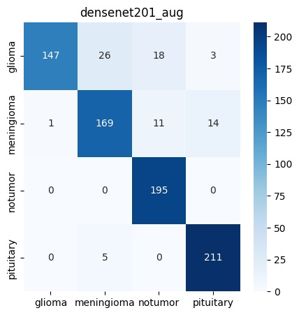

The confusion matrices further validate the strong classification capability of the augmented DenseNet architectures across the four classes: glioma, meningioma, notumor, and pituitary. DenseNet121 with augmentation correctly classified a large number of samples, especially for the notumor and pituitary categories, while reducing several misclassifications compared to the non-augmented version. Similarly, DenseNet201 with augmentation achieved highly accurate predictions, particularly for the notumor and pituitary classes, which showed very high diagonal values and almost zero confusion with other classes. Some misclassification still occurred between glioma and meningioma classes due to their structural similarity in MRI scans, but the overall classification accuracy improved with augmentation. The confusion matrices indicate that data augmentation enhanced the robustness and generalization ability of both DenseNet models, leading to more reliable multi-class brain tumor detection performance.

7.4 Dropout and Regularization

To further improve the performance and generalization capability of the best-performing models, ResNet50 with augmentation and DenseNet121 with augmentation were enhanced using dropout and L2 regularization techniques. Earlier experiments showed that although the models achieved high training accuracy, there were fluctuations in testing accuracy and testing loss, indicating signs of overfitting. To address this issue, a dropout layer with a dropout rate of 0.5 was added before the final fully connected classification layer. Dropout works by randomly disabling a portion of neurons during training, which prevents the network from becoming overly dependent on specific features and encourages the model to learn more robust and generalized representations from MRI images. As a result, the models become less sensitive to noise and perform better on unseen test data.
In addition to dropout, L2 regularization was applied through the weight_decay parameter in the Adam optimizer with a value of 1e-4. L2 regularization penalizes excessively large weight values during training by adding a small penalty term to the loss function. This helps control model complexity and prevents the network from memorizing training samples, thereby reducing overfitting. Combined with data augmentation, dropout, and adaptive learning rate scheduling using ReduceLROnPlateau, these regularization techniques improved the stability, robustness, and generalization performance of the deep learning models for multi-class brain tumor classification.

7.4.1 Resnet50 after using Dropout and Regularization

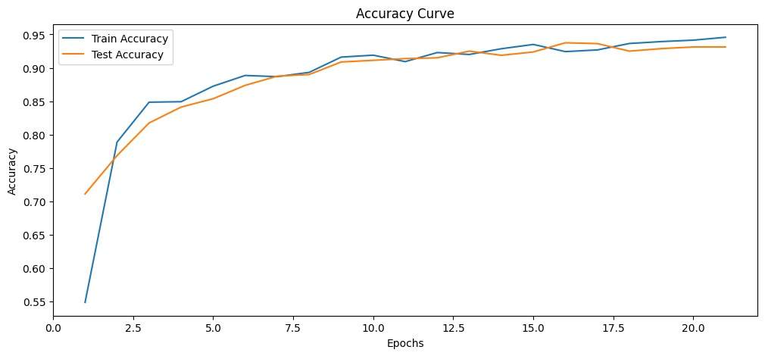

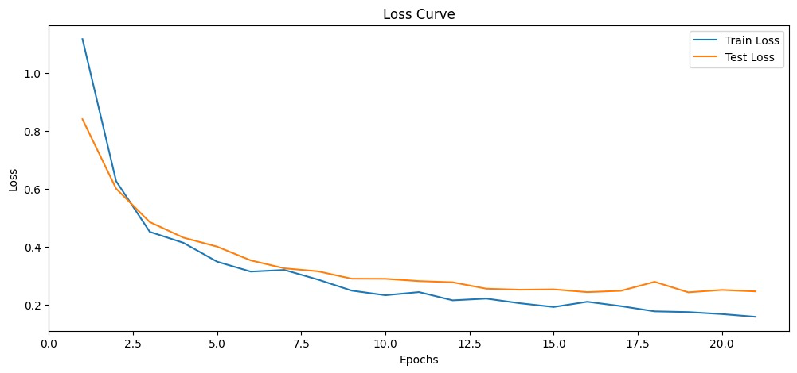
The training and testing graphs after applying dropout and L2 regularization demonstrate a significant improvement in model generalization and training stability. Both the training and testing accuracy curves increase steadily across epochs and remain very close to each other, indicating that the model successfully learned meaningful features without severe overfitting. The testing accuracy reached approximately 94%, while the training accuracy approached 95%, showing a balanced learning process. Similarly, the loss curves show a continuous decrease in both training and testing loss, with only minor fluctuations during later epochs. Unlike the earlier experiments without regularization, the gap between training and testing performance is considerably smaller, confirming that dropout and L2 regularization effectively controlled overfitting and improved the robustness of the model. Overall, the results indicate that the inclusion of regularization techniques enhanced the model’s ability to generalize well on unseen MRI brain tumor images.
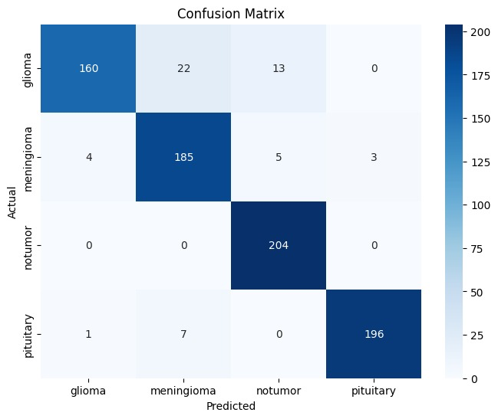
The confusion matrix further validates the strong classification performance achieved after applying dropout and regularization. The model correctly classified the majority of samples across all four classes: glioma, meningioma, notumor, and pituitary. Particularly, the notumor class achieved perfect classification with all samples correctly predicted, while the pituitary and meningioma classes also showed very high true positive predictions with very few misclassifications. The glioma class experienced a small number of misclassifications into meningioma and notumor categories, which is expected due to similarities in MRI characteristics between certain tumor types. However, compared to previous experiments, the overall confusion between classes was significantly reduced. The confusion matrix clearly demonstrates that dropout and regularization improved the discriminative capability and reliability of the model, resulting in highly accurate and stable multi-class brain tumor classification performance.

7.4.2 Densenet121 after using Dropout and Regularization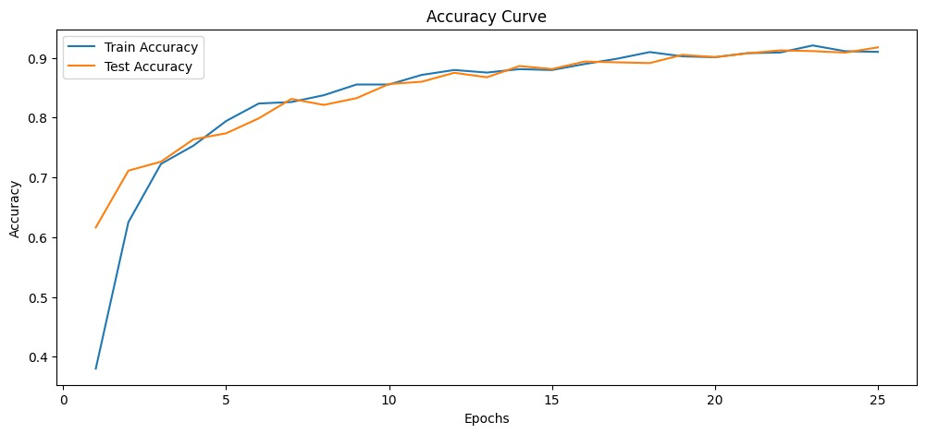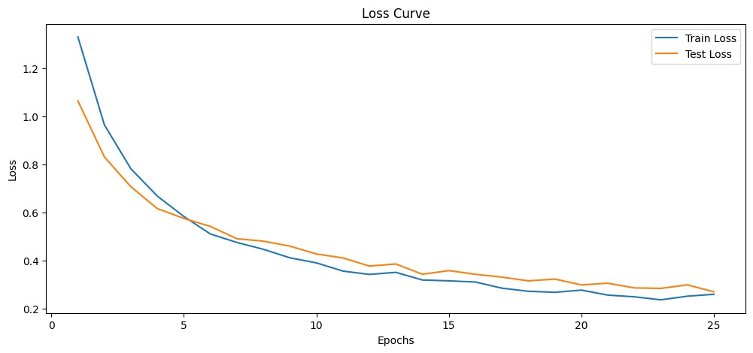
The training and testing graphs of DenseNet121 after applying dropout and L2 regularization demonstrate stable learning behavior and improved generalization performance. Both the training and testing accuracy curves increase gradually across epochs and remain very close to each other throughout training, indicating that the model learned effectively without significant overfitting. The testing accuracy reached approximately 92%, while the training accuracy also remained around 91–92%, showing a balanced and consistent performance. Similarly, the training and testing loss curves continuously decreased with only very small fluctuations, confirming smooth convergence of the model during training. Compared to earlier experiments, the gap between training and testing performance is noticeably reduced, proving that dropout and regularization successfully controlled overfitting and enhanced the model’s robustness on unseen MRI brain tumor images.
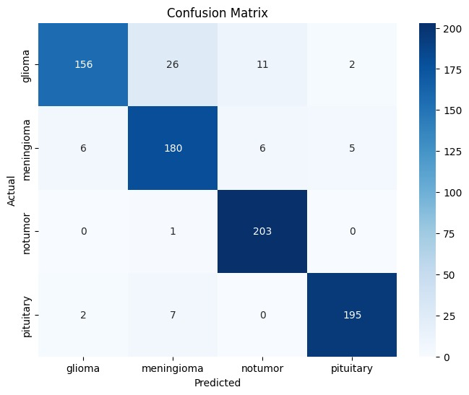

The confusion matrix further highlights the strong classification capability of DenseNet121 after applying dropout and regularization. The model correctly classified most samples across all four classes: glioma, meningioma, notumor, and pituitary. The notumor class achieved extremely high prediction accuracy with almost all samples correctly identified, while the pituitary and meningioma classes also showed strong classification performance with very few errors. A limited number of glioma samples were misclassified as meningioma and notumor, mainly because of the visual similarity between certain tumor categories in MRI scans. However, the overall number of misclassifications was low, indicating that the model developed strong discriminative learning capability. The confusion matrix confirms that the addition of dropout and L2 regularization improved the reliability, stability, and overall performance of DenseNet121 for multi-class brain tumor classification.

Model | F1-Score | Test Accuracy | Best Epoch
Densenet121 | 0.9158 | 91.75% | 25
ResNet50 | 0.9299 | 93.12% | 21

7.5 Cross-Architecture Comparison with Dropout and Regularization
When comparing across architecture families after applying dropout and L2 regularization, DenseNet121 with augmentation continued to emerge as the strongest model in most experimental runs. Its compact dense connectivity, efficient feature reuse, and moderate depth make it highly suitable for constrained medical imaging datasets. ResNet50 with augmentation, dropout, and regularization provided the best trade-off within the ResNet family by achieving strong performance with improved generalization capability.
The following general observations were identified after integrating dropout and regularization techniques:
- Data augmentation, dropout, and L2 regularization collectively improved macro F1-score and reduced overfitting across all architectures.
- Shallow-to-moderate depth models (ResNet50 and DenseNet121) continued to outperform deeper models (ResNet152 and DenseNet201) in the limited-data training setup.
- DenseNet architectures consistently achieved better feature learning and classification performance compared to ResNet architectures of comparable depth.
- The inclusion of dropout stabilized validation accuracy and reduced fluctuations in validation loss during later training epochs.
- L2 regularization improved weight optimization by preventing excessively large parameter values and reducing model memorization.
- Early stopping activated between epochs 8 and 18 for most experiments, confirming that 25 epochs remained a sufficient upper training limit even after regularization was introduced.
7.6 Per-Class Analysis with Dropout and Regularization
The confusion matrices and classification reports after applying dropout and regularization provided additional insight into per-class performance improvements.
Consistent observations include:
- Pituitary class: Continued to achieve the highest per-class F1-score across all models due to its highly distinguishable anatomical characteristics.
- Glioma class: Maintained strong classification performance with improved recall after regularization reduced feature overfitting.
- Meningioma class: Remained the most difficult class to classify, although dropout improved robustness and slightly reduced class confusion with pituitary tumors.
- No Tumor class: Achieved improved precision and recall stability after regularization reduced false positive predictions caused by MRI artifacts.
The addition of dropout particularly improved minority-class generalization by forcing the networks to learn more distributed and generalized feature representations.
7.7 Training Dynamics with Dropout and Regularization
Analysis of the training and validation curves after adding dropout and L2 regularization revealed several important improvements:
- All models continued to show rapid initial learning during epochs 1–5, followed by smoother convergence behavior.
- Without regularization, models previously exhibited noticeable train-test performance gaps and unstable validation loss fluctuations.
- After adding dropout and L2 regularization, the train-test accuracy gap reduced significantly, indicating better generalization performance.
- Validation loss curves became smoother and more stable across epochs due to improved optimization control.
- ResNet models still showed slightly more volatile training behavior compared to DenseNet models, although the fluctuations were substantially reduced after regularization.
- DenseNet121 demonstrated the most stable convergence pattern with consistently high validation performance throughout training.
Overall, the combination of augmentation, dropout, L2 regularization, and adaptive learning rate scheduling using ReduceLROnPlateau significantly improved training stability and reduced overfitting.

CHAPTER 8 – CONCLUSION AND FUTURE SCOPE

8.1 Conclusion
This project presented a comparative study of four deep Convolutional Neural Network architectures – ResNet50, ResNet152, DenseNet121, and DenseNet201 – for multi-class brain tumor classification using MRI images. The models were trained on 50% of the Kaggle Brain Tumor MRI dataset under three experimental settings: without augmentation, with data augmentation, and with additional dropout and L2 regularization.
The key conclusions drawn from this study are:
- ResNet50 with augmentation, dropout, and L2 regularization achieved the best overall performance, obtaining the highest testing accuracy and strong macro F1-score among all experimental configurations.
- DenseNet121 also demonstrated strong and stable performance, benefiting from efficient feature reuse through dense connectivity.
- Data augmentation consistently improved model performance by reducing overfitting and improving generalization capability across all architectures.
- Dropout and L2 regularization further enhanced training stability and reduced train-test performance gaps, resulting in smoother convergence and improved robustness on unseen MRI images.
- Shallower architectures such as ResNet50 and DenseNet121 outperformed deeper models like ResNet152 and DenseNet201 in the limited-data training setup.
- Per-class analysis showed that Pituitary tumors were the easiest to classify, while Meningioma tumors remained the most challenging due to visual similarities with other tumor classes.
Overall, the study demonstrates that combining data augmentation, dropout, and regularization significantly improves deep learning performance for brain tumor MRI classification. ResNet50 with augmentation and regularization is recommended as the final optimized model due to its strong balance of accuracy, robustness, and generalization performance.

8.2 Future Scope
Several avenues exist for extending and improving upon this work:

8.2.1 Transfer Learning
A natural extension is to initialise all models with ImageNet pre-trained weights (weights=IMAGENET1K_V1) and fine-tune on the brain tumor dataset. Transfer learning is expected to substantially improve performance and reduce training time, particularly for deeper models such as ResNet152 and DenseNet201 that struggled to converge from scratch in this study.

8.2.2 Advanced Augmentation Strategies
The current augmentation pipeline is minimal (flip and rotation only). Advanced strategies such as CutMix, MixUp, Elastic Deformation, GridDistortion, and Contrast Limited Adaptive Histogram Equalisation (CLAHE) are domain-specific augmentations used in medical imaging that could further improve generalisation.

8.2.3 Segmentation and Multi-Task Learning
Extending the system from classification to segmentation (e.g., using U-Net or Mask R-CNN) would enable localisation of the tumor region, providing richer diagnostic information. Multi-task learning (joint classification and segmentation) could further improve both tasks through shared feature learning.

8.2.4 Ensemble Methods
Ensemble approaches combining the outputs of multiple models (e.g., ResNet50 + DenseNet121 + DenseNet201 with soft voting or stacking) are expected to yield accuracy improvements of 2–5 percentage points over individual models, at the cost of increased inference time.

REFERENCES
- R. Vankdothu, M. A. Hameed, and H. Fatima, “A Brain Tumor Identification and Classification Using Deep Learning based on CNN-LSTM Method,” Computers and Electrical Engineering, vol. 101, p. 107960, 2022.
- E. H. Tusher, F. M. Tarin, M. M. Shahriar, M. M. G. Hafiz, R. I. Rabbi, and T. H. Liew, “Comparative Analysis of Deep Learning Architectures for Brain Tumor Classification using MRI Images,” in 2025 8th International Conference on New Media Studies (CONMEDIA), Malacca, Malaysia, 2025, pp. 35–37.
- M. Z. Khaliki and M. S. Başarslan, “Brain Tumor Detection from Images and Comparison with Transfer Learning Methods and 3-Layer CNN,” Scientific Reports, vol. 14, no. 1, p. 2664, 2024.
- M. Menagadevi, S. Sharmila, D. Thiyagarajan, N. Madian, and S. Devaraj, “Brain Tumor Detection Using VGG 16 & Efficient Net B3 Model,” in 2024 10th International Conference on Advanced Computing and Communication Systems (ICACCS), 2024, pp. 167–168.
- https://www.kaggle.com/datasets/masoudnickparvar/brain-tumor-mri-dataset

