Project Submission

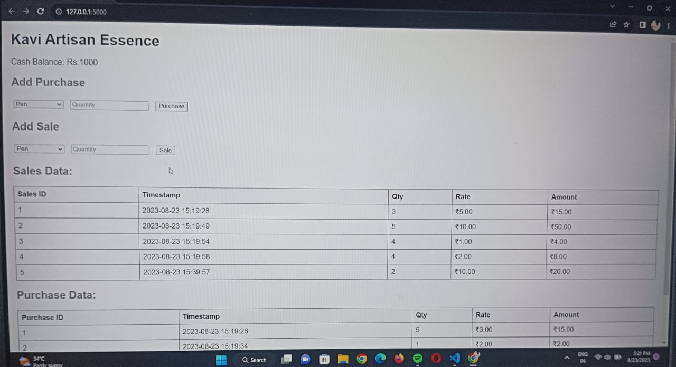

Working database store the values

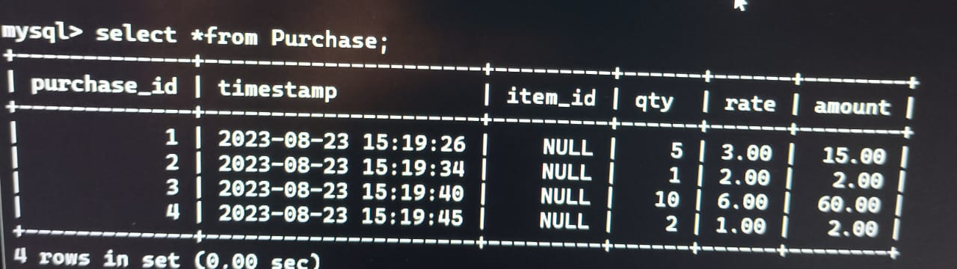

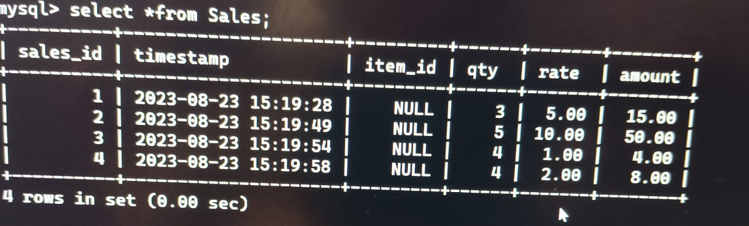

Transaction History

