CCT College Dublin

Assessment Cover Page

Module Title:

Assessment Title:

Lecturer Name:

Student Full Name: | Dorjragchaa Chuluunbaatar
Student Number: | 2025336
Assessment Due Date:

Date of Submission:

Declaration

By submitting this assessment, I confirm that I have read the CCT policy on Academic Misconduct and understand the implications of submitting work that is not my own or does not appropriately reference material taken from a third party or other source. I declare it to be my own work and that all material from third parties has been appropriately referenced. I further confirm that this work has not previously been submitted for assessment by myself or someone else in CCT College Dublin or any other higher education institution.

1. Use Case Specifications & Diagram
This section describes the five main use cases for the Bank Organisation System. Each use case shows how the Bank Staff interacts with the system to complete a task.

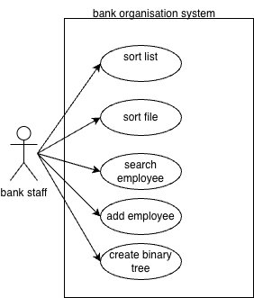
Figure 1: Use Case Diagram – Bank Organisation System

UC1: Load Applicants File

Field | Description
Use case ID | UCI
Name | Load Appliocation File
Actor | Bank staff
Description | The user loads the Applications_Form.txt file to initialise the employee data in the system
Pre-condition | The system has started and is waiting for file input
Post-condition | Employee records are loaded into memory and the sorted list is prepared

Main Steps:
- 1. System prompts user to enter a filename.
- 2. User types "Applicants_Form.txt".
- 3. System reads and parses each employee record.
- 4. System sorts the records.
- 5. System shows a success message with total records.
- 6. Main menu is displayed.

Alternative Paths:
- A1: User enters wrong filename — system shows error and stops.
- A2: File is empty or badly formatted — system shows parse error and stops.

UC2: Sort Employee List

Field | Description
Use case ID | UC2
Name | Sort Employee List
Actor | Bank staff
Description | The user sorts all employee records alphabetically and views the first 20
Pre-condition | The file has been loaded successfully
Post-condition | The first 20 sorted employees are shown in a formatted table

Main Steps:
- 1. User picks option 1 (Sort) from the menu.
- 2. System runs recursive Merge Sort on all records.
- 3. System shows the first 20 sorted records in a table.
- 4. Each row shows Name, Manager Type, and Department.
- 5. System goes back to the main menu.

Alternative Paths:
- A1: Fewer than 20 records exist — system shows all available records.

UC3: Search Employee by Name
Field | Description
Use case ID | UC3
Name | Search employee by name
Actor | Bank staff
Description | The user searches for an employee using their full name or part of their name
Pre-condition | File is loaded and employees are sorted
Post-condition | Matching employee records are shown with full details

Main Steps:
- 1. User picks option 2 (Search) from the menu.
- 2. System shows two search options.
- 3. User picks Exact Search.
- 4. System asks for the full name.
- 5. User enters the name.
- 6. System runs recursive Binary Search.
- 7. Matching records are shown with full details.
- 8. System goes back to the main menu.

Alternative Paths:
- A1: User picks Partial Search — system searches all records for partial matches.
- A2: No match found — system shows "No matching records were found."

UC4: Add New Employee
Field | Description
Use case ID | UC4
Name | Add new new employee
Actor | Bank staff
Description | The user adds a new employee by entering their first name, last name, manager type, and department
Pre-condition | File has been loaded
Post-condition | New employee is added and the sorted list is updated

Main Steps:
- 1. User picks option 3 (Add Record).
- 2. System asks for first name.
- 3. User enters a valid first name.
- 4. System asks for last name.
- 5. User enters a valid last name.
- 6. System shows manager type options.
- 7. User picks a valid manager type.
- 8. System shows department options.
- 9. User picks a valid department.
- 10. System creates the employee and shows confirmation.

Alternative Paths:
- A1: User enters a blank name — system keeps asking until a valid name is given.
- A2: User enters a number out of range — system shows an error and asks again.

UC5: Create Employee Binary Tree

Field | Description
Use case ID | UC5
Name | Create employee binary tree
Actor | Bank staff
Description | The user builds a binary tree hierarchy using the first 20 sorted employee records
Pre-condition | At least 20 employee records are loaded
Post-condition | Binary tree is shown level by level, with height and node count

Main Steps:
- 1. User picks option 4 (Create Binary Tree).
- 2. System sorts all records.
- 3. System inserts first 20 records using level-order insertion.
- 4. System shows all tree levels with employee details.
- 5. System shows tree height and total node count.
- 6. System goes back to the main menu.

Alternative Paths:
- A1: Fewer than 20 records — system shows error and returns to menu.

2. UML Model 1 – Class Diagram
The class diagram below shows all the classes in the Bank Organisation System, including their attributes, methods, and relationships to each other.

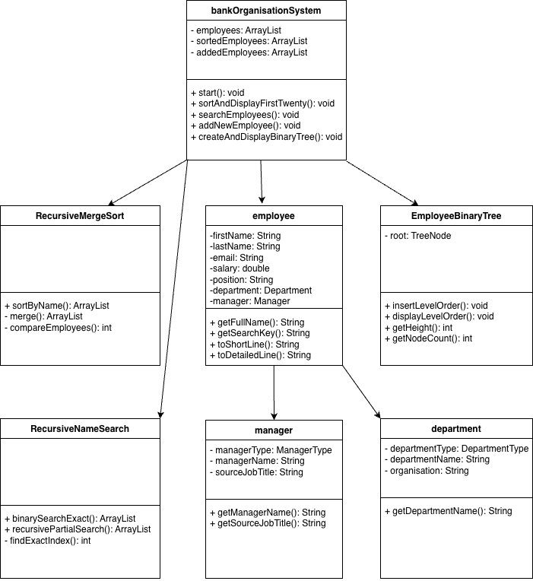
Figure 2: Class Diagram – Bank Organisation System

The Employee class is the main entity in the system. BankOrganisationSystem manages all Employee objects and uses RecursiveMergeSort for sorting and EmployeeBinaryTree for the tree structure. Each Employee has one Manager and one Department linked to it. RecursiveNameSearch handles both exact and partial name searching.

3. UML Model 2 – Sequence Diagram
The sequence diagram below shows what happens step by step when the user adds a new employee. It shows the messages between the User, BankOrganisationSystem, InputValidator, and Employee objects.

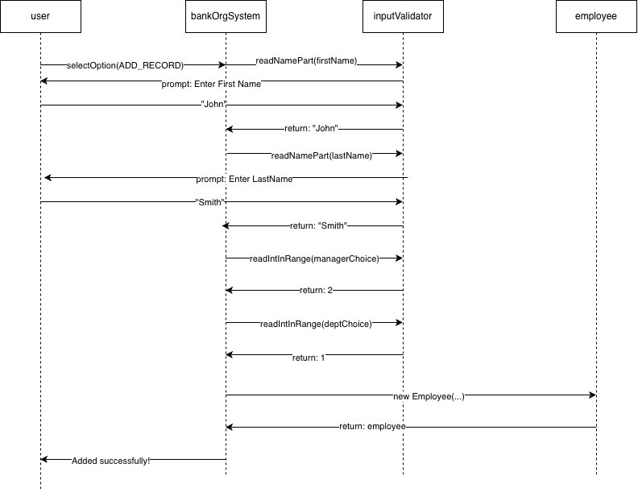
Figure 3: Sequence Diagram – Add New Employee (UC4)

The process starts when the user selects Add Record. BankOrganisationSystem uses InputValidator to collect and validate the first name, last name, manager type, and department. Once all inputs are collected, a new Employee object is created and a confirmation message is shown.

4. System Requirements
The requirements below describe what the system must do (functional) and the quality standards it needs to meet (non-functional).

4.1 Functional Requirements
ID | Requirement | Reason
FR1 | The system shall read employee data from a file called Applicants_Form.txt. | File loading is the starting point of the system.
FR2 | The system shall sort all employees alphabetically using recursive Merge Sort. | Sorting is needed for binary search and organised display.
FR3 | The system shall show only the first 20 sorted employees in a table. | The assignment says only the first 20 names should be displayed.
FR4 | The system shall support exact full-name search using recursive Binary Search. | Binary search gives fast O(log n) lookup on a sorted list.
FR5 | The system shall support partial name search across all records. | Users may not always know the full name of an employee.
FR6 | The system shall let the user add a new employee with a name, manager type, and department. | The assignment requires dynamic data entry.
FR7 | The system shall validate all inputs and keep asking until valid input is given. | This prevents crashes and keeps data correct.
FR8 | The system shall build a binary tree using level-order insertion for the first 20 sorted records. | The assignment requires breadth-first binary tree insertion.
FR9 | The system shall display the binary tree level by level with tree height and node count. | Level-order display clearly shows the hierarchy.
FR10 | The system shall use Enums for menu options, manager types, and department types. | Enums provide structured, type-safe constants as required.

4.2 Non-Functional Requirements

ID | Requirement | Reason
NFR1 | The system shall run in the command line with no GUI. | The assignment does not allow JavaFX or Swing.
NFR2 | All variable and method names shall be clear and descriptive. | Code quality is assessed and poor naming loses marks.
NFR3 | All Java classes shall have comments explaining key methods. | Comments make the code easier to follow and maintain.
NFR4 | The project shall be a NetBeans Maven project with all files using the CA_2 package. | The assignment requires this specific project structure.
NFR5 | The system shall handle file errors by showing a clear message and stopping safely. | This prevents silent failures and improves user experience.
NFR6 | Sorting and searching must use recursive implementations, not loops. | The assignment specifically requires recursive algorithms.
NFR7 | The GitHub repository shall have at least 10 to 15 commits. | The assignment requires version control evidence.

5. User Stories & Acceptance Criteria
The five user stories below describe the system from the point of view of Bank Staff. Each story includes acceptance criteria to show when the story is done.

US1: Load Employee Data

Field | Content
Story ID | US1
Title | Load Employee Data
User Story | As a Bank Staff member, I want to load employee data from a file so that I can work with the records in the system.

Acceptance Criteria:
- AC1: Given the system has started, when I type "Applicants_Form.txt", then the file loads and a success message shows the total records.
- AC2: Given I enter a wrong filename, then an error message is shown and the program stops.
- AC3: Given the file loads successfully, then the main menu appears.

US2: Sort and View Employee List

Field | Content
Story ID | US2
Title | Sort and view employee list
User Story | As a Bank Staff member, I want to sort employees alphabetically so that I can view a clean list of the first 20 names

Acceptance Criteria:
- AC1: Given data is loaded, when I select Sort, then all records are sorted using recursive Merge Sort.
- AC2: Given sort is done, then the first 20 names show in a table with Name, Manager Type, and Department.
- AC3: Given fewer than 20 records exist, then all available records are shown.

US3: Search for an Employee

Field | Content
Story ID | US3
Title | Search for an employee
User Story | As a Bank Staff member, I want to search for an employee by name so that I can quickly find their details.

Acceptance Criteria:
- AC1: Given I choose exact search and type a full name, then matching records show with full details.
- AC2: Given I choose partial search and type part of a name, then all matching records are returned.
- AC3: Given no match is found, then the system shows "No matching records were found."

US4: Add a New Employee

Field | Content
Story ID | US4
Title | Add a new employee
User Story | As a Bank Staff member, I want to add a new employee so that new staff are included in the records.

Acceptance Criteria:
- AC1: Given I select Add Record and enter a valid first and last name, then the system moves to manager selection.
- AC2: Given I enter a blank name, then the system keeps asking until a valid name is given.
- AC3: Given I pick a valid manager type and department, then the employee is added and a confirmation shows.
- AC4: Given the employee is added, then the sorted list is updated automatically.

US5: View Employee Binary Tree

Field | Content
Story ID | US5
Title | View employee binary tree
User Story | As a Bank Staff member, I want to see an employee hierarchy binary tree so that I can understand the organisational structure.

Acceptance Criteria:
- AC1: Given at least 20 records are loaded, when I select Create Binary Tree, then 20 employees are inserted using level-order.
- AC2: Given the tree is built, then it shows level by level with Name, Manager Type, and Department.
- AC3: Given display is done, then tree height and total node count are shown.
- AC4: Given fewer than 20 records exist, then an error message shows and the menu returns.

6. Unit Test Documentation
The three unit tests below check the core functionality of the system. Each test includes setup steps, test steps, expected results, and edge cases.

UT1: Recursive Merge Sort – Alphabetical Order

Field | Details
Test ID | UTI
Test Name | Recursive Merge Sort – Alphabetical Order
Class | RecursiveMergeSort
Method | sortByName(ArrayList<Employee>)
Objective | Check that the recursive Merge Sort correctly sorts employees alphabetically by full name.

Setup:
- Create three Employee objects: "Zara Ahmed", "Alice Brown", "Mike Chen".
- Add all three to an ArrayList.
- Create a RecursiveMergeSort object.

Test Steps:
- Call sortByName(employees).
- Check that index 0 is "Alice Brown".
- Check that index 1 is "Mike Chen".
- Check that index 2 is "Zara Ahmed".

Expected Result:
The list is sorted alphabetically: Alice Brown, Mike Chen, Zara Ahmed.

Edge Cases:
A list with one item should be returned unchanged. An empty list should return empty without crashing.

Expected Outcome:
PASS

UT2: Recursive Binary Search – Exact Name Found

Field | Details
Test ID | UT2
Test Name | Recursive Binary Search – Exact Name Found
Class | RecursiveNameSearch
Method | sortByName(ArrayList<Employee>)
Objective | Check that recursive Binary Search returns the correct record when given an exact full name.

Setup:
- Create a sorted ArrayList of 5 Employee objects.
- Create a RecursiveNameSearch object.

Test Steps:
- Call binarySearchExact(sortedList, "Alice Brown").
- Check result is not empty.
- Check result.get(0).getFullName() equals "Alice Brown".
- Call binarySearchExact(sortedList, "Unknown Name").
- Check result is empty.

Expected Result:
Search for "Alice Brown" returns one record. Search for "Unknown Name" returns an empty list.

Edge Cases:
A blank or null query should return an empty list without throwing an error.

Expected Outcome:
PASS

UT3: Binary Tree – Level-Order Insertion and Node Count

Field | Details
Test ID | UT3
Test Name | Binary Tree – Level-Order Insertion and Node Count
Class | EmployeeBinaryTree
Method | insertLevelOrder(Employee), getNodeCount()
Objective | Check that inserting 20 employees using level-order gives the correct node count and tree height.

Setup:
- Create 20 Employee objects.
- Create an EmployeeBinaryTree object.

Test Steps:
- Insert all 20 employees using insertLevelOrder() in a loop.
- Call getNodeCount() and check it equals 20.
- Call getHeight() and check it equals 5.

Expected Result:
Node count is 20. Tree height is 5.

Edge Cases:
Inserting into an empty tree should set the root to the first employee. getHeight() on an empty tree should return 0.

Expected Outcome:
PASS

