This lab session covers Django Models (Part 2 – Q operator, sorting objects, aggregation functions, and multi-models). By the end of this session, students should have a very good understanding of how to build advanced queries with multi-model query in Django.
Pre-lab Preparation:
- The table book as in lab7.
- The fake data from mockaroo.com website or any other methods.
Lab Activities:
Task 1: Create a URL ‘/books/lab8/task1’ with any necessary HTML file and view function to list books that have price less than or equal 80 using Q operator.
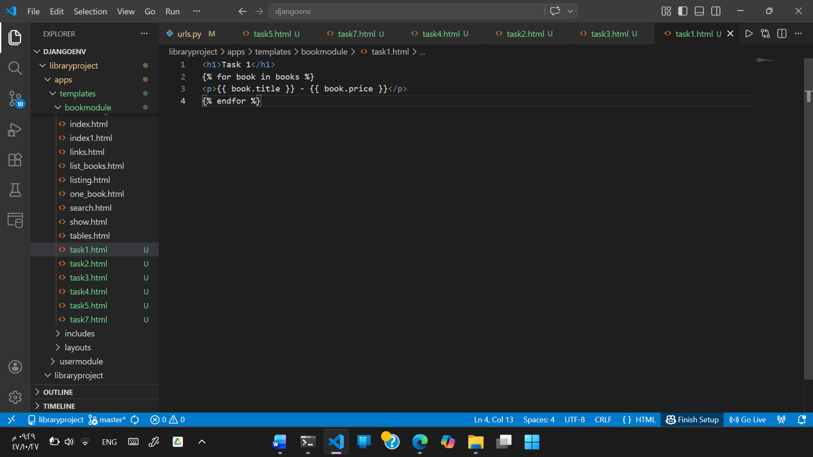
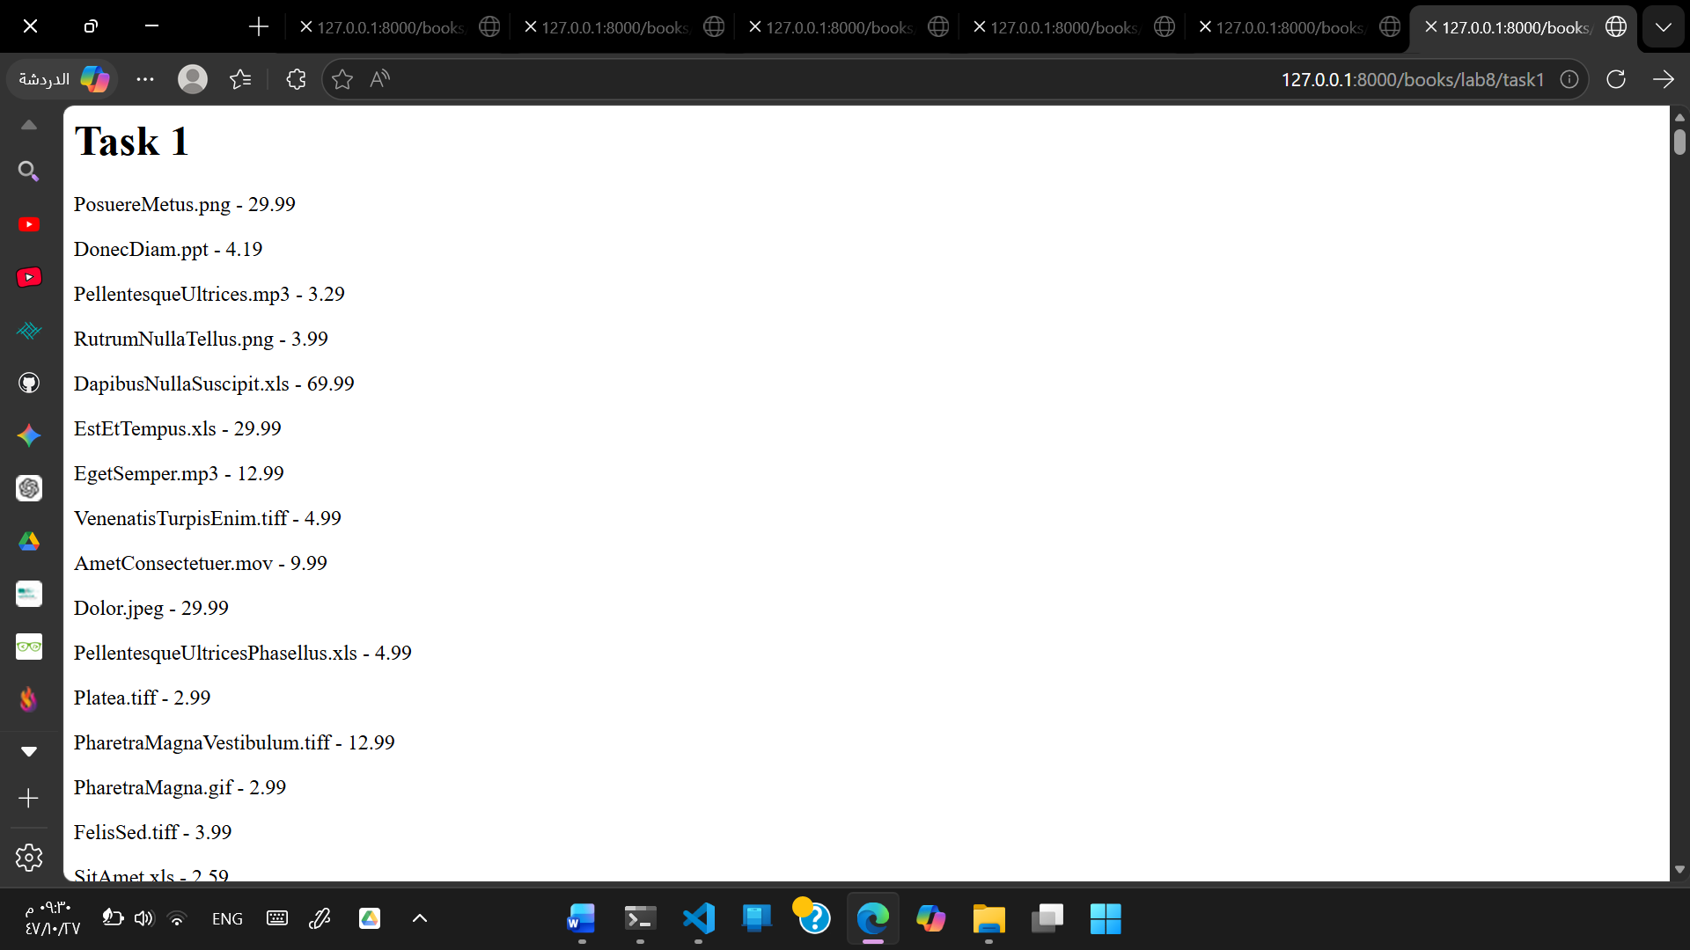

Task 2: Create a URL ‘/books/lab8/task2’, HTML file, and view function to list books that have editions higher than three and either the title or author of the book contains the two adjacent letters ‘qu’ by combining two or more Q operator (through “&” or “|”).
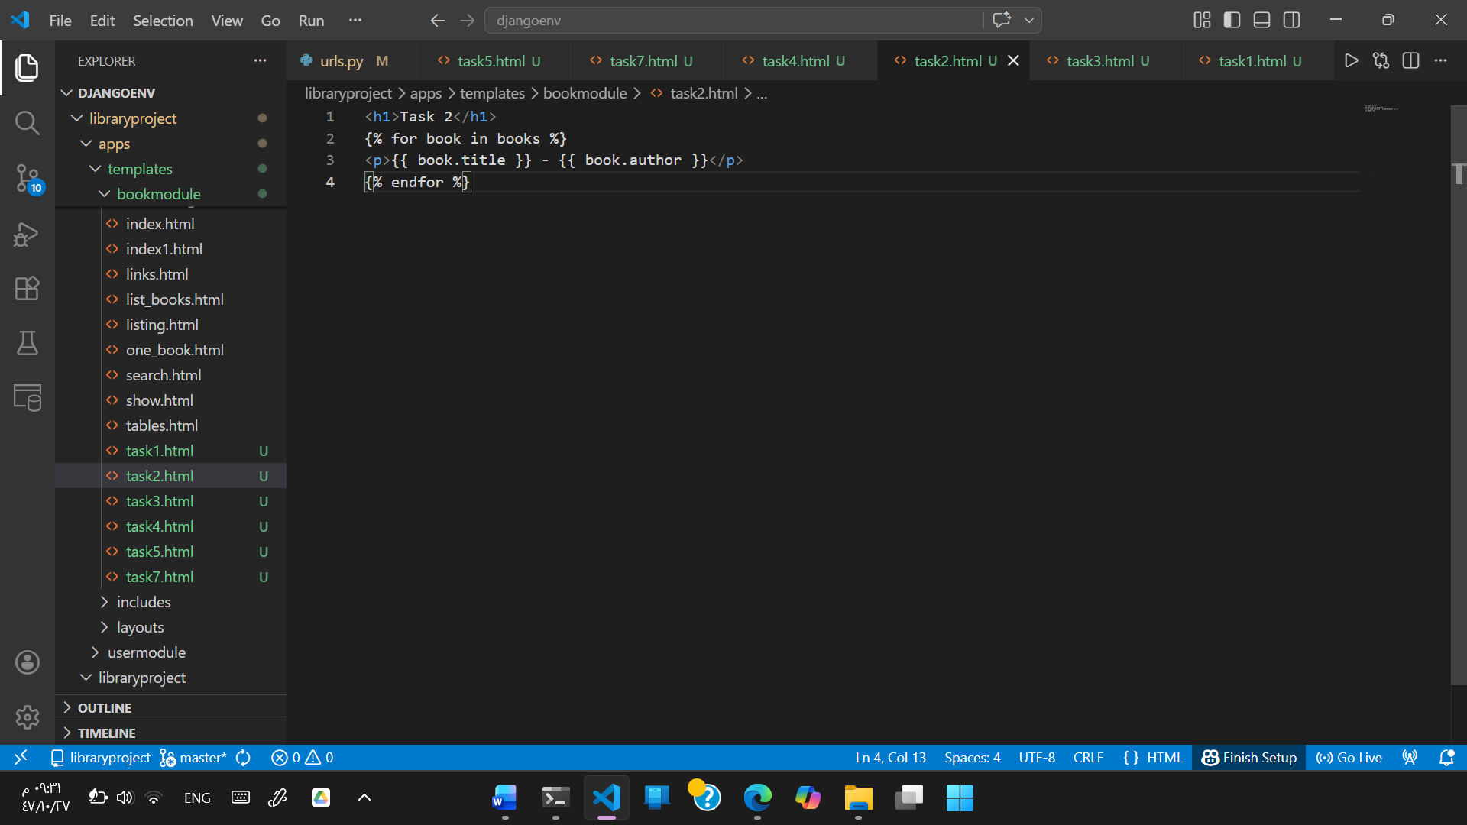
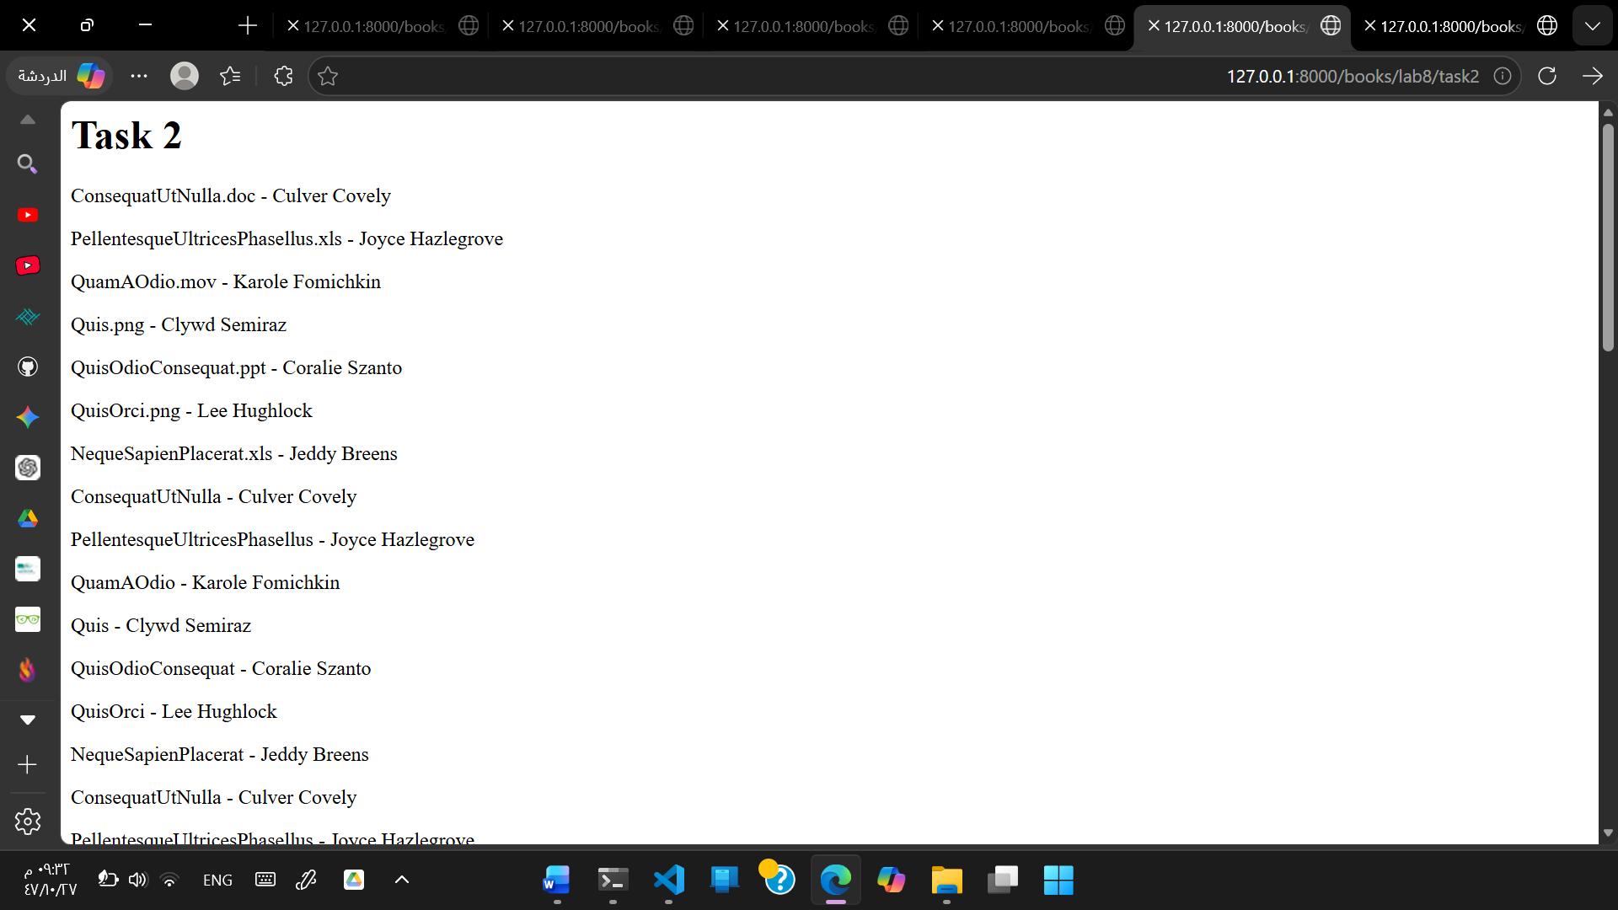
Task 3: (opposite to Task 2) Create a URL ‘/books/lab8/task3’, HTML file, and view function to list books that have no editions higher than three and either the title or author of the book that does not contain the two adjacent letters “qu” by combining two or more Q operator (through “&” or “|”, beside ~ operator).
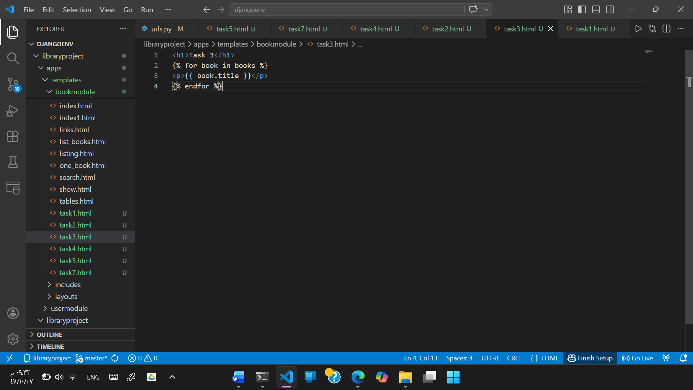

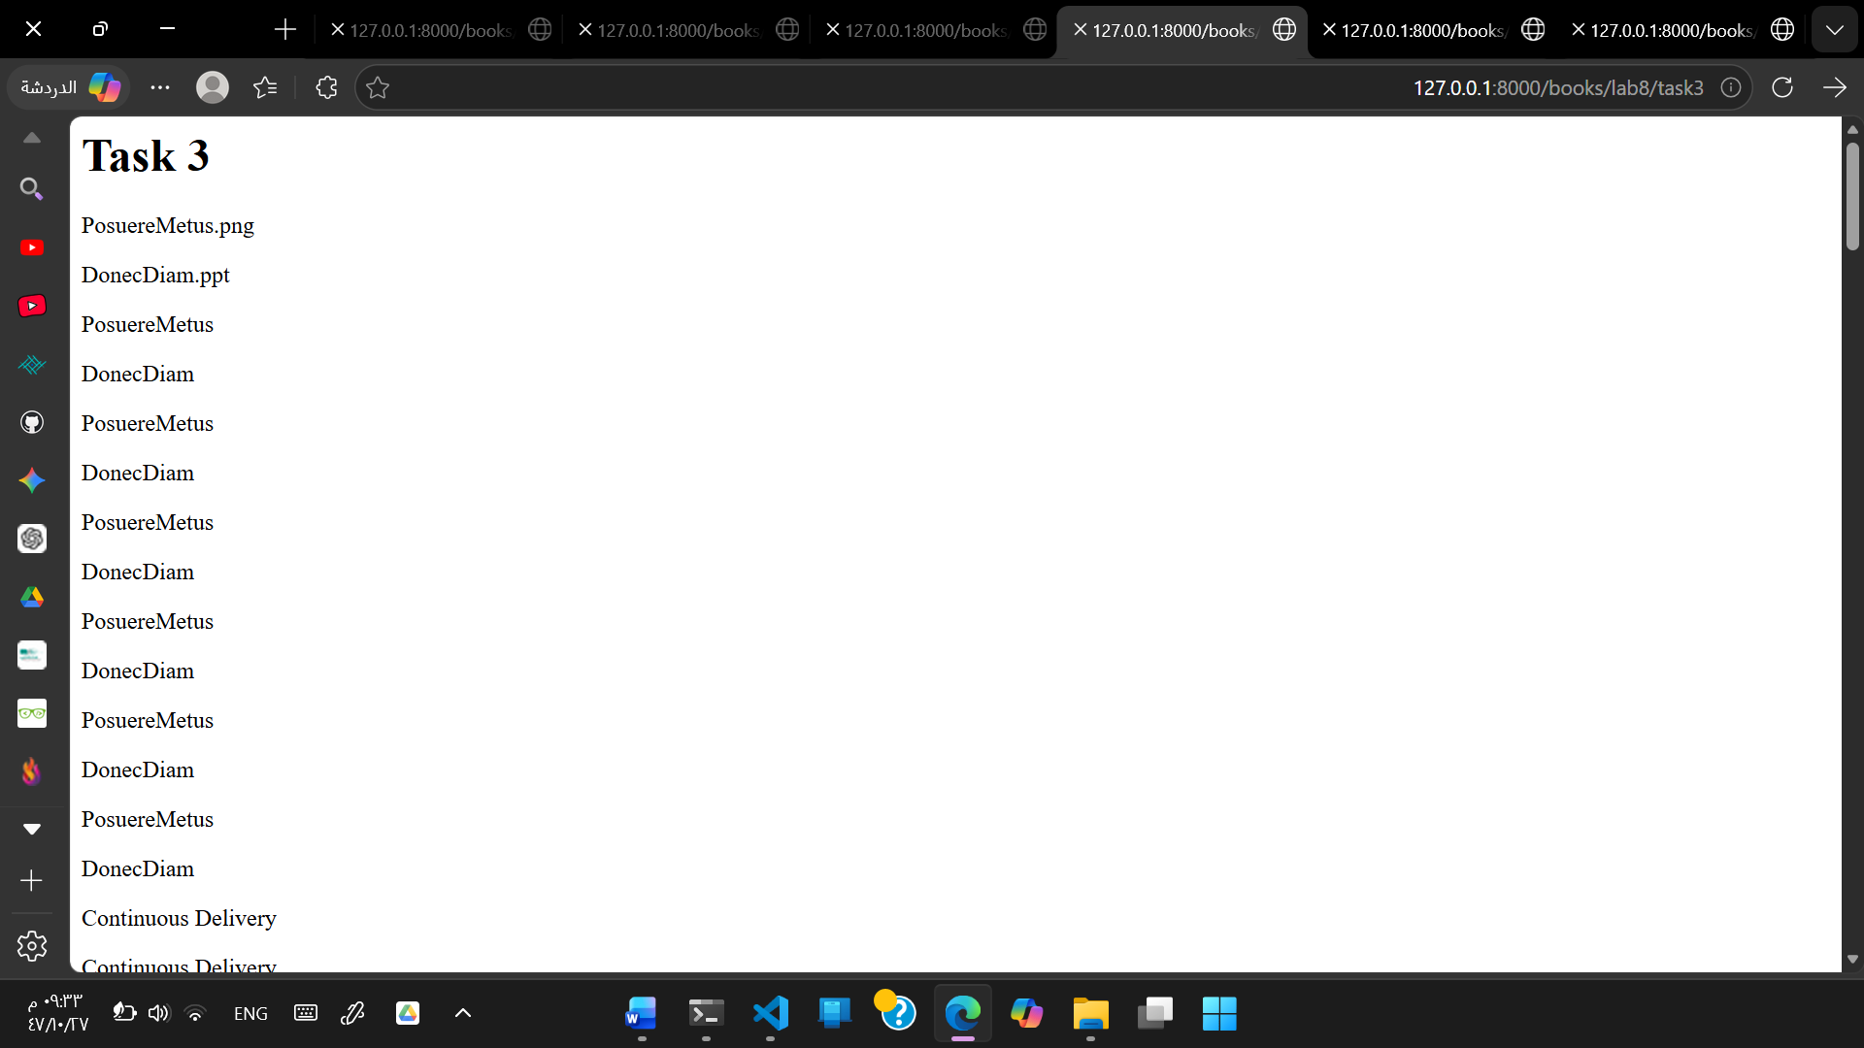
Task 4: Create a URL ‘/books/lab8/task4’, HTML file, and view function to list books and order by their titles using the function “order_by”.
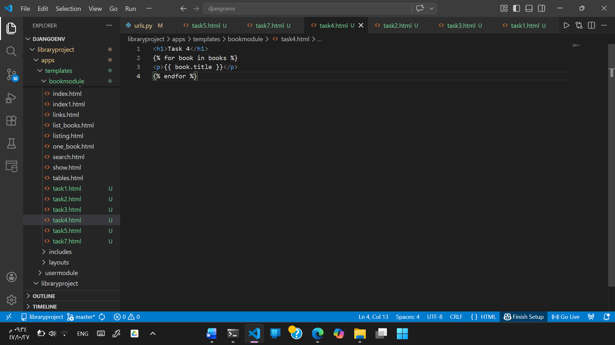
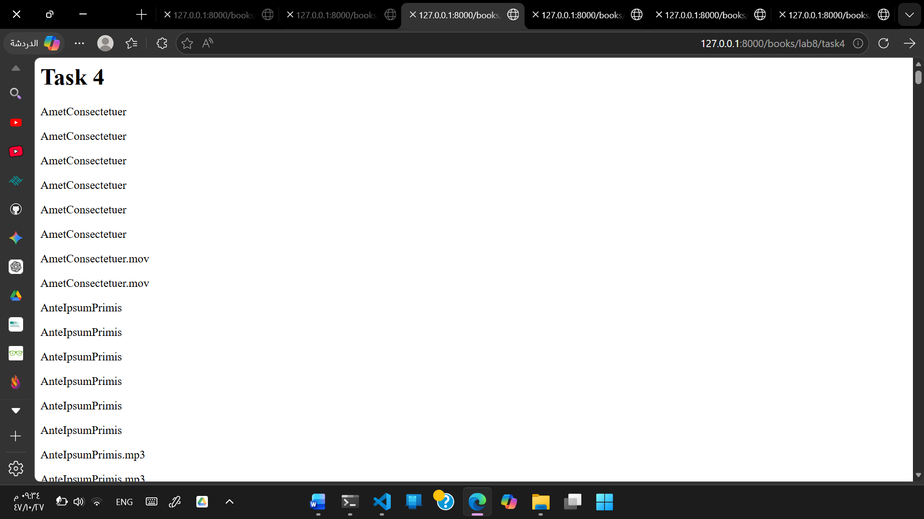
Task 5: Create a URL ‘/books/lab8/task5’, HTML file, and view function to display the number of books, total price of all books, average price, maximum price, and minimum price using aggregation functions.
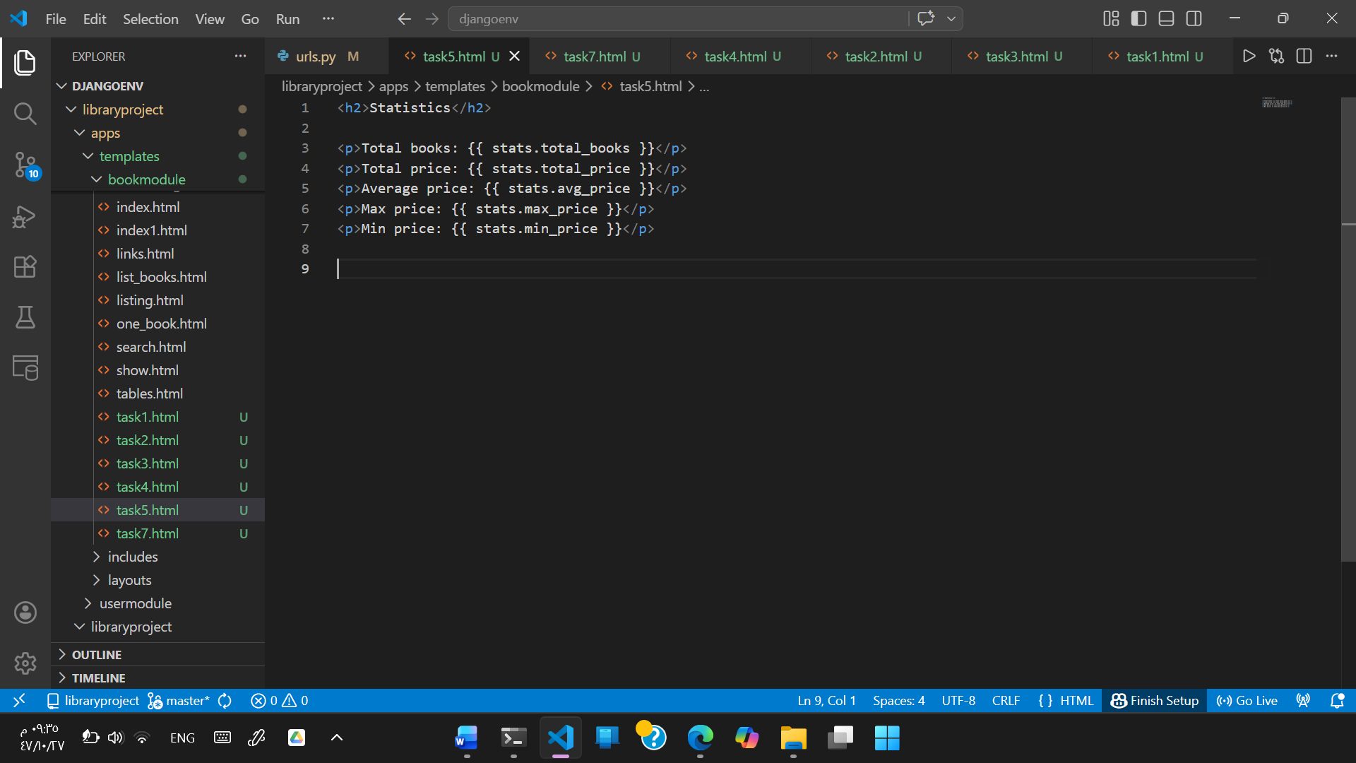
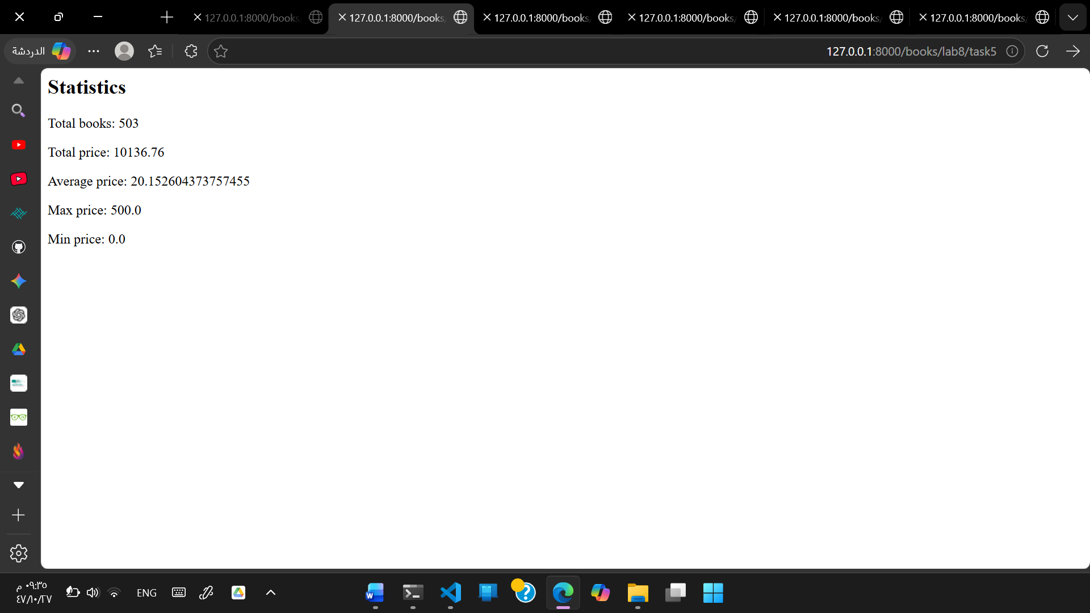

Task 6: Create a database scheme (through models in Django)
Note that instead of creating another app to handle student applications, you may exploit existing apps, like user or book modules
Student
ID | as an integer (this is done automatically by Django)
name | as a string
age | as an integer
address | as a foreign key to table address
Address
ID | as an integer (this is done automatically by Django)
city | as a string

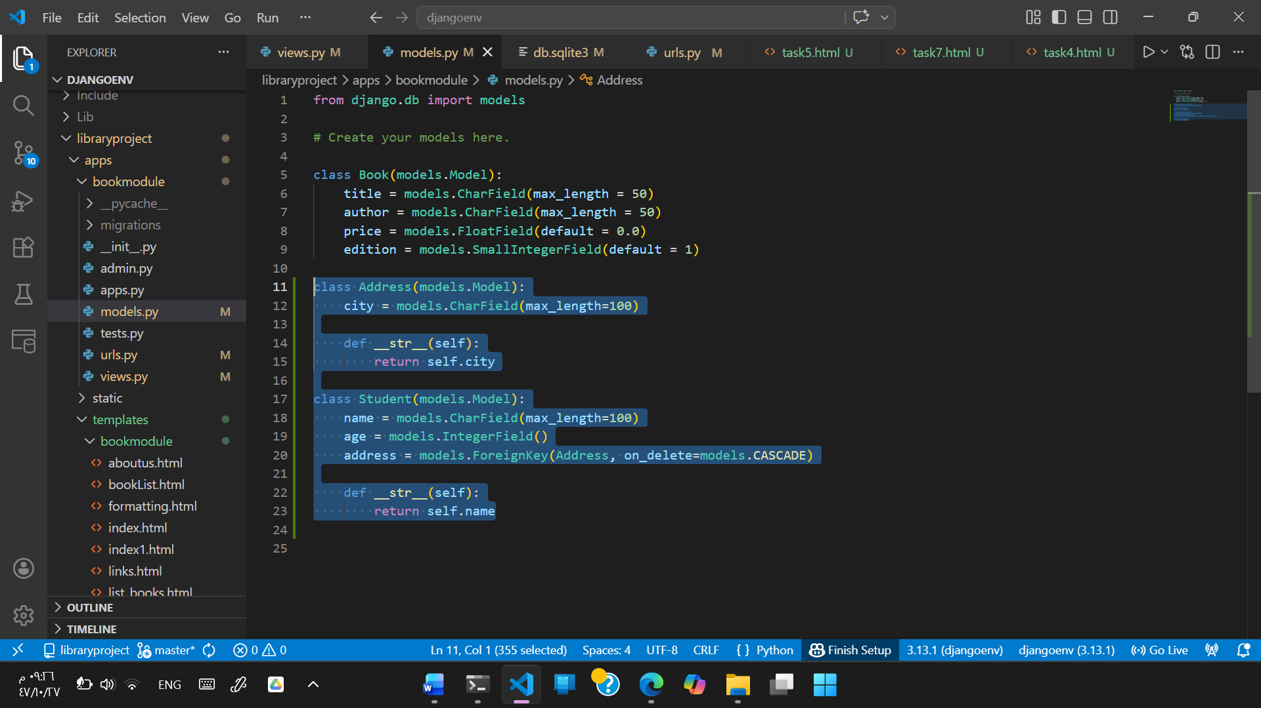

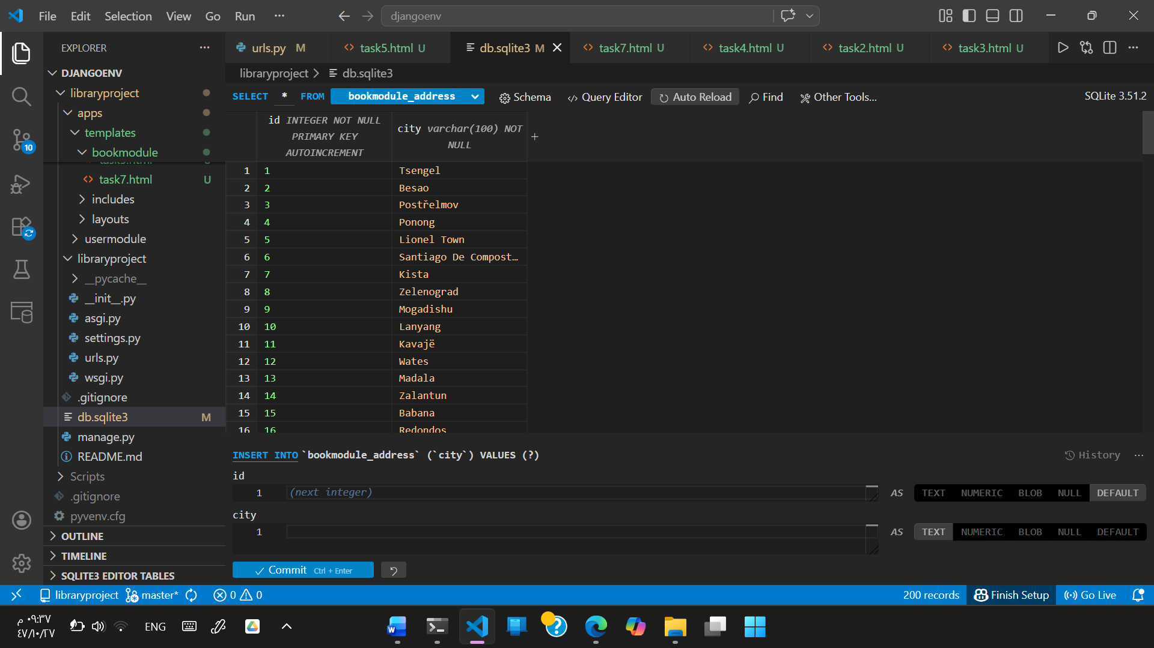
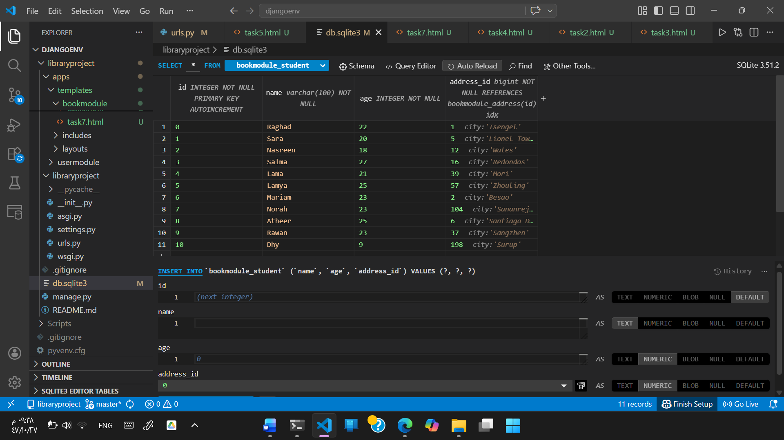

Task7: Create a page that shows the number of students in each city.

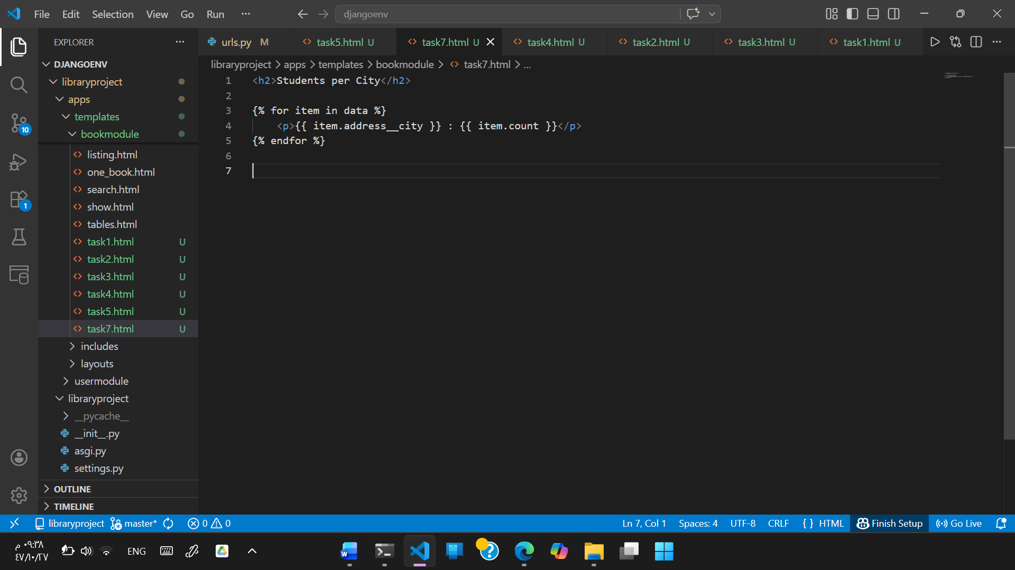

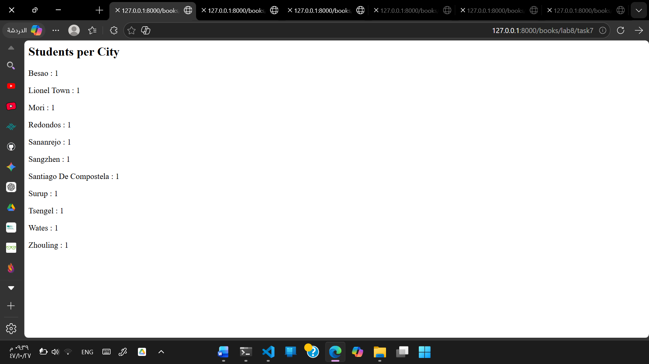

View.py – all tasks functions :

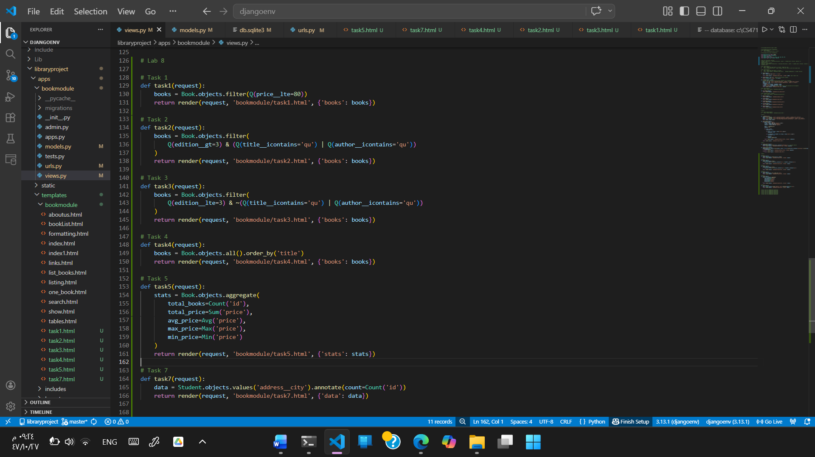

Urls.py for all tasks functions :

