This lab session covers Django Models (Part 3). By the end of this session, students should have a very good understanding of how to make advanced queries using annotations.

Pre-lab Preparation:
- The following DB models scheme

class Publisher(models.Model):
name = models.CharField(max_length=200)
location = models.CharField(max_length=300)

class Author(models.Model):
name = models.CharField(max_length=200)
DOB = models.DateField(null=True)

class Book(models.Model):
title = models.CharField(max_length= 100)
price = models.FloatField(default=0.0)
quantity = models.IntegerField(default=1)
pubdate = models.DateTimeField()
rating = models.SmallIntegerField(default = 1)

publisher = models.ForeignKey(Publisher, null=True, on_delete=models.SET_NULL)
authors = models.ManyToManyField(Author)

- Use fake data from mockaroo.com website or any other methods to fill tables above. Make sure that you handle the Book.publisher and Book.authors fields correctly.

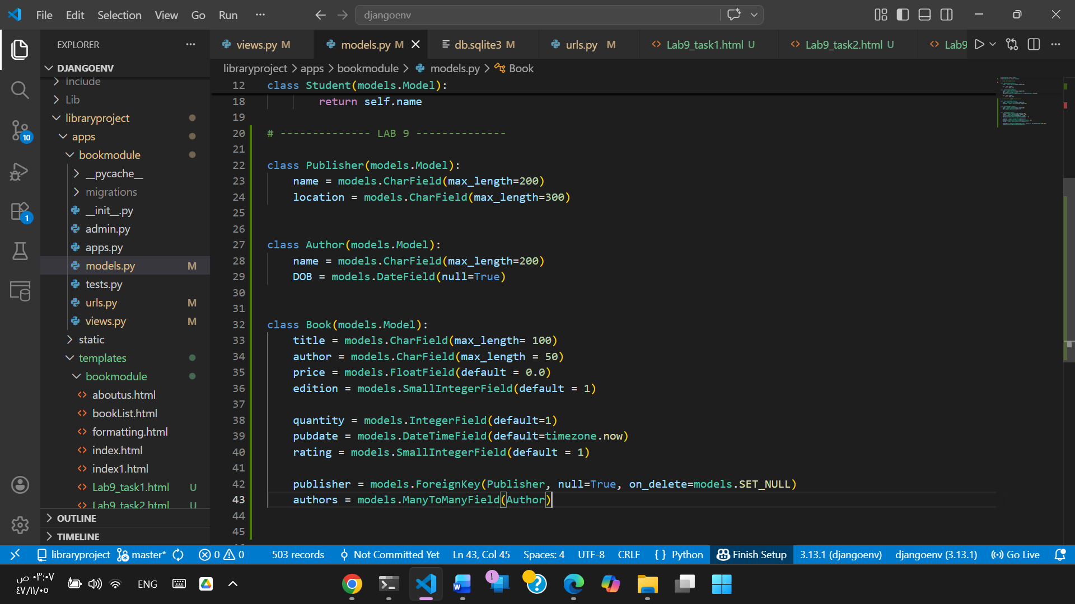
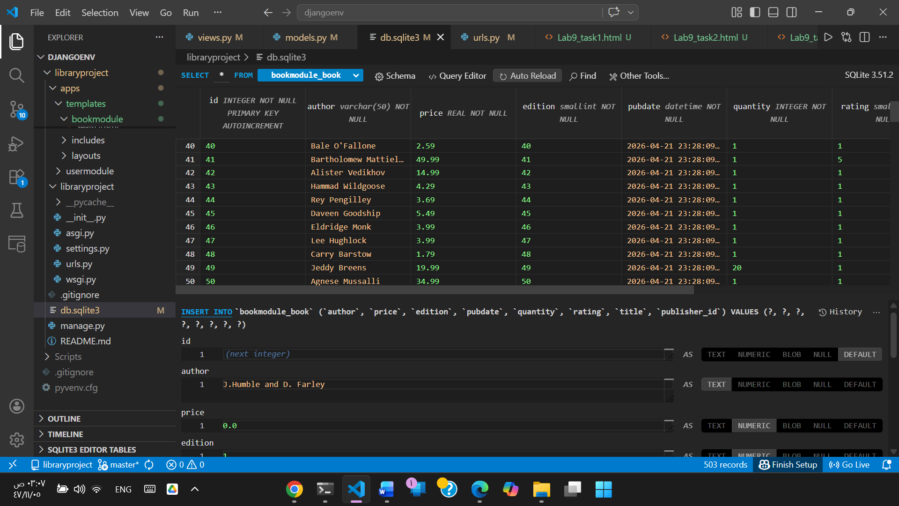

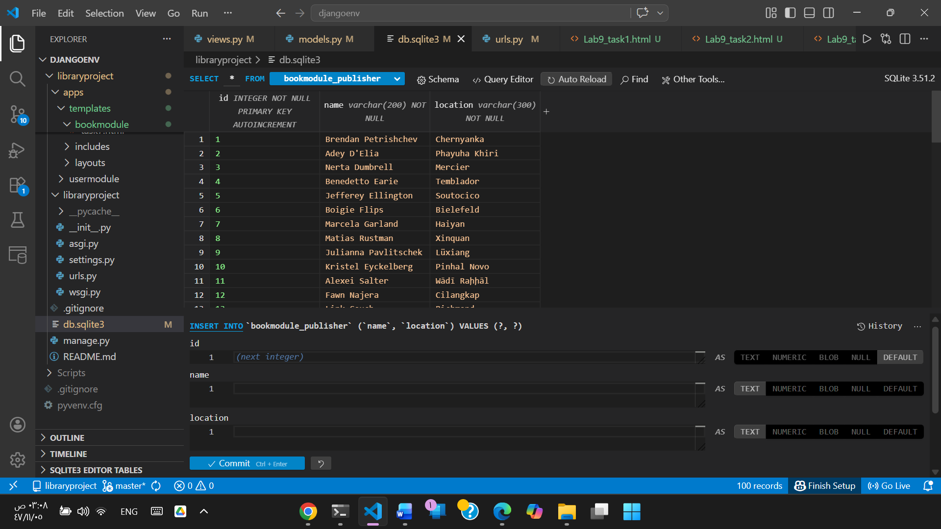

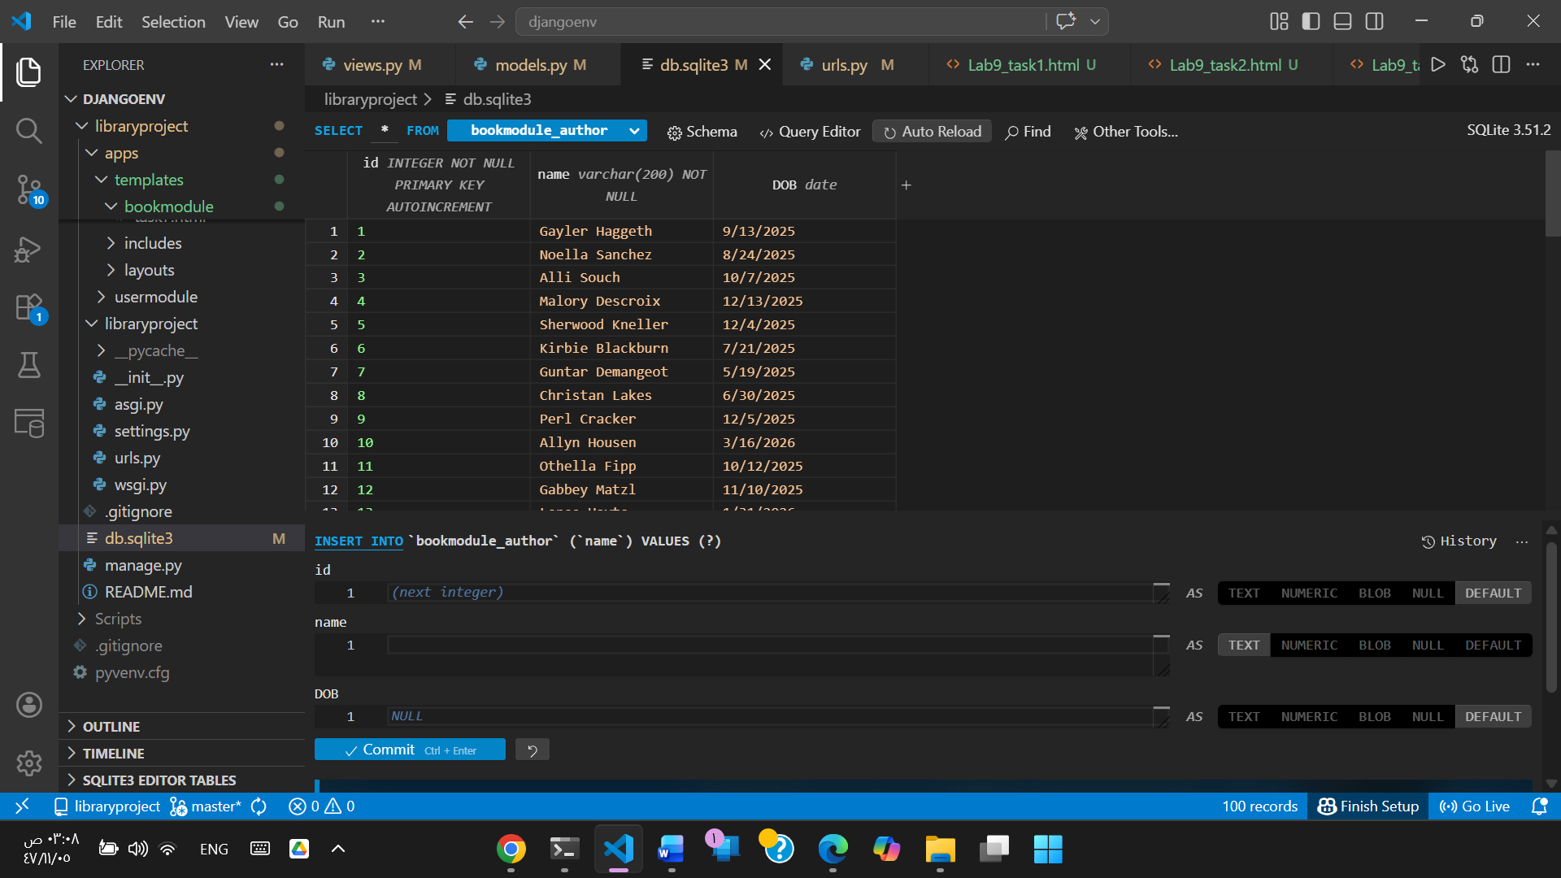
Lab Activities:
Task 1: Create a URL ‘/books/lab9/task1’ with any necessary HTML file and view function to list books along with percentage availability. For example, if the number of books in 350 and the quantity of a book is 7, then the percentage of availability is 2%. Use transient field for the percentage.
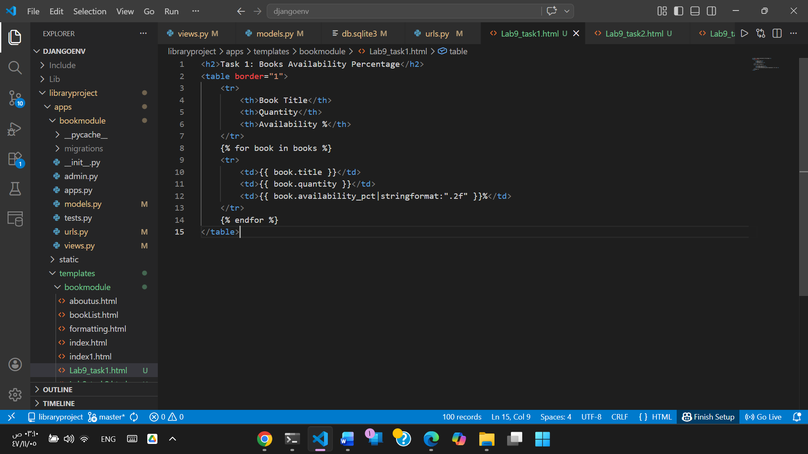

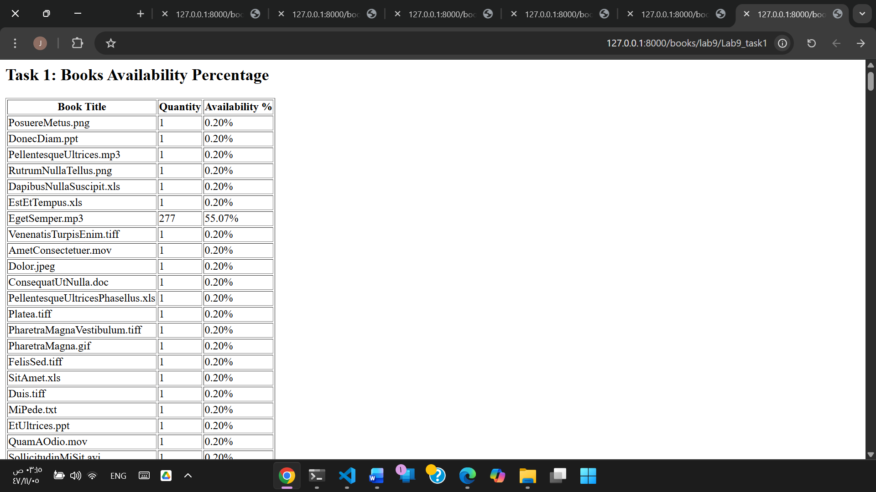
Task 2: Create a URL ‘/books/lab9/task2’, HTML file, and query list books that all publishers, annotated with their respective total book stock.
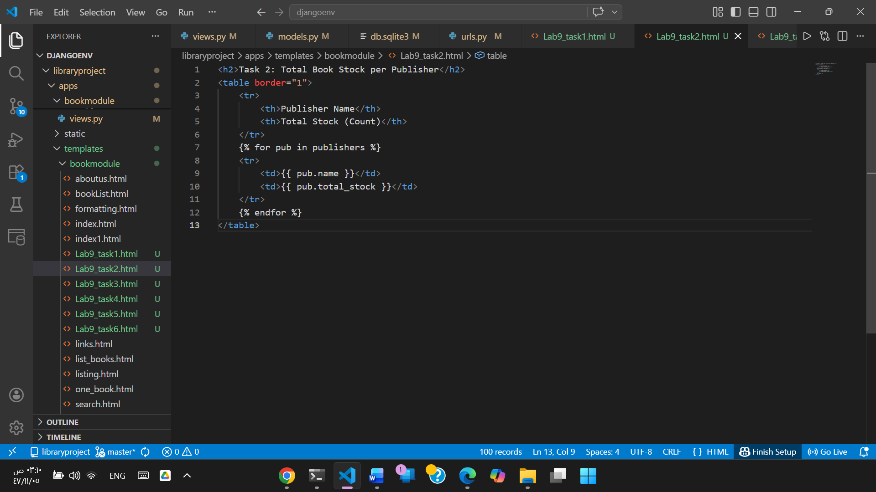

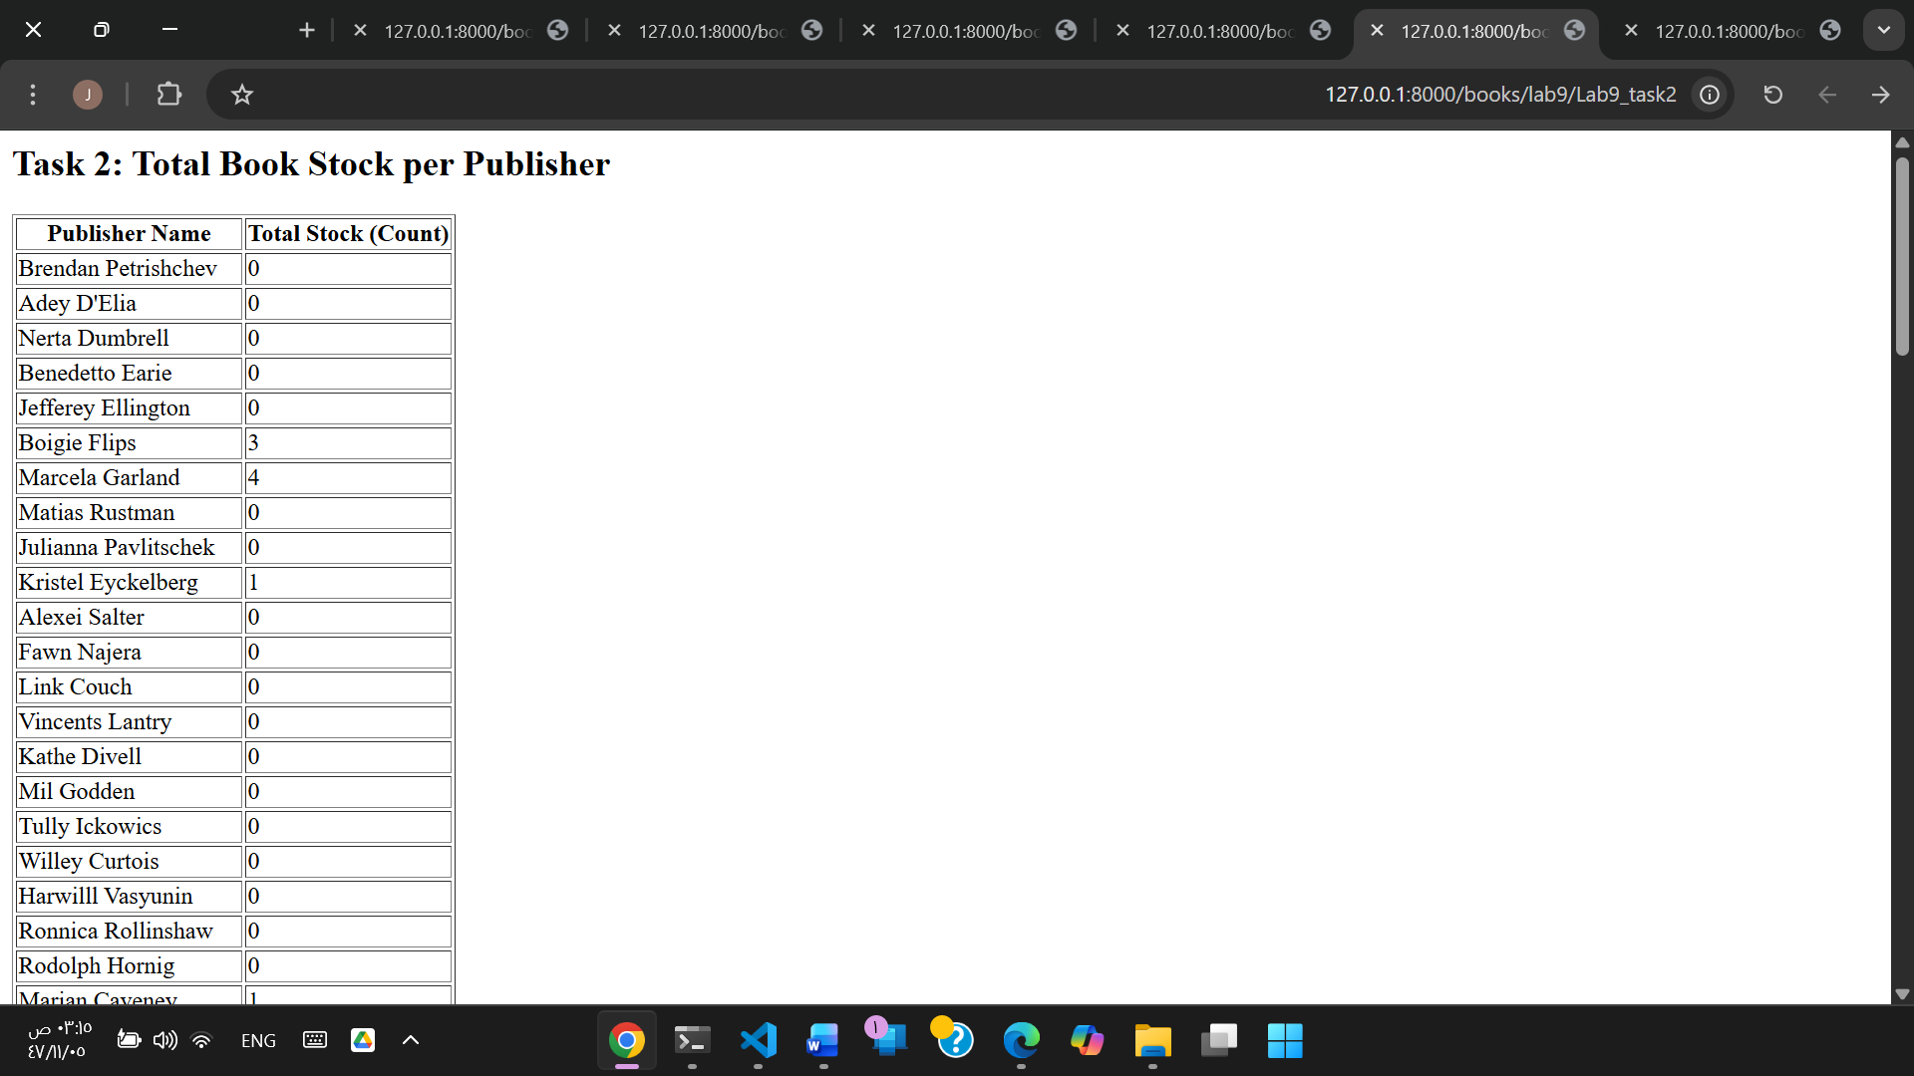
Task 3: (opposite to Task 2) Create a URL ‘/books/lab9/task3’, HTML file, and a query to get oldest book of any of those managed by every publisher.
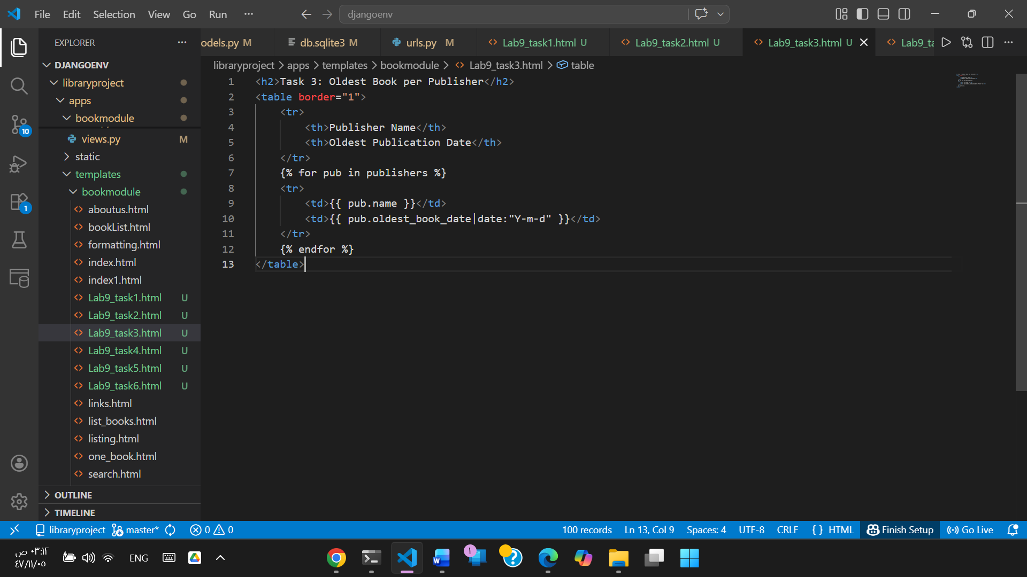

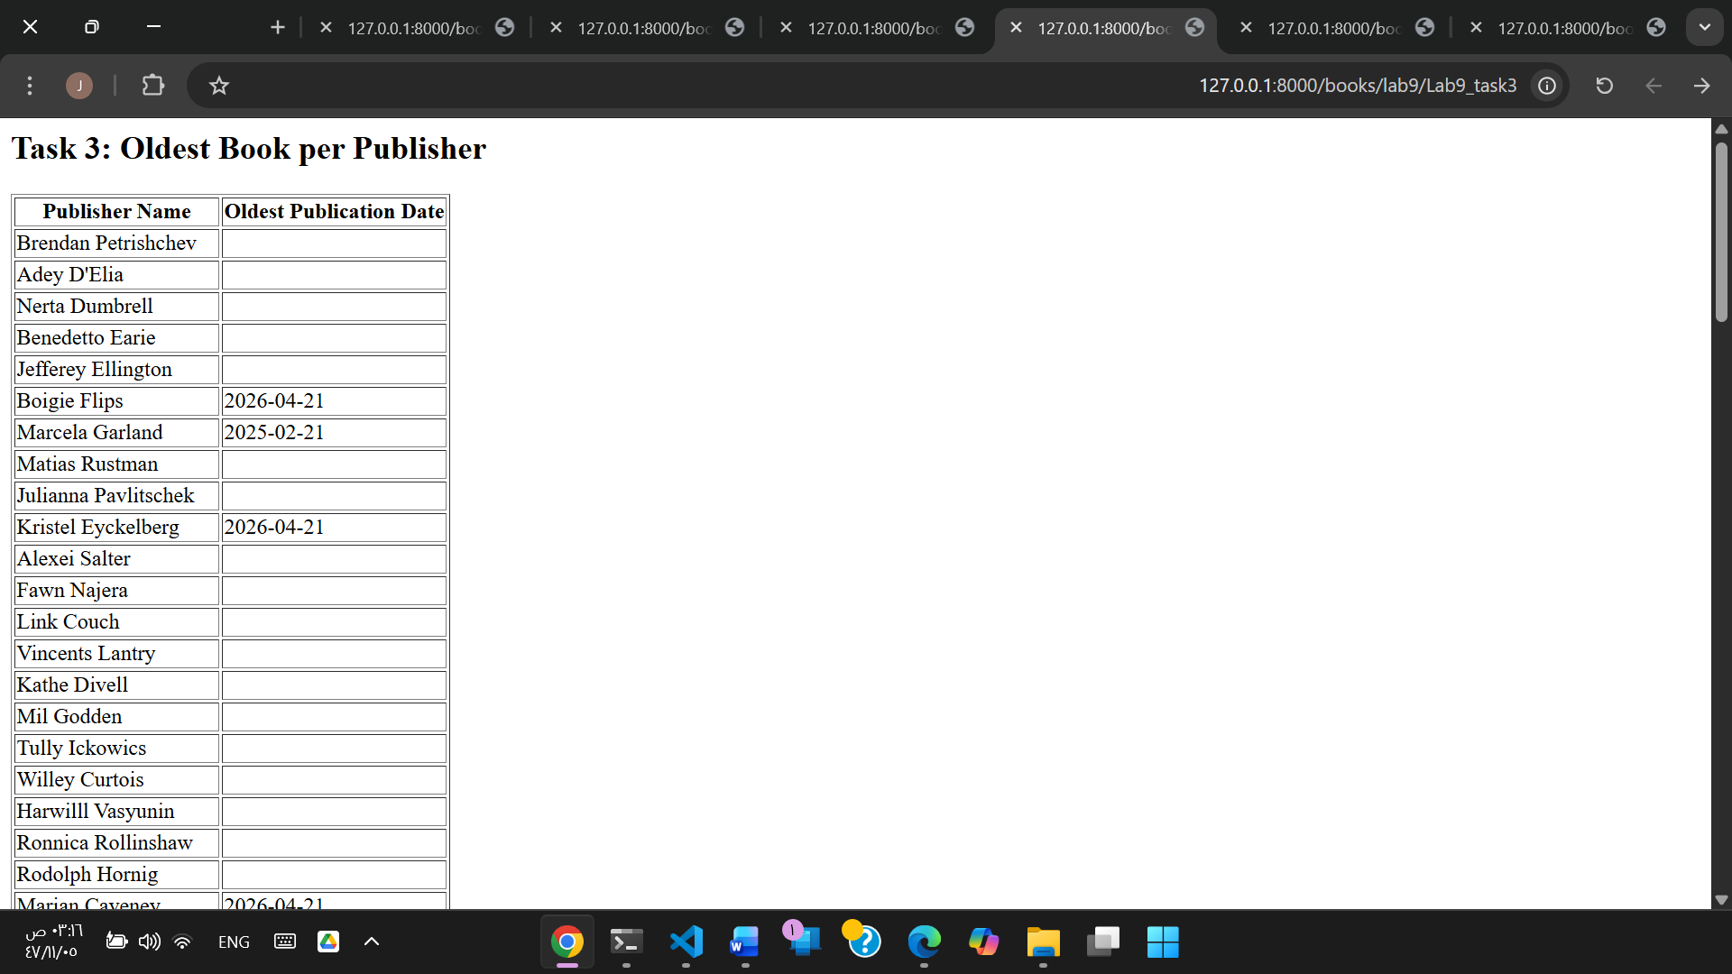
Task 4: Create a URL ‘/books/lab9/task4’, HTML file, and query to calculate the average, min, and max price of books for each publisher.
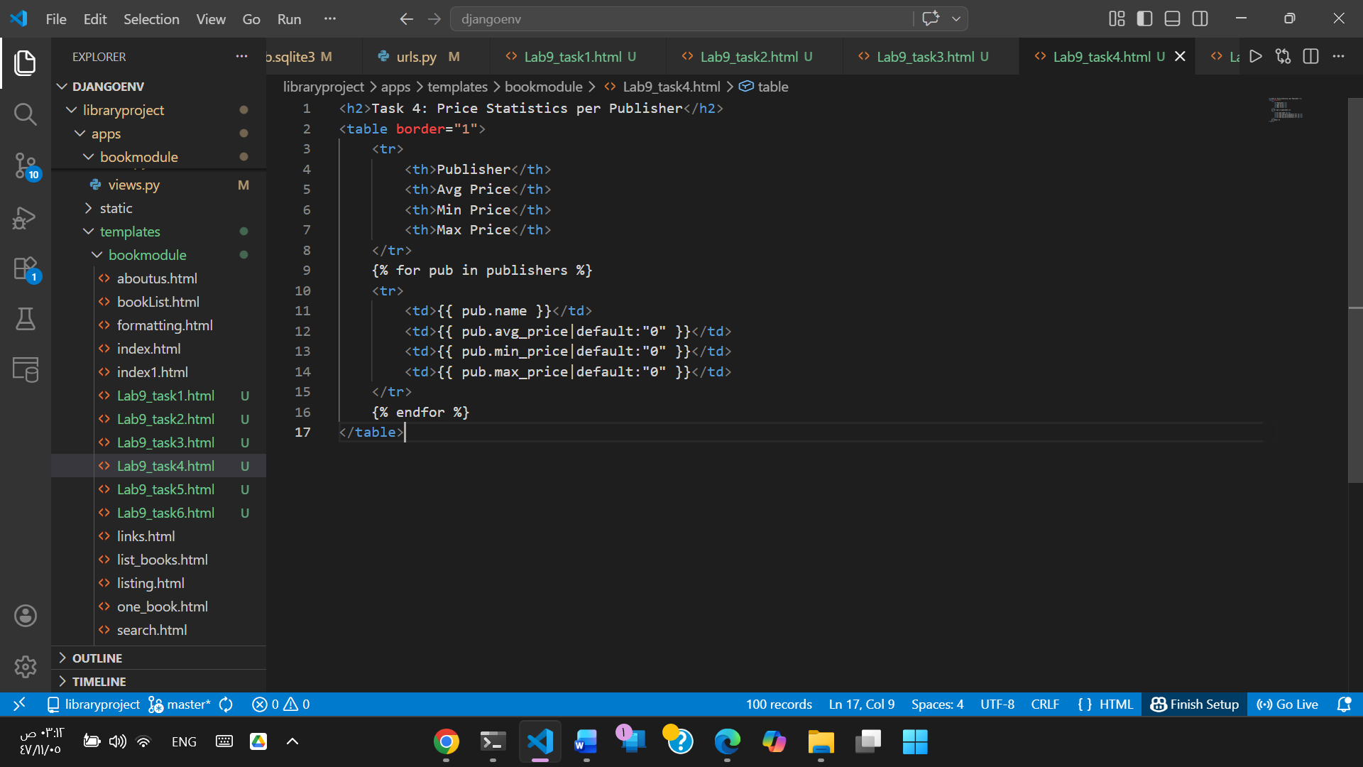

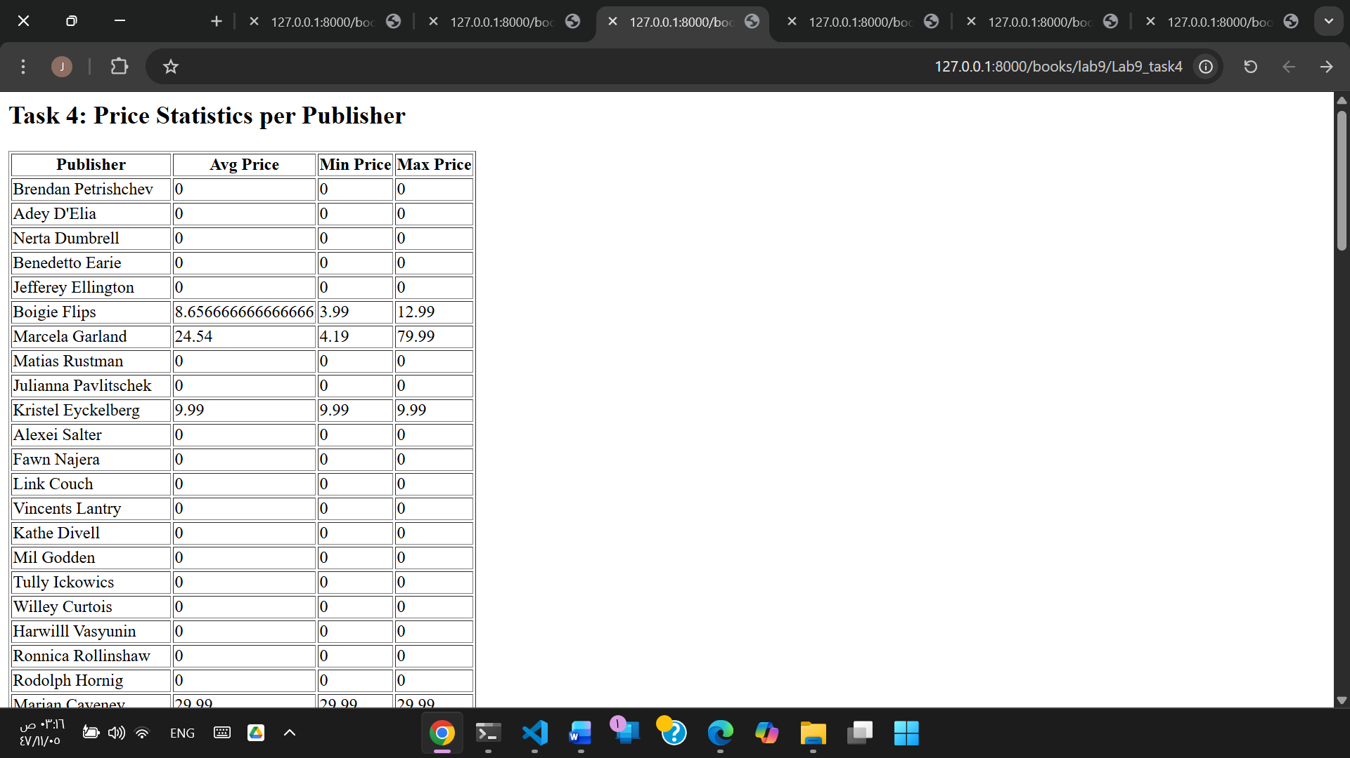
Task 5: Create a URL ‘/books/lab9/task5’, HTML file, and a query to list publishers with a count of highly rated books, with their names and quantity.
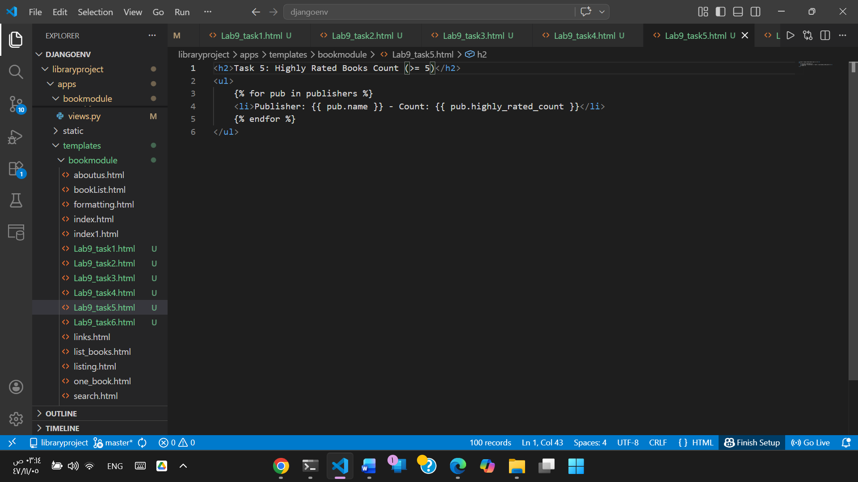

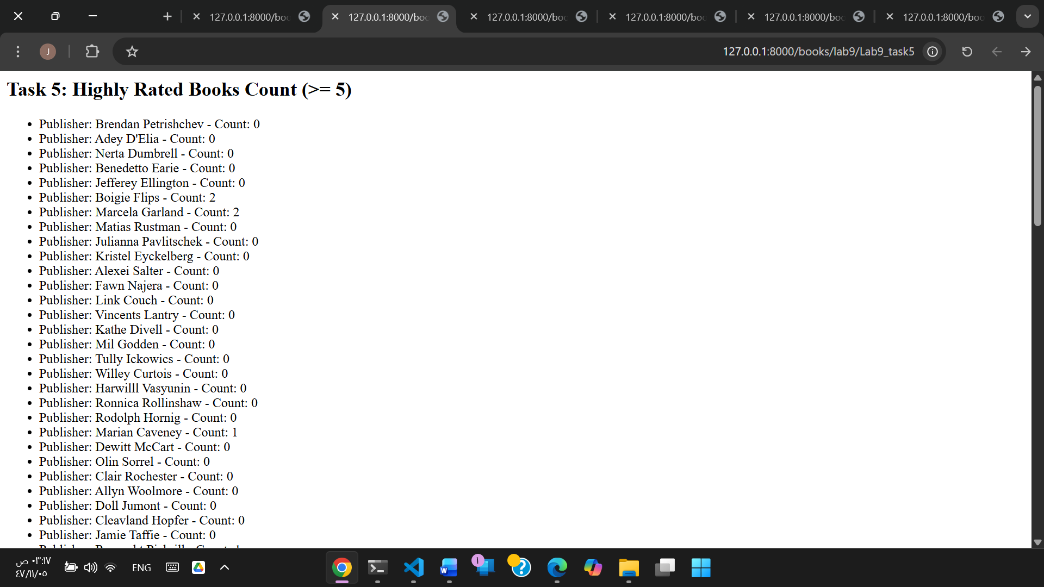
Task 6: Create a URL ‘/books/lab9/task6’, HTML file, and a query to count of books for each publisher, filter only books with price greater than 50 and quantity less than 5 and greater than or equal to 1.
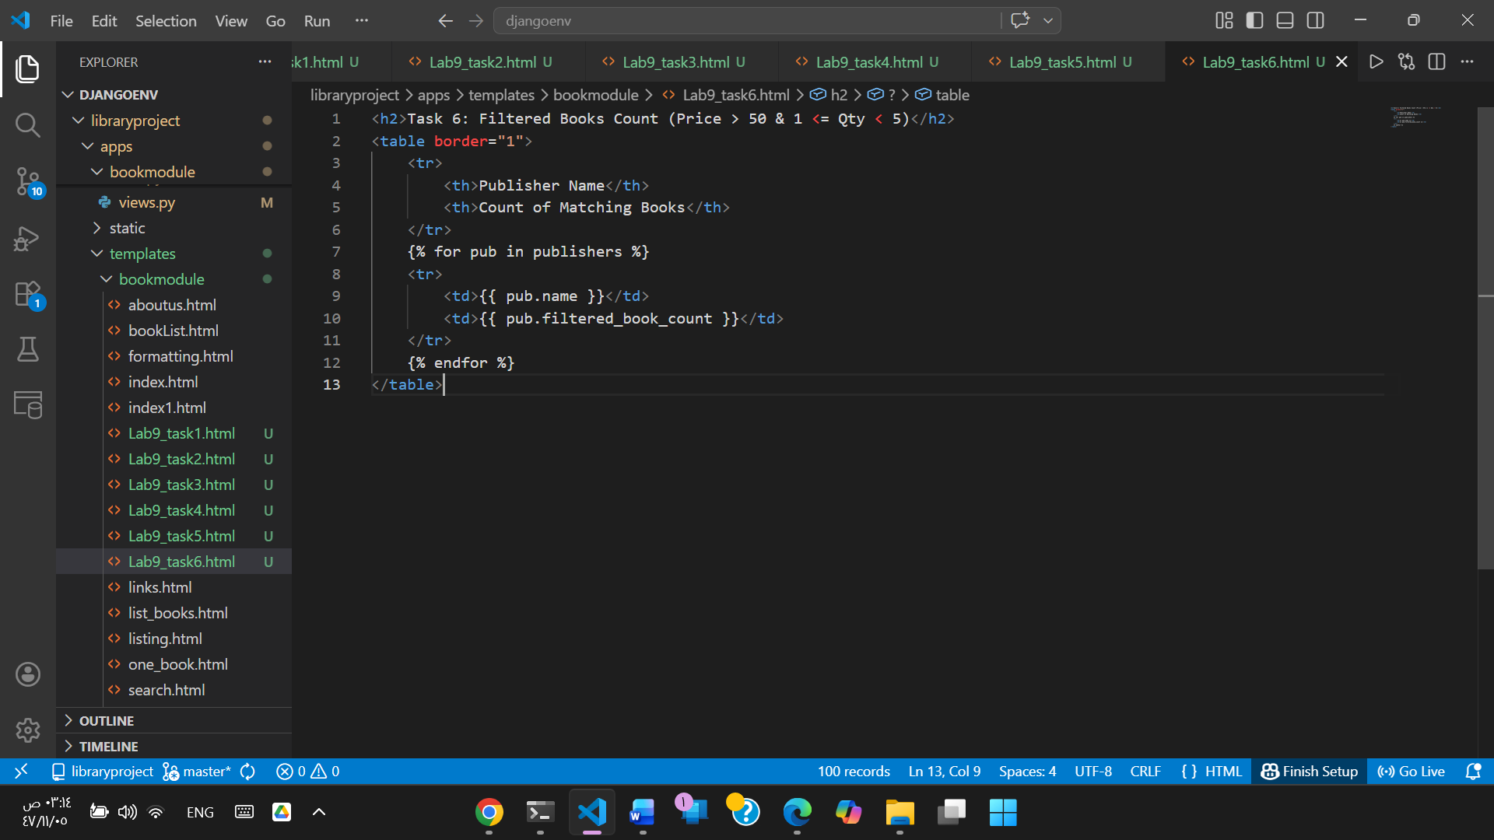

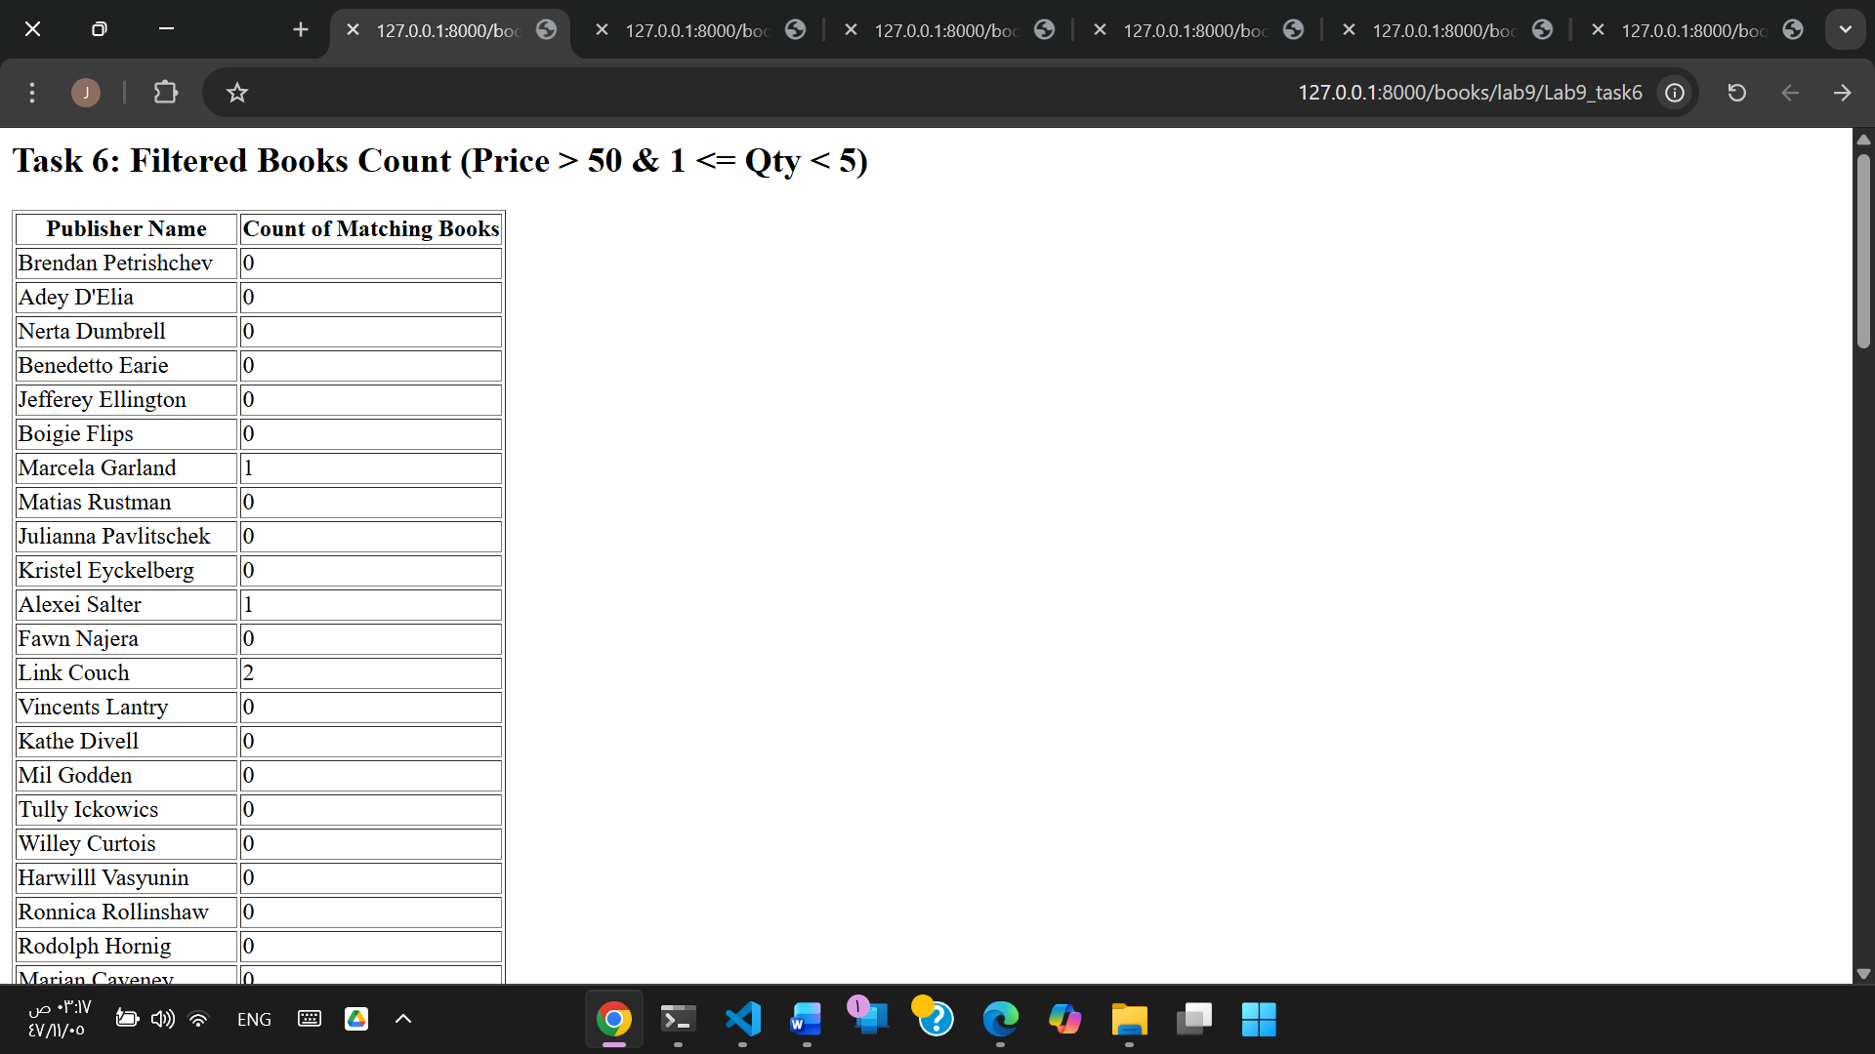
views.py with all tasks functions :
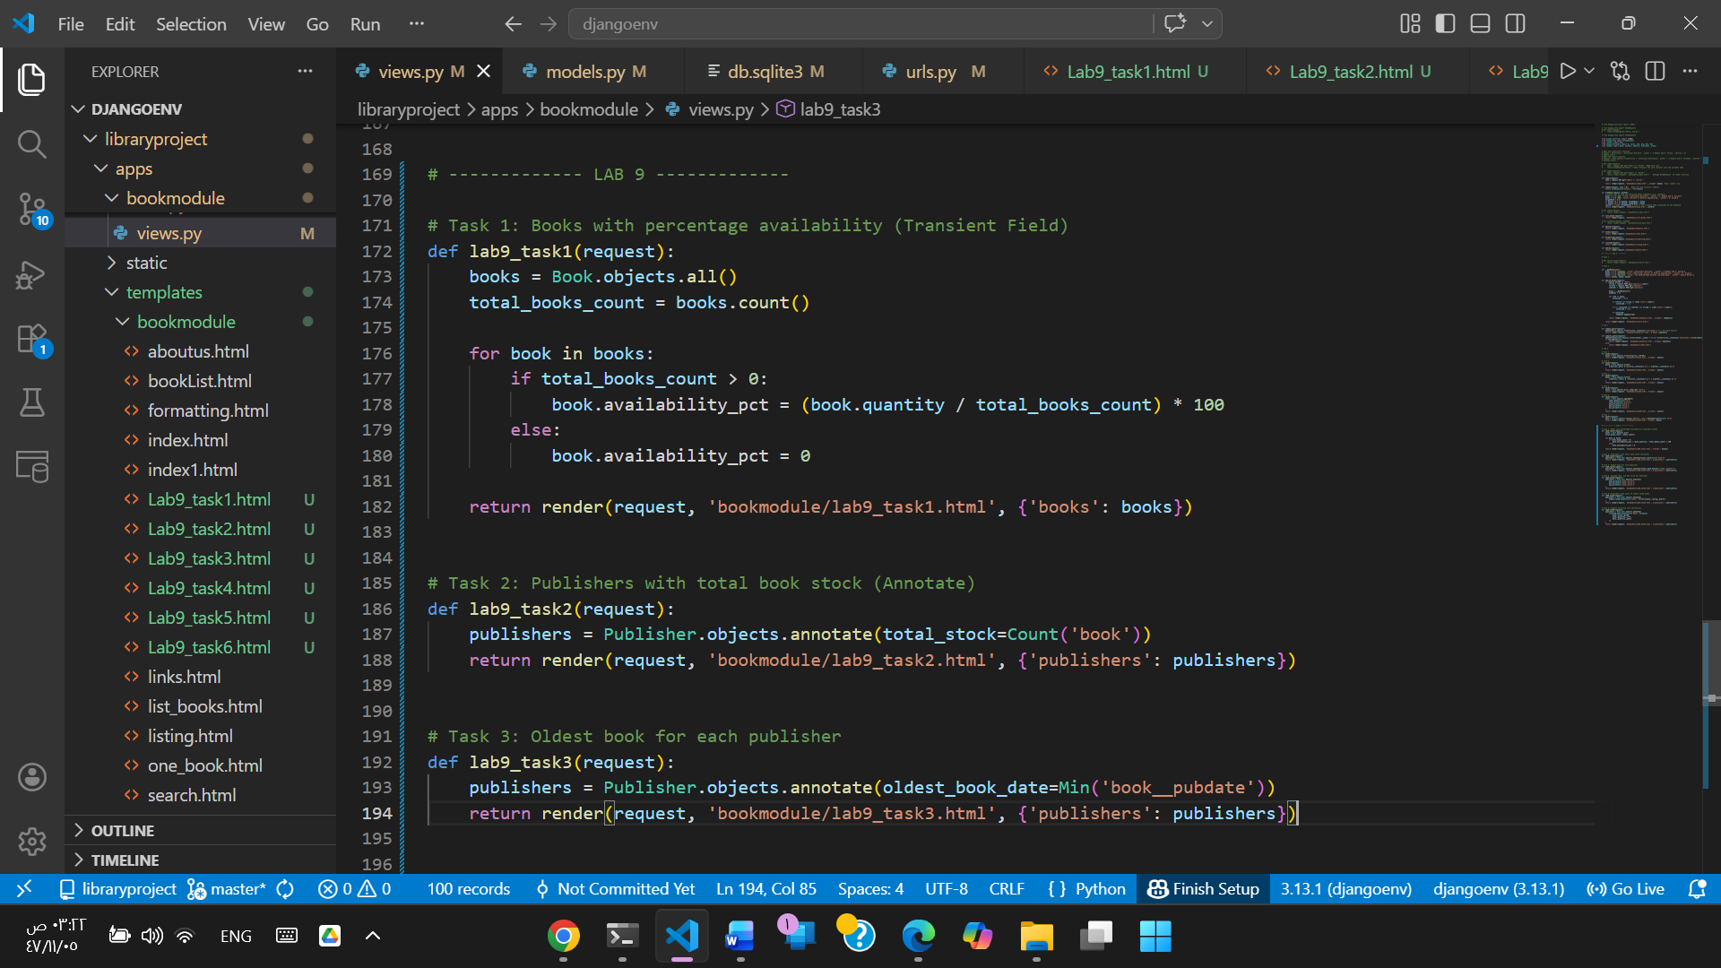

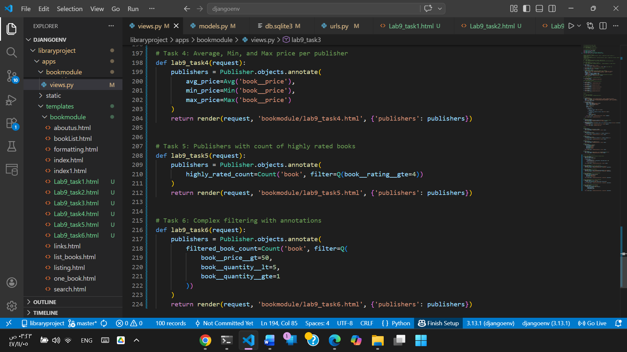
urls.py for all tasks :
