This lab session covers the basics of HTML form. By the end of this session, students should have a very good understanding of how to build a basic form and how to Handle form in Django.

Pre-lab Preparation:
- Having bookmodule and usermodule in apps directory, each containing separate URL configurations.
- Template directory located in ‘apps’ with necessary settings.
- Master template ‘base.html’

Lab Activities: A complete webpage example with html form and Handling form in Django

Task 1: Build HTML form template
Step 1: Using the master template base.html from Lab4, import it in <head> section in base.html the following:
<link rel="stylesheet" href="https://cdnjs.cloudflare.com/ajax/libs/font-awesome/4.7.0/css/font-awesome.min.css">
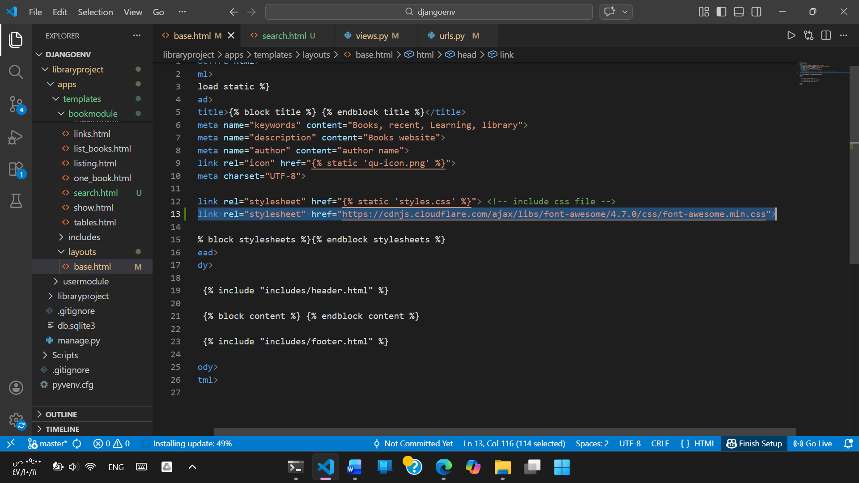

Step 2: using the master template ‘base.html’, Create a view function and URL ‘/books/search’ to a page that contains the following HTML form:
{% extends "layouts/base.html" %}
{% load static %}
{% block title %} Searching Page {% endblock title %}
{% block stylesheets %}
<style>
.searchForm{
margin-top: 20px;
}

button {
color: #fff;
background-color: #17a2b8;
border-color: #17a2b8;
border: none;
padding: 16px 32px;
text-align: center;
text-decoration: none;
display: inline-block;
font-size: 16px;
margin: 4px 2px;
transition-duration: 0.4s;
cursor: pointer; /* hand pointer */
}
button:hover {
background-color: green;
color: white;
}

</style>
{% endblock stylesheets %}

{% block content %}
<form class="searchForm" method="post" action="">
{% csrf_token %}
<label>Keywords:</label>
<input type="text" name="keyword" placeholder="enter a keyword"/>
<br/>

<label>Search in:</label>
<input type="checkbox" name="option1"/><label>Title</label>
<input type="checkbox" name="option2"/><label>Author</label>
<br/>

<button type="submit" ><i class="fa fa-search" aria-hidden="true"></i> Search</button>
</form>
{% endblock content %}

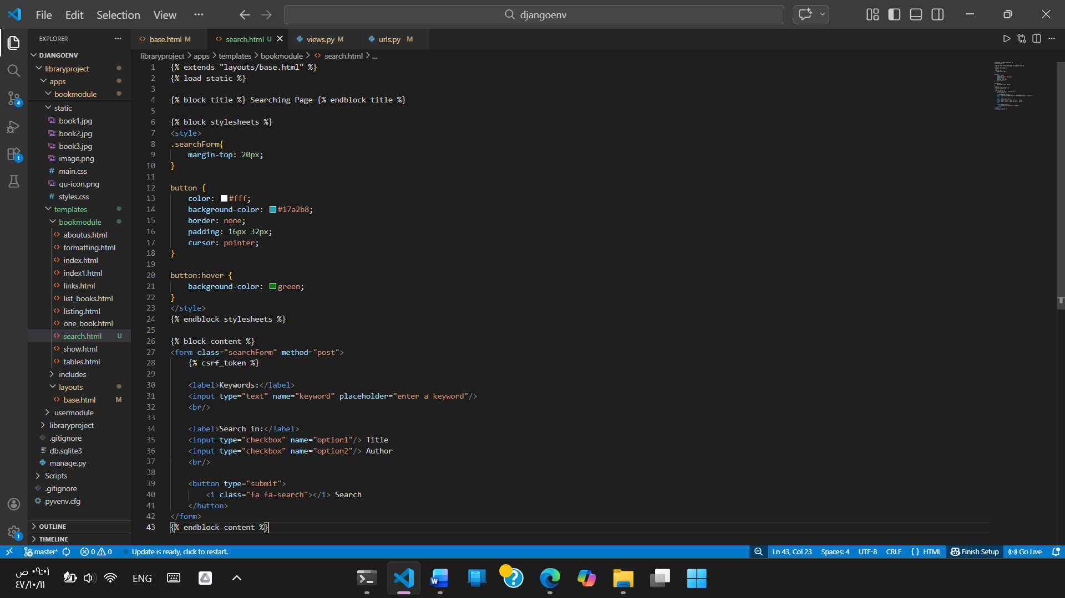

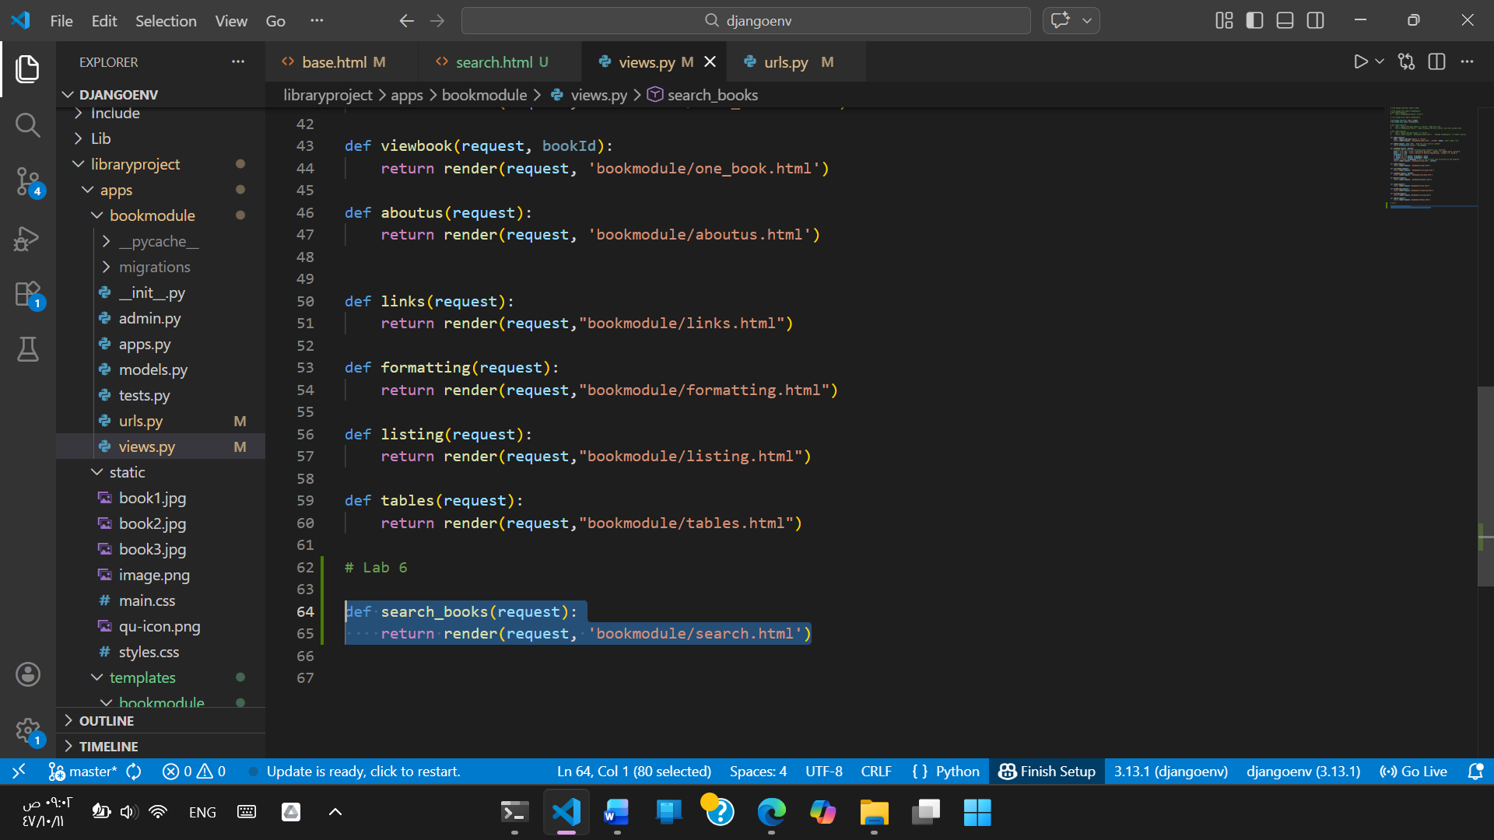
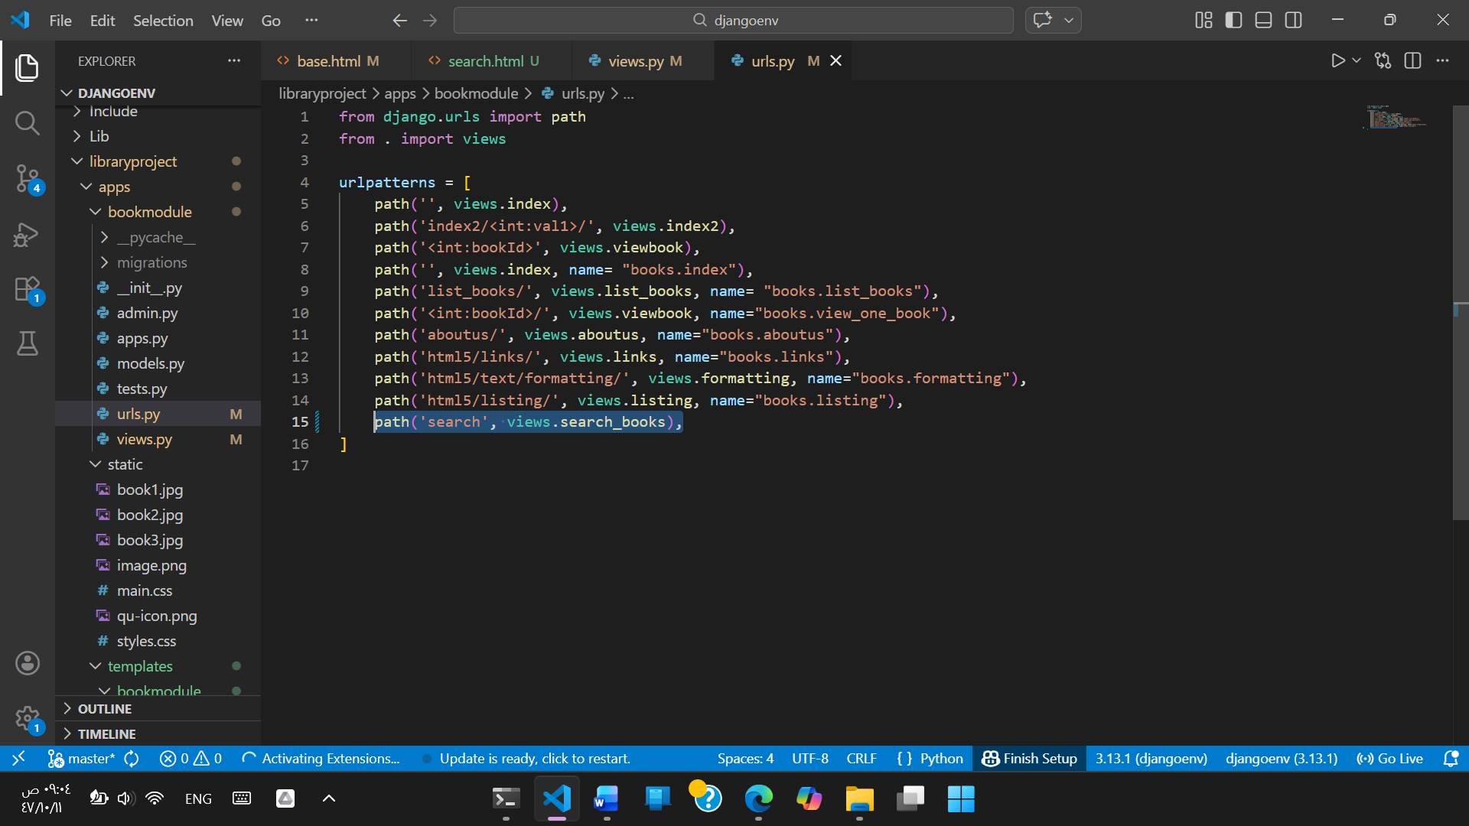
Step 3: After running the server, open the web browser and navigate to http://127.0.0.1:8000/books/search. You should see the form.
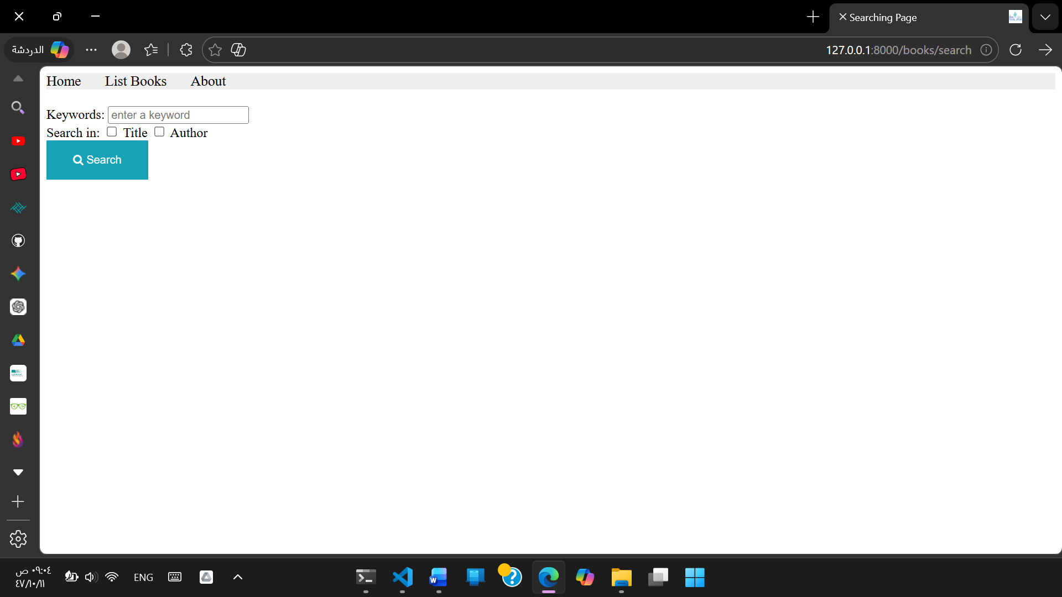

Task 2: Handle the form once submitted
Step 1: In ‘apps/bookmodule/view.py’, create the following function:
def __getBooksList():
book1 = {'id':12344321, 'title':'Continuous Delivery', 'author':'J.Humble and D. Farley'}
book2 = {'id':56788765,'title':'Reversing: Secrets of Reverse Engineering', 'author':'E. Eilam'}
book3 = {'id':43211234, 'title':'The Hundred-Page Machine Learning Book', 'author':'Andriy Burkov'}
return [book1, book2, book3]

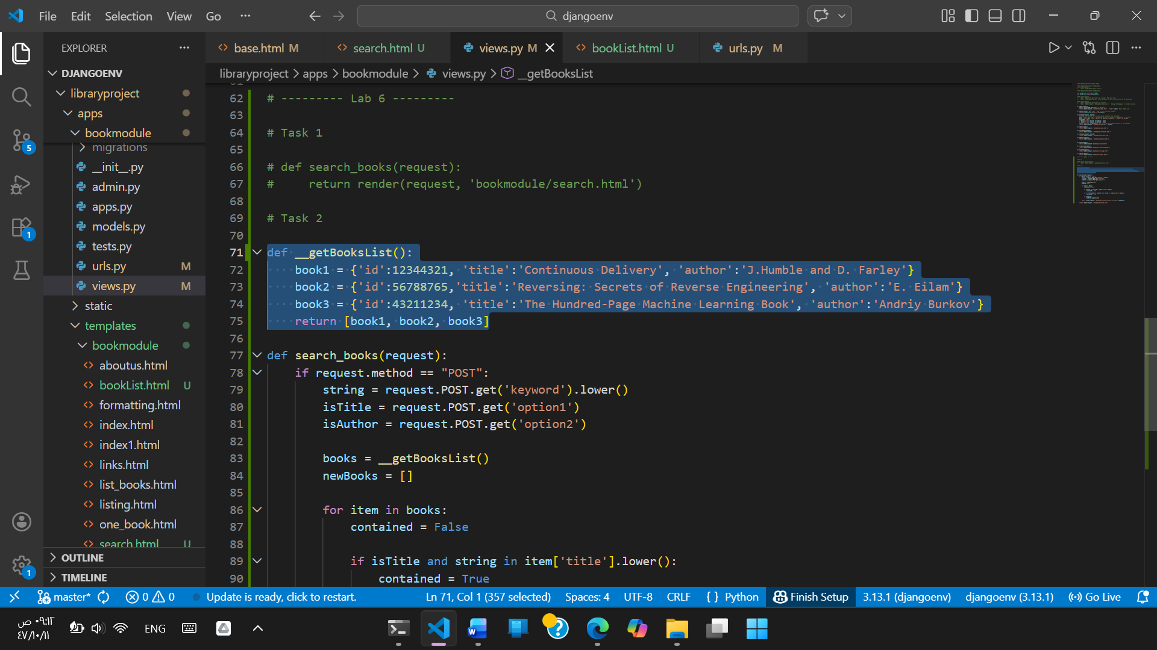
Step 2: In the same corresponding view/controller in views.py that shows the form, add the code where If there is an action in the form, the form needs to be handled in that view.
Note: it is possible to direct the action to an exclusive view function specific to handle the submitted form.
if request.method == "POST":
string = request.POST.get('keyword').lower()
isTitle = request.POST.get('option1')
isAuthor = request.POST.get('option2')
# now filter
books = __getBooksList()
newBooks = []
for item in books:
contained = False
if isTitle and string in item['title'].lower(): contained = True
if not contained and isAuthor and string in item['author'].lower():contained = True

if contained: newBooks.append(item)
return render(request, 'bookmodule/bookList.html', {'books':newBooks})
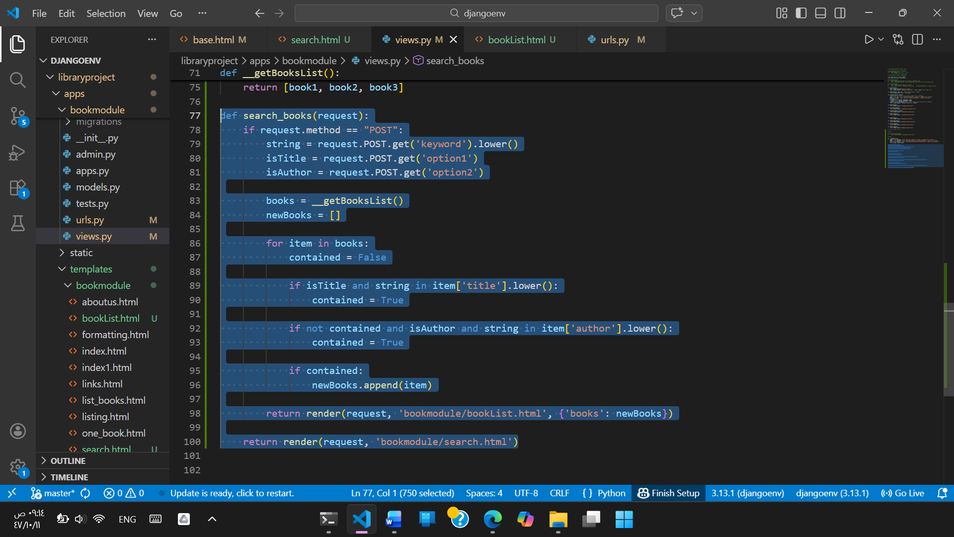

Step 3: Create an HTMl file ‘bookList.html' to list the books (you should use the master template ‘base.html’)

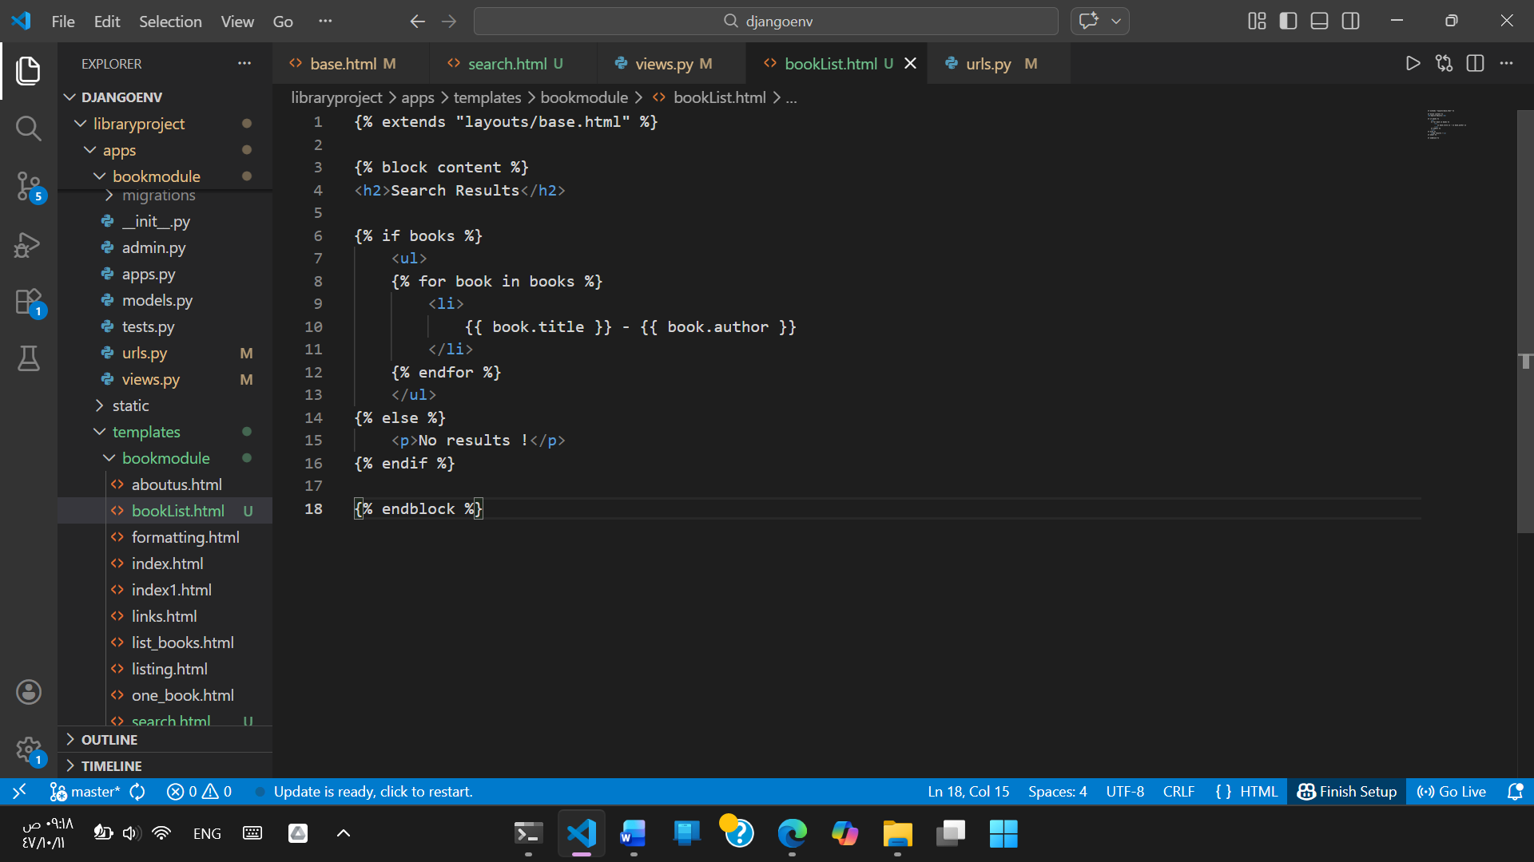

Step 4: Now from the web browser, navigate to http://127.0.0.1:8000/books/search, and submit the form with data.

Existing book Result :
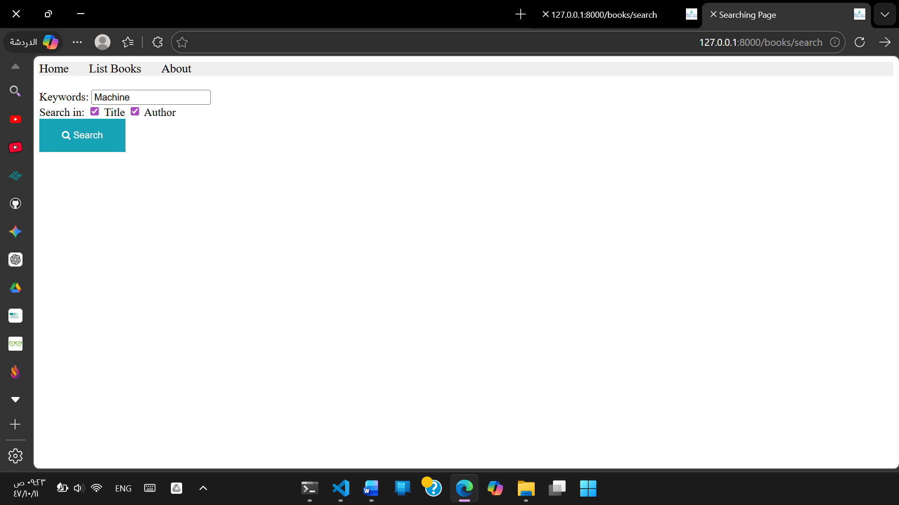

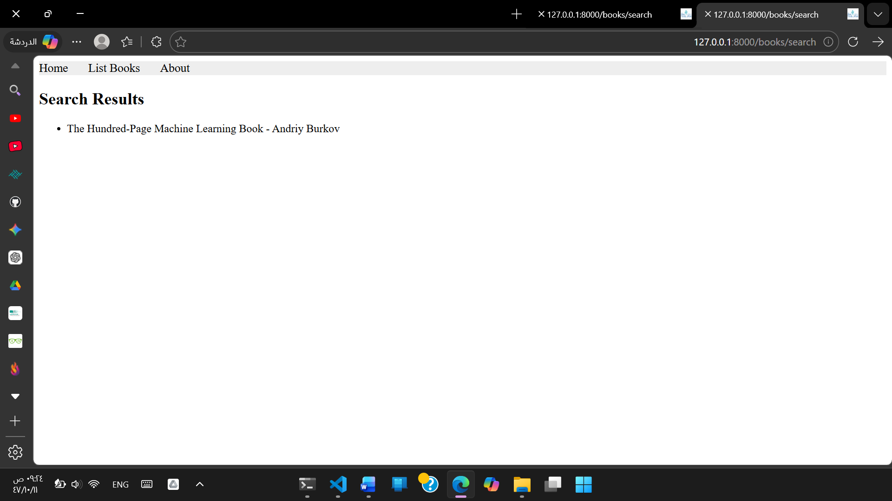
Not Existing book Result :

