# ESP32

**Example – Turning on or off an LED**

we will turn on and off an LED with a push-button switch. But instead of using polling, we will be using the GPIO interrupt.

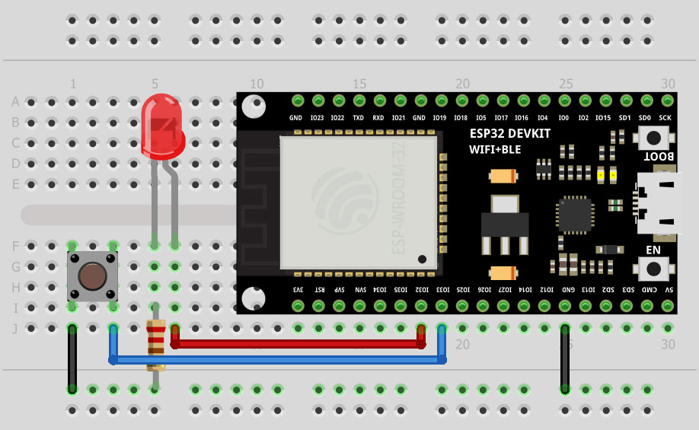

**CODE:**

#define pushButton_pin 33

#define LED_pin 32

void IRAM_ATTR toggleLED()

{

digitalWrite(LED_pin, !digitalRead(LED_pin));

}

void setup()

{

pinMode(LED_pin, OUTPUT);

pinMode(pushButton_pin, INPUT_PULLUP);

attachInterrupt(pushButton_pin, toggleLED, RISING);

}

void loop()

{

}

**رغد أحمد الزهراني**