**Test Cases :**   
  
Using this website <https://magento.softwaretestingboard.com/> .

1- Search for the item “bag” and print the page title inside the result page .   
  
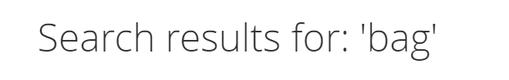  
  
2- Print the name of the categories in the nav bar .   


3- Login functionality .

4- Filter functionality .