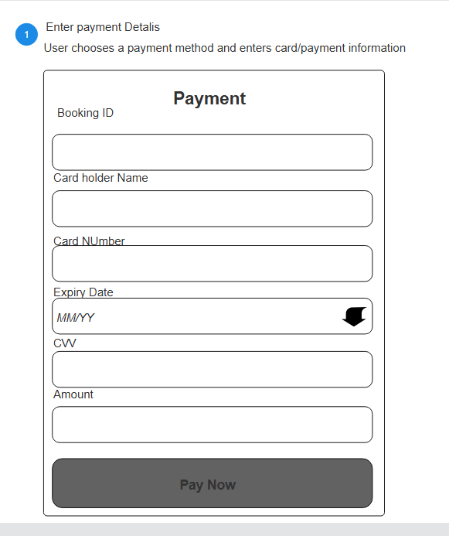

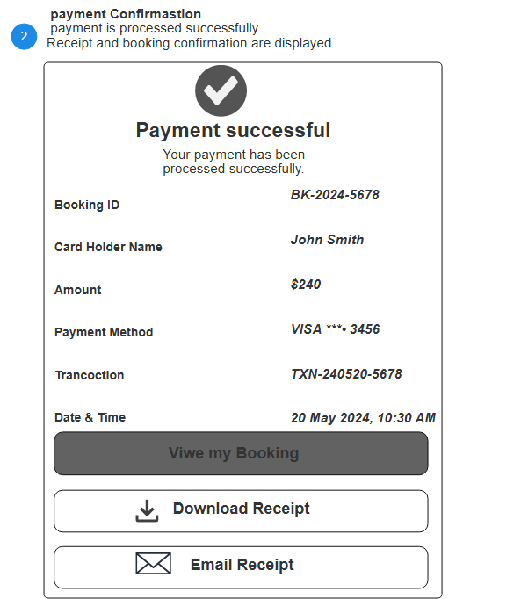

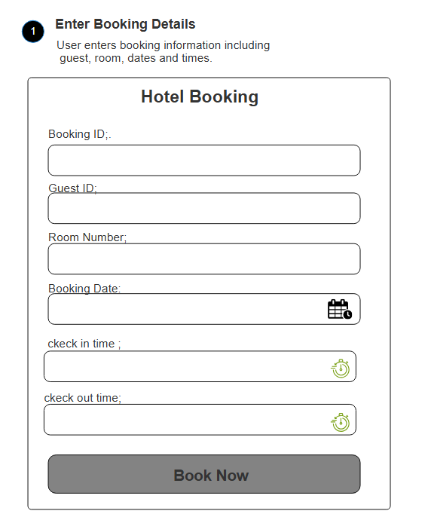

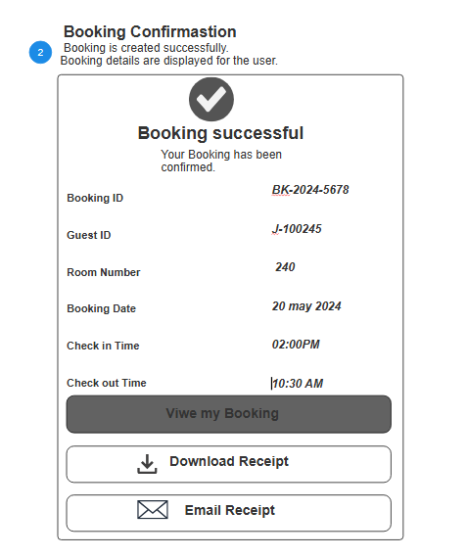

/*
* Click nbfs://nbhost/SystemFileSystem/Templates/Licenses/license-default.txt to change this license
* Click nbfs://nbhost/SystemFileSystem/Templates/Classes/JApplet.java to edit this template
*/
package javaapplication.raghad;

import java.applet.Applet;
import java.awt.*;
import java.awt.event.*;
import javax.swing.Timer;
/**
*
* @author Student
*/
public class Raghad extends Applet implements ActionListener{
// Position of the text
int x = 20;
// Timer for animation
Timer timer;

@Override
public void init() {
// Pass 'this' class as the ActionListener instead of null
timer = new Timer(100, this);
timer.start();
setBackground(Color.WHITE);
}

@Override
public void paint(Graphics g) {
// Call the superclass paint method
super.paint(g);
// Set font and color
g.setColor(Color.RED);
g.setFont(new Font("Arial", Font.BOLD, 18));
// Display message
g.drawString("The selected room has already been reserved during this period.", x, 100);
}

@Override
public void actionPerformed(ActionEvent e) {
// Move text horizontally
x += 5;
// Reset position when text reaches end
if (x > getWidth()) {
x = -450; // Adjusted slightly to ensure long text clears off completely
}
repaint();
}
}

import java.applet.Applet;
import java.awt.*;
public class Hotel2 extends Applet implements Runnable {
String message = "The selected room has already been reserved during this period.";
int y = 50;
boolean down = true;
public void start() {
new Thread(this).start();
}
public void run() {
while (true) {
if (down)
y += 2;
else
y -= 2;
if (y >= 80)
down = false;
if (y <= 40)
down = true;
repaint();
try {
Thread.sleep(50);
} catch (Exception e) {
}
}
}
public void paint(Graphics g) {
g.setColor(Color.RED);
g.setFont(new Font("Arial", Font.BOLD, 18));
g.drawString(message, 20, y);
}
}

