HW 5: Threads

Student name: raghad abu sammour
Student number: 217099

THE CODE
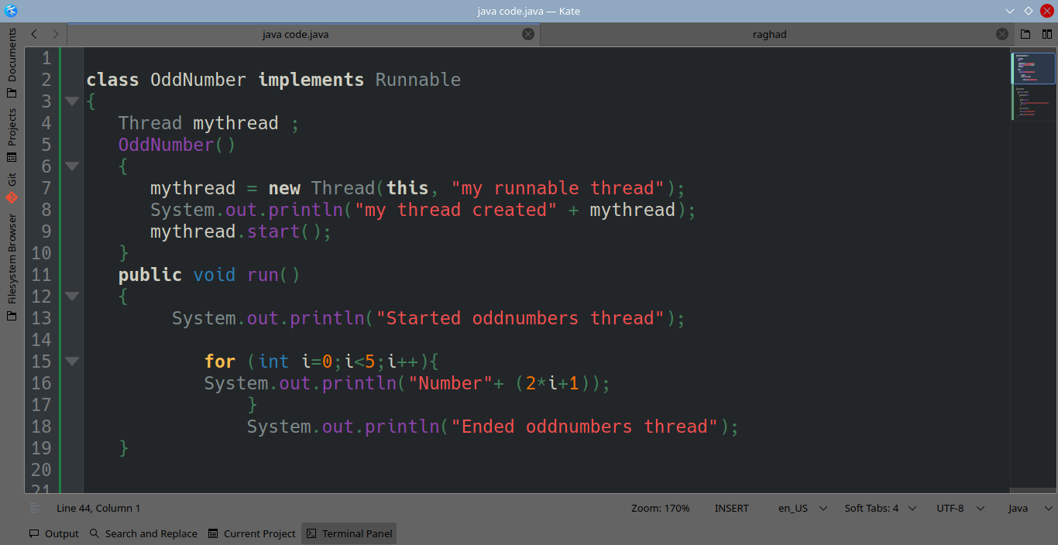
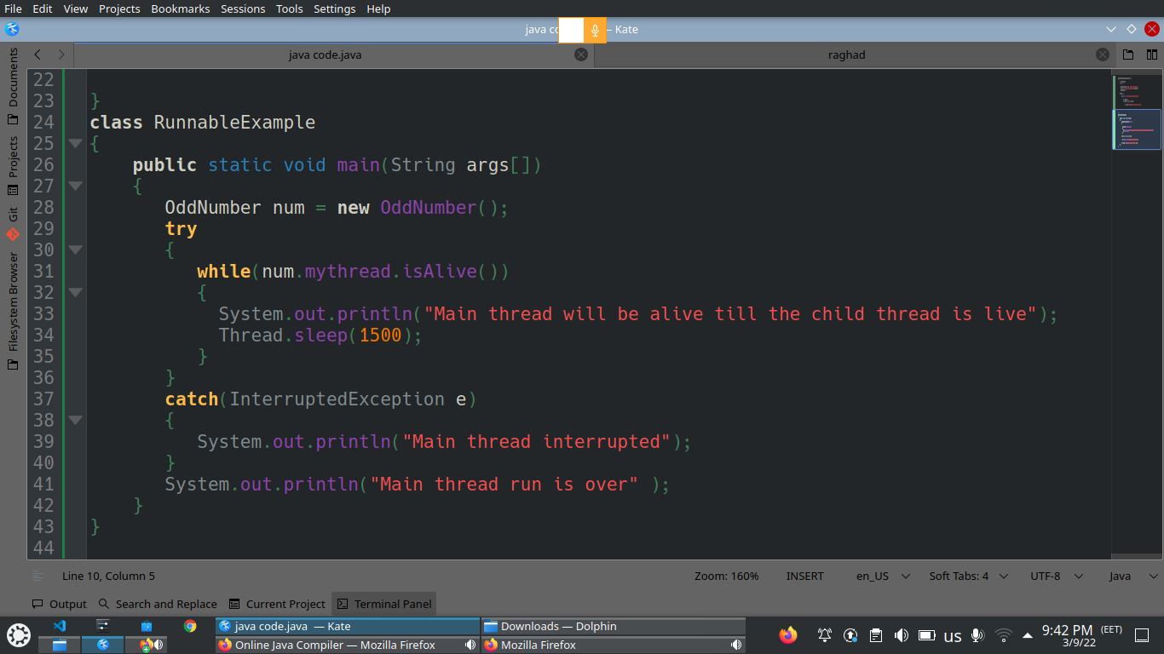

THE CODE
class OddNumber implements Runnable
{
Thread mythread ;
OddNumber()
{
mythread = new Thread(this, "my runnable thread");
System.out.println("my thread created" + mythread);
mythread.start();
}
public void run()
{
System.out.println("Started oddnumbers thread");
for (int i=0;i<5;i++){
System.out.println("Number"+ (2*i+1));
}
System.out.println("Ended oddnumbers thread");
}
}
class RunnableExample
{
public static void main(String args[])
{
OddNumber num = new OddNumber();
try
{
while(num.mythread.isAlive())
{
System.out.println("Main thread will be alive till the child thread is live");
Thread.sleep(1500);
}
}
catch(InterruptedException e)
{
System.out.println("Main thread interrupted");
} System.out.println("Main thread run is over" );}}
THE OUTPUT

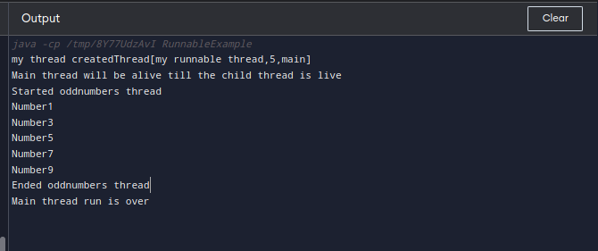
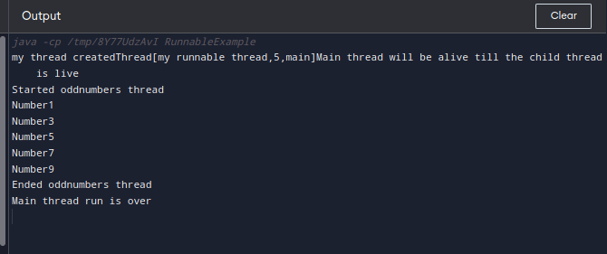

THE END
THANK YOU

