**YouTube views for titles , categories and States:**

<https://public.tableau.com/views/project_tableau-Dashbord1/Dashbord-YuoTubeviews?:language=en-US&:display_count=n&:origin=viz_share_link>

This Dashboard includes 3 visualizations that are related to the top YouTube views for states ,titles and categories. Also, it shows the top States that have most views as shown below

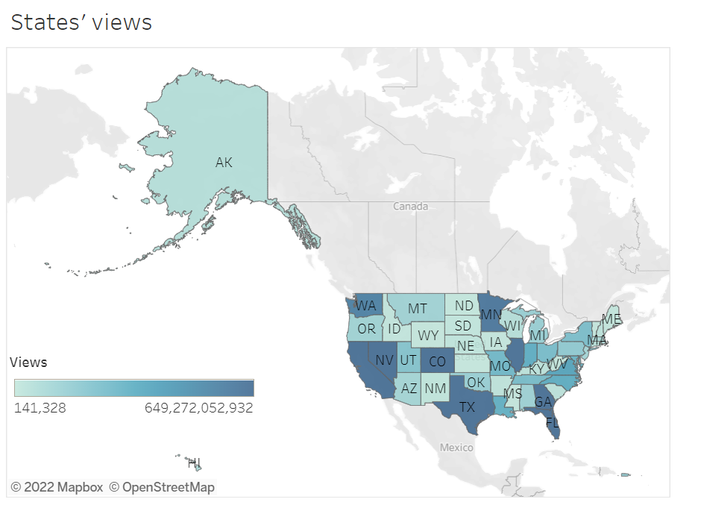

This visualization shows the top YouTube views for all categories. As it is shown above that the top state’s view is in the USA is Florida with almost 2 billion views. However, the MS state record the lowest views in the USA with only 202 Millions.

**Design Comment:**

I used in this insight the map chart because I worked with states data, so the best represent in this case is by display the states in a map

**Resources:**

N/A

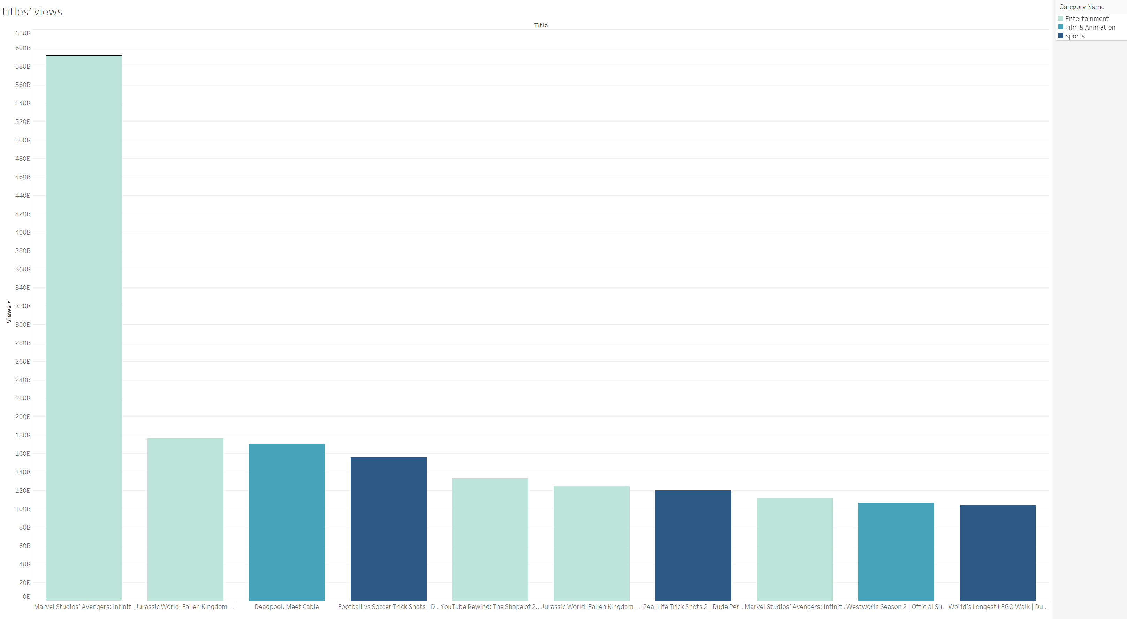

This visualization illustrates the top YouTube videos’ views. As it is shown above that the top 2 videos are under entertainment which are YouTube Marvel Studios with 591 Million and Jurassic 176 Million. While Deadpool , Meet cable that are under film & animations number third

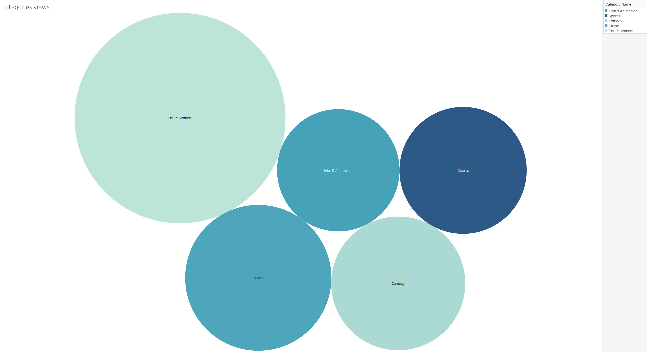

This visualization illustrates the top YouTube categories views. As it shows that entertainment top views in YouTube with almost 4 billion views with 2 billion difference with second category music .

**Design Comment:**

I used the bar chart to the dashboard to make the data more readable and easily to understand the data and finding the result in a quickly.

**Resources:**

N/A

**YouTube views for music , top 10 songs and most unwanted song:**

[**https://public.tableau.com/views/project_tableau-Music2/Dashboard-music?:language=en-US&:display_count=n&:origin=viz_share_link**](https://public.tableau.com/views/project_tableau-Music2/Dashboard-music?:language=en-US&:display_count=n&:origin=viz_share_link)

This Dashboard includes 3 visualizations that are related to Music category in YouTube views for likes and dislikes

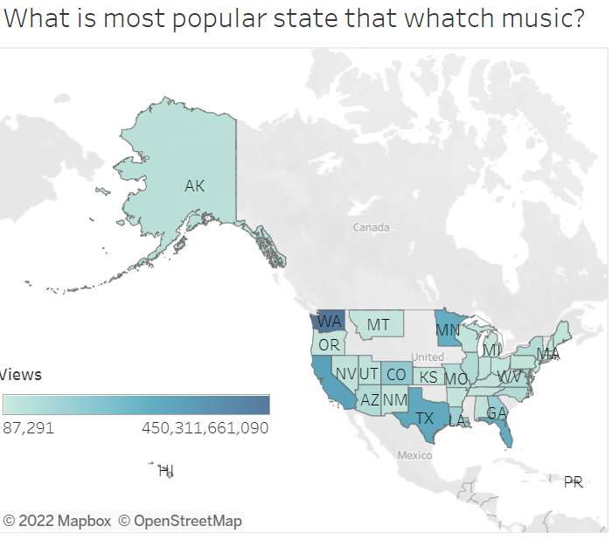

This visualization shows the top states YouTube views for videos that are under music . As it is shown above that the top state’s view is in the USA is WA with 450 Millions views. While CA is number two with 276 Millions views. However, the NM state record the lowest views in the USA with only 87 Thousands.

**Design Comment:**

I used in this insight the map chart because I worked with states data, so the best represent in this case is by display the states in a map

**Resources:**

N/A

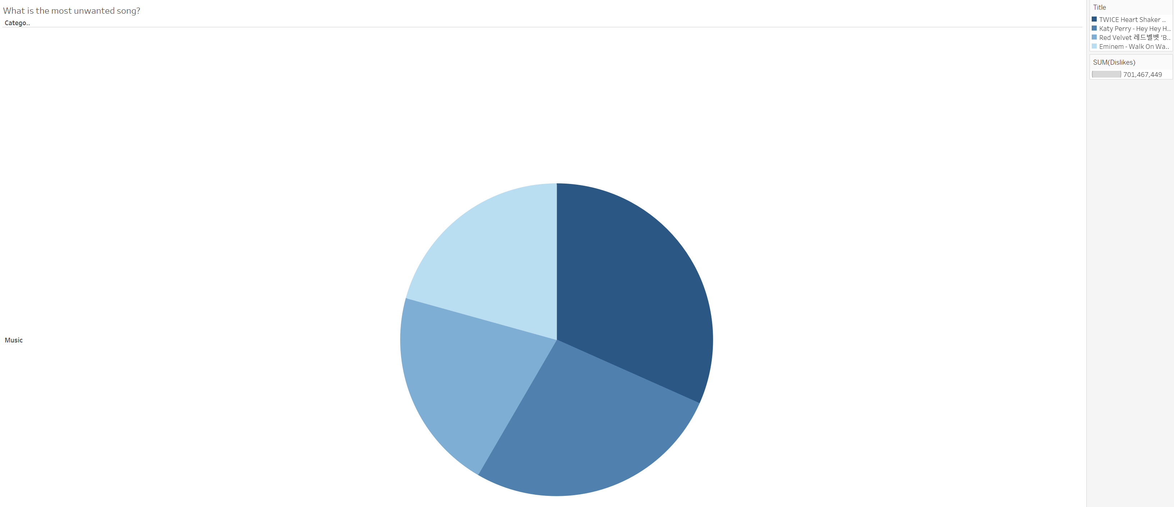

This visualization illustrates the most unwanted song . As it is shown above that TWICE Heart Shaker is the number 1 son that got dislike with 222,218,304 dislikes

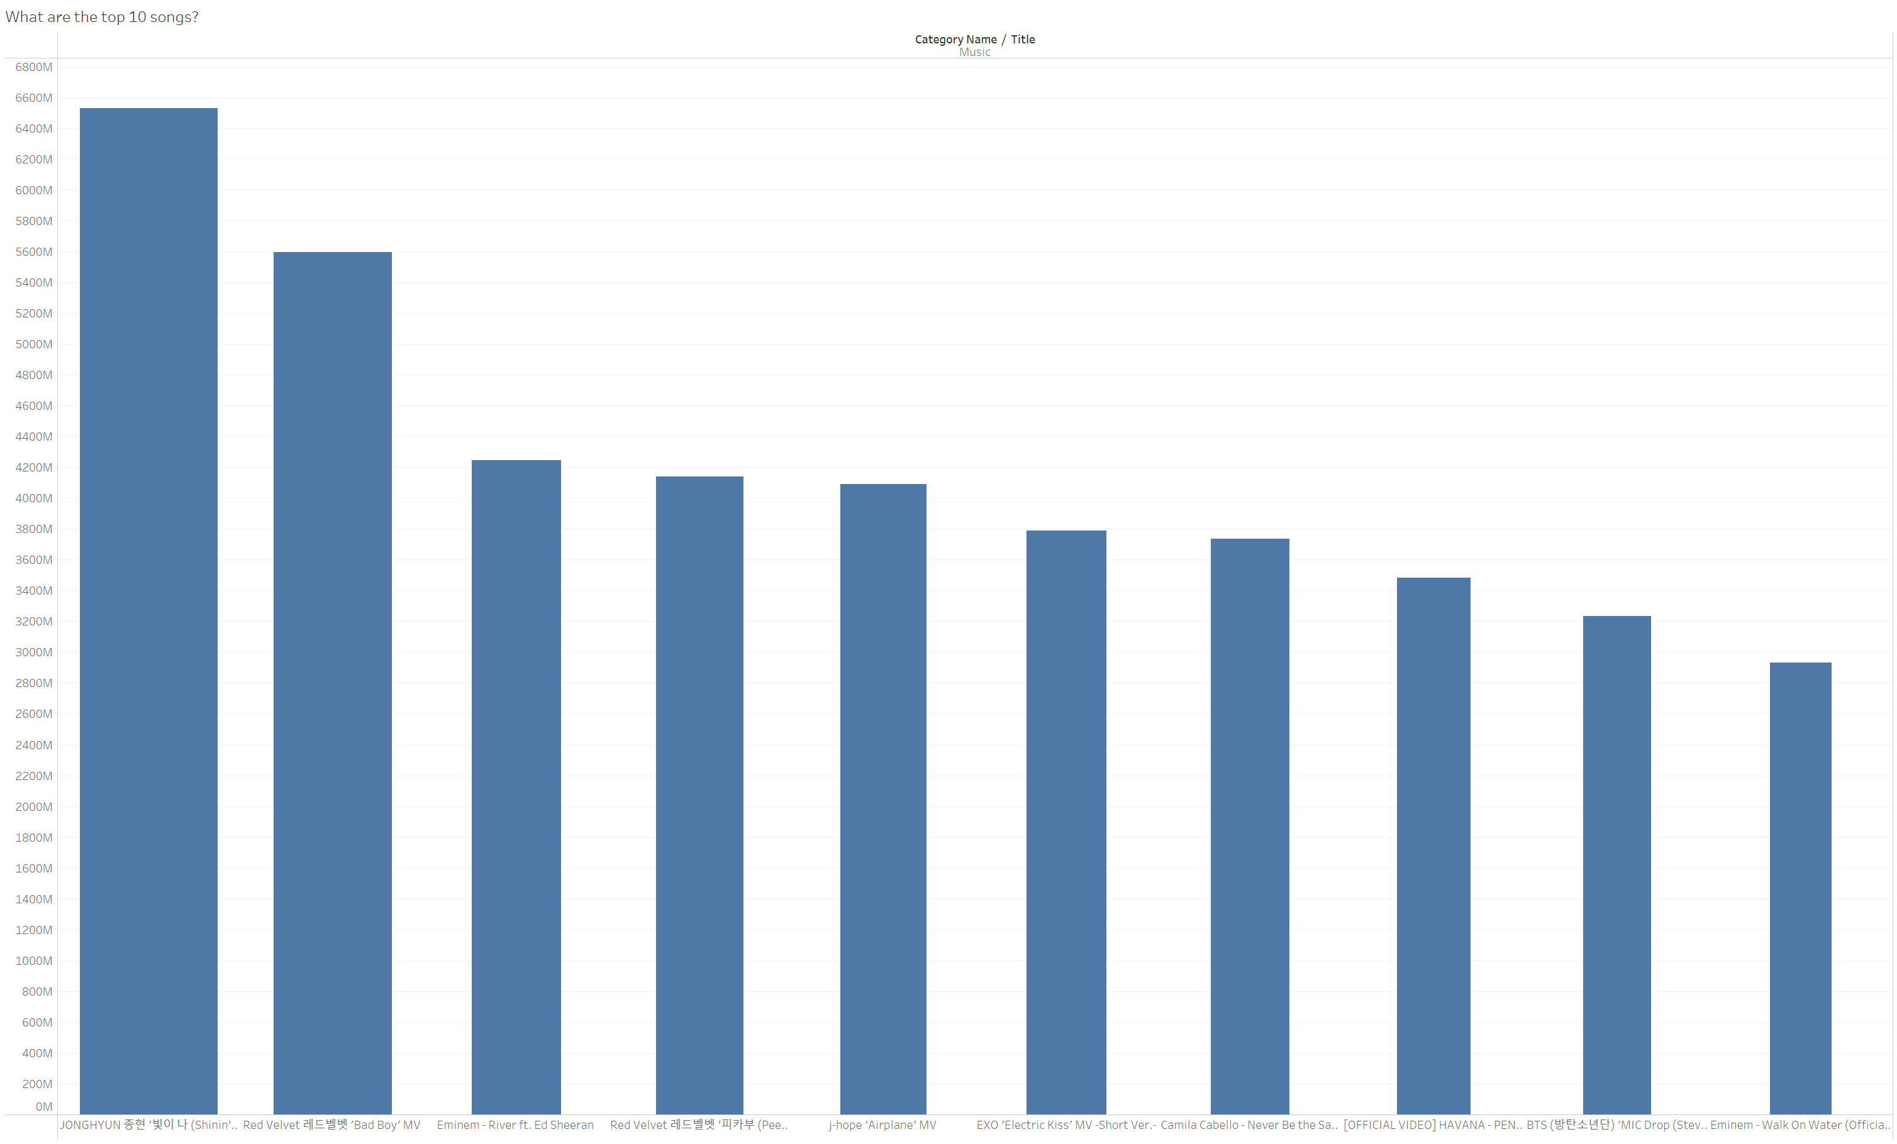

This visualization illustrates the top YouTube views for Music . As it is shown above that the top JONGHYUN 종현 빛이 나 (Shinin) is the number 1 son that got likes with 6,529,201,350 likes

**Design Comment:**

I used the chart to the dashboard to make the data more readable and easily to understand the data and finding the result in a quickly.

**Resources:**

N/A