

The Missing Panda
Report
Computer Graphics (CS2206)

Student Name | ID Number | Group
Raghad Almatrfy (Leader) | 446000651 | 5
Layan Alshreef | 44610583 | 5
Munirah Ali Sulaiman | 446003246 | 5
Ethar Tamim | 446000516 | 5
Sama AlSilaimi | 446004294 | 5

Instructor: Omniah H.Nagoor

Table of Contents

Page 3 | Task Table
Page 4 | Chapter 1: 1.1 Introduction
Pages 4 | Chapter 1: 1.2 Abstract and Project Introduction
Pages 5-10 | Chapter 2: 2.1 Functional and Implementation Details
Pages 11-16 | Chapter 3: 3.1 Screenshots with descriptions
Page 17 | The Conclusion, Future Work and References

The design and modeling of the mother panda and baby panda have been finished in terms of being the two main characters in this story with the inclusion of other environmental objects like a pond that can be interacted with, some ducks, and a tree formation in the backdrop. | Ethar Tamim
Implemented Scene 2 (Mother Panda Searching), including applying translation and rotation to simulate the searching movement, creating simple facial expressions such as tilted eyebrows and eyes to reflect the panda’s emotions, and adding text rendering to display the message "Where is my baby?!" near the character. | Layan Alshreef
In this scene, the panda continues her search for her baby in the forest. As she walks, she encounters a rabbit and asks him if he has seen her baby. She then continues on her way and her search | Sama AlSilaimi
Redesign the panda mom and the environment to suit the scene 4 that Described change in the weather condition with another image in the background | Munirah Ali Sulaiman
The Concept of scene 5 is finally, the mother panda finds her baby and moves toward him for a warm hug,(when the mother hugs her baby, animated hearts appear to symbolize the love between them), and shows text " Family is the most important thing ." | Raghad  Al-matrfy
Task Table

Chapter 1: Introduction1.1
Abstract:
This project is an animated short story called The Missing Panda. The goal of the project is to apply the concepts learned in Computer Graphics, such as translation, rotation, scaling, colors, texts, and animation, in a creative and interactive way. The story follows a mother panda living with her baby panda. While the baby is playing near the lake, he accidentally gets lost in the forest. The mother panda then begins searching for him through several different scenes until they are finally found.
The project was developed using C++ and OpenGL in Visual Studio. It contains multiple connected scenes with animated characters and environmental effects such as rain, moving trees, textures, and 2 different images for backgrounds. The project shows how simple computer graphics techniques can be combined to create an emotional story.
1.2 Introduction
The Missing Panda is a story-based computer graphics project designed to combine technical graphics with stories. The project focuses on creating a short emotional animation that can be enjoyed by both children and adults. The story emphasizes the importance of family and shows the strong connection between a mother and her child, and how important family is.
The animation begins with a peaceful forest scene where the baby panda is playing by the lake while the mother watches him carefully. During playtime, the baby panda loses its mother, and the mother asks the rabbit if it has seen her baby; he slowly moves away from his mother until he becomes lost. After noticing that her baby has disappeared, the mother panda starts searching for him across different locations and scenes. During the journey, the weather changes to rain, the trees move with the wind, and the environment becomes more dramatic to reflect the mother’s emotions. Finally, the mother finds her baby panda and hugs him, ending the story with the message " Family is the most important thing ".
The project includes five connected scenes and several animated objects such as the mother panda, baby panda, rabbit, duck, rain, lake, trees, textured, and 2 deferent images backgrounds. Different computer graphics techniques were used to create movement and interaction between the objects. Translation was applied to move characters from one place to another, rotation was used for some object motions, and scaling was used to change object sizes during animation effects. Textures were added to improve the visual appearance of the scenes.
The project was implemented using C++ and OpenGL in Visual Studio. Functions were organized to simplify the drawing and animation process, and simple animation logic was used to create smooth scene transitions.

2.1. Functional and Implementation Details

Methodology (Scene 1- Ethar)
1.Texture Mapping
LoadTexture: A user-defined routine created to read BMP image files and extract their raw contents into a "Texture" structure for processing on the graphics card.
glBindTexture & glTexImage2D: Functions for binding the texture to an object and applying it to the background plane (Quad), acting as the background.
2 .Primitive Assembly
glBegin(GL_QUADS): Invoked to draw rectangles, including tree trunks, grass, and the background plane.
glBegin(GL_POLYGON): The primary routine invoked in drawcircle, used to draw circles (panda body, leaves, ducks, and sun) by computing vertices via Sin/Cos functions.
glBegin(GL_TRIANGLES): Used exclusively to draw small polygon details like the nose of the panda.
3. Geometric Transformations
glPushMatrix & glPopMatrix: These functions represent the two most important components in the program as they allow us to make separate transformations for each element, for example, only for particular trees or pandas and not for all the other elements.
glTranslatef: Utilized to place elements in a certain place on the 2D plane (such as placing ducks in the lake).
glScalef: Used to modify the size of elements (stretching the lake into an oval form or changing the size of the baby panda).
4 .Animation & Logic
glutTimerFunc: The main mechanism for implementing animations. Modifies the values of several variables (for example, timerCount and moveSmallPanda) every 16 milliseconds to get a smooth performance at the speed of 60 frames per second.
Mathematical Functions (sin):
A mathematical Sine function is used in this project to animate movements of ducks and a baby panda.
5. Coordinate System (Projection)
glOrtho: Allows defining a 2D coordinate system with ranges from -20 to 20 along the horizontal axis and from -15 to 15 along the vertical axis to maintain consistency among elements and their proportionality regardless of window size.

Methodology (Scene 2- Layan)

Programming Logic:
Scene 2 shows the mother panda searching for her lost baby in the forest. This scene focuses on showing movement and emotion to support the story. Translation is used to place the panda in the scene, and rotation is used to make the panda move slightly from side to side, as if she is looking around searching for her baby.
To make the movement look more natural, the head is transformed separately from the body so it can rotate independently. This helps control the direction of the panda’s movement and makes the searching behavior clearer. The facial expression is also important in this scene. The eyebrows are drawn using simple lines and are tilted to show that the panda is worried. The eyes are drawn using circles, with small highlights added to make them look more expressive and alive.
In addition, text rendering is used to show the panda’s feelings more clearly. The sentence "Where is my baby?!" is displayed near the panda to express panic and concern. This helps the viewer understand the situation and the emotion of the character.
Overall, this scene demonstrates how simple transformations and basic graphical shapes can be combined to create movement, facial expression, and emotion in an effective way.
Mother Panda Movement: The mother panda is animated using translation and rotation transformations. Translation is used to position the panda in the forest scene, while rotation is applied to create a side-to-side searching movement. This makes the panda appear as if she is looking around for her lost baby instead of standing still.
Head Animation: To improve the realism of the searching behavior, the panda’s head is transformed separately from the body. This allows the head to rotate independently and creates smoother movement when the panda changes direction.
Facial Expressions: Simple facial expressions are added to show the panda’s emotions. The eyebrows are drawn using line primitives and tilted to represent worry and panic. Circular shapes are used for the eyes, with small highlights added to make the expression clearer and more expressive.
Text Rendering: A text message is displayed near the panda using a text rendering function. The sentence "Where is my baby?!" is shown to help explain the situation and express the mother panda’s concern.

Geometric Transformations:
Translation: Used to place the panda in a specific position inside the forest scene.
Rotation: Applied to the panda and head to simulate the searching movement from side to side.

Libraries Used:
FreeGLUT: Used for window management, rendering graphics, handling colors, and displaying text.
cmath: Used for mathematical calculations related to movement and animation.

Methodology (Scene 3- Sama)

Panda Movement:
I moved the panda along the X-axis using a simple variable to maintain her movement's clarity and steadiness. The text appears when the panda reaches a specific area in the scene.

Rabbit Movement:
The rabbit is drawn using its own function, and it has a light hopping motion that makes it look natural while interacting with the panda.

Background and Trees:
I started by drawing the background and the grass, then placed the apple trees in different positions around the scene.

Sun Rendering:
The sun is drawn as a yellow circle and placed at the top-left of the scene using a simple translation.

Ducks Animation:
The ducks move with a light motion that adds life to the scene.

Text Rendering:
The text appears only when the panda reaches a certain point, showing the line:
“Have you seen my baby?”

Geometric Transformations Used:
Translation: Used to move the panda and position the sun.
Scaling: Used to change the size of the trees.
Sine Motion: Used to give the ducks a simple wave-like movement.

Libraries Used:
FreeGLUT: For window creation and drawing.
GLEW: For accessing OpenGL functions.
cmath: For math operations like sin.

Methodology (Scene 4- Munirah)

Programming Logic:

Scene 4 shows the mother panda continuing her journey in the forest as the weather changes and rain begins to fall. This scene focuses on combining movement, environmental effects, and mood to support the story progression. Translation is used to move the panda smoothly across the scene, while slight vertical motion using a sin function makes the movement appear more natural and realistic during walking.
To enhance realism, the panda head is transformed separately from the body, allowing independent rotation. This creates a subtle searching motion, even during the rain, and improves the overall animation quality.
Rain System:
A rain animation system is implemented using multiple raindrops. Each raindrop falls from the top of the screen toward the bottom with a constant speed, with slight horizontal movement to simulate wind. When raindrops reach the ground, they reset to the top, creating a continuous rainfall effect.
Mother Panda Movement:
The mother panda is animated using translation along the X-axis to simulate walking through the forest. A sine function is applied to the Y-axis to create a gentle up-and-down motion, making the walking animation smoother and more natural.
Text Rendering:
A text message is displayed using a text rendering function. The sentence"...The rain started falling" appears on the screen to describe the change in weather and enhance the emotional atmosphere of the scene.
Geometric Transformations:
-Translation:
Used to move the panda across the forest scene.
-Rotation:

Applied to slightly to environmental elements (like trees) to simulate wind
Oscillation (Sin Function):
Used to create smooth walking motion and subtle environmental animation effects.
Environmental Effects:
The scene environment is modified to represent rainy weather. The background becomes darker, the sun appears dim or hidden, and the grass color is slightly darker to reflect wet conditions. Trees may also move slightly to simulate wind.
Libraries Used:
-FreeGLUT:
Used for rendering graphics, managing the window, handling colors, and displaying text.
-cmath:
Used for mathematical functions such as sine to create smooth animations.

Methodology (Scene 5- Raghad)

Programming Logic:
Panda Movement: I implemented the mother panda's movement using a Translation variable named momX. This ensures the mother moves strictly along the X-axis while the Y-axis remains constant. To simulate a "hug" effect, I programmed a condition to stop the movement when the distance to the baby is less than 1.5. This prevents the mother from overstepping or appearing above the baby.
Hearts System: This system is designed to trigger exactly when the mother reaches the specified point. Three hearts appear at the moment of reunion. To fulfill the project requirements, I applied Rotation to make the hearts sway, along with Transparency (Alpha) transitions to manage their disappearance.
Text Rendering: The final message is implemented using the drawText function. It appears after the hearts fade out, displaying the phrase: "Family is the most important thing."
Geometric Transformations:
Translation: As mentioned, this is used for the mother’s horizontal transition across the X-axis.
Scaling: This transformation is applied to create the "pulsing" effect of the hearts, where they repeatedly grow and shrink in size.
Transparency (Alpha Blending): I used the Alpha channel to implement a Fade-out effect. This allows the hearts to disappear gradually and smoothly instead of vanishing abruptly.
Libraries Used: The project relies on four main libraries, each handling specific tasks:
FreeGLUT: The primary library used for window creation, color management, and overall rendering of the project’s graphics.
GLEW: Used to manage advanced OpenGL functions and extensions.
cmath: A mathematical library used for calculations, specifically for the heart’s pulsing motion via the sine (sin) function.
SOIL: A specialized library for image handling, used to load the background textures in BMP format.

Duck Animation:
This function call is responsible for drawing multiple ducks at different positions while adding a smooth animation effect. Each part of the code plays a specific role:
-drawDuck1(x, y):
This is a custom function used to draw a duck at a given position on the screen using the coordinates (x, y).
-X Position (5.5f + i * 1.8f):
The X-coordinate controls the horizontal placement of each duck.
-The value 5.5f is the starting position.
-The variable i is used inside a loop to create multiple ducks.
-Multiplying i by 1.8f ensures that each duck is spaced evenly from the others along the X-axis.
-Y Position (-10.5f + sin(timerCount + i) * 0.3f):
The Y-coordinate controls the vertical movement of the ducks.
-The base value -10.5f sets the general height of the ducks (near the lake).
-The sin() function is used to create a smooth wave-like motion.
- timerCount changes over time (updated using a timer), which makes the ducks move continuously.
-Adding i inside the sine function gives each duck a slightly different phase, so they do not move exactly the same way.
-Multiplying by 0.3f reduces the amplitude of the movement, making the motion small and realistic.
-Animation Effect:
By combining the sine function with a changing timer variable, the ducks appear to gently move up and down, simulating floating on water.

3.1 Screenshots with descriptions(Ethar)
3.1. Scene 1:
In this section of the results, the mother panda is depicted as calmly sitting down and watching her baby play around in front of the duck pond, concentrating on making her baby happy while she watches him calmly.

Visual & Technical Results:
The video depicts the use of translations in the transformation of the panda baby and ducks in the pond. Scaling was also performed to distort the circular pond to become oval-shaped. Trees and the sun were used as environmental elements, along with a background image to create the visual picture.
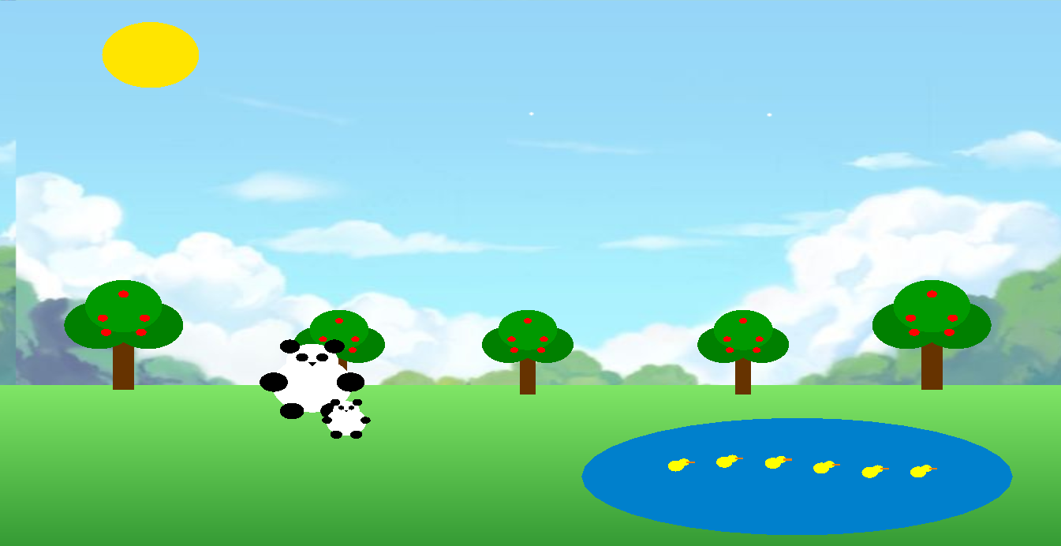
The environment elements, such as the trees, lake, ducks, sun, and grass, are also displayed successfully to create a complete forest atmosphere. The animated ducks inside the lake add more life and movement to the scene, making the environment appear more dynamic and realistic.

3.1. Scene 1: 3D (Ethar)
In this particular section of the result of the project, it shows the mother panda as calm and as she sits to watch her baby play around the duck pond area, focusing entirely on ensuring that the baby is happy as she watches.

Visual & Technical Results:
In the video, there is a demonstration of translations in the transformation of the baby panda as well as the ducks at the pond. Scaling was also carried out to change the circular pond into an oval form. Trees and sun were used as the environmental features alongside the background for the creation of this visual.
Note: As can be noted from the above, the initial scene of the project was done in 3D. Here in the 3D scene, the baby panda moved via translations and had an illusionary movement of orbital rotations through trigonometry formulas. The ducks, however, moved through translations based on the sine formula, moving back and forth.

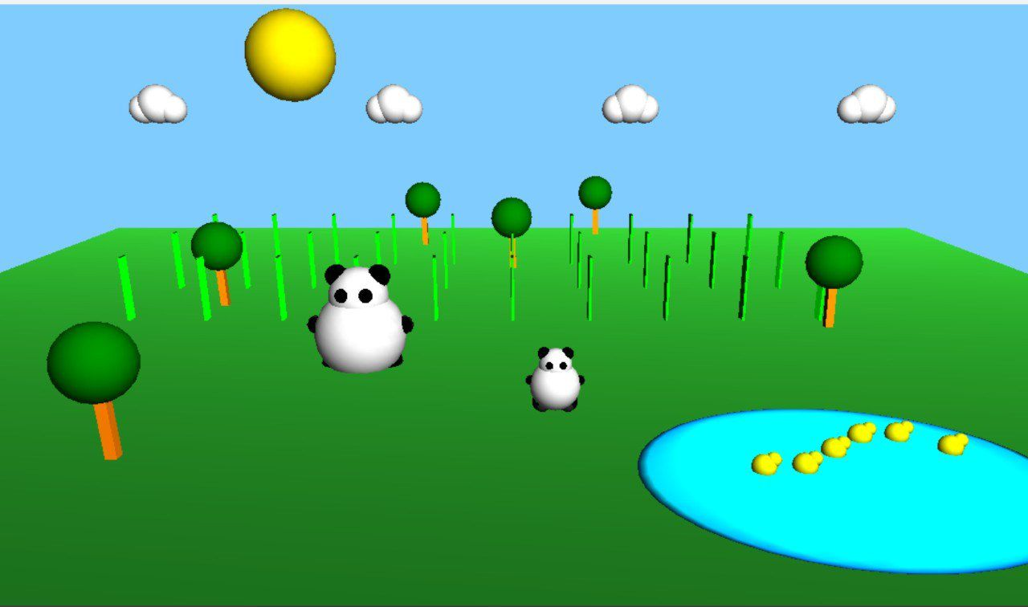

3.1. Scene 2: Mother Panda Searching (Layan)

Image Description:
In this part of the results, the screenshots show the mother panda searching for her lost baby inside the forest environment. The scene focuses on expressing movement and emotion through simple animation techniques. As shown in the scene, the mother panda appears to be looking around while standing near the trees and lake area.

Visual & Technical Results:
The screenshots demonstrate the successful implementation of translation and rotation transformations. The panda is positioned correctly within the scene using translation, while rotation creates the side-to-side searching movement. In addition, the facial expressions are clearly visible through the tilted eyebrows and expressive eyes, helping to show the panda’s worried emotions.

The environment elements, such as the trees, lake, ducks, sun, and grass, are also displayed successfully to create a complete forest atmosphere. The animated ducks inside the lake add more life and movement to the scene, making the environment appear more dynamic and realistic.

Conclusion of the Scene:
Finally, the text "Where is my baby?!" appears near the panda to clearly express the mother’s concern and support the story. The final result confirms that the movement, facial expressions, text rendering, and background elements are all functioning correctly together to create an emotional and visually clear scene
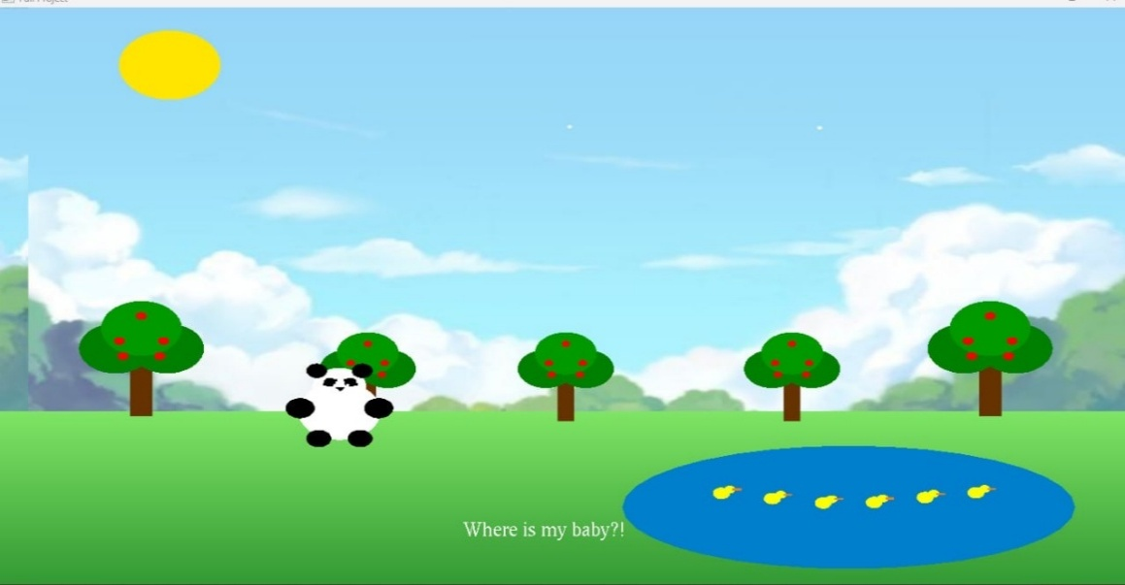
Finally, the text "Where is my baby?!" appears near the panda to clearly express the mother’s concern and support the story. The final result confirms that the movement, facial expressions, text rendering, and background elements are all functioning correctly together to create an emotional and visually clear scene.

3.1 Scene 3: Asking the Rabbit (Sama)
Image Description:
The scene shows the mother panda searching for her baby in the forest. She appears in the center of the scene while asking the rabbit standing next to her. Apple trees fill the background, and the sky is clear with the sun and clouds. The small ducks are also moving near the rabbit, adding simple motion to the scene. At the bottom, the text "Have you seen my baby" appears to show the panda’s question during her search.
Visual & Technical Results:
The scene demonstrates the use of basic transformations such as translation to place the characters correctly and scaling to adjust the size of the trees. The background elements like the grass, clouds, and sun are drawn clearly, and the ducks add a small animated movement that makes the scene feel more lively and balanced.
Conclusion of the Scene:
This scene represents the mother panda continuing her search for her baby and interacting with the rabbit. The presence of the ducks and the movement in the scene help create a lively forest environment , while the text shows the panda’s question as part of the moment.

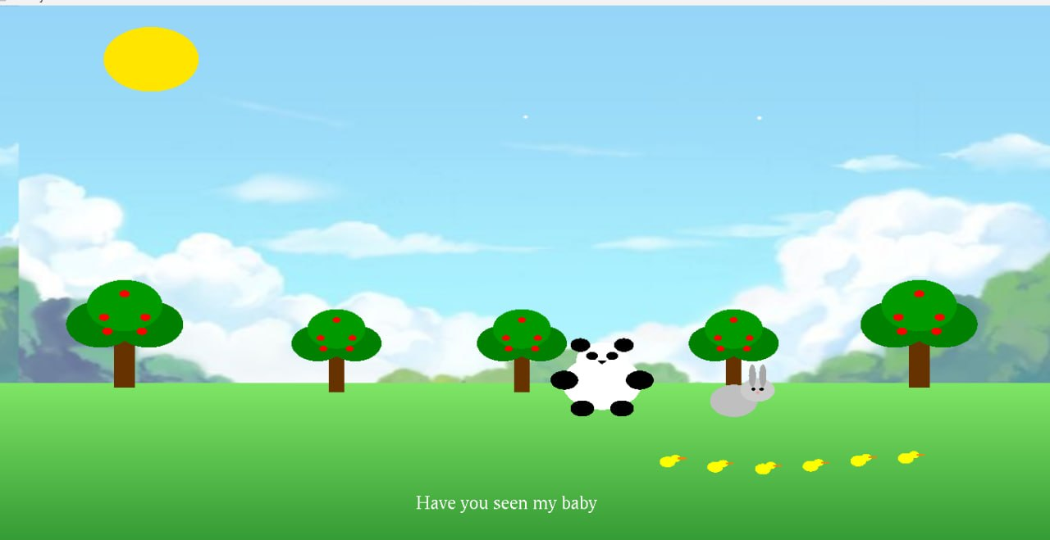

3.1. Scene 4: The rain falls while the panda mother is searching(Munirah)

Image Description:
In this part of the results, the screenshots show the mother panda continuing to search for her lost baby in the forest, but now in a rainy environment. The scene focuses on expressing stronger emotions through weather effects and animation. As shown in the scene, the mother panda appears to be searching while the rain falls and the trees sway from the wind, creating a more emotional and dramatic atmosphere.

Visual & Technical Results:
The screenshots demonstrate the successful implementation of translation, rotation, and scaling transformations. The panda is positioned correctly using translation, while rotation creates the tree's movement from side to side.
The environment has been updated to reflect the rainy weather. The sun is dim or hidden, and animated rain is clearly visible falling across the scene. The trees *and grass are still present, but the overall color tone appears darker to match the mood.

Conclusion of the Scene:
Finally, the text “The rain started falling!" appears when the rain falls *. The rain animation adds continuous motion, making the scene feel more dynamic. The ducks may still be present, contributing to the liveliness of the environment despite the gloomy weather.

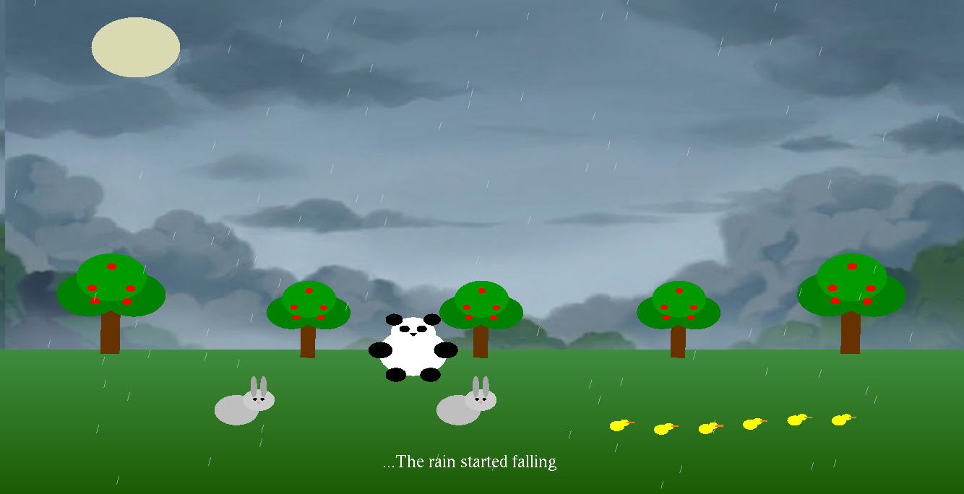

3.1. Scene 5: Finally, the mother found her baby(Raghad)

Image Description:

"In this part of the results, I focus on the final climax of the story. As shown in the screenshots, the mother panda finally reaches her baby. This scene demonstrates the successful implementation of the movement logic I built. You can see the mother standing next to her child in a 'hug' position, which happens exactly when the distance condition is met."

Visual & Technical Results:
"The screenshots also capture the heart animation system in action. These hearts appear around the pandas to show their love. As a result, you can notice how the hearts vary in size and rotation, proving that the Scaling and Rotation transformations are working dynamically. Also, the high-quality BMP background is clearly visible, providing a peaceful forest atmosphere for the ending.

Conclusion of the Story:

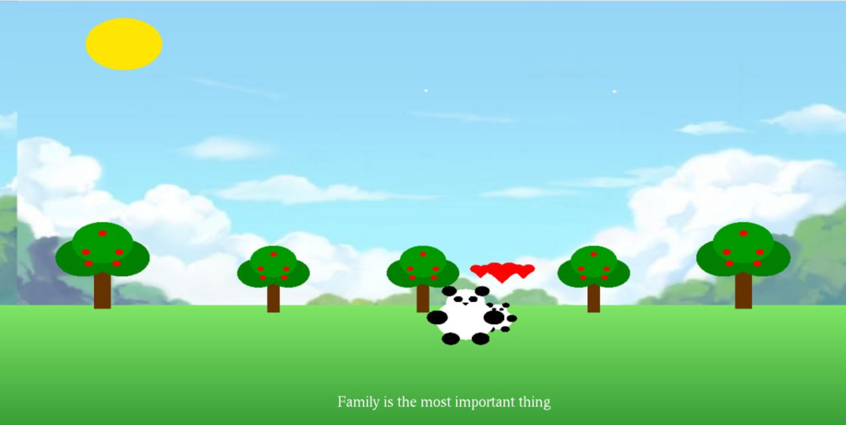
Finally, the result shows the rendering of the text: "Family is the most important thing". The text appears clearly at the bottom of the screen after the animation finishes. This final result confirms that all technical requirements, like textures, text rendering, and complex animations, are fully functional and integrated to deliver the project's message.

Conclusion:
In conclusion, this project demonstrates how basic computer graphics techniques such as translation, rotation, and simple shapes can be used to create animation and express emotions. The scenes successfully combine movement, environment, and text to tell the story of the mother panda. Overall, the project helped us understand the fundamentals of OpenGL and animation.

Future Work:
In the future, the project can be improved by adding more detailed graphics, smoother animations, sound effects, and user interaction. More dialogues can also be added between the mother panda and her baby, as well as between the mother panda and the rabbit, to make the story more engaging. Advanced lighting and weather effects can also be included to make the scenes more realistic.

References
- Computer Graphics Course Materials, CS2206, Lecture Notes and Lab Sessions, 2026.
- Computer Graphics with OpenGL by Donald Hearn and M. Pauline Baker, 4th Edition, Pearson Education.
- Khronos Group, OpenGL Documentation. Available at: https://www.khronos.org/opengl/ (Accessed: May 2026).
- YouTube Video Tutorial:
OpenGL Tutorial
Available at: https://youtu.be/XpBGwZNyUh0?si=zpTz_jLFYvnjiyeZ (Accessed: May 2026).
- ChatGPT, developed by OpenAI. Available at: https://chat.openai.com (Accessed: May 2026).
- Google Gemini, developed by Google. Available at: https://gemini.google.com (Accessed: May 2026).
- Grammarly, developed by Grammarly Inc.. Available at: https://www.grammarly.com (Accessed: May 2026).

