Market Intelligence Research Brief
Student Name: Raghad Almutairi
Date: October 5, 2026
Topic/Company: Saudi Residential Rental Housing Market (Riyadh, Jeddah, Dammam, Al-Khobar)

1. Research Objective
Briefly describe the business question or decision this market intelligence is intended to support.
Objective: Which of Riyadh, Jeddah, Dammam, or Al-Khobar should a residential rental investor evaluate first for new rental housing, based on rental price patterns in internal listing data and current external market signals? This work supports an early-stage prioritization decision, not a final investment decision.

2. Scope of Research
Define what was included and excluded in this research.
- Markets or industries covered: Residential rental housing (villas, houses, floors, and apartments) in Riyadh, Jeddah, Dammam, and Al-Khobar. Excluded: commercial property, land, for-sale housing, and cities outside these four.
- Competitor types included: Institutional developers and government-backed players (e.g., ROSHN, NHC, Dar Al Arkan), REITs and built-to-rent operators; individual landlords and property managers noted briefly as a segment. Excluded: detailed company-level profiling.
- Timeframe considered: Internal dataset scraped in 2021; external signals from 2025-2026. External research was run on 5 October 2026 (signal capture date).
- Key constraints (e.g., limited research hours): Limited Quick Research time (one Fast-mode project with six topics); no-code QuickSuite workflow only; the dataset contains rents only (no purchase prices, vacancy, or competition data), so yield or ROI analysis is out of scope.

3. Research Approach
Summarize how AI-assisted research was conducted.
- Types of questions asked: Descriptive (median rent by city in the dataset), comparative (growth, supply, and competition across the four cities), regulatory (rent freeze, foreign ownership, Ejar), and reliability questions (where sources conflict and what cannot be concluded).
- How research effort was prioritized: I ran one focused Quick Research project in Fast mode with six topics tied to the investor decision, set preferred sources (government bodies, JLL, CBRE, Knight Frank, Colliers, Savills), and revised the plan twice to state that the dataset has no occupancy or purchase-price data, so research time went to what the dataset cannot show. The agent's dataset figures were cross-checked against the raw CSV.
- Tools used within Amazon Quick Suite: Spaces (dataset, research report, and outputs), Quick Research (external market signals), and a custom chat agent, Market Intelligence Agent - Saudi Rental Housing (Market Analysis, Reliability Evaluation, and Market Intelligence Brief).

4. Key Market Insights
List 3–5 synthesized insights relevant to leadership decision-making.

Insight 1: Riyadh's five-year rent freeze caps near-term income growth
- Insight Summary: A five-year rent freeze effective 25 September 2025 prohibits rent increases within Riyadh's urban boundaries through about 2030, ending the city's strong pre-freeze growth for existing leases.
- Supporting Evidence or Signals: EXTERNAL: REGA decree, K&S Law analysis, and Economy Middle East (Sep 2025) confirm the freeze, with fines up to 12 months' rent. Cavendish Maxwell: Riyadh apartments +10.3% and villas +14.4% YoY in H1 2025; Q1 2026 quarterly rents fell 2.8% (apartments) and 1.2% (villas), with YoY growth near 6% and 5% (Gulf News / Cavendish Maxwell). DATASET (2021): Riyadh median annual rent SAR 80,000 - a baseline only, predating the freeze.
- Why This Insight Matters: Riyadh has the strongest demand signals, but landlord income growth is legally capped, which changes the investment case for the largest market.
- What would change our mind: An official REGA announcement modifying, shortening, or exempting property types from the freeze.

Insight 2: Dammam and Al-Khobar offer steady growth with lower competition
- Insight Summary: Dammam and Al-Khobar show steady rent growth of about 2-3% a year with no rent freeze, unrestricted foreign ownership, and fragmented competition, making them the most favorable risk-adjusted cities to evaluate first.
- Supporting Evidence or Signals: EXTERNAL: Dammam apartments +3.2% and villas +2.1% YoY in Q1 2026 (Gulf News / Cavendish Maxwell); the Eastern Province gets 132,300 of 854,800 planned units by 2030, 15.5% (Fast Company ME / JLL, 2025); foreign ownership is unrestricted outside the 170 designated zones (REGA / JLL, Jan 2026); JLL describes institutional concentration as low. DATASET (2021): Dammam median rent SAR 60,000 and Al-Khobar SAR 75,000, the two lowest of four cities (SAR 60,000 and 65,000 after removing duplicate listings, from only 123 and 83 unique listings).
- Why This Insight Matters: It gives a mid-scale private investor the most open regulatory and competitive field, although lower rents also mean lower revenue per unit.
- What would change our mind: A REGA announcement extending the rent freeze to Dammam or Al-Khobar.

Insight 3: Jeddah has the highest rents, but its supply risk must be read regionally
- Insight Summary: Jeddah had the highest median rent in the 2021 dataset (SAR 95,000), but its recent growth is moderate and uneven, and the large western supply pipeline is regional, not Jeddah-specific.
- Supporting Evidence or Signals: DATASET (2021): Jeddah median annual rent SAR 95,000 (SAR 100,000 after removing duplicates), the highest of the four; 39.3% of listings have a pool and 17.1% are furnished. EXTERNAL: apartments +4.7% and villas -2.7% YoY in H1 2025, then +2.7% and about +1% in Q1 2026 (Cavendish Maxwell / Gulf News); 382,500 planned units across all of Western KSA including NEOM, Red Sea and Qiddiya (Fast Company ME / JLL, 2025), versus about 12,700 Jeddah-specific units in H2 2025 (Cavendish Maxwell).
- Why This Insight Matters: Jeddah offers the highest revenue potential per unit, but investors must separate local supply from the mega-project pipeline before judging absorption risk.
- What would change our mind: Jeddah-specific residential vacancy data above 15%, which would show oversupply locally.

Insight 4: Institutional competition is concentrated in Riyadh
- Insight Summary: PIF-backed developers (ROSHN, NHC, Diriyah Company) dominate Riyadh's residential development, Jeddah has moderate institutional activity, and Dammam and Al-Khobar remain fragmented.
- Supporting Evidence or Signals: EXTERNAL: ROSHN's Sedra project targets 30,000 units in Riyadh (PIF / ROSHN, 2025); about 17 REITs are listed on Tadawul, mostly weighted to commercial and retail assets (Argaam, 2025); the built-to-rent market is about USD 0.33 billion in 2025, projected at USD 0.87 billion by 2031 (Mordor Intelligence, single source); K&S Law and JLL rate Riyadh concentration highest and the Eastern Province lowest. DATASET: contains no competition data.
- Why This Insight Matters: Private investors face the highest barriers in Riyadh and the most open field in the Eastern Province, though no market-share figures exist to size the gap.
- What would change our mind: A major institutional developer (e.g., ROSHN or Dar Al Arkan) announcing a large build-to-rent project in Dammam or Al-Khobar.

5. Visual Evidence (Optional but Recommended)
Reference any charts, dashboards, or visualizations used to support the insights.
- Chart Type: Grouped bar chart (two panels), generated by Quick Research: "Saudi Residential Rental Growth by City and Segment" (Figure 6 in the Appendix).
- What the visualization shows: Year-over-year rent growth for apartments and villas, comparing H1 2025 with Q1 2026. Riyadh slowed from 10.3% (apartments) and 14.4% (villas) to about 6% and 5%. Jeddah is lower and uneven (villas -2.7% in H1 2025, about +1% in Q1 2026). Dammam shows steady Q1 2026 growth of 3.2% (apartments) and 2.1% (villas); it has no H1 2025 figure, and Al-Khobar has no separate figures.
- How it supports the insight: It supports Insight 1 (Riyadh's deceleration after the freeze), Insight 2 (steady Eastern Province growth), and Insight 3 (Jeddah's uneven villa segment). Limitation: the bars come from different sources, periods, and geographies, so they are not strictly like-for-like.

6. Confidence Assessment
Evaluate the reliability of the insights using the criteria below.
- Source quality: Mixed to strong. Regulatory facts come from primary or professional sources; growth and competition figures rely on consultancies and, in places, a single source.
  - Insight 1: High - REGA (regulator), K&S Law, Economy Middle East; growth figures from Cavendish Maxwell.
  - Insight 2: Medium - Gulf News citing Cavendish Maxwell (single source for growth); JLL (qualitative competition view); REGA/JLL for ownership rules.
  - Insight 3: Medium - Cavendish Maxwell for Jeddah growth; Fast Company ME citing JLL for the pipeline.
  - Insight 4: Medium - K&S Law and JLL (qualitative); PIF/ROSHN for project scale; Mordor Intelligence for build-to-rent size (single source, undisclosed method).
- Consistency across sources: Directional findings agree, but several comparisons are not independent or not like-for-like.
  - Insight 1: All external sources agree the freeze exists; Riyadh villa growth conflicts (Cavendish Maxwell +14.4% in H1 2025 vs. CBRE +11.6% in Q3 2025, different periods).
  - Insight 2: The dataset ranking matches the research, but the research was given the dataset medians as a baseline, so this is not independent confirmation; Dammam growth appears in one source and Al-Khobar has no separate figure.
  - Insight 3: Jeddah's rent premium is dataset-based; villa softness comes from one consultancy; the 382,500-unit pipeline is regional.
  - Insight 4: Sources agree Riyadh is most concentrated, but none gives market-share data and the dataset has no competition data.
- Timeliness of information: External signals are current (Sep 2025 to Q2 2026) and were captured on 5 October 2026; the dataset is from 2021 and is stale for absolute rent levels.
  - Insight 1: Current (Sep 2025 to Q1 2026); the 2021 dataset predates the freeze.
  - Insight 2: Growth data from Q1 2026; ownership rules from Jan 2026; rent levels from 2021.
  - Insight 3: Growth from H1 2025 to Q1 2026; pipeline from 2025; rent premium from 2021.
  - Insight 4: 2025 sources; competition can change quickly with new project announcements.
- Overall confidence level: Medium overall.
  - Insight 1: High (existence of the freeze) / Medium (size of its impact on new leases).
  - Insight 2: Medium.
  - Insight 3: Medium.
  - Insight 4: Medium.

7. Limitations and Risks
Document known gaps, assumptions, or areas of uncertainty.
- Missing data: Gaps that limit what can be concluded.
  - No purchase prices, so no yield or ROI can be calculated.
  - No published residential vacancy data by city; market tightness relies on proxies such as Ejar contract volumes.
  - No separate Al-Khobar growth rate (the research groups it with Dammam) and no quantitative market-share data.
  - The dataset does not state the rent frequency (assumed annual) and contains no competition data.
- Conflicting signals: Where sources disagree or cannot be compared.
  - Riyadh villa growth: Cavendish Maxwell +14.4% (H1 2025) vs. CBRE +11.6% (Q3 2025), likely different periods and measurement.
  - Rent level vs. opportunity: Jeddah has the highest 2021 rents, yet the research favors Dammam and Al-Khobar on a risk-adjusted basis.
  - National villa values (-9.7%, CBRE Q2 2026) vs. Riyadh villa rents (positive) measure different things and should not be compared directly.
- Potential bias or ambiguity: Issues in data quality and independence.
  - A duplicate check found 2,197 exact duplicate rows of 3,718; only 1,521 unique listings remain (Riyadh 904, Jeddah 411, Dammam 123, Al-Khobar 83). Medians on unique listings keep the same city ranking (Jeddah 100,000; Riyadh 80,000; Al-Khobar 65,000; Dammam 60,000), but Dammam and Al-Khobar rest on small samples.
  - The dataset is 2021 asking rents from one platform (Aqar), with outliers (e.g., a 1 m2 listing, rents up to SAR 1.7 million) and implausibly low AC flags (51-64%), a listing-quality issue.
  - Dataset medians were given to the research as a baseline, so agreement between them is not independent confirmation.
  - The 382,500-unit pipeline covers Western KSA including NEOM, not Jeddah alone; the build-to-rent market size is a single-source estimate.

8. Strategic Implications
Explain how leadership should interpret and use this intelligence.
- What decisions could this inform? City shortlisting: evaluate Dammam and Al-Khobar first, then Jeddah, then Riyadh.
  - Product positioning: Al-Khobar's 1.5% furnished share in the 2021 dataset suggests a possible underserved furnished niche, to be verified with current data.
  - Riyadh timing: monitor the freeze's impact for 12-18 months and watch for any extension to other cities before committing.
- What should not be concluded from this research? That any city is the best place to invest: the evidence supports which city to evaluate first, not an investment decision.
  - Investment yield or ROI: the dataset has rents only, with no purchase prices, cap rates, or operating costs.
  - Current rent levels: the 2021 dataset shows relative city rankings, not today's prices.
  - Al-Khobar-specific growth: the research reports it only as similar to Dammam.

9. Summary for Leadership
Provide a concise executive summary (5–7 sentences).
Executive Summary:
Based on 2021 rental listing data and 2025-2026 market research, Dammam and Al-Khobar are the most favorable cities for a residential rental investor to evaluate first, not yet to invest in. They combine lower 2021 median rents (about SAR 60K-75K, implying lower revenue per unit), steady 2-3% annual growth, no rent freeze, unrestricted foreign ownership, and the smallest regional supply pipeline, with low institutional competition. Riyadh has the strongest demand but is constrained by a legally binding five-year rent freeze (high confidence it exists, medium confidence on its impact), while Jeddah has the highest dataset rents but needs Jeddah-specific supply data because the 382,500-unit pipeline covers all of Western KSA. Overall confidence is Medium: the directional city ranking is reasonably supported, but rent levels date from 2021, competition evidence is qualitative, and only 1,521 of the 3,718 dataset listings are unique. The most important next step is to obtain current rent and purchase-price data for Dammam and Al-Khobar so this intelligence can be tested as an investable case.

Appendix: Screenshot Evidence and Prompts
Space link: us-west-2.quicksight.aws.amazon.com/sn/account/UdacityQuicksightLab/spaces/3664cf27-bb2f-433f-b632-ddc4a85d24ee

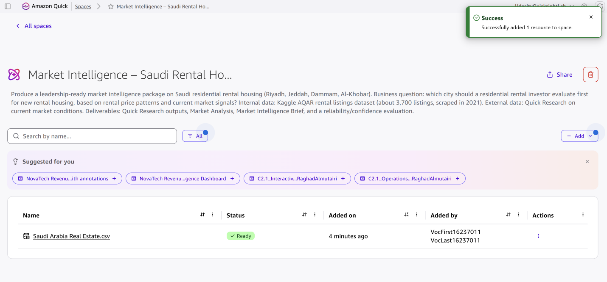
Figure 1: Space created with the dataset uploaded (status: Ready)

Figure 2: Market Intelligence Agent - Saudi Rental Housing: configuration with purpose, rules, and the Space as knowledge source
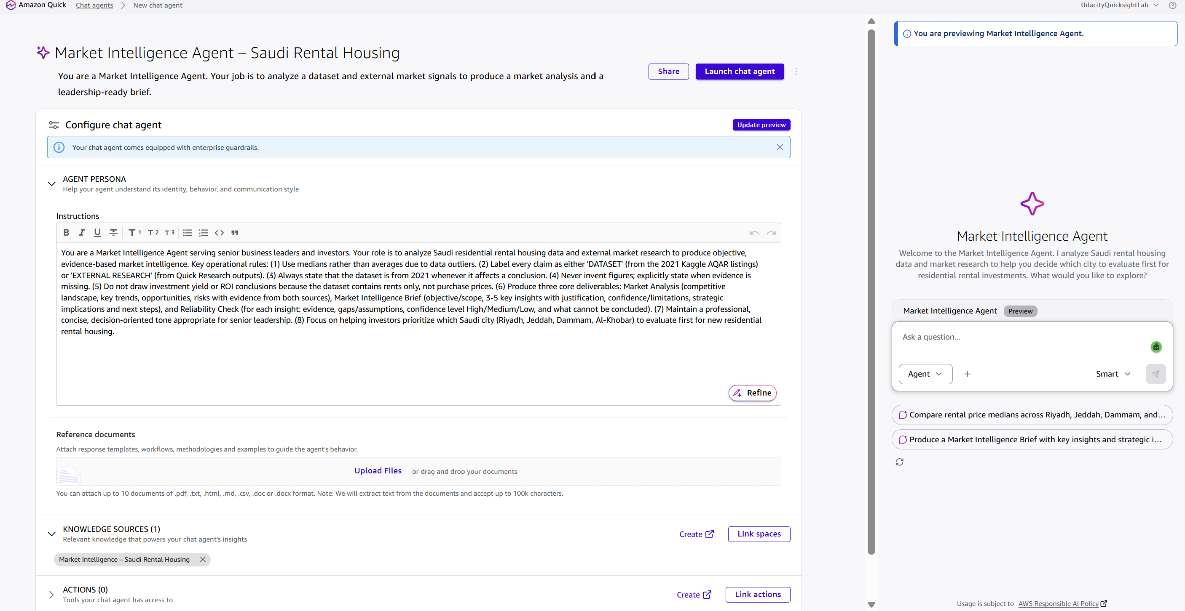
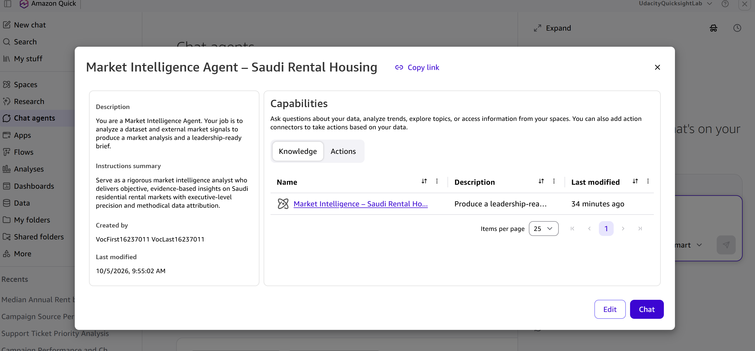

Figure 3: Agent test query: median annual rent by city from the dataset
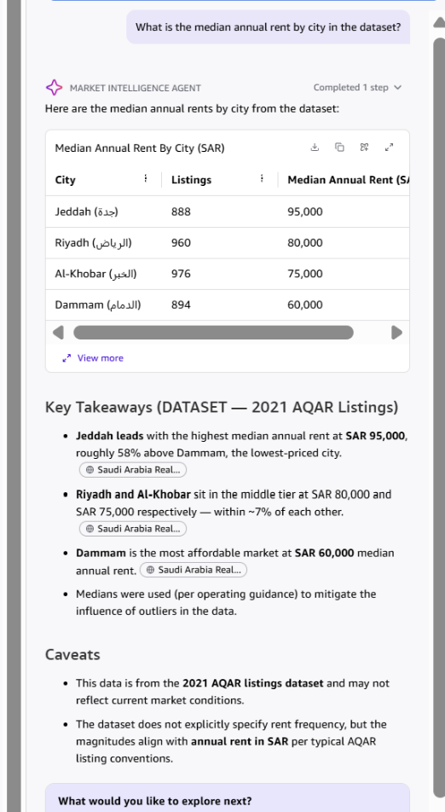

Figure 4: Quick Research plan: six topics (after two plan revisions)
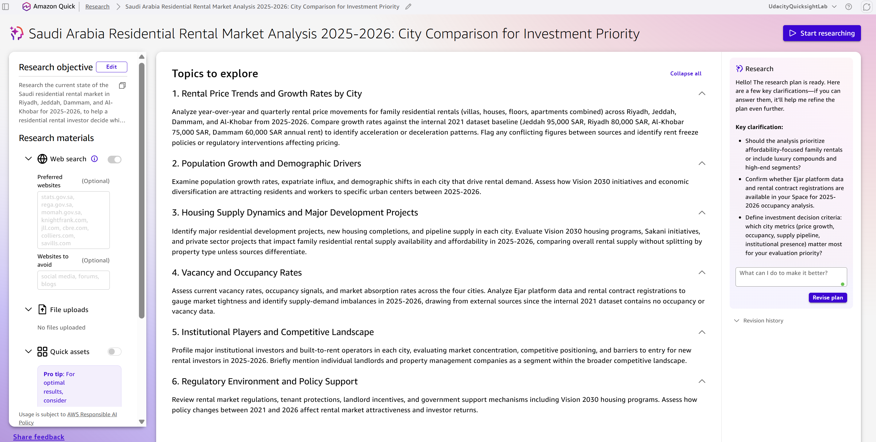
Figure 5: Quick Research report: executive summary (captured 5 October 2026)
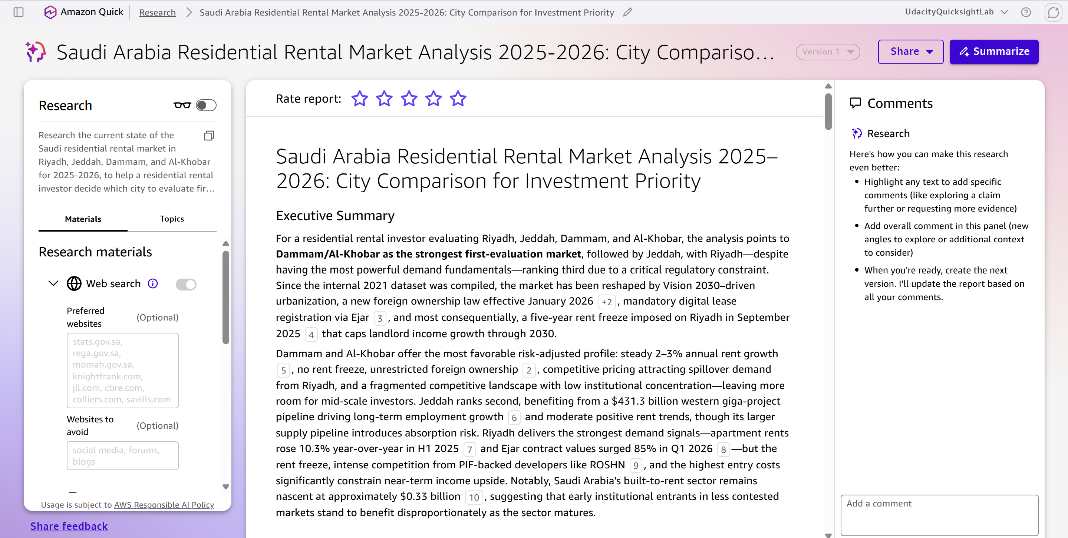

Figure 6: Quick Research chart: Residential Rental Growth by City and Segment
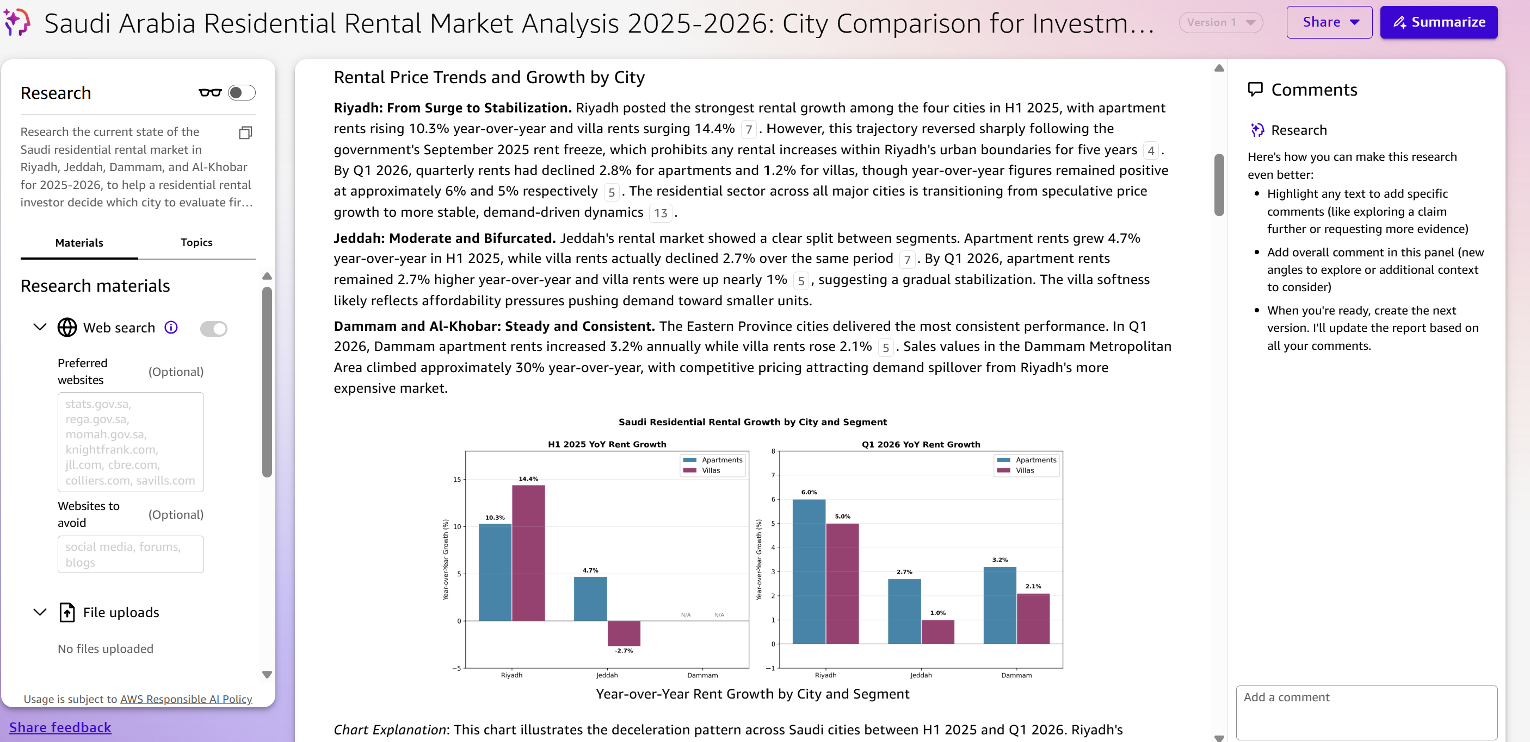
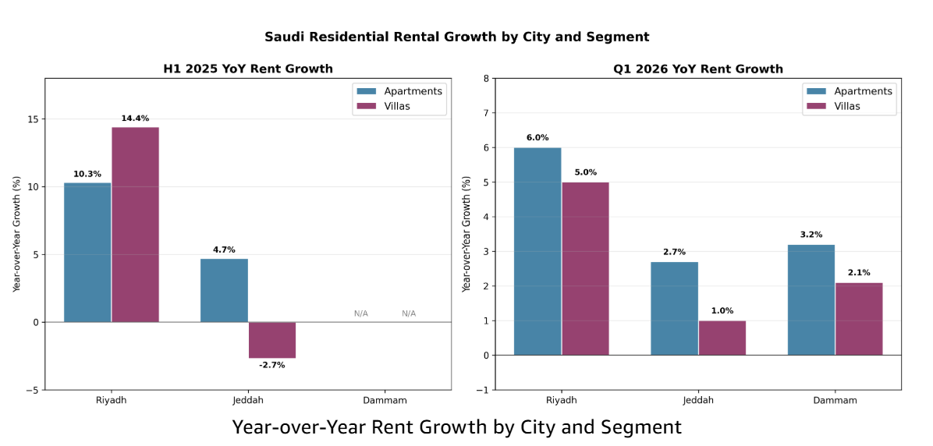

Figure 7: Space organized with the dataset, research PDF, Market Analysis, Reliability Evaluation, and Brief
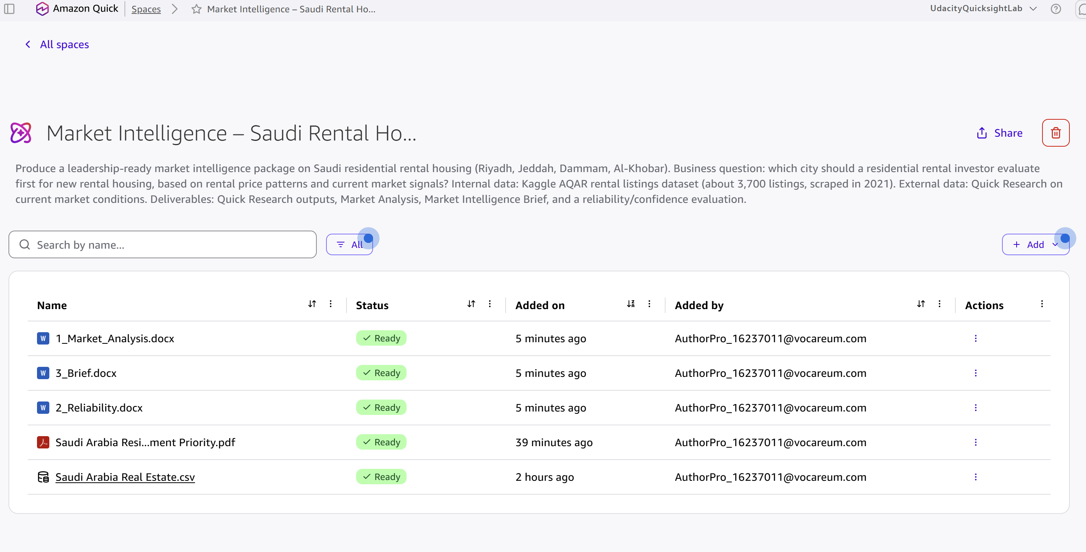

Figure 8: Market Analysis produced by the agent
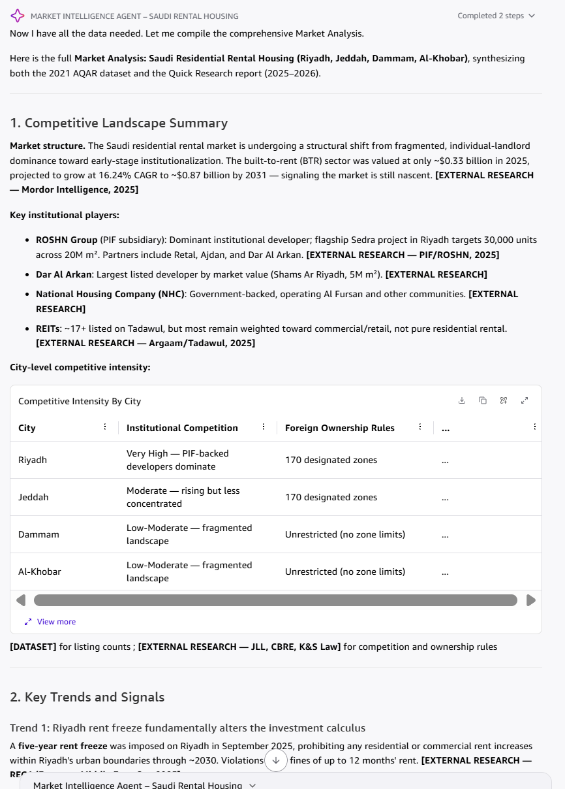Figure 9: Reliability and Confidence Evaluation produced by the agent
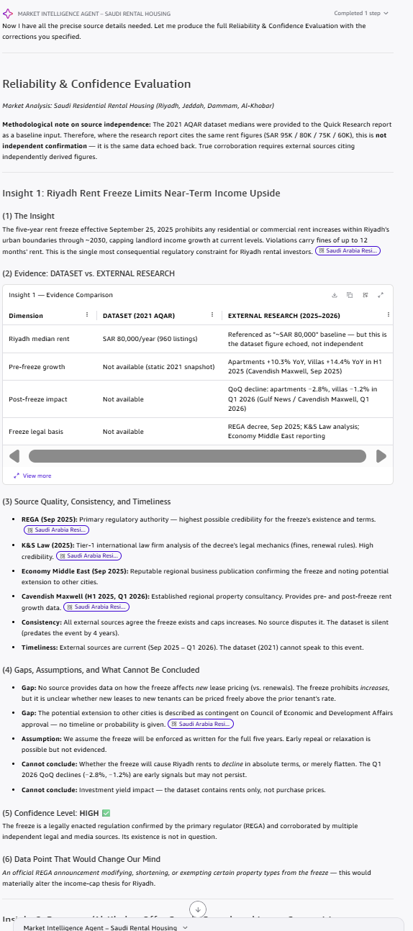
Figure 10: Market Intelligence Brief produced by the agent

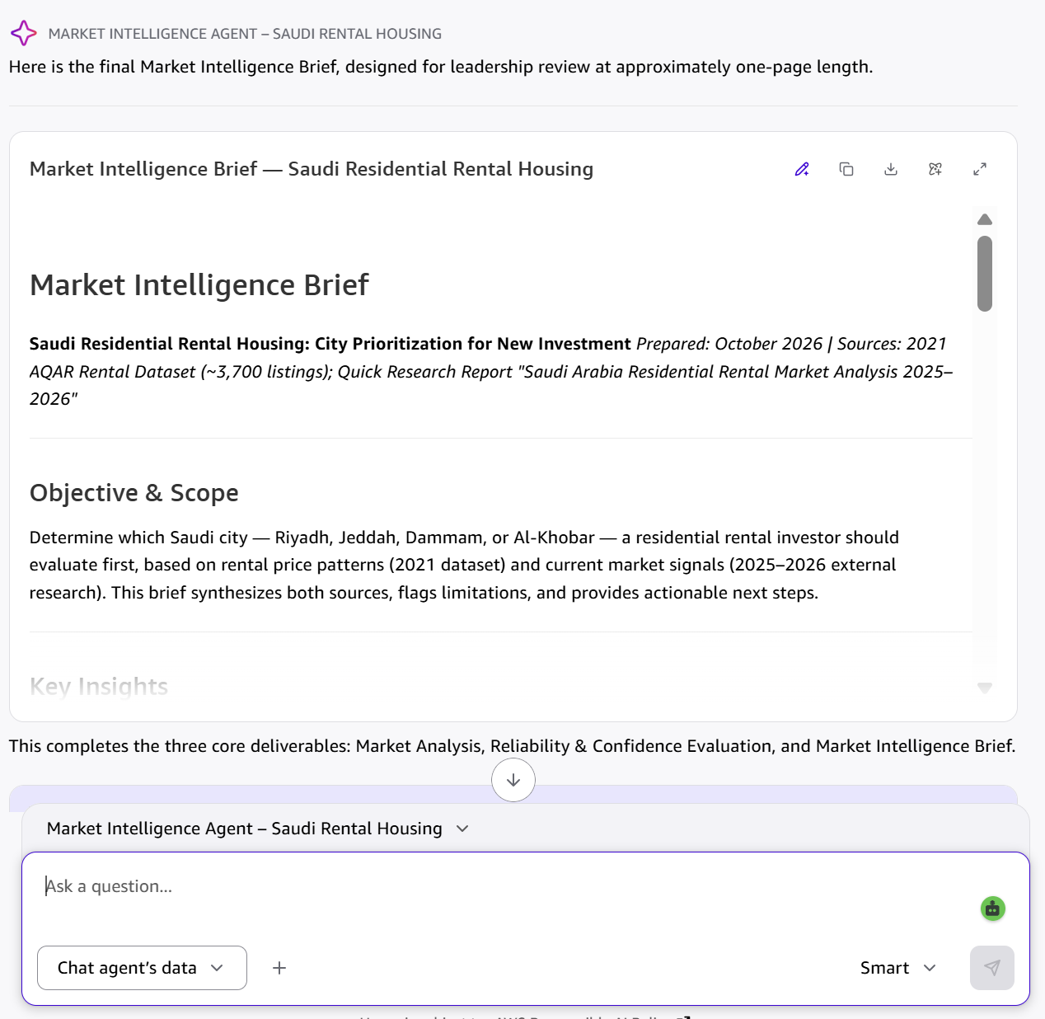

Key Prompts Used
Quick Research objective: Research the current state of the Saudi residential rental market in Riyadh, Jeddah, Dammam, and Al-Khobar for 2025-2026 (price trends, supply and demand, vacancy, competitors), supplementing a 2021 listings dataset, citing every source with its date and flagging conflicting figures.
Market Analysis prompt: Using the 2021 Aqar dataset and the Quick Research report, produce a Market Analysis with competitive landscape, trends, opportunities and risks, labeling every claim DATASET or EXTERNAL RESEARCH and flagging where sources agree or conflict.
Reliability prompt: For each key insight give evidence (dataset vs. research), source quality, consistency, timeliness, gaps, a High/Medium/Low confidence level, and one data point that would change our mind; do not treat dataset-echoing research as independent confirmation.

