

##### Palestine Technical University - Kadoorie

##### Faculty of Engineering and Technology

##### Department of Computer Systems Engineering

##### D:\Users\Raghad Hanon\Desktop\SoftwareProject\images\logo-modified.png

**Software Engineering Requirements Document**

**Medical Care System**

##### Prepared By:

|  |  |
| --- | --- |
| **Abeer Mahmoud** | **202110119** |
| **Hanan Issa** | 202110057 |
| **Nada Asad** | 202112529 |
| **Raghad Hanon** | 202110023 |

##### Supervisor:

# Dr. Osama Hamed

**Table of contents**

**CHAPTER 1 Introduction 1**

* 1. Purpose 1
  2. Document Convections 1
  3. Intended Audience and Reading Suggestions 1
  4. Project Scope 2

**CHAPTER 2 Overall Description 1**

* 1. Product Perspective 1
  2. Product Features 1
  3. User Classes And Characteristic 1
  4. Operating Environment 2
  5. Design And Implementation Constraints 2
  6. Assumption and Dependencies 2

**CHAPTER 3 System Features 3**

**3.1** Functional Requirements 3

**CHAPTER 4 External Interface Requirements 6**

* 1. User Interfaces 6
  2. Hardware Interfaces 7
  3. Software Interfaces 6
  4. Communication Interfaces 7

**CHAPTER 5 Nonfunctional Requirements 7**

* 1. Performance Requirements 7
  2. Safety Requirements 11
  3. Security Requirements 7
  4. Software Quality Attributes 11

**CHAPTER 6 System Models 12**

* 1. Use-case Diagrams 12
  2. Class Diagram 14
  3. Activity Diagrams 15
  4. Sequence Diagram 18

**CHAPTER 7 System Evolution 23**

**CHAPTER 9 Conclusion 24**

**References 25**

**Abstract**

As technology continues to advance, its impact on society becomes increasingly evident, touching various aspects of our lives. Nowhere is this more pronounced than in the field of medicine. To keep pace with these advancements, it has become essential to embrace technology that not only saves time and effort for users but also enhances the delivery of healthcare services.

One of the remarkable achievements of modern medicine is the development of applications and websites that leverage technological progress to offer convenience and efficiency to both healthcare providers and patients. Our project aims to provide an archiving and healthcare system suitable for use in clinics as well as for personal use by patients. It is designed to streamline access to patients' medical histories, offering several advantages over traditional methods where doctors obtain patient information directly from the patient. Additionally, it allows patients to contribute to their own medical history.

In our healthcare system, we offer the following features:

1. Medical reports authored by healthcare providers: This includes previous medical reports, test results, imaging studies, and other relevant medical documentation authored by healthcare professionals, available for review by treating doctors.
2. Allergies: Information regarding any known allergies the patient may have to medications, foods, or other substances.
3. Chronic diseases: Details about any chronic conditions or ongoing health issues the patient has, such as diabetes, hypertension, asthma, or heart disease, are recorded in their medical records.
4. Maintenance medicines: Details about any maintenance medicines that the patient takes.
5. Vital signs of the patient: Records of the patient's vital signs, including blood sugar levels, blood pressure, etc., which may be recorded during routine check-ups, hospital visits, or other medical encounters.
6. Personal information for users: Basic demographic information about the user, such as name, date of birth, gender, contact information, and address.
7. List of doctors categorized based on their medical specialization: Patients can choose a doctor that matches their needs and request treatment accordingly.
8. List of patients for each doctor: Each doctor has a list of patients they have treated, allowing for efficient management of patient-doctor relationships.

By centralizing this information in a digital format, our system aims to enhance the efficiency and effectiveness of healthcare delivery, benefiting both patients and healthcare providers alike

**CHAPTER 1: Introduction**

**CHAPTER 5: Nonfunctional Requirements**

1. 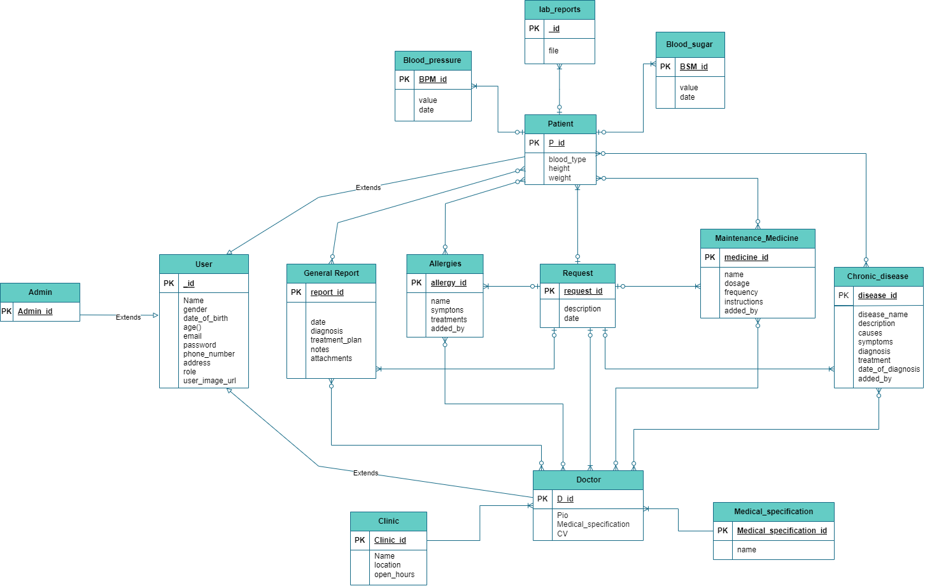**E-R Diagram**