

##### Palestine Technical University - Kadoorie

##### Faculty of Engineering and Technology

##### Department of Computer Systems Engineering

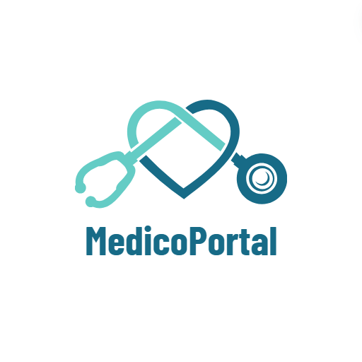

**Software Engineering Requirements Document**

**Medical Care System**

##### Prepared By:

|  |  |
| --- | --- |
| **Abeer Mahmoud** | **202110119** |
| **Hanan Issa** | 202110057 |
| **Nada Asad** | 202112529 |
| **Raghad Hanon** | 202110023 |

##### Supervisor:

# Dr. Osama Hamed

**Table of contents**

[**1 Introduction**](#Chapter1) **4**

* 1. [Purpose](#Chapter1_1Purpose) 4
  2. [Document Convections](#Document_Convection) 4
  3. [Intended Audience and Reading Suggestions](#Intended_Audience) 4
  4. [Project Scope](#Project_scope) 5
  5. [References](#References) 5

**2**  [**System Models**](#Chapter6) **6**

**2.1** [Sequence Diagram](#SequenceDiagram) 6

**2.1.1** ER-Diagram6 6

**Software Requirements Specification**

**Abstract**

As technology continues to advance, its impact on society becomes increasingly evident, touching various aspects of our lives. Nowhere is this more pronounced than in the field of medicine. To keep pace with these advancements, it has become essential to embrace technology that not only saves time and effort for users but also enhances the delivery of healthcare services.

One of the remarkable achievements of modern medicine is the development of applications and websites that leverage technological progress to offer convenience and efficiency to both healthcare providers and patients. Our project aims to provide an archiving and healthcare system suitable for use in clinics as well as for personal use by patients. It is designed to streamline access to patients' medical histories, offering several advantages over traditional methods where doctors obtain patient information directly from the patient. Additionally, it allows patients to contribute to their own medical history.

In our healthcare system, we offer the following features:

1. Medical reports authored by healthcare providers: This includes previous medical reports, test results, imaging studies, and other relevant medical documentation authored by healthcare professionals, available for review by treating doctors.
2. Allergies: Information regarding any known allergies the patient may have to medications, foods, or other substances.
3. Chronic diseases: Details about any chronic conditions or ongoing health issues the patient has, such as diabetes, hypertension, asthma, or heart disease, are recorded in their medical records.
4. Maintenance medicines: Details about any maintenance medicines that the patient takes.
5. Vital signs of the patient: Records of the patient's vital signs, including blood sugar levels, blood pressure, etc., which may be recorded during routine check-ups, hospital visits, or other medical encounters.
6. Personal information for users: Basic demographic information about the user, such as name, date of birth, gender, contact information, and address.
7. List of doctors categorized based on their medical specialization: Patients can choose a doctor that matches their needs and request treatment accordingly.
8. List of patients for each doctor: Each doctor has a list of patients they have treated, allowing for efficient management of patient-doctor relationships.

By centralizing this information in a digital format, our system aims to enhance the efficiency and effectiveness of healthcare delivery, benefiting both patients and healthcare providers alike

Github repo : <https://github.com/RaghadHanon/SoftwareProject>

**CHAPTER 1: Introduction**

* 1. **Purpose**

The purpose of this Software Requirements Specification (SRS) document is to outline functional and non-functional requirements of the development of the MedicoPortal website and to serve as a guide for the development team to ensure that the product meets the perspective.

Our website aims to offer a versatile platform suitable for both medical clinics doctors and personal use, enabling users to access various medical services. These services include retrieving medical records, summarizing medical history, and securely storing it within a personal account. This setup facilitates healthcare professionals in receiving personalized health information through the platform, ensuring patients receive appropriate medical care.

The system's objectives are to enhance access to healthcare services, streamline communication between patients and healthcare providers, and ultimately improve the overall patient care experience.

* 1. **Document Convections**

|  |  |  |
| --- | --- | --- |
| Acronym | Term | Definition |
| SRS | Software Requirements Specification | comprehensive document that outlines the functional and non-functional requirements for a software system. |
|  | Medico Portal | The name of the medical care software website. |
| ER | Entity Relationship model | The Entity-Relationship model is a conceptual framework used to describe the data and relationships within a database system. |
| DI | Drug interaction | refers to the effects that occur when two or more drugs are administered together, influencing the efficacy or toxicity of one or more of the drugs involved. |

* 1. **Intended Audience and Reading Suggestions**

This SRS document is beneficial for :

1. **Developer**

The document will serve the development team as a guide to make it easier to move from one development phase to another, ensuring that the final product meets the specified needs and requirements of the system.

1. **Users**

* **Healthcare Professionals**

Guidelines on utilizing the website for patient management, accessing patients’ medical records efficiently, and the ability to provide the patients with medical reports.

* **Patients**

Instructions on how to use the website to consult with healthcare providers, and access personalized health information, with the ability to add a daily checkup.

* **General Users**

Overview of the website features, benefits, and how it can improve access to healthcare services.

* 1. **Project Scope**

This website was built to help the doctor diagnose the patient more accurately, through the doctor’s access to the patient’s complete record of diseases, allergies, medications, previous medical reports, and personal information. Therefore:

1. It enables the patient to obtain an overview of his general medical condition and archive it.
2. It enables the doctor to review the patient’s medical condition very accurately.
3. It increases the efficiency and accuracy of the diagnosis given by the doctor.
4. Preventing many possible mistakes, such as:

* DI (Drug interaction).
* Giving medication that is dangerous to his health condition.
* Unintentional neglect for the patient’s allergies or chronic diseases.

The purpose of the online medical care system is to archive patients’ medical records and to create a convenient and easy-to-use application for patients to get the best medical care and doctors to get all the information to do their work in the best way. The system relies on a relational database that includes all medical information about the patient, whether personal or written by former doctors.

Our Medico Portal website has some features which make it special to use, such as:

* Data Security and Privacy.
* User-Friendly Interface.
* Mobile Accessibility.
* Continuous Improvement.
* Collaboration with Healthcare Providers.

Above all, we hope to provide a comfortable user experience along with the best prices available.

* 1. **Refernces**
* [http://users.encs.concordia.ca/~eshihab/teaching/slides/srs\_template\_sep14.pdf](http://users.encs.concordia.ca/~eshihab/teaching/slides/srs_template_sep14.pdf" \o "http://users.encs.concordia.ca/~eshihab/teaching/slides/srs_template_sep14.pdf" \t "_blank)

**CHAPTER 2: System Models**

* 1. **Sequence Diagram**

**2.4.1 E-R Diagram :**

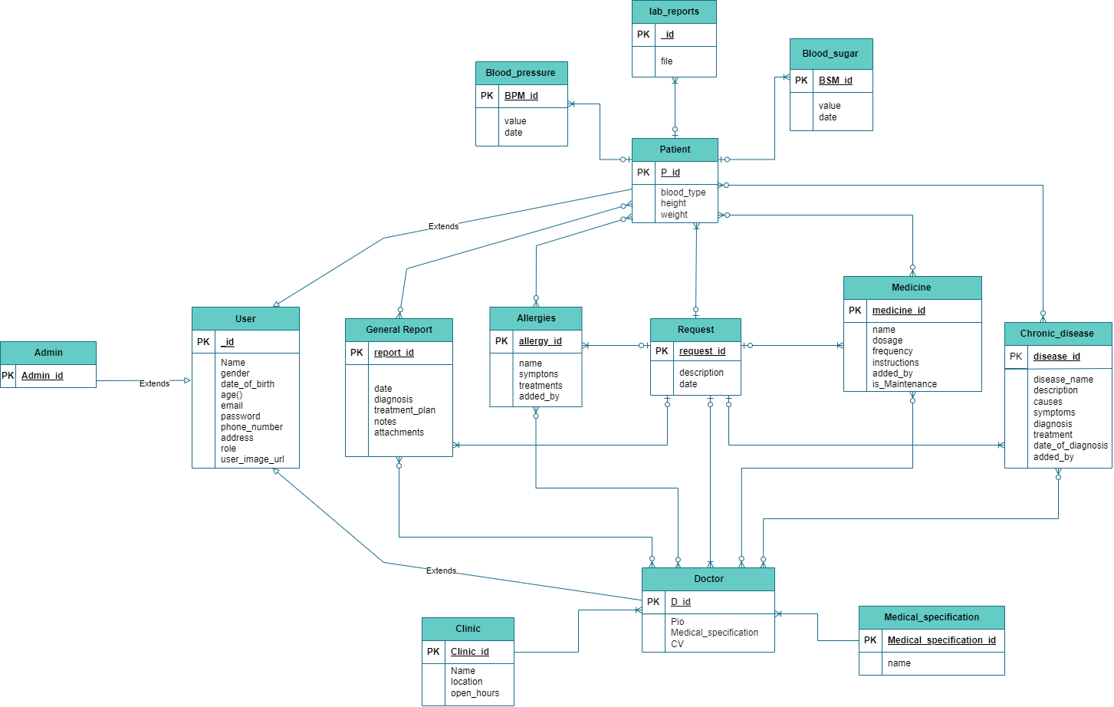

Figure 1: Medico Portal System ER-diagram