

Artificial Intelligence and Intelligent Systems

Assignment Title
Intelligent Systems

Submitted to
Eng. Batool Alarmouti

Submitted by
Raghad Jaber 23110155

Contents
Compare the advantages and challenges of several tools and techniques for the development of your intelligent system. 3
Investigate options around the approaches, techniques and tools for the deployment of your intelligent system 4
Evaluate the potential impact of deploying several types, approaches and tools of AI and Intelligent Systems on both users and organizations. 6
Explore the technical options to enhance the performance of your model. 7
Modify the implementation of the problem using Microsoft Azure and deploy it. Submit evidence of your implementation. And demonstrate your modification and show enhancement using benchmarking metrics by providing screenshots. 8
Evaluate the decisions you made during your model development process. This includes the model you selected, how you handled data, which hyperparameters you tuned, and how you evaluated performance. Reflect on how each of these choices influenced the results and suggest ways you could improve your approach if you repeated the task in the future. 15

Compare the advantages and challenges of several tools and techniques for the development of your intelligent system.
Tools | Usage in my Heart Detection disease model | Advantages | Challenges
Scikit-Learn | Used it when implementing ML algorithms and in feature selection using sequential features selector and evaluated with metrics like mean squared error, R squared and, accuracy. | - Open-Source & Free.  - Easy to Use with simple syntax.  - Comprehensive Documentation  with examples.  - Wide Range of Algorithms (regression, classification, clustering, etc.)  - Feature Engineering Support  - Integration with Python libraries (e.g. NumPy, Pandas, and Matplotlib, etc.) | - Black-Box Nature, some algorithms lack detailed interpretability  - Memory Intensive  - Dependency on NumPy and SciPy, users unfamiliar with these libraries may face challenges.
Pandas | for loading and preprocessing the data set and for exploratory data analysis such as head(), describe() and to ensure that the data set is clean with isnull and dtypes. | - Easy Data Handling  - Powerful Data Cleaning with Built-in functions for cleaning.  - Fast Operations  - Rich Functionality (e.g. filtering, merging, time-series, etc.)  - Great for Exploratory Data Analysis (EDA) | - High Memory Usage  - Slower if my dataset was larger.  - It is harder to trace logic errors since it doesn't show the error location and explanation.  - Poor documentation in some cases.

Techniques | Usage in my Heart Detection disease model | Advantages | Challenges
Supervised Learning (KNN) | I used KNN to distinguish if the patient has a heart disease or not based on multiple features. | - Simple, comprehensible, and scalable for medical diagnosis.  - Easy to interpret  - High Predictive power  - Effective for large training sets  - Useful for nonlinear data, often found in health data.  - High accuracy | - Expensive on memory and storage when determining K especially if the dataset is large.  - High sensitivity to data’s scale and irrelevant features.  - Lazy learning algorithm as it doesn’t learn from the training data; it memorizes it and then classifies the new input.  - Can be slow during prediction.
Hyperparameter Tuning | I used a loop to iterate the different values of K then, measured accuracy for each K and choose the best K based on the highest accuracy. | - Boosted model accuracy  - Prevents Overfitting and Underfitting  - Models are simpler and easier to interpret | - High computational time.  - Expensive computational power when evaluating

Investigate options around the approaches, techniques and tools for the deployment of your intelligent system
Model deployment is the process of putting machine learning models into production making it available to users, developers or systems.
Microsoft Azure is one of the tools that I have used for the deployment of my intelligent system. It is a public cloud computing platform offering multiple cloud services, including computers, analytics, storage and networking. It allows developers to develop and scale new applications or run existing applications in the public cloud.
Azure is known for its high scalability, security, and reliability to deploy AI models and intelligent systems simplifying ML lifecycle, from data preparation to deployment.
One of the most popular tools in Azure for Intelligent System Deployment is Azure Machine Learning (Azure ML) which is a complete platform for building, training, and deploying machine learning models. Offering model training with AutoML and model registry and version control. Also, drag-and-drop interface to show the process of experimenting of different ML algorithms. It also enables unexperienced users to pre-process and create accurate models. Additionally, Microsoft Azure ML Studio supports both visual design and advanced coding options with flexibility for customizing and deploying.
Nevertheless, it’s important to evaluate Microsoft Azure ML weaknesses as well such as developers find data cleaning and preparation capabilities to be inadequate and simplifying Pricing structure and clarity for better understanding. Also, its lack of integration with platforms outside Microsoft Azure, such as AWS and IBM and the integration of different ML models and frameworks needs enhancement and more support for deep learning models.
Deployment in Azure Could be done in different ways like One-off, where it allows the user to use Azure ML to deploy models for single use. Another way is batch, Azure ML supports batch inference pipelines, where large datasets are processed at once. Finaly, Real-time Offering low-latency predictions.
For local deployment of my intelligent system I used ML Flow. Which is an open-source platform for developing models and generative AI applications offering features like tracking experiments, managing and deploying models from various ML libraries from staging to production, and AI agent evaluation and tracing. Some of the deployment techniques I have used when deploying via ML flow is model logging with MLflow tracking (mlflow.sklearn.log_model(model, "trained_knn_model")), model loading for predictions (mlflow_loaded_model = mlflow.sklearn.load_model(logged_model)), and tracking model performance before and post deployment (mlflow.log_metric("accuracy", accuracy) for before deployment and mlflow_accuracy = accuracy_score(y_test, mlflow_predictions) for post-deployment). So, we can say that ML Flow does have many advantages such as consistent environments from training to serving, monitoring through the whole process, security, and scalability. There are also some cons that we should investigate, like high learning curve, set-up and maintenance need effort, dependency on Ecosystem (e.g. Databricks). I also incorporated Joblib, which is a tool helpful for saving and loading machine learning models efficiently. I specifically used it for saving the trained Ken and the model as a .PKL file. This helped me reload and reuse the model without the need to retain it again each time I want to use it. All in all, Joblib alongside ML Flow, offered flexibility and quick local reuse with a structured stretchable and scalable deployment path.

Evaluate the potential impact of deploying several types, approaches and tools of AI and Intelligent Systems on both users and organizations.
AI and Intelligent Systems are rapidly transforming the landscape of organizations and users experience nowadays. Since they are becoming increasingly integrated into everyday tasks from decision-making to writing emails. Their impact is felt across industries and society.
Impact of AI on Organizations was noticed on their performance positively and significantly by automating repetitive tasks and data driven decision-making this impacted positively on metrics like profitability, customer satisfaction, and innovation. Also, enhancing employee productivity by automating tasks, allowing employees to focus on creativity. There could be some negative impact as well like the competitive environment it created for organizations to invest heavily in AI to stay up-to-date and the best in the market without propre planning leading to wasted resources and strategic misalignment. Also, over-reliance on technology will reduce critical thinking which could be risky especially in scenarios where models could fail. Additionally, security vulnerabilities since AI systems are vulnerable to cyberattacks.
On the other hand, the impact of AI on users was also noticed on their performance positively like reducing routine manual work by automating it (e.g., data entry). Also, skill development is enhanced by AI training tools and decision-support as well as their job satisfaction as it reduces stress and burnout. There are also some concerns and challenges that could be encountered when deploying AI systems like job displacement fears, ethical concerns like lack of privacy, infrastructure limitations (in some countries), and unclear AI policies.
In healthcare, AI impact on organizations can be noticed on many aspects as well like improving diagnostic accuracy and speed as it aids in early and accurate results. Also, clinical decision support like chatbots as it offers answers to medical questions based on evidence. Additionally, early disease detection since AI models can identify early signs that humans could miss. In the other hand negative impacts of AI in healthcare, inaccurate data some tools could produce fake references, ethical & privacy concerns since the data health AI models carry valuable making it attractive for hackers.
AI impact on users in healthcare is shown positively in different ways like analyzing patient history, genetics, and lifestyle to personalize treatment plans, and reducing waiting time by virtual assistants to provide fast responses to questions and arranging patients’ appointments.
Also, monitoring patients since it minimizes human error and notifying doctors when something is wrong. For the negative impact of AI in healthcare on users, the accountability of issues, meaning if AI misdiagnoses a patient, we don’t know who is legally responsible. And Over-Reliance on AI leading to loss of human critical thinking and patients distrust. Also, job displacement concerns.

Explore the technical options to enhance the performance of your model.
Hyperparameter Tuning,
In my heart disease prediction model, I have used KNN ML algorithm so choosing the best K (hyperparameter) is critical for my model accuracy and performance due to that it is important to investigate. I have implemented a for loop which tests multiple values for K and then measures its accuracy then choose the best accuracy but there are some better ways to choose K with this computational power and higher accuracy. For instance, Bayesian Optimization, many studies have witnessed its powerful technique for optimizing hyperparameters in ML models including the selection of K in KNN algorithm. This is done due to its:
- Efficient Search in Hyperparameter Space - since traditional ways of finding K like grid and for loops are computationally expensive so BO uses probabilistic models (e.g., Gaussian Process) to find K and the model’s accuracy reducing the number of evaluations.
- Balancing exploration - traditional testing chooses random values for K so it could miss optimal values. So, BO uses functions to ensure balanced exploration
Feature Engineering,
By feature engineering we can enhance data and use techniques to extract meaningful patterns from medical data. Like:
- Collaborate with healthcare professionals to extract new meaningful features from data.
- Automated feature extraction – by deep learning algorithms for imaging data or NLP for feature extraction
- Feature selection & dimensionality reduction – by using filter methods (e.g. chi-square) or embedded methods (e.g. tree-based models)
Using Artificial Neural Networks (ANN),
Are tools in ML that are modeled to mimic human brain cells and functionalities. It is used in many industries like finance, engineering, and healthcare, to make effective predictions and insights based on data. ANN design is about layers of interconnected nodes or "neurons" that process and transmit information similarly to the nerve cells in humans’ brains. This makes models recognize complex patterns, learn from changing data, and make real time predictions. There are many types of artificial neural networks like Feedforward NN, Recurrent NN, Convolutional NN, etc.
In my heart disease prediction model, I have used KNN algorithm for training the model and making predictions. But implementing ANN model could enhance the performance and the accuracy of predictions. The best ANN algorithm for this model is Multilayer Perceptron (MLP) which is a Feedforward NN, this is due to many reasons like:
- It deals very well with tabular data by finding patterns since the data columns are age, cholesterol, blood pressure, etc.
- Perfect for binary classification output since the target value of the data is heart disease (0 No heart disease and 1 heart disease) because MLP will use sigmoid function that transforms the output to a probability between 0 and 1 so instead of saying yes or no because of the prediction we can say that the patient has 65% chance of heart disease. This will improve relying on the model. This probabilistic output makes predictions easier to understand and more reliable.
- Great performance with non-linear relationships, this is important since the dataset has many features with non-linear relationships like cholesterol, age, and blood pressure interactions.

Modify the implementation of the problem using Microsoft Azure and deploy it. Submit evidence of your implementation. And demonstrate your modification and show enhancement using benchmarking metrics by providing screenshots.
Nowadays heart diseases are one of the most leading causes of death globally so early diagnosis will reduce mortality rates. In this project I have developed a machine learning model to protect they're the patient has heart disease or not based on data such as age gender cholesterol levels blood pressure Heart rate and a unique feature a quantum pattern feature. Which is a mathematically derived feature. Inspired by quantum computing and pattern entanglement, it significantly increases the accuracy of classification as it introduces high dimensional interactions between variables that linear features may miss.
My first approach for implementation was using a local Python environment, Jupiter notebook. I have used K-Nearest Neighbors (KNN) algorithm where the model was trained and tested and ML Flow and joblib for deployment.
To train the model, the first step is to initialize Y (target feature) and X (all other features) then split the dataset into training and testing sets.
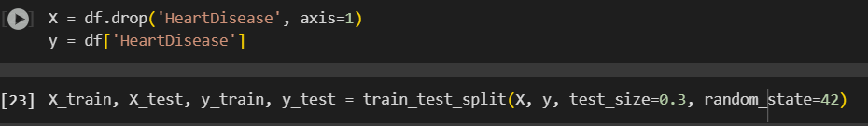
standardizes the training and testing data using StandardScaler to ensure consistent preprocessing.
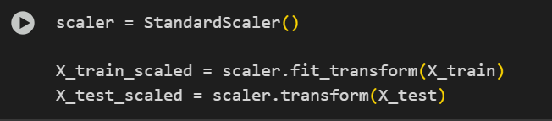
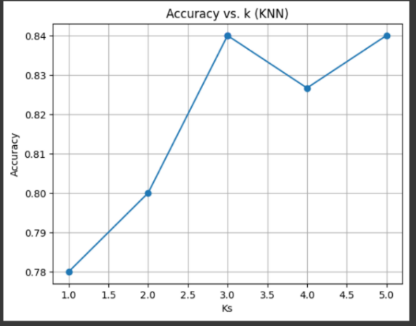
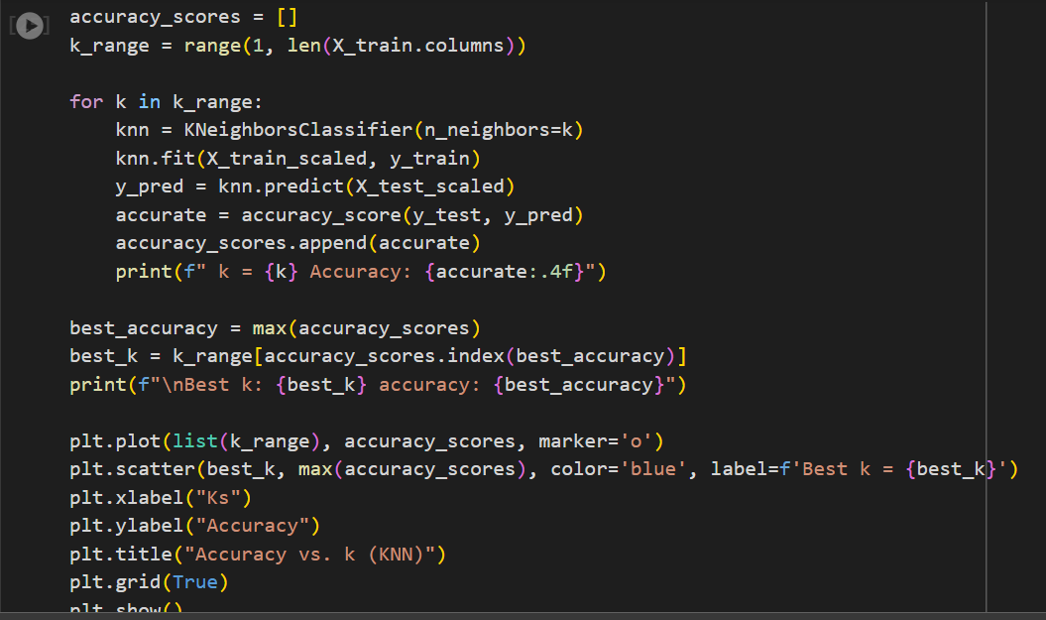
For hyperparameter tuning I have implemented a for loop to evaluate different values of k (number of features) and measuring its accuracy scores to identify the best k, and plots accuracy vs. k to visualize performance.

Then I initialized and trained a KNN classifier (best_knn) using the optimal k (best_k) found in the previous step, fitting it (training the model) to the scaled training data (X_train_scaled, y_train).
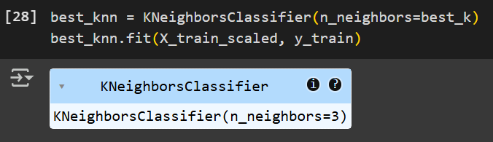
Then I used the best_knn model to generate predictions on both the scaled training and testing data.
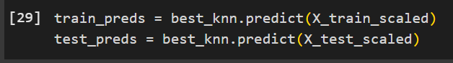
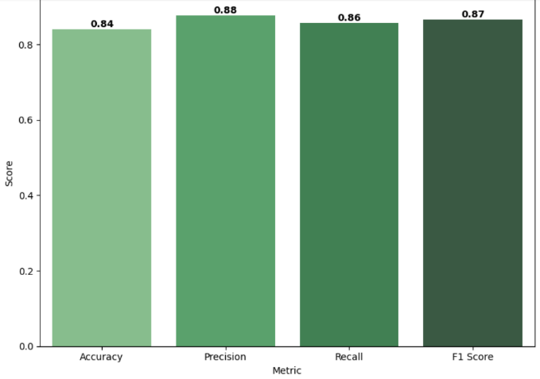
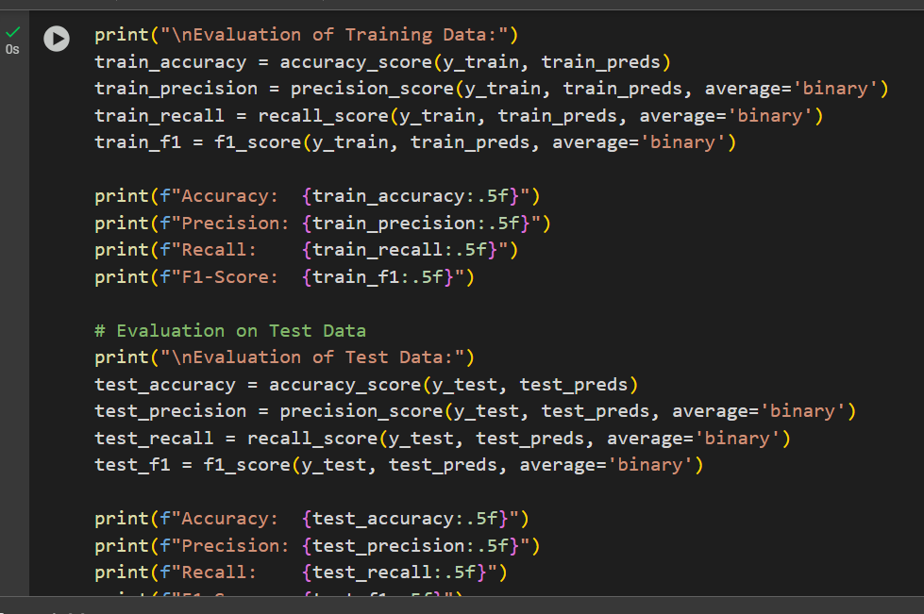
Finally, I evaluated the model's performance by calculating accuracy, precision, recall, and F1-score for both training and testing to compare how well the model performs to unseen data. And I plot the results of the unseen data (testing).

Now for deployment I have used ML flow by setting up an MLflow experiment to track a KNN classification model for heart disease, logs the best number of neighbors, and saves the trained model
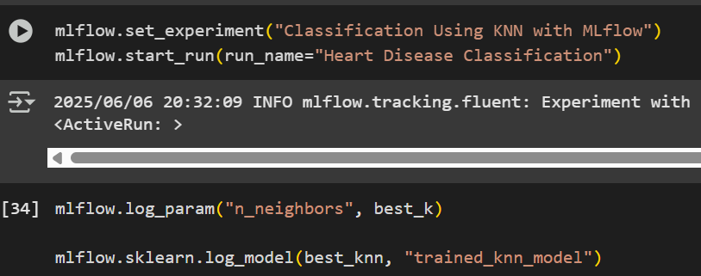
Then I logged the model's performance metrics (accuracy, precision, recall, and F1-score) to MLflow for tracking and comparison.
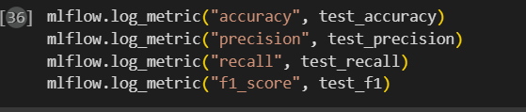
Then I loaded the model from MLflow from its run ID so it can be reused later for predictions.
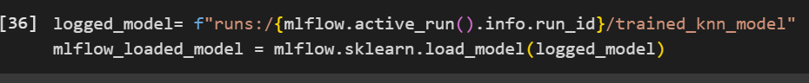
I used this loaded model to make predictions on scaled test data and then print accuracy.
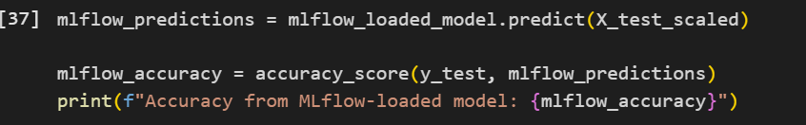
After that I scaled a new patient’s data using the same scaler and used the loaded KNN model to predict whether the patient has heart disease.
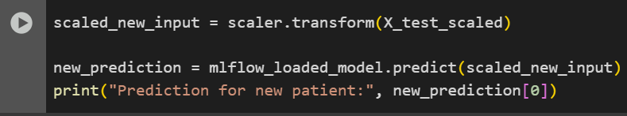
Finally, I saved the model as a .pkl file using joblib, logs it as in MLflow for tracking and ending the MLflow run.
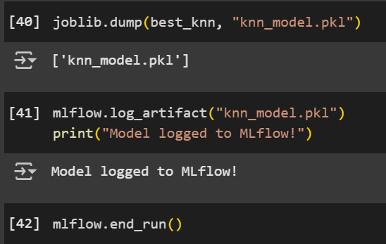
While the model achieved great performance it had some limitations like performance issues, dependency management as libraries may conflict, not ideal for real-time etc.
To address these limitations, I deployed the model on Microsoft Azure as well.
By uploading my dataset on azure ML Studio.
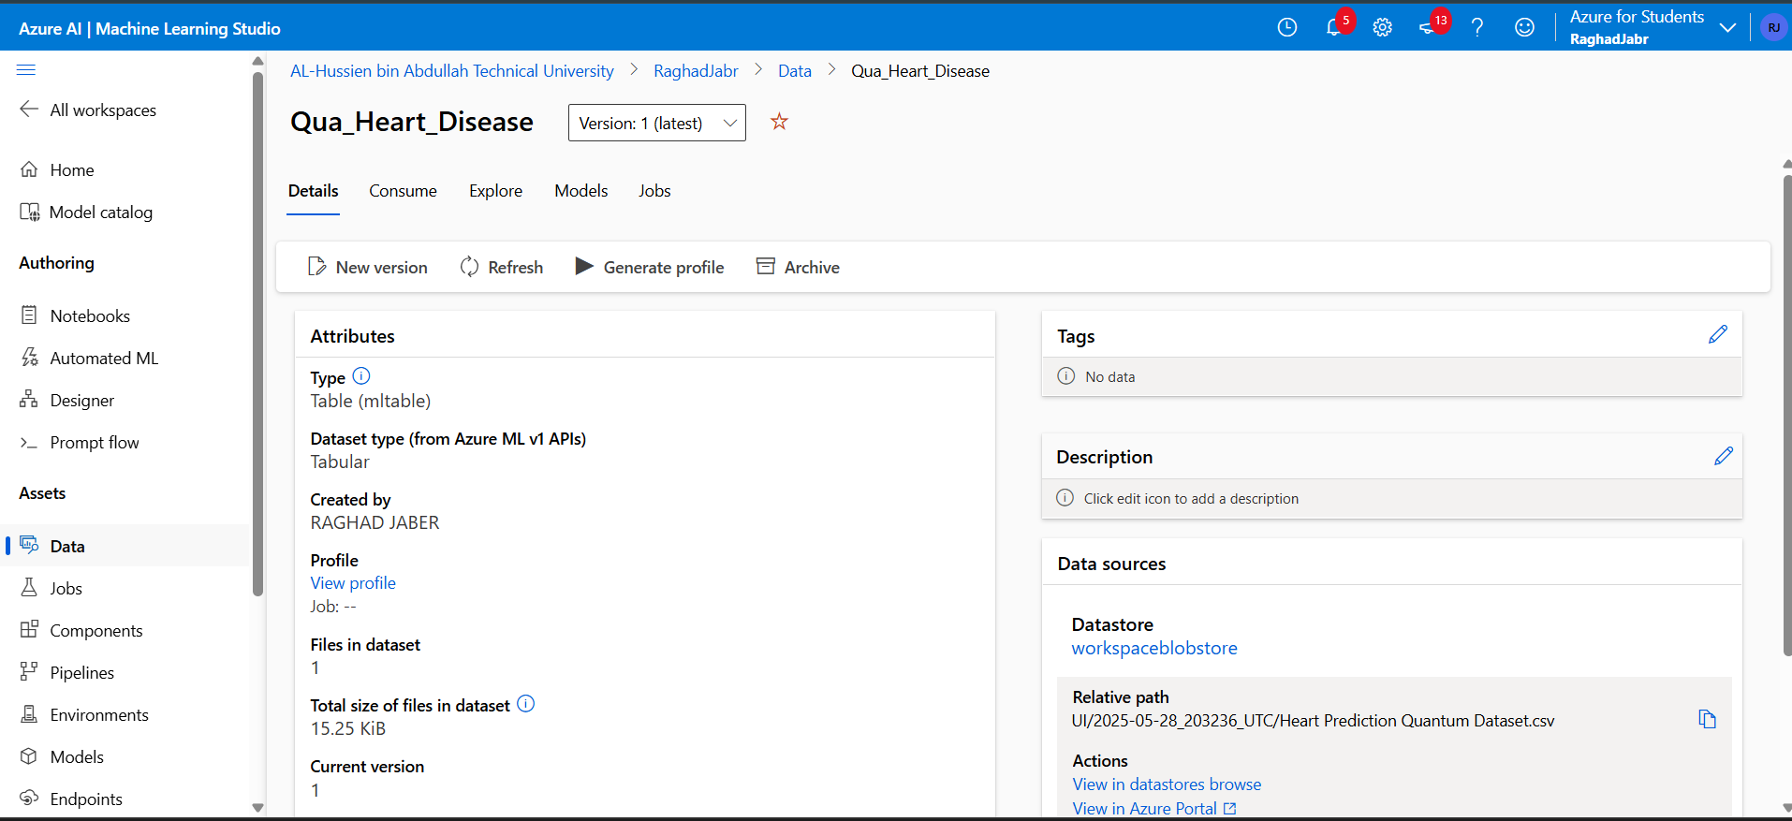
Then training the model on the dataset and using the computing instance (labAiclus)
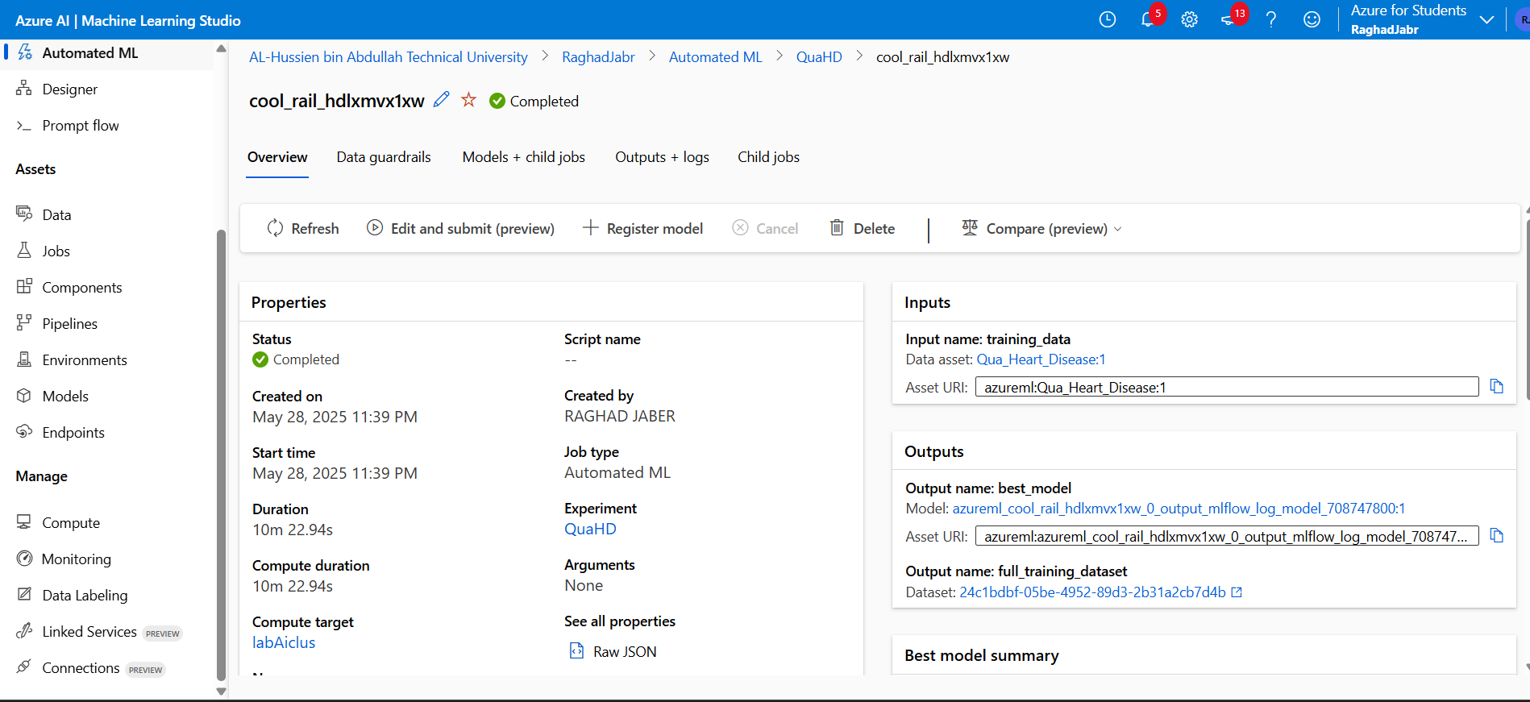
Here are the trained models with their accuracy scores
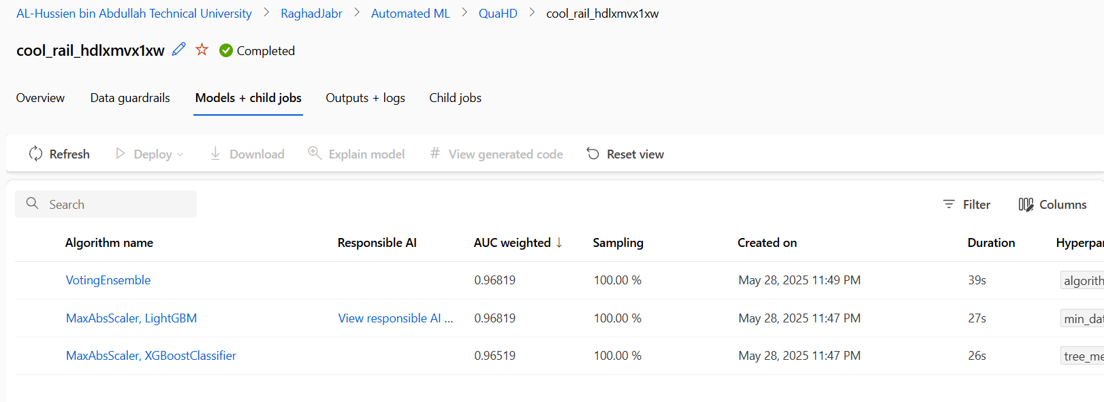
I chose VotingEnsemble as my deployment algorithm since it has high accuracy of 0.96819.
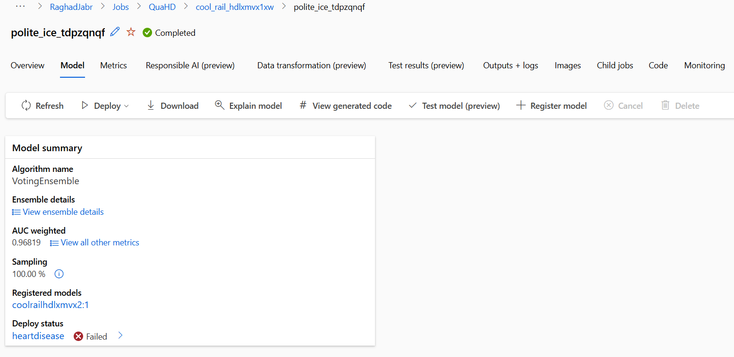
The deploy status is failed because I have a student account.

Here are the results of my automated ML model
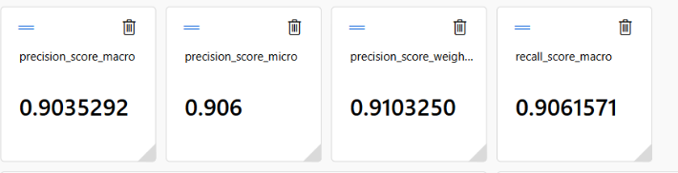
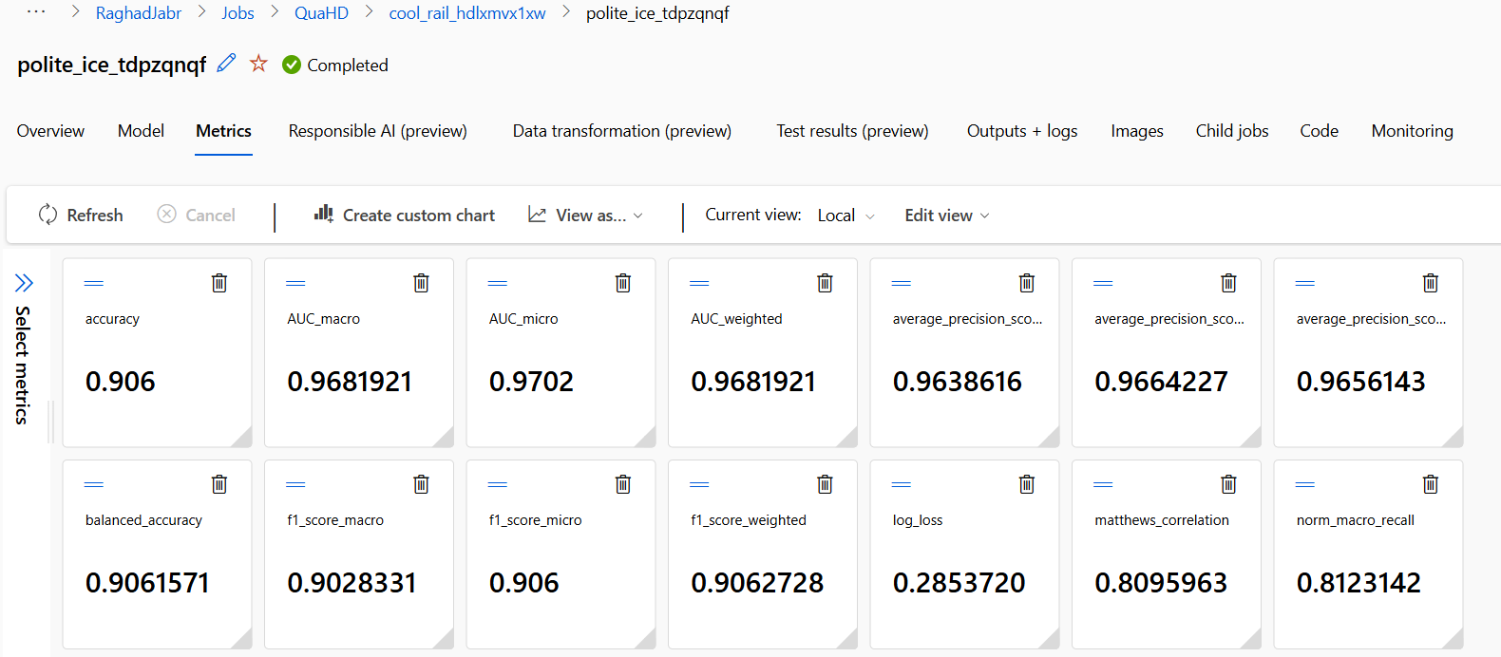

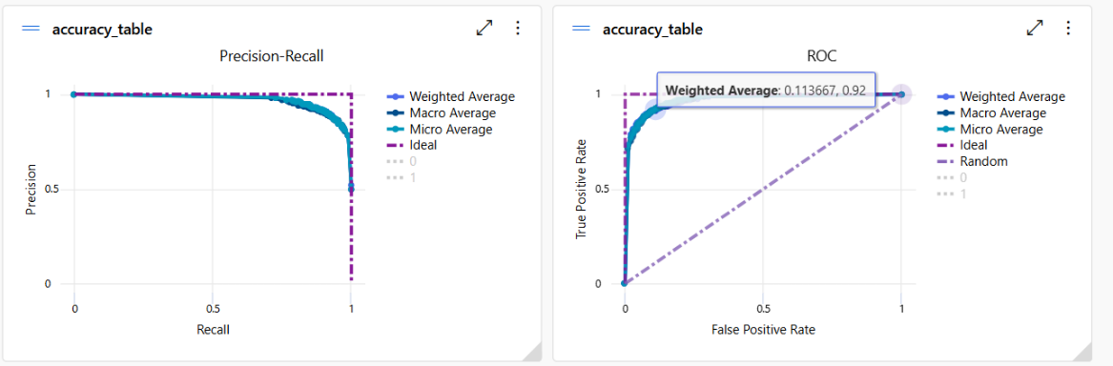

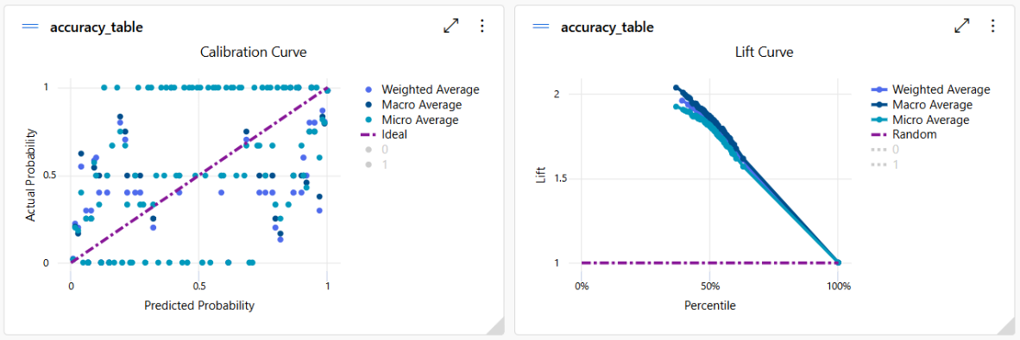

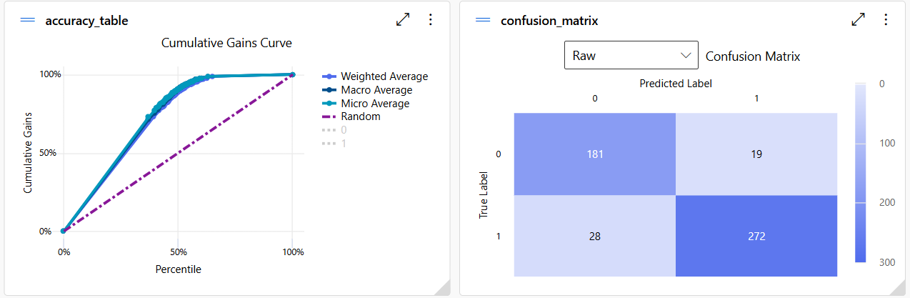
And by comparing metrics from both azure and python:
Metric | Python Local Environment | Azure
Accuracy | 0.84000 | 0.906
Precision | 0.87640 | 0.91032
Recall | 0.85714 | 0.90615
F1 Score | 0.86667 | 0.90627
We can see that both approaches performed well with high values of metrics, but we can see that Azure has better performance as it has higher accuracy indicating that it is model is more instance and has better performance. Azure also has higher precision indicating for fewer false positives also it captures more true positives than the local model and this is extra important when diagnosis since missing diagnosis is expensive. And F1 showed that Azure has a better balance between precision and recall indicating to overall stronger performance.
So, we can conclude that Azure has better performance due to its hardware and computer resources (GPU, TPU), scalability for hyperparameter tuning of larger datasets, Advanced preprocessing and feature engineering, Ensuring consistent environment, comprehensive data storage, and AI infrastructure with latest GPUs.

Evaluate the decisions you made during your model development process. This includes the model you selected, how you handled data, which hyperparameters you tuned, and how you evaluated performance. Reflect on how each of these choices influenced the results and suggest ways you could improve your approach if you repeated the task in the future.
Model selection KNN algorithm,
It is a simple algorithm and perfect for classification for data sets with limited features. Its main concept is about measuring distances usually Euclidean between points to see which are the closest neighbors. This approach makes the algorithm lazy learning meaning it makes no assumptions about the data distribution it learns and memorizes rather than finding patterns and correlations. This is extra beneficial for my heart disease prediction models since I have multiple features with nonlinear relationships. So, it makes predictions by looking at the most similar instances in the dataset rather than making assumptions. This is ideal for the unknown distribution of some clinical data sets. Also, there is a high chance of encountering outliers and inconsistency in clinical data KNN can be flexible in these situations. It could also enhance the decision-making process because of the algorithm’s approach since it offers predictions based on the closest distance we can easily justify and interpret new data. For instance, if a patient came with unusual conditions and symptoms KNN can still make locally accurate predictions by finding the most similar patient to their symptoms.
For further improvement there are other algorithms that we could use, especially if we did a set expanded because can an algorithm is not for huge data sets such as artificial neural networks algorithms (explained above). Or tree-based models like random forest, since it has many advantages like its high accuracy, its great performance with noisy data, it calculates features importance, and it handled missing data and outliers.
Data handling,
When I started developing my model I started with understanding and preparing it my data set already preprocessed specifically categorical values like gender were encoded however I would have applied encoding to ensure high performance of the model. It is important to evaluate the contribution of each feature to the target variable “heart disease”, so I did sequential feature selection although I did not use the selected features for training my model, so it helped me gain a better understanding of the dataset and decision-making process. During the training Phase I did feature scaling (Standard scaling) to ensure features contribute equally to the model. And for exploratory data analysis I have utilized multiple libraries such as pandas seaborn, and scikit-learn. As I created a correlation heat map to identify relationships among variables and ensure consistency of the dataset, also multiple visualizations to understand this distribution like box plots and pair plots. And calculated descriptive statistics like the average of the target variables to understand the balance between both classes zero and one and the target valuable.
For future enhancements I would have used the selected features of the sequential feature selected since it reduces dimensionality, training time, and noises. Also using automated pipelines where they combine preprocessing feature selection and modeling at once This will help in cleaning and scaling the data select features train the model all in one single object.
hyperparameter Tuning,
My technique was implementing a manual grid search by creating a for loop to check multiple values of K and then evaluating the model's performance. Hyperparameter tuning in can an algorithm is critical because the results are based on the number of neighbors K. The lower the K is the more overfitting the model is and the higher the more underfitting the model is. The results were that K equal to 0 is the best value for K with high accuracy of 0.84. I measured the accuracy of k values because my data set is imbalanced. After that I added a visualization to visualize the accuracy of k values this helps in the decision-making process by showing the trend. And since my data set is small to medium size this approach was effective on the computational power and cost.
In machine learning it is better to have larger data sets with different data for a more accurate model so in the future if I want to implement this model again, I will choose a larger dataset. Due to that manual grid search is not an effective wave for choosing the right cave value due to its high computational power and cost with larger datasets. Other approaches could be done like Bayesian optimization (explained above). Another approach is automated grid search a technique for automatic search of the best hyperparameter as it doesn't have a manual loop and uses cross validation for more accurate answers and avoid overfitting of the test set.
Model Performance Evaluation,
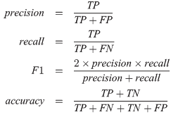
Metrics used in the local Python environment and Azure:
Accuracy - which is the proportion of all correct predictions of all predictions and based on the table provided above we can see that Azure has better classification performance with a higher accuracy rate.
Precision - the proportion of true positives predictions out of all positive predictions. This is an important metric to look at when diagnosis since the cost of false positives is high. Based on the results Azure does have fewer false positives.
Recall - The proportion of true positive predictions out of all actual positives is extra important when detecting diseases and diagnosis since missing a positive case is very costly. also performed better than the local Python environment meaning it captures more of the actual positives.
F1 score - It balances between the precision and recall Azure balances them better making it a more reliable model overall.
AUC (Area under the curve) - the measurements of the ability of the model to distinguish between classes is the best measurement for evaluating binary classification. Azure showed excellent class separation.
For future enhancement of model evaluation is k-fold cross-validation, a type of cross validation which splits the data set into equal parts of k then iterates through these values and then tests the performance of the model during these iterations. This approach will reduce the variance of performance and ensure that the model is exposed to all data, and it helps dedicate overfitting.
In conclusion I think I have implemented an effective care and machine learning model for heart disease diagnosis. There could be some enhancements to the model as mentioned above additionally to some other things like hybrid KNN model where I integrate KNN with other algorithms like clustering or fuzzy KNN. Or testing my model with an entirely separate data set from other hospitals. Or collaborating with people in the healthcare field for better understanding of the features and creating derived features such as BMI introducing new patterns.

What is QuantumPatternFeature?
Quantum features are features that are encoded by classical data into quantum states and the processing them with quantum circuits to extract nonclassical patterns to improve the performance of the heart disease prediction model by performing better on noisy medical data due to quantum entanglement and better computational efficiency. It could be generated using quantum machine learning techniques like quantum algorithms. This feature enhances the prediction power by encoding classical medical data, for instance cholesterol into a quantum state this simulates uncovering complex nonlinear patterns that traditional methods might miss. Classical machine learning models treat quantum features as engineered inputs. This means that the variables have been artificially created from raw data to improve ML model performance. So, the feature was derived using quantum inspired math, but they function like any other feature in classical machine learning to uncover nonlinear relationships.

  - References:
Patil, R. (2023). Exploring the Pros and Cons of Pandas. [online] Medium. Available at: https://rohanjpatil63.medium.com/exploring-the-pros-and-cons-of-pandas-1675463971d4.
AltexSoft. (n.d.). Pandas Pros and Cons Compared. [online] Available at: https://www.altexsoft.com/blog/pandas-library/.
Vadapalli, P. (2020). Scikit-learn in Python: Features, Prerequisites, Pros & Cons. [online] upGrad blog. Available at: https://www.upgrad.com/blog/scikit-learn-in-python/.
Editorial (2022). Pros and cons of the K-Nearest Neighbors (KNN) algorithm. [online] Roboticsbiz.com. Available at: https://roboticsbiz.com/pros-and-cons-of-the-k-nearest-neighbors-knn-algorithm/#google_vignette.
GeeksForGeeks (2023). Hyperparameter tuning. [online] GeeksforGeeks. Available at: https://www.geeksforgeeks.org/hyperparameter-tuning/.
Iguazio. (n.d.). What is Model Deployment. [online] Available at: https://www.iguazio.com/glossary/model-deployment/.\
Azure, M. (2021). Microsoft Azure Machine Learning Studio: Pros and Cons 2025. [online] Peerspot.com. Available at: https://www.peerspot.com/products/microsoft-azure-machine-learning-studio-pros-and-cons [Accessed 5 Jun. 2025].
Databricks.com. (2025). MLflow for gen AI agent and ML model lifecycle | Databricks Documentation. [online] Available at: https://docs.databricks.com/aws/en/mlflow/ [Accessed 5 Jun. 2025].
CSO Online. (n.d.). Frequent critical flaws open MLFlow users to imminent threats. [online] Available at: https://www.csoonline.com/article/1293302/frequent-critical-flaws-open-mlflow-users-to-imminent-threats.html.
Kassa, B.Y. and Worku, E.K. (2025). The Impact of Artificial Intelligence on Organizational Performance: The Mediating Role of Employee Productivity. Journal of Open Innovation: Technology, Market, and Complexity, 11(1), p.100474. doi:https://doi.org/10.1016/j.joitmc.2025.100474.
North, M. (2025). 6 ways AI is transforming healthcare. [online] World Economic Forum. Available at: https://www.weforum.org/stories/2025/03/ai-transforming-global-health/.
Rahman, Md.A., Victoros, E., Ernest, J.T., Davis, R., Shanjana, Y. and Islam, Md.R. (2024). Impact of Artificial Intelligence (AI) Technology in Healthcare Sector: A Critical Evaluation of Both Sides of the Coin. Clinical Pathology, [online] 17(1). doi:https://doi.org/10.1177/2632010x241226887.
file:///C:/Users/user/Downloads/Enhanced_K-NN_with_Bayesian_Optimization_Algorithm.pdf
Roe, K.D., Jawa, V., Zhang, X., Chute, C.G., Epstein, J.A., Matelsky, J., Shpitser, I. and Taylor, C.O. (2020). Feature engineering with clinical expert knowledge: A case study assessment of machine learning model complexity and performance. PLOS ONE, 15(4), p.e0231300. doi:https://doi.org/10.1371/journal.pone.0231300.
Marcucci (2024). Hands-On: Feature Engineering with Python - Part I | TDS Archive. [online] Medium. Available at: https://medium.com/data-science/feature-engineering-techniques-for-healthcare-data-analysis-part-i-7dfeec78f2a2 [Accessed 6 Jun. 2025].
Staff, C. (2024). What Is an Artificial Neural Network, and Why Does It Matter for AI? [online] Coursera. Available at: https://www.coursera.org/articles/artificial-neural-network.
Ali, R., Hussain, J. and Lee, S.W. (2023). Multilayer perceptron-based self-care early prediction of children with disabilities. Digital Health, [online] 9. doi:https://doi.org/10.1177/20552076231184054.
Li, X.-D., Wang, J.-S., Hao, W.-K., Wang, M. and Zhang, M. (2022). Multi-layer perceptron classification method of medical data based on biogeography-based optimization algorithm with probability distributions. Applied Soft Computing, [online] 121, p.108766. doi:https://doi.org/10.1016/j.asoc.2022.108766.
www.linkedin.com. (n.d.). What are the downsides of using Python in a Machine Learning project? [online] Available at: https://www.linkedin.com/advice/1/what-downsides-using-python-machine-learning-project.
https://www.dbta.com/Editorial/Think-About-It/Top-Benefits-of-Using-Azure-Machine-Learning-149029.aspx
https://www.dbta.com/Authors/Sanjit-Debroy-General-Manager-at-AgreeYa-Solutions-9315.aspx (2021). Top Benefits of Using Azure Machine Learning. [online] Database Trends and Applications. Available at: https://www.dbta.com/Editorial/Think-About-It/Top-Benefits-of-Using-Azure-Machine-Learning-149029.aspx.
GeeksForGeeks (2024). What are the Advantages and Disadvantages of Random Forest? [online] GeeksforGeeks. Available at: https://www.geeksforgeeks.org/what-are-the-advantages-and-disadvantages-of-random-forest/.
Barreto, A.G., Fanchini, F.F., Papa, J.P. and Hugo, V. (2024). Letter: Why consider quantum instead classical pattern recognition techniques? Applied Soft Computing, 165, pp.112096–112096. doi:https://doi.org/10.1016/j.asoc.2024.112096

