

Data Science Programming
Section (3)

Assignment Title
Part 3: Data Cleansing and Visualization Project

Submitted to
Dr. Yara Alharahsheh

Submitted by
Raghad Jaber 23110155

Contents
Comprehensive Data Preprocessing and Visualization Analysis: Data of Child Development and Technology Use 3
Data visualization 14

Comprehensive Data Preprocessing and Visualization Analysis: Data of Child Development and Technology Use
Understanding the data:
To Start with a comprehensive data preprocessing at first, we need to import pandas library to be able to read the csv file.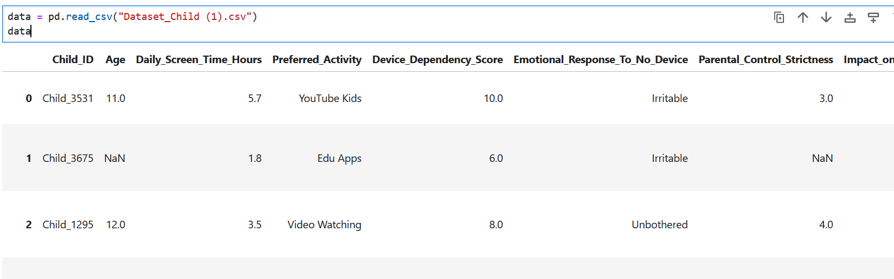
Then some basic operations were done to initially analyze the data with its features and rows such as:
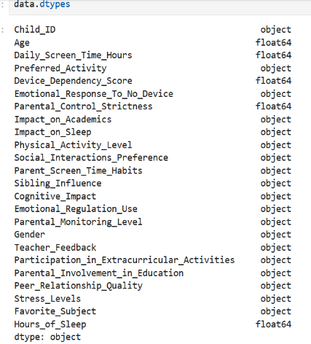
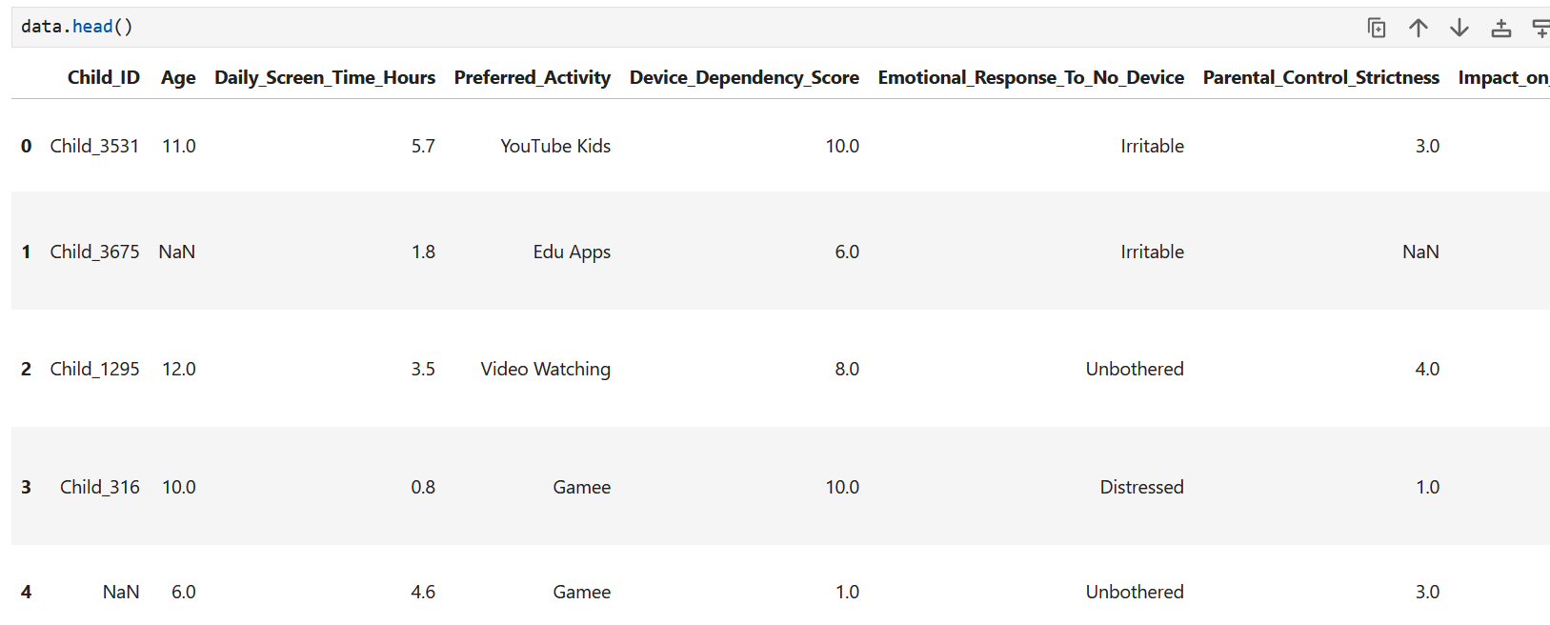
Head -> shows the first 5 rows of the data frame
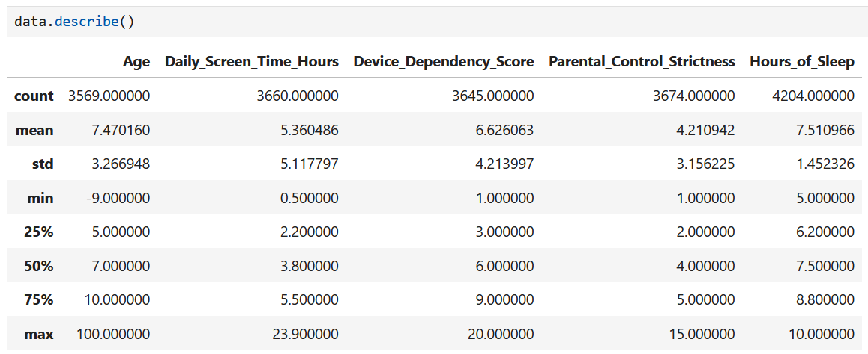
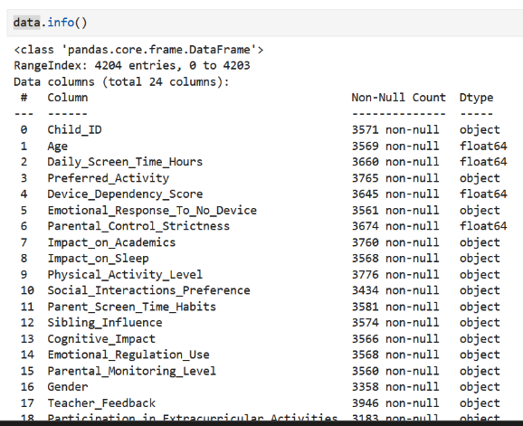
dtypes -> data types of columns (would be beneficial for encoding later)

info -> To check for the non-null values in data set
describe -> statistical overview of your numerical columns
After gaining some insights into the data set, now we can start cleaning. Starting with duplicates values
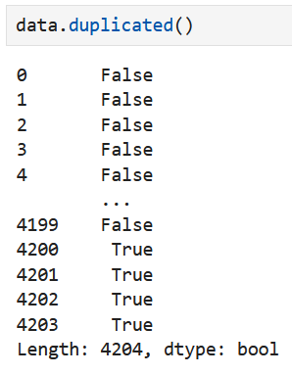
We can see that there are indeed some duplicate values. So, we drop them:
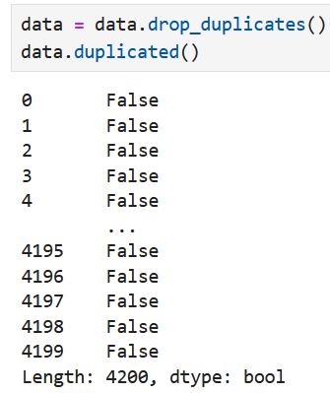
Now we need to check for the null values to start with the cleaning:
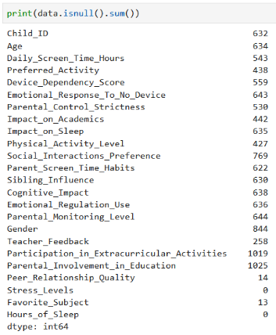
We can say that none of the features we have has more than its quarter null values due to that none of the features can be dropped.

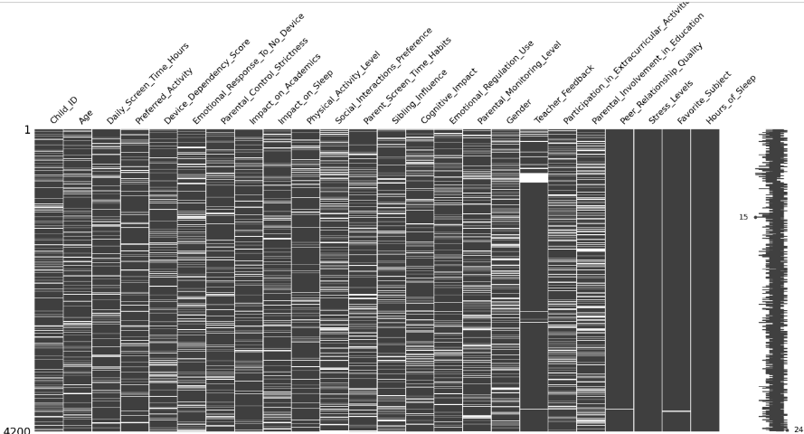

To have a better understanding of the null values we can import missingno library and create a figure to visualize the missing values. We can say that stress levels and hours of sleep are fully imputed. And peer relationship quality and favorite subjects are slightly full.
Handling inconsistencies:
This step is to identify and correct errors in a dataset which affects the quality and reliability of the analysis and correlations. Inconsistencies can be in mismatched formats and wrong spelling in categorical data. Addressing these inconsistencies is crucial for ensuring that the dataset is accurate and meaningful.
Starting with Gender column where inconsistencies were found in multiple ways like wrong spelling, F letter and unknown values. All these labels were handled only in two labels ‘Female’ and ‘Male’ by replacing the misspelled words. Null and unknown by using mode method to replace it with the most frequent one.
Why handling Gender null values in this way?
Due to its unsignificant impact relatively when seeing comparing it with other columns. It will simplify data cleaning to ensure consistency this will minimize impact on the overall analysis allowing focus on more important features.
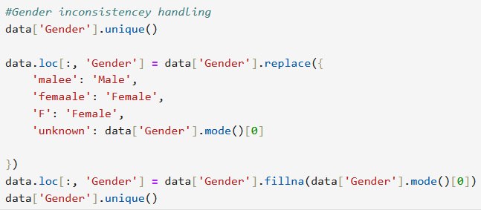
For the age column inconsistency values were checked if there are any values below or above the wanted range. These values then dropped
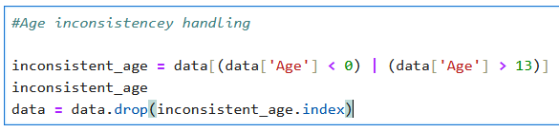
Then for the preferred activity feature inconsistency were checked and found the handled using replace function this will then help when we encode to then find correlation based on encoded labels with unique values.
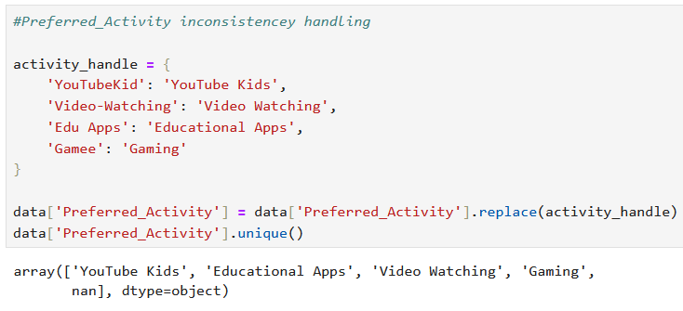

Teacher Feedback feature was handled using replace function too by filling the unclear data with no feedback and all null and no feedback assigned to one value only to limit labels to unique ones only.
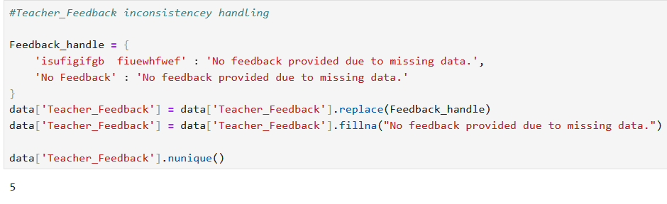
For impact on Academics and physical activity level inconsistency were found in two ways by misspelling and duplicate labels with same meaning. Misspelled labels were handled by replace function with the correct spelling. And for making labels unique for more accurate consistency by assigning "Negative" to "Low" and "Positive" to "High" this improves interpretability and allows for easier analysis especially when calculating correlations or training data into models.
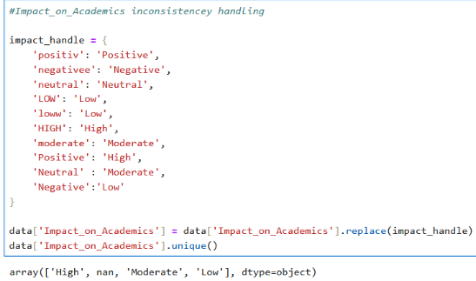
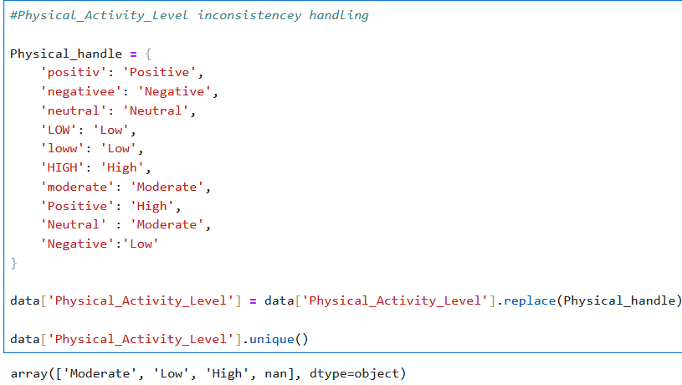
Also, Social interactions preference inconsistency handling by replacing the misspelled values with its correct spelling
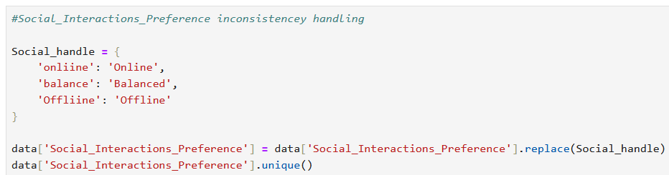
The feature Parent Screen Time Habits was handled by replacing the inconsistent value with np.nan (null value) this value is commonly used to represent missing values in datasets.
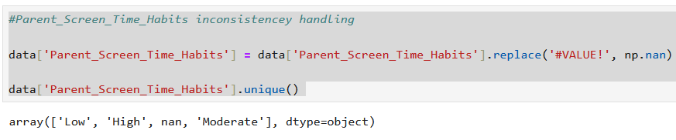
For the Child ID feature which is a unique value that doesn’t have a relation with any of the features in the data set it was handled uniquely and dependently. By going through all rows in the child ID column and using fillna to fill all null values with child_ + passing the row to a function where a new ID is generated by a random number generator and then checking if the generator number is already in the IDs list if so, it will sum it to one until finding a unique number.
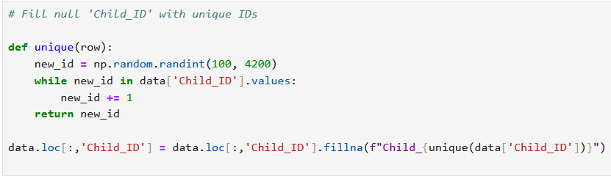
All other features were checked for any inconsistencies.
Correlation & Heatmap:
Now to check for relations between the features we need to find values of correlations and visualize them using heatmap to do so certain steps should be taken:
- import sklearn preprocessing library to do label encoding only on categorical features.
- I created a new data frame called data to copy the data frame (after inconsistency handling)
- Then I created a categorical column variable to save all columns in encoded_df with ‘Object’ datatypes (categorical). By this we will have a more affective encoding for more accurate analysis with all numerical values.
- Then a for loop is created to go through all categorical columns values to encode them all using label encoding with fit_transform function (imported from sklearn preprocessing) all saved inside the econded_df
- After encoding correlation has been calculated using corr function and save into encoded_correlation_matrix (all features had their correlation calculated not only the categorical since all features are now numeric)
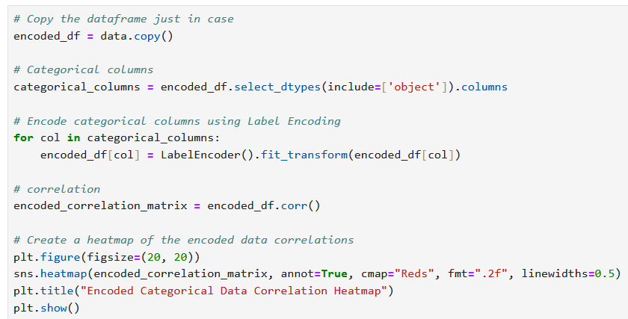
- Then a heatmap figure is created using seaborn library
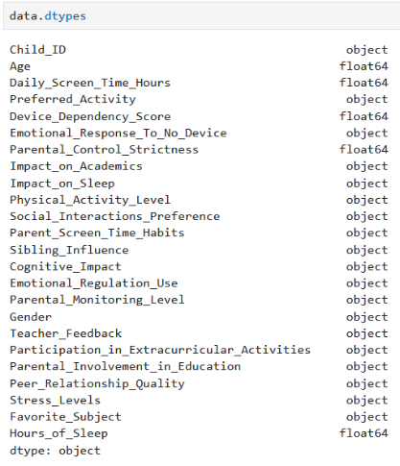
To know the categorical datatypes

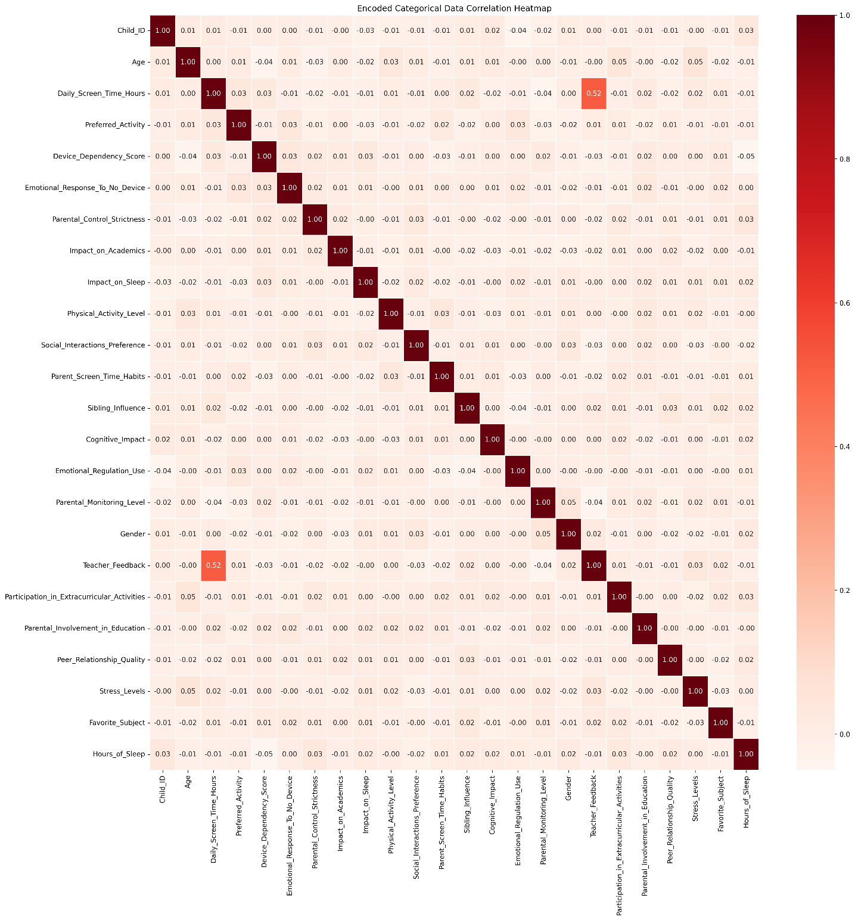
Correlation heatmap is a visual to show how strongly two features are in a dataset. It uses colors to represent the strength and direction of these relationships. Correlation tells us how two things are related. A positive correlation means that as one thing goes up, the other goes too. A negative correlation means that as one thing goes up, the other goes down too.
correlation values in the heatmap range from -1 to +1:
  - +1 perfect positive relation both features always move in the same direction.
  - 0 no relation
  - -1 perfect negative relation one features goes up while the other goes down
So, if we want to look at it as colors, we can say that the darker or lighter the color the stronger or weaker the relation is.
So based on the resalted heatmap we can say that the strongest relation in the dataset is between teacher feedback and daily screen time hours. And there isn’t any strong correlation between any other features.
Cleaning data based on correlations:
Starting with the stronger correlation which is between teacher feedback and daily screen time hours. First, I created a bar plot to help me visualize the distribution between both features
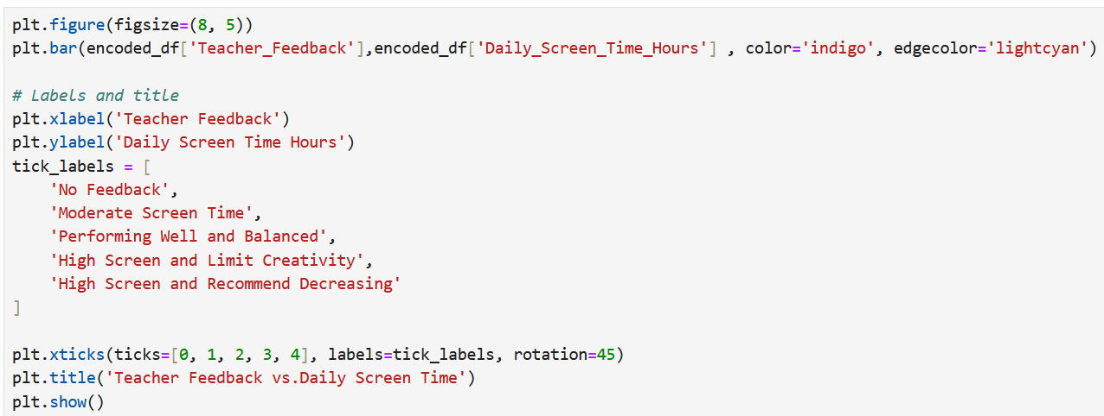
Note: labels were assigned manually by going back to before encoding data frame
We can see that the distribution makes sense that both high screen values have a higher screen time than the balanced and the moderate. So, filling in the missing data in daily screen time depending on the teacher’s feedback will be accurate.
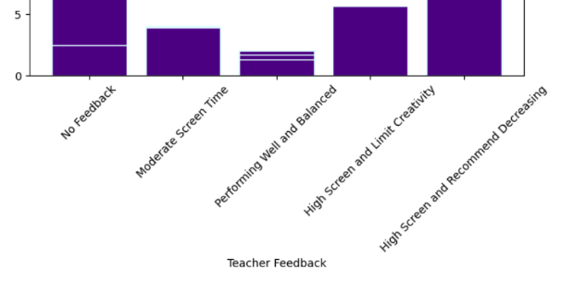
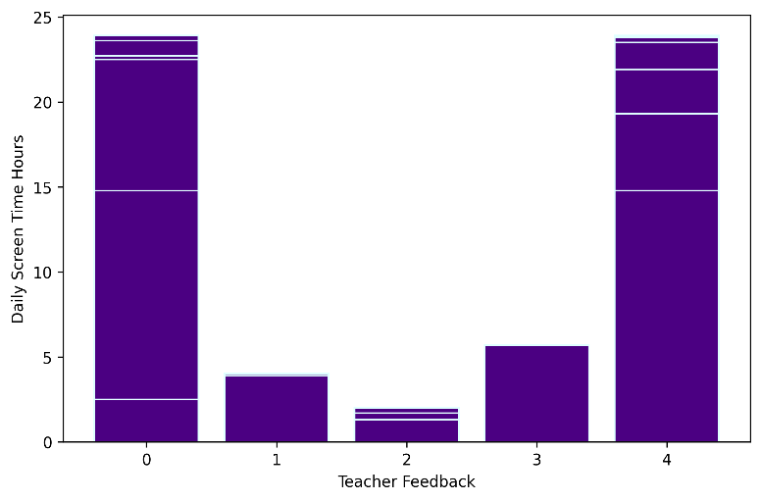
The method I used to fill the daily screen time null values is to visually capture the ranges of daily screen time of each teacher’s feedback and create a function inside fillna that has if statements of teacher feedback encoded values and then generate a random number between the ranges of daily screen time based on the teacher feedback. For example, encoded teacher feedback 4 which is “High screen and recommend decreasing” its daily screen time range is between 23 and 25.
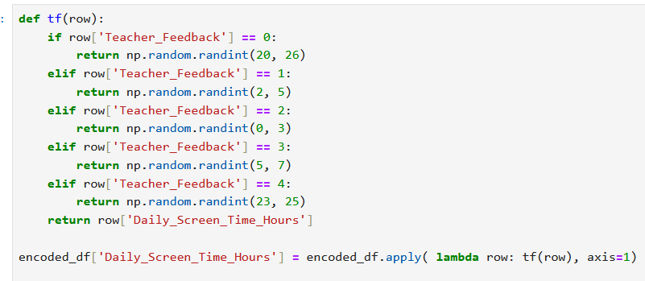
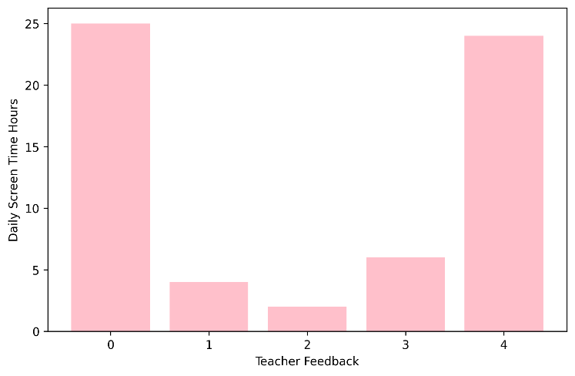
We can see that daily screen time is effectively filled since the distribution is very similar from what it was before cleaning. And does make since both high labels have more screen time ranges than the other labels

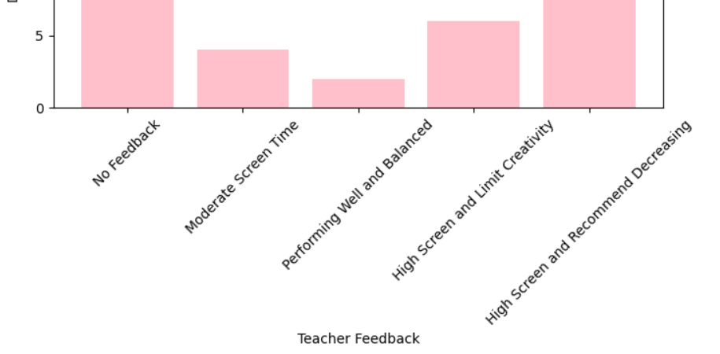

Now for the next correlation imputing is gender and impact on academics since gender is already filled. They both have very small correlation values but when visualizing it in seaborn plot we can see that there is a pattern. The countplot visualizes the distribution of Impact on Academics categories (High, Low, Moderate, Null) across Female and male. The x-axis represents the impact while y-axis shows the count of occurrences within each category. The plot allows us to compare how each gender is distributed across different levels of academic impact.
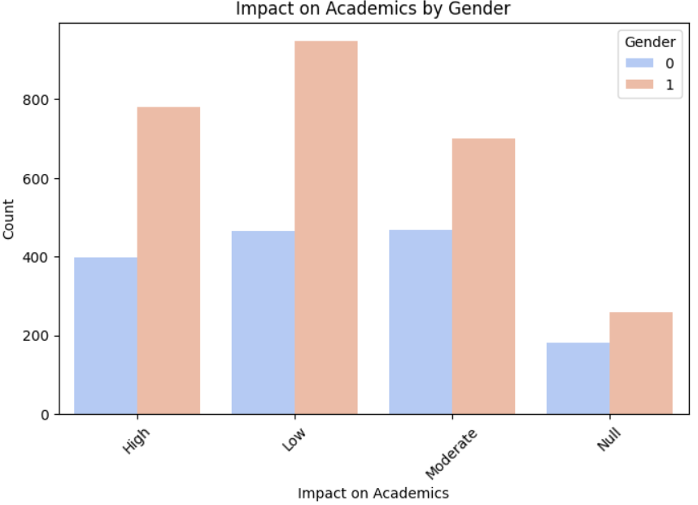
This code first uses groupby and agg() then calculates the most frequent value (mode) of Impact on Academics for each gender. Then, it updates the rows where Impact on Academics is 3 (null value checked manually) by replacing the value with the mode of that gender’s Impact on Academics this ensures filled null values with the most common impact value for each gender.
This bar plot is after cleaning we can see that the Impact on Academics categories are now more evenly distributed across Gender after cleaning. This means that the imputation of missing values did not disrupt the distribution, and the cleaned dataset reflects more consistency.
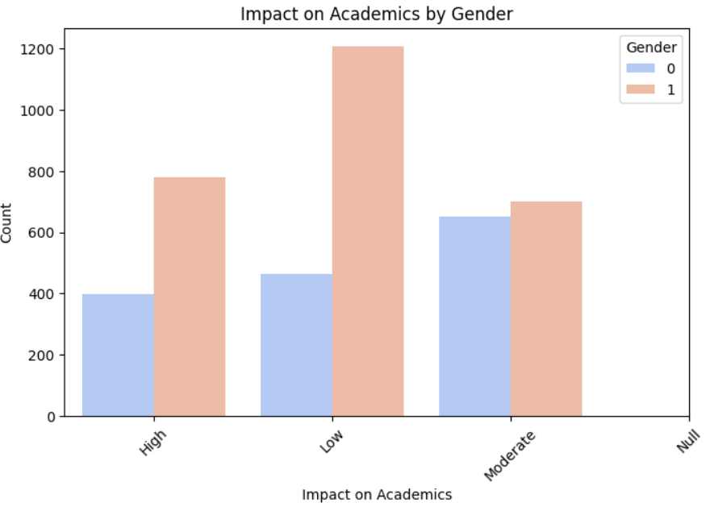
Since the correlation values are too low moving on to more into logical thinking by filling values of device dependency based on daily screen time. Dependency scores are filled by a function to assign a random score within ranges depending on daily screen time hours values (e.g., 1-5 for 6 hours or less). This makes sense because the dependency and daily screen time has positive and slightly higher than other correlation values.
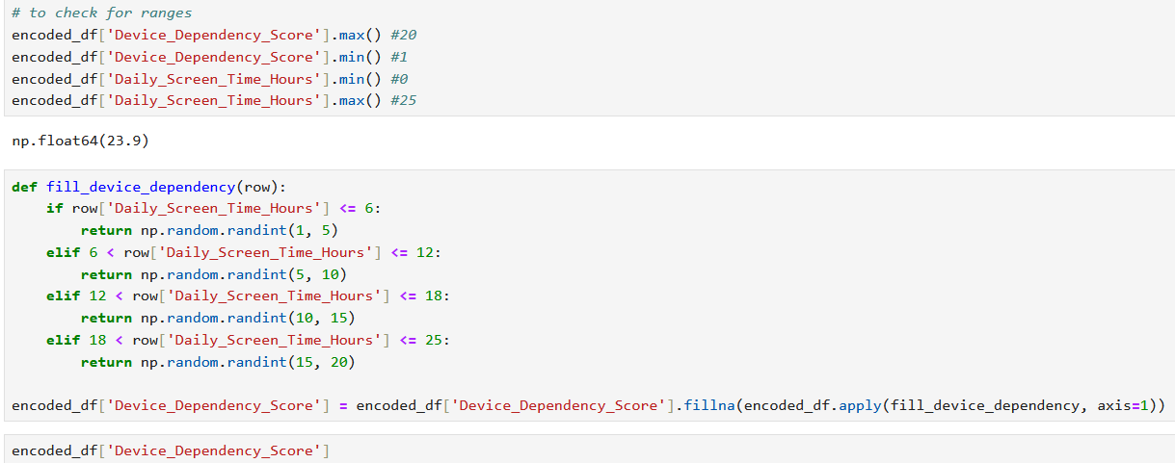

After that I imputed all positive and relatively higher correlation such as hours of sleep and parental control strictness and it does make sense because the stricter the parents are the earlier the kids get to bed and the more sleep they have. Also, Age is computed in the same way but depending on Stress level since the older the kid gets the more stressed, he gets due to school and other circumstances.
The first code fills missing values in the parental control strictness column by replacing them with the median value of parental control strictness for each hour of sleep group. The second block fills missing values in the Age by replacing them with the median value of Age for each stress levels group and both operations use fillna function along with.
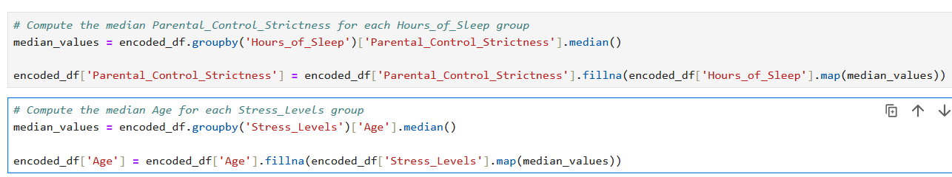
Calculates the most frequent (mode) preferred activity for each group of impact on academics. Then, it fills the missing preferred activity values (4 in null) by replacing them with the most common preferred activity corresponding to each impact on academics group done by using map() to assign the mode based on the group. Mode is used instead of median because it is categorical.
Finally, all other categorically encoded columns were filled using mode to their 3 encode values since I checked it manually and got that result.
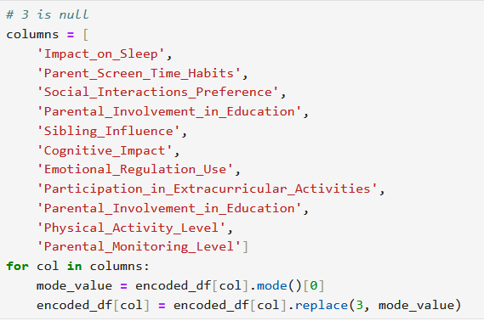

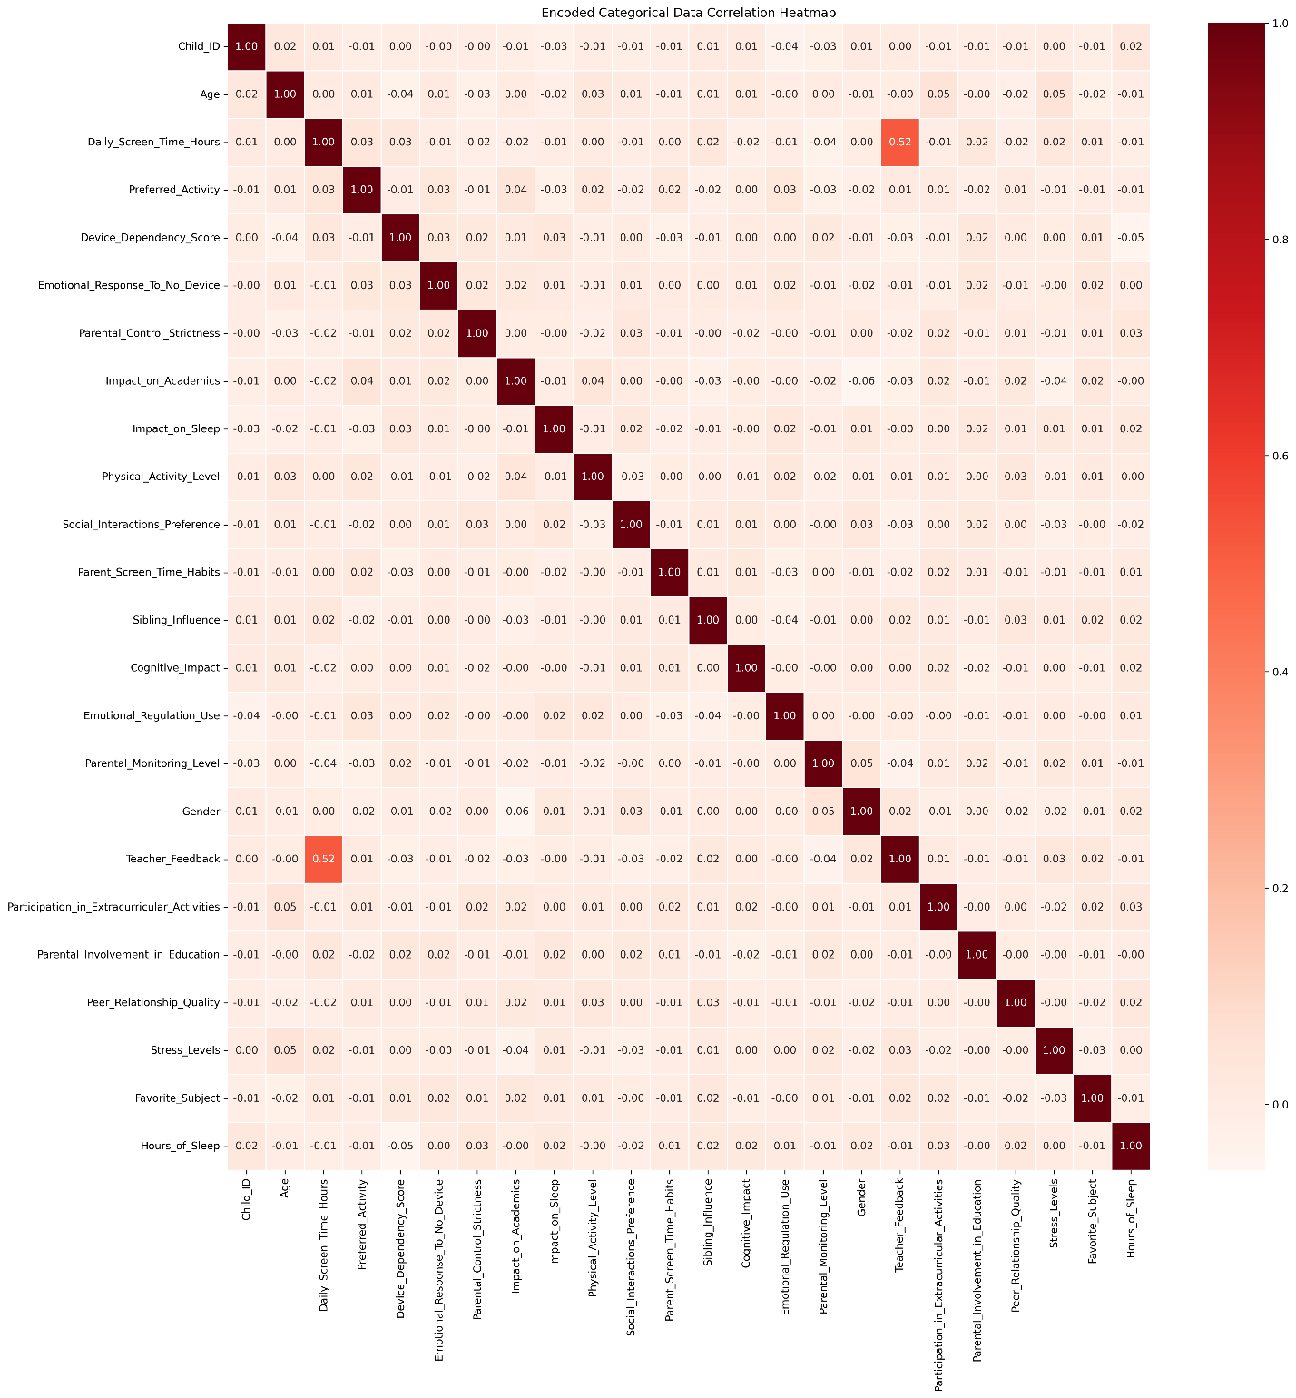
Heatmap after cleaning shows that the correlation between certain features has become stronger, meaning more consistent data. For example, the correlation between Teacher feedback and daily screen time increased significantly after cleaning. This means that the data cleaning process effectively reduced noise and filled missing values by consistency.

Data visualization
Age density before cleaning
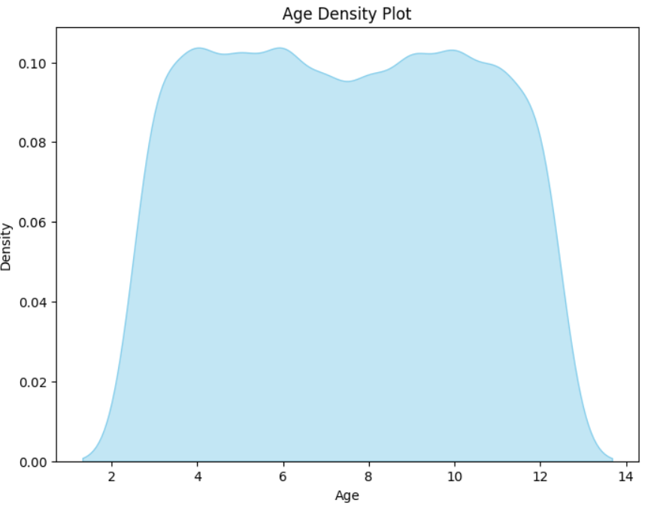
Age density after cleaning
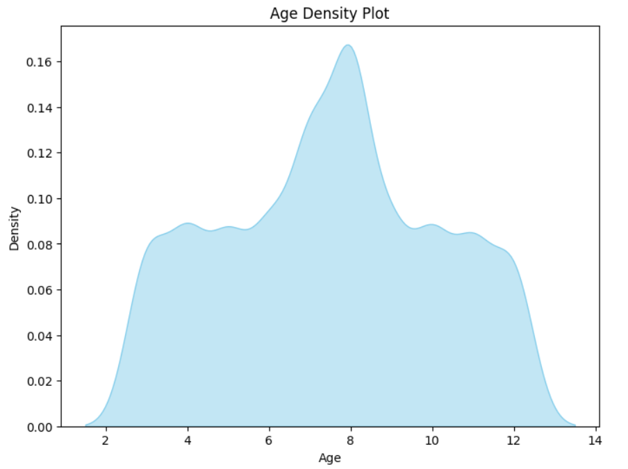
Before Cleaning The density plot peaks in specific age ranges (around 5 and 9) which shows gaps in certain age groups. After Cleaning the density plot appears much smoother with a relatively even spread across ages. This means that the cleaning process has filled the missing values balanced age range.

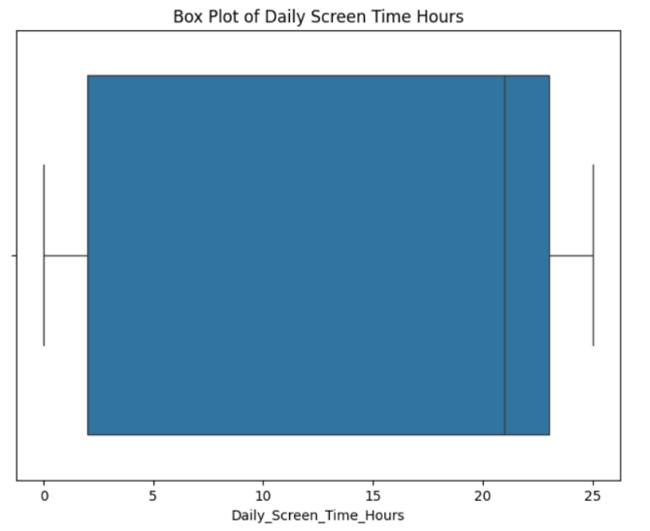
Before cleaning:
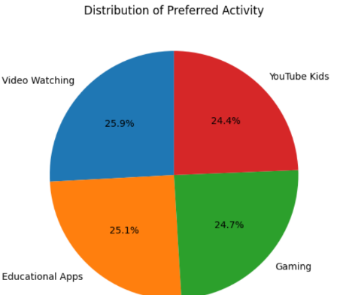
After cleaning:
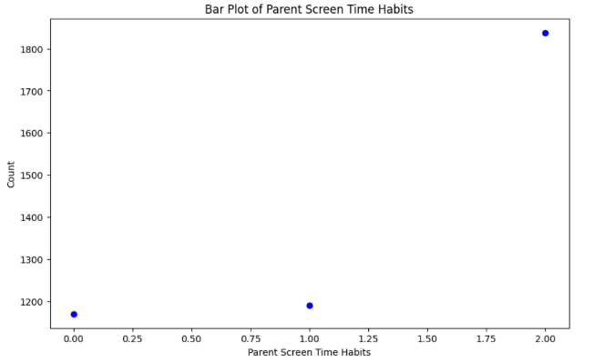
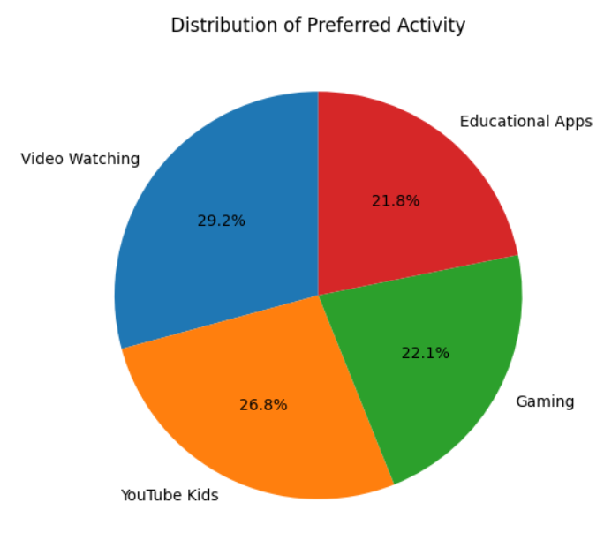

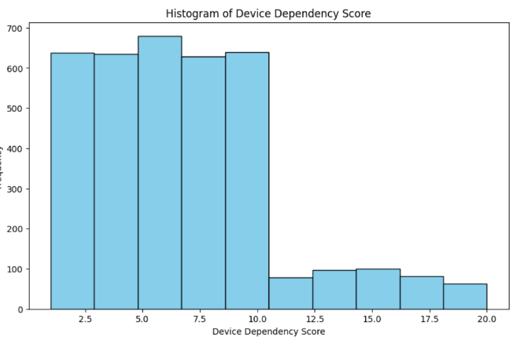
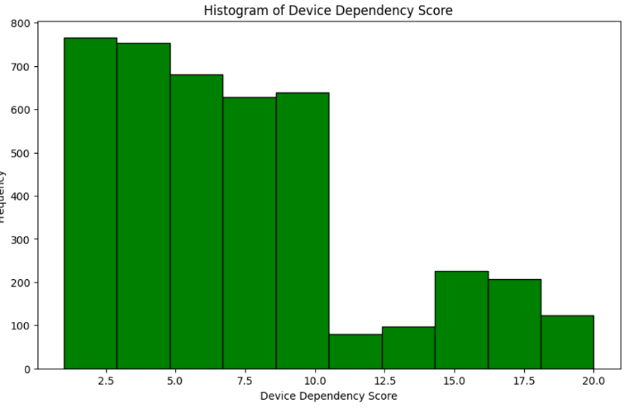
Before cleaning: After cleaning

Policy Impact:
After going through the data cleaning, we made sure to have a dataset free from inaccuracies that could lead to faulty conclusions. This prevents the risk of developing policies based on wrong data that could harm children. For instance, understanding how screen time is impacting academic outcomes to ensure that any policies from data driven decisions are benefiting children’s health and identify those who may be at greater risk for negative outcomes

