

Data Structures and Algorithms

Assignment Title
Implementing Data Structures and Algorithms to Solve
Real-World Problems

Submitted to
Dr. Anas Amaireh

Submitted by
Raghad Jaber 23110155
Table of Contents
1. Provide a design specification using class diagram for the used data structures, explaining their valid operations. The design should consider a set of different ADTs for each single feature. Naming; List, Stack, Queue, Trees (BST), and Graph. 3
2. Implement the solution in Java with a user menu and error handling. Explain use cases, justify your choice of ADTs, show how the system meets user needs, and list three benefits of using these ADTs. 5
3. Critically evaluate the complexity of each implemented algorithm and ADT in the proposed solution. 9
4. For feature #3, illustrate step by step in detail the implemented algorithms. 15
5. In reference to your solution, explain how information hiding and encapuslation helped you when using the implemented ADTs. Discuss with justification the view that ADTs are a basis for OOP 19
6. For each implemented feature using a selected ADT, interpret the trade-off with its alternatives in terms of time and space complexities for all valid operations, support your answer with examples. 20
References: 28

Provide a design specification using class diagram for the used data structures, explaining their valid operations. The design should consider a set of different ADTs for each single feature. Naming; List, Stack, Queue, Trees (BST), and Graph.
Feature | Data Structure & Algorithms | ADTs | Operations | Class diagram
Track lost/found record | Singly Linked  List | addFirst()  removeFirst()  searchBy  Description(keyword)  printList()  size() | Insert your lost item at the beginning.  Remove most recent added item.  Search for the item to look for it. After finding it the remove item is removed.  Print all lost items.  Return number of lost items. | 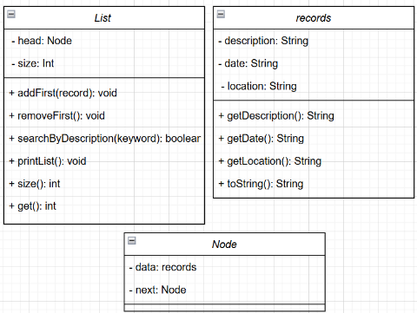
Room Booking | Array + Merge Sort (for sorting by academic year)  Since the priority for booking is based on the student’s academic year. The higher the academic year is, the higher the priority. | insert()  remove()  searchRoom(int roomNumber)  isFull() / isEmpty() | Add new booking  Remove the most recent booking  Check if a room is already booked and to see to whom it is booked by printing the student ID who booked it.  View all bookings, sorted by priority (academic year) using Merge Sort.  Check capacity and emptiness | 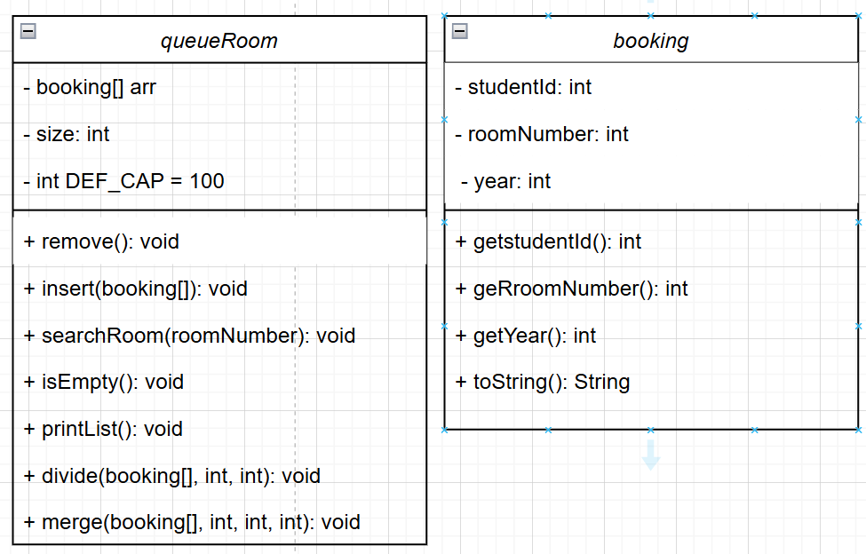
Student Orientation Help | Graph +  Dijkstra's Algorithm | addBuilding(id, name)  addEdge(src, dest, weight)  printGraph()  dijkstra(source) | Adds a new building to the campus graph.  Creates a directed edge (path) from one destination to another with a specific weight (distance/time).Displays the full campus map as a graph.  Runs Dijkstra's Algorithm to compute the shortest path from the source building to all other buildings and prints out the shortest distances. | 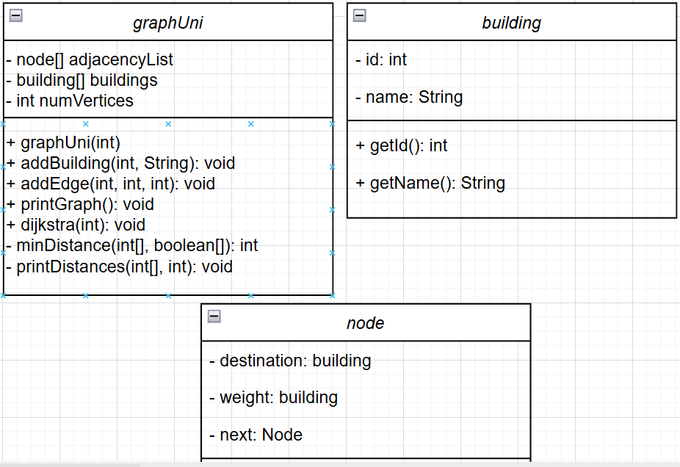
Undo/Redo Booking Operations | Stack | doAction(String action)  undo()  redo() printUndoRedoStatus() | Adds a new booking room operation to prepare the system for undo/redo functionality.  Pops (delete) the last action from the undo stack, pushes it to the redo stack, and prints out "undone."  Pops the last action from the redo stack, pushes it back to the undo stack, and reports it as "redone."  Prints contents of both undo and redo stacks for debugging or tracking history. | 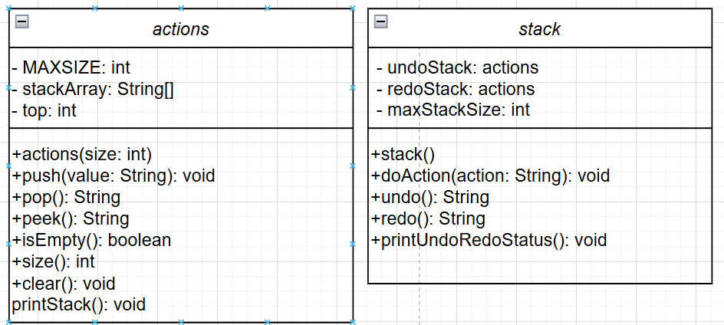
Event Participation Registration | Queue | enqueue(participant)  dequeue()  peek()  isEmpty()  printQueue() | Add a student to the queue.  Remove the latest registered student from the queue.  View the student at the front, latest registered student.  Check if the queue has no students.  Print all registered students. | 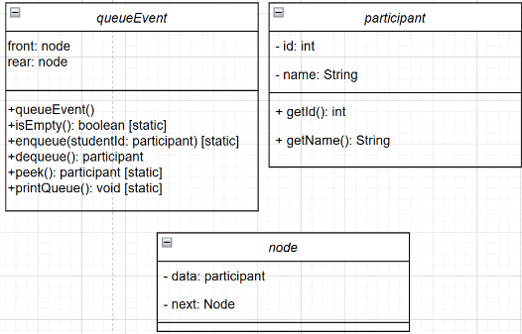
Student Locker Allocation | Binary Search Tree (BST) | insert(looking)  search(studentID)  remove(studentID)  printAll() | Reserve a locker based on Student ID.  Search for a locker using Student ID.  Remove a locker assignment by Student ID.  Display all locker assignments. | 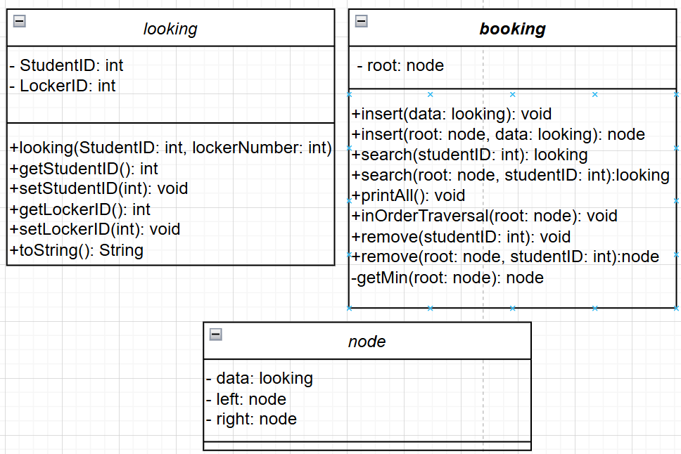

Implement the solution in Java with a user menu and error handling. Explain use cases, justify your choice of ADTs, show how the system meets user needs, and list three benefits of using these ADTs.
Java implementation of the campus management system included error handling in many ways such as:
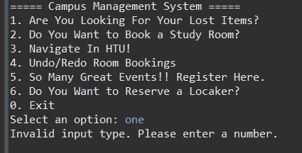
- Input type validation: by implementing a try and catch approach for the non-integer inputs (InputMismatchException)

- checking if the selected option is within bond of the menu
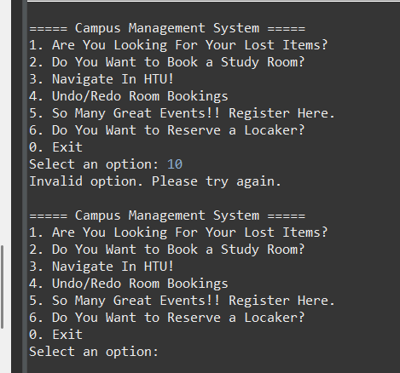

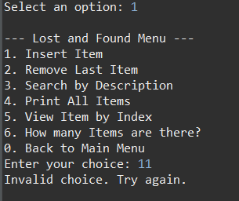
- Each feature has a default case to catch invalid choices. If the user enters an option not listed a “Invalid Choice statement will be displayed”.

Feature One “Track Lost/Found Records”,
Why Linked List ➝ it is used due to many features like its dynamic size allowing an easy insertion, deletion, and traverse of records. Another point is its efficiency and insertions and deletions, especially for frequent usage without the need for shifting elements as array lists require. And no need to have a fixed size since we don't know how many records we will have in the list.
Use cases ➝ there are multiple useful scenarios for this feature, when a student loses their card they submit a lost item record and added to the list or when a student finds a valuable item like a USP they can also report it to the list and when a student search for their lost items and find the item will be deleted after the owner finds it. Finally, the admin can oversee all found items by displaying them.
How It meets user needs ➝ this feature is useful since it provides an organized way for reporting and tracking lost found items also supports real time updates without the need to resize the system also maintaining order of submissions to help match the items efficiently.
Benefits and weaknesses➝ linked list or flexible so no need to redefine the size and efficiency when adding and removing records making it faster than arrays. Also, no memory is wasted since it allocates memory only as needed. On the other hand, linked list can be slower in search and no direct access can go through an element because it's indexed like the array in addition to its need for more memory per item for additional pointers pair node.
Feature Two “Room Booking”,
Why Array + Merge Sort ➝ array is a fixed size data structure this allowed us to store the fixed number of study rooms in the campus in a simple and indexable since it provides direct access to any element making it easy to retrieve update bookings. Additionally, because we have different priorities for students when booking rooms higher the academic year is the priority due to that sorting the requests is essential for efficient processing of bookings and notifying students by e-mail by administrators it is perfect for that allowing us for a seamless integration with merge sort to ensure quick organized access request.
Moreover, merge sort efficiently handles the growing number of requests and guarantees us consistent performance for real-time booking.
Use cases ➝ since the campus has limited number of study rooms and there are differ priorities for students (graduates or not) they can request booking A room by entering their ID broom number and academic year then the administrator will navigate through the sorted list to e-mail the student that they got the room.
How It meets user needs ➝ this implementation will ensure fair and efficient processing of requests also students get rooms based on their priorities to avoid conflicts and overriding of requests, easy navigation for the administrator when they process rooms as well as providing quick response time for students.
Benefits and weaknesses➝ arrays have many benefits like efficient memory and access, fixed memory usage, simple implementation, and can store various data types. On the other hand, memory wastage when not fully using the allocated memory, could be costly when inserting and deletion for middle position operations.
Merge sort also has many benefits like consistent sorting and performance, suitable for large datasets, Parallelizable meaning that her problems can be sorted independently, and predictable memory usage. On the other hand, it could have some limitations like it's needed for additional memory for temporary arrays which causes extra space, complex implementation, and high space cost.
Feature Three “Student Orientation Help”,
Why Graph + Dijkstra's Algorithm➝ Graphs are an ideal way to model a real-world campus layout in computer systems, representing each node as a building and connecting them using edges with weights to represent distances. Ensuring accurate navigation across campus. To compute the shortest path between buildings the gesture algorithm is ideal for that as it ensures students get to the fastest roads without exploring all paths. Making an accurate solution for navigation around campus.
Use cases ➝ during orientation day new students enter the university for the first time, so they can explore buildings and navigate through them in an efficient way.
How It meets user needs ➝ it provides guidance and clarity for new students, save time by helping students and instructors to arrive on time for lectures, flexible and user friendly, and gives user confidence when using the graph since the Castro algorithm ensures that the path is the shortest.
Benefits and weaknesses➝ graphs have many strengths like its representation model like a real-world systems, dynamic structure, path optimization making it extra useful for shortest path algorithms, and directional and weighted edges. However, it does have some limitations like high memory cost, complexity of implementation, and redundant edges which create waste.
The gesture algorithm also has many strengths as well like its efficiency with graphs also how it always produced this same result unlike other methods making it a guaranteed way of finding the shortest path. On the other hand, it Requires high time and memory complexity.
Feature Four “Undo/Redo Booking Operations”,
Why Stack ➝ since it follows last and first out principle which perfectly suits the undo redo operation a user can perform an action booking or cancelling A room the operation then is pushed onto the undo stack undoing an action pops the last action from the undo stack and pushing it onto the redo stack this will ensure that the recent action it's reserved first and redo can undo actions in the correct order making stocks the ideal data structure for tracking commands.
Use cases ➝ students can book a room and immediately cancel it and if they accidentally cancel it, they can quickly redo the cancellation. Admins can debug errors when booking operations and review history.
How It meets user needs ➝ it enables users to reverse accidental operations quickly and allow flexible navigation through action history which makes it a very reliable operation for making and changing bookings it also improves overall user experience by error correction and recovery without complexity.
Benefits and weaknesses➝ stack have many advantages like its LIFO efficiency, constant time operations, simplicity in implementation, and ease of memory management. Alternatively, it does have limited access to its elements as stacks are only accessible by their top element and no flexibility in order.
Feature Five “Event Participation Registration”,
Why Queue ➝ since its ADT is first in first out order allowing for a suitable implementation for event registrations to ensure that students are registered like a line. Students who registered first are served first and this will simplify managing registration flow, especially when spaces are limited.
Use cases ➝ for upcoming events students can register in a queue that mimics a real-life line. Admins can monitor registration in real time and check who's next in line (peek) also print full list of registered students in order.
How It meets user needs ➝ this implementation will ensure fairness by not skipping students by accident, transparency for admins when viewing and managing participants, fast registration, and clarity for students and admins to know who is next in line.
Benefits and weaknesses➝ Queue have many benefits, like FIFO order which ensures fairness add scheduling, efficient insertion/deletion with simple in enqueue/dequeue operations time complexity, and flexible size. However, queues have some limitations like slow random access for indices other than the front, and not suitable for all operations like searching.
Feature Six “Student Locker Allocation”
Why Binary Search Tree (BST) ➝ it is perfect for managing looker assignments since it enables efficient insertion, deletion, and search based on lockers’ IDs. Each student has one locker; this application will ensure one-to-one relation to map lockers perfectly. Administrators can manage hundreds of records without performance issues, especially for frequent operations like insertion and deletion. They would be handled efficiently without scanning the entire data set each time, which would be costly in the linear data structure. Moreover, BST will automatically sort records by student IDs eliminating the need for manual sorting implementation this will allow a clear consistent readable structure. It is also scalable and maintainable, making it a great choice for systems that may expand to ensure long-term performance.
Use cases ➝ students can assign lockers without overwriting an existing assignment it also immediately checks and prevents if the locker is already taken and search their locker number by their student ID while administrators can easily review assignments in a clear sorted list to manage availability.
How It meets user needs ➝ fast search, insertion, and deletion which helps admins manage lockers and guarantees that the locker is assigned to one student, automatic sorting by students ID.
Benefits and weaknesses➝BST have many benefits like efficiency, ordered structure, flexible size (dynamically grows), and efficient memory. However, it is complicated to implement and stores extra points which increase memory usage and could require extra logic like rotations to maintain balance.

Critically evaluate the complexity of each implemented algorithm and ADT in the proposed solution.
What is Time Complexity?
A fundamental concept in computer science which describes the runtime of an algorithm and how it grows as the size of the input increases. It is represented using big O notation which describes the upper bound on the growth rate of an algorithm running time relatively to its input.
Time complexity is important due to many reasons such as evaluating the performance by estimating how the algorithm performs as input increases. It is also used to compare algorithms to see which the best approach is to solve a problem. And to determine if this solution would work on larger data sets. This will guide developers into choosing the best algorithms.
Types of time complexity (Best to worst):
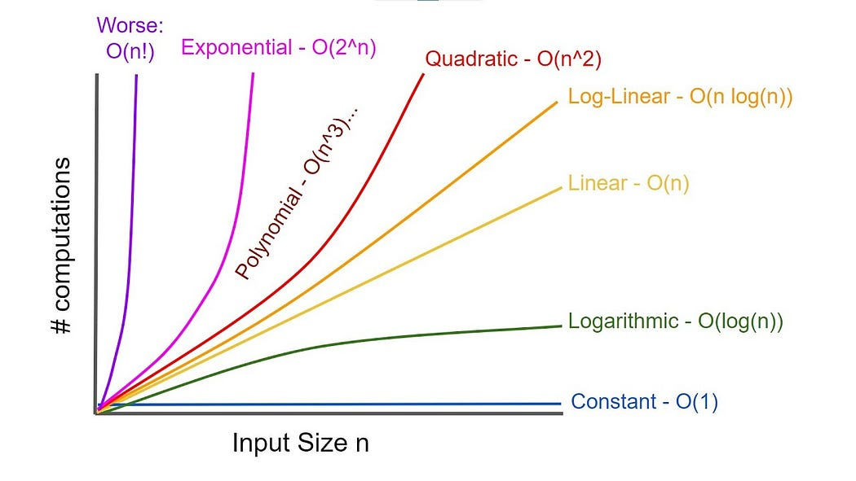
- Constant Time O (1) - runtime does not change as input size changes
- Logarithmic Time O (log n) - runtime grows logarithmically (slowly) with input size
- Linear Time O(n) - runtime grows proportionally with input size
- Linearithmic Time O (n log n) - between linear and quadratic
- Quadratic Time O(n²) - runtime increases proportionally to the square of the input size
- Exponential Time O(2ⁿ) - runtime doubles with each additional input
- Factorial Time O(n!) - runtime growth factorially with input size
Feature One “Lost/found record”,
Operations of LinkedList | Time Complexity |  |  | Discussion
Operations of LinkedList | Best | Average | Worst | Discussion
Add First (addFirst) | O (1) | O (1) | O (1) | I chose addFirst over addLast because it offers constant time efficiency O (1) for insertion since it adds the new node directly at the beginning without traversing (only updates the head). Unlike addLast which requires linear time O(n) due to traversal.
Remove First (removeFirst) | O (1) | O (1) | O (1) | I chose removeFirst over removeLast because it offers constant time efficiency O (1) for deletion since it deletes the latest added node directly at the beginning without traversing (only updates the head). Unlike addLast which requires linear time O(n) due to traversal.
Search by Description (searchByDescription) | O (1) | O (n) | O (n) | Best case: match at head without traversal.  Worst & Average case: keyword not found, so we need to travers.
Print List (printList) | O (1) | O (n) | O (n) | Best case: only to print the first element (head) no need for traversal.  Worst & Average case: Needs to traverse the list to print all elements either fully or not.
Size (size) | O (1) | O (1) | O (1) | Size is tracked with a counter, so it’s returned directly.
Feature Two “Room Booking”,
Operations of ArrayList & Merge Sort Algorithm | Time Complexity |  |  | Discussion
Operations of ArrayList & Merge Sort Algorithm | Best | Average | Worst | Discussion
Insert(booking booking) | O(1) | O(1) | O(1) | Add a booking at the end of the array in constant time if not full. Since it directly places the last index by the size tracker and increments it without the need to shift any elements and since the array has a fixed capacity there is no need for dynamic resizing which requires O(n) operation.
remove() | O(1) | O(1) | O(1) | Remove the last booking in constant time. Since it decreases the size variable without shifting any other elements.
searchRoom(int roomNumber) | O(1) | O(n) | O(n) | Best case: if the room is found at index 0.  Worst & Averege case: since it scans some or all elements.
divide | O(n log n) | O(n log n) | O(n log n) | Recursively divides the array into halves until base cases, resulting in log n recursive levels with n operations each.
merge | O(n) | O(n) | O(n) | Merges two sorted subarrays in linear time relative to the number of elements being merged.
printList | O(n log n) | O(n log n) | O(n log n) | Calls divide() to sort the array before printing all elements, so overall merge sort complexity dominates.
isFull() | O(1) | O(1) | O(1) | Simply check if the size equals the array length.
isEmpty() | O(1) | O(1) | O(1) | Returns true if size is zero. Constant-time check.
Feature Three “Student Orientation Help”,
Operations of Graph & Dijkstra Algorithm | Time Complexity |  |  | Discussion
Operations of Graph & Dijkstra Algorithm | Best | Average | Worst | Discussion
addBuilding(id, name) | O(1) | O(1) | O(1) | assigning a building object by updating the pointer of the node no need for traverse so Constant time.
addEdge(src, dest, weight) | O(1) | O(n) | O(n) | Best case: by only checking the first node of the adjacency list to find it at index node this happens with the list is empty so you don't have to traverse to any other edges.  Average & Worst case: Adding an edge involves traversing the adjacency list for the source node. traverses all nodes to append when finding null. (n = number of edges)
PrintGraph() | O(V +E ) | O(V + E) | O(V + E) | To print the graph you need to visit all vertex and edges so V (number of buildings) + E (number of vertex)
dijkstra(source) | O(V²) | O(V²) | O(V²) | the algorithm is done by implementing nested loop.
minDistance() | O(V) | O(V) | O(V) | the function is looping around the vertices to find the minimum distance

Feature Four “Undo/Redo Booking”,
Operations of Stack | Time Complexity |  |  | Discussion
Operations of Stack | Best | Average | Worst | Discussion
push() | O(1) | O(1) | O(1) | Adding an element at the top is done by incrementing the top and assigning value without the need to go through elements which will only require constant time.
pop() | O(1) | O(1) | O(1) | Removing the top element by decrementing top without the need to go through elements which will only require constant time.
peek() | O(1) | O(1) | O(1) | Accessing the top element without removing it without the need to go through elements which will only require constant time.
isEmpty() | O(1) | O(1) | O(1) | Checking if top is -1.
size() | O(1) | O(1) | O(1) | Returns top + 1.
clear() | O(1) | O(1) | O(1) | Resetting top to -1.
printStack() | O(n) | O(n) | O(n) | Prints all elements from top to bottom which requires linear time proportional to the number of elements.
Feature Five “Event Participation Registration”,
Operations of Queue | Time Complexity |  |  | Discussion
Operations of Queue | Best | Average | Worst | Discussion
enqueue() | O(1) | O(1) | O(1) | Inserts at the rear (last element) using a pointer, which is a constant-time operation since it doesn’t require traversal.
dequeue() | O(1) | O(1) | O(1) | Remove from the front (first element) by updating a pointer which is a constant-time operation since it doesn’t require traversal.
peek() | O(1) | O(1) | O(1) | Accessing the front of the queue directly.
isEmpty() | O(1) | O(1) | O(1) | Checks if the front pointer is null.
printQueue() | O(1) | O(n) | O(n) | Best case: only print peek.  Worst & Average case: Traverses the entire queue to print each participant or some of them.
Feature Six “Student Locker Allocation”,
Operations of Binary Search Tree | Time Complexity |  |  | Discussion
Operations of Binary Search Tree | Best | Average | Worst | Discussion
insert() | O(log n) | O(log n) | O(n) | A balanced tree is a binary tree where nodes are arranged so that the depth of only two leaf nodes defer to maximum one.  Best & Average case: If the tree is balanced the insertion process will go as traversing from the root to the leaf and comparing these results to O (log n) complexity since each level eliminates about half of the nodes.  Worst case: if the tree in unbalanced insertion must check every node from root to the last.
search() | O(log n) | O(log n) | O(n) | Best & Average case: if the tree is balanced the process will be done recursively by eliminating the tree based on comparison, going to the left if the target is smaller or right if larger  Worst case: if the tree is unbalanced, the search will be by traversing in all nodes
remove() | O(log n) | O(log n) | O(n) | Best & Average case: when the tree is traversed recursively to find the target node and eliminating subtree based on comparison going left if the target is smaller and right if larger  Worst case: if tree is unbalanced removal will be by traversing around all elements
inOrderTraversal() | O(n) | O(n) | O(n) | Visits every node exactly once to maintain left right order, it doesn't matter if the tree is balanced or not as it performs a constant amount of operations.
getMin() | O(log n) | O(log n) | O(n) | Best & Average case: if the tree is balanced, we only have to go to the left to find the minimum nod sense the left side is the minimum operations  Worst case: if the tree is unbalanced, we will have to traverse all nodes

For feature #3, illustrate step by step in detail the implemented algorithms.
The shortest path algorithms are methods to find the most efficient routes between nodes in a graph with weighted edges.
Algorithm 1: Dijkstra Algorithm
because her algorithm is one of these algorithms which calculate the minimum distance from a starting nod to all the other and selecting the closest node. It is implemented with graphs with non-negative weights used in multiple applications like GPS navigation, network routing, and logistics such as time travel and cost.
Dijkstra Algorithm in detail:
Note: to Represent the Campus Graph
Nodes = buildings
Edges = paths between buildings
Weights = distance/time between buildings
- Dist[] -> To store shortest distances from the source to every vertex (building)
sptSet[] -> To keep track of which vertex has been finalized or shortest path of that reference has been found.
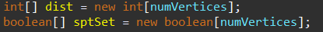
- Set all distances to Infinity (Using Max value to represent a large number) since we assumed that we can't reach any vertex and sptSet[] to ensure that no vertex has been found yet.
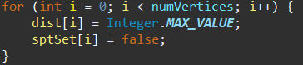
- To ensure that distance from the source to itself is 0
- Main loop to find shortest paths for all Vertices by running a loop numVertices -1 times.
Which calls the helper method minimum distance vertex to help with finding in minimum distance from the source you is B smallest distance that has not been finalized yet after finding the minimum distance using the method minDistance u is then marked as true to ensure that it has been found.
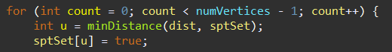
minDistance helper method goes through all vertex and returns the index of the vertex that has the smallest distance value (dist[v]) and not been finalized (!sptSet[v])
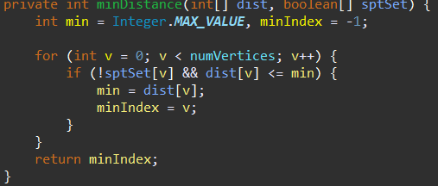
- Then iterate through all neighbors (connected buildings) of the current building u. And adjacencyList[u] which saves linked list of neighbors for building u.
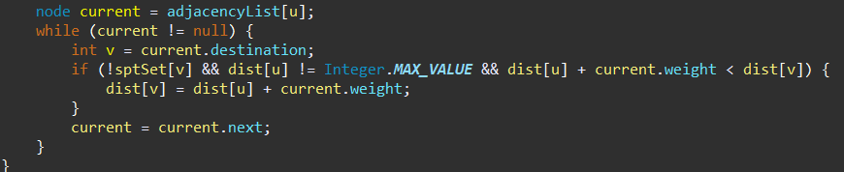
By intializing the index of the neighbor vertex (v) whick is connected to the current vertex u. current.destination is the connected buildings connected to u by an edge all saved in the adjacency list. If the statement checks if the shortest path to v has been visited yet it only updates the distance to vertices that are connected. To ensure that u are reachable. If dist[u] is still infinity, it means there’s no path to u, so we can’t use it to reach v. This is the core of Dijkstra’s update: it checks going from the source to u, and then to v, is shorter than the currently known shortest path to v dist[u] + current.weight calculates the new possible distance to v through u. If it’s less than the current value of dist[v], we’ve found a shorter and better path. we update the distance in the dist[] array to the new shorter distance.
- Move to Next Neighbor Repeat the same edge relaxation check (i.e., is there a shorter path through u?) for every neighbor v of u.
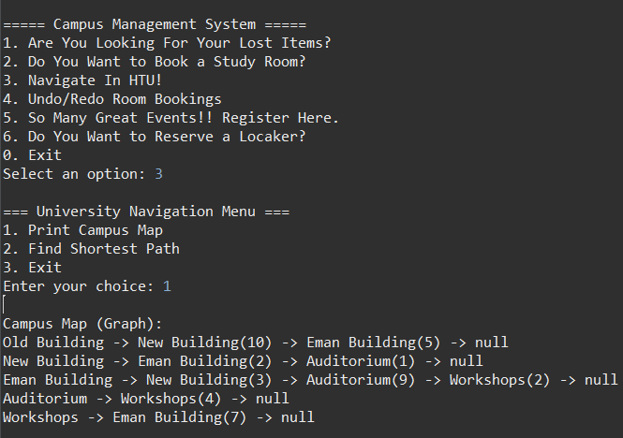
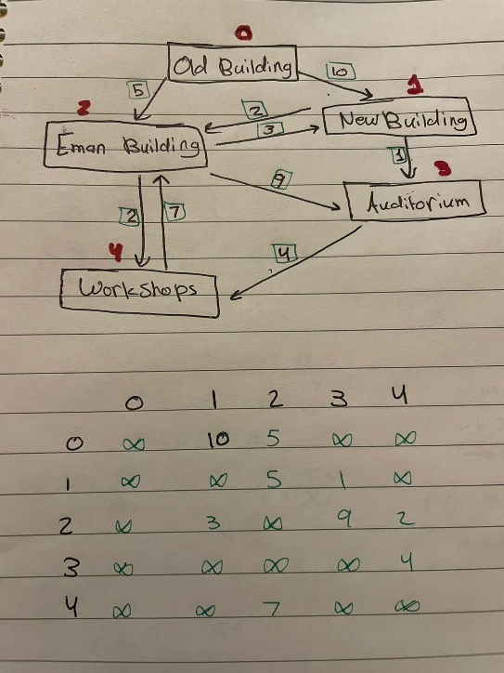

After analyzing the code, we can see how simple Dijkstra is in terms of implementation. And with the step-by-step drawing, we can analyze each and think what is the shortest path to navigate and to get to it as we can see in the drawing each building has a number from zero to 4 and weighted vertex as destinations. For instance, let's measure the shortest path of the old building (0) to all other buildings:
- From 0 to 1:
  - Direct path: 0→1 (weight 10)
  - Alternative path: 0→2→1 (weight 5 + 3 = 8)
  - Shortest path: 0→2→1 (total weight 8)
- From 0 to 2:
  - Direct path: 0→2 (weight 5)
  - Shortest path: 0→2 (weight 5)
- From 0 to 3:
  - Path 1: 0→1→3 (10 + 1 = 11)
  - Path 2: 0→2→1→3 (5 + 3 + 1 = 9)
  - Path 3: 0→2→3 (5 + 9 = 14)
  - Shortest path: 0→2→1→3 (total weight 9)
- From 0 to 4:
  - Path 1: 0→2→4 (5 + 2 = 7)
  - Path 2: 0→2→1→3→4 (5 + 3 + 1 + 4 = 13)
  - Path 3: 0→1→3→4 (10 + 1 + 4 = 15)
  - Shortest path: 0→2→4 (total weight 7)
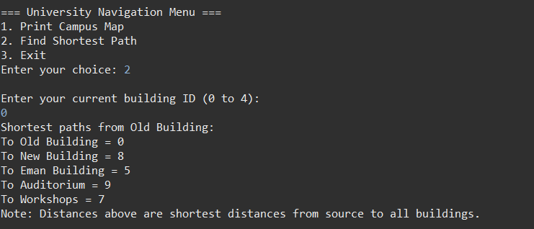
This is the mechanism of measuring the shortest distance in Dijkstra algorithm.
Algorithm 2: Bellman-Ford Algorithm
This algorithm also aims to find the shortest path between source vertex and all other vertices in a weighted graph. What makes it unique is it deals with negative edge weights.
To implement it as a Java program the growth is built using edges to connect two nodes together with certain weights then the algorithm will first set all distances to a large value Infinity except for the source which is set to 0 then it repeats the process of updating the shortest distances through each edge multiple times then it checks if there are any circuits to keep measuring distances to give the smallest one making a negative cycle possible.
During iterations in this algorithm we do relaxing of vertex which is we guessed that all vertices R Infinity and then we navigate through all the paths and see which one is the shortest one and then we update the distance and we keep doing this for all paths until there is no more changes.
Evaluation of both shortest path algorithms:
Aspect | Dijkstra | Bellman-Ford
Edge Weights | Only non-negative | Can handle negative weights
Speed | Faster (O(V²) | Slower (O(V×E))
Negative Cycle Check | No | Yes
Use Case | Real-time, standard routing | Accessibility-based or complex routing
Complexity in Code | Simpler | More complex

We can see that the Dijkstra and Bellman-Ford are both great algorithms for shortest path but considering our scenario of campus navigation system we have nonnegative distances meaning that Dijkstra is perfectly suitable for this approach. It is also faster with time complexity of O(V²) compared to bellman being slower with O(V×E) runtime. Also, it is much simpler to implement it and manage it therefore for real time and efficient navigation of a university campus.

In reference to your solution, explain how information hiding and encapsulation helped you when using the implemented ADTs. Discuss with justification the view that ADTs are a basis for OOP
Core principles of object-oriented programming are encapsulation, abstraction, inheritance, and polymorphism. These concepts deeply align with the design and management of abstract data types (ADTs) to maintain a secure code.
Encapsulation is one of the four fundamentals of OOP concepts Which restrict direct access to some objects components basic principles are that's a hiding, accessing by methods, and to control data. This is significantly important for ADT's since it protects the internal data structure and makes implementation interchangeable, for example changing between data structures like linked list and array in a certain class users won't need to change their codes. To reflect that into my implementation in the graphUni class attributes like adjacencyList, buildings, and numVertices were kept private Ensuring a well-defined interface and allowing for interactions with these attributes by public methods like ddBuilding(), addEdge(), printGraph(), and dijkstra(). Similarly for location class only the methods insert(), remove(), and search() are exposed for public use hiding internal BST traversal logic from the main application.
Additionally, abstraction is hiding complex implementation details and showing only essential high-level features for an object to provide a simplified interface for users. This is also an important concept for ADT's since they focus on what the operation does rather than the actual implementation and maintain constant interface even when internal changes happen. Reflecting on my code in stack class in undoRedoMenu() provides actions like doAction(), undo(), and redo() without exposing how actions are stored.
These two OP principles are the most perfect for ADT since the nature of them is high level operations and keep the low level privately into the class to ensure secure user-friendly interactions and smooth operation Consistent interfaces without any changes to the user if it occurs.
On the other hand, when a class inherits properties from other class which is the parent class, polymorphism has an object in different classes with multiple implementations. These concepts are very useful when it comes to Java OOP projects but for ADT usage. Since they are designed for defining operations not to create shared behaviors across different types so each ADT like stack or queue has its own interface and behavior trying to force inheritance between them will lead to unsatisfying outcomes, for instance if a stack subclass of its list introduces methods like insert at a certain index will break the stack model ADT. Additionally, polymorphism will introduce runtime overhead and complexity which is undesirable for data structure implementation. Sharing a common interface which is the core idea of polymorphism, is not a core idea for ADT's since we're looking for specific operations so it could blur the distinct behavior of these ADTs.

For each implemented feature using a selected ADT, interpret the trade-off with its alternatives in terms of time and space complexities for all valid operations, support your answer with examples.
Operation | LinkedList | Dynamic Array | Fixed Array
Add new lost item at beginning | O(1) | O(n) (shift) | O(n) if not full, shift elements.  Can’t operate if full
Remove first found item | O(1) | O(n) (shift) | O(n)
Search by description | O(n) | O(n) | O(n)
Access to a certain record (not used in my system) | O(n) | O(1) | O(1)
Insert in the middle (not used in my application) | O(n) (traverse) | O(n) (shift) | O(n) (shift)
Space Complexity | O(n) | O(n) | O(n)
Feature One “Lost/found record”,
Linked lists are known for their dynamic size without predefined capacity, making it suitable for the implementation of this feature since we don't know the number of records and can change frequently. Unlike fixed size array which require allocating a certain memory which could possibly waste space. Also linked lists excel at insertion and deletions since they only require updating pointers unlike arrays which will require shifting in both fixed and dynamic. For instance, removing the first record in an array would require shifting all other elements to fill the gap making it O(n) complexity whereas in linked list you can simply just change one pointer (head) with complexity O(1). When speaking about space complexity dynamic arrays will require resizing and copying all elements to the new larger one while linked list will never need to resize every node is assigned independently making memory usage only when needed. However, linked lists use more memory due to storing pointers hints and tail, this trade off its worth in some scenarios were flexibility and efficiency in insertion and deletion is more critical than tight memory.
Feature Two “Room Booking” Using LinkedList,
Operation | LinkedList | Dynamic Array | Fixed Array
Access by index | O(n) | O(1) | O(1)
Insert at end | O(1) (w/ tail),  O(n) w/o | O(1) if space available  O(n) if resize | O(1) if space available
Insert at position | O(n) | O(n) | O(n)
Remove by index | O(n) | O(n) | O(n)
Search by value | O(n) | O(n) | O(n)
Space Complexity | O(n) | O(n) | O(1) predefined size

For room booking features I think this is the most practical data structure because of its predictable memory usage and excellent performance in real time operations and integration with other algorithms like sorting algorithms. In the campus study rooms are fixed variable so using a fixed array with space complexity of O(1) will ensure memory management and efficiency and like linked list and dynamic arrays were very quiet O(n) space complexity with additional memory usage like head and pointer for node storage and resizing. With fixed array accessing a certain index for checking and updating a status for a specific study room with require O(1) time complexity (e.g., Room[5] = "Taken By student with ID 5") insertion is done at the end of the array with a constant time complexity sense inserting at the certain position or remove by index are not relative for this kind of context since bookings follow a sequential pattern making movements and deletion an important since it is managed by the administrator. For search which is an important operation in this feature it should be fast so with time complexity O(n) to all data structures fixed energy is still the best choice for faster approach with better performance and supporting for other advanced algorithms with a straightforward logic.
Sorting Algorithms Using Merge Sort,
 | Selection Sort | Merge Sort | Binary Sort
Time Complexity (Best) | O(n²) | O(n log n) | O(n log n)
Time Complexity (Average) | O(n²) | O(n log n) | O(n²)
Time Complexity (Worst) | O(n²) | O(n log n) | O(n²)
Space Complexity | O(1) (in-place) | O(n) (needs auxiliary array) | O(1) (in-place)
miss sort follows divide and conquer strategy which breaks the input list into smaller subsets and sort them in independently after that it merges the sorted subarrays producing the final sorted array this approach will guarantee a constant time complexity of O (n log n) for all best average and worst cases. This approach makes sorting stable and predictable regardless of the input, making it a constant choice for sorting. Also, it requires additional space O(n) depending on the input its ability to handle large datasets efficiently with stability, which makes it an effective approach for this feature since we can't predict the dataset so no matter if the data set gets larger it will still have a stable performance. On the other hand selection sort has a time complexity of O(n²) (worst time complexity than merge sort) add space complexity of O (1) (better space complexity than merge sort) but it performs poorly on large datasets since it needs to scan the entire unsorted portion in every iteration making it unsuitable for unpredictable sizes of data set which we have in this feature. Moreover, binary sort has best case time complexity of O(n log n) if the input is nearly sorted fewer shifts are required. But for the worst and average case time complexity O(n²) because inserting an element will require shifting all the other elements. Binary sort has space complexity O(1). All in all merge sort will require extra space than other sorting algorithm but in addition to this trade off it is still a stable, recursive, and, divide and conquer approach making it suitable for real time applications and maintain consistent performance for whatever input is there which will enhance the user experience by increasing scalability, performance and eliminates conflicts of priority in bookings.
Feature Three “Student Orientation Help” Using Graph by Linked List,
Operation | Graph by Linked List (Adjacency List) | Graph by Array (Adjacency Matrix)
Space Complexity | O(V + E) | O(V²)
Insert Edge | O(1) | O(1)
Remove Edge | O(k) k = number of neighbors | O(1)
Search Edge | O(k) | O(1)
Get All Neighbors | O(k) | O(V)
in graph data structure we have multiple fundamental attributes like vertices V (buildings in this scenario), E representing number of edges which are paths between buildings, K the number of neighbors or connections from vertex to another. Using Adjacency List implementation using linked list each vertex stores a list of its neighbors with their weights of the edges which represent distances between buildings this will result in O(V+E) space complexity. Erase with adjacency matrix will result in O(V²) space complexity since it will store vertex and weights using a 2D array regardless of how many edges exist. This means even if only a few buildings are connected, memory is still reserved for all possible pairs of buildings, most of which may not have a direct path, leading to wasted high space. This makes inked list graph implementation much more efficient and less complex due to space perspective. Moreover, both methods require constant time for insertion of edges, but in removal and searching linked list takes O(K) time complexity and arrays take O (1) due to direct indexing, despite that linked lists are still better overall for real world applications due to its full lower space complexity and better performance. Also, for getting all neighbors to print them linked lists offers a better service for that as it scans what needs to be scanned by iterating through existing connections O(k) while arrays will scan entire row including zeros where there are no edges O(V). Linked list approach is much better for this kind of scenario of campus buildings since most buildings are not connected to every other offering efficiency in space and time complexity.
Shortest Path Algorithm “Dijkstra”,
Operation | Dijkstra Algorithm | Bellman-Ford
Time Complexity | O(V²) | O(V × E)
Space Complexity | O(V + E) | O(V + E)
we can see that both algorithms have the same space complexity since they both store distances and visited knots to represent the graph in an adjacency list Despite that the Castro algorithm is much more efficient unsuitable for campus navigation system since Bellman Ford does require extra space to store negative weights which is not something we consider in this scenario. In terms of time complexity dijkstra algorithm runs with O(V²) time complexity since it does linear search of vertices to select the unvisited node with minimum distances (via minDistance()). Bellman-Ford algorithm has a time complexity of O(V × E), where E is number of paths between buildings. Despite that dikstra algorithm is much efficient for campus navigation since buildings and distances are non-negative and non-general Bellman-Ford is better for a more general approach. In terms of implementation the Dijkstra is simpler and faster to avoid cycle checks resulting in better running for graphs for real world applications as it is commonly used for GPS systems and network routing while bellman Ford is better for financial models.
Feature Four “Undo/Redo Booking”By stack array,
Operations | Stack by Linked List | Stack by Array
Push | O(1) — add at head | O (1) — if space available  O(n) — if resizing needed
Pop | O(1) | O(1)
Peek | O(1) | O(1)
IsEmpty | O(1) | O(1)
Space complexity | O(n) | O(n)
By examining the table comparing both approaches to implementing a stack we can see that they are similar, but each way has its own tradeoffs. With time complexity of constant time for push pop peek is empty in both implementations this will make them equally efficient for axis updating runtime speed. However, implementing stack using array we could have O(n) runtime if we want to resize the array when it's full but for booking operation we have a fixed size memory of 100 due to that we will always have constant time for push operation using arrays in our system. Meaning with entries we will have constant time for push operation with better efficiency of space complexity than linked lists, this is because linked lists require extra memory for node pointers. Making array implementation much faster for memory access and simpler for management.
Feature Five “Event Participation Registration” Queue by LinkedList,
Operation | Queue By LinkedList | Queue By Array | Queue By Circular Array
Enqueue | O(1) | O(1)  O(n) if resizing | O(1)
Dequeue | O(1) | O(n) (shifting elements) | O(1)
Peek/Front | O(1) | O(1) | O(1)
IsEmpty | O(1) | O(1) | O(1)
Space | O(n) | O(n) | O(n)
linked list is the best approach to implement a queue due to many things for instance constant time for insertion and deletion by only removing the pointer from the end which is ideal for dynamic event registration as number of participants is unpredictable and dynamic. On the other hand, implementing queue using a regular array will have O(n) runtime for deleting and inserting when array is full since we will need to shift all elements. Circular array will solve shifting all elements, by implementing a circular modular arithmetic for front and rear pointers enabling O(1) time for both enqueue and dequeue without shifting. It is also the most efficient in terms of space complexity if the size is predictable despite event participation registration size. So if the number of participants is known, circular array is the best choice in terms of efficiency and space but since we have unpredictable size linked list is the best approach for flexible consistent performance.
Feature Six “Student Locker Allocation” BST by LinkedList,
Operation | BST By LinkedList | BST By Array
Insert | O(log n) (balanced)  O(n) (unbalanced) | O(1) (if position known), O(log n) otherwise  O(n) if resizing needed
Search | O(log n) (balanced)  O(n) (unbalanced) | O(log n)
Remove | O(log n) (balanced)  O(n) (unbalanced) | O(log n)  O(n) if resizing needed
Traversal | O(n) (In-order, Pre-order, Post-order) | O(n)
IsEmpty | O(1) | O(1)
space complexity | O(n) | O(n)
student locker allocation system when you use blender search tree with linked list approach since its managed dynamic datasets were frequent insertion deletion and searching is happening. By comparing array-based BST and linked list we can say that linked list will offer much flexibility and efficiency. In array-based BST insertion is constant time if we know the exact position because it could be done by just placing the element directly but usually finding the position requires log n runtime this is because of its similar binary search approach but sometimes if it is our dynamic resizing could cause runtime of o(n). Searching and removing in array-based BST requires O(log n) and sometimes removal will have O(n) runtime due to shifting elements traversal as well to scan all elements and constant time to check if it's empty. On the other hand, BST linked list operations like insertion, searching, and deletion is O(log N) runtime for balanced tree because the height of the tree is proportional to the logarithm of the number of nodes allowing efficient traversal of only about log n level to find the target. For instance, if we have 1000 locker (log₂(1000) ≈ 10), we will need to traverse for 10 nodes to find, insert, and delete the locker. While unbalanced BST, since lockers are stored eventually with increasing locker number makes the tree height equal to the number of nodes n due to that with worse cases, we will have O (N) time complexity to traverse all nodes sequentially. For traversal most nodes are being visited resulting in O(n) runtime and to check if the tree is empty, we will only check the size requiring constant time. Both think this and it really has the same space complexity O(n) But sometimes it could have constant space complexity if the space was predefined which is not the case for our scenario. But with linked lists even though pointers will maintain extra memory it will only allocate this space we need unlike arrays. Based on real life examples if students want to quickly locate insert lockers with frequent resizing linked list BST are perfect for that without the need for constant shifting of elements which could requires time and space complexity.
Operation | Recursive Approach | Iterative Approach
Time Complexity | O(n) | O(n)
Space Complexity | O(h) (h = height of tree)  With O(log n) for balanced trees and O(n) for unbalanced | O(h),  With O(log n) for balanced trees and O(n) for unbalanced
Both approaches have the same time and space complexity in terms of balance or unbalanced trees since they visit every node exactly once. In recursive approach it is much simpler than iterative approach which requires more logic to implement than recursive. Making recursive approach much better for simple implementation like insertion search and traversal for lockers location and like the complexity of understanding the comparison that happens in alternative approaches making it extra complex when it comes to real world systems where clarity and debugging is prioritized.
Operation | Post-Order | In-Order | Breadth First (Level-Order)
Order of Visit | Left → Right → Root | Left → Root → Right | Level by level (Top to Bottom, Left to Right)
Time Complexity | O(n) | O(n) | O(n)
Space Complexity | O(h) (h = tree height) | O(h) | O(w) (w = width of tree)
since ascending order is what matters for locker ID's to allocate them in order traversal is ideal for that because it visits each node in ascending order offering a sorted readable management. Even though post order is extra useful for deleting knots and breadth first is excellent for examining the tree across layers neither of them provide this sorted output that we are aiming for. All traversal approaches have the same time complexity as O(n). But in terms of usability in order traversal will deliver these sorted results w with efficient processing and navigation across lockers for quick access. For instance, as the administrator wants to print all lockers in order traversal will directly sort them for him depending on the increasing number of lockers making it a straightforward approach. Since both post and traversal use recursive approach, we will end up with space complexity of O(h) for balance the trees it is O (log n) and O(n) For unbalanced and for the little order traversal space complexity is O(w), where w can be much larger than the height. Making in and post orders is much more efficient in terms of space complexity.
To conclude, the student locker allocation system with binary search tree of linked list, recursive, in order traversal is the best approach to implement this system. Since we will have a dynamic data set with frequent insertions, deletions, and searching. Linked list will give us a dynamic approach despite arrays with fixed approach. A recursive approach will also make the code simpler to implement and easier to debug and in-order traversal for the ascending order to print or lockers for administrative oversee.

References:
GeeksforGeeks (2022). Applications, Advantages and Disadvantages of Array. [online] GeeksforGeeks. Available at: https://www.geeksforgeeks.org/dsa/applications-advantages-and-disadvantages-of-array-data-structure/ [Accessed 13 Jun. 2025].
GeeksforGeeks (2013). Merge Sort Data Structure and Algorithms Tutorials. [online] GeeksforGeeks. Available at: https://www.geeksforgeeks.org/dsa/merge-sort/.
GeeksforGeeks (2022). Applications, Advantages and Disadvantages of Queue. [online] GeeksforGeeks. Available at: https://www.geeksforgeeks.org/dsa/applications-advantages-and-disadvantages-of-queue/ [Accessed 13 Jun. 2025].
GeeksforGeeks. (2022). Applications, Advantages and Disadvantages of Binary Search Tree. [online] Available at: https://www.geeksforgeeks.org/applications-advantages-and-disadvantages-of-binary-search-tree/.
GeeksforGeeks (2022). Applications, Advantages and Disadvantages of Stack. [online] GeeksforGeeks. Available at: https://www.geeksforgeeks.org/applications-advantages-and-disadvantages-of-stack/.
GeeksforGeeks (2022). Applications, Advantages and Disadvantages of Graph. [online] GeeksforGeeks. Available at: https://www.geeksforgeeks.org/dsa/applications-advantages-and-disadvantages-of-graph/ [Accessed 13 Jun. 2025].
GeeksforGeeks (2012). Dijkstra’s Algorithm to find Shortest Paths from a Source to all. [online] GeeksforGeeks. Available at: https://www.geeksforgeeks.org/dsa/dijkstras-shortest-path-algorithm-greedy-algo-7/ [Accessed 13 Jun. 2025].
Aubry, F. (2024). Big O Notation and Time Complexity Guide: Intuition and Math. [online] Datacamp.com. Available at: https://www.datacamp.com/tutorial/big-o-notation-time-complexity.
GeeksforGeeks (2017). Encapsulation in Java. [online] GeeksforGeeks. Available at: https://www.geeksforgeeks.org/java/encapsulation-in-java/ [Accessed 15 Jun. 2025].
‌ GeeksforGeeks (2017). Abstraction in Java. [online] GeeksforGeeks. Available at: https://www.geeksforgeeks.org/java/abstraction-in-java-2/.
‌ GeeksforGeeks (2019). Difference between Inheritance and Polymorphism. [online] GeeksforGeeks. Available at: https://www.geeksforgeeks.org/cpp/difference-between-inheritance-and-polymorphism/.
geeksforgeeks (2023). What is Dijkstra’s Algorithm? | Introduction to Dijkstra’s Shortest Path Algorithm. [online] GeeksforGeeks. Available at: https://www.geeksforgeeks.org/introduction-to-dijkstras-shortest-path-algorithm/.
GeeksforGeeks (2012). Bellman–Ford Algorithm. [online] GeeksforGeeks. Available at: https://www.geeksforgeeks.org/dsa/bellman-ford-algorithm-dp-23/ [Accessed 15 Jun. 2025].
‌

