

Networking
Section (1)

Assignment Title
DataTech company

Submitted to
Eng. Eman Zyoud

Submitted by
Raghad Jaber 23110155

Part 3:
- Comprehensive Network Design Description:
- For setting a secure efficient LAN The must-haves are networking devices, nodes, cables, and connectivity. There are 5 steps for building a LAN:
- Identify network services: By listing the services that you want to share across the network such as printers, disk drives, data, etc that will be shared among workstations. This will result in knowing the right amount of hardware and software.
- Select and prepare networking devices: by choosing the right switches and routers that met your needs by taking the number of ports into account for all hardware devices you will connect. Then identify the number of your end devices.
- Caballing devices and wireless: Based on the network diagram, start connecting devices using the appropriate cables such as Ethernet cable, and Fiber Optic cables. Or connecting the end devices wirelessly by using Wi-Fi which connects network devices without making any physical connection. A wired LAN network is more secure than a wireless LAN.
- Configure IP addressing: In this step decide what type of IP addressing you want either static (often used for servers and network devices) or dynamic through DHCP server. For static IPs, manually enter IP addresses for each device in the desktop tap in IP configuration. For dynamic IPs DHCP should be included on your router by its admin panel to automatically assign IPs to connect devices.
- Testing: Connectivity Testing: Verify that all devices can communicate with each other. And check internet access.
LAN Subnets
Subnet number | Branch | Network ID | First IP | Last IP | Broadcast IP | Subnet Mask
Sub 0 | Amman Data Centre | 130.10.0.0/25 | 130.10.0.1 | 130.10.0.126 | 130.10.0.127 | 255.255.255.228
Sub 1 | Amman HQ | 130.10.0.128/25 | 130.10.0.129 | 130.10.0.254 | 130.10.0.255 | 255.255.255.228
Sub 2 | Ankara | 130.10.1.0/25 | 130.10.1.1 | 130.10.1.126 | 130.10.1.127 | 255.255.255.228
Sub 3 | Riyadh | 130.10.1.128/25 | 130.10.1.129 | 130.10.1.254 | 130.10.1.255 | 255.255.255.228
Sub 4 | Dubai | 130.10.2.0 | 130.10.2.1 | 130.10.2.126 | 130.10.2.127 | 255.255.255.228
Sub 5 | Beirut | 130.10.2.128 | 130.10.2.129 | 130.10.2.254 | 130.10.2.255 | 255.255.255.228
Sub 6 | Doha | 130.10.3.0 | 130.10.3.1 | 130.10.3.126 | 130.10.3.127 | 255.255.255.228
Sub 7 | Kuwait | 130.10.3.128 | 130.10.3.129 | 130.10.3.254 | 130.10.3.255 | 255.255.255.228

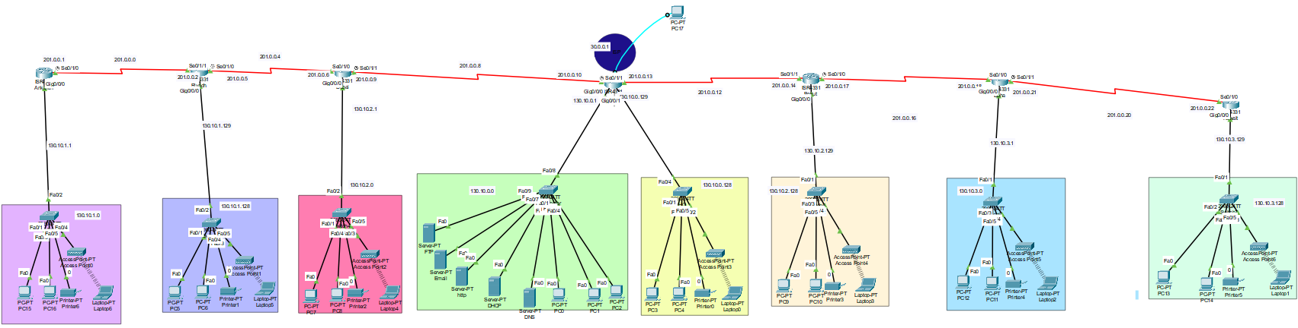

WAN Subnets
Subnet number | Between which Branches | Network ID | First IP | Last IP | Broadcast IP | Subnet Mask
Sub 0 | Ankrah & Riyadh | 201.0.0.0 | 201.0.0.1 | 201.0.0.2 | 201.0.0.3 | 255.255.255.252
Sub 1 | Riyadh & Dubai | 201.0.0.4 | 201.0.0.5 | 201.0.0.6 | 201.0.0.7 | 255.255.255.252
Sub 2 | Dubai & Amman | 201.0.0.8 | 201.0.0.9 | 201.0.0.10 | 201.0.0.11 | 255.255.255.252
Sub 3 | Amman & Beirut | 201.0.0.12 | 201.0.0.13 | 201.0.0.14 | 201.0.0.15 | 255.255.255.252
Sub 4 | Doha & Beirut | 201.0.0.16 | 201.0.0.17 | 201.0.0.18 | 201.0.0.19 | 255.255.255.252
Sub 5 | Doha & Kuwait | 201.0.0.20 | 201.0.0.21 | 201.0.0.22 | 201.0.0.23 | 255.255.255.252
Data Centre:
- Devices
Device | IP address | Static or dynamic | Default gateway
PC0 | 130.10.0.7 | dynamic | 130.10.0.2
PC1 | 130.10.0.8 | dynamic | 130.10.0.2
PC2 | 130.10.0.10 | dynamic | 130.10.0.2

- Router Amman
Protocol | RIP
Password | amman11
Interface Name | IP address | Static or dynamic
Gig0/0/0 | 130.10.0.1 | Static
Gig0/0/1 | 130.10.0.129 | Static
Se0/1/1 | 201.0.0.10 | Static
Se0/1/0 | 201.0.0.13 | static
Amman HQ:
- Device
Device | IP address | Static or dynamic | Default gateway
PC3 | 130.10.0.132 | Dynamic | 130.10.0.129
PC4 | 130.10.0.133 | Dynamic | 130.10.0. 129
Printer | 130.10.0.140 | Static | 130.10.0. 129
laptop | 130.10.0.131 | Dynamic | 130.10.0. 129
- Router Amman
Protocol | RIP
Password | amman11
Interface Name | IP address | Static or dynamic
Gig0/0/0 | 130.10.0.1 | Static
Gig0/0/1 | 130.10.0.129 | Static
Se0/1/1 | 201.0.0.10 | Static
Se0/1/0 | 201.0.0.13 | static

Ankara:
- Device
Device | IP address | Static or dynamic | Default gateway
PC15 | 130.10.1.4 | Dynamic | 130.10.1.1
PC16 | 130.10.1.5 | Dynamic | 130.10.1.1
Printer | 130.10.1.6 | Static | 130.10.1.1
laptop | 130.10.1.3 | dynamic | 130.10.1.1
- Router Ankara
Protocol | RIP
Password | ankarah11
Interface Name | IP address | Static or dynamic
Gig0/0/0 | 130.10.1.1 | static
Se0/1/0 | 201.0.0.1 | static
Riyadh:
- Device
Device | IP address | Static or dynamic | Default gateway
PC5 | 130.10.1.135 | Dynamic | 130.10.1.129
PC6 | 130.10.1.136 | Dynamic | 130.10.1.129
Printer | 130.10.1.138 | Static | 130.10.1.129
laptop | 130.10.1.137 | dynamic | 130.10.1.129
- Router Riyadh
Protocol | RIP
Password | riyadh11
Interface Name | IP address | Static or dynamic
Gig0/0/0 | 130.10.0.129 | Static
Se0/1/1 | 201.0.0.2 | Static
Se0/1/0 | 201.0.0.5 | Static
Dubai:
- Device
Device | IP address | Static or dynamic | Default gateway
PC7 | 130.10.2.4 | Dynamic | 130.10.2.1
PC8 | 130.10.2.5 | Dynamic | 130.10.2.1
Printer | 130.10.2.6 | Static | 130.10.2.1
laptop | 130.10.2.3 | dynamic | 130.10.2.1
- Router Dubai
Protocol | RIP
Password | dubai11
Interface Name | IP address | Static or dynamic
Gig0/0/0 | 130.10.2.1 | Static
Se0/1/1 | 201.0.0.9 | Static
Se0/1/0 | 201.0.0.6 | Static
Beirut:
- Device
Device | IP address | Static or dynamic | Default gateway
PC9 | 130.10.2.132 | Dynamic | 130.10.2.129
PC10 | 130.10.2.133 | Dynamic | 130.10.2.129
Printer | 130.10.2.134 | Static | 130.10.2.129
laptop | 130.10.2.131 | dynamic | 130.10.2.129
- Router Beirut
Protocol | RIP
Password | beirut11
Interface Name | IP address | Static or dynamic
Gig0/0/0 | 130.10.2.129 | Static
Se0/1/1 | 201.0.0.14 | Static
Se0/1/0 | 201.0.0.17 | Static
Doha:
- Device
Device | IP address | Static or dynamic | Default gateway
PC12 | 130.10.3.4 | Dynamic | 130.10.3.1
PC11 | 130.10.3.5 | Dynamic | 130.10.3.1
Printer | 130.10.3.6 | Static | 130.10.3.1
laptop | 130.10.3.3 | dynamic | 130.10.3.1
- Router Doha
Protocol | RIP
Password | doha11
Interface Name | IP address | Static or dynamic
Gig0/0/0 | 130.10.3.1 | Static
Se0/1/1 | 201.0.0.21 | Static
Se0/1/0 | 201.0.0.18 | Static
Kuwait:
- Device
Device | IP address | Static or dynamic | Default gateway
PC13 | 130.10.3.132 | Dynamic | 130.10.3.129
PC14 | 130.10.3.133 | Dynamic | 130.10.3.129
Printer | 130.10.3.136 | Static | 130.10.3.129
laptop | 130.10.3.129 | dynamic | 130.10.3.129
- Router Kuwait
Protocol | RIP
Password | kuwait11
Interface Name | IP address | Static or dynamic
Gig0/0/0 | 130.10.3.129 | Static
Se0/1/0 | 201.0.0.22 | Static

2- Server Installation and Services
Service | Why did you add this service? | IP address of the server that holds the service | Configuration of the service
DHCP | To implement IP Addresses for the network devices dynamically | 130.10.0.3 | Giving the device IP Address, subnet mask, and default gateway statically. Then configure the server by activating the DHCP in server category then adding pool names that we need and their subnet masks, and default gateway then click add. Repeat that step as you need. Then go to the router that you want to implement the DHCP in and apply these commands:  - Interface <interface-name>  - IP helper-address <DHCP-server-address>  finally click on the pc on the same LAN as the router you implemented the commands in and go to desktop and activate the DHCP IP configuration method
DNS | Resolves domain names to IP addresses, facilitating. Easy network communication. Using DNS server will make it possible to access.  The previous website using its domain name instead of the IP address | 130.10.0.2 | Open server, click on Services tab and choose DNS service and activate it then add records to the DNS table by entering the name of the web browser and its IP address. Then start adding records to all pcs enabling access to its Domain. Then on each PC add the DNS server IP address on IP configuration. To ensure that the pc is assigned to its domain name open the Desktop/web browser and enter the Domain name of the web server as the URL and click Go or use the domain name instead of the IP address to ping the pc.
FTP | It allows users to transfer files between client and server over the network. | 130.10.0.6 | Open the server, click on Services tab, and choose FTP service and activate it. Then Assign usernames and passwords to users, and specify the access privileges for each user regarding file operations such as write, read, delete, rename, or list. Then go to the pcs command prompt and access the FTP server using the username and its password.
Email | Simple Mail Transfer Protocol is used to send outgoing mail between email servers. Post Office Protocol version3 enables users to retrieve emails from a remote mail server. | 130.10.0.5 | Open the server, click on Services tab, and choose Email service and activate. Then set the email domain name. Then Proceed and add users and provide their passwords. Now, enable email communication between two PCs go to the first pc and choose email in the desktop category. Then a configure mail tap will be displayed enter the pcs name and its email and the email’s IP address for the Incoming and Outgoing Mail Server and the username which is the same as the name and a password then click save. Repeat this on the other pc. To send an email from the first PC to the other one. Open the PC on email then compose and write the other pc’s email and the massage. Then go to the other pc to receive the email by clicking on email and press receive.
HTTPs | Ensures secure website browsing over the  network. | 130.10.0.4 | Click on the server and go to services activate the type of HTTP you want (secure HTTPs-> Non-secure HTTP). Then in the File Manager section click on edit next to index.html edit the file by adding a sentence within <hr> tag to display on the server’s webpage. After that Save the file. Then, on any PC on any network, open the Desktop/web browser and enter the IP address of the web server as the URL and click Go. NOTE: if you selected HTTPs attempting to access the  webpage via HTTP will not be successful. So, replace "http" with "https" in the URL, and then click on "Go" again to  access the webpage securely

3- Detailed Test Plan:
What to be tested: | Tools or commands used for testing: | Expected results:
FTP | ftp <IP Address> | Success connectivity with the FTP server and asking for the username and password
Emails | Two PCs | Receiving and sending emails
Connectivity | Ping | Success (0% loss)
HTTPs | Two PCs | Displaying the html header on web browser
DNS | Two PCs | Displaying the html header on web browser
IP Address implementation | Ipconfig | Ip address and subnet mask of the pc
DHCP | IP configuration | Displaying the Ip address of the Ip configuration tap once its activated

4- Maintenance Schedule :
 | Frequency | Maintenance
Regular checks on hardware health | Daily | continuously monitors the performance of all network devices, including servers, switches, and routers, tracking key metrics such as Errors and Discards, Disk Utilization, CPU and Memory Utilization.
Software updates | Monthly | managing to keep the network devices and OpManager itself updated with the latest features and security improvements.
Security patch applications | Monthly | traps are received and monitored, providing alerts when there are issues, which includes the need for applying security patches.
Network performance assessments | Daily | Monitors VoIP services for packet loss, delay, and jitter values, ensuring optimal network performance.
plan for scalability to accommodate future network growth, additional devices, or expanded communication requirements. | Yearly | choosing technologies and infrastructure that can be scaled up or adapted easily, ensuring the network can grow in tandem with the organization’s needs. And ensuring that the subnetting can insure future devices

For Highlighting procedures for routine backups, disaster by following the maintenance plan to ensure the network remains reliable, secure, and capable of scaling to meet future needs.

5- Critically evaluate:
IEEE802.3: it is a combination of standards and protocols defined by the Institute of Electrical and Electronics Engineers (IEEE). It is a Data Link technology – responsible for delivering a frame of bits from one network interface to another and it is responsible for data encapsulation and media access control and provides data link layer addressing.
- Data encapsulation includes the following:
- Ethernet frame - This is the internal structure of the Ethernet frame.
- Ethernet Addressing - The source and destination MAC addresses are 6-byte fields that uniquely identify network interfaces on the Ethernet network.
- Ethernet Error detection - This 4-byte field at the end of the Ethernet frame is used for error detection. It contains a cyclic redundancy check (CRC) value, which is computed based on the frame's contents. When the frame is received, the CRC is recalculated and compared to the FCS value. If they match, the frame is considered error-free.
- Collision Avoidance and Detection: The CSMA/CD (Carrier Sense Multiple Access with Collision Detection) algorithm allows stations to sense the medium before transmitting, that reduces the chances of collisions.
- Full Duplex Operation: In full duplex mode, where supported, stations can transmit and receive simultaneously without contention, leading to higher throughput and more efficient use of the medium.
- Frame Size Optimization: In half duplex mode, where the minimum frame size might not be sufficient for proper CSMA/CD protocol operation, the MAC sublayer appends extension bits to frames, ensuring that the duration of transmission is adequate for efficient protocol operation.
- Adaptability to Network Topologies: The standard addresses different network topologies and media types, ensuring that the MAC sublayer's mechanisms are suitable for various deployment scenarios, whether it's a broadcast network or a point-to-point link between two stations.
IEEE 802.11: known as Wi-Fi, outlines the architecture and defines the MAC and physical layer specifications for wireless LANs (WLANs).
- Quality of Service (QoS): is a feature designed to improve the performance of delay-sensitive applications, such as voice, streaming multimedia, and online gaming, by allowing packets to belong to different traffic classes with different transmit priorities this helps in managing delays and collisions.
- Optimized Spectrum Utilization: CCA (Clear Channel Assessment) scheme has capability to detect co-channel interference. to maximize spectrum utilization and minimize interference.
- Fault Tolerance: Centralized management helps in minimizing bottlenecks and creats more resilience in the WLAN.
- Flexible format: Supports both temporary smaller networks and larger, and more permanent ones.
- Load balancing: load balancing algorithms to give devices across multiple access points efficiently.

6- Explore Server Types:
Server type | Services that can be run by the server | suitability for the services requires | Server operating system type | hardware specification selection, infrastructure needs | Cost | performance
Web server | HTTPS | For secure web hosting used to open various kinds of sites which are very useful and useful for all people. | macOS, Linux (Apache HTTP Server, Nginx), Windows (Microsoft IIS) | Fire Fox Processor Windows, Process Mac Pentium 4.  Ram 512 MB, Desk space 200 MB, NIC, 2 CPU to 4 CPU and memory between 2GB to 6GB. | Process Mac Pentium 4. Ram 512 MB around 200$ CPU 19$-26$ RAM 20$-30$  You will need a Secure Sockets Layer (SSL) certificate which costs around $60/year.  OS: Linux free  Windows needs license payment | Depending on the os Linux is Higher in efficiency and flexibility than windows
DHCP server | DHCP | Dynamically assigning IP addresses so Efficient IP Address Management other than the scalability and Network Growth | Windows, Linux (ISC DHCP, Kea DHCP) | Depends on the devices for example 40000 to 60000 · CPU: 24 cores, 2.0GHz. Memory: 64GB or above. Disk: 2 × 500GB | CPU around 60$  Memory 80$  OS: Linux free  Windows needs license payment | Depending on the os Linux is Higher in efficiency and flexibility than windows.  Overall, server high for assigning ip addresses
File server | FTP | File sharing between devices and suitability for transferring sensitive data over networks. | Linux (vsftpd, ProFTPD), Windows (FileZilla Server) | Hardeware around 500-3000$ | 2 GHz Pentium class processor 80$-30$  8GB RAM 10-30$  OS: Linux free  Windows needs license payment | Depending on the os Linux is Higher in efficiency and flexibility than windows  Overall high for transferring files throw LANs
Mail server | SMTP/POP3 | For sending and receiving email | Windows (Microsoft Exchange), and Linux (Postfix, Exim, Dovecot) | CPU 1 GHz processor or higher (dual core CPU 2.4 GHz or higher recommended) ,2 GB RAM (4 GB RAM recommended), Hard disk space: 1 GB.  Subscribions:  Google Workspace from $6/month for a 1-year plan | CPU 1 GHz processor around 60$  2 GB RAM around 20$  OS: Linux free  Windows needs license payment | Depending on the os Linux is Higher in efficiency and flexibility than windows  Overall, high for mails
DNS Server | DNS | is a directory service that provides a mapping between the name of a host on the network and its numerical address. | Linux (BIND, PowerDNS), Windows Server DNS | Hardware purchase ($10,000), Software license ($5,000), Installation ($3,000). | CPU 2 cores 2.4 GHz around 100-300$  OS: Linux free  Windows needs license payment | Depending on the os Linux is Higher in efficiency and flexibility than windows.  Overall high for

- Discuss the inter-dependences:
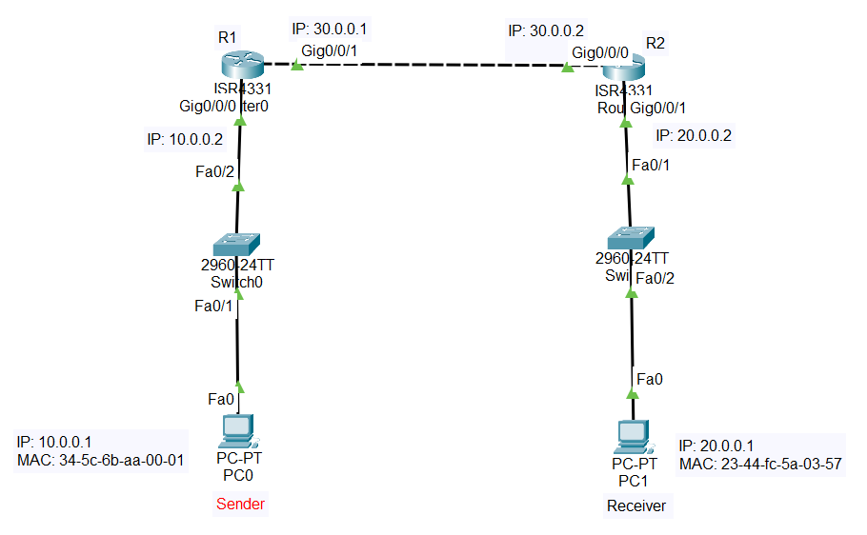
 | The packet trip in the device
PC0 | The application layer provides the interface between the applications used to communicate, and the underlying network. The user enters the data (PDU). Then the data will be encapsulated into packets and then transferred to transport layer where TCP/UDP is. Then data moves to network layer where IP addresses are implemented. These packets are then sent to the data link layer where they are being framed with the destination port, source port, and sequenced number to send data to the physical layer where bits are transferred to the desired output
Switch 0 | The packets are received by the data link layer. The switch examines the destination MAC table of the packet and send it to the right port
R1 | The packet arrives at the data link layer, where it is forwarded based on the destination IP address found in the packet's header. The router looks up the destination IP address by using routing table and determines destination.
R2 | The packet arrives at the data link layer, performs a similar routing process as Router 1. Then it forwards the packet to Switch 1
Switch 1 | The packet arrives at the data link layer it examines the destination MAC address of the packet and send it to pc1
PC1 | receives the packet at the data link layer, then it is passed up to the application layer for processing.

B: Implementation, Testing, and Enhancements
- Verification and Test Results:
DNS
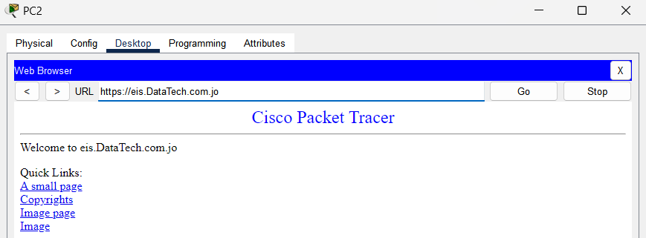

HTTPs
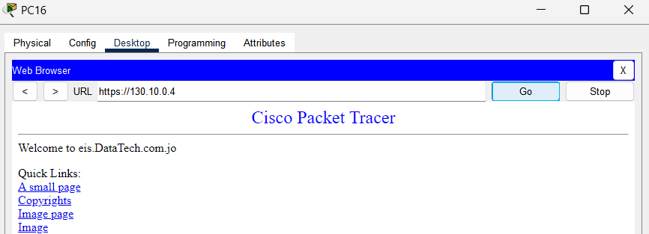
Connectivity
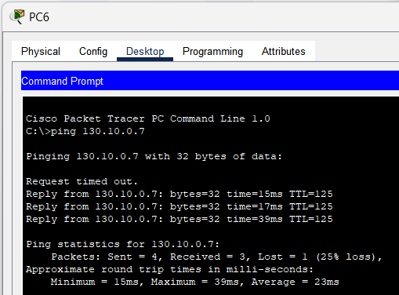

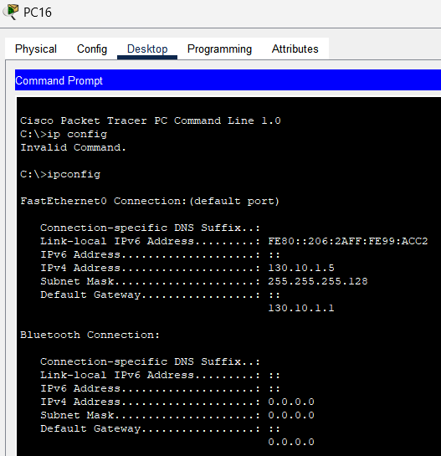
DHCP
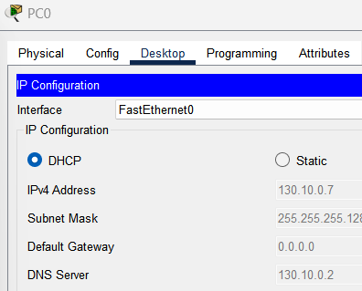

FTP
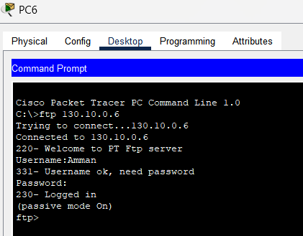
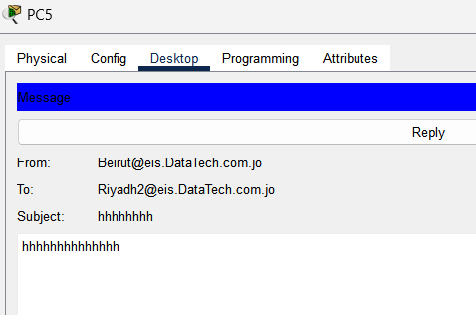
Mail

2. Enhancements and Future Proofing:
efficiency | security | scalability
Optimizing network design: A well-designed network is fundamental to efficiency. This involves strategic placement of hardware, choosing the right network topology such as star, ring, mesh, and ensuring appropriate network bandwidth allocation to avoid bottlenecks. | Tracking Software Vulnerabilities: Software updates frequently include essential patches and security fixes for newly found threats and vulnerabilities, in addition to new features and capabilities. Most current software programs will check for freshly published updates automatically. | Network segmentation (subnetting) is by dividing the network into smaller, more manageable segments, organizations can enhance both network performance and security.
Implementing advanced technologies: applying advanced technologies like cloud-based network and AI-powered network operations. These technologies enable proactive monitoring, troubleshooting, which leads to smarter network planning. | VLAN: is a LAN except it allows various computers and devices to be virtually linked to one other as if they were in a LAN sharing a single broadcast domain. | Load balancing: This technique prevents any single server from becoming overwhelmed, thus maintaining optimal network performance and reliability.
Enhanced remote work rise of remote work for reliable access, ensuring that remote employees can work without interruptions, contributing positively to their overall job | Single Sign-On: Singe sign on (SSO) typically refers to a system of authentication where a user logs into a central system, and then a secondary authentication method, such as SAML, can be used to automatically log the user further into other external, but integrated systems. In other words, the user logs in once,
With the rise of remote work, Timely updates ensure that software vulnerabilities are patched are dangerous for attackers if they were open. since gaining these unauthorized accesses will cause damage to your infrastructure. And stealing data. Timely updates, protects them. And reduce Threats by highlighting them and improve overall performance.

3. Critical Reflection:
In my topology I used the bus topology, which is an easy cheap topology, but it may cost a lot in the long term due to trouble shooting handling, but by using the star topology I will have more control in mistake tolerance, more Scalability for adding more switches and add more pcs for future expansion since the bus topology is harder in cables management even that star topology is initially more expensive. As I did subnetting considering the number of pcs that could be implemented in the future. Also, bus topology is considered outdated this affects the overall performance, reliability, and ease of management unlike star topology which is a modern one that has all updates for better performance. Since in my bus topology it is hard to connect more devices due to the hard Collisions are also common in my topology especially when adding devices in the future to handle this, we can implement protocols like CSMA/CD (Carrier Sense Multiple Access with Collision Detection) to prevent collisions and ensure smooth communication flow. Also lack of security might be encountered so to enhance network security, use firewalls and SIEM which is a system to monitor and analyze security events in real-time. Other than adding IPS this will protect data and prevent data loss. Also merging all services (DHCP, DNS, Web, email, and FTP) into one server will help more in managing them and lower the cost.

References:
https://www.enterprisenetworkingplanet.com/management/how-to-configure-local-area-network/
https://www.geeksforgeeks.org/how-to-set-up-a-lan-network/
https://learn.microsoft.com/en-us/windows-server/troubleshoot/dynamic-host-configuration-protocol-basics
https://www.zenarmor.com/docs/network-basics/types-of-servers
https://www.manageengine.com/network-monitoring/network-performance-monitoring.html#2
https://nilesecure.com/network-design/network-scalability#:~:text=Planning%20for%20scalability%20from%20the%20outset&text=Designing%20a%20network%20with%20future,tandem%20with%20the%20organization's%20needs.
https://phoenixnap.com/kb/server-operating-system
https://www.javatpoint.com/server-operating-system
https://www.cisco.com/c/en/us/support/docs/ip/domain-name-system-dns/12683-dns-descript.html
https://www.liveaction.com/glossary/ethernet-ieee-802-3/
https://www.ccnahub.com/ip-fundamentals/understanding-data-link-layer-encapsulation/#:~:text=Layer%202%20at%20this%20point,for%20further%20processing%20(3).
https://ieee802.org/3/as/public/0503/4d0_1_CMP.pdf
https://inet.omnetpp.org/docs/showcases/wireless/qos/doc/index.html
https://www.versitron.com/blogs/post/the-role-of-dhcp-in-efficient-ip-address-management
https://hal.science/hal-00326059/document
https://www.ibm.com/docs/sk/aix/7.2?topic=protocol-dhcp-server-file-known-options
https://www.h3c.com/en/Support/Resource_Center/HK/SDN/Campus/AD-Campus/Technical_Documents/Configure___Deploy/Configuration_Guides/AD_Campus_6.2_CG-9156/12/
https://docs.cloudblue.com/cbc/21.0/DNS-Hosting-Services/Hardware-Requirements-for-BIND-DNS-Servers.htm
https://mdaemon.com/pages/mdaemon-system-requirements
https://medium.com/@khaliszikrul/what-is-a-web-browser-features-and-benefits-aa23de12a0a0
https://wirexsystems.com/resource/protocols/ftp/#:~:text=In%20summary%2C%20FTP%20is%20a,transferring%20sensitive%20data%20over%20networks.
https://www.ebay.com/b/Pentium-4-Computer-512-MB-RAM-Servers/11211/bn_2800124
https://www.hostinger.com/tutorials/ssl-certificate-cost#:~:text=On%20average%2C%20a%20Secure%20Sockets,or%20the%20certificate%20authority%20itself.
https://nilesecure.com/network-management/network-efficiency
https://www.zenarmor.com/docs/network-security-tutorials/what-are-ways-to-improve-network-security
https://nilesecure.com/network-design/network-scalability#:~:text=Investing%20in%20high%2Dcapacity%20infrastructure,the%20growth%20of%20network%20traffic.
https://fastercapital.com/topics/understanding-the-importance-of-timely-updates.html

