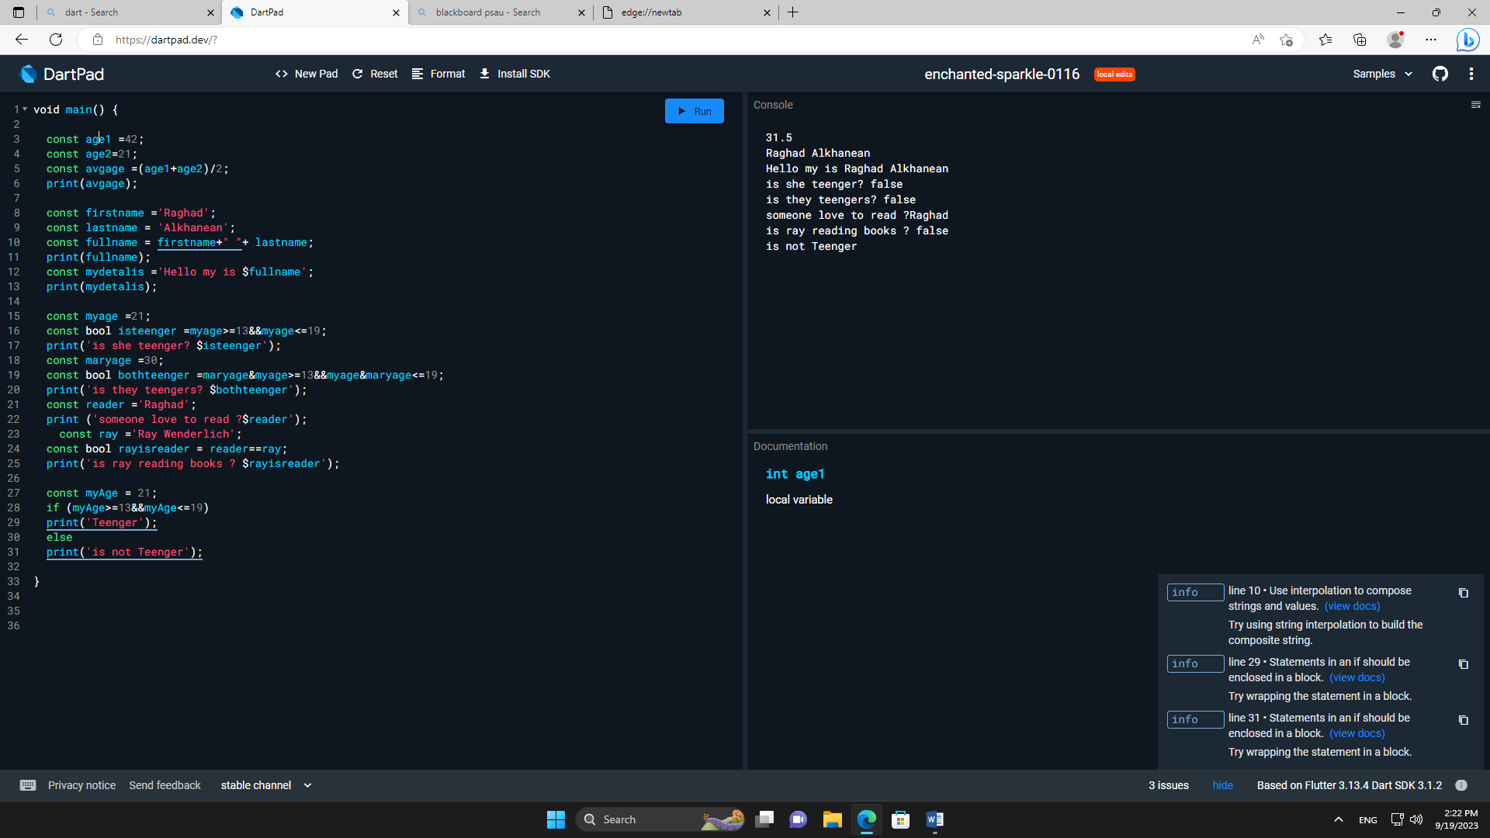

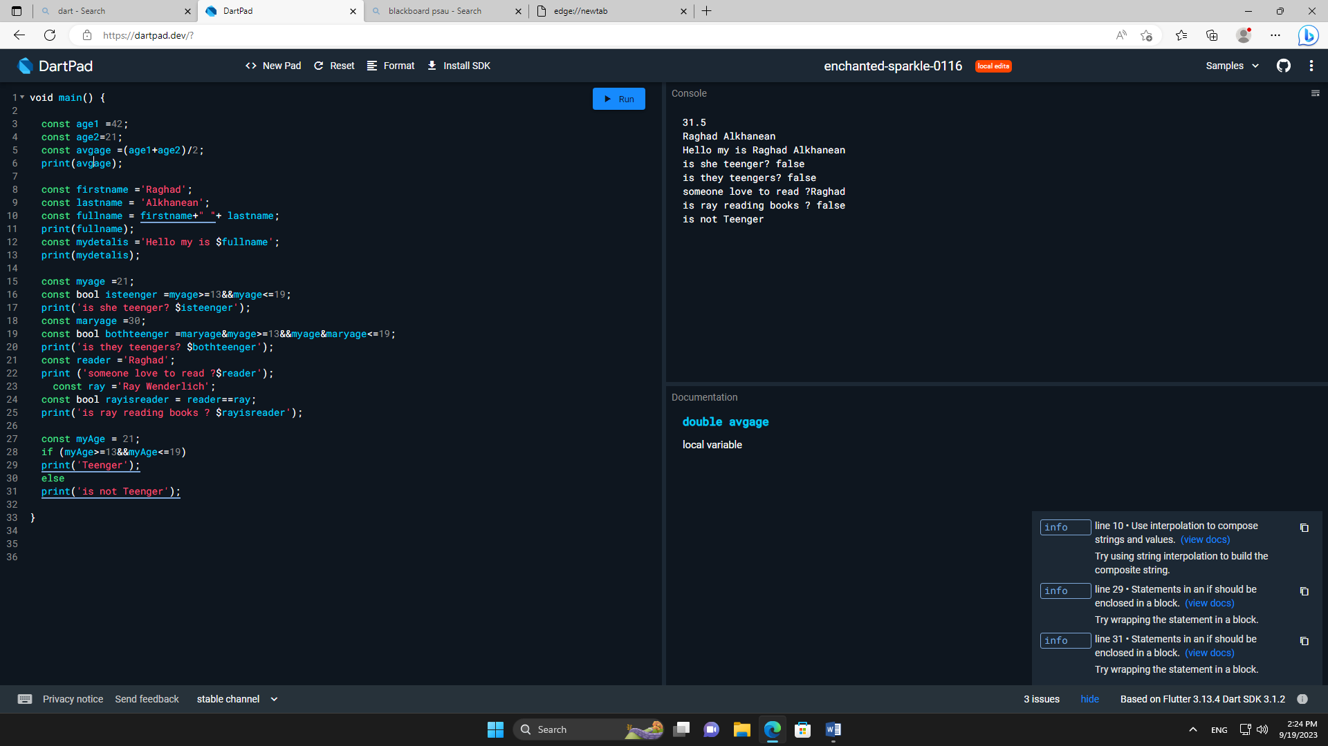

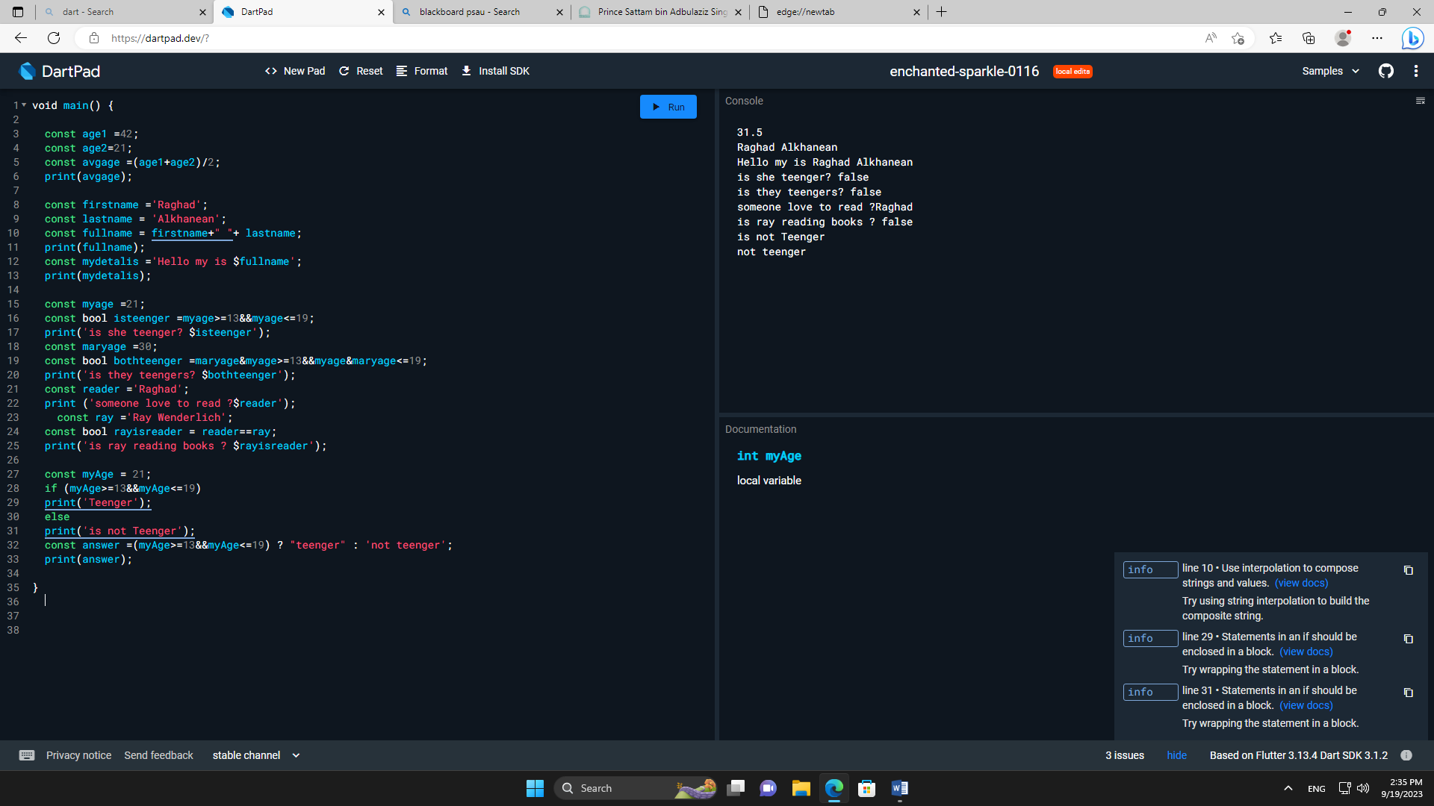

const age1 =42;

const age2=21;

const avgage =(age1+age2)/2;

print(avgage);

const firstname ='Raghad';

const lastname = 'Alkhanean';

const fullname = firstname+" "+ lastname;

print(fullname);

const mydetalis ='Hello my is $fullname';

print(mydetalis);

const myage =21;

const bool isteenger =myage>=13&&myage<=19;

print('is she teenger? $isteenger');

const maryage =30;

const bool bothteenger =maryage&myage>=13&&myage&maryage<=19;

print('is they teengers? $bothteenger');

const reader ='Raghad';

print ('someone love to read ?$reader');

const ray ='Ray Wenderlich';

const bool rayisreader = reader==ray;

print('is ray reading books ? $rayisreader');

const myAge = 21;

if (myAge>=13&&myAge<=19)

print('Teenger');

else

print('is not Teenger');

const answer =(myAge>=13&&myAge<=19) ? "teenger" : 'not teenger';

print(answer);