

Secure Messaging App

ICS344 G10 F05

Project Report

Raghad almunirawi 202182030
Danah Aldossary 202255300

1. Introduction
This project implements a secure end-to-end messaging demo application for the ICS344 course. The goal is to combine modern cryptographic primitives with a simple graphical user interface (GUI) to illustrate how confidentiality, integrity, authentication, and replay protection can be achieved in practice.
The application simulates a Sender and a Receiver exchanging secure messages using AES-GCM, RSA key wrapping, and RSA-based digital signatures. Several common attacks are also demonstrated to show how the system detects tampering, wrong keys, and replayed messages.

2. System Overview
The GUI is built with Tkinter and consists of three main areas:
• Sender panel: where the user types the plaintext message and presses Encrypt.
• Receiver panel: shows the encoded secure bundle that is "sent" over the (insecure) channel.
• Log panel: records important actions, such as key generation, encryption, decryption, and attack detection.
The main workflow is:
1. The Sender types a message and clicks Encrypt.
2. The app encrypts the message using AES-GCM with a fresh random key and nonce.
3. The AES key is wrapped (encrypted) with the Receiver’s RSA public key.
4. The nonce, ciphertext, wrapped AES key, and a digital signature are combined into a Base64-encoded bundle and displayed in the Receiver panel.
5. When the Receiver clicks Decrypt, the app verifies the signature, unwraps the AES key using the Receiver’s RSA private key, and finally decrypts the ciphertext.

3. Cryptographic Design
The cryptographic core is implemented in three Python modules under crypto_core/:
• aes_gcm.py – provides AES-GCM encryption and decryption with 256-bit keys and 12-byte nonces.
• key_exchange.py – generates RSA key pairs and performs RSA-OAEP wrapping/unwrapping of AES keys. It also defines the SecureMessageBundle structure and encodes/decodes bundles to/from Base64.
• signatures.py – implements RSA digital signatures using SHA-256 and PSS padding, and verifies signatures.
Security properties:
• Confidentiality: AES-GCM ensures that message contents remain secret.
• Integrity and authenticity: digital signatures bind the ciphertext and nonce to the Sender’s RSA key.
• Secure key exchange: the AES session key is never sent in the clear; it is wrapped with the Receiver’s RSA public key.
• Replay protection: the Receiver tracks previously seen nonces and rejects bundles that reuse a nonce.

4. Implementation Details
• gui/app_gui.py: contains the Tkinter GUI, event handlers for Encrypt and Decrypt, logging, and attack detection logic (signature failures, wrong key errors, and replay detection based on nonces).
• main.py: creates an instance of SecureMessagingApp and starts the Tkinter main loop.
• crypto_core/: contains the cryptographic building blocks used by the GUI.

5. Normal Operation (Encrypt & Decrypt)
Figure 1 shows a normal run of the application. The Sender types a short message ("hi"), clicks Encrypt, and the Receiver panel displays a long Base64 bundle containing the wrapped AES key, nonce, ciphertext, and signature. When Decrypt is pressed, the signature is verified successfully and the original plaintext is shown in a popup, while the log records both encryption and decryption steps.
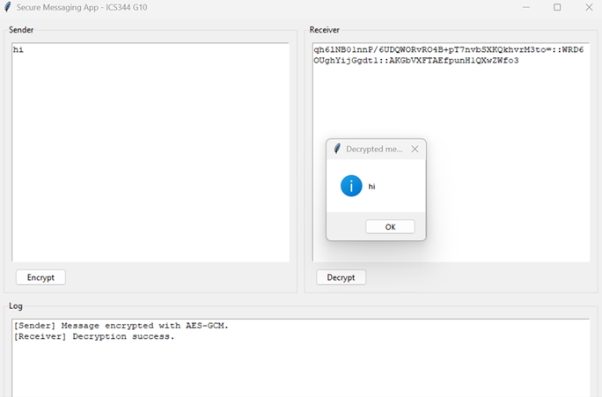

Figure 1 – Normal encryption and decryption with AES-GCM, RSA key wrapping, and signature verification.

6. Tampering / Modification Attack
To simulate a modification attack, a character in the encoded bundle inside the Receiver panel is edited manually before pressing Decrypt. Because the ciphertext or nonce no longer matches the original signed data, signature verification fails. The application pops up an Integrity error and logs that signature verification failed and the message may be tampered.
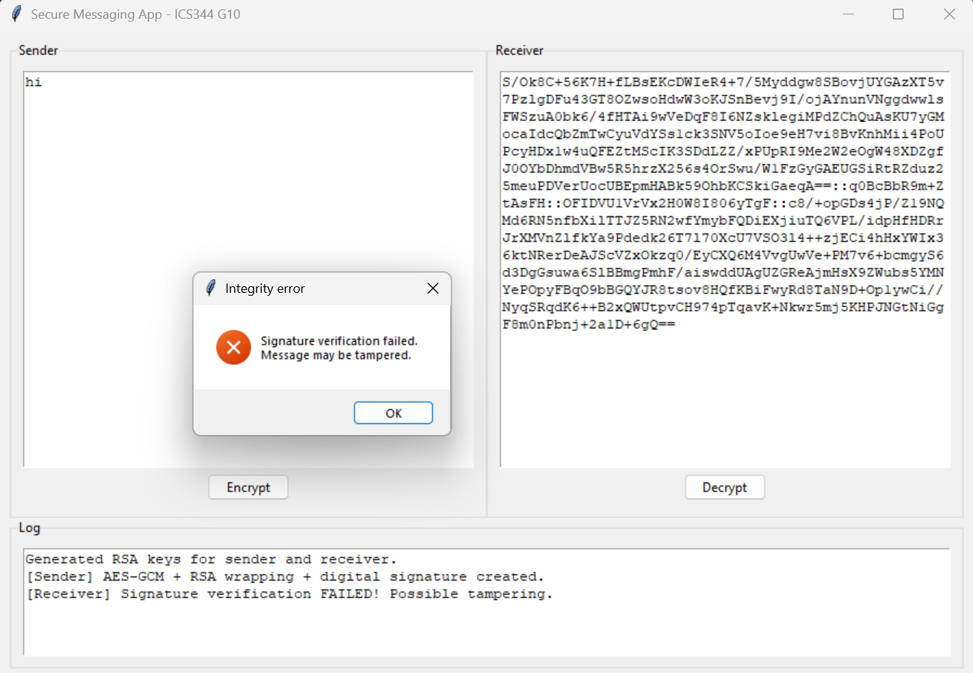
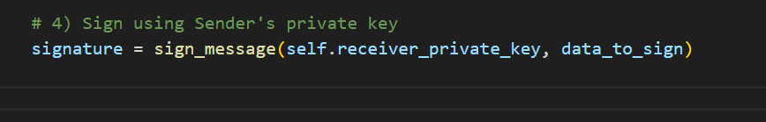

Figure 2 – Tampering attack: modified bundle causes signature verification to fail.

7. Wrong AES Key Attack
A second experiment demonstrates what happens if the Receiver attempts to unwrap the AES key using the wrong RSA private key (for example, using the Sender’s private key instead of the Receiver’s). In this case the signature still verifies successfully (the bundle has not been altered), but decryption fails because the derived AES key is incorrect. The log shows a successful signature verification followed by a decryption error, illustrating the separation between integrity/authenticity and confidentiality.
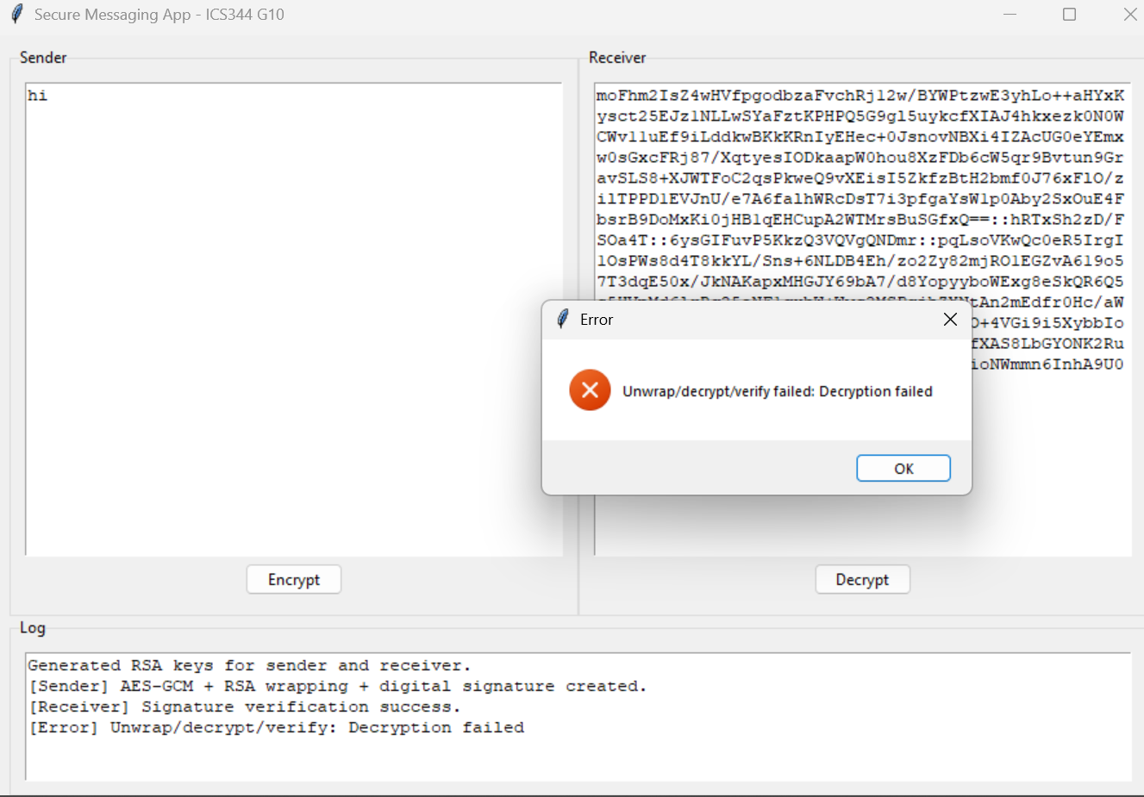
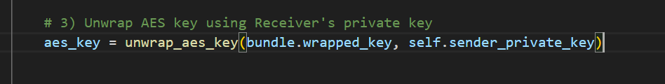
Figure 3 – Wrong AES key attack: signature succeeds but decryption fails with an error.

8. Replay Attack and Nonce Reuse Detection
Finally, a replay attack is simulated by attempting to decrypt the exact same bundle more than once. The application keeps track of previously seen nonces on the Receiver side. When a nonce is reused, the app treats this as a replay and rejects the message, showing a Replay Attack warning and logging that the nonce was reused.
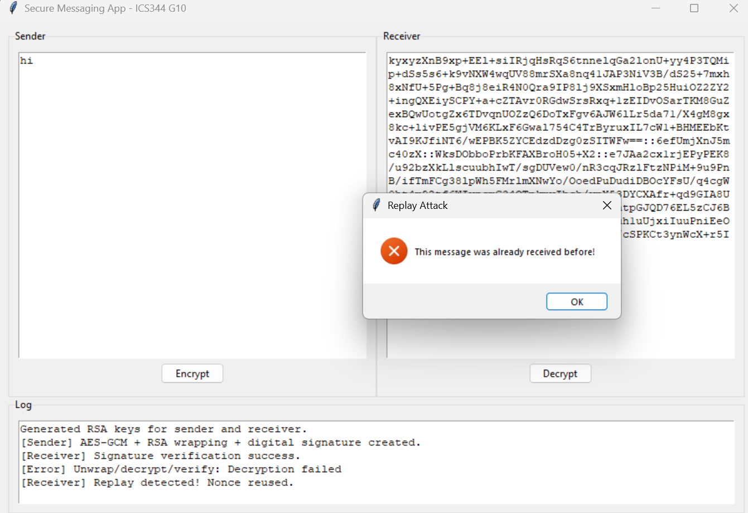
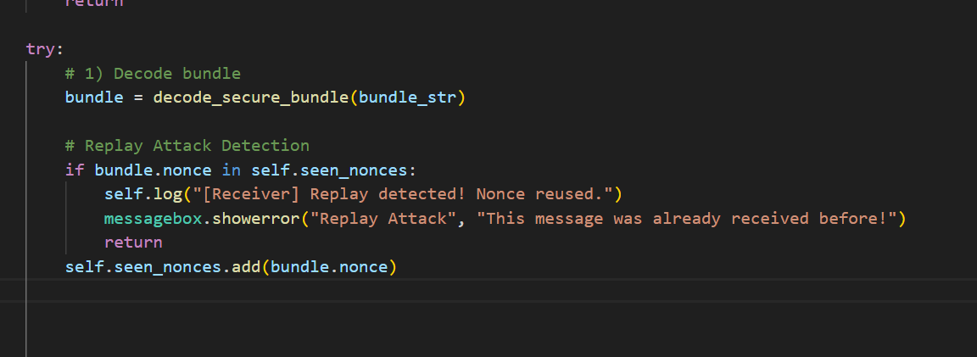
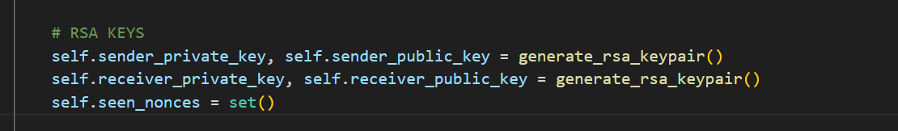
Figure 4 – Replay attack: the same bundle is decrypted again and detected as a replay based on nonce reuse.

