

Palestine Technical University – Kadoorie

College of Engineering and Technology Department of Computer Systems Engineering

Course name:

Software Engineering

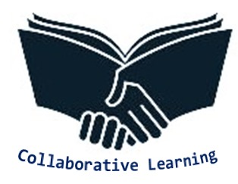

Project title:

**DESIGNING A WEBSITE TO ENHANCE ACADEMIC SUPPORT AND FACILITATE BOOK EXCHANGE AMONG PEERS AT PALESTINE TECHNICAL UNIVERSITY - KADOORIE IN TULKARM**

By:

Raghad Mousleh – 202110283 - Section 1

Raghad Suliman - 202110010 - Section 3

Supervisor:

Dr. Nael Salman

Dr. Osama Hamed

Tulkarm, Palestine

9 April 2024

|  |
| --- |
| **Collaborative Learning** |

**Table of Contents**

Abstract:.............................................................................................................3

Introduction:………………………………………………………………………………………………… 4

Description of the system & services:............................................................... 5

Objectives:......................................................................................................... 6

Plan Of Work:.................................................................................................... 6

1.1 System Mechanism:.......................................................................... 6

1.2 Our role in the success of the project:…………………………………………… 7

ER preliminary diagram of the projec:……………………………………………………….…..8

|  |
| --- |
| **I** |

|  |
| --- |
| **Collaborative Learning** |

|  |
| --- |
| **Collaborative Learning** |

**Abstract:**

Collaborative Learning is a website that helps students exchange books and study summaries in paper form. It provides students with everything they need in their academic journey, including books, summaries, explanations, and previous exams electronically. The site contains a search feature by image and sound to facilitate the search process for students. In addition, students can add any book or summary to another that is not present on the site to expand the site and benefit the largest possible number of students.

|  |
| --- |
| **Collaborative Learning** |

|  |
| --- |
| **II** |

**Introduction:**

Most people tend to aim for leaving a mark or making their names shine, but as university students, they are still working on developing themselves in various fields of study and sharing their personal efforts can sometimes be embarrassing for some and exhausting when it comes to finding a means for it. Additionally, some individuals enjoy helping others in the context of fostering self-satisfaction but don't know how. Our system will be the means for users to present their academic efforts to others in various courses.

In the digital age, students face many challenges in accessing essential resources for their studies and managing academic materials efficiently. To address these challenges, this project focuses on designing a multi-faceted website designed to meet the diverse needs of students in their educational endeavors. The website aims to serve as a hub offering a wide range of tools, resources and services to support students throughout their academic journey.

In line with the evolving landscape of education and the challenges faced by students, our project seeks to create a dynamic and inclusive online platform that fosters knowledge sharing and collaboration among university student. This platform will not only provide a space for students to showcase their academic efforts but also facilitate seamless access to educational resources such as textbooks, study guides, and past exam papers. Through user-friendly features like advanced search capabilities and interactive forums, students will be empowered to engage with peers, share insights, and contribute to a vibrant community of learners. By promoting a culture of mutual support and academic excellence, our project aims to enhance the overall learning experience and cultivate a sense of collective achievement among students at all levels of their educational journey.

|  |
| --- |
| **Collaborative Learning** |

|  |
| --- |
| **1** |

|  |
| --- |
| **Collaborative Learning** |

**Description of the system & services :**

"Our innovative system, called " Collaborative Learning" is a dynamic and user-centred platform designed to revolutionize students' access to and participation in educational materials. Unlike traditional academic programmes, our system integrates smoothly the functions of sharing digital and material resources to meet different needs and learning preferences. Through our clear confrontation, students can discover a treasure of resources, including e-books, study guides, lecture notes and previous examination papers, which can be easily obtained by just a few clicks.

What distinguishes our system from others is its unique approach to facilitating the exchange of physical books as well as electronic participation. Students can include their paper books for exchange, donation or lending, thereby promoting a vital culture of resource sustainability and community participation. Our system has advanced features such as the possibilities of searching for images and sound, making it easier for students to find specific resources even without knowing the exact address or author. Our platforms go beyond traditional online warehouses by promoting communications in the real world and collaborative learning experiences.

|  |
| --- |
| **Collaborative Learning** |

|  |
| --- |
| **2** |

**Objectives:**

|  |
| --- |
| **Collaborative Learning** |

The project aims to facilitate the exchange of books not only electronically but also in physical paper form among students. This dual approach recognizes the diverse preferences and needs of students who may prefer traditional printed materials for study.

in addition, Serving many students in their studies, saving time and effort, exchanging knowledge between different universities, and collecting all materials related to academic courses in an easily accessible place**.**

**Plan Of Work:**

1.1 System Mechanism:

* Students can register on the site using their personal data, such as name, e-mail and password.
* Then (as an optional step) enable the student to enter the names of his or her courses in order to facilitate the search and display of any ads or leaflets related to these tracks.
* Students can add their books to the database by entering information about the book, such as the title of the course, title and author.
* In addition, they can search for books that are available in different ways, such as voice, image, or title, or course name, and ask for books that they would like to borrow from their colleagues and confirm the request by sending a message to writers, and then send a letter to writers to approve the exchange and metaphor.
* Discussion rooms are provided for all disciplines. So that the registered student will find guidance on his academic journey.
* Providing technical support aimed at finding continuity in case of a problem, requesting reports to be sent to address t

|  |
| --- |
| **3** |

* hem by the system administrator.

|  |
| --- |
| **Collaborative Learning** |

1.2 Our role in the success of the project:

|  |
| --- |
| **Collaborative Learning** |

First of all, our team consists of only two people, a choice that is due to our belief in our ability to understand and communicate effectively, in addition to our ability to deal with pressure and complete tasks efficiently. In addition, we are old-fashioned and live in the same area, which contributes to enhancing our harmony and the effectiveness of our work. In light of the current circumstances, which include the closure of roads due to the occupation, this consensus and understanding in the team enhances our ability to face challenges in a solid and successful manner.

|  |  |
| --- | --- |
| Team Member | Points of Strength & Expertise |
| Raghad Suliman  {202110010} | * Experienced with database management and serverside programming. * Fluent in English language & excellent in technical writing. * He has experience in Java, C++ and SQL languages |
| Raghad Mousleh  {202110283} | * Has a sense of creativity * Excellent at analyzing data and extracting useful data from databases to support decision making and improve website performance. * He has experience in Java, C++ and SQL languages |

|  |
| --- |
| **4** |

|  |
| --- |
| **Collaborative Learning** |

|  |
| --- |
| **Collaborative Learning** |

The project requires approximately three months to be implemented

|  |
| --- |
| **Collaborative Learning** |

and implemented according to the mechanism shown in Table 1.1

|  |  |  |  |  |  |  |  |  |  |  |  |  |  |  |  |  |  |
| --- | --- | --- | --- | --- | --- | --- | --- | --- | --- | --- | --- | --- | --- | --- | --- | --- | --- |
| **June** | | | **May** | | | | | **April** | | | | | **March** | | | **Month**  **Week**  **Task** | |
| **12** | **11** | | **10** | **9** | **8** | **7** | | **6** | **5** | **4** | **3** | | **2** | **1** | |
|  |  | |  |  |  |  | |  |  |  |  | |  |  | | Determining Idea | |
|  |  | |  |  |  |  | |  |  |  |  | |  |  | | Collect information | |
|  |  | |  |  |  |  | |  |  |  |  | |  |  | | Introduction | |
|  |  | |  |  |  |  | |  |  |  |  | |  |  | | Prototyping | |
|  |  | |  |  |  |  | |  |  |  |  | |  |  | | System Design and Development | |
|  |  | |  |  |  |  | |  |  |  |  | |  |  | | Testing and Deployment Planning | |

Table 1.1 : Timeline of project

**ER preliminary diagram of the project:**

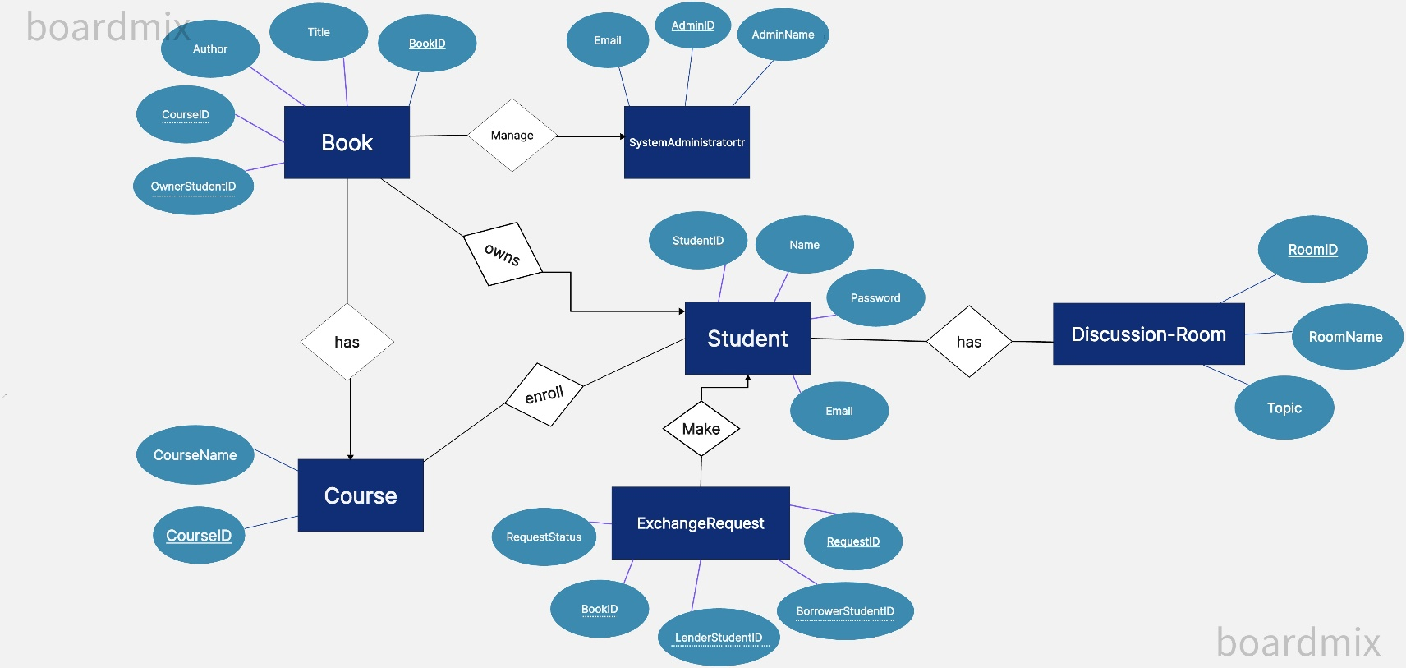

figure 1.1 : ER Diagram of the system

|  |
| --- |
| **5** |