**Deep Neural Network**

**Medical Image Analysis with CNN**

Experimentation:

**I used different configurations and parameters to enhance performance.**

**-The first result is so bad, and this is the model, I don’t use early stop and used Adam:**

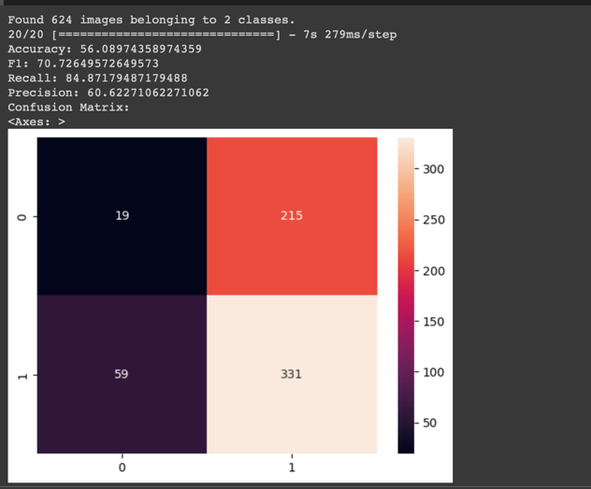

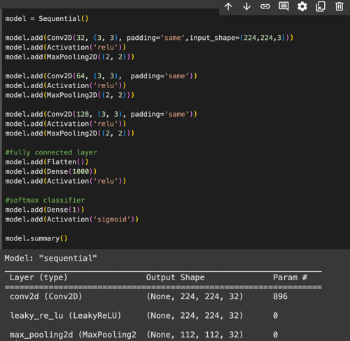

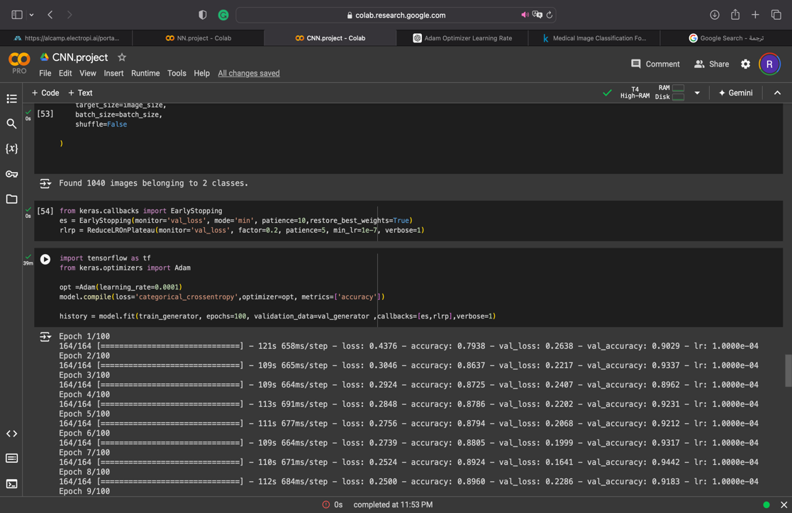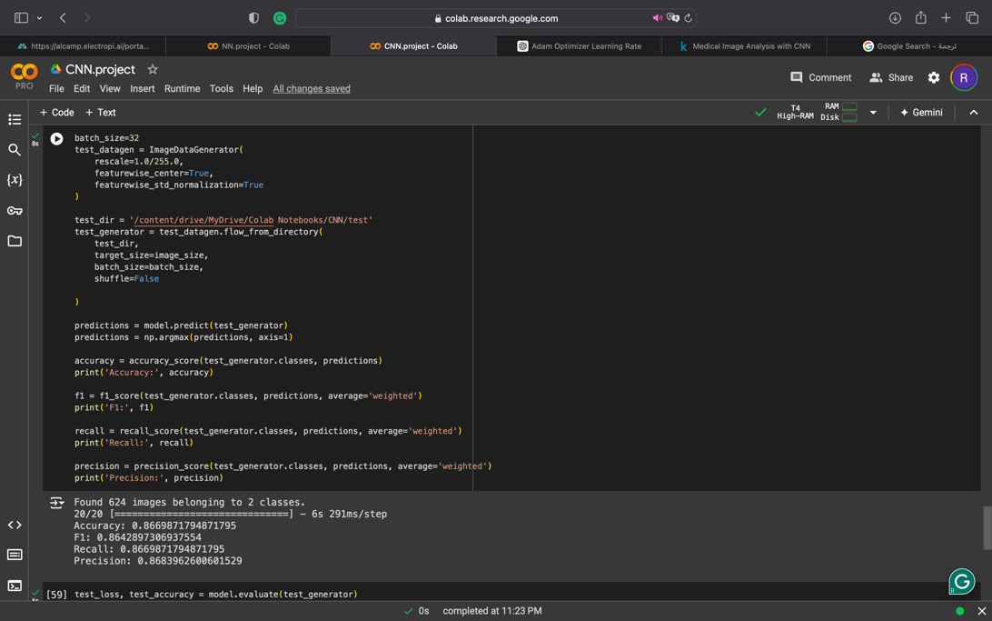**The second result comes with some improved performance. The same model but I used early stopping and ReduceLROnPlateau and Data Augmentation:**

**Then I iterate and iterate to the last and best result I changed opt to Adam, I used VGG16, I used early stopping, ReduceLROnPlateau, and Data Augmentation:**

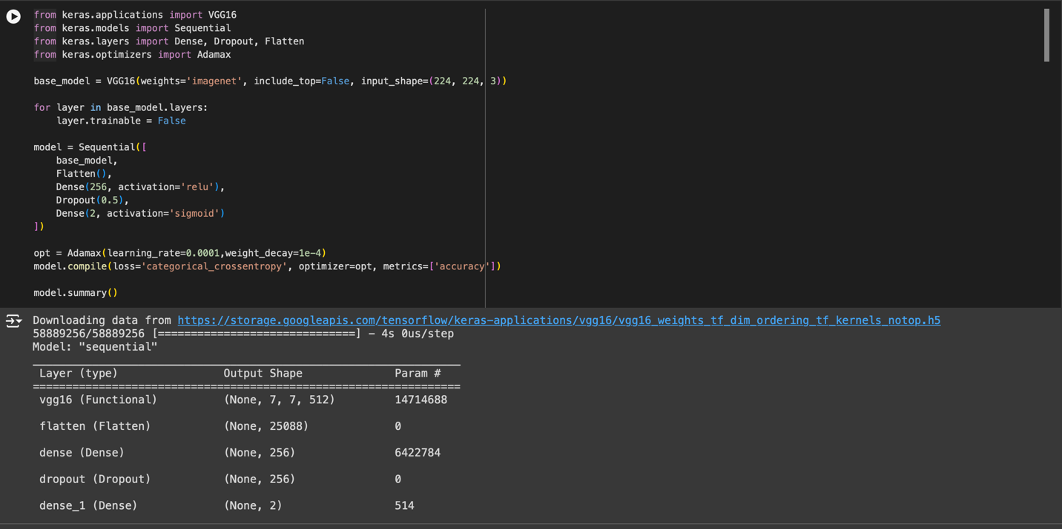

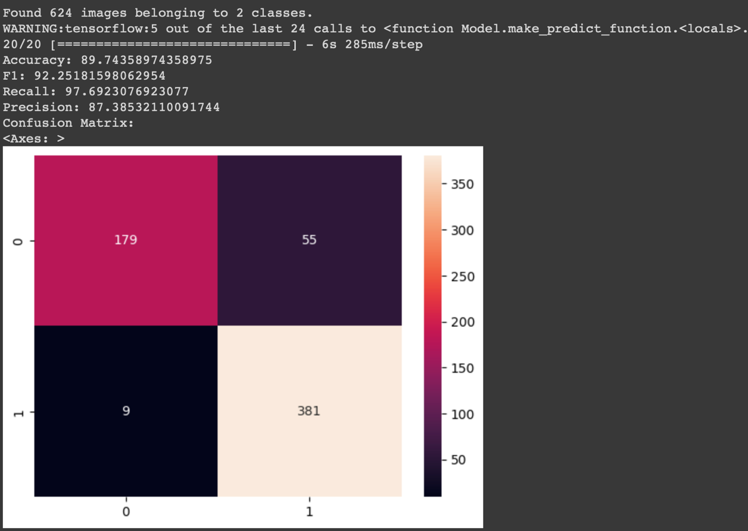

**Result Analysis:**

**Performance good:**

**Accuracy: 89.74358974358975**

**F1: 92.25181598062954**

**Recall: 97.6923076923077**

**Precision: 87.38532110091744**

**And I test the model to classifier Image (Normal, Pneumonia):**

