**Deep Neural Network**

**Sentiment Analysis on Social Media Posts with LSTM**

Experimentation:

**I used different configurations and parameters to enhance performance.**

**-The first result is bad, and I created LSTM, and added bidirectional and globaAveragepooling1D, I didn’t use early stop and used Adam:**

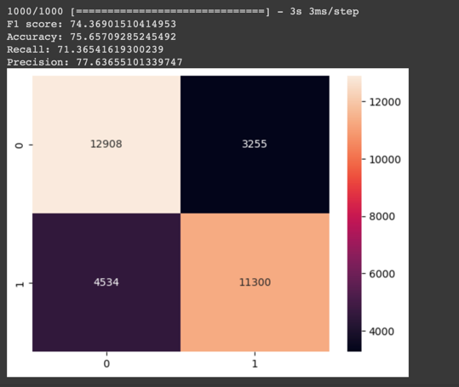

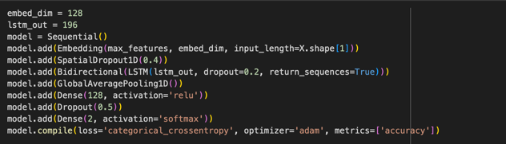

**The second result comes with little decrease in performance. The same model but I used early stopping and ReduceLROnPlateau and used embedding.**

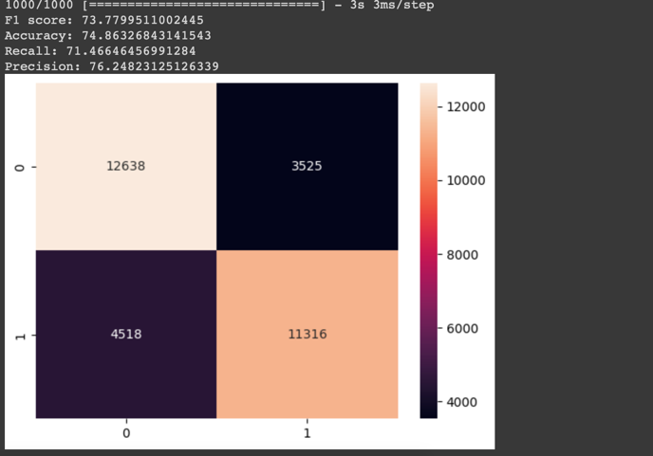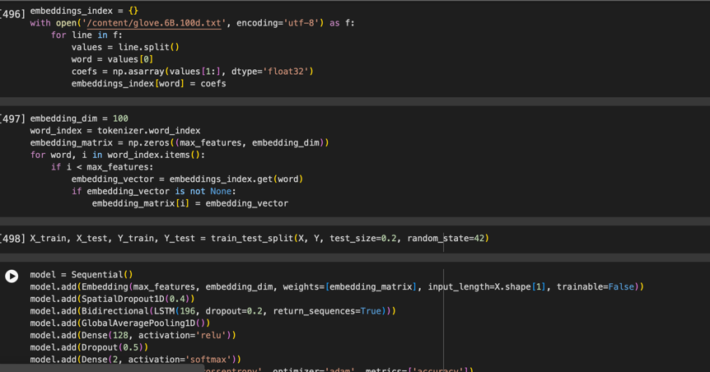

**The last result and the best i used way to tokenize and increase input_dim**

**And decrease epoch without early stopping and increase the batch size and cleaning text**

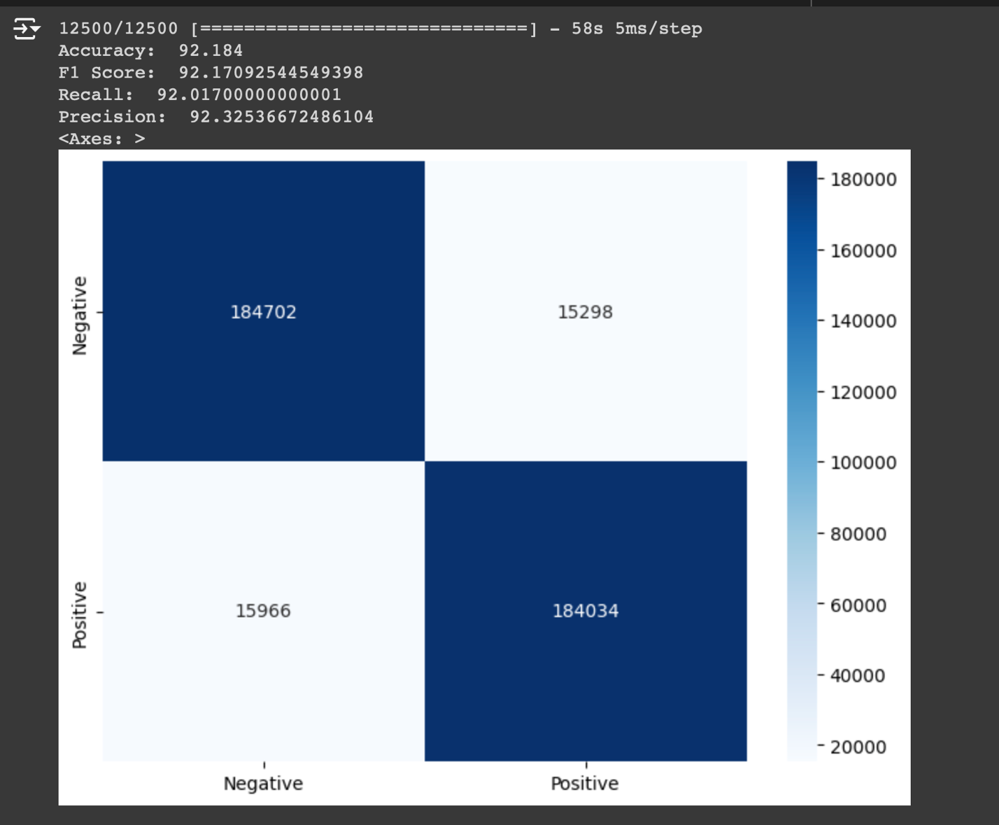

**Result Analysis:**

**Accuracy: 92.184**

**F1 Score: 92.17092544549398**

**Recall: 92.01700000000001**

**Precision: 92.32536672486104**

**Model Performance Summary:**

• **High Accuracy**: The model is right most of the time when predicting sentiments.

• **High F1 Score**: The model does a great job balancing both correctly identifying sentiments.

• **High Recall**: The model is good at catching most of the actual positive or negative sentiments.

• **High Precision**: When the model says something is positive or negative, it’s usually correct.

**And I test the model to classifier sentiments (Positive, negative):**

