Student Performance Prediction System
Phase 1 Report - Synopsis
Project Id: AIML-5
Student Name  Garima Thakur (Team Leader) | University Roll Number  2028419
Section & Group  G (G1) | Branch  CSE (AI/DS)
Student Name  Raghav Pandey | University Roll Number  2028469
Section & Group  G (G1) | Branch  CSE (AI/DS)
Student Name  Arnav Singh | University Roll Number  2028661
Section & Group  G (G1) | Branch  CSE (AI/ML)

1. Problem Description
The Student Performance Prediction System is a Python-based machine learning application designed to analyze and predict student academic outcomes using real-world educational data sourced from Kaggle. In modern academic institutions, identifying at-risk students before their performance deteriorates is a significant challenge. This system addresses that gap by leveraging machine learning to provide early warnings and data-driven insights.
The system processes student data including weekly self-study hours, attendance percentage, class participation scores, and total scores. It applies a complete ML pipeline including data preprocessing, exploratory data analysis, feature selection, regression and classification models, and an interactive Streamlit dashboard to help educators identify students who may need additional academic support.

2. Dataset Description (Kaggle)
The dataset used in this project is sourced from Kaggle and contains 1,000,000 student records. For this project, a random sample of 10,000 records was used to ensure efficient processing. The dataset contains the following features:

Original Column | Range | Description
weekly_self_study_hours | 0 - 40 hrs | Weekly hours spent on self-study
attendance_percentage | 50 - 100% | Percentage of classes attended
class_participation | 0 - 10 | Class participation score
total_score | 9.4 - 100 | Final exam/total score (target variable)
pass_fail (derived) | 0 or 1 | 1 = Pass (score >= 40), 0 = Fail

2.1 Dataset Sample (First 10 Rows)
The following screenshot shows the first 10 rows of the processed dataset after loading and renaming columns:

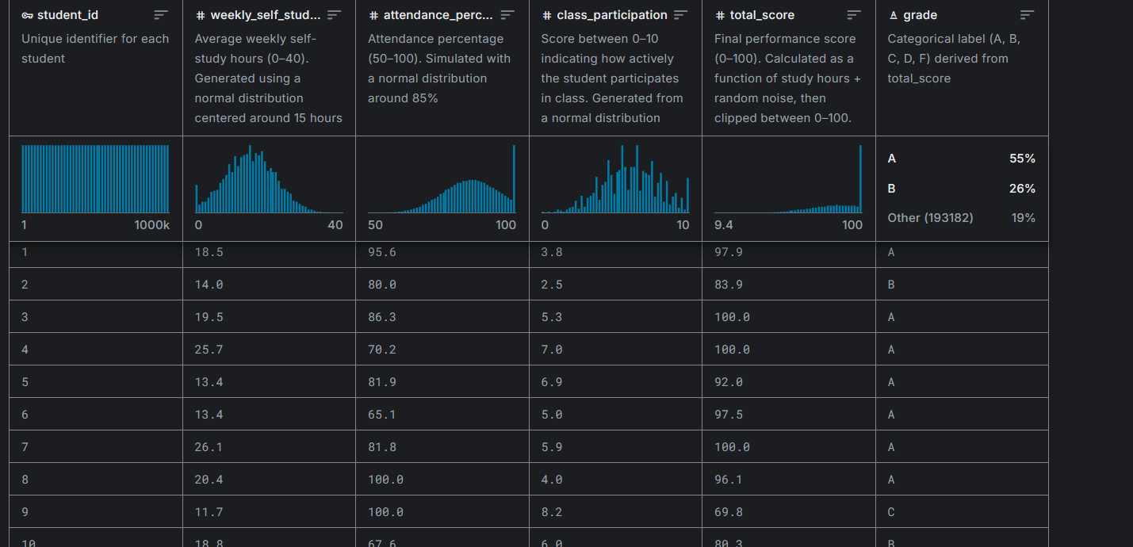
Fig. 1 - Dataset

3. Steps of Implementation
- Dataset Loading: Load Kaggle dataset (student_performance.csv), rename columns, create pass_fail column, sample 10,000 records.
- Data Preprocessing: Check missing values, separate features (X) and target (y), apply 80/20 train-test split, normalize using StandardScaler.
- Exploratory Data Analysis (EDA): Visualize score distributions, analyze feature relationships through scatter plots and heatmaps, detect outliers via box plots.
- Feature Selection: Apply Forward Selection, Backward Selection, and PCA to identify the most influential features for prediction.
- Model Development: Train Linear Regression and Random Forest for score prediction; Logistic Regression for pass/fail classification.
- Model Evaluation: Evaluate using R2 Score and MSE for regression; Accuracy, Precision, Recall for classification.
- Dashboard: Build interactive Streamlit dashboard for live student performance prediction.

4. Proposed Modules

4.1 Data Loading Module
Loads the Kaggle CSV dataset using Pandas, renames columns to standardized names, creates the derived pass_fail binary column, and samples 10,000 records for efficient processing.

4.2 EDA Module
Performs exploratory analysis using histograms for score distribution, scatter plots for feature-score relationships, correlation heatmaps, and box plots for outlier detection.

4.3 Preprocessing Module
Handles feature-target separation, train-test splitting (80/20), and StandardScaler normalization to bring all features to the same scale.

4.4 Feature Selection Module
Implements Forward Selection, Backward Selection using SequentialFeatureSelector, and PCA for dimensionality reduction and key feature identification.

4.5 ML Model Module
Trains Linear Regression and Random Forest Regressor for score prediction, and Logistic Regression for binary pass/fail classification.

4.6 Dashboard Module
Interactive Streamlit web dashboard for live predictions, EDA visualizations, and model result display.

5. Platform Required
- Python 3.11 - Primary programming language
- Visual Studio Code - Code editor with integrated terminal and debugger
- Streamlit - Web framework for interactive ML dashboard
- scikit-learn - Machine learning models and preprocessing
- Pandas & NumPy - Data manipulation and numerical computation
- Matplotlib & Seaborn - Data visualization

6. Books and Link Sources

Books:
- Hands-On Machine Learning with Scikit-Learn, Keras, and TensorFlow - Aurelien Geron
- Introduction to Machine Learning with Python - Andreas C. Muller & Sarah Guido
- Python Machine Learning - Sebastian Raschka
- Let Us Python - Yashavant Kanetkar

Online Resources:
- Kaggle Dataset Source - https://www.kaggle.com/
- scikit-learn Documentation - https://scikit-learn.org/stable/
- Streamlit Documentation - https://docs.streamlit.io/
- GeeksforGeeks ML - https://www.geeksforgeeks.org/machine-learning/
- Stack Overflow - https://stackoverflow.com

