Student Performance Prediction System
Phase 2 Report - Architecture & Preliminary Results
Student Name  Garima Thakur (Team Leader) | University Roll Number  2028419
Section & Group  G (G1) | Branch  CSE (AI/DS)
Student Name  Raghav Pandey | University Roll Number  2028469
Section & Group  G (G1) | Branch  CSE (AI/DS)
Student Name  Arnav Singh | University Roll Number  2028661
Section & Group  G (G1) | Branch  CSE (AI/ML)
Project Id: AIML-5

1. Problem Description
The Student Performance Prediction System analyzes real-world student data from Kaggle (1,000,000 records) to predict academic performance. The system uses a 10,000-record sample with three key features: weekly self-study hours, attendance percentage, and class participation score to predict total exam scores and classify students as pass or fail.

2. System Architecture
Stage | Description
Stage 1 | Kaggle Dataset Load - student_performance.csv loaded, columns renamed, pass_fail derived, 10,000 records sampled
Stage 2 | EDA - Histogram, scatter plots, correlation heatmap, box plots generated
Stage 3 | Preprocessing - Missing value check, 80/20 train-test split, StandardScaler normalization
Stage 4 | Feature Selection - Forward/Backward Selection and PCA applied
Stage 5 | Model Training - Linear Regression, Random Forest (regression); Logistic Regression (classification)
Stage 6 | Evaluation - R2=0.66, MSE=79.57 (RF); Accuracy=99%, Precision=99%, Recall=100%
Stage 7 | Streamlit Dashboard - Interactive live prediction and visualization

3. Models Used

3.1 Linear Regression
Models the linear relationship between features and exam score. Achieved R2 Score of 0.64 and MSE of 83.44 on the Kaggle dataset.

3.2 Random Forest Regressor
Ensemble of 100 decision trees. Outperformed Linear Regression with R2 Score of 0.66 and MSE of 79.57.

3.3 Logistic Regression
Binary classifier for pass/fail prediction using sigmoid function. Achieved 99% accuracy, 99% precision, and 100% recall.

4. Evaluation Metrics Used
Metric | Formula | Interpretation
R2 Score | 1 - (SS_res / SS_tot) | Closer to 1.0 = better fit
MSE | Mean of (y_actual - y_pred)^2 | Lower is better
Accuracy | Correct / Total | Overall classification correctness
Precision | TP / (TP + FP) | When model predicts fail, how often correct?
Recall | TP / (TP + FN) | Of all fails, how many did model catch?

5. Preliminary Results and Visualizations

5.1 Dataset Overview Output
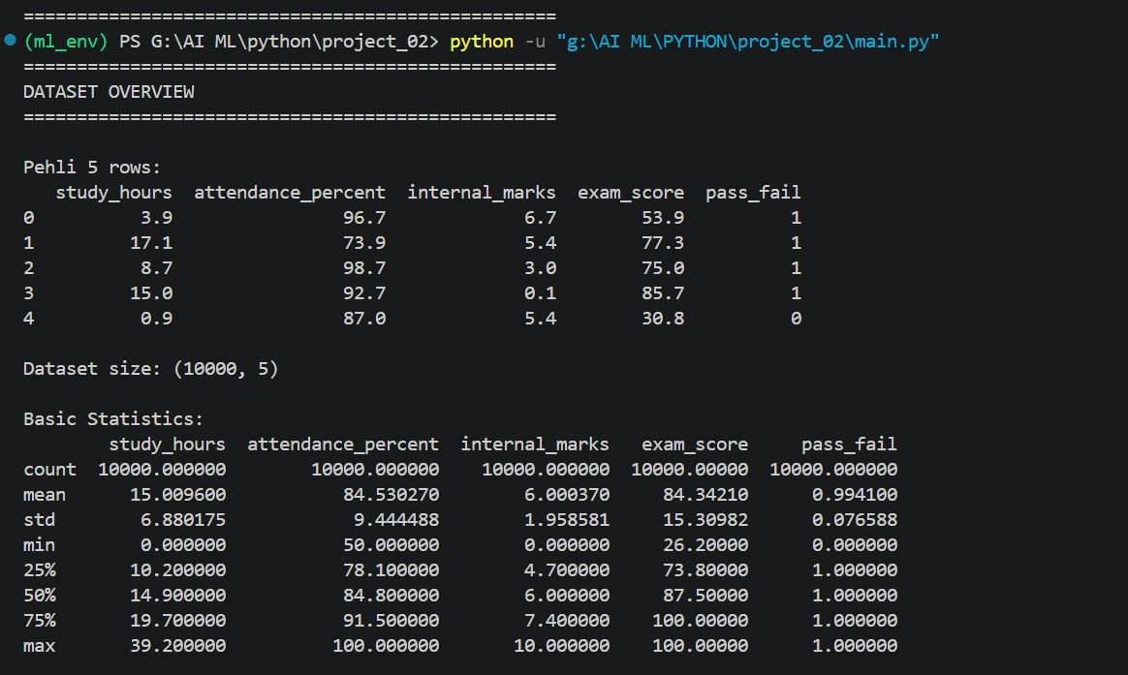
Fig. 1 - Dataset overview: first 5 rows, size (10000, 5), and basic statistics

5.2 Exam Score Distribution
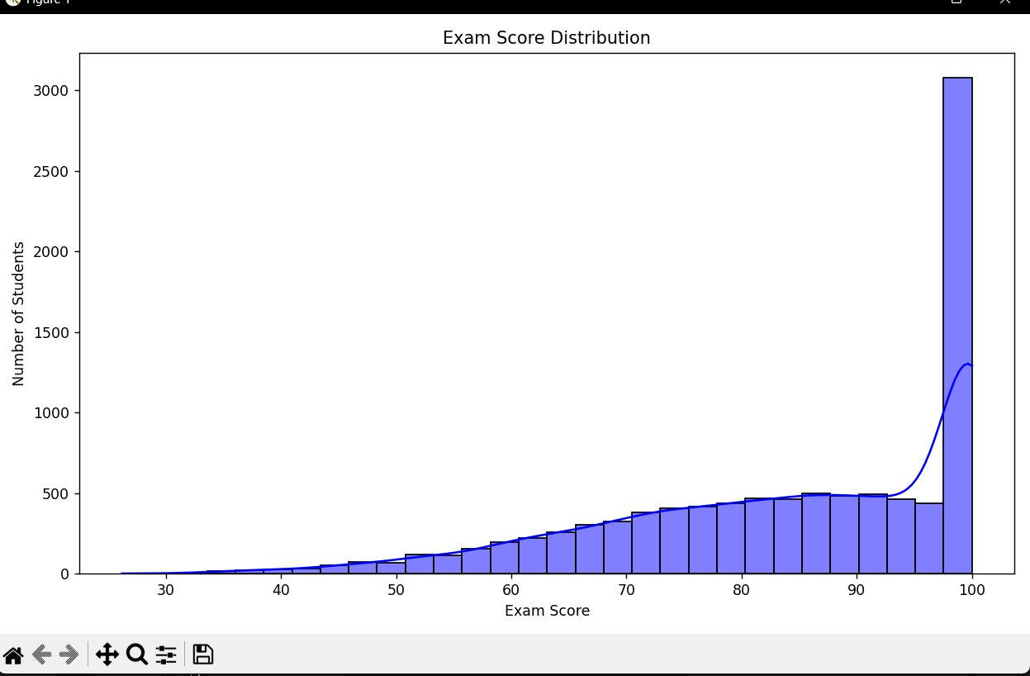
Fig. 2 - Exam Score Distribution: Right-skewed with majority scoring 80-100

5.3 Feature vs Exam Score (Scatter Plots)
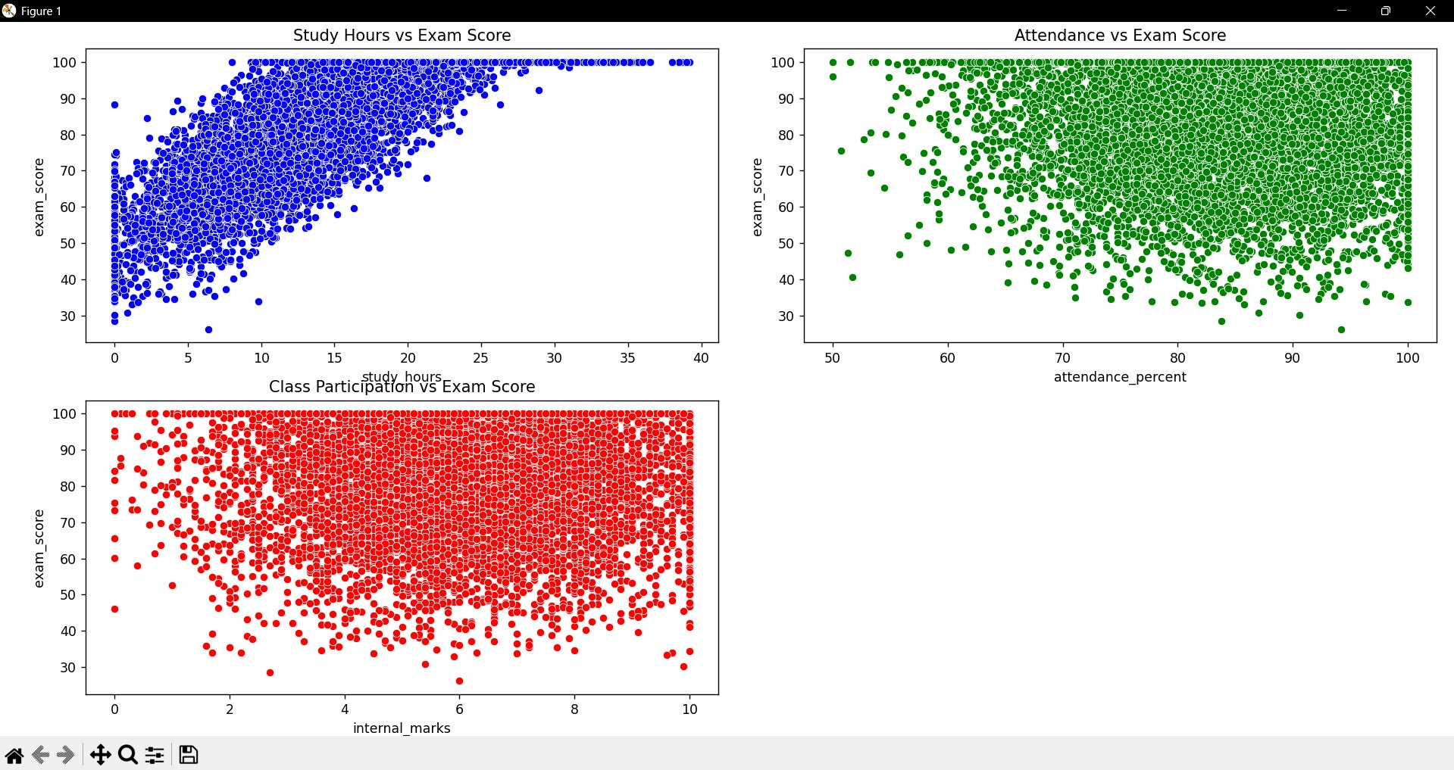
Fig. 3 - Scatter plots: study_hours shows strongest positive correlation with exam_score

5.4 Correlation Heatmap
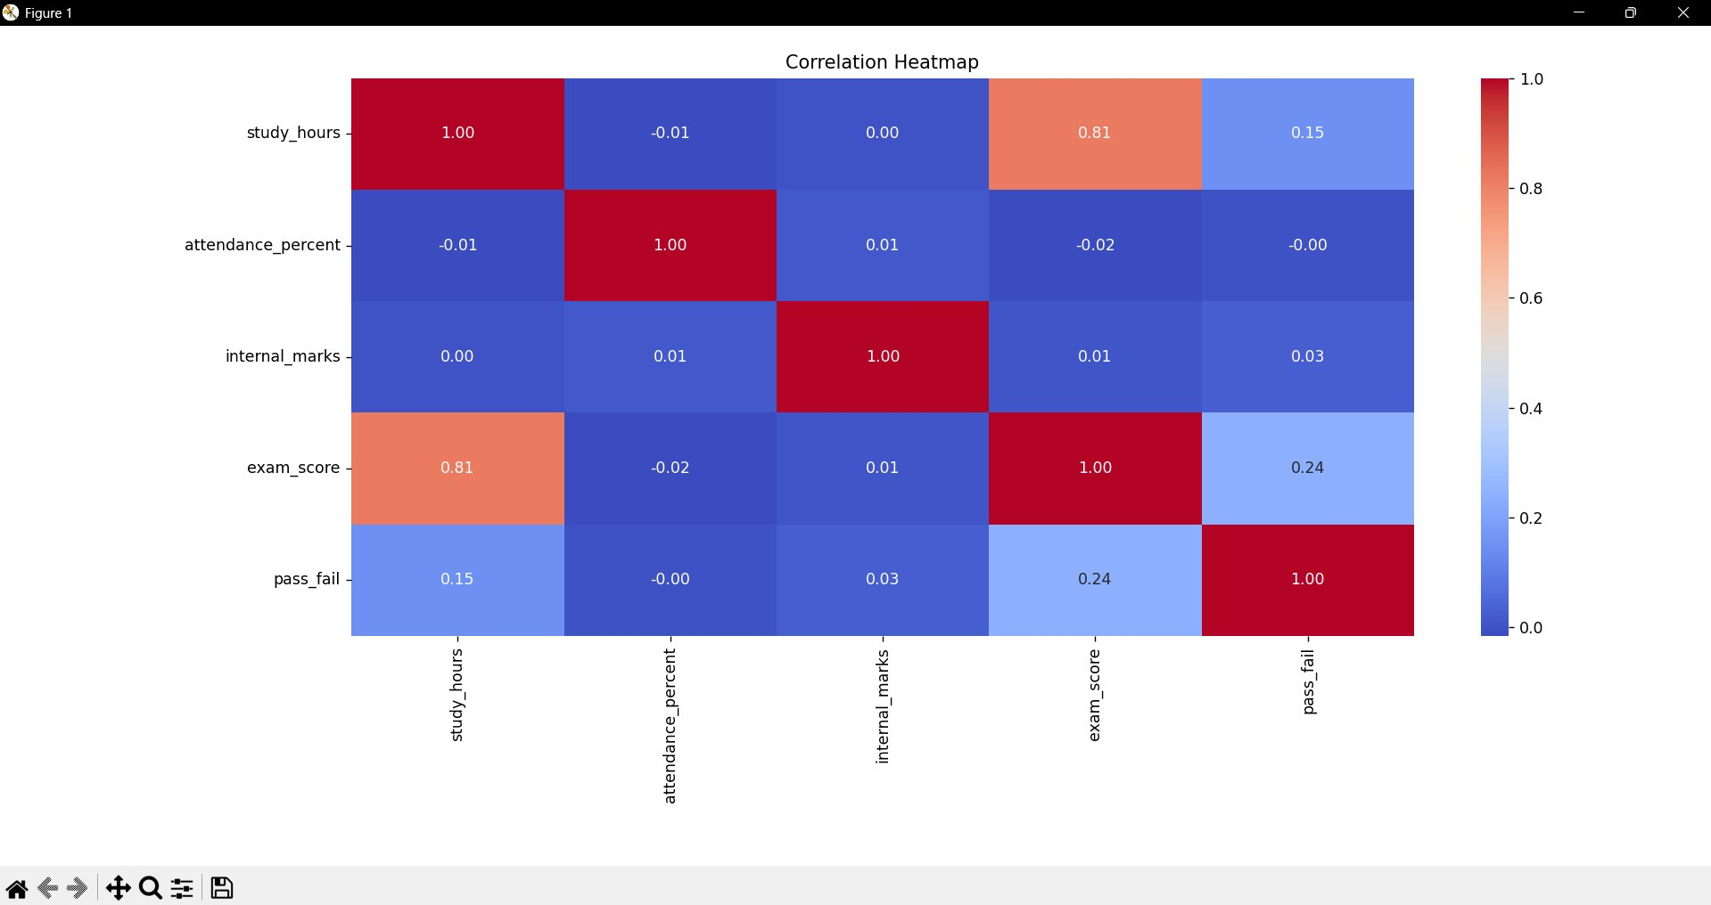
Fig. 4 - Correlation Heatmap: study_hours (0.81) has highest correlation with exam_score

5.5 Model Results
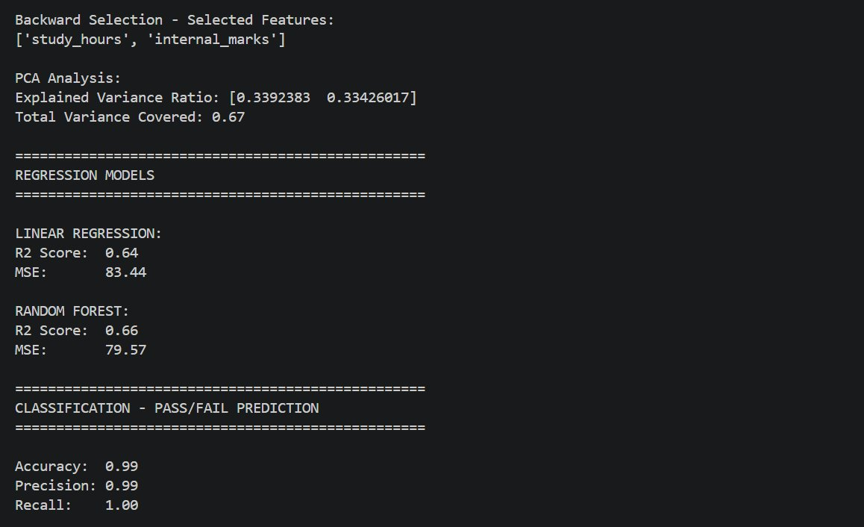
Fig. 5 - Model results: Linear R2=0.64, Random Forest R2=0.66, Classification Accuracy=99%

6. References

Books:
- Hands-On Machine Learning with Scikit-Learn - Aurelien Geron
- Introduction to Machine Learning with Python - Andreas C. Muller
- Let Us Python - Yashavant Kanetkar

Online Resources:
- Kaggle - https://www.kaggle.com/
- scikit-learn - https://scikit-learn.org/stable/
- GeeksforGeeks - https://www.geeksforgeeks.org/
- Stack Overflow - https://stackoverflow.com

