Dear Participant,

Thank you for your submissions on mock data set released on 27 Sep 25. The submissions of most of the participants were aligned to the format and naming conventions prescribed by us. However, some of the submissions were not in the desired format.

Please note, your submissions are going to be evaluated by automated scripts at our end. Hence, your submissions (the five result files) should be machine readable i.e. with prescribed naming convention and prescribed format. All five files should be in CSV format and UTF-8 encoded. To ensure that your submission is properly evaluated and enhance your selection, please take extra care and submit in desired format and naming conventions.

Check points and some common mistake points for your submissions are as under :-

**Check List**

1. The result files are in CSV (Comma Separated Value) format only. Any other format like tab separation will be summarily rejected.
2. Only UTF-8 fonts are to be used.
3. The values are arranged in the desired format only as these are going to be evaluated by Script at our end. Like for Speaker Diarization result, the SD_01 (01 in this case) file has :-

AudioFileName,Speaker,Confidence,StartTS ,EndTS

ps6_01_201.wav,Speaker1,100,002.341,002.798

ps6_01_201.wav,Speaker2,100,006.638,007.552

1. Naming convention is followed properly i.e. file names are ASR_01.csv, LID_01.csv etc.
2. The file ID01.wav is enrolment audio for Speaker Diarization for the speaker named “ID01”.
3. There is no requirement to submit your solution HASH for this submission (will be mandatory during shortlisting stage).
4. Prepare a text file named <your application_id/registration_id>_<evaluation_id (01 in this case)>.txt with only following info to run/execute your solution :-

a. Hardware Requirement

b. Platform/Virtualization Requirement (i.e exsi, hperV etc with virtual cores, memory and storage etc)

c. Any other point you want to bring out.

1. All five result files and text file as per point 5 above is zipped in single file named as <your application_id/registration_id>_<evaluation_id (01 in this case)>.zip

**Common Mistake Points.**

1. **Audio file names to be picked and appended as it is.**

Here “ps6_00_015_proc.wav” is used in place of “ps6_00_015.wav”. This will be rejected by script.

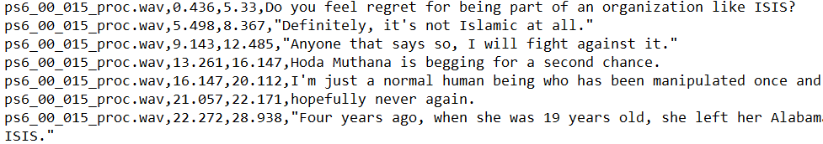

1. **File name of all five result files should be SID_<evaluation_id>.csv, SD_<evaluation_id>.csv, LID_<evaluation_id>.csv, ASR_<evaluation_id>.csv and NMT_00.csv, SD_00.csv.** Any change in the naming convention will be rejected.

Here “ASR_00_modified.csv” is used in place of “ASR_00.csv”. Similarly, for other files. This will be rejected by script.

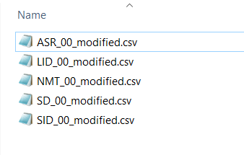

1. **Use only UTF-8 fonts.**

Here UTF-8 with BOM has been used.

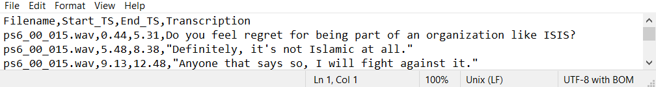

1. **The file IDXX.wav [ ID01.wav] is enrolment data for speaker Diarization. The name IDXX [i.e. ID01] is the name of speaker known to us. No result is expected on this file.**

Here no result is expected on file ID01.wav

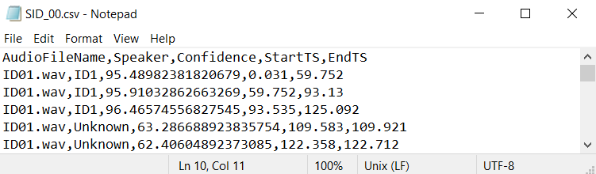

Here **ID1** is used in place of ID01

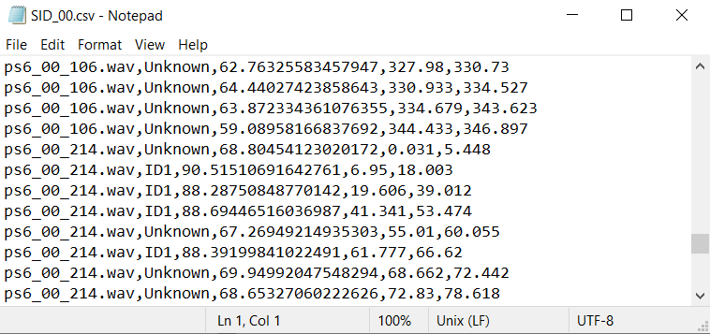

1. **Only lines with correct file name will be evaluated.**

Here, the encircled lines will be ignored. As file name is “XXX”

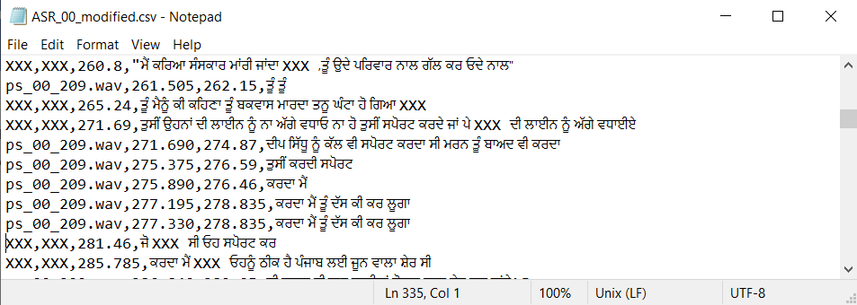

1. **Please follow correct format as defined for each result file.**

The format for the result files are

SID file -> Audio File Name, speaker ID, confidence score (in %), start TS, end TS

SD file -> Audio File Name, speaker, confidence score (in %), start TS, end TS

LID file -> Audio File Name, language, confidence score (in %), start TS, end TS

ASR file -> Audio File Name, start TS, end TS, Transcript

NMT file -> Audio File Name, start TS, end TS, Translation

Here speaker is included in LID result. Also, the confidence score is given at the last. Which will be rejected by our script.

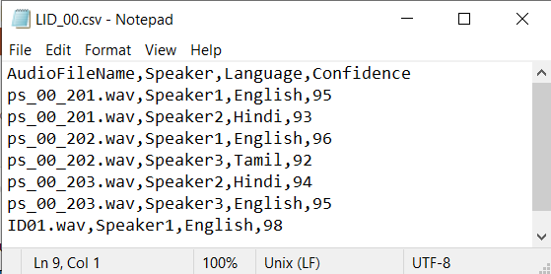

1. **Only five result files are required to be submitted.** Separate Result files for each audio files will not be processed.

Here, three ASR files (for three audio files) are submitted separately. Which is wrong.

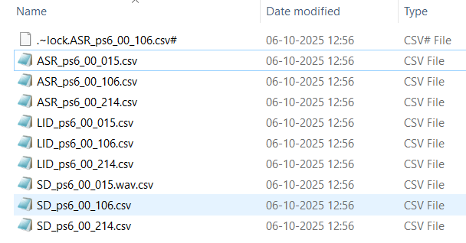

1. The final submission is a zip file and named as

<your application_id/registration_id>_<evaluation_id (01 in this case)>.zip

Here naming convention is not followed and one file is in rar compression.

