**Experiment :-** Automatic Night Lighting System

**Circuit Diagram:-**

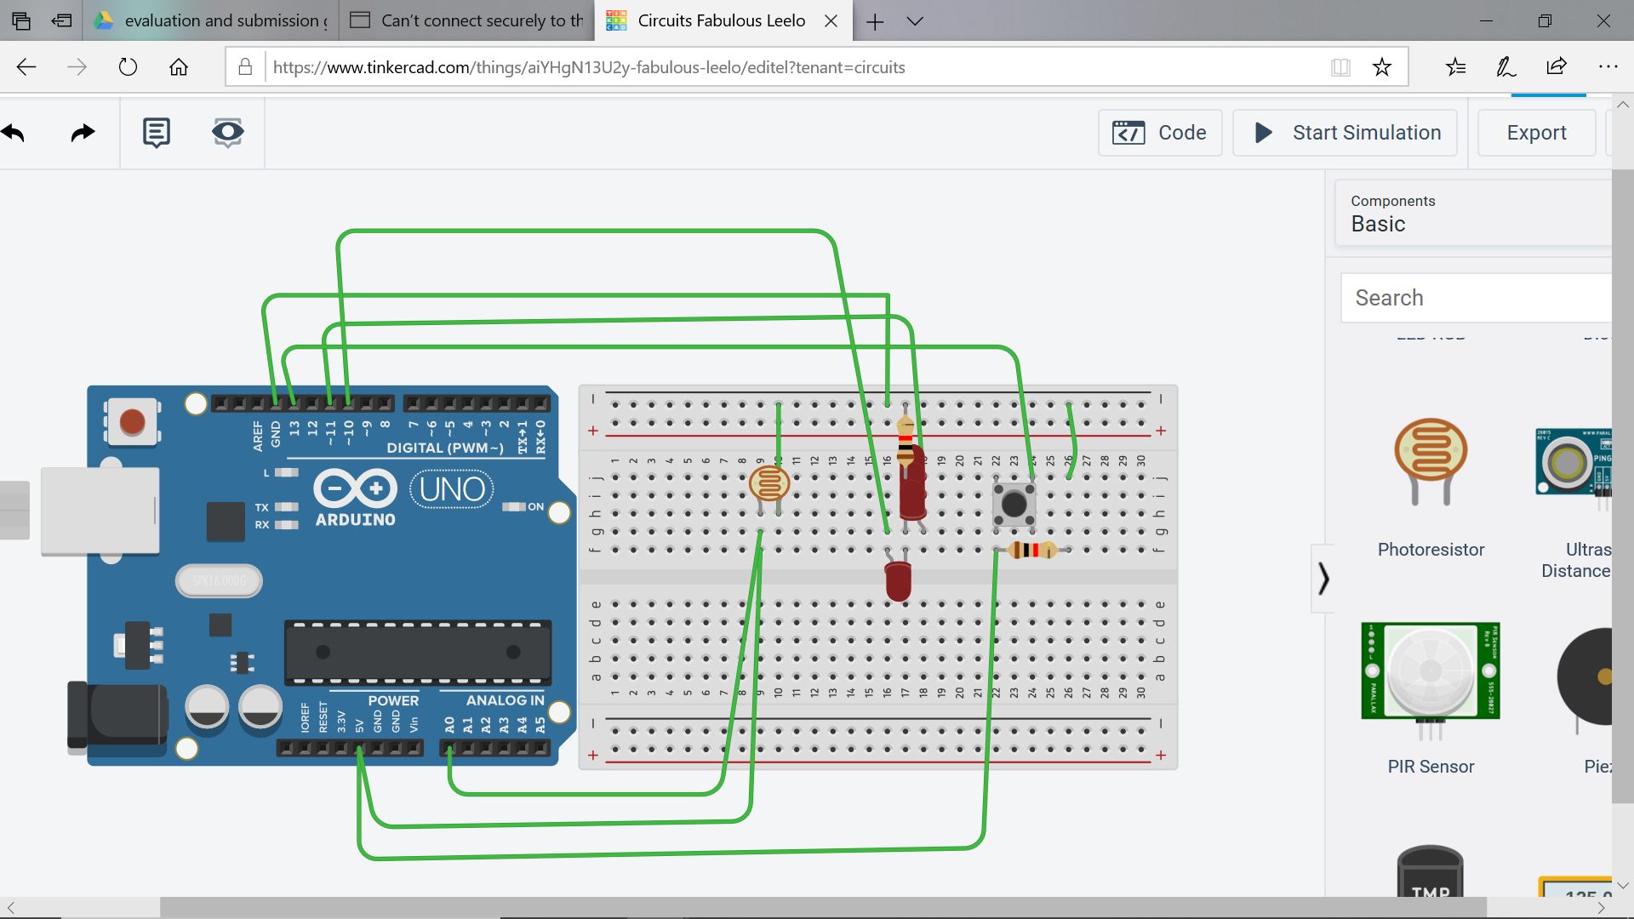

**Theory:-**

**Concept used:-**

The concepts used by me for doing this task can be listed as:-

* The arduino board can supply a power of 5v as digital output signals through the 14 pins (namely 0-13) present in it as digital input or output pins.
* The GND pin of the arduino board acts as ground.
* In the bread board present in the above circuit diagram the two rows present at the top and bottom each, are connected with each other in series and the columns present in between are connected in a set of 5 each. The connection pattern is shown below: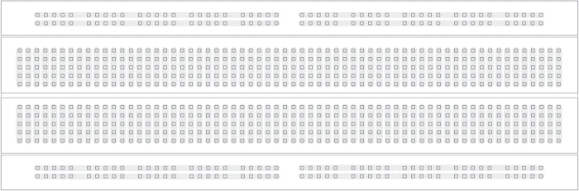

**Learning and Observation:-**

**Leanings:**

* I have learned about how to make a series circuit using an arduino board and a breadboard.
* I have learned about how an arduino works and I also learned how current flows and how it works.
* I have now gained a practical experience of how an LED and a resistor work.

**Observations:-**

* When we pass electrical signals to the arduino through our code the LED glow and gets off accordingly.

**Problems and Troubleshooting:-**

The problems faced by me while doing this task are :-

* The LED bulb was not working . I had to replace the bulb with another one.
* The circuit was not getting closed because the wires were not placed at the right position so I had to change the position of the wires to the right position.

**Precautions:-**

The precautions that we need to keep in mind while doing this experiment are:-

* The connections at different points should not be loose and the pins should be inserted properly.
* The two pins of the LED should be connected at their appropriate point that is the positive point should be connected with the p pin and the negative point should be connected with the negative pin.
* We should take care that the circuit is closed .

**Learning Outcomes:-**

* I have learned how to make circuits using an arduino board and a bread board and some other hardwares.
* Through this experiment I have gained the skill of making a circuit using different hard wares and controlling the functions done by that circuit with the help of codes.