Documentation by Raghav Shukla (GSBSP-MP02)

This Documentation is for the Frontend Workshop and Hackathon conducted by Girlscript Bilaspur.

Name – Raghav Shukla

Code- GSBSP-MP02

Website link - <https://raghav-byte.github.io/Frontend_Memes-Page_GSBSP-MP02/index.html>

The theme I chose for the hackathon is creating a Meme Page which should have the following elements in minimum

* Nav Bar
* Home Page / Landing Page
* About Section
* Footer
* 30 memes

I created the website by the help of following resources :

1. Pinterest ( For downloading Memes )
2. Canva ( For logo and Background Image )
3. Created the Bootstrap Template using Bootstrap Studio

This is the first website I’ve created on my own .The workshop cleared my concept and helped me remarkably .

Here are some snapshots of my website 🡪

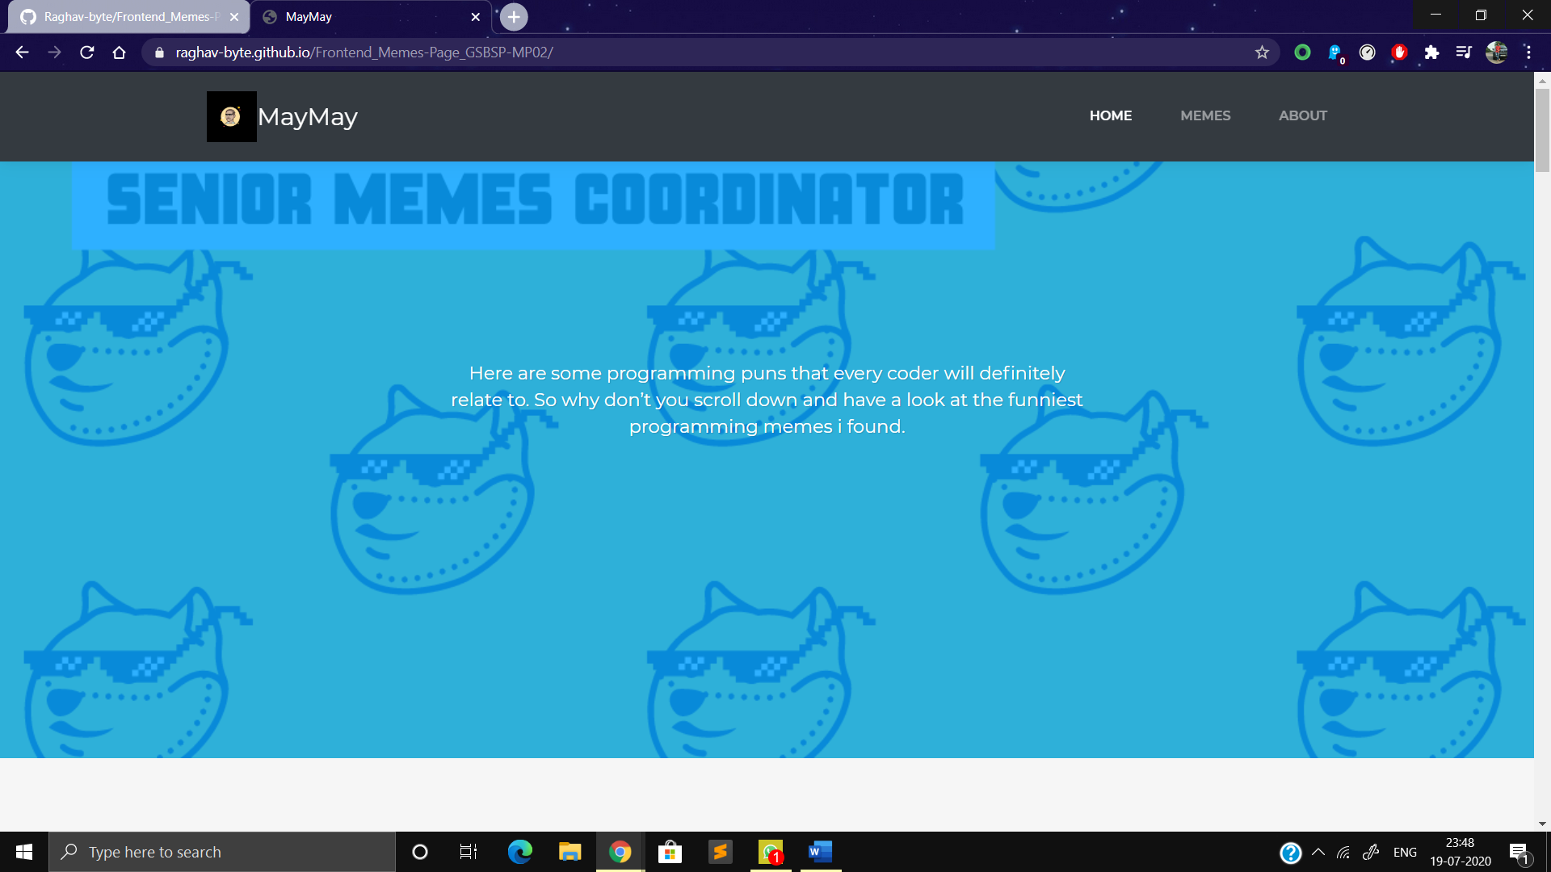

This is the home page

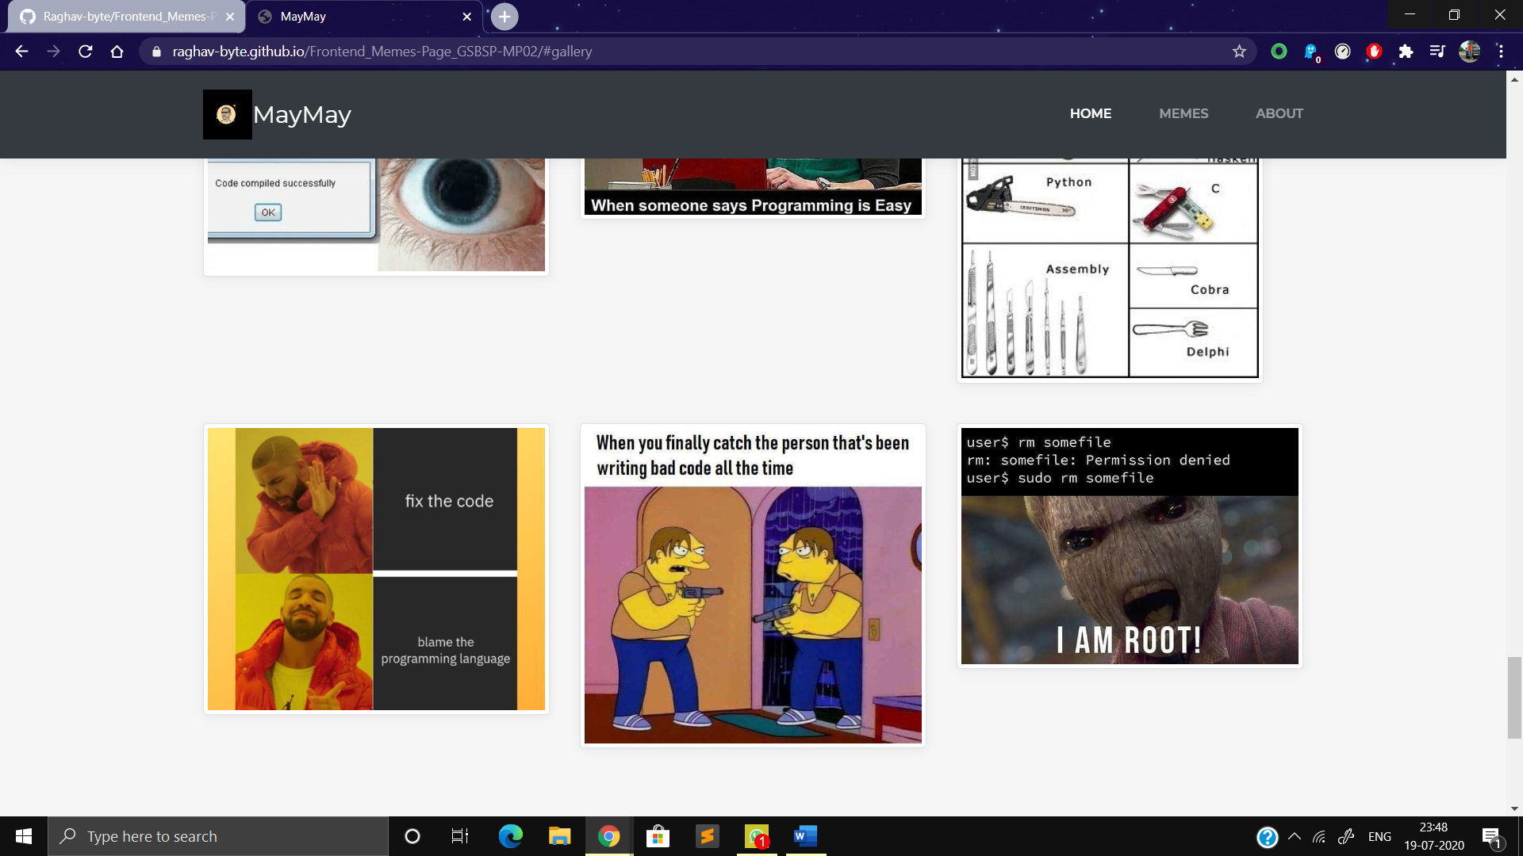Some memes

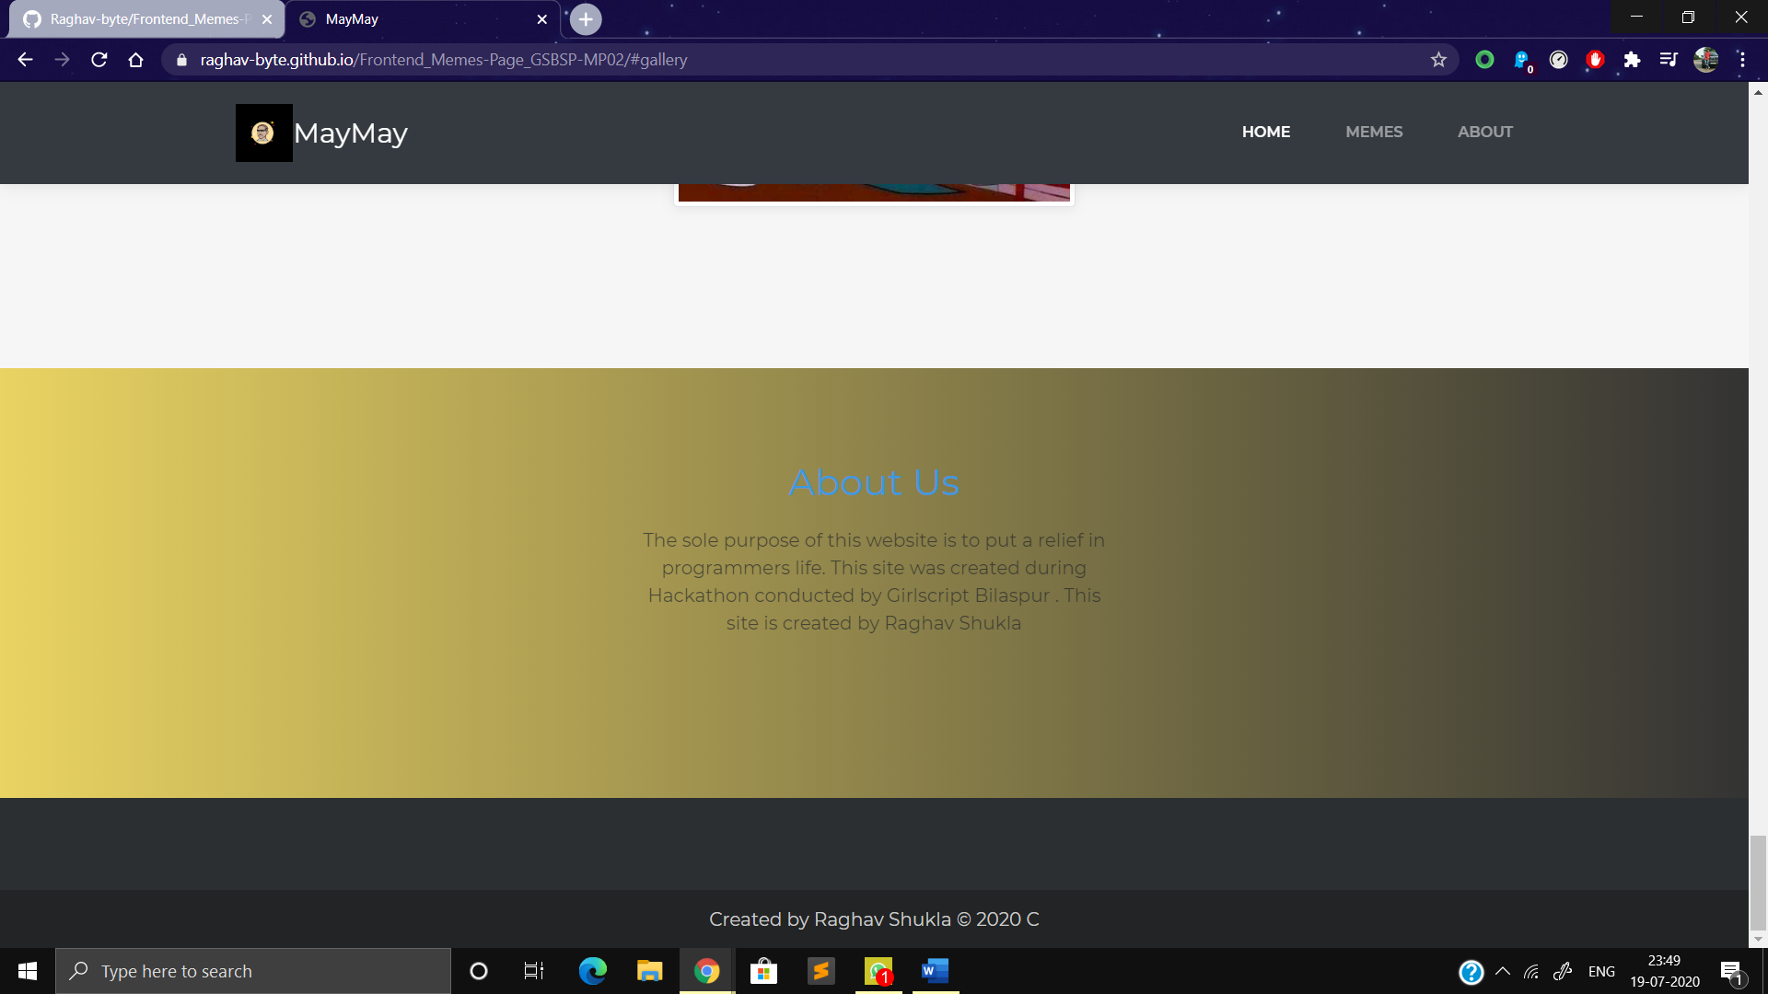And the about us section .

I tried my best in this . Hope you’ll like it !

Thanks