Trader Performance vs. Market Sentiment
Hyperliquid Historical Trades × Bitcoin Fear/Greed Index
Prepared by Raghav | Primetrade.ai Data Science Assignment

1. Overview & Methodology
This analysis merges two datasets: 211,224 individual trade records from 32 Hyperliquid accounts (May 2023 - May 2025), and the daily Bitcoin Fear/Greed Index (Feb 2018 - May 2025). Trades were joined to sentiment by calendar date, matching 211,218 of 211,224 records (99.997%). Only 6 trades fell outside the sentiment index's coverage and were dropped.
Sentiment days are grouped into five classes on the standard Fear/Greed scale: Extreme Fear, Fear, Neutral, Greed, Extreme Greed. "Closed PnL" rows (non-zero) represent realized profit/loss events and are the basis for all performance metrics below; the full trade set (including position opens) is used for volume and sizing metrics.

2. Headline Numbers
Sentiment | Trades | Total PnL (USD) | Avg PnL / Trade | Win Rate
Extreme Fear | 10,406 | $739,110 | $71.03 | 76.2%
Fear | 29,808 | $3,357,155 | $112.63 | 87.3%
Neutral | 18,159 | $1,292,921 | $71.20 | 82.4%
Greed | 25,176 | $2,150,129 | $85.40 | 76.9%
Extreme Greed | 20,853 | $2,715,171 | $130.21 | 89.2%

Two things jump out immediately. First, traders are net profitable in every sentiment regime, which says less about market timing skill and more about this being a curated set of active, surviving Hyperliquid accounts (29 of 32 accounts are net profitable overall). Second, performance is not linear across the fear-greed spectrum: Neutral days are the weakest regime, while both tail sentiments (Extreme Fear and Extreme Greed, but especially Extreme Greed) produce the best average PnL and the best win rates.

3. Key Findings

3.1 Extreme sentiment days outperform neutral days
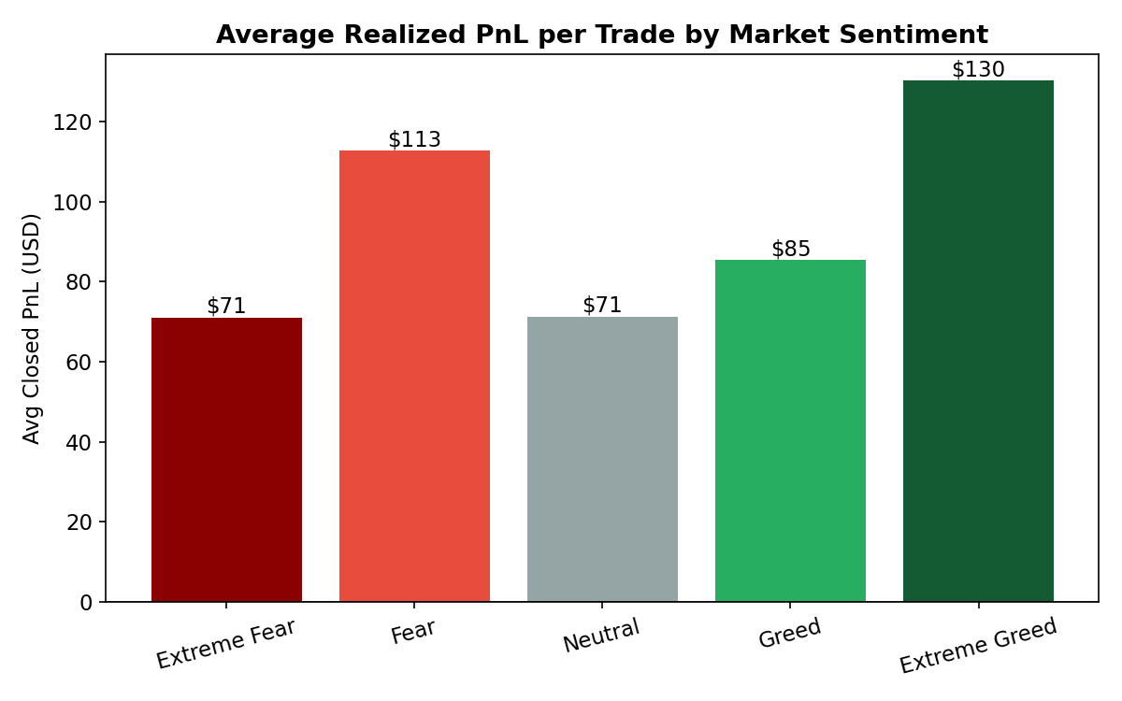
Figure 1. Average realized PnL per closed trade, by sentiment.
Average PnL per trade is lowest on Neutral days ($71.20) and highest on Extreme Greed days ($130.21) and Fear days ($112.63). This is a classic "trade the extremes, not the middle" pattern: when sentiment is undecided, price action is choppier and less directional, which shows up directly in realized PnL.

3.2 Win rate follows the same U-shape
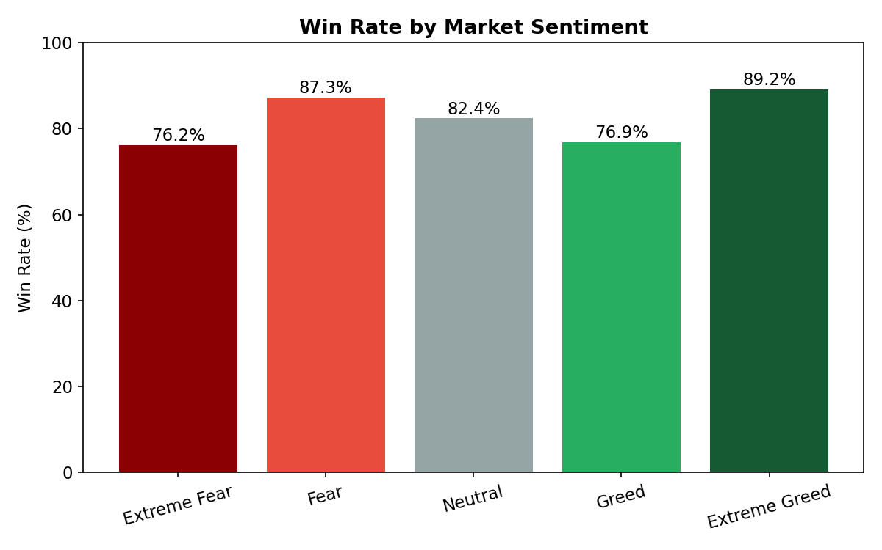
Figure 2. Win rate (% of closed trades with positive PnL), by sentiment.
Win rate is highest during Extreme Greed (89.2%) and Fear (87.3%), and noticeably lower during plain Greed (76.9%) and Extreme Fear (76.2%). Extreme Fear is the interesting outlier here: PnL and win rate are both weaker than plain Fear, suggesting panic-driven days are more volatile and harder to trade cleanly than a steady "Fear" grind.

3.3 Traders size up during Fear, size down during Extreme Greed
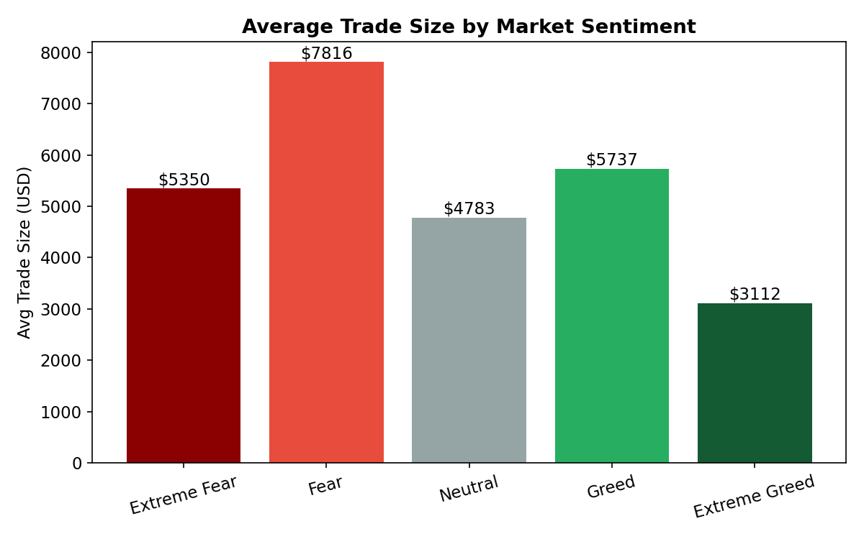
Figure 3. Average trade size (USD), by sentiment.
Average trade size is largest during Fear ($7,816) and smallest during Extreme Greed ($3,112) - roughly 2.5x apart. Combined with the volume chart below, this points to traders adding size when the market is fearful (buying dips / accumulating) and trading smaller, more frequent tickets once sentiment turns euphoric, consistent with de-risking or scalping behavior near tops.

3.4 Volume is concentrated in Fear and Greed, not the extremes
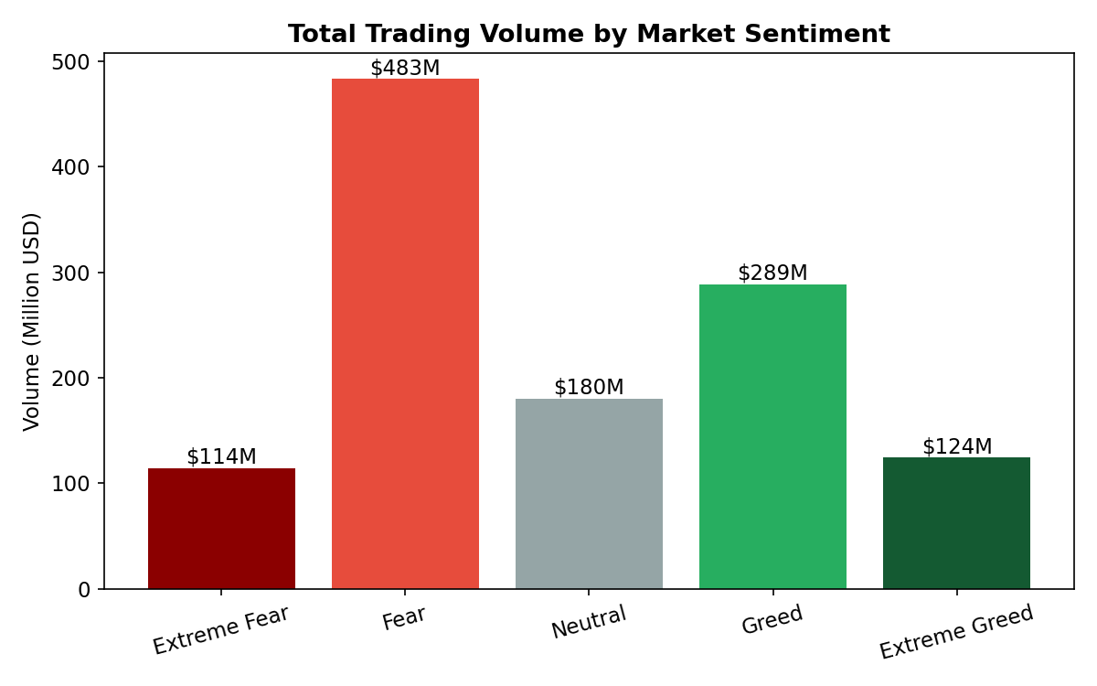
Figure 4. Total trading volume by sentiment (in $M).
Fear ($483M) and Greed ($289M) account for the majority of total notional volume, well ahead of Extreme Fear ($114M) and Extreme Greed ($125M). Traders are most active in the moderate zones of the cycle, and pull back on both the panic and euphoria tails, even though (per 3.1) the tails are actually where the best average PnL shows up.

3.5 Sentiment flips the long/short bias
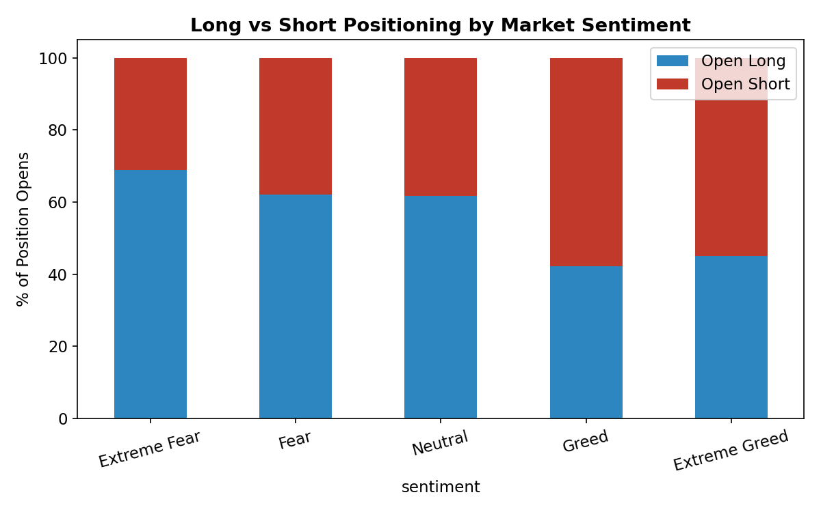
Figure 5. Share of new Long vs. Short positions opened, by sentiment.
This is the most actionable pattern in the dataset. During Extreme Fear, 69% of new positions opened are Longs; during Fear, 62% are Longs. That flips during Greed (58% Short) and Extreme Greed (55% Short). In other words, these traders behave as contrarians: buying into fear and fading strength/greed, rather than chasing sentiment. Given this cohort is mostly net profitable, that contrarian bias looks like a contributor to their edge rather than noise.

4. Supplementary Observations
- Correlation between the raw Fear/Greed index value and per-trade PnL is essentially zero (r = 0.009). The relationship is not linear in the index score - it's the categorical extremes vs. middle pattern shown above, not "higher score = more profit."
- HYPE, BTC, ETH and SOL account for the bulk of trading activity by trade count; @107, HYPE and SOL are the top three coins by total realized PnL.
- Fee burden (fees as % of notional volume) is essentially flat across sentiment, around 1.9-2.2%, so fees are not a confound in the PnL patterns above.
- Looking at the 24 accounts with sufficient trade history in both Fear and Greed, two-thirds (16/24) post higher average PnL per trade during Greed than during Fear, even though in aggregate Fear produces a higher portfolio-wide average. This means a handful of high-volume accounts are driving the aggregate Fear number, so account-level strategy should be validated per-trader rather than assumed from the pooled averages alone.
- The dataset itself is survivorship-biased: it only contains 32 accounts, all of which are active/traceable on Hyperliquid, and 90% of them are net profitable. Real-world sentiment-based strategies should be validated on a broader, unfiltered trader population before drawing causal conclusions.

5. Strategic Implications
- Extremes over the middle: position sizing and signal confidence should scale up on Extreme Fear / Extreme Greed days and scale down on Neutral days, where realized edge is measurably thinner.
- Respect the contrarian tilt: the profitable pattern in this data is fading sentiment (long into fear, short into greed) rather than momentum-chasing it - worth testing as an explicit signal rather than an incidental behavior.
- Watch Extreme Fear separately from Fear: despite the "Fear" label, Extreme Fear has the weakest win rate after Neutral, suggesting panic conditions carry more execution risk even when the eventual average PnL is fine.
- Size discipline in euphoria: the smaller average ticket size in Extreme Greed already looks like good risk management by this cohort, and is consistent with the standard advice to reduce size as speculative excess builds.

6. Limitations
- Sentiment is a single daily label applied to all trades on that date; it doesn't capture intraday sentiment shifts.
- Small sample of accounts (32) and a two-year window; results may not generalize across market cycles or to less active/less skilled traders.
- PnL captured here is realized/closed PnL only; open positions carried across sentiment regimes are not attributed to a single regime.

