**Language Learning Chatbot - Technical Documentation**

**1. Introduction**

The Language Learning Chatbot represents an advanced application of artificial intelligence (AI) and natural language processing (NLP) to facilitate second-language acquisition through interactive, scenario-based dialogue. By leveraging state-of-the-art large language models (LLMs) and structured data storage, this system provides dynamic conversational feedback, real-time linguistic corrections, and personalized learning pathways tailored to individual proficiency levels. The chatbot is designed to systematically track linguistic errors, store them for future reference, and offer targeted pedagogical interventions to enhance the user’s language proficiency.

**2. System Architecture**

**Core Components**

1. **User Interface (CLI or GUI):** Serves as the primary medium for user interaction, processing text-based input and rendering chatbot responses.
2. **Conversational Engine (OpenAI GPT-4 via LangChain):** Utilizes a robust AI model to generate coherent, contextually appropriate responses in the target language while identifying syntactical and grammatical errors.
3. **Persistent Memory (LangChain Memory):** Maintains contextual continuity within conversations, ensuring a natural and coherent user experience.
4. **Error Logging and Analysis (SQLite Database):** Implements structured data storage for capturing linguistic errors, which supports long-term learning and personalized feedback.
5. **Feedback and Improvement Module:** Processes error data to provide users with an analytical review of their mistakes and suggest targeted learning strategies.

**System Architecture Diagram**

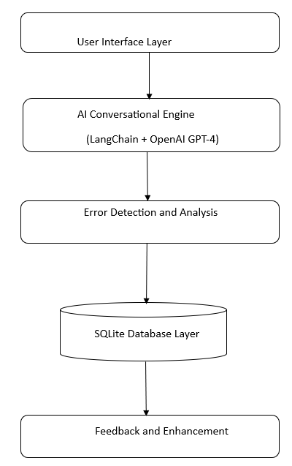

**3. Functional Workflow**

**Processing Pipeline**

1. **User Initialization:**
   * The system prompts the user to specify their native language, target language, and current proficiency level.
2. **Contextual Engagement:**
   * The chatbot establishes a relevant conversational scenario (e.g., social interactions, professional discussions, travel-based conversations) to simulate real-world language usage.
3. **Error Detection & Real-Time Correction:**
   * The NLP model identifies linguistic errors, including syntax, semantics, and phonetics (where applicable).
   * Corrections and suggestions are logged for structured review.
4. **Memory-Based Contextual Adaptation:**
   * Prior conversational history is leveraged to maintain coherence and improve retention.
5. **Post-Interaction Feedback Analysis:**
   * The system generates a structured report summarizing frequent errors, key learning areas, and personalized recommendations.

**4. Technological Stack**

| **System Component** | **Technology Utilized** |
| --- | --- |
| Language Model | OpenAI GPT-4 via LangChain |
| Context Management | LangChain Memory |
| Database Management | SQLite |
| Backend Framework | Python |
| Environment Variables | . env |

**5. Conclusion and Future Scope**

The Language Learning Chatbot is an intelligent, AI-driven language tutor that facilitates active, interactive learning through natural dialogue. Integrating adaptive memory retention and error-tracking capabilities enhances linguistic competence in a highly personalized manner. Future enhancements may include multimodal support (text and voice), integration with mobile platforms, and the implementation of reinforcement learning techniques to optimize error detection and correction mechanisms.