Name: Raghav Birewar  
PRN: 21070521056  
GenAI CA2 Submission  
  
Q2. Generate a model in Python to represent a Housing loan scheme and create a chart to

display the Emi based on rate of interest and reducing balance for a given period. If a customer

wishes to close the loan earlier, print the interest lost distributed over the remaining no. Of

months. Assume suitable data and inputs as necessary.

Solution:

class HousingLoan:

def __init__(self, loan_amount, annual_interest_rate, loan_period_years):

self.loan_amount = loan_amount

self.annual_interest_rate = annual_interest_rate

self.loan_period_years = loan_period_years

self.loan_period_months = loan_period_years * 12

self.monthly_interest_rate = annual_interest_rate / 12 / 100

self.emi = self.calculate_emi()

* Defines a class HousingLoan that initializes with loan_amount, annual_interest_rate, and loan_period_years.
* Converts the loan period into months and calculates the monthly interest rate.
* Calls a method to calculate the Equated Monthly Installment (EMI) immediately upon initialization.

def calculate_emi(self):

r = self.monthly_interest_rate

n = self.loan_period_months

P = self.loan_amount

emi = (P * r * (1 + r)**n) / ((1 + r)**n - 1)

return emi

* This method calculates the EMI using the standard EMI formula.
* It returns the EMI value based on the principal loan amount, monthly interest rate, and total number of months.

def calculate_outstanding_balance(self, months_paid):

r = self.monthly_interest_rate

n = self.loan_period_months

P = self.loan_amount

remaining_balance = (P * ((1 + r)**n - (1 + r)**months_paid)) / ((1 + r)**n - 1)

return remaining_balance

* This method computes the outstanding loan balance after a certain number of months have been paid.
* The formula subtracts the effects of the months paid to determine how much remains of the loan.

def calculate_interest_lost(self, months_paid):

total_paid = self.emi * months_paid

remaining_balance = self.calculate_outstanding_balance(months_paid)

interest_lost = self.loan_amount + (self.emi * self.loan_period_months) - (total_paid + remaining_balance)

return interest_lost / (self.loan_period_months - months_paid)

* This method calculates the amount of interest lost if the loan is closed before the complete loan term.
* It finds how much interest is lost monthly over the remaining period of the loan.

def plot_emi_vs_interest(loan_amount, loan_period_years):

interest_rates = np.linspace(5, 15, 100) # Interest rates from 5% to 15%

emis = []

for rate in interest_rates:

loan = HousingLoan(loan_amount, rate, loan_period_years)

emis.append(loan.emi)

plt.figure(figsize=(10, 6))

plt.plot(interest_rates, emis, label='EMI', color='blue')

plt.xlabel('Interest Rate (%)')

plt.ylabel('EMI Amount')

plt.title('EMI Amount vs Interest Rate for Loan Period of {} Years'.format(loan_period_years))

plt.grid(True)

plt.show()

* This function generates and plots a graph showing the variation in EMI as a function of different interest rates (from 5% to 15%) for a given loan period.
* Uses numpy to generate a range of interest rates and iterates to calculate EMI for each rate, which is then plotted using matplotlib.

loan_amount = 500000 # Example loan amount

loan_period_years = 10 # Example loan period (years)

annual_interest_rate = 8 # Example interest rate

loan = HousingLoan(loan_amount, annual_interest_rate, loan_period_years)

months_paid = 5 * 12

outstanding_balance = loan.calculate_outstanding_balance(months_paid)

interest_lost = loan.calculate_interest_lost(months_paid)

print(f"EMI for loan amount {loan_amount} at {annual_interest_rate}% interest: {loan.emi:.2f}")

print(f"Outstanding balance after {months_paid} months: {outstanding_balance:.2f}")

print(f"Interest lost per month if loan is closed after {months_paid} months: {interest_lost:.2f}")

plot_emi_vs_interest(loan_amount, loan_period_years)

* **Initialize loan**: Create a loan object with specified loan amount, interest rate, and loan period.
* **Calculate EMI**: Print EMI, outstanding balance after 5 years (60 months), and interest lost if the loan is closed early.
* **Plot**: Plot EMI vs. interest rates using the plot_emi_vs_interest function.

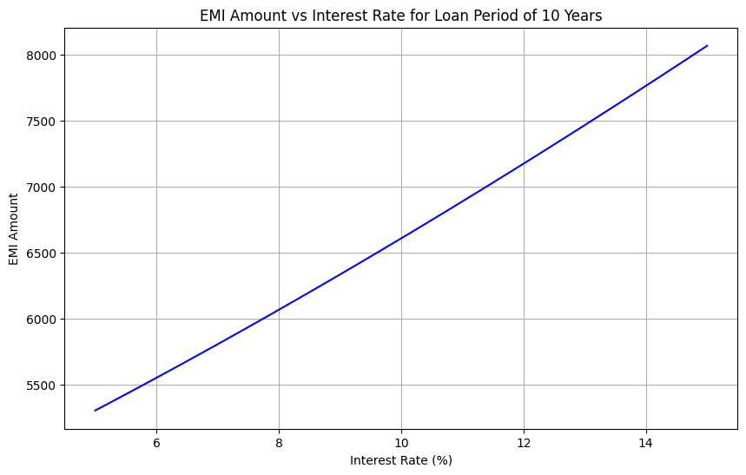]

Q4. Generate a model to represent interest calculations of a Bank account where the process of

calculating interest for 6 months is a. Find minimum balance for each month b. Make a total of

all minimum balances c. Calculate interest based on interest rate d. Divide interest by 12 to

find one-month interest e. Multiply interest by 6 to show interest in the account. Generate a

model to represent transactions and interest calculations for 6 months.

Solution:

class InterestBankAccount:

def __init__(self, account_id, initial_balance, annual_interest_rate):

self.account_id = account_id

self.initial_balance = initial_balance

self.annual_interest_rate = annual_interest_rate

self.transactions = [[] for _ in range(6)] # Transactions for 6 months

self.min_balances = [initial_balance] * 6 # Initialize with initial balance

* Initializes a InterestBankAccount class with account_id, initial_balance, and annual_interest_rate.
* Sets up lists to store 6 months of transactions and initialize the minimum balances for each month with the initial balance.

def add_transaction(self, month, amount):

if 0 <= month < 6:

self.transactions[month].append(amount)

self.update_min_balance(month)

* Allows adding a transaction (deposit/withdrawal) for a specified month.
* After a transaction is added, it calls the update_min_balance method to recalculate the minimum balance for that month.

def update_min_balance(self, month):

current_balance = self.initial_balance

min_balance = current_balance

for amount in self.transactions[month]:

current_balance += amount

min_balance = min(min_balance, current_balance)

self.min_balances[month] = min_balance

* This method recalculates the minimum balance after all transactions for a given month.
* It simulates month-by-month balances and updates the minimum balance, ensuring it reflects the lowest value for that month.

def calculate_interest_for_6_months(self):

total_min_balance = sum(self.min_balances)

monthly_interest = (total_min_balance * self.annual_interest_rate / 100) / 12

interest_for_6_months = monthly_interest * 6

return interest_for_6_months

* Computes the total minimum balances over the 6 months.
* Calculates interest based on the sum of minimum balances and the annual interest rate, and then multiplies the monthly interest by 6 to get the interest for 6 months.

def __str__(self):

return f"Account ID: {self.account_id}, Min Balances: {self.min_balances}"

* Defines a string representation of the account, displaying the account ID and the minimum balances for each month.

def simulate_account_interest():

account = InterestBankAccount(account_id="ACC001", initial_balance=50000, annual_interest_rate=4)

transactions = [

[-5000, 1000], # Month 1

[-2000, -3000], # Month 2

[5000], # Month 3

[-1000, 2000], # Month 4

[-1500], # Month 5

[-2500, 4000] # Month 6

]

for month, txn_list in enumerate(transactions):

for txn in txn_list:

account.add_transaction(month, txn)

interest_for_6_months = account.calculate_interest_for_6_months()

print(f"Minimum balances for each month: {account.min_balances}")

print(f"Interest for 6 months: {interest_for_6_months:.2f}")

* Simulates an account with an initial balance of ₹50,000 and 4% annual interest rate.
* Processes transactions for each of the 6 months and calculates the interest earned over 6 months.
* Prints the minimum balances for each month and the total interest earned.

def plot_minimum_balances(account):

months = ['Month 1', 'Month 2', 'Month 3', 'Month 4', 'Month 5', 'Month 6']

min_balances = account.min_balances

plt.figure(figsize=(10, 6))

plt.plot(months, min_balances, marker='o', color='blue', label='Minimum Balance')

plt.xlabel('Months')

plt.ylabel('Minimum Balance (₹)')

plt.title('Minimum Balances for Each Month')

plt.grid(True)

plt.legend()

plt.show()

* Plots the minimum balances for each month using matplotlib.
* Displays the data points and the trend of minimum balances for 6 months.

if __name__ == "__main__":

simulate_account_interest()

account = InterestBankAccount(account_id="ACC001", initial_balance=50000, annual_interest_rate=4)

transactions = [

[-6000, 3000], # Month 1

[-4000, -1000], # Month 2

[3000], # Month 3

[-2000, 15000], # Month 4

[-2500], # Month 5

[-2300, 5300] # Month 6

]

for month, txn_list in enumerate(transactions):

for txn in txn_list:

account.add_transaction(month, txn)

plot_minimum_balances(account)

* Simulates account interest and prints the results for one set of transactions.
* Creates a new account and processes another set of transactions for plotting minimum balances over 6 months. The minimum balances are visualized using the plot_minimum_balances function.

