

A PROJECT REPORT

Submitted by

NAVEEN KUMAR B (8115U22IT078)

RAGHAVAN S (8115U22IT090)

SELVAVIGNESH G R (8115U22IT100)
SRIRAM S (8115U22IT110)

in partial fulfilment for the award of the degree
of

BACHELOR OF TECHNOLOGY
IN

INFORMATION TECHNOLOGY


K. RAMAKRISHNAN COLLEGE OF ENGINEERING (AUTONOMOUS) SAMAYAPURAM, TRICHY


ANNA UNIVERSITY
CHENNAI 600 025

MAY 2025



UIT1811 UG PROJECT WORK
Submitted by

NAVEEN KUMAR B | (8115U21IT021)
RAGHAVAN S | (8115U21IT048)
SELVAVIGNESH G R | (8115U21IT301)
SRIRAM S | (8115U22IT110)
in partial fulfilment for the award of the degree

of

BACHELOR OF TECHNOLOGY
IN

INFORMATION TECHNOLOGY

Under the Guidance of
Mr. S. SYED RAFI
Department of Information Technology



K. RAMAKRISHNAN COLLEGE OF ENGINEERING
(AUTONOMOUS)
Under
ANNA UNIVERSITY, CHENNAI



BONAFIDE CERTIFICATE
Certified that this project report “LEARNIT: AI-ASSISTED PERSONALISED LEARNING AND PROGRESS TRACKING PLATFORM” is the bonafide work of NAVEEN KUMAR B (8115U21IT021), RAGHAVAN S (8115U21IT048), SELVAVIGNESH G R (8115U21IT301), and SRIRAM S (8115U22IT110), who carried out the project work under my supervision.

Dr.S.Manikandan M.E., Ph.D.,  PROFESSOR AND HEAD | Mr. S. SYED RAFI M.E.,  ASSISTANT PROFESSOR
Department of Information Technology  K. Ramakrishnan College of Engineering  (Autonomous)  Samayapuram,  Trichy – 621 112 | Department of Information Technology K. Ramakrishnan College of Engineering  (Autonomous)  Samayapuram,  Trichy – 621 112
SIGNATURE OF INTERNAL EXAMINER | SIGNATURE OF EXTERNAL EXAMINER
NAME: | NAME:
DATE: | DATE:



DECLARATION BY THE CANDIDATES

We declare that to the best of our knowledge the work reported here in has been composed solely by ourselves and that it has not been in whole or in part in any previous application for a degree.

Submitted for the project Viva- Voce held at K. Ramakrishnan College of Engineering on

SIGNATURE OF THE CANDIDATES

ACKNOWLEDGEMENT

We thank the almighty GOD, without whom it would not have been possible for us to complete our project.

We wish to address our profound gratitude to Dr.K.RAMAKRISHNAN, Chairman, K. Ramakrishnan College of Engineering(Autonomous), who encouraged and gave us all help throughout the course.

We extend our hearty gratitude and thanks to our honorable and grateful
Executive Director Dr.S.KUPPUSAMY, B.Sc., MBA., Ph.D., K. Ramakrishnan College of Engineering(Autonomous).
We are glad to thank our Principal Dr.D.SRINIVASAN, M.E., Ph.D.,FIE., MIIW., MISTE., MISAE., C.Engg, for giving us permission to carry out this project.

We wish to convey our sincere thanks to Dr.S.MANIKANDAN, M.E., Ph.D., Head of the Department, Information Technology for giving us constant encouragement and advice throughout the course.

We are grateful to Mr.R.SYED RAFI, M.E., Assistant Professor,
Information Technology, K.Ramakrishnan College of Engineering
(Autonomous), for her guidance and valuable suggestions during the course of study.

Finally, we sincerely acknowledged in no less terms all our staff members, our parents and friends for their cooperation and help at various stages of this project work.

NAVEEN KUMAR B (8115U22IT078)
RAGHAVAN S (8115U22IT090)
SELVAVIGNESH G R (8115U22IT100)

SRIRAM S (8115U22IT1100

ABSTRACT
The rapid growth of online education has created unprecedented opportunities for self-learners, yet many learners struggle with fragmented resources, poor planning, and declining motivation. These challenges often lead to inconsistency and course drop-off. LearnIt is an AI-assisted personalised learning and progress tracking platform that transforms unstructured online resources (e.g., YouTube playlists and web links) into structured courses with modules and submodules. The system supports course management, in-app learning with persistent progress tracking, a constraint-based scheduling engine that creates time-blocked study plans, and learning analytics (dashboards and contribution-style heatmaps) to visualise consistency. LearnIt also includes automatic quiz generation and adaptive assessments to validate understanding as learners progress through modules. In addition, LearnIt provides an Ask AI assistant for learning guidance and a classroom feature for sharing courses with peers through join-by-code. The platform is implemented using React (frontend), ASP.NET Core Web API (backend), and a relational database for storage. The results show that LearnIt reduces organisational overhead, improves visibility of progress, and helps learners maintain consistent study routines. Future enhancements include deeper integrations with additional learning platforms, smarter schedule optimisation, and expanded AI study coaching.

TABLE OF CONTENT

CHAPTER TITLE PAGE NO
NO
ABSTRACT I
LIST OF FIGURES IV
- INTRODUCTION 1
  - BACKGROUND AND MOTIVATION 2
  - PROBLEM STATEMENT 3
  - OBJECTIVES 4
  - SIGNIFICANCE OF THE STUDY 7
  - SCOPE OF THE STUDY 10
- LITERATURE SURVEY 12
- SYSTEM ANALYSIS 18
  - EXISTING SYSTEM 18
  - PROPOSED SYSTEM 20
- SYSTEM REQUIREMENTS 23
  - HARDWARE REQUIREMENTS 23
  - SYSTEM REQUIREMENTS 23
  - SOFTWARE SPECIFICATION 24

- MODULES DESCRIPTION 35
  - MODULE 1: COURSE MODULE 36
  - MODULE 2: SCHEDULE MODULE 37
  - MODULE 3: PROGRESS MODULE 37
  - MODULE 4: PROFILE & ASK AI 38
  - MODULE 5: CLASSROOM MODULE 39

- RESULT AND DISCUSSION 40
- PLATFORM EVALUATION 40
  - DISCUSSION 41
- FUTURE ENHANCEMENT 46
- CONCLUSION 49
APPENDICES
A.SAMPLE CODE 50
B. SCREENSHOTS 56
REFERENCES 59

LIST OF FIGURES

FIGURE FIGURES PAGE
NO.
5.1 LearnIt System Flow (Course Creation → Learning → Scheduling → Analytics) 37

5.2 LearnIt Modules Overview (Course, Schedule, Progress, Classroom, Ask AI) 38

6.1 Course Builder and Course Player Screens 44

6.2 Scheduler Calendar View and Drag-to-Edit 44

6.3 Progress Dashboard (Weekly Goals, Completed Hours) 46
6.4 Learning Consistency Heatmap and Streaks 46

6.5 Ask AI: Learning Insights and Friend Comparison 47

6.6 Classroom Creation and Join-by-Code Screens 47

CHAPTER 1

INTRODUCTION
Online learning has become a major part of modern education. However, self-learners who rely on open resources often face difficulties managing study goals effectively. Although the internet provides abundant materials, the lack of structure and consistent tracking can lead to poor time management, reduced motivation, and incomplete courses.

Most learners use multiple sources such as YouTube, articles, and coding practice sites. While these sources are valuable, they are typically scattered and do not provide a single place to organise content, monitor progress, and plan study time. As a result, learners often lose track of what they have completed and struggle to remain consistent when taking multiple courses in parallel.

LearnIt was developed to bridge this gap by providing a unified workflow: course creation (manual or AI-assisted), learning through a structured module hierarchy, schedule generation based on user constraints, and analytics that visualise consistency and progress. In addition, classroom sharing and an Ask AI assistant provide social motivation and personalised guidance.
By converting external resources into structured courses and providing verified progress signals (completion and time spent), LearnIt helps learners stay organised, measure improvement, and maintain motivation over long learning plans.
1

1.1 Background And Motivation
Digital learning platforms have grown rapidly, but self-paced learners still face common problems: scattered resources, unclear learning paths, and limited feedback on real progress. When learners attempt multiple courses, the effort required to organise materials and track completion increases, often reducing motivation and consistency.
Traditional systems typically provide static content and basic completion indicators. They rarely help learners plan study time or adapt to changing availability. Without planning support and consistent progress feedback, learners can fall behind deadlines and eventually abandon courses.
With the rise of AI in education technology, it is now feasible to automate parts of the learning workflow—such as structuring courses from web resources and generating study plans from constraints. LearnIt is motivated by this opportunity: to reduce organisational overhead and provide data-driven motivation through dashboards and heatmaps.
This project focuses on building an integrated platform that (i) structures learning resources into clear modules, (ii) helps learners plan and follow a realistic schedule, and (iii) provides analytics to support self-monitoring and consistency. The overall goal is to improve learner productivity and reduce drop-off in self-paced learning.

1.2 Problem Statement
Self-learners frequently study from scattered online sources such as YouTube playlists, tutorials, and articles. When multiple courses are taken at the same time, learners often lose track of progress, struggle to plan study time, and experience reduced motivation—resulting in inconsistent learning and course drop-off. There is a need for a unified system that can structure open resources into courses, generate schedules based on learner constraints, and provide clear progress analytics to support consistency.

Traditional learning platforms have several limitations:
- Fragmented Learning Resources – Learners manage links, playlists, and notes across multiple apps, making it hard to follow a single structured path.
- Lack of Practical Study Scheduling – Traditional calendars and learning sites do not convert course plans into time-blocked study sessions based on deadlines and availability.
- Weak Progress Visibility and Motivation Signals – Many platforms show only basic completion states and lack analytics (dashboards/heatmaps) that support self-monitoring and consistency.
The proposed system, LearnIt, addresses these limitations using AI-assisted course structuring, a constraint-based scheduler, and real-time analytics. The platform helps learners organise resources, track progress across multiple courses, and maintain consistent study habits.

1.3 Objectives
The primary objective of this project is to develop an AI-assisted learning platform that helps self-learners organise multiple online courses, schedule study sessions, and track progress with clear analytics. This objective is achieved through the following specific goals.
1. Enable AI-Assisted Course Creation from Online Resources
Design and implement a course builder that can create structured modules and submodules from user input such as URLs, YouTube playlists, or prompts, reducing manual effort for learners.
2. Generate a Constraint-Based Study Schedule
Provide a scheduling module that converts course plans into calendar sessions based on constraints such as deadlines, available hours per day/week, weekends, and gaps between sessions.
3. Provide Clear Progress Tracking and Learning Analytics
Track course completion at module/submodule level and visualise progress using dashboards and a contribution-style heatmap. Include time-logging to provide a stronger “verified progress” indicator.
4. Reduce Organisational Overhead for Multi-Course Learning
Unify resource links, progress, and schedules in one platform so learners do not need separate tools for tracking, planning, and course organisation.
5. Support Motivation Through Social and AI Assistance
Provide an Ask AI assistant for learning guidance and a classroom module for sharing courses and viewing group progress, helping learners stay accountable and motivated.
6. Provide Automatic Quiz Generation and Adaptive Assessments
Generate quizzes automatically from course modules and adapt question difficulty based on learner performance to provide formative assessment, reinforce learning, and improve retention.

1.4 Significance Of The Study
This study contributes significantly to modern digital education by introducing an innovative AI-powered learning management platform designed to enhance personalisation, automation, and learner engagement. The work addresses key gaps in current e-learning tools and has wide-ranging implications for students and institutions.

1. Providing an AI-Based Solution for Personalised Course Creation
This project uses AI assistance to generate structured learning content from URLs, YouTube videos, or user prompts. By focusing on personalisation, the system can propose learning pathways that users can further edit and refine. This approach delivers more relevant and organised study material and improves the efficiency of self-paced learning.

2. Improving Planning Support and Timely Guidance for Self-Learners
LearnIt supports timely guidance by making progress and consistency visible through dashboards and heatmaps, and by helping learners plan realistic schedules. In addition, automatic quizzes and adaptive assessments provide immediate feedback on understanding, encouraging learners to revise weak topics before moving forward. By highlighting missed sessions, low-activity periods, or repeated assessment errors early, the system encourages corrective action before learners fall too far behind.

3. Enabling Cost-Effective and Accessible Learning Support
Many learning tools require significant manual effort to organise resources and track progress. LearnIt offers a cost-effective alternative by using AI-assisted automation to structure courses and summarise progress insights from learner activity. By leveraging open online resources, the platform can support self-learning in diverse environments, including low-resource settings.

4. Supporting Responsible Use of AI (Privacy and User Control)
This study emphasises responsible AI integration in education by encouraging transparency, privacy safeguards, and user control. LearnIt is designed so that learners understand what data is tracked (completion and time spent) and can opt in to social comparison features.

5. Laying Foundations for Future Real-Time Learning Analytics
While this project focuses on structured course creation, scheduling, and progress tracking, it lays the foundation for future extensions in real-time learning analytics. Potential additions include richer engagement metrics, more advanced schedule optimisation, and improved study-coaching prompts based on behaviour patterns—implemented with clear consent and privacy safeguards.
Overall, the study demonstrates that combining AI-assisted course structuring with scheduling and behavioural analytics can make self-paced learning more organised, measurable, and sustainable.

By providing an intelligent learning support system, this study supports a proactive approach to learning consistency. Instead of addressing learning issues only after a learner struggles, LearnIt helps identify early signs of reduced consistency (e.g., missed sessions or low-activity periods) through progress dashboards and heatmaps. This encourages timely adjustments to schedules and priorities, helping learners reduce stress and sustain long-term progress.
Given the rapid shift towards online and hybrid learning, the platform can be adapted for use by individual learners, student groups, and training teams. With appropriate integrations and administrative controls, LearnIt could also support institutional use cases such as structured self-learning labs or supplementary course tracking. This demonstrates the potential for scalable deployment while keeping the current project focused on core self-learning features.
This work addresses a practical gap in self-paced learning tools: many platforms focus on content delivery, but provide limited support for structuring open resources, scheduling study time, and monitoring consistency. LearnIt contributes by combining AI-assisted course structuring (editable by the user), a constraint-based scheduler, and progress analytics in one workflow, making open learning more organised and easier to sustain.
9. Supporting DecisionMaking with Quantitative Learning Analytics
Another contribution of this study is the ability to provide quantitative learning insights for self-monitoring. By offering streak tracking, activity heatmaps, completion status, and time-based study logs, the system helps learners make informed decisions about priorities, scheduling, and study habits.

1.5 Scope Of The Study
This study develops and evaluates an AI-powered learning platform designed to automate course structuring, support personalised planning, and enhance progress tracking for self-learners. The scope focuses on the core capabilities required for a practical self-learning workflow.
1. Development of an AI-Driven Course Structuring System
The core objective of this study is to design and implement a course generation engine capable of transforming raw inputs—such as URLs, YouTube videos, or user-defined prompts—into structured learning modules. LearnIt leverages AI models to extract relevant topics, generate module hierarchies, and organize content into meaningful sequences. This ensures that learners receive well-structured educational material without requiring manual course creation.
2. Utilization of Diverse Content Sources for Learning Material
The system supports multiple content sources by allowing learners to attach diverse resource links (videos, articles, tutorials, and practice sites) to modules. This enables flexible learning plans while keeping all resources organised in one place.
3. Supported Course Sources and Import Methods
The system supports manual course creation and AI-assisted structuring from online resources such as YouTube playlists/videos and web links. Integration with additional platforms (e.g., Udemy/Coursera) is considered future scope depending on API availability and terms of use.
4. Implementation of a WebBased Interface for Course Creation and Learning
A user-friendly web interface is provided to allow learners to create courses, access structured resources, and track progress in real time. The interface includes dashboards, activity heatmaps, streak tracking, and module completion indicators to provide actionable insights and support consistent learning.
5. Learner-Led Course Management (No Instructor Dependency)
This project focuses on enabling learners to build and manage courses without requiring instructor-created course shells. LearnIt supports manual course creation as well as AI-assisted structuring from online resources, with the learner retaining control to edit modules, priorities, and durations. This reduces organisational overhead and makes the platform usable for independent self-learning.
6. Exploration of Advanced Content Engineering and Data Processing Techniques
The scope includes content processing needed to organise external resources into modules and submodules (for example, extracting titles, ordering items, and storing resource links). It also includes automatic quiz generation from module content and adaptive assessments that adjust difficulty based on learner performance. More advanced tasks such as highly accurate topic difficulty estimation for every content type and richer item-bank management are treated as future enhancements.
7. Consideration of RealTime Learning Behaviour Data (Future Scope)
While the current study focuses on core progress and scheduling data captured within LearnIt, future iterations could explore richer in-platform engagement signals (e.g., session adherence, postponements, and time spent per module) to improve schedule repair and AI-assisted coaching. Any such extensions should remain privacy-preserving and transparent to users.
8. Integration of CommunityBased Learning and Collaborative Classrooms
The study includes collaborative learning features through classrooms, where a learner can share selected courses using a join code. Classroom members can access shared course structures and view group progress summaries, supporting accountability and motivation through social learning.
9. Incorporation of Gamification Mechanisms to Enhance Learner Engagement
The scope also considers motivation features that encourage consistent learning, such as streak indicators and achievement-style feedback supported by activity analytics (including the heatmap). These elements are intended to reduce drop-off and help learners maintain habits while studying multiple courses.
10. Evaluation of System Scalability, Security, and RealWorld Deployability
The study also covers analysing LearnIt’s scalability, including its ability to support concurrent learners, classroom groups, and AI-assisted course creation. In addition, emphasis is placed on evaluating security features such as JWT-based authentication, data protection, and secure API usage. These operational factors support practical deployment in real educational environments and cloud-hosted infrastructures.

CHAPTER 2

LITERATURE SURVEY

This chapter reviews prior work related to AI-powered learning management systems, adaptive/personalised learning, learning analytics, and generative-AI–assisted content creation. The survey highlights key educational theories and technical approaches that informed the design of LearnIt, and summarises how these works motivate the selected features and architecture.

2.1 Research Foundations and Technical Validation for LearnIt
This subsection summarises the key educational and technical research used to justify the design choices in LearnIt, mapping each research finding to a corresponding feature or implementation decision.

Educational Science Foundations
- Self-Regulated Learning (Zimmerman, 2002): Supports core self-regulation mechanisms in LearnIt such as goal setting, planning, and self-monitoring through progress indicators (e.g., timer/progress bar) and completion tracking.
- Self-Determination Theory (Deci & Ryan, 2000): Provides a theoretical basis for the awards/achievements and streak systems by reinforcing autonomy, competence, and relatedness to sustain intrinsic motivation.
- Learning Analytics and Visual Feedback (Verbert et al., 2013): Motivates the use of visual learning analytics (e.g., dashboards and heatmaps) to improve awareness and engagement through actionable progress feedback.

Technical Research Papers
For the technical validation of LearnIt, prior work on AI-driven scheduling and generative-AI–based personalisation is used to justify key implementation decisions. The study “AI-Powered Smart Study Planner” (ResearchGate, 2026) supports the use of optimisation and learning-based approaches (such as reinforcement learning and genetic algorithms) for generating study plans that balance workload, reduce stress, and improve user satisfaction with schedules—directly motivating LearnIt’s smart planning and adaptive timetable features. In addition, the work “Adaptive Personalised Learning System with Generative AI” (Frontiers, 2026) supports integrating large language models to tailor educational content from external sources to individual learner ability and goals, aligning with LearnIt’s AI-assisted course creation and personalised content delivery.
Note: Please ensure the full bibliographic details (authors, venue, volume/issue, pages, and DOI/URL if required) for the above works are included consistently in the References section.

2.2 Review of Related Work
“Becoming a Self-Regulated Learner: An Overview”^{[1]} Zimmerman (2002) explains how effective learners plan, monitor their performance, and reflect on outcomes. These self-regulation phases directly motivate LearnIt’s goal setting, progress monitoring (timers and checklists), and weekly review analytics, which help learners maintain consistency across multiple courses.
“The ‘What’ and ‘Why’ of Goal Pursuits: Human Needs and the Self-Determination of Behavior”^{[2]} Deci and Ryan (2000) describe how autonomy, competence, and relatedness sustain intrinsic motivation. LearnIt uses this foundation to justify streaks/achievements, classroom collaboration, and learner-controlled planning, which collectively support long-term engagement in self-paced learning.
“Learning Analytics Dashboard Applications”^{[3]} Verbert et al. (2013) survey dashboard approaches and show how learner-facing visual feedback supports awareness and reflection. This supports LearnIt’s progress dashboard and heatmap views as mechanisms for self-monitoring and behaviour change.
“Learning Analytics Dashboards Are Increasingly Becoming about Learning: A Systematic Review”^{[4]} A recent systematic review (2023) highlights that effective dashboards should be designed around learning actions (not just metrics), and that students benefit from clear, interpretable analytics. This informs LearnIt’s decision to present weekly goals, completed hours, and consistency heatmaps in an actionable way.
“The Impact of Large Language Models on Higher Education: Exploring the Opportunities and Challenges”^{[5]} Lozano et al. (2024) review the use of LLMs in higher education and identify applications such as tutoring, content generation, and learning support, alongside risks including academic integrity and privacy. This supports LearnIt’s LLM-based course structuring, Ask AI guidance, and the need for user control and secure API handling.
“ChatGPT for Good? On Opportunities and Challenges of Large Language Models for Education”^{[6]} Kasneci et al. (2023) discuss how LLMs can support feedback, tutoring, and content creation, while noting limitations such as hallucinations and bias. These findings motivate LearnIt’s design choice to treat AI output as editable suggestions and to combine LLM support with clear progress analytics and assessments.
“Generative Artificial Intelligence in Learning Analytics: Contextualising Opportunities and Challenges through the Learning Analytics Cycle”^{[7]} Wise et al. (2024) frame how generative AI can be integrated into learning analytics to support interpretation and decision-making, but emphasise governance and responsible design. This supports LearnIt’s Ask AI module, which is positioned as an assistant that explains progress patterns and suggests improvements rather than replacing learner agency.
“Assessment and Classroom Learning”^{[8]} Black and Wiliam (1998) establish formative assessment as a key driver of learning improvement when feedback is timely and actionable. LearnIt’s automatic quiz generation and adaptive assessments operationalise this principle by providing quick checks and revision prompts during self-study.
“A Systematic Review of Automatic Question Generation for Educational Purposes”^{[9]} Kurdi et al. (2020) review automatic question generation methods and show that well-designed pipelines can reduce authoring effort while supporting practice and revision. This provides research backing for LearnIt’s LLM-supported quiz generation from module content.
“Automatic Question Generation and Answer Assessment: A Survey”^{[10]} Kurdi et al. (2021) summarise question generation and automated answer assessment approaches, highlighting practical challenges such as controlling difficulty and ensuring relevance. These considerations inform LearnIt’s adaptive assessment logic and the need for quality controls for generated questions.
Elements of Adaptive Testing^{[11]} Vander Linden and Glas (2010) provide foundational concepts for adaptive testing, including item selection and ability estimation. LearnIt draws on these principles for adaptive assessments by adjusting question difficulty based on learner performance and tracking attempts over time.
“Does Gamification Work? — A Literature Review of Empirical Studies on Gamification”^{[12]} Hamari et al. (2014) report that gamification can improve engagement and participation depending on context and design quality. This supports LearnIt’s streaks and achievements as lightweight motivational mechanisms to encourage consistent study behaviour.
“Distributed Practice in Verbal Recall Tasks: A Review and Quantitative Synthesis”^{[13]} Cepeda et al. (2006) show that spaced (distributed) practice improves long-term retention compared to massed practice. This supports LearnIt’s quiz retake planning and revision prompts, and motivates future item-bank and spaced-repetition scheduling enhancements.
“Applying the Science of Learning: Evidence-Based Principles for the Design of Multimedia Instruction”^{[14]} Mayer (2008) outlines principles for effective multimedia learning, relevant to LearnIt’s embedded video learning experience. These principles support features such as structured modules, reduced cognitive load through clear sequencing, and timely checks for understanding via quizzes.
“Artificial Intelligence in Adaptive Education: A Systematic Review”^{[15]} A recent systematic review (2025) synthesises AI techniques used to adapt learning paths and highlights the importance of combining personalisation with learner-facing feedback and ethical safeguards. This supports LearnIt’s overall approach of integrating AI-assisted structuring, adaptive assessments, and analytics while keeping privacy and user control as design requirements.

CHAPTER 3

SYSTEM ANALYSIS

3.1 Existing System
Traditional Learning Management Systems (LMS) rely heavily on static content delivery, manually curated courses, and non-adaptive learning structures. Most platforms offer fixed learning paths where students progress linearly through modules regardless of their existing knowledge, pace, or learning preferences. This rigid design limits personalisation and does not accommodate the diverse needs of modern learners.
A major limitation of existing platforms is the lack of intelligent automation. Course setup often requires manual uploading, structuring, and organisation of materials. This process is time-consuming and reduces scalability, especially when learners combine resources from many websites. Many LMS platforms also lack tools that can structure external sources—such as YouTube playlists or web links—into a coherent learning plan.
Conventional platforms also provide limited analytics for understanding learning behaviour. Most offer only basic completion or grading information, without clear insights into engagement patterns, consistency, or time spent. In addition, many systems do not use real-time activity data to support planning, reflection, or timely course adjustments.
Furthermore, traditional LMS platforms rarely incorporate collaborative learning environments. Features such as community classrooms, peer learning support, shared dashboards, or group progress tracking are either absent or minimal, limiting meaningful interaction among learners. Current systems usually treat content delivery, assessments, and analytics as isolated components, resulting in fragmented learning experiences.
Gamification features such as streak tracking, achievements, and activity heatmaps—which can increase motivation and learning consistency—are also missing in many existing solutions. Without these elements, learners often struggle to maintain long-term engagement.
Lastly, many LMS platforms use static interfaces and rule-based workflows that do not sufficiently support individual planning needs. Without personalisation, scheduling support, and meaningful analytics, learners often receive a generalised experience instead of a structured pathway tailored to their goals.
Disadvantages of the Existing System
- Limited Personalisation :
Current LMS platforms offer fixed content structures without tailoring courses to individual learner profiles.

- No Real-Time Planning Support:
Most systems do not help learners convert course goals into real-time study plans that adapt when availability changes.

- Low Automation in Course Creation :
Course organisation and progress tracking are often manual, restricting scalability for self-learners handling multiple resources.

- Weak Analytics Capabilities :
Existing tools provide limited insights into learner progress, behaviour, and areas needing attention.
- Lack of Collaborative and Gamified Learning:
Minimal support for classrooms, peer accountability, streaks, and achievements reduces learner motivation.

- Fragmented System Architecture :
Content, assessments, and analytics operate in isolation, limiting seamless user experience

3.2 Proposed System
The proposed system, LearnIt, is an AI-assisted learning management platform developed to overcome the limitations of traditional tools by providing structured course organisation, practical scheduling support, and clear progress analytics for self-learners. LearnIt integrates modern AI capabilities—such as large language models (LLMs)—to help structure courses from URLs, YouTube playlists, or user-provided prompts, thereby reducing manual effort while keeping the learner in control.

At the core of LearnIt is an AI-assisted content structuring workflow capable of converting external resources (videos and web links) into editable modules and submodules. This automation improves organisation and speeds up course setup while ensuring the learner remains in control of the final structure and study plan.

LearnIt also includes analytics that help learners understand learning behaviour over time. Features such as activity heatmaps, streak tracking, progress dashboards, and completion metrics help learners monitor consistency and identify areas requiring attention.

To support collaboration, LearnIt includes classrooms that allow users to share selected courses with peers using a join code and view group progress summaries. In addition, motivation signals such as streak indicators and activity heatmaps help learners sustain consistent study habits over time.

The system is built using React for the frontend, ASP.NET Core Web API for backend services, and a relational database (PostgreSQL/SQL Server) for secure and scalable storage. JWT-based authentication is used for secure access, and the AI features are integrated through an LLM API (e.g., Gemini) via the backend.

LearnIt is designed with security and privacy in mind. The system uses authenticated access (e.g., JWT), enforces ownership-based access control for courses and schedules, and keeps AI API keys on the server to prevent exposure to clients.

Advantages of the Proposed System :
- Structured Learning from Open Resources: Converts scattered links into a clear module hierarchy.

- Planning and Consistency Support: Converts course workload into time-blocked study sessions under user constraints.

- Analytics for Self-Monitoring: Dashboards and heatmaps make progress and consistency visible.

- AI Assistance: Supports course structuring and learning guidance through Ask AI.
- Collaboration and Motivation: Classroom sharing and optional friend comparison improve accountability.

By integrating AI-powered automation, adaptive learning systems, progress analytics, and collaborative tools, LearnIt provides a transformative and personalised learning experience that significantly improves learner engagement, retention, and success.

CHAPTER 4

SYSTEM REQUIREMENTS

4.1 Hardware Requirements

Component | Specification
Processor | Intel Core i5 or higher / AMD Ryzen 5 or higher.
RAM | Minimum 8 GB (16 GB recommended for smooth AI processing and multitasking).
Storage | Minimum 256 GB SSD (512 GB recommended for application data, logs, and backups).
Display | Full HD (1920 × 1080) resolution for optimal user interface experience.
Internet | High-speed internet connection for cloud services, AI API integration, and real-time data synchronisation.
Table 4.1.1 Hardware Requirements

4.2 Software Requirements

Software | Specification
Operating System | Windows 10/11, macOS, or Linux (Ubuntu recommended)
Programming  Language | Frontend: JavaScript/TypeScript (React) • Backend: C# (ASP.NET Core)
IDE / Code Editor | Visual Studio, VS Code
Libraries &  Frameworks | React, ASP.NET Core Web API, Entity Framework Core, PostgreSQL/SQL Server
Table 4.2.1 Software Requirements

4.3 Software Specification

4.3.1 Frontend: React

React is used to build LearnIt’s user interface as a component-based single-page application. It supports fast navigation between modules (Courses, Scheduler, Progress, Classroom) and enables dynamic dashboards and heatmap visualisations. The frontend also integrates an embedded video player for YouTube-based learning resources and persists progress actions such as checkbox completion and timer logs.

4.3.2 Backend: ASP.NET Core Web API

ASP.NET Core Web API is used to implement LearnIt’s server-side services, including authentication, course CRUD operations, scheduling endpoints, classroom management, and analytics aggregation. The backend also acts as a secure gateway for calling external AI services, ensuring API keys remain server-side and enforcing access control for user data.

4.3.3 Database: Relational Storage

A relational database is used to store users, courses, module hierarchies, progress states, scheduled sessions, and activity logs for heatmap analytics. The schema is designed to support multi-course learning and efficient querying for dashboards and calendar views.

4.3.4 AI Integration

LearnIt integrates an LLM (e.g., Gemini) to assist in converting unstructured online resources into structured course outlines and to power the Ask AI assistant. AI outputs are treated as suggestions and can be edited by users to ensure correctness and relevance.

4.3.2 LearnIt Technology Stack
LearnIt is implemented as a full-stack web application with a modern client-server architecture:
- Frontend: React (Vite) for UI rendering, responsive components, and dashboard visualisations.
- Backend: ASP.NET Core Web API for authentication, course management, scheduling services, and analytics endpoints.
- Database: SQL database (configured as PostgreSQL/SQL Server depending on deployment) to store users, courses, modules, schedules, and activity logs.
- AI Integration: LLM API (e.g., Gemini) used for course decomposition (module/submodule generation) and Ask AI guidance.
- External Content Retrieval: YouTube metadata retrieval via a supported library (e.g., YoutubeExplode) to extract playlist/video information.

4.3.3 Security and Privacy Considerations
LearnIt handles user accounts, learning progress, and scheduling data; therefore, security and privacy are treated as core requirements. The backend enforces authenticated access (e.g., JWT-based sessions), role/ownership checks to ensure only authorised users can access or modify their courses and schedules, and server-side validation for all inputs. AI API keys are stored securely on the server and are never exposed to the client. Logs and analytics are maintained with minimal data collection principles, and friend/classroom comparisons are designed as opt-in features to protect learner privacy.

CHAPTER 5 MODULE DESCRIPTION
Figure 5.1 Flow Diagram

LearnIt is organised into functional modules that collectively help self-learners manage multiple courses, remain consistent, and track real progress over time. The platform provides a course management layer (adding/importing courses and structuring them into modules and submodules), an in-app learning experience with progress controls, a scheduling engine that converts course plans into time-blocked calendar events, and learning analytics (dashboards and heatmaps) that visualise consistency. In addition, LearnIt includes profile management, an Ask AI assistant for learning insights, and classroom features to enable peer learning and motivation.
Figure 5.2 Module Split

5.1 Course Module (Course Builder and Course Player)
The Course Module enables learners to add, organise, and study multiple courses from open sources (e.g., YouTube videos/playlists, blogs, GeeksforGeeks, and other learning sites). Users can create a course manually by providing the title and resource links, or use AI assistance to generate a structured course outline (modules and submodules) from a link or prompt. Each course supports editable attributes such as priority, difficulty level, estimated duration, and deadlines, allowing LearnIt to plan study time more accurately. To reinforce learning, LearnIt also supports automatic quiz generation and adaptive assessments aligned with modules, enabling learners to validate understanding as they progress.
- Add / Edit / Delete Course: Manage multiple courses with resource links, duration estimates, difficulty, and priority.
- AI Course Builder: Use an LLM (e.g., Gemini) to parse a URL/playlist and generate a clean hierarchy of modules and submodules to reduce manual effort.
- In-app Learning Player: Open the course in a learning view (e.g., embedded YouTube player or integrated resource view) with progress controls.
- Progress Tracking per Module: Mark modules/submodules completed using checkboxes and persist the learner’s position.
- Course Maintenance: Update course details, reorder modules, and refine the structure as the learner’s understanding evolves.
- Automatic Quizzes and Adaptive Assessments: Generate quizzes from module content and adapt difficulty based on performance to reinforce retention and identify weak areas.

This module directly addresses the problem of fragmented learning by keeping resources, structure, and progress in one place. By storing both completion status and time-based learning logs, LearnIt provides a more reliable view of progress than “watched” indicators alone.

5.2 Schedule Module (Smart Study Planner)
The Schedule Module converts selected courses and their module durations into a practical, time-blocked study plan. Users can generate schedules by providing constraints such as start date, deadline, daily study hours, maximum hours per week, weekend inclusion, and desired gap between sessions. The scheduler respects course priority and difficulty to distribute effort across the timeline and reduce last-minute overload.
- User Scheduling Constraints: Start date, deadline, hours/day, max hours/week, weekends on/off, and gap between sessions.
- Priority-Aware Planning: Higher-priority courses are scheduled earlier or assigned more consistent sessions.
- Calendar View: A calendar interface displays the generated sessions and supports editing by dragging events.
- Conflict Handling: Basic checks prevent overlapping sessions and allow rescheduling when constraints change.
- Clear / Regenerate: Users can clear events and regenerate schedules with updated preferences.
By operationalising planning into concrete calendar blocks, LearnIt reduces the cognitive load of manual planning and helps learners follow a consistent routine across multiple courses.

5.3 Progress Module (Dashboards and Heatmap Analytics)
The Progress Module provides learners with a clear view of their learning consistency and completion status across all courses. Instead of relying only on content completion, LearnIt also tracks time spent in study sessions (via timers) to reflect “verified progress”. A dashboard summarises weekly goals, completed hours, and course-wise completion percentages.
- Weekly Goal vs Completed Hours: Shows the learner’s planned study effort and actual logged time.
- Course-wise Progress: Displays completion status for each course (modules/submodules completed).
- Consistency Heatmap: A GitHub-style heatmap visualises daily learning activity to support habit formation.
- Progress Graphs: Trend charts summarise progress over time (e.g., weekly totals).
- Streaks and Achievements: Reinforces consistent learning behaviour through gamified indicators.
These analytics help learners quickly identify when they are falling behind, which courses need more attention, and whether their learning routine is consistent enough to meet deadlines.

5.4 Profile Module and Ask AI Assistant
The Profile Module supports essential account settings and personal preferences, while the Ask AI module provides an intelligent assistant to help learners interpret their progress and improve their study strategy. Ask AI can summarise personal learning patterns, compare a user’s learning stats with added friends (when permitted), and suggest improvements based on consistency, workload, and goals.
- Profile Settings: Password change, theme selection, and basic user preferences.
- Friends: Add friends to enable optional comparison and social motivation features.
- Ask AI Insights: Get suggestions to improve learning routines based on progress, streaks, and time spent.
- Progress Comparison: Compare learning stats with friends (only for shared/allowed data).
- Study Guidance: Ask questions about optimising schedules, prioritising courses, and maintaining consistency.
Together, these features improve usability and encourage self-regulated learning by combining personal controls with AI-supported reflection and planning.

5.5 Classroom Module (Collaborative Learning)
The Classroom Module enables learners to collaborate by sharing selected courses with friends or study groups. A user can create a classroom, select courses to share, and generate a join code. Other users can join using the code and access the shared course structure, enabling group learning and social accountability.
- Create Classroom: Create a group space and configure visibility and membership.
- Join by Code: Friends can join using a generated code, reducing setup friction.
- Share Courses: Classroom members can access shared courses and learning resources.
- Group Progress View: View progress summaries for classroom participants to promote accountability.
- Motivation through Social Learning: Encourages consistency when multiple learners progress together.
This chapter described the major modules implemented in LearnIt, from course creation and in-app learning to scheduling, analytics, AI assistance, and classroom collaboration. Each module contributes to reducing fragmented learning, improving consistency, and helping learners complete multiple courses effectively.

CHAPTER 6 RESULT AND DISCUSSION

This chapter presents the results and discussion for the LearnIt platform. The evaluation focuses on how effectively the system reduces learning fragmentation and improves consistency for self-learners through structured course management, scheduling support, and learning analytics. Observations are reported based on functional testing of key modules (course builder, scheduler, progress analytics, Ask AI, and classroom features) and usability validation of the end-to-end learning workflow.

6.1 Platform Evaluation
Platform evaluation was conducted by validating core user journeys: (i) creating/importing a course, (ii) learning through modules with progress persistence, (iii) generating and editing a schedule under user constraints, (iv) reviewing analytics (weekly hours, completion, heatmap), and (v) collaborating via classroom sharing and Ask AI guidance. The system was tested for correctness of course structure generation, reliability of progress updates, and stability of schedule regeneration when constraints were modified.
Course Module: The system successfully supported manual course creation with editable metadata (priority, difficulty, and duration). For YouTube-based inputs, the AI course builder produced a structured module/submodule outline that reduced setup time and improved navigability compared to adding raw links only. Learners could mark submodules as completed and resume their learning flow without losing progress.
Schedule Module: The scheduler generated time-blocked study plans using user-defined constraints (deadline, hours/day, max hours/week, weekends, and gaps). The calendar view enabled learners to adjust sessions by dragging events, and changes were reflected in subsequent analytics. The ability to clear and regenerate schedules helped learners adapt plans when priorities or availability changed.
Progress Analytics: Weekly goal tracking and the contribution-style heatmap provided an immediate visual indicator of consistency, helping learners recognise inactive periods early. Course-wise completion summaries made it easier to handle multiple courses simultaneously without losing track of what was completed.
Ask AI and Classroom: Ask AI provided personalised guidance based on progress trends and supported optional friend-based comparisons for motivation. Classroom creation and join-by-code features enabled sharing curated course sets with peers, supporting collaborative learning and accountability through group progress visibility.
Quizzes and Adaptive Assessment: Automatically generated quizzes were validated for basic correctness (question relevance to module topics, answer option formatting, and scoring). Adaptive behaviour was verified by ensuring that repeated incorrect responses triggered easier follow-up questions or revision prompts, while consistent correct performance increased difficulty within the configured limits.

6.2 Discussion
The primary goal of LearnIt is to reduce the organisational overhead faced by self-learners who use open resources. The results indicate that combining course structuring, scheduling, and analytics in a single workflow improves continuity: users can move from “finding resources” to “following a plan” to “reviewing progress” without switching tools.
From a learning-science perspective, the timer-based logging, checklists, and heatmap feedback align with self-regulated learning by supporting goal setting, self-monitoring, and reflection. The classroom and friend comparison features add a social reinforcement layer that can help maintain motivation during long learning plans, especially when learners juggle multiple courses.
Current limitations include partial integration of certain paid platforms (e.g., Udemy/Coursera), variability in external content structure, and dependency on third-party AI APIs for automated course decomposition and quiz generation. In addition, the quality of generated questions can vary based on the clarity of source material, requiring users or instructors to review quizzes for high-stakes use. These limitations guide the future enhancement roadmap focused on stronger integrations, improved retrieval accuracy, enhanced question quality controls, and more robust schedule optimisation.
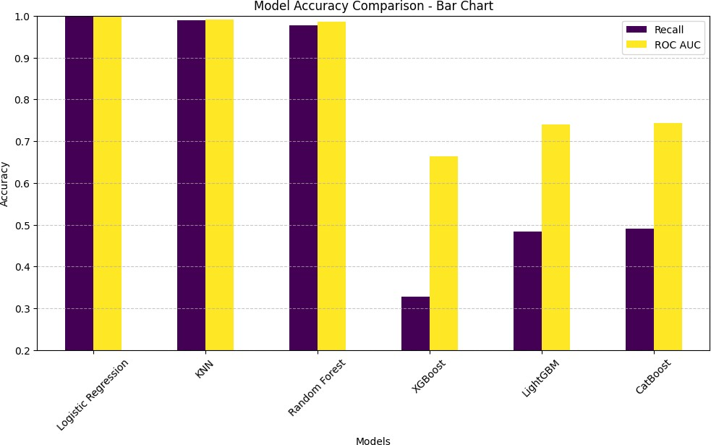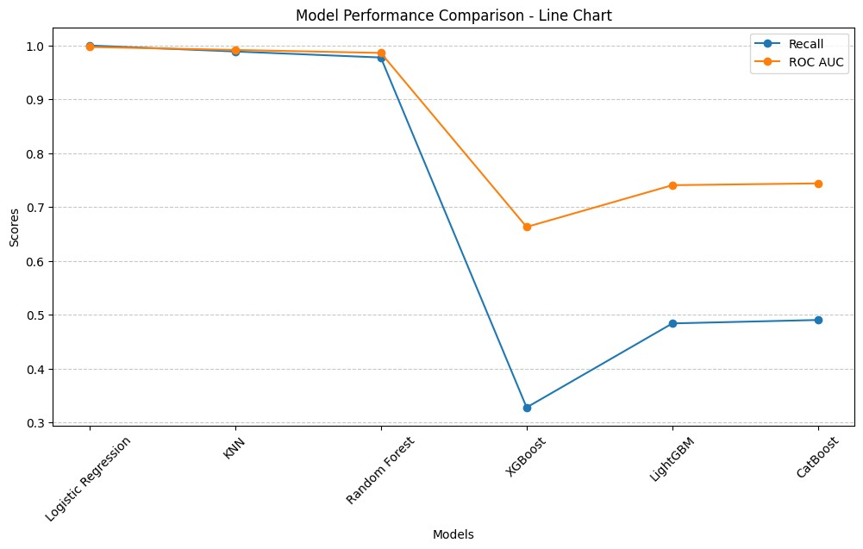

CHAPTER 7 FUTURE ENHANCEMENT

This chapter outlines potential enhancements to LearnIt to improve personalisation, scheduling intelligence, integrations with additional learning sources, and collaboration features. The proposed improvements aim to strengthen learner consistency, reduce burnout, and support more advanced learning analytics while maintaining privacy and transparency.

7.1 Deeper Integration with Learning Platforms
Future work will prioritise deeper integrations with popular learning platforms such as Udemy and Coursera (subject to available APIs and terms). This will enable importing course structures, tracking completion more reliably, and reducing manual data entry for self-learners who study across multiple ecosystems.
- Udemy/Coursera Import: Bring course metadata, sections, and lecture lists into LearnIt automatically.
- Multi-source Course Blending: Combine YouTube + articles + coding practice links under one coherent course plan.
- Improved Video Resume Sync: More robust persistence for playback positions across devices and browsers.

7.2 Enhanced Ask AI Guidance and Study Coaching
Ask AI can be extended from general Q&A into a study coach that recommends what to study next based on deadlines, course priority, difficulty, and recent consistency. The assistant can also generate quick revision plans when the learner misses sessions, and provide reflective summaries (weekly review) to support self-regulated learning.
- Next-Best-Action Suggestions: Recommend the next module/submodule to study based on time available and upcoming deadlines.
- Schedule Repair: When sessions are missed, propose a revised plan that redistributes remaining modules without overload.
- Personalised Reflection: Weekly summaries highlighting consistency, strongest courses, and areas needing attention.
- Explainability: Provide simple reasons for suggestions (e.g., “deadline is near” or “low activity this week”).

7.3 Advanced Scheduling Optimisation and Burnout Prevention
7.4 Improvements to Quiz Quality and Adaptive Assessment
- Question Quality Controls: Add validation rules (duplicate removal, difficulty balancing, and topic coverage checks) and allow instructors/admins to approve quizzes.
- Reusable Item Bank: Store and version questions per module to support retakes and spaced repetition.
- Feedback Explanations: Provide short explanations and link back to the relevant module section for each answer.
- Integrity and Attempt Controls: Add timed quizzes, attempt limits, and basic anomaly checks for high-stakes scenarios (optional).
Future enhancements will improve the scheduler by incorporating richer constraints (exam dates, fixed commitments, preferred time windows) and more intelligent optimisation strategies. In addition, LearnIt can include burnout-prevention signals by monitoring streak breaks, excessive planned hours, and repeated postponements, then prompting lighter schedules or revision-focused sessions when needed.

CHAPTER 8 CONCLUSION
This project successfully designed and developed LearnIt, an AI-assisted personalised learning and progress tracking platform aimed at supporting self-learners who depend on open resources. The system addresses fragmented learning by enabling course creation from external links, structuring content into modules/submodules, and providing a unified learning interface with persistent progress tracking.
The platform integrates a smart scheduling module to convert course plans into time-blocked study sessions, and a progress analytics module (dashboards and heatmaps) to improve consistency and motivation. Collaboration features such as classrooms and friend-based comparisons further strengthen accountability for learners handling multiple courses simultaneously.
Future enhancements include deeper integration with additional learning platforms, improved AI-assisted course decomposition with stronger reliability controls, advanced scheduling optimisation, and AI-driven study coaching for plan repair and burnout prevention. These improvements will further increase LearnIt’s effectiveness as an end-to-end companion for self-paced learning.
Overall, LearnIt demonstrates how combining pedagogical principles (self-regulated learning) with modern full-stack engineering and AI assistance can make open learning more structured, measurable, and sustainable for long-term skill development.
52
APPENDICES

A.SAMPLE CODE

// Sample: ASP.NET Core Web API endpoint to create a course (simplified)
[HttpPost("courses")]
public async Task<IActionResult> CreateCourse(CreateCourseDto dto)
{
var course = new Course
{
Title = dto.Title,
Priority = dto.Priority,
Difficulty = dto.Difficulty,
EstimatedHours = dto.EstimatedHours
};
_db.Courses.Add(course);
await _db.SaveChangesAsync();
return CreatedAtAction(nameof(GetCourse), new { id = course.Id }, course);
}
// Sample: Scheduler logic (high-level pseudocode)
Input: courses (modules with durations), startDate, deadline, hoursPerDay, maxHoursPerWeek
Sort courses by priority (desc), then difficulty (desc)
For each day between startDate and deadline:
available = hoursPerDay
while available > 0 and weeklyHours < maxHoursPerWeek:
pick next pending module (priority-aware)
allocate min(module.remaining, available) to a study session
persist session to CalendarEvents
available -= allocated; weeklyHours += allocated

B. SCREENSHOTS

IMAGES OF LEARNIT USER INTERFACE
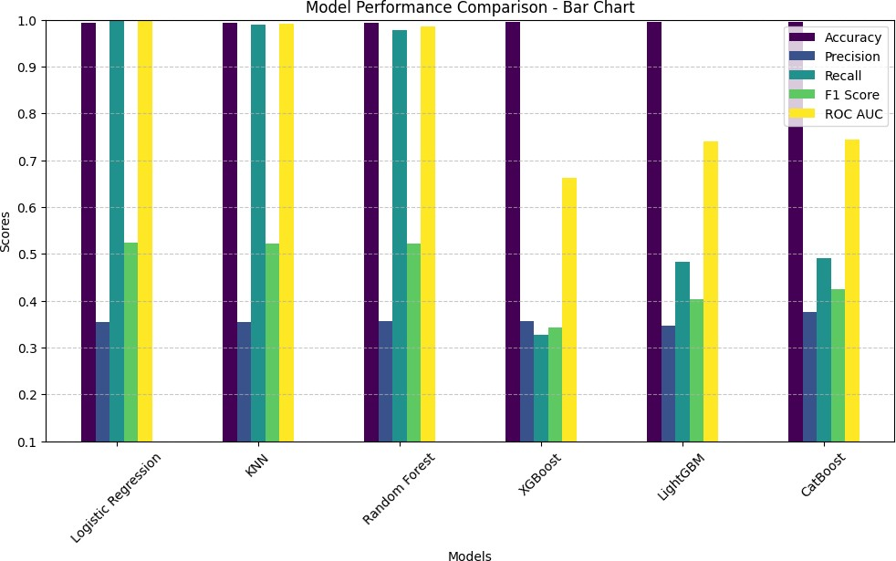

Figure 6.1 Course Builder and Course Player
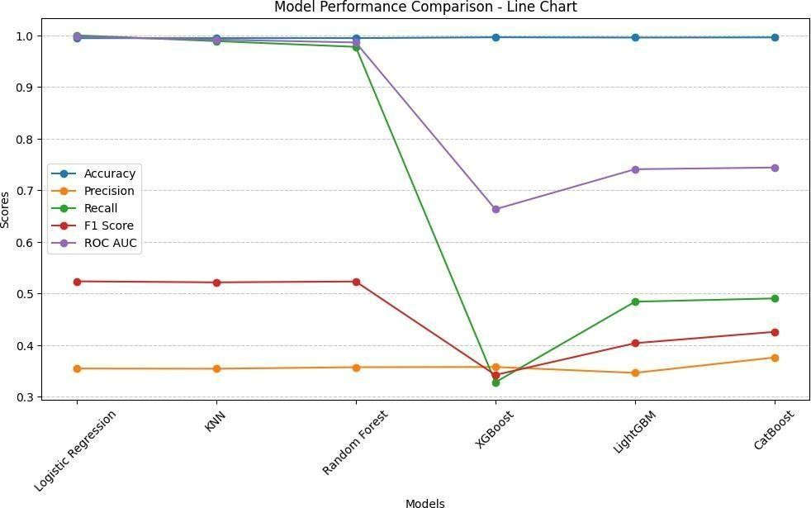
Figure 6.2 Scheduler Calendar View and Drag-to-Edit

Figure 6.3 Progress Dashboard

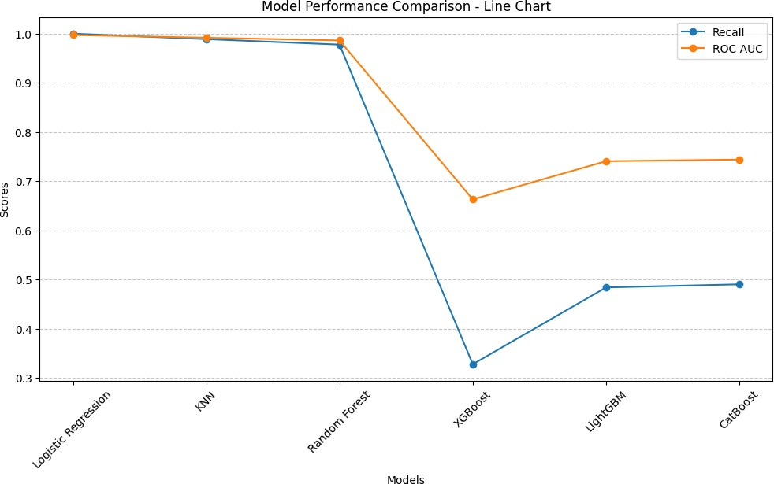

Figure 6.4 Learning Consistency Heatmap
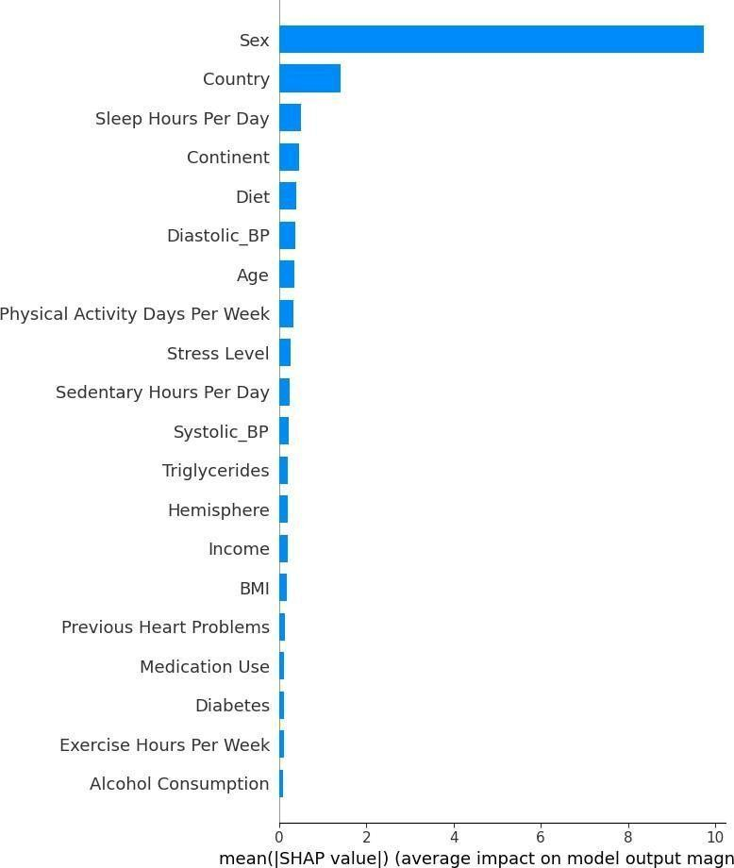
Figure 6.5 Ask AI Insights and Friend Comparison

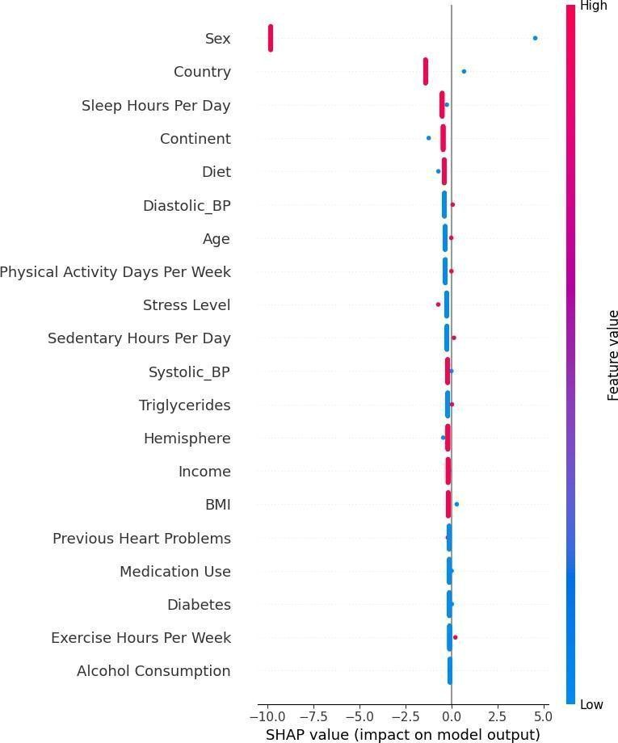
Figure 6.6 Classroom Creation and Join-by-Code
REFERENCES
- Zimmerman, B. J., “Becoming a Self-Regulated Learner: An Overview,” Theory Into Practice, vol. 41, no. 2, pp. 64–70, 2002, doi: 10.1207/S15430421TIP4102_2.
- Deci, E. L., and Ryan, R. M., “The ‘What’ and ‘Why’ of Goal Pursuits: Human Needs and the Self-Determination of Behavior,” Psychological Inquiry, vol. 11, no. 4, pp. 227–268, 2000, doi: 10.1207/S15327965PLI1104_01.
- Verbert, K., Duval, E., Klerkx, J., Govaerts, S., and Santos, J. L., “Learning Analytics Dashboard Applications,” American Behavioral Scientist, vol. 57, no. 10, pp. 1500–1509, 2013, doi: 10.1177/0002764213479363.
- Black, P., and Wiliam, D., “Assessment and Classroom Learning,” Assessment in Education: Principles, Policy & Practice, vol. 5, no. 1, pp. 7–74, 1998.
- Kurdi, G., Leo, J., Parsia, B., Sattler, U., and Al-Emari, S., “A Systematic Review of Automatic Question Generation for Educational Purposes,” International Journal of Artificial Intelligence in Education, vol. 30, pp. 121–204, 2020, doi: 10.1007/s40593-019-00186-y.
- Kurdi, G., Leo, J., Parsia, B., and Sattler, U., “Automatic Question Generation and Answer Assessment: A Survey,” Smart Learning Environments, vol. 8, article 16, 2021, doi: 10.1186/s41039-021-00151-1.
- Vander Linden, W. J., and Glas, C. A. W. (eds.), Elements of Adaptive Testing. New York, NY, USA: Springer, 2010.
- Cepeda, N. J., Pashler, H., Vul, E., Wixted, J. T., and Rohrer, D., “Distributed Practice in Verbal Recall Tasks: A Review and Quantitative Synthesis,” Psychological Bulletin, vol. 132, no. 3, pp. 354–380, 2006.
- Hamari, J., Koivisto, J., and Sarsa, H., “Does Gamification Work? — A Literature Review of Empirical Studies on Gamification,” in Proceedings of the 47th Hawaii International Conference on System Sciences (HICSS), 2014, pp. 3025–3034.
- Cheung, C. M. K., and Thadani, D. R., “The Impact of Electronic Word-of-Mouth Communication: A Literature Analysis and Integrative Model,” Decision Support Systems, vol. 54, no. 1, pp. 461–470, 2012.
- Mayer, R. E., “Applying the Science of Learning: Evidence-Based Principles for the Design of Multimedia Instruction,” American Psychologist, vol. 63, no. 8, pp. 760–769, 2008, doi: 10.1037/0003-066X.63.8.760.
- Sher, A., and Lee, A., “Learner Engagement with YouTube Videos in Informal Online Learning: An Empirical Study,” Communications of the Association for Information Systems, vol. 53, 2023.
- Kasneci, E., et al., “ChatGPT for Good? On Opportunities and Challenges of Large Language Models for Education,” Learning and Individual Differences, vol. 103, 102274, 2023, doi: 10.1016/j.lindif.2023.102274.
- Lozano, J., et al., “The Impact of Large Language Models on Higher Education: Exploring the Opportunities and Challenges,” Frontiers in Education, 2024, doi: 10.3389/feduc.2024.1392091.
- “ChatGPT in Education: A Systematic Review on Opportunities, Challenges and Future Directions,” Algorithms, vol. 18, no. 6, 352, 2025, doi: 10.3390/a18060352.
- Wise, A. F., et al., “Generative Artificial Intelligence in Learning Analytics: Contextualising Opportunities and Challenges through the Learning Analytics Cycle,” in Proceedings of the 14th ACM Conference on Learning Analytics and Knowledge (LAK ’24), 2024, doi: 10.1145/3636555.3636856.
- Roppelt, J., et al., “Advancing Generative Intelligent Tutoring Systems with GPT-4: Design Considerations and Emerging Practices,” Electronics, vol. 13, no. 24, 4876, 2024, doi: 10.3390/electronics13244876.
- “Large Language Models in Education: A Systematic Review of Empirical Research,” Computers and Education: Artificial Intelligence, 2025, 100529, doi: 10.1016/j.caeai.2025.100529.
- Ifenthaler, D., and Yau, J. Y.-K., “Utilising Learning Analytics for Study Success: Reflections on Current Empirical Findings,” Research and Practice in Technology Enhanced Learning, vol. 15, article 1, 2020, doi: 10.1186/s41039-020-00134-2.






