OLIST MARKETPLACE
Data Analytics Hackathon — Analysis Report
Marketplace Performance, Customer Satisfaction & Operational Drivers
Executive takeaway
The analysis covers 96,478 delivered orders with R$ 15,422,605.23 in total order value. Delivery reliability is the clearest operational signal: low-rated orders had a 33.7% late-delivery rate versus 3.5% for high-rated orders, approximately 9.6× higher.

Delivered orders | Product revenue | Freight | Total order value | Avg review
96,478 | R$ 13.22M | R$ 2.20M | R$ 15.42M | 4.14/5

1. Problem Understanding
Olist is a Brazilian e-commerce marketplace integrator connecting small and medium merchants to major marketplaces. The business challenge is to understand marketplace performance, customer satisfaction, geographic and seller variation, product-category performance, payment behavior, and the factors most strongly associated with low customer ratings.
The hackathon asks for evidence-based answers to six core questions. The objective is not prediction; it is descriptive and diagnostic analytics that can guide operations and customer-experience decisions.

2. Analytical Approach
- Use the cleaned order-level master as the primary analysis table for marketplace, delivery, geography, payment and review analysis.
- Use delivered orders as the main scope because complete delivery timing is meaningful for completed orders.
- Use order-level totals to avoid double-counting multi-item and multi-payment orders.
- Segment delivery delay relative to estimated delivery date into Early, 1–3 days late, 4–7 days late and 8+ days late.
- Compare states using order volume, review score, freight and late-delivery rate.
- Use the original product tables only for Q4, restricting them to cleaned delivered-order IDs.
- Use descriptive comparisons and correlations; do not interpret observational relationships as proven causation.

3. Key Insights
- Total delivered orders: 96,478; total order value: R$ 15,422,605.23.
- November 2017 was the peak month with 7,289 orders and R$ 1,153,528.05 in total order value.
- Overall customer satisfaction was 4.14/5, with an overall late-delivery rate of 8.11%.
- Average review declined from 4.28 for early deliveries to 1.72 for orders 8+ days late.
- Low-rated customers were about 9.6× more likely to have a late delivery than high-rated customers.
- Geographic differences in freight and late delivery accompany differences in review performance.
- Credit card is the dominant payment method and is associated with higher order value, but payment type shows little variation in review scores.

4. Question 1 — Marketplace Performance Over Time
Order volume and value increased substantially across the observed period, while review performance did not rise uniformly with scale.
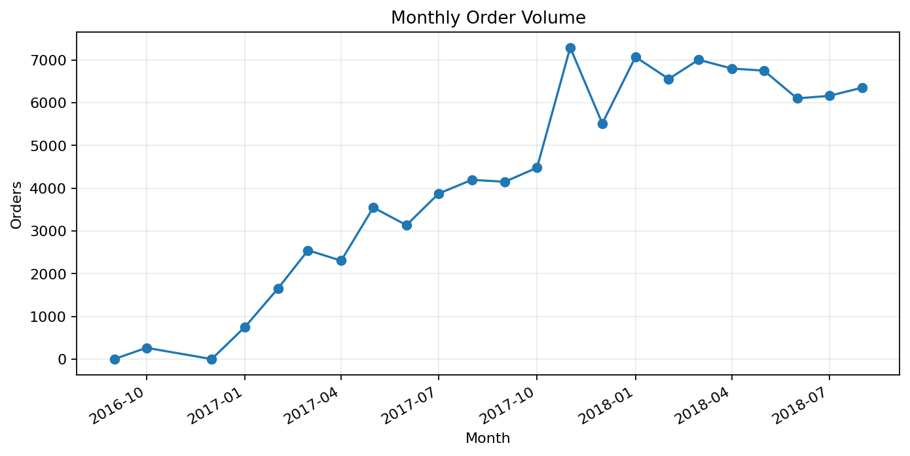
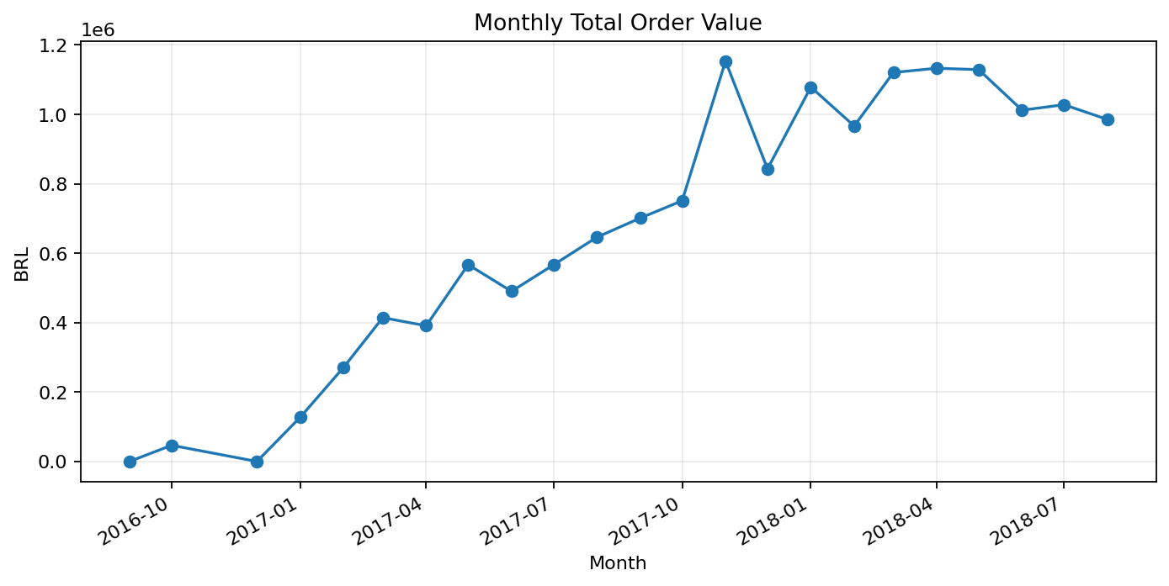
November 2017 was the strongest month: 7,289 orders, product revenue of R$ 987,765.37, freight of R$ 165,598.83, and total order value of R$ 1,153,528.05. The month’s average review score was 3.98, below the overall average of 4.14.
Business finding
Marketplace growth and customer experience do not move perfectly together. Operational capacity needs to scale alongside demand.

5. Question 2 — Delivery Performance & Customer Satisfaction
Delivery timing shows the clearest relationship with review scores.
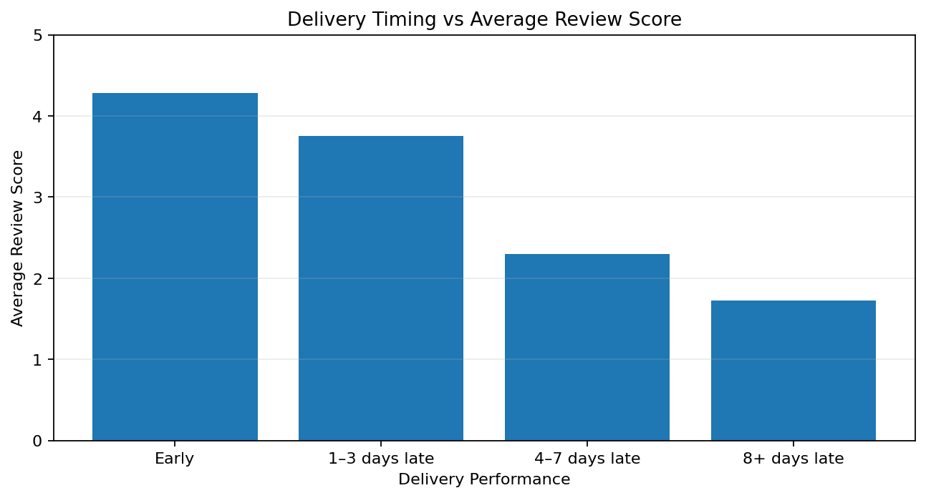
Delivery bucket | Orders | Avg delay (days) | Avg review | Low rating %
Early | 88,644 | -13.01 | 4.28 | 9.46%
1–3 days late | 2,662 | 1.40 | 3.75 | 19.53%
4–7 days late | 1,819 | 5.12 | 2.30 | 61.79%
8+ days late | 3,345 | 18.45 | 1.72 | 78.51%
Low-rated orders had a late-delivery rate of 33.74%, versus 3.51% among high-rated orders. That is approximately 9.6× higher.
Factor | Correlation with review score
delivery_delay_days | -0.27
total_freight_value | -0.09
total_payment_value | -0.04
total_item_price | -0.04
max_installments | -0.03
Business finding
Delivery reliability is the primary measured operational signal. Freight is a weaker secondary signal; transaction value and installments are weaker still.

6. Question 3 — Seller & Geographic Patterns
São Paulo is the largest customer market with 40,501 orders (42.0% of the dataset), average review 4.23, average freight R$ 17.33, and late rate 5.89%.
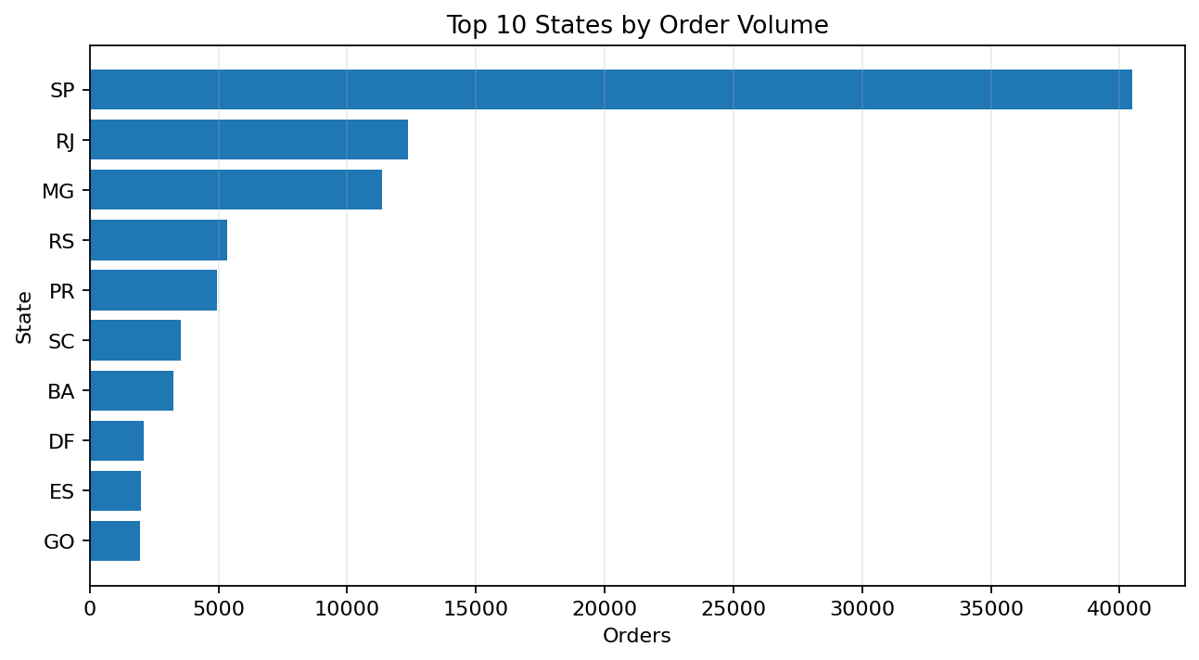
State | orders | avg_review | avg_freight | late_rate_pct
SP | 40,501 | 4.23 | R$ 17.33 | 5.89%
RJ | 12,350 | 3.95 | R$ 23.95 | 13.47%
MG | 11,354 | 4.18 | R$ 23.46 | 5.61%
RS | 5,345 | 4.18 | R$ 24.80 | 7.15%
PR | 4,923 | 4.23 | R$ 23.49 | 5.00%
SC | 3,546 | 4.12 | R$ 24.85 | 9.76%
BA | 3,256 | 3.91 | R$ 29.96 | 14.04%
DF | 2,080 | 4.13 | R$ 23.86 | 7.07%
ES | 1,995 | 4.05 | R$ 24.57 | 12.23%
GO | 1,957 | 4.09 | R$ 26.25 | 8.18%
Lowest-review states among states with at least 300 orders:
State | orders | avg_review | avg_freight | late_rate_pct
MA | 717 | 3.81 | R$ 42.95 | 19.67%
AL | 397 | 3.83 | R$ 38.58 | 23.93%
PA | 946 | 3.89 | R$ 39.70 | 12.37%
SE | 335 | 3.90 | R$ 40.94 | 15.22%
BA | 3,256 | 3.91 | R$ 29.96 | 14.04%
Seller screening — primary seller field, minimum 100 orders:
Seller | orders | avg_review | avg_freight | late_rate_pct
1ca7077d890b907f89be8c954a02686a | 106 | 2.38 | R$ 13.82 | 22.64%
2eb70248d66e0e3ef83659f71b244378 | 186 | 2.75 | R$ 16.22 | 13.98%
710e3548e02bc1d2831dfc4f1b5b14d4 | 129 | 3.42 | R$ 28.60 | 4.65%
88460e8ebdecbfecb5f9601833981930 | 234 | 3.49 | R$ 21.18 | 20.51%
7c67e1448b00f6e969d365cea6b010ab | 967 | 3.50 | R$ 52.60 | 10.13%
229c3efbfb0ea2058de4ccdfbc3d784a | 118 | 3.60 | R$ 19.50 | 1.69%
18a349e75d307f4b4cc646a691ed4216 | 108 | 3.61 | R$ 17.48 | 6.48%
7040e82f899a04d1b434b795a43b4617 | 206 | 3.63 | R$ 15.26 | 9.71%
1835b56ce799e6a4dc4eddc053f04066 | 394 | 3.68 | R$ 21.87 | 12.44%
897060da8b9a21f655304d50fd935913 | 301 | 3.70 | R$ 20.84 | 11.96%
Business finding
Geography appears to matter through logistics: some regions combine higher freight and/or higher late-delivery rates with weaker satisfaction.

7. Question 4 — Product Category Performance
The cleaned master does not contain product-category fields. Therefore the original order_items, products and category_translation tables were used only for this question and restricted to the cleaned delivered-order IDs. This preserves the delivered-order scope while recovering category information.
category | orders | items | revenue | avg_review | avg_revenue_per_order
bed_bath_table | 9,272 | 10,953 | R$ 1,023,434.76 | 3.98 | R$ 110.38
health_beauty | 8,647 | 9,465 | R$ 1,233,131.72 | 4.22 | R$ 142.61
sports_leisure | 7,530 | 8,431 | R$ 954,852.55 | 4.22 | R$ 126.81
computers_accessories | 6,530 | 7,644 | R$ 888,724.61 | 4.07 | R$ 136.10
furniture_decor | 6,307 | 8,160 | R$ 711,927.69 | 4.04 | R$ 112.88
housewares | 5,743 | 6,795 | R$ 615,628.69 | 4.18 | R$ 107.20
watches_gifts | 5,495 | 5,859 | R$ 1,166,176.98 | 4.11 | R$ 212.23
telephony | 4,093 | 4,430 | R$ 309,860.23 | 4.04 | R$ 75.70
auto | 3,810 | 4,140 | R$ 578,966.65 | 4.14 | R$ 151.96
toys | 3,804 | 4,030 | R$ 471,286.48 | 4.22 | R$ 123.89
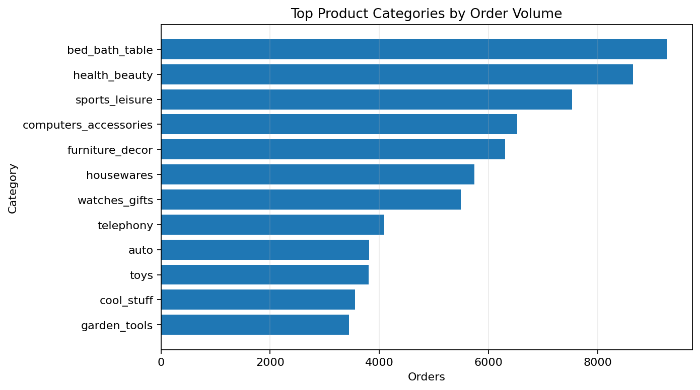
Lowest-rated categories among categories with at least 100 orders:
category | orders | revenue | avg_review
office_furniture | 1,254 | R$ 268,154.31 | 3.63
fashion_male_clothing | 106 | R$ 10,452.33 | 3.79
audio | 348 | R$ 50,570.60 | 3.82
home_confort | 392 | R$ 58,008.45 | 3.88
fixed_telephony | 212 | R$ 55,315.21 | 3.95
Business finding
The most actionable category targets are categories with meaningful demand or revenue combined with below-average reviews.

8. Question 5 — Payment Behavior
Credit card was used for 73,220 orders, approximately 75.9% of cleaned delivered orders. Payment type is more closely associated with transaction value than with customer satisfaction.
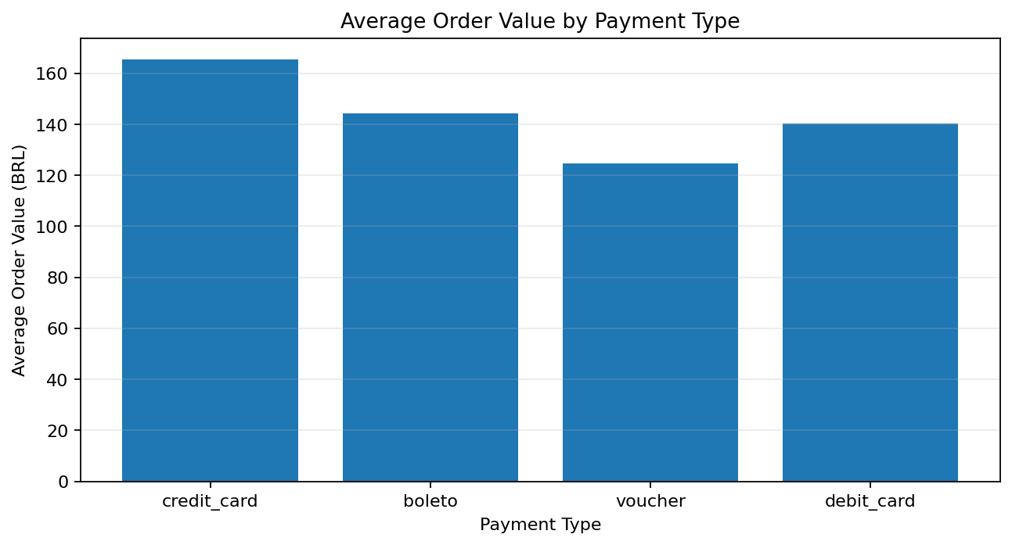
primary_payment_type | orders | avg_order_value | avg_installments | avg_review
credit_card | 73,220 | R$ 165.56 | 3.52 | 4.14
boleto | 19,191 | R$ 144.33 | 1.00 | 4.14
voucher | 2,582 | R$ 124.75 | 1.47 | 4.11
debit_card | 1,484 | R$ 140.41 | 1.00 | 4.23
Business finding
Payment should be treated as a secondary commercial optimization rather than the primary customer-experience lever.

9. Question 6 — Root Cause Analysis
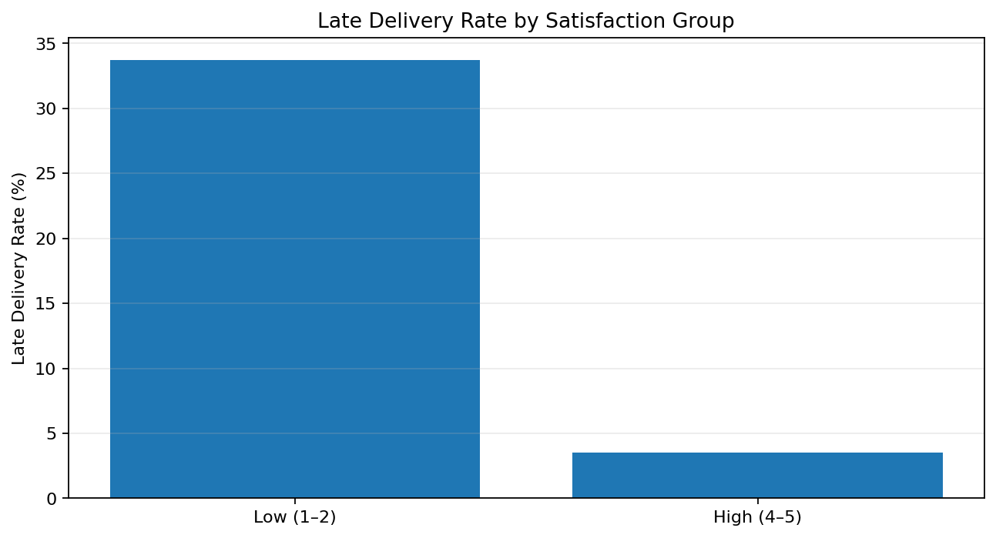
The root-cause analysis compares low and high satisfaction groups and ranks candidate factors by their observed association with review score.
Group | Orders | Avg review | Late rate % | Avg freight | Avg order value
Low rating (1–2) | 12,655 | 1.24 | 33.74% | R$ 27.74 | R$ 188.55
High rating (4–5) | 75,758 | 4.75 | 3.51% | R$ 21.88 | R$ 156.00
Root-cause conclusion
Primary contributor: delivery reliability. Secondary contributor: freight/logistics burden. Weaker contributors: order value, product value and installment count. These are associations, not causal estimates. Comment presence is not treated as a cause because it is a customer response behavior.

10. Actionable Recommendations
1. Make delivery reliability the primary operational KPI.
Track late-delivery rate with average review at marketplace, region, seller and category levels. Focus on reducing materially late orders.
2. Prioritize high-risk regions.
Create a regional watchlist for late rate, freight and review score. Investigate carrier coverage, routing and fulfillment capacity where all three deteriorate.
3. Identify and coach high-risk sellers.
Use seller screening to flag sufficiently large sellers with unusually high late rates or weak reviews; investigate dispatch and carrier handoff processes.
4. Protect customer experience during demand peaks.
Use peak-month evidence to strengthen fulfillment-capacity monitoring, carrier coordination and estimated-date accuracy during high-volume periods.
5. Prioritize high-demand, low-satisfaction categories.
Separate product-quality problems from logistics problems before selecting category-specific interventions.
6. Keep payment optimization secondary.
Use payment analysis to improve basket value and financing convenience, but do not treat payment type as the main satisfaction problem.
7. Build an operational dashboard.
Monitor orders, total order value, late rate, review score, low-rating share, freight and regional/seller/category breakdowns on a recurring basis.

11. Limitations
- The main analysis is restricted to delivered orders.
- The data is observational, so the relationships identified should not be interpreted as proven causality.
- Seller analysis uses the primary_seller_id field in the cleaned master and is therefore a screening view.
- Very small state or seller groups can produce unstable averages; minimum-volume thresholds are used where appropriate.
- Product category analysis requires the original product tables because category information is absent from the cleaned master.

12. Conclusion
Olist scaled strongly across the observed period, but customer experience did not scale uniformly with marketplace volume. The strongest and most actionable signal is delivery reliability: as delivery becomes later, review scores fall sharply, and low-rated orders have a substantially higher incidence of late delivery. Geographic and freight differences reinforce the importance of logistics as the main operational lens.
The recommended priority is therefore to improve delivery reliability, supported by regional, seller and category diagnostics. Payment behavior should remain a secondary commercial optimization. This approach directly connects marketplace performance analysis to operational action while keeping the conclusions appropriately evidence-based.

Appendix — Key Metrics
Metric | Value
Delivered orders | 96,478
Product revenue | R$ 13,221,498.11
Freight value | R$ 2,198,275.64
Total order value | R$ 15,422,605.23
Average review | 4.14/5
Late delivery rate | 8.11%
Peak month | November 2017
Peak month orders | 7,289
Low-rating late rate | 33.74%
High-rating late rate | 3.51%
Low/high late-rate ratio | 9.6×

13. Teammate Dashboard — Supporting Evidence
The team’s Power BI-style dashboard was reviewed and incorporated as a supporting visual layer for the analytical report. It presents the same marketplace story through executive KPI cards, trend charts, geographic breakdowns, category performance, payment behavior and a driver-ranking view. The dashboard covers September 2016 to August 2018.
On page 1 of the teammate dashboard, the executive summary reports approximately R$15.42M total revenue, 96.5K delivered orders, a 4.14 average review score, an 8.11% late-delivery rate and R$22.79 average freight cost. The revenue/order-volume chart shows strong growth through 2017, while the satisfaction chart shows that review scores move differently from revenue.
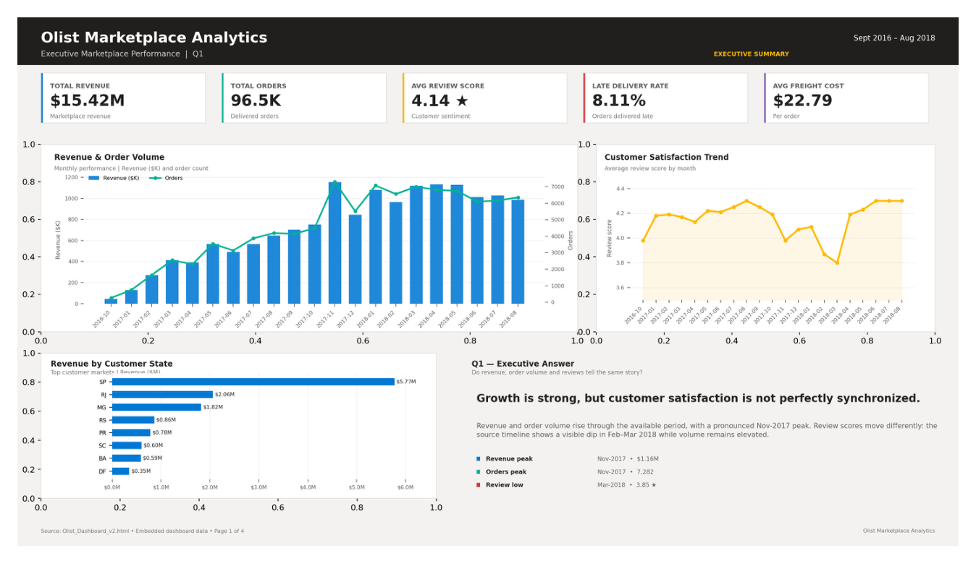
Figure 13.1 — Teammate dashboard: executive marketplace performance view
Page 2 focuses on delivery and geography. It reports an average review score of about 4.28 for on-time orders versus 2.55 for late orders. It also highlights regional differences in delivery penalty, with the largest penalty shown for RJ, and identifies state-level logistics bottlenecks using orders, days early, freight, review and late rate.
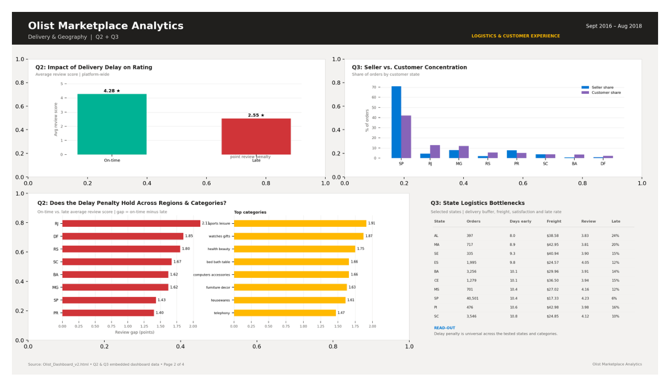
Figure 13.2 — Teammate dashboard: delivery and geographic analysis
Page 3 provides a category and payment view. The category matrix compares orders, average price, average freight, average review and late rate. It identifies books_general_interest as the highest-rated category at about 4.53, while office_furniture is the lowest at about 3.64 among the displayed categories. The payment charts show credit card as the dominant revenue source and show increasing order value with higher installment bands, while review scores decline.
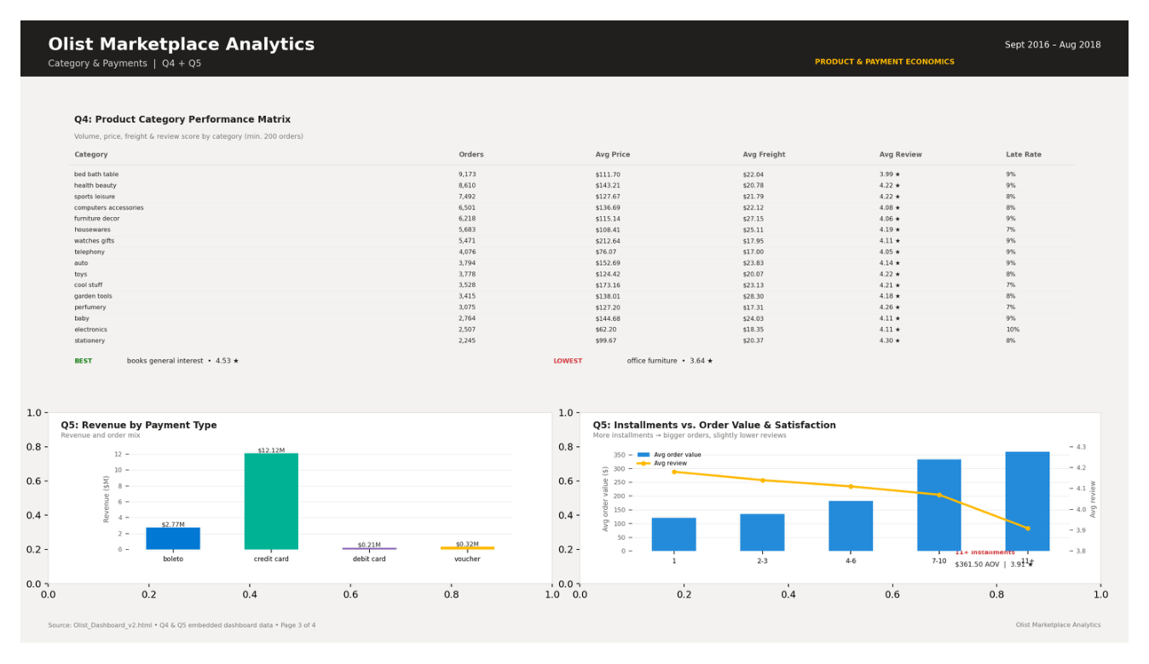
Figure 13.3 — Teammate dashboard: category and payment economics
Page 4 presents a driver-ranking framework for low review scores. The dashboard ranks delivery timing as the primary driver, followed by product category, geography, installment count and payment type. The displayed review-score spreads are 1.74, 0.89, 0.42, 0.27 and 0.12 points respectively. This reinforces the main report conclusion that delivery reliability deserves the highest operational priority, while category and geography are useful secondary diagnostic lenses.
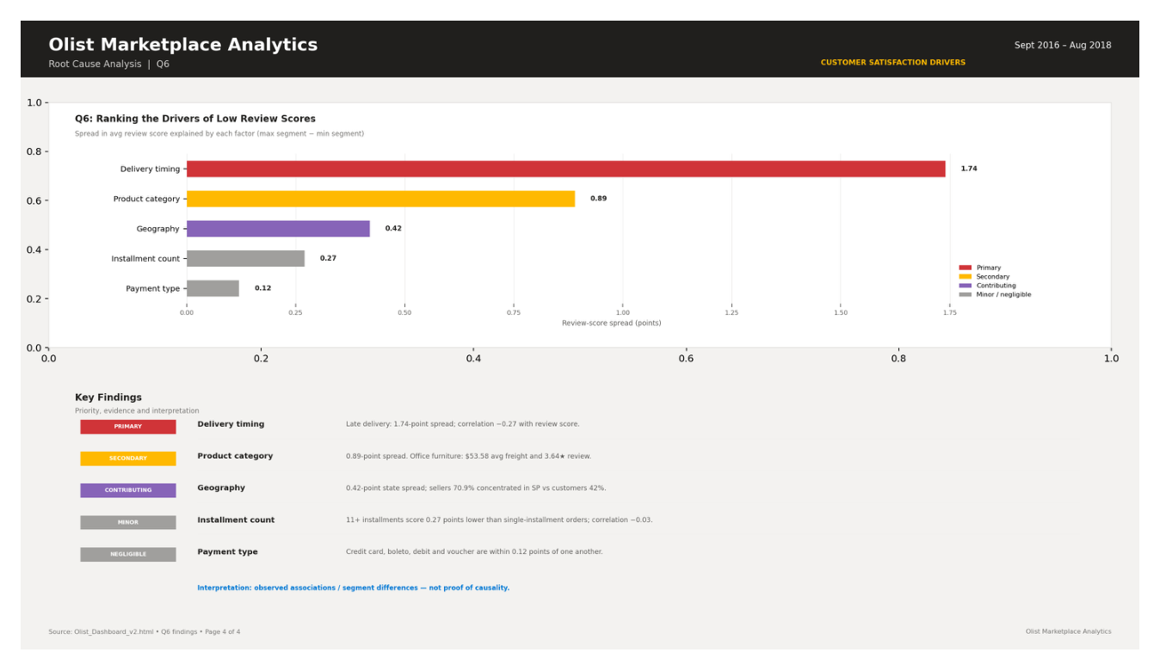
Figure 13.4 — Teammate dashboard: ranking of low-review drivers
Dashboard driver | Teammate dashboard evidence
Delivery timing | Primary driver; dashboard shows a 1.74-point review spread and approximately −0.27 correlation with review score.
Product category | Secondary driver; dashboard shows a 0.89-point review-score spread and meaningful variation in freight and review performance.
Geography | Contributing driver; dashboard shows a 0.42-point spread and highlights regional logistics bottlenecks.
Installment count | Minor driver; dashboard shows a 0.27-point spread, with higher installment bands associated with lower reviews.
Payment type | Weak/negligible driver; dashboard shows only a 0.12-point difference across payment types.
Important interpretation: the teammate dashboard is treated as supporting evidence rather than as a replacement for the cleaned-data analysis. Its driver ranking is an observed association/segment comparison, not a causal model. Where the dashboard uses different aggregation or segmentation, its figures are presented as dashboard evidence and are not silently substituted for the main cleaned-data figures in this report.

14. Integrated Business Interpretation
Combining the cleaned-data analysis with the teammate dashboard creates a consistent decision story. The marketplace has substantial scale and revenue, but satisfaction is not perfectly synchronized with growth. Delivery timing is the most actionable operational lever. Geography and product category help identify where the delivery and experience problems are concentrated, while payment behavior is less important for satisfaction.
For management, the practical implication is to move from a marketplace-wide average view to a segmented operating model: monitor late-delivery performance by region, seller and category; investigate high-risk combinations; and protect service quality during demand peaks.

