Oral Cancer Detection using Deep Learning


[2025-2026]
Project Phase-I Report
Bachelor of Technology
(INFORMATION TECHNOLOGY)

Supervised by:  Dr. Manjeet Soni  [Professor]  [Information Technology] | Submitted by:  Raghav Birla  Enroll No - 0801IT233D06  [Information Technology]  Rohit Singh Rathor  Enroll No - 0801IT233D09  [Information Technology]  Adarsh Agrawal  Enroll No - 0801IT223150  [Information Technology]

DEPARTMENT OF INFORMATION TECHNOLOGY
SHRI GOVINDRAM SEKSARIA INSTITUTE OF TECHNOLOGY AND SCIENCE, INDORE(M.P.)
A Govt. Aided Autonomous Institute, Affiliated to RGPV, Bhopal

DEPARTMENT OF INFORMATION TECHNOLOGY

CERTIFICATE
This is to certify that the Dissertation Phase-I entitled “Oracle Cancer Detection using Deep Learning” submitted by Raghav Birla, Adarsh Agrawal, Rohit Singh Rathor is accepted in partial fulfillment of the degree of Department of Information Technology of Rajiv Gandhi Proudyogiki Vishwavidyalaya, Bhopal during the session 2025-2026.

Internal Examiner  Date: | External Examiner  Date:

ABSTRACT
Oral cancer and oral potentially malignant disorders (OPMDs) are often diagnosed at advanced stages due to subtle visual differences, limited specialist availability, and the dependency on expert clinical examination. This delay in early identification significantly increases treatment complexity and reduces survival rates. To address this challenge, this project proposes an AI-powered, deep learning–based Oral Cancer Detection System designed to assist clinicians and improve early screening accuracy.
The system uses a convolutional neural network (CNN) integrated with transfer learning to classify oral cavity images into four major categories: Oral Cancer, OPMD, Benign Lesions, and Healthy Tissue. It leverages advanced data augmentation and imbalance-handling techniques—such as geometric transformations and Deep SMOTE—to enhance minority classes like oral cancer images. The model is trained using TensorFlow on a curated medical dataset of annotated oral lesions, enabling it to identify subtle morphological patterns often missed by human observers.
Beyond visual diagnosis, the system incorporates a behavioral risk assessment module that evaluates individual habits such as tobacco use, betel quid consumption, and alcohol intake. This generates a personalized malignancy-risk score, supporting more informed clinical decision-making.
This Phase-1 report presents the problem background, literature review, system architecture, dataset preparation, augmentation strategies, and deep learning implementation. The proposed solution is accurate, scalable, and clinically relevant—offering a low-cost screening aid that can support early detection, improve accessibility in resource-limited regions, and ultimately contribute to reducing the global burden of oral cancer

Table of Contents
Certificate | 1
Abstract | 2
List of Figures
- INTRODUCTION  - Overview:  - Objectives:  - Problem Statement: | 1  1  2  3
- LITERATURE REVIEW | 4
- SYSTEM DESIGN  - Existing System  - Proposed System  - Modules  - Data Collection  - Preprocessing Step  - Feature Extraction  - Data Prediction  - Algorithms Used  - System Analysis  - Class Diagram  - Usecase Diagram  - Activity Diagram  - Language Used  - Python  - OpenCV + cvzone  - Implementation and Testing  - IMPORT PACKAGES:  - Code Flow  - Gesture Recognition Logic  - Key Mapping  - Output Screens | 5  5  5  7  7  8  9  10  11  13  13  14  15  16  16  17  18  18  18  19  20  20
5 Conclusion | 21
REFERENCES | 22

LIST OF FIGURES
Fig.No. Title | Page No.
3.1 Class Diagram……………………………………………………………… | 13
3.2 Usecase Diagram…………………………………………………………… | 14
3.3 Activity Diagram…………………………………………………………… | 15

INTRODUCTION
1.1 Overview
Early detection of oral cancer and potentially malignant disorders (OPMDs) plays a crucial role in improving survival rates, reducing treatment costs, and preventing disease progression. However, accurate diagnosis often depends on expert clinical examination, which is not always accessible—especially in rural or resource-limited regions. Subtle differences between benign, pre-malignant, and malignant lesions can be difficult to distinguish through visual inspection alone, leading to missed or late diagnoses. This gap highlights the need for an intelligent, accessible, and reliable screening tool that can support clinicians and improve patient outcomes.
To address this challenge, the proposed project introduces an AI-powered Oral Cancer Detection System built using convolutional neural networks (CNNs) and transfer learning. The system analyzes oral cavity images and classifies them into four categories: Oral Cancer, OPMD, Benign Lesions, and Healthy Tissue. Using TensorFlow and advanced data augmentation techniques—including geometric transformations and Deep SMOTE—the model learns to recognize subtle visual patterns that are often overlooked during manual screening.
In addition to image-based detection, the system integrates a behavioral risk assessment module. This module evaluates patient-specific factors such as tobacco consumption, betel quid chewing, and alcohol use to estimate the probability of malignant transformation. By combining visual analysis with lifestyle risk profiling, the system provides a more comprehensive and personalized diagnostic support tool.
The proposed solution offers several advantages:
- Non-invasive screening: Uses standard images without requiring specialized equipment.
- Accessible and cost-effective: Ideal for regions with limited access to oral cancer specialists.
- Early detection support: Helps identify high-risk lesions before progression.
- Data-driven decision support: Enhances clinical judgment with AI-based insights.
- Scalable and customizable: Can be integrated into clinics, mobile health units, and telemedicine platforms.
Overall, this system aims to make oral cancer screening more accurate, efficient, and widely accessible—supporting clinicians in early diagnosis and improving the overall healthcare outcomes for at-risk populations.
1.2 Objectives
Primary Objectives
- To develop an AI-based diagnostic system capable of accurately detecting oral cancer and potentially malignant disorders (OPMDs) from oral cavity images.
- To assist clinicians in early-stage identification of malignant and pre-malignant lesions, improving patient outcomes and reducing late-stage diagnoses.
Technical Objectives
- To implement a deep learning model using convolutional neural networks (CNNs) and transfer learning for multi-class classification of oral lesions.
- To apply data augmentation and imbalance-handling techniques (such as geometric transformations and Deep SMOTE) to enhance model robustness and accuracy.
- To integrate TensorFlow for model training, validation, and deployment in a clinical setting.
Clinical & Healthcare Objectives
- To provide a cost-effective and scalable screening tool for regions with limited access to oral cancer specialists.
- To combine visual diagnosis with behavioral risk assessment—including tobacco, betel quid, and alcohol usage—to offer a personalized malignancy-risk profile.
- To support clinicians with AI-driven insights that enhance decision-making and streamline early detection workflows.

1.3 Problem Statement
Oral cancer remains one of the most prevalent and life-threatening malignancies worldwide, particularly in regions where tobacco use, betel quid consumption, and alcohol intake are widespread. Despite advances in medical technology, early-stage detection of oral cancer and potentially malignant disorders (OPMDs) remains a significant challenge. Clinical diagnosis relies heavily on expert visual examination, which requires extensive experience to differentiate between benign lesions, pre-cancerous conditions, and malignant growths that often appear visually similar in their early stages.
In many rural and underserved areas, access to trained oral pathologists or specialists is limited, resulting in late diagnoses when treatment becomes more complex, invasive, and less effective. Conventional screening methods are time-consuming, subjective, and prone to variability between clinicians. This leads to inconsistent interpretation, missed early signs, and delayed intervention—contributing to high mortality rates associated with oral cancer.
Additionally, large annotated medical image datasets are scarce, and existing diagnostic systems often fail to generalize well due to data imbalance, especially for rare but critical lesion categories. Most available digital tools focus solely on image classification and do not incorporate behavioral risk factors such as tobacco or alcohol consumption, which play a crucial role in assessing a patient's likelihood of malignant transformation.
Further, advanced diagnostic devices like histopathology scanners or specialized imaging tools are expensive and not feasible for many healthcare centers with limited resources. This creates a pressing need for an accessible, cost-effective, and automated screening solution capable of assisting clinicians in early detection and risk assessment.
An AI-powered, camera-based oral lesion detection system—leveraging deep learning and risk profiling—can address these limitations by providing consistent, scalable, and expert-level support for early diagnosis. Such a solution has the potential to improve screening accuracy, increase accessibility in low-resource settings, and ultimately reduce the global burden of oral cancer.

LITERATURE REVIEW
Deep learning has become an essential approach in medical imaging, especially for early detection of cancers and pre-malignant conditions. Several studies demonstrate that convolutional neural networks (CNNs) achieve high accuracy in classifying oral lesions by extracting complex visual patterns that traditional methods often miss. Research by Liangbo Li et al. highlights the effectiveness of multi-class CNN models in distinguishing between malignant, pre-malignant, and benign lesions. Similarly, work by Ram Kumar Yadav et al. shows that deep learning can be integrated into clinical workflows for faster and more reliable screening.
Earlier image-processing techniques—such as color segmentation, texture analysis, or handcrafted features—were easier to implement but performed poorly under real-world variations in lighting, texture, and lesion shape. These limitations led researchers to prefer deep learning approaches, which offer stronger generalization and consistent performance.
Studies also emphasize the importance of combining image analysis with behavioral risk factors like tobacco, betel quid, and alcohol use, as these significantly influence a patient's likelihood of developing oral cancer. Commercial diagnostic tools exist, but they are often costly and require specialized equipment, making them unsuitable for low-resource healthcare settings.
Because deep learning models can run on standard hardware and offer accurate classification, recent literature supports the development of affordable AI-based systems for oral cancer screening. This makes CNN-driven solutions practical, scalable, and highly relevant for improving early detection.

SYSTEM DESIGN
3.1 Existing System
Most existing oral cancer screening methods rely heavily on manual clinical examination, where dentists or specialists visually inspect the oral cavity for abnormal lesions. While this approach works for experienced clinicians, it is highly subjective and depends on the practitioner’s expertise. Subtle differences between benign, pre-malignant, and malignant lesions often go unnoticed, leading to inconsistent or delayed diagnosis. Biopsy remains the gold standard, but it is invasive, time-consuming, and not feasible for large-scale screening.
Some advanced diagnostic tools—such as ViziLite, autofluorescence imaging, high-resolution endoscopy, and commercial AI scanners—offer improved visualization, but they come with multiple drawbacks.

Limitations of Existing Systems
- Subjective Diagnosis: Manual visual examination varies between clinicians and often misses early-stage lesions.
- Late Detection: Many lesions are identified only when symptoms appear, reducing treatment success.
- Lack of Specialists: Rural and underserved areas often do not have trained oral pathologists.
- High Cost: Advanced diagnostic devices like autofluorescence scanners are expensive and unaffordable for many clinics.
- Limited Accessibility: Specialized equipment requires trained operators and clinical infrastructure.
- Dataset Scarcity: Existing AI models suffer from limited, imbalanced, or non-standardized datasets

3.2 Proposed System
The proposed system introduces an AI-driven oral cancer detection platform designed to support clinicians in identifying malignant, pre-malignant, benign, and healthy oral tissue using deep learning. Instead of relying solely on traditional visual inspection or expensive diagnostic devices, the system utilizes a convolutional neural network (CNN) integrated with transfer learning to classify oral cavity images with high accuracy. By processing clinical photographs of lesions, the model extracts hierarchical features that reveal subtle patterns—such as texture, color variations, and morphological changes—that may be difficult for clinicians to detect during manual examination.
The system incorporates advanced data augmentation techniques, including rotation, flipping, scaling, and Deep SMOTE-based synthetic sample generation, which help overcome dataset imbalance between cancer, OPMD, benign, and healthy classes. These methods ensure better generalization and reduce bias toward majority lesion categories. The trained model is deployed using TensorFlow, allowing efficient inference on standard hardware without requiring specialized medical imaging equipment.
In addition to image classification, the proposed system integrates a behavioral risk assessment module that evaluates patient-specific factors such as tobacco usage, betel quid consumption, and alcohol intake. These inputs are combined with the image-based diagnosis to compute a personalized malignancy-risk score, offering clinicians a more comprehensive, data-driven approach to decision-making.
The system’s architecture is modular and extendable, enabling future upgrades such as additional lesion subtype classification, real-time screening capabilities, integration with electronic health records, and mobile-based deployment. Its low-cost and non-invasive nature make it ideal for primary healthcare centers, community clinics, telemedicine setups, and outreach programs where access to oral cancer specialists is limited.
Overall, the proposed system provides a practical, accurate, and accessible AI-based solution that supports early detection, reduces diagnostic subjectivity, and enhances the quality of oral healthcare in both urban and rural environments.

3.3 Modules
The proposed AI-powered oral cancer detection system is organized into four major modules, each handling a critical stage of the diagnostic pipeline. These modules work sequentially and collaboratively to ensure that oral cavity images are accurately processed, analyzed, and classified into their respective lesion categories. Together, they form an efficient workflow that supports early detection and clinical decision-making.

1. Data Acquisition Module
This module collects raw oral cavity images that serve as the primary input for the system. Images may be sourced from clinical datasets or captured using standard imaging devices. The module ensures consistent image quality and manages data loading, storage, and organization. Since no specialized hardware is required, the system remains highly accessible for real-world screening setups.

2. Preprocessing & Augmentation Module
Once images are acquired, they undergo a series of preprocessing steps to enhance their quality and standardize them for model input. Operations include resizing, normalization, contrast adjustment, and noise reduction.
To handle dataset imbalance—especially between cancer and non-cancer categories—this module also applies data augmentation techniques such as rotation, flipping, scaling, color adjustments, and Deep SMOTE–based synthetic image generation. These enhancements improve the model’s robustness and reduce bias during training.

3. Feature Extraction & Model Training Module
This module uses convolutional neural networks (CNNs) with transfer learning to extract deep features from the processed images. The model identifies patterns in lesion texture, color, and morphology—patterns that may be difficult to detect visually.
The CNN is trained using TensorFlow, with the extracted features forming the basis for distinguishing between Oral Cancer, OPMD, Benign Lesions, and Healthy Tissue. This module is responsible for both training and validation, ensuring the model achieves high accuracy and generalization capability.

4. Diagnosis & Risk Assessment Module
The final module performs classification and provides diagnostic insights. Based on the extracted features, the system predicts the lesion category with high confidence.
Additionally, this module integrates behavioral inputs such as tobacco use, betel quid consumption, and alcohol intake to generate a personalized malignancy-risk score. The combined analysis offers a more comprehensive understanding of the patient’s risk level.
The output is then presented in a user-friendly format, supporting clinical decision-making and early intervention.

3.3.1 Data Collection
Data collection is the first and most essential step of the proposed AI-powered oral cancer detection system. Instead of capturing live video frames through a webcam, this project uses a medically curated dataset specifically developed for oral lesion analysis. The dataset provides high-quality, annotated oral cavity images that are used for training, validating, and testing the deep learning model.
The images were sourced from the Dataset of Annotated Oral Cavity Images for Oral Cancer Detection, created by Piyarathne N.S., Liyanage S.N., Rasnayaka R.M.S.G.K., Hettiarachchi P.V.K.S., Devindi G.A.I., Francis F.B.A.H., Dissanayake D.M.D.R., Ranasinghe R.A.N.S., Pavithya M.B.D., Nawinne I., Ragel R.G., Jayasinghe R.D and obtained from Zenodo https://zenodo.org/records/10664056

3.3.2 Preprocessing Step
Once an image is loaded from the dataset, it undergoes a series of preprocessing operations to enhance clarity and prepare the data for efficient feature extraction. Preprocessing ensures that the oral cancer detection model performs reliably across different imaging conditions, camera qualities, and lesion variations.
Key Preprocessing Operations:
• Image Resizing
Every image is resized to a uniform resolution (e.g., 224×224 or 299×299 depending on the CNN model).
This standardization ensures compatibility with the deep learning architecture and improves training stability.
• Normalization
Pixel values are scaled (typically between 0 and 1) to reduce intensity-related variations.
Normalization helps the model learn faster and prevents training instability caused by large pixel-value differences.
• Contrast & Brightness Adjustment
To address variations in lighting and oral cavity illumination, contrast enhancement or histogram equalization may be applied.
This step improves the visibility of lesion boundaries, texture details, and color patterns.
• Noise Reduction
Minor lighting noise, camera artifacts, and background disturbances are minimized using smoothing filters such as Gaussian blur or median filtering.
This enhances the clarity of lesion regions and improves feature extraction.
• Data Cleaning
Images with poor quality, blur, or missing annotations can be filtered out to ensure consistent and meaningful training data.

3.3.3 Feature Extraction
Feature extraction is the core of the oral cancer detection system. In this module, each preprocessed image is passed through a convolutional neural network (CNN), which automatically learns and extracts clinically relevant features from the oral cavity. These features help the model distinguish between malignant, pre-malignant, benign, and healthy tissues based on subtle visual patterns that may be difficult for human observers to detect.
Why Feature Extraction Matters?
Feature extraction enables the system to analyze complex visual characteristics of lesions with high precision. Without robust feature extraction:
- classification accuracy would drop sharply
- early-stage lesions might go undetected
- the model would fail to differentiate between visually similar categories
This module forms the analytical backbone of the system, allowing it to interpret medical images in a clinically meaningful way.

3.3.4 Data Prediction
In this module, the extracted deep features from the CNN are analyzed and classified into one of the four lesion categories: Oral Cancer, OPMD, Benign Lesions, or Healthy Tissue. Instead of using simple rule-based logic, this system employs a trained deep learning model capable of identifying subtle visual cues and predicting the correct class with high accuracy. The prediction step represents the final stage of the diagnostic pipeline where the model interprets the learned patterns and provides clinically meaningful outputs.
CNN-Based Cancer Classification
The trained model uses the extracted features to determine the most likely category:
• Oral Cancer
- Features such as irregular borders, ulceration, or deep color variations
- Model outputs high cancer probability
• OPMD (Potentially Malignant Disorders)
- Presence of leukoplakia, erythroplakia, lichen planus patterns, etc.
- Indicates risk but not confirmed malignancy
• Benign Lesions
- Features suggest non-cancerous conditions such as candidiasis or fibrous hyperplasia
- Lower risk with typical benign morphology
• Healthy Tissue
- Normal coloration, texture, and uniform surface appearance
The model uses softmax activation to assign probability scores to each category, ensuring that the final prediction is interpretable and clinically useful.
Risk Assessment Integration
Along with image classification, the system incorporates behavioral risk factors such as:
- Tobacco consumption
- Betel quid chewing
- Alcohol intake
These inputs are processed alongside the model prediction to generate a combined malignancy-risk score, offering more personalized and reliable diagnostic support.

3.5 SYSTEM ANALYSIS
3.5.1 Class Diagram
––––

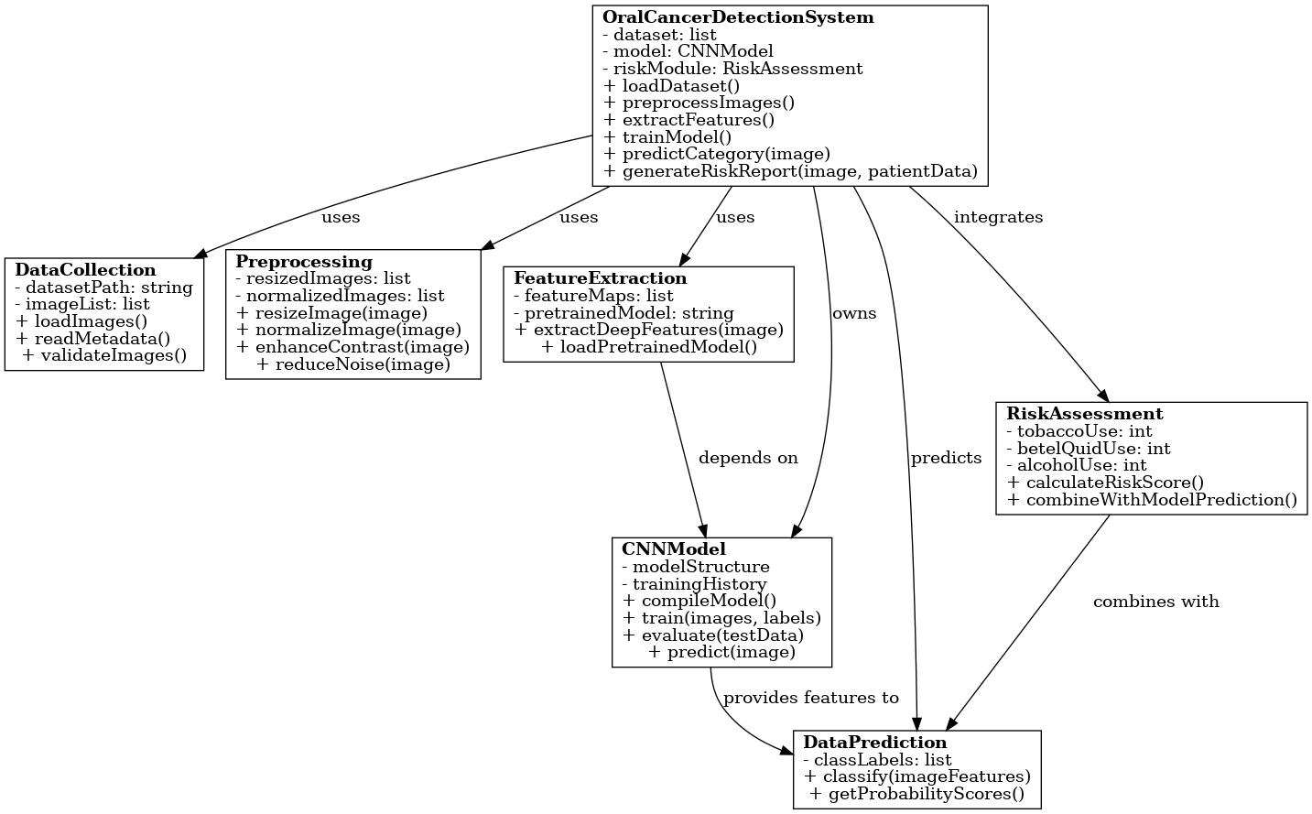
3.5.2 Use-Case Diagram
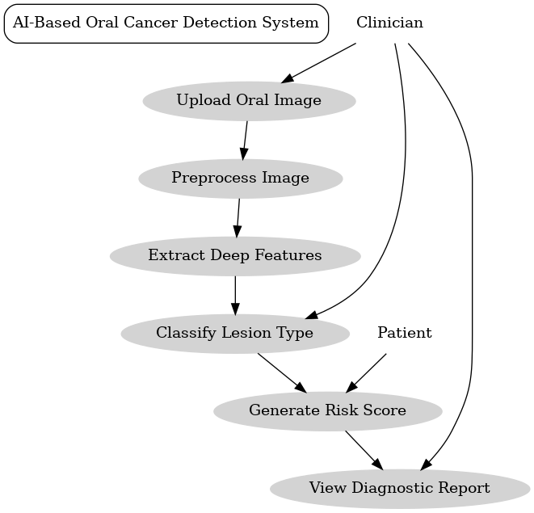
3.5.3 Activity Diagram
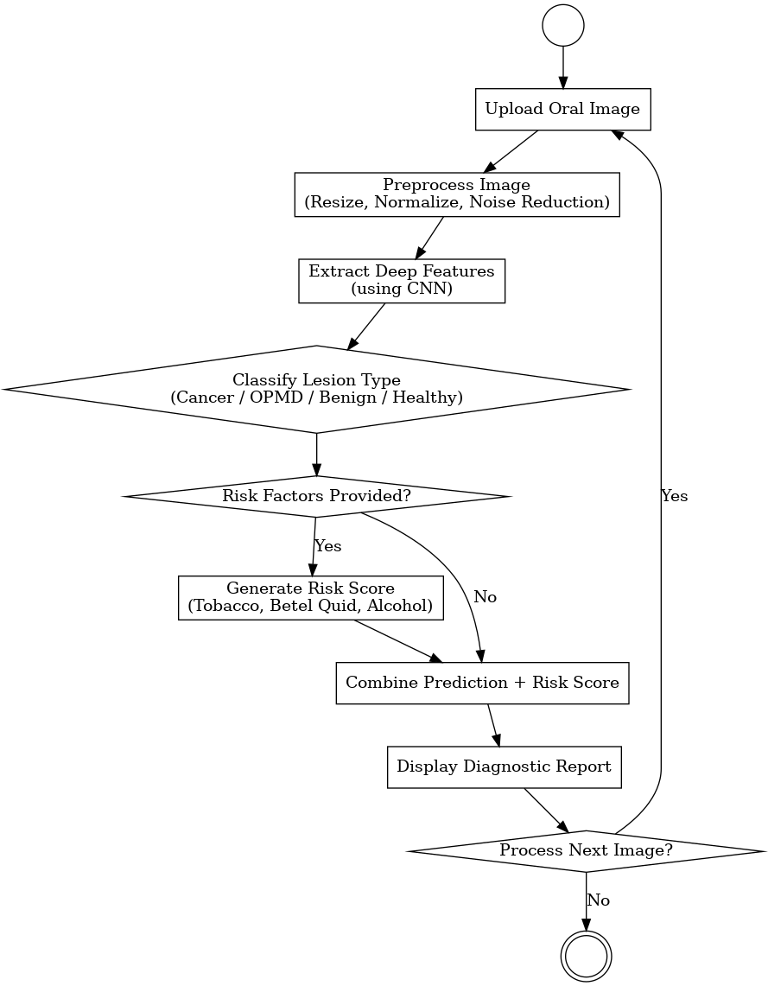
3.6 Languages and Technologies Used
The development of the AI-based oral cancer detection system primarily utilizes Python, TensorFlow, and computer-vision libraries such as OpenCV. These technologies were selected because they are open-source, scalable, widely adopted in machine learning, and ideal for medical image analysis. Below is a detailed explanation of each technology used in this project.
Python
Python is the main programming language used in this project due to its simplicity, flexibility, and powerful ecosystem of machine learning and image-processing libraries. Its extensive community support and availability of deep-learning frameworks make it highly suitable for building clinical diagnostic models.
Image Processing Logic:
Python integrates seamlessly with OpenCV to load, preprocess, and enhance oral cavity images. Operations such as resizing, normalization, and noise removal are implemented using Python functions.
CNN Model Development:
Using TensorFlow and Keras, Python allows easy construction, training, and evaluation of convolutional neural networks used for lesion classification.
Data Augmentation & Handling:
Python’s libraries such as NumPy and TensorFlow Image help perform dataset balancing, augmentation, and normalization to improve model robustness.
Prediction Pipeline:
The classification logic, probability calculations, and risk assessment integration (tobacco, betel quid, alcohol use) are implemented using Python’s clean workflow.
Visualization & Reporting:
Python’s Matplotlib and Seaborn libraries are used to visualize accuracy curves, confusion matrices, and performance metrics.

TensorFlow / Keras
TensorFlow is the primary deep-learning framework used to build and train the CNN model for lesion classification.
Model Architecture Definition:
CNN layers, transfer learning models, activation functions, and loss functions are implemented using TensorFlow/Keras.
Training & Validation:
The framework handles backpropagation, optimization, batch processing, and GPU acceleration for efficient model training.
Transfer Learning:
Pretrained models (such as MobileNet, Inception, or ResNet) allow high accuracy even with limited medical images.
Prediction & Probability Scoring:
Softmax-based classification and probability distribution generation are performed through TensorFlow functions.

CONCLUSION
The development of this AI-powered oral cancer detection system demonstrates a practical, accurate, and accessible approach to improving early diagnosis of oral cancer and potentially malignant disorders (OPMDs). By leveraging deep learning, transfer learning, and advanced image-processing techniques, the system is capable of identifying subtle lesion characteristics that are often difficult to detect through manual examination alone. This enhances the reliability of early screening and supports clinicians in making timely diagnostic decisions.
Using only standard clinical images and open-source technologies such as Python, TensorFlow, and OpenCV, the system provides a cost-effective solution that does not require expensive diagnostic hardware. The integration of a behavioral risk assessment module—considering tobacco use, betel quid consumption, and alcohol intake—adds an additional layer of clinical insight, helping estimate the patient’s likelihood of malignant transformation and strengthening the overall diagnostic process.
The system demonstrates strong potential for real-world application in hospitals, dental clinics, mobile health units, and telemedicine platforms, especially in regions where access to oral cancer specialists is limited. Its modular and extendable architecture allows future enhancements, such as real-time screening, expanded lesion categories, larger datasets, and integration with electronic health record (EHR) systems.
Overall, this project shows that effective, scalable, and affordable AI-driven diagnostic tools can be developed to support early detection and reduce the global burden of oral cancer. It contributes meaningfully to the goal of improving public health outcomes through accessible, technology-enabled clinical support systems.

