BODH :A Learning Management System

Synopsis Report

in Partial Fulfilment of the Requirements for the Course of

#### Minor Project - II

IN

Third year – Sixth Semester of **Bachelor of Technology Computer Science & Eng.**

Specialization in

#### CCVT

Under the guidance of

**Ms. Abhirup Khanna**

**Assistant Professor**

**Department of Virtualization**

By

|  |  |  |
| --- | --- | --- |
| **500069956**  **500067476** | **R110218047 R110218114** | **Dhairya Chugh**  **Raghav Jindal** |
| **500068477** | **R110218119** | **Raman Kumar** |
| **500067770** | **R110218129** | **Sachin Agrawal** |



Department of Virtualization

## SCHOOL OF COMPUTER SCIENCE

UNIVERSITY OF PETROLEUM AND ENERGY STUDIES

Bidholi Campus, Energy Acres, Dehradun – 248007

**January, 2021**



**School of Computer Science**

### University of Petroleum & Energy Studies, Dehradun

**Project Proposal Approval Form (2020-2021)**

**Minor 2**

Project Title:

BODH: A Learning Management System

#### Abstract

As COVID-19 brought many challenges to the people around the globe, schools and universities have been closed temporarily to protect students and staff from possible infection.

This project focuses on creating a web-based system called Learning Management System(LMS) which helps in conducting all the class activities online. The two main end-users of these products are instructors and students. Typically, this LMS provides an instructor a way to create and deliver content such as synchronous and asynchronous online classes, syllabus, discussions, etc, and monitoring student’s participation and their performance.

# TABLE OF CONTENT

|  |  |  |
| --- | --- | --- |
|  | **TOPIC** | **PAGE NO.** |
| 1) | Introduction | 1 |
| 2) | Literature Review | 2 |
| 3) | Problem Statement | 3 |
| 4) | Objectives | 4 |
| 5)  6) | Methodology  User Interface Design | 5  6-7 |
| 7) | System Requirements | 8 |
| 8) | Gantt Chart | 9 |
| 9) | References | 10 |

1. **INTRODUCTION**

This project focuses on creating a web-based system called Learning Management System(LMS) which helps in conducting all the class activities online. The two main end-users of these products are instructors and students. Typically, this LMS provides an instructor a way to create and deliver content such as synchronous and asynchronous online classes, syllabus, discussions, etc, and monitoring student’s participation and their performance. It allows students to perform several actions such as attending all these online live classes and recorded sessions, completing uploaded tests and assessments in the given deadline, viewing their results, etc. Offering **teachers and students a Virtual Campus**, personalized and unique, is what makes LMS classrooms a success in education and learning experiences.

Another aspect of this project is to train the teacher to use this product. Since technology is evolving day by day and in the coming time LMS would be one of the most important tools in the field of education, so this project also focuses on raising the awareness of this technology in the instructors.

UPES has decided to create a system i.e. LMS which can help those unprivileged students to get access to their study material free of cost, watch videos for better understanding, and communicate with their teachers for effective education.

Due to COVID 19, pandemic out struck the schools are shut down and the major issues are being faced by the government schools rather than private ones as they are not having any online educational system.

1. **LITERATURE REVIEW**
   * In [1], the author Chirag Patel, Mahesh Gadhavi and Dr. Atul Patel has presented a comprehensive study of different e-learning based LMSs. This study would help researchers involved in development of e-learning based LMS.To solve this problem we conducted this survey after counseling students for 30 minutes about these novel features. Many institutes started using these systems for serving different department needs.Each system is classified as per the parameters such as technology, features and platform-tools. Based on these parameters a new unified cloud based system is proposed with all these parameters and other new features.
   * In [2], the authors Nor Aziah Alias & Ahmad Marzuki Zainuddin included study of an emphasis on innovation, rather than the technology should be adopted. If an environment that supports opportunities for staff to try new teaching and learning methods is created, and that encourages them to support each other and share knowledge and skills, it has a greater likelihood of success. This paper describes the concerns of a group of International Islamic University Malaysia (IIUM) lecturers regarding a technological innovation. Hall & Hord’s stages of concern questionnaire (SoCQ) is employed for the purpose of gauging the participants’ concerns about the use of a learning management system.A common mistake made by educational practitioners in planning and implementing new technologies is to enthusiastically select a technological medium and imposing its use to solve educational problems when the staff are not being prepared well in advance nor are they kept on alert so they could be regularly integrated into such projects.
   * In [3], the author Cynthia Gautreau has included study of numerous e-learning based learning management systems(LMS). Each system is classified as per the parameters such as technology, features and platform-tools. Based on these parameters a new unified cloud based system is proposed with all these parameters and other new features. The manner in which universities conduct administration, educators teach, and students learn are affected by technology advancements. Researchers address numerous benefits of technology integration.Furthermore, Edelstein and Edwards (2002) noted that online courses are successful when the students are involved and active participants. Online instruction contains advantages that support student learning, however, faculty development training is necessary to understand the effective techniques.

# PROBLEM STATEMENT

Due to COVID-19 the proper continuity of the education has been broken and not only this COVID-19 has brought about a revolution in the field of education.While many of the privileged schools and institutes have already adopted a effective way of education , there are still a part of society who have not taken advantage of this efficient method of education i.e virtual education.

In this time of pandemic, it was really hard to transfer the basic education this society deserved.So , our LMS makes sure that they always get effective and efficient education in the future.

1. **OBJECTIVES**

The main objective of the project is to implement a Learning management system to support the learning of under privileged students adopted by UPES CSR.

Sub-objectives for the project are:

➔ Facilitating faculty and admin login

➔ Providing a platform that will support content management. This objective would be achieved by adding documents, video links and weblinks related to the particular course.

➔ Integration of existing interactive tools (Zoom, Google Meet, Microsoft Teams) for Synchronous Learning

➔Testing and Assignment Submission & Evaluation

🡪Providing efficient communication medium for discussions via chat support.

Project Components:-

1. **User Management** (login for student faculty and admin)
2. **Content Management** (documents videos and weblinks related to the particular course)
3. **Synchronous Learning (**Integration of existing tools (Zoom, Google Meet, Microsoft Teams)
4. **Asynchronous Learning** (Recorded video lectures for self pace learning)
5. **Testing & Assessment (**Assignment Submission & Evaluation for testing student’s knowledge)
6. **Contact & Communication** (whatsapp links and email options for discussions )

# METHODOLOGY

Agile methodology of software development will be followed for the proposed project.

The project is divided into 12 sprints where the sprint 7 and 8 will consist of parallel development by different members of the team. Each sprint is provided ample time to complete itself as well as to maintain the product's backlog (if any). The project can accommodate changes if required at any stage of the project. The sprints 1, 2 and 3 are specifically for requirement analysis and designing of the project. One sprint is specifically designed for setting the environment like maintaining the Version Control (Git in our case) .

Each development sprint is followed by Unit Testing and an Integration Testing at the end. Sprints are also designed for the reviewing as well as retrospection part.

Overall, the time for the project is dedicated to an approach where the beginning time is dedicated towards the requirement analysis and the documentation part and during the implementation part all the team members are following their dedicated sprints cycles to implement the functionality. After the implementation, testing is to be done for the whole application. Finally, the application is deployed with the documentation.

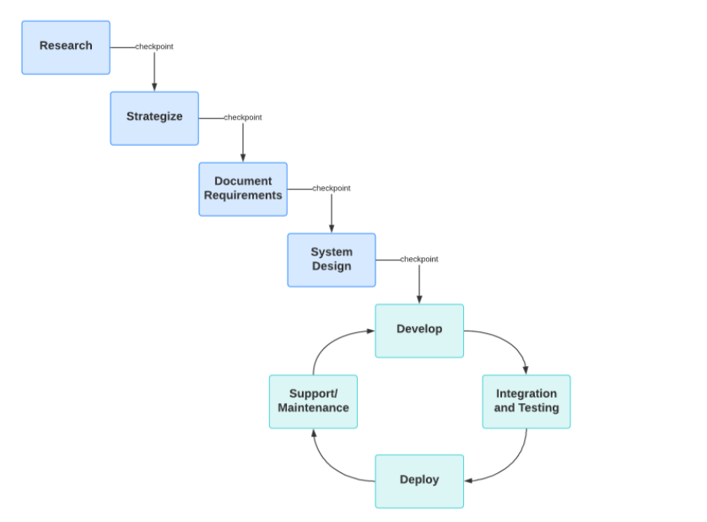

**Figure-1 Combination of Agile and Waterfall Model**

**6.User Interface Design**

User Interface Design for any website should be very simple. This website is clear, consistent and responsive.it is spacious and easy to understand.

**Home Page-**



**Students Dashboard-**

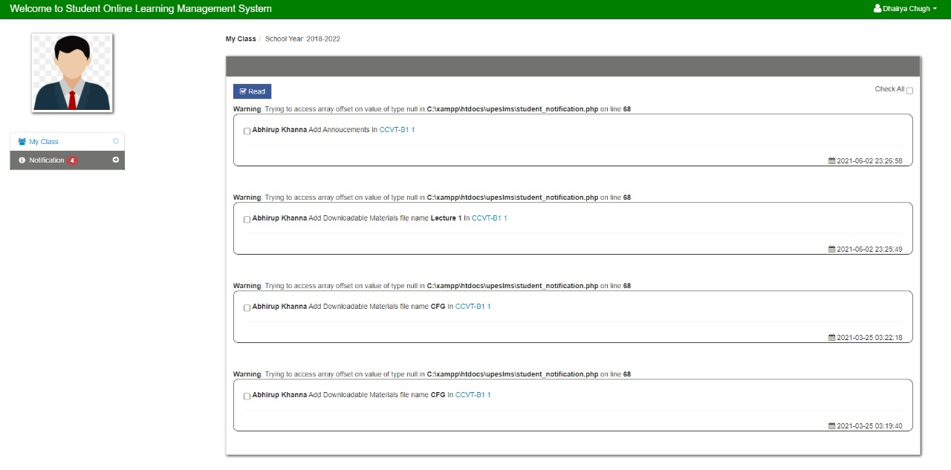

**Asynchronous Module-**

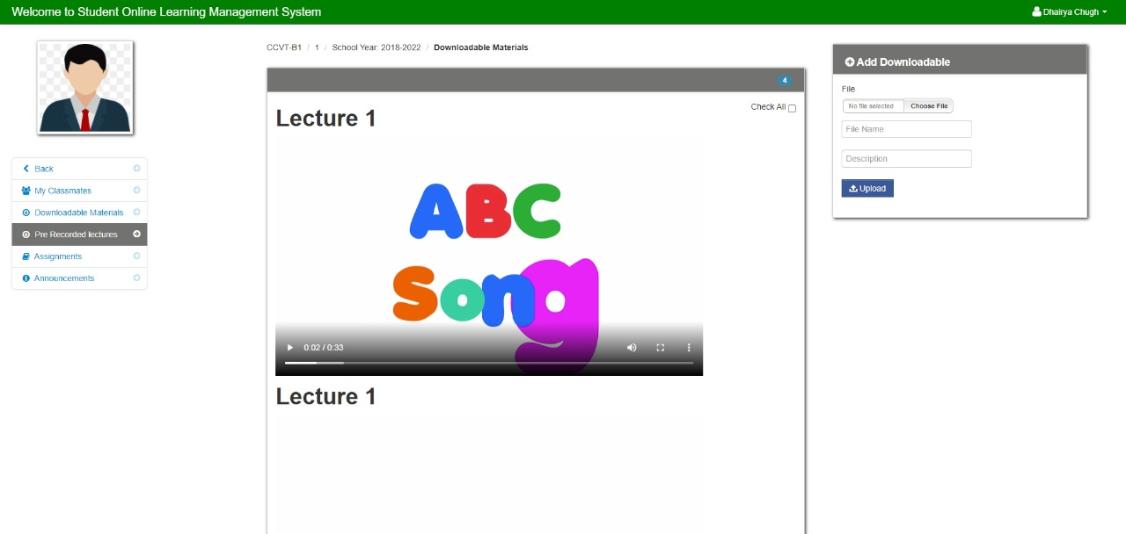

**7. SYSTEM REQUIREMENTS**

1. **Software**
   * Visual studio Text-Editor
   * Linux/Windows Operating System
   * Apache Web Server
   * AWS CLI
2. **Hardware**
   * 512 MB RAM
   * i3 5th Generation or above processor

# 8.GANTT CHART

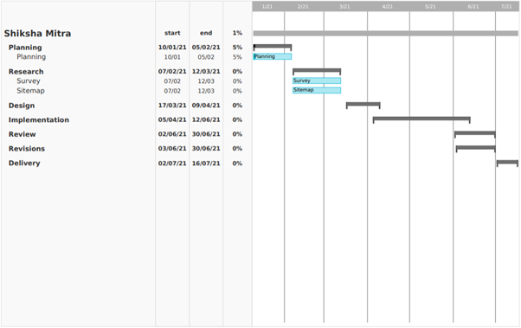

**Figure-4 Gantt Chart**

**9. REFERENCES**

[1]. Chirag Patel, Mahesh Gadhavi and Dr. Atul “A survey paper on e-learning based learning

management Systems (LMS)” (Istanbul, Turkey, May 31--June 2, 2004), 239--243.

[2].Nor Aziah Alias & Ahmad Marzuki Zainuddin :”Adopting the Learning Management System” . Distance Education Report 9, 9 (May 2005), 6--7

[3]. Armatas, C., Holt, D. & Rice, M. (2003). Impacts of an online resource-based learning

environment - Does one size fit all?Distance Education,24(2), 141-158.

## Synopsis Draft verified by

### Mr. Abhirup Khanna Dr. Deepshikha Bhargava

Assistant Professor Head of Department Department of Virtualization Department of Virtualization

School of Computer Science School of Computer Science

### Project Guide HOD

#### (Mr. Abhirup Khanna) (Dr. Deepshikha Bhargava)