**Events file upload to Flywheel**

**Steps to set up –**

1. Setup Flywheel account, access and Api-key

<https://docs.flywheel.io/hc/en-us/articles/360019252953-CLI-fw-upload>

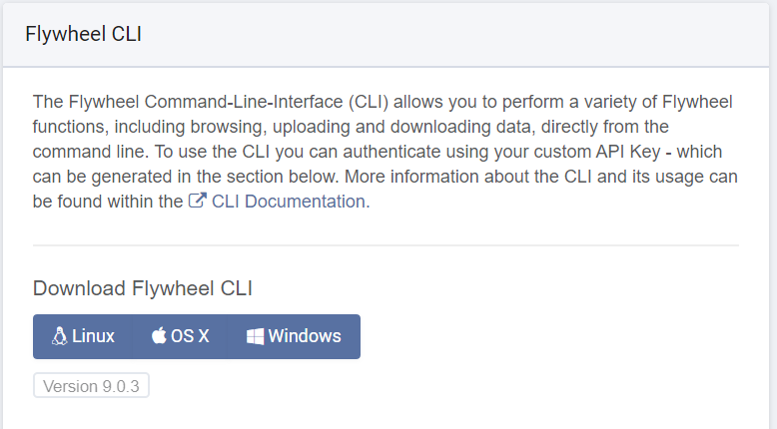Download FW CLI to the target directory from profile settings of your Flywheel account

1. Get access to loki1 repository and Download SSH key for Github for your system

<https://help.github.com/en/articles/adding-a-new-ssh-key-to-your-github-account>

1. Open fw_file_path.txt and change the file path to the directory with FW CLI
2. Ensure the particular subject and session with BIDS data exists in FW before running this script

**Initiate upload from command prompt –**

1. Open command prompt
2. Login to Flywheel - Fw login “api_key”
3. Download Repository from Github.
   1. If fetching repo for the first time- python loki1_git_fetch.py
   2. If pulling repo updates – python loki1_git_pull.py
4. 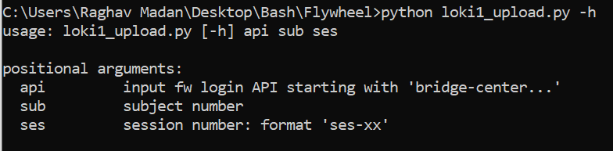Run script to upload event files – python loki1_upload.py -api “api key” -sub “subject number” -ses “session number”