**T1 files shift in Flywheel**

**Steps to set up –**

1. Setup Flywheel account, access and Api-key

<https://docs.flywheel.io/hc/en-us/articles/360019252953-CLI-fw-upload>

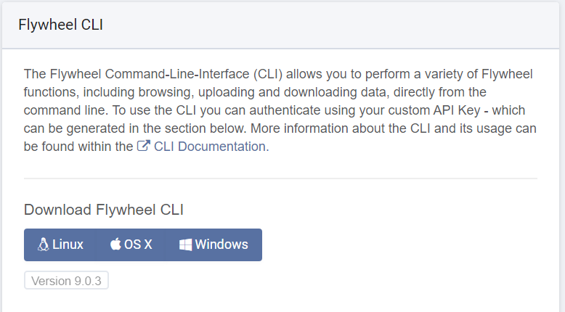Download FW CLI to the target directory from profile settings of your Flywheel account

1. Get access to loki1 repository and Download SSH key for Github for your system

<https://help.github.com/en/articles/adding-a-new-ssh-key-to-your-github-account>

1. Open fw_file_path.txt and change the file path to the directory with FW CLI
2. Ensure the particular subject and session with BIDS data exists in FW before running this script
3. **Create a folder “t1” in the Flywheel CLI directory**.
4. **Modify the API key in t1_fetch.py and t1_shift.py to your own.**

**Initiate upload from command prompt –**

1. Open command prompt
2. Login to Flywheel - Fw login “api_key”
3. **Fetch t1 data from LOKICAT for the first time – python t1_fetch.py -sub ” -sub “subject number” -ses “session number”**

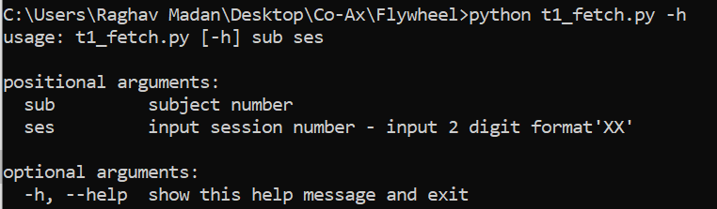

1. **Run script to upload t1 files to LOKI1– python t1_shift.py -sub “subject number” -ses_s “starting session ” -ses_e “ending session ”**

