Landing Page (“About Me”)

“I am inspired by scientific efforts that stretch our collective human ability to observe, understand, and improve the world around us. From listening for faint ripples in spacetime (LIGO), to probing the smallest (LHC) and most distant structures (JWST) of the universe. These projects embody a form of inquiry I find deeply inspirational: interdisciplinary, patient, and driven by questions that go beyond any single field. In my own work, I strive to apply that spirit to the brain, developing computational systems that make the brain's complex, invisible dynamics more visible and measurable.

I am a computational neuroscientist working at the intersection of neuroimaging, digital histopathology, and spatial statistical modeling. My research focuses on understanding how neurodegenerative disease unfolds across the human brain by developing integrative frameworks that unify imaging, pathology, and clinical data within a coherent spatial representation. During my PhD at the University of Washington, advised by Prof. John Gennari and Dr. Paul Crane, I developed NeuroPathPredict (NPP), a spatial modeling framework designed to estimate Alzheimer’s disease–related neuropathology in unsampled brain regions. This work integrates ex vivo MRI, quantitative digital pathology, and machine learning approaches.

Before entering neuroscience, I worked in engineering research and innovation management within industrial R&D environments. That experience shaped how I approach science: as systems-building. I am drawn to problems that require integrating heterogeneous components — data, methods, and people — into scalable, reproducible frameworks that extend beyond a single project or cohort.”

“CV” page

Saved separately

“Research/projects” page

NeuroPathPredict (NPP)

Spatial modeling of neuropathology in unsampled brain regions
NeuroPathPredict (NPP) is a computational framework for estimating whole-brain distributions of Alzheimer’s disease pathology from sparse regional samples. It integrates ex vivo MRI, quantitative digital histopathology, and spatial statistical learning, including universal kriging and machine learning, to model disease as a continuous spatial process. By embedding multimodal data within a voxel-level representation, NPP enables scalable, cross-cohort inference of neurodegenerative spread.
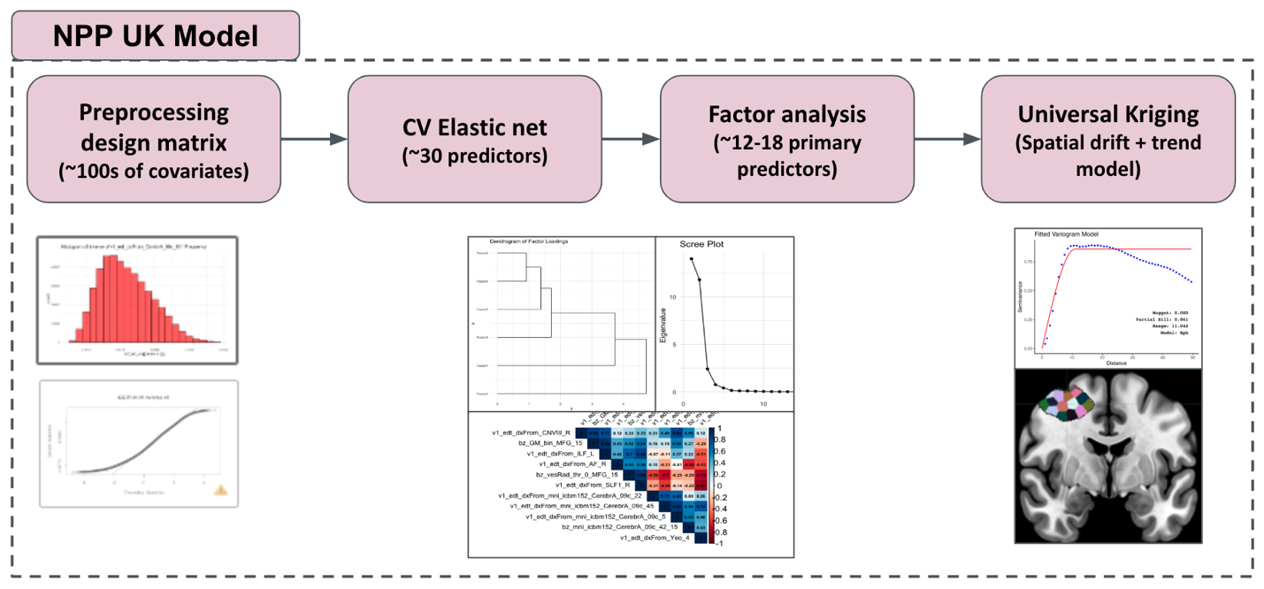
Github repo - https://github.com/RaghavMadan/NeuroPathPredict

QNPtoVox (Quantitative Neuropathology to Voxels)
Mapping 2D quantitative pathology into 3D brain space
QNPtoVox is an open-source pipeline that transforms two-dimensional histopathology measurements into three-dimensional measurements in a standardized brain space. Registering tissue slabs to ex vivo MRI and MNI coordinates enables direct integration of digital pathology with neuroimaging analyses. The system bridges microscopic and macroscopic data scales, supporting voxel-level modeling and reproducible multimodal brain mapping.
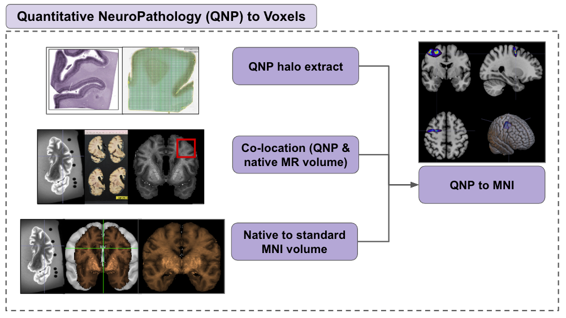
Github repo- https://github.com/RaghavMadan/QNPtoVox

I-BIS (Integrated Brain Information System)
Voxel-level covariate engineering for large-scale brain modeling
I-BIS is a scalable voxel-level feature engineering framework designed to support integrative spatial modeling. It constructs a high-resolution brain representation (~50 million voxels) and associates each voxel with thousands of engineered covariates derived from imaging, atlases, and spatial priors. By transforming heterogeneous brain data into structured inputs for modeling, I-BIS provides reusable infrastructure for multimodal statistical learning.
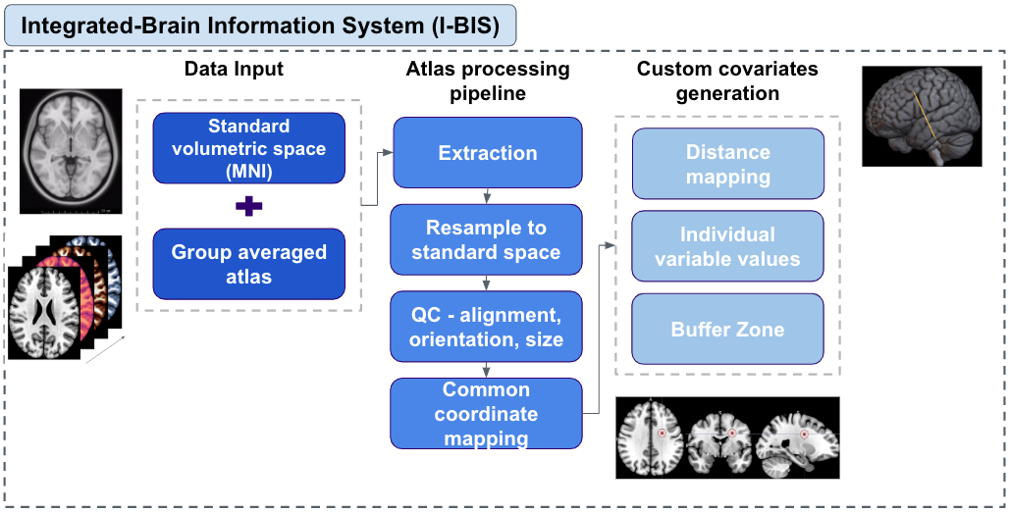
Github repo - https://github.com/RaghavMadan/IBIS

Neural Competition in Human Decision-Making
Systems-level fMRI analysis of evidence accumulation
At the Co-Ax lab at Carnegie Mellon University, I contributed to a systems neuroscience study examining how competing neural representations shape evidence accumulation during decision-making. Using large-scale fMRI datasets and generalized linear modeling, we analyzed cortico-basal ganglia-thalamic circuits involved in adaptive choice behavior. This work, published in eLife, grounded my computational modeling in experimental circuit neuroscience.
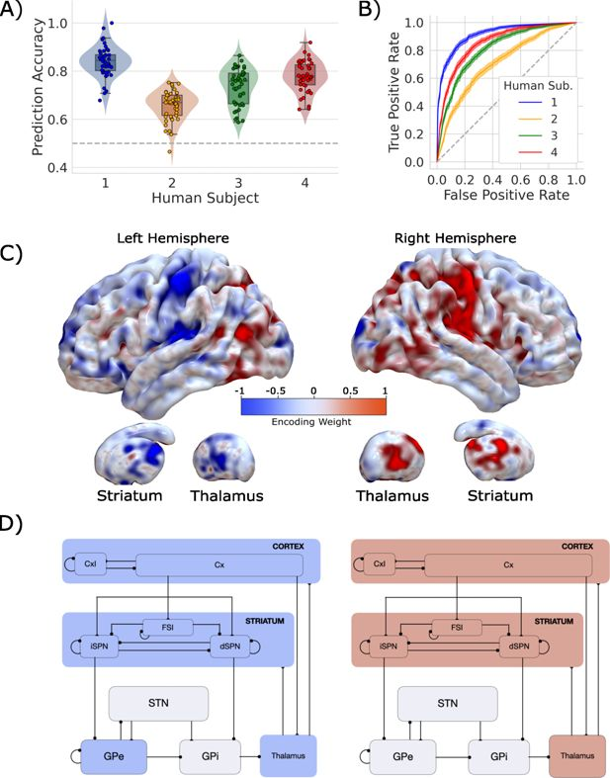
Github repo - https://github.com/kalexandriabond/loki_1

SABHI — Sustainable and Accessible Brain Health Initiative
Designing scalable models for early neurological care
SABHI was a translational initiative that explored scalable, data-informed approaches to the early detection and management of neurological disorders in resource-constrained settings. The project examined how digital screening, risk stratification, and health system design could be integrated into sustainable care models. It reflects my broader interest in connecting computational neuroscience with real-world implementation.
