Computer Architecture – CSE590

Project 2: Guessing Game

# Introduction:

This game has been designed using Xilinx ISE Design Suite and the Basys2 board. The game has been programmed in Verilog. This is a two player guessing game, where player one enters a number on the Basys2 board using the slider switches and the player two guesses the number that was entered. To assist the player two in his guesses, hints are provide after every wrong guess, these hints are in the form of ‘2LO’ or ‘2HI’, indicating that the guess made was either too low or too high. Once the right guess is made by player two, the LEDs on the board start to blink in celebration and the seven segment display shows the guesses taken by the player.

# Playing the game:

Once the board is powered up and the project2.bit or the project2.mcs *(for non-volatile download)* files are downloaded into the board, the below instructions are to be followed.

1. Switch ‘ON’ the enable slider switch S7 (logic ‘1’) to start the game. Once this is done, the seven segment displays ‘PL-1’ which indicates that player one is to enter the numbers into the board.
2. Player one to use the slider switches S3 to S0 to select a number in binary and then use the buttons B3 to B0 to enter the number into the board.

Example: To enter 5 in the first digit of the display, the player one is to switch ON S2 and S0 to logic ’1’ and keep S3 and S1 at logic ‘0’ making the sequence as 0101, which is equal to 5. This number is then entered into the digits of the seven segment display using the buttons. If button 0 is pressed, then the number is entered into digit 0.

1. Once all the buttons are pressed and the player one is satisfied with the all the numbers on the display, the switch S4 is switched ON (logic ‘1’). This shifts the control to player two and displays ‘PL-2’ on the seven segment display. It also saves the numbers entered by player one.
2. Now, player two to enter the numbers (guess) on the board in a similar way as done by player one.
3. Once all the numbers are entered, the player two can finalize his guess by moving switch 5 from low position to high and back to low position (logic ‘0’ to logic ‘1’ and back to ‘0’). This saves the guess entered by player two and compares it with the numbers entered by player one.
4. If the guess is higher that the numbers entered by player one, then a message/hint ‘2HI’ is displayed on the board. Else, if the guess is lower than the number, a hint ‘2LO’ is displayed. Player two to use these hints to make changes in his next guess.
5. If the guess turns out to be same as the number entered by player one, the LED’s on the board start to blink in a celebration mode indicating that number has been guessed correctly. The seven segment display indicates the number of guesses *(guess count displayed in hexadecimal)* that the player two took to get the right number.
6. To start again, switch the enable button to low position and turn it back ‘ON’ again.

# Design:

The system has been designed and operates as per the project requirements.

* The slider switch S7 is used to start the game. This is the enable switch and the game can only be played when it is at logic ’1’.
* The slider switches (S3 to S0) are for the player input. Players enter the numbers into the game via the slider switches in binary.
* The buttons (B3-B0) under the seven segment latch and display the number entered using the slider switches on its corresponding digit of the seven segment display.
* The slider switch S4 is to choose the player. Logic ‘0’ indicates player one and logic ‘1’ indicates player two.
* The slider switch S5 is to latch the guess made by the player two.

The pin connections on the board are given below:

**Description Pin**

Clock B8

Anode [3-0] K14, M13, J12 & F12

Button [3-0] A7, M4, C11 & G12

LEDs [7:0] G1, P4, N4, N5, P6, P7, M11 & M5

Slider Switches [3:0] B4, K3, L3 & P11

Cathodes [a, b, c, d, e, f, g, dp] L14, H12, N14, N11, P12, L13, M12 & N13

Enable (Slider Switch 7) N3

Player Key (Slider Switch 4) G3

Set Guess (Slider Switch 5) F3

The game has been programmed in behavioral Verilog using the ISE Design Suite. Tasks were created to handle common instructions, such as displaying numbers on the seven segment display. As the basys2 board uses a common anode for the 4 seven segment display, strobing was done to make it possible to display different digits on the display. All the digits were alternated at equal intervals of time in for strobing.

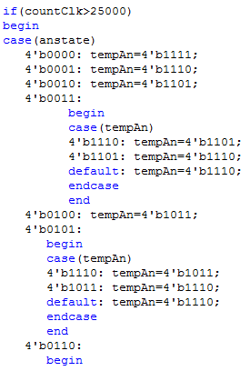

Here, the state of the button pressed is stored in the variable anstate which dictates the alternation of anodes. For example, if only button 0 is pressed, then the display would only energize anode 0, whereas if buttons 0 and 1 are pressed, then the anodes 0 and 1 would get energized at alternate cycles. The variable tempAn stores the anode[3-0] information.

The main control logic for the guessing game was dictated by states using flag bits to check if the buttons were pressed or if the switch positions were changed. An example of this has been shown below;

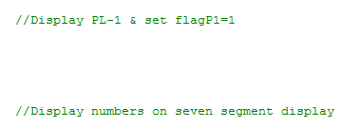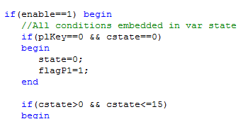

The state variable was then used to display the appropriate values on the seven segment display.

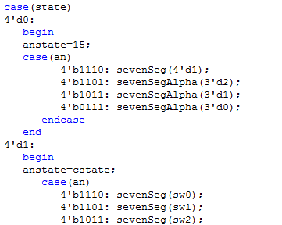

The CCLK clock was opted in the generate programming file properties and the bit file was generated. Using impact and the project2.bit file, a project2.mcs file was generated which was downloaded into the board’s onboard non-volatile flash memory.