CHHATTISGARH PUBLIC SCHOOL

Computer Science Report File
Session-2019-2020

Submitted by
Raghav Pandit

Under the Guidance of
Mr. Shashwat Sharma

Certificate

This is to certify that Raghav Pandit of class 12 has prepared the report with 30 python programs .The report is the result of his efforts & endeavors. The report is found worthy of acceptance as final report for the subject Computer Science of class 12. He has prepared the report under my guidance.

(Mr. Shashwat Sharma)
Computer Science
Chhattisgarh Public School

Acknowledgment

I would like to express my special thanks and gratitude to my Computer Science educator Mr. Shashwat Sharma Sir ,who gave me the opportunity to make this wonderful report.

Raghav Pandit
Class 12 science

Contents

- Python libraries used
- Working description
- Coding
- Output
- Bibliography

Python Libraries used

- Tkinter
- Pyplot from Matplotlib
- Pillow
- Collections
- CSV

Working Description

This program is designed to provide a user friendly Graphical user interface for the ease of use.

This Program can generate three type of graphs

- Bar Graph
- Pi Chart
- Line Chart

Coading

#Project on GUI graph generator
#This can be used to generate graphs and charts with the help of graphical user interface,
#so it is easily usable to any person
#made by :- Raghav Pandit

import tkinter as tk
from tkinter import messagebox
from tkinter import colorchooser
from PIL import ImageTk,Image
import matplotlib.pyplot as pl
from tkinter.filedialog import askopenfile
import csv
from collections import Counter
pl.style.use("fivethirtyeight")
HEIGHT = 600
WIDTH = 800
lineColor =("adf","black")
markerColor = ("adf","black")

isBar = False
isLine = True

root = tk.Tk()
root.geometry(f"{WIDTH}x{HEIGHT}")
root.title("Graph Generator")

####################__FUNCTIONS_######################
#Contains all the function required in programm

def reverse(ls):
return [ele for ele in reversed(ls)]

def lineChart(xValues,yValues,xLabel,yLabel,ls,lw,color,marker,markersize,markercolor,title):
xValues=eval(xValues)
yValues = eval(yValues)

pl.plot(xValues,yValues,ls=ls,linewidth=lw,color=color,marker=marker,markersize=markersize,markerfacecolor=markercolor)
pl.title(title)
pl.xlabel(xLabel)
pl.ylabel(yLabel)
#pl.grid(True)
print(pl.style.available)

pl.show()

def barChart(xLabel,yLabel,yValues,xValues,title,width=.8):

pl.bar(eval(xValues),eval(yValues),width=width)

pl.xlabel(xLabel)
pl.ylabel(yLabel)
pl.title(title)
pl.show()

def piChart(values,labels,title):
values = eval(values)
labels = eval(labels)
pl.pie(values,labels=labels)
pl.title(title)
pl.plot()
pl.show()

def getMarkerColor():
global markerColorLabel
global markerColor
markerColor = colorchooser.askcolor()
markerColorLabel.config(bg=markerColor[1])

def getLineColor():
global colorLabel
global lineColor
lineColor = colorchooser.askcolor()
colorLabel.config(bg=lineColor[1])

def barFrameRaise():
mainFrameBar.tkraise()
global isBar , isLine
isBar = True
isLine = False

def lineFrameRaise():
mainFrameLine.tkraise()
global isBar , isLine
isBar = False
isLine = True

def piFrameRaise():
mainFramePi.tkraise()
global isBar , isLine
isBar = False
isLine = False

def generate():

if isLine:
lineChart(xValueLine.get('1.0',tk.END),yValueLine.get('1.0',tk.END),xLabelValueLine.get(),yLabelValueLine.get(),ls=lineStyle.get(),lw=lineWidth.get(),color=lineColor[1],marker=markerStyle.get(),markersize=markerSize.get(),markercolor=markerColor[1],title=title.get())
elif isBar:
barChart(xLabelValueBar.get(),yLabelValueBar.get(),yValueBar.get('1.0',tk.END),xValueBar.get('1.0',tk.END),barTitle.get(),barWidth.get())
else:
piChart(piValues.get('1.0',tk.END),piLabels.get('1.0',tk.END),piTitle.get())

def about():
messagebox.showinfo("About Creator","This program is created by Raghav Pandit of class 12 Science")
man='''
Inserting the value:-
To insert value seperate them by commas ',' and use inverted commas for strings but not for integers
Example :- X-Values = 'val1','val2','val3'
Y-Values = 10,20,30 '''
def manual():
messagebox.showinfo("User_Manual",man)
####################__XXXXXXXXX_######################

####################__IMAGES__######################
#Contains All images in need in the programm

#Background image
bgImage = ImageTk.PhotoImage(Image.open(r"Images\background.jpg"))

#Image of line icon
lineImage = ImageTk.PhotoImage(Image.open(r"Images\icons8-line-chart-64.png"))

#Image of bar chart
barImage = ImageTk.PhotoImage(Image.open(r"Images\icons8-bar-chart-96.png").resize((69,69),Image.ANTIALIAS))

#Image for icon
iconImage = ImageTk.PhotoImage(Image.open(r"Images\appicon.png"))
#Set icon of application
root.iconphoto(False,iconImage)

#Image for heading icon
headingImage = ImageTk.PhotoImage(Image.open(r"Images\HeadingIcon.png").resize((55,55),Image.ANTIALIAS))

#image of pi chart icon
piImage = ImageTk.PhotoImage(Image.open(r"Images\icons8-doughnut-chart-256.png").resize((64,64),Image.ANTIALIAS))

####################__XXXXXX__######################

####################__WIDGETS__######################
#Contains all the widgets

#Menu

menu = tk.Menu(root)
helpMenu = tk.Menu(root)
aboutMenu = tk.Menu()

menu.add_cascade(label="Help",menu=helpMenu)

helpMenu.add_command(label="About",command=about)
helpMenu.add_command(label="User-Manual",command=manual)
root.config(menu=menu)

#Setting background image
imageLabel = tk.Label(root,image=bgImage)
imageLabel.pack()

#Setting Top Frame with Heading
topFrame = tk.Frame(root)
topFrame.place(relx=.005,rely = .005 , relwidth = .985 , relheight = .09)

headingLabel = tk.Label(topFrame,text="Graph Generator",font=("Caslon",35,"bold"),fg="#26cdeb")
headingLabel.pack()

#icon of the app
mainIconLabel = tk.Label(topFrame,image=headingImage)
mainIconLabel.place(relx=.18,rely=0)

#Side Frame which will contain main navigation of programm
sideFrame = tk.Frame(root)
sideFrame.place(relx=.005,rely = .1 , relwidth = .19 , relheight = .84)

#Side Button for line chart
tk.Button(sideFrame , text="Line Chart" , font = ("Caslon",21,"bold") , bg="#e8e8e8",pady=61,relief="raised",command=lineFrameRaise).place(relx=0,rely=0,relwidth=1,relheight =.3335)

#Side button for bar chart
tk.Button(sideFrame , text="Bar Chart" , font = ("Caslon",21,"bold") , bg="#e8e8e8",pady=61,command=barFrameRaise).place(relx=0,rely=.33,relwidth=1,relheight =.3335)

#Side button for pi chart
tk.Button(sideFrame , text="Pi Chart" , font = ("Caslon",21,"bold") , bg="#e8e8e8",pady=61,command=piFrameRaise).place(relx=0,rely=.66,relwidth=1,relheight =.3445)

#Generate button
tk.Button(root,text="Generate",font=("Caslon",10,"bold"),command = generate).place(relx=.903,rely=.95)

####################__MainPiChart__######################

#Main frame for pi chart
mainFramePi = tk.Frame(root)
mainFramePi.place(relx=.2,rely=.1 , relwidth = .79 , relheight = .84)

tk.Label(mainFramePi,text="Pi Chart",font=("Caslon",28,"bold")).place(rely=.03,relx=.13)

piImageLabel = tk.Label(mainFramePi,image=piImage)
piImageLabel.place(relx=.01,rely=.01)

#X-Value and it's text area
tk.Label(mainFramePi,text="Values:-",font=("Caslon",18)).place(relx=.01,rely=.3)
piValues = tk.Text(mainFramePi)
piValues.place(relx=.01,rely = .38,relheight = .20,relwidth=.48)

#Y-Value and it's entry
tk.Label(mainFramePi,text="Labels",font=("Caslon",18)).place(relx=.5,rely=.3)
piLabels = tk.Text(mainFramePi)
piLabels.place(relx=.5,rely=.38,relwidth=.48,relheight = .20)

#Title of bar graph
piTitle = tk.StringVar()
tk.Label(mainFramePi,text="Title",font=("Caslon",20)).place(relx=.20,rely=.88)
tk.Entry(mainFramePi,textvariable = piTitle,font = ("Caslon",15)).place(relx = .30,rely=.89)

####################__XXXXXXXXXXXXX__######################

####################__MainBarChart__######################

#Main frame for bar chart
mainFrameBar = tk.Frame(root)
mainFrameBar.place(relx=.2,rely=.1 , relwidth = .79 , relheight = .84)

tk.Label(mainFrameBar,text="Bar Chart",font=("Caslon",28,"bold")).place(rely=.03,relx=.13)

barImageLabel = tk.Label(mainFrameBar,image=barImage)
barImageLabel.place(relx=.01,rely=.01)

#X-Label and it's Entry
xLabelValueBar = tk.StringVar()
tk.Label(mainFrameBar,text="x-label",font=("Caslon",18)).place(relx=.01,rely=.2)
tk.Entry(mainFrameBar,textvariable = xLabelValueBar,font = ("Caslon",15)).place(relx = .12,rely=.21)

#Y-Label and it's Entry
yLabelValueBar = tk.StringVar()
tk.Label(mainFrameBar,text="y-label",font=("Caslon",18)).place(relx=.5,rely=.2)
tk.Entry(mainFrameBar,textvariable = yLabelValueBar,font = ("Caslon",15)).place(relx = .63,rely=.21)

#X-Value and it's text area
tk.Label(mainFrameBar,text="x-values:-",font=("Caslon",18)).place(relx=.01,rely=.3)
xValueBar = tk.Text(mainFrameBar)
xValueBar.place(relx=.01,rely = .38,relheight = .20,relwidth=.48)

#Y-Value and it's entry
tk.Label(mainFrameBar,text="y-values:-",font=("Caslon",18)).place(relx=.5,rely=.3)
yValueBar = tk.Text(mainFrameBar)
yValueBar.place(relx=.5,rely=.38,relwidth=.48,relheight = .20)

#To set bar width
tk.Label(mainFrameBar,text="Bar Width",font=("Caslon",18)).place(relx=.5,rely=.59)
barWidth = tk.DoubleVar()
barWidth.set(.8)
tk.Entry(mainFrameBar,font=("Caslon",18),textvariable=barWidth,).place(relx=.70,rely=.59,relwidth=.15)

#Title of bar graph
barTitle = tk.StringVar()
tk.Label(mainFrameBar,text="Title",font=("Caslon",20)).place(relx=.20,rely=.88)
tk.Entry(mainFrameBar,textvariable = barTitle,font = ("Caslon",15)).place(relx = .30,rely=.89)

####################__XXXXXXXXXXXXXX__######################

####################__MainLineChart__######################

#Main frame for line chart
mainFrameLine = tk.Frame(root)
mainFrameLine.place(relx=.2,rely=.1 , relwidth = .79 , relheight = .84)

#Top label of the line chart frame
tk.Label(mainFrameLine,text="Line Chart",font=("Caslon",28,"bold")).place(rely=.03,relx=.13)

#Top icon of the linechart frame
tk.Label(mainFrameLine,image=lineImage).place(relx=.01,rely=.01)

#X-Label and it's Entry
xLabelValueLine = tk.StringVar()
tk.Label(mainFrameLine,text="x-label",font=("Caslon",18)).place(relx=.01,rely=.2)
tk.Entry(mainFrameLine,textvariable = xLabelValueLine,font = ("Caslon",15)).place(relx = .12,rely=.21)

#Y-Label and it's Entry
yLabelValueLine = tk.StringVar()
tk.Label(mainFrameLine,text="y-label",font=("Caslon",18)).place(relx=.5,rely=.2)
tk.Entry(mainFrameLine,textvariable = yLabelValueLine,font = ("Caslon",15)).place(relx = .63,rely=.21)

#X-Value and it's text area
tk.Label(mainFrameLine,text="x-values:-",font=("Caslon",18)).place(relx=.01,rely=.3)
xValueLine = tk.Text(mainFrameLine)
xValueLine.place(relx=.01,rely = .38,relheight = .20,relwidth=.48)

#Y-Value and it's entry
tk.Label(mainFrameLine,text="y-values:-",font=("Caslon",18)).place(relx=.5,rely=.3)
yValueLine = tk.Text(mainFrameLine)
yValueLine.place(relx=.5,rely=.38,relwidth=.48,relheight = .20)

#To set line Style
lineStyle = tk.StringVar()
tk.OptionMenu(mainFrameLine,lineStyle,"-","--","-.",":").place(relx=.20,rely=.59)
lineStyle.set("-")
tk.Label(mainFrameLine,text="Line Style",font=("Caslon",18)).place(relx=.01,rely=.59)

#To set line width
tk.Label(mainFrameLine,text="Line Width",font=("Caslon",18)).place(relx=.5,rely=.59)
lineWidth = tk.IntVar()
lineWidth.set(1)
tk.Entry(mainFrameLine,font=("Caslon",18),textvariable=lineWidth,).place(relx=.70,rely=.59,relwidth=.15)

#Line color
tk.Button(mainFrameLine,text="Choose Line Color",command=getLineColor,font=("Caslon",10)).place(relx=.01,rely=.69)
colorLabel = tk.Label(mainFrameLine,text="Choosen Color",font=("Caslon",13),bg="white")
colorLabel.place(relx=.23,rely=.70,relwidth=.18)

#Marker style
tk.Label(mainFrameLine,text="Marker Style",font=("Caslon",18)).place(relx=.5,rely=.69)
markerStyle = tk.StringVar()
markerStyle.set("None")
tk.OptionMenu(mainFrameLine,markerStyle,"None",".",",","o","+","x","D","d","s","p","*","h","H","1","2","3","4","v","^","<",">","|").place(relx=.72,rely=.69)

#Maker Size
tk.Label(mainFrameLine,text="Marker Size",font=("Caslon",18)).place(relx=.01,rely=.78)
markerSize = tk.IntVar()
markerSize.set(1)
tk.Entry(mainFrameLine,font=("Caslon",14),textvariable=markerSize).place(relx=.25,rely=.78,relwidth=.08)

#Marker color
tk.Button(mainFrameLine,text="Choose Marker Color",command=getMarkerColor,font=("Caslon",10)).place(relx=.50,rely=.78)
markerColorLabel = tk.Label(mainFrameLine,text="Choosen Color",font=("Caslon",13),bg="white")
markerColorLabel.place(relx=.73,rely=.79,relwidth=.18)

#Title of graph
title = tk.StringVar()
tk.Label(mainFrameLine,text="Title",font=("Caslon",20)).place(relx=.20,rely=.88)
tk.Entry(mainFrameLine,textvariable = title,font = ("Caslon",15)).place(relx = .30,rely=.89)

####################__XXXXXXXXXXXXXXX__######################

####################__XXXXXXX__######################
root.mainloop()

Output
1. Line Chart
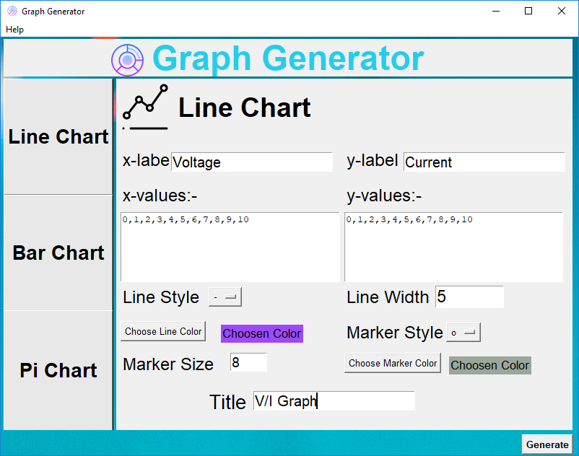
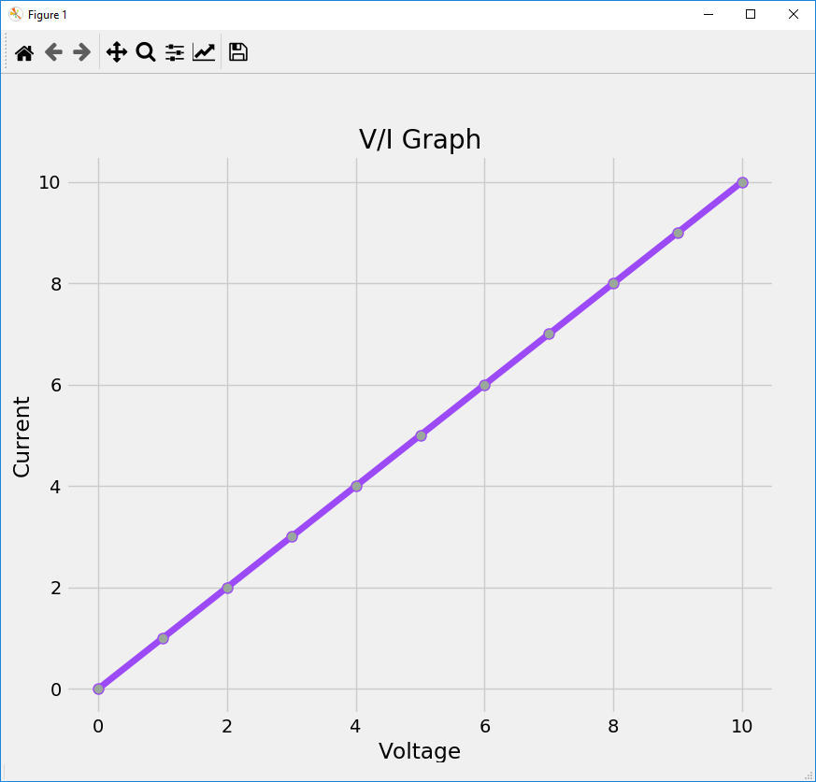
2.Bar Graph
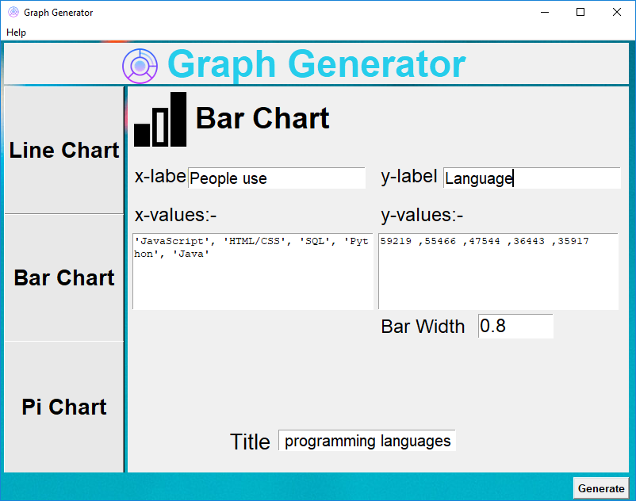
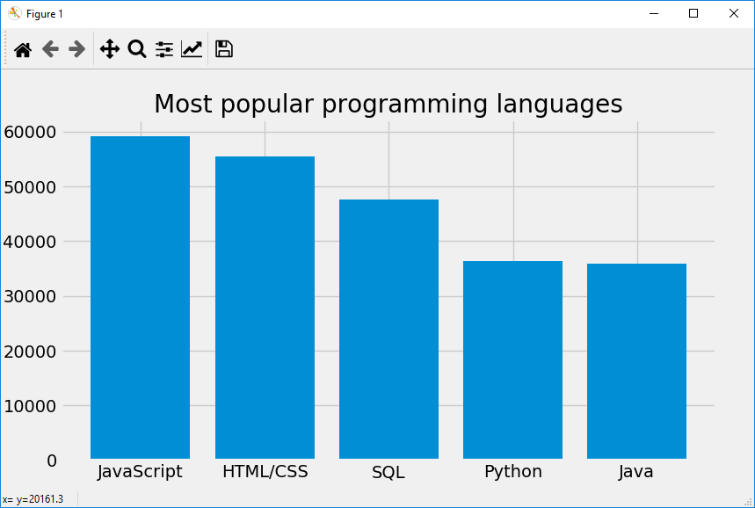

- Pi Chart
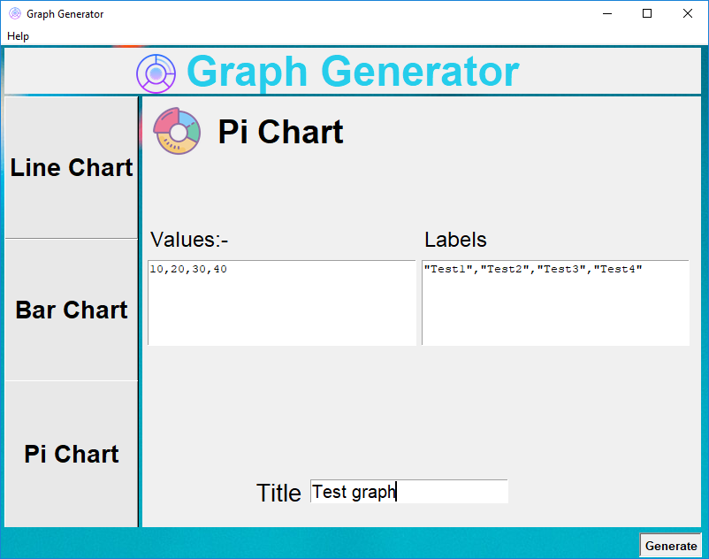
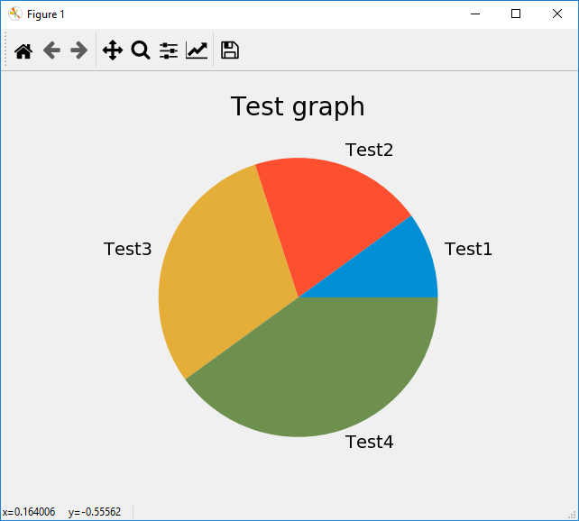

Bibliography

- www.tutorialspoint.com
- www.stackoverflow.com
- www.google.com
- www.youtube.com

