PERSONALIZED NUTRITION ANALYSIS & RECOMMENDATION SYSTEM
A
PROJECT REPORT OF
MAJOR PROJECT

SUBMITTED
FOR THE PARTIAL FULLFILMENT OF THE REQUIREMENTS
FOR THE DEGREE OF
BACHELOR OF TECHNOLOGY
IN
COMPUTER SCIENCE & ENGINEERING


SUBMITTED BY SUBMITTED TO
Raghav Sharma (22303179) Mrs. Shivani
Nikhil Kumar Singh (22303154) Assistant Professor
Prince Kumar (22303175)

DEPARTMENT OF COMPUTER SCIENCE & ENGINEERING
SARDAR BEANT SINGH STATE UNIVERSITY, GURDASPUR SESSION: JULY- DECEMBER-2025
CERTIFICATE

This is to certify that the Major Project titled Personalized Nutrition Analysis & Recommendation System submitted by Raghav Sharma (22303179), Nikhil Kumar Singh (22303154), Prince Kumar (22303175) in partial fulfilment of the requirements for the award of the Bachelor of Technology in Computer Science & Engineering, is a record of original work carried out under my supervision. The work embodied in this report is genuine to the best of my knowledge, and the results presented have not been submitted to any other institution or university for the award of any degree, diploma, or certification.

Mrs. Shivani Raghav Sharma (22303179)
Assistant Professor, Nikhil Kumar Singh (22303154)
Computer Science and Engineering Prince Kumar (22303175)

Dated:

ABSTRACT

The Personalized Nutrition Analysis & Recommendation System is an advanced data-driven software solution designed to analyze individual dietary habits and provide personalized nutritional recommendations using modern data science techniques and machine learning algorithms. As lifestyle-related health issues continue to rise, there is a growing need for intelligent systems that assist individuals in understanding their daily food intake and making scientifically informed dietary choices. This project bridges the gap between nutritional science and technology by offering a streamlined, interactive, and computation-driven approach to diet evaluation.
The system begins by collecting crucial user-specific parameters such as age, gender, height, weight, activity level, dietary preferences, and comprehensive details of daily food consumption. Using these inputs, the system computes the user’s Basal Metabolic Rate (BMR) and Total Daily Energy Expenditure (TDEE) using established and medically accepted formulations. These values are further utilized to determine daily calorie requirements, macro-nutrient targets, and deviations in actual consumption. The backend processing module evaluates the nutritional value of each food item consumed by referencing a curated dataset comprising over 240 foods with detailed calorie, protein, carbohydrate, and fat values.
Beyond traditional nutritional calculations, the project incorporates relevant machine learning models to enhance the intelligence of the system. The K-Means clustering algorithm categorizes food items based on nutrient similarity, enabling the system to analyze the nature of the user’s meals and identify whether they fall into high-protein, high-carbohydrate, or balanced clusters. Additionally, a content-based filtering approach is used to recommend food items tailored to the user’s dietary goals, deficiencies, and preferences. This allows the system to deliver recommendations that are not general or random, but highly specific and personalized.

ACKNOWLEDGEMENT

We take this opportunity to express our profound sense of gratitude to our respected project guide Mrs. Shivani, whose constant guidance, patience, and encouragement have played a pivotal role in the successful completion of this project. Throughout the development lifecycle, from the initial conceptualization to the final implementation, his valuable insights, constructive criticism, and deep understanding of the subject matter helped us refine our ideas and improve the technical quality of our work. His ability to simplify complex concepts and his readiness to provide support at every stage greatly inspired us and contributed immensely to the clarity and direction of the project.
We also extend our sincere thanks to the Head of the Department, [HOD Name], for creating a positive academic environment that nurtures innovation, research, and project-based learning. His leadership has always encouraged students to explore new technologies, apply theoretical knowledge to real-world problems, and think critically while designing technical solutions. The facilities, laboratory infrastructure, and academic resources made available to us by the department contributed significantly to the productivity and smooth progression of our project.
We are equally thankful to all the faculty members of the Department of Computer Science & Engineering for their continuous motivation and technical assistance. Their lectures, workshops, and timely advice helped us develop the skills required to work on this project. Several discussions with them provided us with new perspectives and ideas that proved to be extremely helpful during various phases of development, testing, and documentation.
We would also like to acknowledge the indirect support received from our classmates and peer groups. Their inputs, feedback, and collaborative discussions helped us refine different aspects of the project. We truly appreciate the friendly and supportive environment they provided throughout this academic journey.
Lastly, and most importantly, we express our heartfelt gratitude to our parents and family members for their unconditional love, moral support, encouragement, and faith. Their belief in our abilities inspired us to work harder and stay dedicated, even during challenging phases. Without their continuous motivation and emotional support, completing this project would not have been possible.

INDEX
1. Introduction
2. Problem Statement
3. Objectives
4. Scope & Limitations
5. Literature Survey
6. System Design
7. Dataset Description
8. Methodology
9. System Architecture
10. Machine Learning Models
11. Implementation
12. Results & Discussion
13. Recommendation Module
14. Output
15. Conclusion
16. Future Scope
17. Bibliography

1. INTRODUCTION
Nutrition plays a fundamental role in maintaining human health, supporting bodily functions, and ensuring long-term wellbeing. However, in today’s fast-paced world, individuals often struggle to maintain a balanced diet due to inconsistent eating habits, increasing dependence on processed foods, and limited awareness of the nutritional composition of their daily meals. With hectic routines, academic pressure, work overload, and lifestyle changes, people frequently consume foods without understanding how these choices affect their calorie balance, macro distribution, or overall fitness goals. As a result, issues such as obesity, nutrient deficiency, fatigue, lifestyle disorders, and lack of energy have become increasingly common.
While nutritional guidelines are widely available through various sources, many individuals find it difficult to apply this knowledge practically in their everyday routine. Manually tracking calories, computing macros, or planning meals requires substantial time, discipline, and understanding of food science. Moreover, generic diet charts fail to cater to individual differences such as metabolism, height-weight ratio, activity level, or personal dietary preferences. This lack of personalization often leads to inconsistent results and reduced motivation, discouraging people from maintaining long-term nutritional discipline.
In the era of digital health, artificial intelligence and data analytics have transformed the way health-related information can be interpreted and delivered. The ability of machine learning to detect patterns, analyze large structured datasets, and provide instant insights offers a promising solution to the problem of personalized diet management. Motivated by this potential, our project introduces the Personalized Nutrition Analysis & Recommendation System, an intelligent and automated platform designed to simplify the process of nutrition tracking and turn complex dietary analysis into an accessible, user-friendly experience.
The system collects essential user-specific information—such as age, gender, weight, height, activity level, goal, and dietary preferences—and combines it with detailed daily food logs. Using scientifically validated formulas like BMR (Basal Metabolic Rate) and TDEE (Total Daily Energy Expenditure), it evaluates the user's daily energy requirements with precision. Further, it analyzes consumed foods to compute calorie intake, protein distribution, carbohydrate levels, fat consumption, and identifies nutritional imbalances that may hinder fitness progress.
What makes this system truly intelligent is the integration of machine learning components. The K-Means clustering model categorizes food items into meaningful groups based on nutrient similarity, enabling deeper insights into the user's eating patterns. Additionally, a content-based recommendation engine suggests food items and meal options tailored specifically to the user’s fitness goals and deficiencies. By incorporating visual dashboards, interactive charts, cluster graphs, and downloadable reports, the project bridges technology and nutrition science to deliver a comprehensive analytical tool.
In essence, this system is an innovative step towards combining health, machine learning, and intuitive design to promote better nutritional awareness. It empowers users with personalized insights that not only support healthy eating habits but also promote informed decision-making in their everyday diet choices.

2. PROBLEM STATEMENT
Although nutrition awareness has increased in the modern world, most individuals still struggle to maintain a balanced and health-oriented diet due to practical challenges in monitoring and interpreting nutritional data. With thousands of food items available and each containing a different mix of calories and macronutrients, determining what and how much to eat becomes a complex task. People generally lack the time, knowledge, and tools required to calculate their daily nutrient intake accurately.
Many individuals underestimate their calorie consumption simply because they do not know the nutritional composition of the foods they eat. For example, a simple homemade dish or packaged snack may contain significantly more calories or fat than expected. Without proper tracking, daily intake often fluctuates, leading to unintentional calorie surplus or deficit. Over time, this inconsistency contributes to weight gain, weakness, nutrient imbalance, and even lifestyle-related diseases.
Another major issue is the difficulty of manual macro calculation. Computing the total amount of protein, carbs, and fats consumed in a day requires mathematical effort and knowledge of food labels, which can be overwhelming for most people. Even if users track calories using mobile applications, they often do not receive personalized suggestions based on their age, gender, body metrics, activity level, or fitness goals.
Generic diet plans available online fail to address individual needs. They do not consider dietary preferences (veg, non-veg, vegan), metabolism differences, or the type of physical activity a person performs daily. Consequently, users follow diets that may not be suitable for their body, resulting in poor progress and reduced enthusiasm.
Another limitation is that many advanced calorie-tracking apps are either paid or too complicated, restricting accessibility for common users. Students, beginners, or individuals with little technical knowledge find it challenging to understand or operate them effectively.
Therefore, there is a strong need for a system that:
● Automatically analyzes daily food intake without requiring manual calculations.
● Computes nutritional values using scientifically validated formulas.
● Understands the user’s personal profile (age, weight, height, activity level, goals, dietarypreferences).
3. OBJECTIVES
The primary objective of this project is to develop a comprehensive and intelligent nutrition analysis system that not only calculates a user’s dietary intake but also interprets it in a meaningful and personalized manner. Modern users require a solution that goes beyond simple calorie tracking, providing them with deeper insight into their eating habits, macro distribution, and the relationship between their daily food consumption and long-term health goals. This project aims to fulfil that need by building a system that integrates nutrition science, data analytics, and machine learning within an easy-to-use interface.
A major part of the project involves creating a systematically organized nutrition dataset that contains detailed information about various food items and their associated nutritional compositions. This includes data on calories, protein, carbohydrates, fats, fiber, and other essential nutrient components. A structured dataset ensures that the system can accurately compute nutritional values when a user logs their daily food consumption. The objective is not merely to catalogue foods, but to build a robust data foundation capable of supporting large-scale analysis, clustering, and intelligent recommendations.
Another significant objective is to design a calculation engine capable of determining an individual’s daily energy requirements based on scientifically validated formulas such as Basal Metabolic Rate (BMR) and Total Daily Energy Expenditure (TDEE). These calculations differ based on gender, age, weight, height, and activity level, making them essential for generating personalized insights. By integrating these formulas, the system can estimate how many calories the user should ideally consume each day, helping them understand whether their current habits support weight maintenance, loss, or gain.
In addition to determining daily energy needs, the system aims to automatically evaluate the user’s actual calorie and macronutrient intake based on their food log. Instead of requiring the user to perform complex calculations, the system instantly processes the nutritional content of each food item and determines total intake for the day. This enables users to identify deficiencies or excesses in their diet, such as insufficient protein, excessive carbohydrates, or imbalanced fat consumption. Such insights are crucial for individuals aiming to align their meals with fitness goals such as fat loss, muscle gain, or overall wellness.
A core objective of the project is the integration of machine learning algorithms—specifically K-Means clustering and content-based filtering—to improve the system’s analytical and recommendation capabilities. The clustering model groups foods based on nutritional similarity, helping users understand the type of meals they are consuming (for example, high-protein meals, carb-dominant meals, or balanced foods). Meanwhile, the recommendation engine analyzes user requirements and deficiencies before suggesting foods that closely match their goals. Together, these machine learning components allow the system to provide intelligent, adaptive, and highly personalized suggestions that improve dietary decision-making.
Another key goal is to enhance user understanding through visual analytics. The project aims to implement a clean and interactive Streamlit dashboard that displays nutritional trends, macro breakdowns, calorie comparisons, radar charts, cluster plots, and summary tables. Visual representation allows users to interpret their nutritional status at a glance, making the entire experience more intuitive and engaging. These charts also help in academic demonstrations, project presentations, and practical evaluations.
Furthermore, the project aims to provide users with well-structured, downloadable PDF reports summarizing their nutritional analysis, food intake, energy calculations, and recommendations. This feature is valuable for academic submission, research documentation, progress tracking, or personal record-keeping.
Ultimately, the overarching objective of this project is to build a complete, intelligent nutrition system that connects user behavior with nutritional science. It combines analytics, automation, and machine learning to guide users toward healthier eating habits and to enable them to make informed choices. By transforming raw dietary data into meaningful insights, the system serves as a bridge between technology and health, empowering users to take charge of their nutrition in a simplified and data-driven manner.

4. SCOPE & LIMITATIONS
Scope
The scope of the Personalized Nutrition Analysis & Recommendation System extends across multiple domains including nutrition science, data analytics, machine learning, and user-centric application design. The system is built to function as a comprehensive digital companion for individuals seeking deeper insights into their dietary patterns, caloric requirements, and overall nutritional balance. Its primary purpose is to convert daily food consumption data into meaningful, personalized guidance that aligns with a user’s health or fitness goals.
The system uses real-time user inputs such as age, gender, height, weight, dietary preference, activity level, and specific food items consumed throughout the day. These inputs are then processed in combination with a predefined, structured nutrition dataset containing the macronutrient composition of various food items. Based on this dataset, the system calculates essential nutritional metrics such as total calorie intake, protein count, carbohydrate levels, and fat distribution. Users gain a clear understanding of whether they are in a calorie surplus, deficit, or maintenance phase.
A major part of the system’s scope lies in its implementation of machine learning models. The K-Means clustering algorithm categorizes food items into distinct nutritional groups such as high-protein, high-carb, or balanced meals. This helps users recognize the type of meals they consume most frequently, creating awareness about dietary patterns. Additionally, the system incorporates a content-based filtering approach that analyzes the user's goals and macronutrient deficiencies to generate intelligent food recommendations. These recommendations are not random; they are mathematically derived based on similarity scores and nutritional relevance.
The project also includes the development of an advanced visual analytics dashboard. Through dynamic charts, bar graphs, pie charts, radar charts, and cluster scatter plots, users can visualize their macro distribution, calorie patterns, and cluster-based meal behavior. This visual representation not only enhances understanding but also simplifies complex nutritional data into easily interpretable formats. The dashboard includes macro comparisons, calorie target tracking, food log breakdowns, and detailed summaries of user profile information.
The Streamlit interface forms another important part of the project’s scope. It transforms the system into a fully interactive web application where users can seamlessly input their details, log their meals, and analyze their dietary health. With features like PDF report generation, CSV export, multi-page navigation, and a clean UI, the system ensures usability for both general users and academic evaluators. The project is scalable, allowing for future integration of enhanced datasets, additional nutrients, advanced ML models, and data-driven meal plans.
Overall, the scope covers nutritional analysis, machine learning integration, data visualization, user interface development, and report generation — forming a holistic system aimed at bridging the gap between raw nutrition data and practical dietary intelligence.
Limitations
Although the system offers a wide range of analytical and recommendation-based functionalities, it operates within certain constraints that define its limitations. The most significant limitation stems from the size, accuracy, and diversity of the nutrition dataset used. Since many publicly available datasets contain macronutrients but not detailed micronutrient values such as vitamins, minerals, omega fatty acids, or amino acid distribution, the system is currently restricted to analyzing only calories, protein, carbohydrates, fats, and basic fiber/sugar metrics. This limits its ability to provide medical-grade dietary guidance or recommendations for individuals with specific nutrient deficiencies.
Another key limitation is the system’s reliance on user honesty and accuracy. The correctness of nutritional analysis depends entirely on how accurately a user logs their daily food consumption. Inaccurate quantities, forgotten meals, or vague entries can lead to misleading results. Although the system performs accurate calculations based on the provided data, it cannot verify the authenticity of user input.
The system is designed to assist with general nutritional understanding and lifestyle improvement, not to serve as a substitute for professional dieticians, nutritionists, or medical advice. Individuals with medical conditions such as diabetes, thyroid issues, renal disorders, hormonal imbalances, or food allergies require customized plans from certified professionals. Since this application does not diagnose or treat medical problems, its recommendations should be considered supportive rather than prescriptive.
Performance limitations can arise depending on the environment in which the Streamlit application is hosted. On platforms with limited processing power or memory, machine learning tasks such as clustering may run slower. Large datasets or high-traffic deployments may also affect responsiveness.

5. LITERATURE SURVEY
The intersection of nutrition science and technology has been an active area of research due to increasing global interest in preventive healthcare and personalized wellness solutions. Numerous studies emphasize that traditional, generic diet plans often fail because they disregard individual differences in metabolism, lifestyle, body composition, and food habits. This has led to the rise of data-driven nutrition systems that adapt to individual needs and provide more sustainable dietary support.
Academic literature highlights the use of machine learning in nutritional recommendation systems, meal classification, and food recognition. Research has shown that clustering algorithms such as K-Means are highly effective for grouping food items based on nutritional similarity. This approach helps categorize meals into groups such as high-protein meals, carbohydrate-dominated meals, balanced dietary options, or low-fat meals. These clusters help users understand their eating tendencies and adjust their diet according to their goals.
Studies also demonstrate the application of regression models, especially linear regression, in predicting energy expenditure, calorie burn, or weight change trends. These algorithms allow systems to forecast how daily calorie intake affects metabolic balance. Content-based filtering is another widely studied method used for personalized recommendations. It compares item attributes (in this case, nutrient profiles) with user needs to suggest the most relevant foods. This approach is commonly used in recommendation engines across domains such as movies, shopping, and music, but is increasingly being adopted in health and nutrition technology.
A survey of popular commercial tools like MyFitnessPal, HealthifyMe, and Cronometer reveals that while these platforms offer extensive food logging and calorie tracking capabilities, many essential features are locked behind paid subscriptions. Furthermore, most commercial apps focus primarily on tracking rather than explaining nutritional patterns. They provide raw numbers but often lack transparent insights or machine learning–based cluster analytics that give users a deeper understanding of their dietary habits.
Several research papers highlight the importance of visual analytics in nutritional applications. Graphs, charts, and dashboards significantly enhance comprehension, especially for individuals without a nutrition background. The integration of visualization with ML analysis creates a more powerful and user-friendly system.

6. SYSTEM DESIGN
The design of the Personalized Nutrition Analysis & Recommendation System (PNARS) follows a structured, multi-layered approach that ensures efficient processing of user inputs, accurate nutritional analysis, and seamless delivery of personalized recommendations. At its core, the system is engineered to bridge the gap between raw dietary data and actionable health insights. The workflow begins with the collection of user information, which forms the foundation for all subsequent calculations and recommendations. Users are presented with an interactive interface built using Streamlit, where they can input personal parameters such as age, gender, height, weight, activity level, dietary preferences, and specific health goals. In addition to personal details, the interface allows users to log the foods they consume daily, including meal type and portion size in grams. This initial step is critical, as the accuracy and relevance of all subsequent analyses depend on precise and complete input data.
Once the input data is collected, it is processed by the backend modules, which form the business logic of the system. This layer is responsible for performing all the essential nutritional calculations, including computing the Basal Metabolic Rate (BMR) using the scientifically validated Mifflin-St Jeor Equation and the Total Daily Energy Expenditure (TDEE) based on activity multipliers. By calculating these metrics, the system establishes a baseline for the user’s daily caloric requirement, which serves as a reference point for evaluating whether the user is in a calorie surplus, deficit, or maintaining their weight. In addition to calories, the system evaluates macronutrient consumption, including protein, carbohydrates, and fats, providing a comprehensive understanding of the user’s dietary balance. The business logic layer not only computes these values but also interprets the results in a meaningful way, highlighting deficiencies, excesses, and trends over time, thereby offering users insights that go beyond raw numbers.
The system incorporates a dedicated Machine Learning layer, which significantly enhances its intelligence and personalization capabilities. This layer utilizes K-Means clustering to categorize food items based on their nutritional composition, allowing the system to identify patterns in the user’s diet. For instance, the clustering model can reveal whether the user tends to consume high-protein meals, carbohydrate-heavy dishes, or balanced options. In parallel, a content-based filtering algorithm analyzes the user’s macro deficiencies and dietary goals, generating recommendations that are specifically tailored to individual needs. This approach ensures that the system provides intelligent guidance rather than generic suggestions, which is one of the key differentiators of PNARS.
Supporting both the business logic and machine learning layers is the Data layer, which manages the structured datasets that form the backbone of the system. These datasets include detailed information on a wide range of food items, including their caloric content, macronutrient breakdown, diet type, meal category, and other relevant attributes. By storing and efficiently querying this data, the system can rapidly compute nutritional values for user inputs, scale them according to portion sizes, and feed them into the machine learning algorithms for further analysis. The data layer also ensures that user logs are temporarily stored and managed securely during each session, enabling accurate reporting and visualization.
The frontend, built using Streamlit, acts as the bridge between the user and the complex backend operations. It provides a clean, interactive, and visually appealing interface where users can not only input their details but also receive insights through interactive charts, tables, and graphical summaries. Visualizations such as pie charts for macro distribution, bar graphs for daily caloric intake, and cluster scatter plots for meal patterns allow users to quickly grasp the state of their diet without needing a background in nutrition. This user-centric design ensures that the system is accessible and intuitive, catering to individuals with varying levels of technical literacy.
Overall, the system’s architecture reflects a modular yet cohesive design philosophy, where each component, from data management to machine learning analysis and visualization, seamlessly integrates to deliver a robust and scalable platform. The multi-layered design not only supports current functionalities but also allows for easy integration of future enhancements such as additional nutrient tracking, deep learning–based food recognition, and connectivity with wearable health devices. The thoughtful separation of concerns ensures that each module can be maintained, upgraded, or debugged independently, making the system highly adaptable and resilient to evolving user needs.

7. DATASET DESCRIPTION
The datasets employed in PNARS are central to its ability to provide precise, personalized nutritional analysis and recommendations. The system primarily relies on two interrelated datasets: the Food Dataset and the User Log Dataset. The Food Dataset is a meticulously curated collection containing detailed nutritional information for approximately 240 commonly consumed food items. Each entry in the dataset includes comprehensive data points such as calories, protein, carbohydrates, fats, dietary fiber, sugar content, diet classification (vegetarian, non-vegetarian, vegan), and the typical meal type (breakfast, lunch, dinner, or snack). This structured format ensures that when users input their consumption data, the system can quickly retrieve the relevant nutritional values and accurately compute totals scaled to the portion size provided. By standardizing data entry in this way, the system avoids inconsistencies, enabling precise calculations that are crucial for meaningful analysis.
The second dataset, the User Log Dataset, is dynamic and grows with every session of user interaction. It records personal details such as age, gender, height, weight, activity level, and fitness goals, as well as the day-to-day intake of food items, including portion size. This dataset allows the system to track the user’s dietary habits over time, facilitating trend analysis, clustering of meal types, and detection of patterns in macro distribution. The temporary storage of this data during analysis also enables the generation of session-based reports and visualizations without permanently retaining sensitive personal information, maintaining privacy while still allowing in-depth computation.
The combination of these datasets creates a robust foundation for the system. The Food Dataset ensures accuracy and consistency in nutrient calculations, while the User Log Dataset enables personalization and temporal analysis. Together, they support the machine learning models in understanding user behavior, classifying meal types, and generating recommendations that align with personal dietary needs. The structured approach to dataset design also allows for easy scalability, making it possible to add new food items, update nutritional values, or extend the range of tracked nutrients in future iterations.
In addition to supporting core system functionalities, these datasets enable the generation of visual analytics that help users interpret complex dietary information in a digestible manner.

8. METHODOLOGY
The methodology adopted in the development of the Personalized Nutrition Analysis & Recommendation System (PNARS) integrates multiple disciplines, including data preprocessing, nutritional science, and machine learning, to create a seamless and intelligent dietary analysis tool. The overall approach is structured to ensure that each user receives accurate, meaningful, and actionable insights into their daily nutrition, while also enabling adaptability for future enhancements. At the outset, the system prioritizes the collection of user input, which forms the foundational dataset for all subsequent analyses. Users are guided through a carefully designed interface where they provide essential personal information, including age, gender, height, weight, activity level, dietary preferences, and specific health or fitness goals. This input process is not only critical for personalization but also serves to ensure that the system adheres to scientific accuracy, as variables such as basal metabolism and caloric needs vary significantly across individuals.
Once the input is received, the system undertakes a rigorous validation process to ensure the completeness and consistency of the data. This validation includes checking for missing values, confirming plausible ranges for physiological parameters, and ensuring that logged food items match entries in the nutrition dataset. By enforcing data integrity at this early stage, the methodology mitigates errors that could otherwise propagate through calculations, machine learning models, and recommendations. Following validation, the system retrieves detailed nutritional information for each food item from the curated food dataset. Each nutrient—calories, proteins, carbohydrates, fats, and fiber—is scaled according to the portion size specified by the user. This scaling ensures that even fractional or non-standard food quantities are accurately accounted for, providing precise daily macro and caloric totals.
With the nutrient data aggregated, the system then applies scientifically validated formulas to evaluate the user’s energy requirements. The Basal Metabolic Rate (BMR) is calculated using the Mifflin-St Jeor Equation, which accounts for gender, age, height, and weight, providing an estimate of the calories the body expends at rest. This baseline is essential for understanding the user’s minimum energy needs and forms the cornerstone for subsequent Total Daily Energy Expenditure (TDEE) calculations. TDEE is computed by multiplying the BMR with activity multipliers, which vary depending on whether the user engages in sedentary, light, moderate, or intense physical activity. This step ensures that the system not only calculates static energy requirements but also incorporates dynamic lifestyle factors, allowing for a highly individualized assessment of daily caloric needs.
Once the baseline caloric and macronutrient requirements are established, the methodology integrates machine learning techniques to enhance the analytical depth of the system. The K-Means clustering algorithm is employed to categorize food items into distinct nutritional groups based on similarities in macro composition. These clusters help users understand patterns in their eating habits, such as a tendency to consume high-protein meals, carbohydrate-heavy meals, or balanced nutrient combinations. Complementing clustering, a content-based filtering recommendation engine analyzes the user’s macro deficits or surpluses and identifies food items that align closely with their nutritional requirements and dietary preferences. This ensures that recommendations are not generic but tailored specifically to the user, addressing gaps in nutrition while supporting individual goals such as muscle gain, weight loss, or overall wellness.
The methodology is intentionally iterative and modular, allowing continuous refinement and feedback loops between components. For example, once recommendations are generated, the system can re-evaluate the user’s projected daily intake if they choose to adopt suggested meals. Similarly, repeated use of the system over time allows tracking of dietary trends, evaluation of improvement in macro balance, and adjustment of clustering outputs as eating patterns evolve. This iterative approach guarantees that the system remains accurate and adaptive, learning indirectly from user behavior while still grounding all calculations in scientifically validated nutritional principles.
In addition to analytical and predictive processes, the methodology incorporates visualization and reporting mechanisms to enhance interpretability. By translating numerical calculations and ML-based patterns into charts, graphs, and tables, users can intuitively understand their dietary behavior. Visual elements such as pie charts for macro distribution, line graphs for trend analysis, and scatter plots for cluster distribution make complex nutritional insights accessible to users without a formal background in nutrition science. Moreover, the methodology ensures that these visualizations are integrated seamlessly into the Streamlit interface, providing a cohesive and interactive user experience.
Overall, the methodology of PNARS represents a holistic approach to dietary analysis.

9. SYSTEM ARCHITECTURE
The system architecture of PNARS has been designed with a focus on modularity, scalability, and efficiency, ensuring that each component seamlessly contributes to the end goal of personalized nutrition analysis. At its foundation, the architecture is composed of multiple interconnected layers, each responsible for specific functionalities, yet designed to operate cohesively with the others. The Input Layer serves as the primary interface between the user and the system, where users submit personal details and dietary logs. This layer ensures that all incoming data is captured in a structured format, validated for accuracy, and securely passed to the processing modules. It also includes real-time error checking and guidance, allowing users to enter data confidently while minimizing the risk of inaccuracies that could affect subsequent calculations.
The Processing Layer forms the computational heart of the architecture. Here, the system performs the core nutritional calculations, including BMR and TDEE, aggregates macro and caloric totals, and scales nutrient values according to food quantities. The processing layer is also responsible for integrating machine learning models, executing clustering operations, and generating personalized recommendations. The modularity of this layer ensures that additional algorithms or nutritional calculations can be integrated in future iterations without requiring significant redesign. By separating processing logic from data management and visualization, the architecture enhances maintainability, allowing individual components to be debugged or upgraded independently.
Supporting these functions is the Data Layer, which manages all static and dynamic datasets. The food dataset, containing detailed nutritional profiles of hundreds of food items, resides here, alongside dynamically generated user logs. The data layer ensures efficient storage, retrieval, and preprocessing of all necessary inputs for calculations and ML models. It also handles the temporary session-based storage of user data, which allows real-time analysis without permanently retaining personal information. This design prioritizes both speed and security, ensuring that large-scale computations are performed swiftly while safeguarding user privacy.
The Visualization Layer translates complex data into intuitive, interactive, and engaging formats. This layer includes charts, graphs, tables, and dashboards that provide users with immediate insights into their dietary behavior. Features such as macro nutrient distribution pie charts, trend analysis line graphs, and cluster scatter plots enable users to grasp patterns and imbalances at a glance. The visualization layer also serves a pedagogical function, helping users understand the implications of their daily dietary choices in the context of their long-term goals.
The Recommendation Layer is where personalization reaches its peak. By leveraging outputs from the processing and machine learning layers, the system generates tailored dietary suggestions that address specific macro deficiencies, caloric imbalances, and user preferences. Recommendations include not only meal options but also hydration guidance, snack suggestions, and advice on nutrient optimization. This layer continuously adapts to user feedback, ensuring that each session provides increasingly accurate and relevant insights.
Finally, the Export Layer allows users to save and share their analysis results through PDF or CSV formats. This functionality is critical for record-keeping, academic reporting, or sharing with dietitians or trainers. By modularizing the export functionality, the architecture ensures that report generation can evolve independently of the computational or visualization layers, allowing for future enhancements such as automated trend reports or cloud-based storage.
In summary, the system architecture of PNARS embodies a layered, modular design philosophy, where each component—from input capture to recommendation generation and visualization—is carefully orchestrated to provide a seamless, accurate, and interactive user experience. The architecture’s extensibility ensures that new datasets, machine learning algorithms, or user interface improvements can be incorporated without disrupting existing functionalities, making it a robust and future-proof framework for personalized nutrition analysis.

10. MACHINE LEARNING MODELS USED
The Personalized Nutrition Analysis & Recommendation System (PNARS) leverages a combination of machine learning techniques to provide intelligent insights into dietary patterns and deliver highly personalized food recommendations. Each algorithm is carefully selected for its ability to process user-specific inputs, identify patterns, and produce actionable results that align with individual nutritional needs.
1. Linear Regression
Linear Regression serves as the foundation for predictive analysis within the system. While it is conceptually simple, linear regression provides a robust statistical framework for predicting trends in calorie balance over time. By analyzing input variables such as daily caloric intake, macronutrient consumption, physical activity level, and individual body metrics, the model can forecast potential surpluses or deficits in energy. This predictive capability is crucial for users aiming to achieve specific health objectives, such as weight maintenance, fat loss, or muscle gain. Beyond simple calculation, the regression model also allows users to anticipate the long-term impact of their dietary habits and adjust food choices proactively, rather than reactively. Its simplicity ensures fast computation while maintaining scientifically valid outputs, making it an ideal choice for real-time applications within PNARS.
2. K-Means Clustering
K-Means Clustering is employed to uncover hidden patterns in the user’s diet by grouping food items into distinct nutritional categories. Each cluster represents a particular dietary profile, such as high-protein meals, carbohydrate-rich dishes, fat-dominant foods, or well-balanced options. By analyzing the distribution of consumed foods across these clusters, the system can provide users with insights into their eating behavior that are not immediately apparent through raw data. For example, a user may believe they are consuming a balanced diet, but clustering analysis may reveal a disproportionate intake of carbohydrates relative to protein and fat. This technique not only enhances self-awareness but also allows the recommendation engine to identify gaps in nutrition and suggest corrective actions. Over time, clustering also helps track changes in eating patterns, providing longitudinal insights that support sustained dietary improvements.
3. Content-Based Filtering
Content-Based Filtering is integrated as the recommendation engine that tailors suggestions to the user’s specific nutritional needs and preferences. Unlike generic diet plans, content-based filtering evaluates the nutrient profile of available foods and matches them to the user’s macro deficits or surpluses. For instance, if a user is consuming insufficient protein, the system identifies foods rich in protein that align with their dietary preferences—such as vegetarian, non-vegetarian, or vegan options—and recommends these for upcoming meals. The algorithm calculates similarity scores between the user’s current nutritional profile and the food dataset, ensuring that recommendations are both nutritionally relevant and practical for daily consumption. This model enhances personalization, making PNARS more than just a tracking tool—it becomes a proactive guide that adapts dynamically to the user’s evolving dietary requirements.
By combining these three machine learning approaches—predictive regression, clustering, and content-based recommendation—PNARS creates a comprehensive, intelligent framework. Each model complements the others, forming a cohesive system where predictions, pattern recognition, and personalized guidance work together to empower users to make informed dietary decisions.

11. IMPLEMENTATION
The implementation phase of PNARS translates theoretical design and methodology into a fully functional system that users can interact with seamlessly. The project is developed primarily using Python, leveraging a suite of libraries for data processing, visualization, and machine learning. The user interface is constructed with Streamlit, which allows rapid development of interactive, web-based applications without compromising on visual appeal or functionality.
The implementation begins with the frontend layout, where users input their personal and dietary information. Streamlit’s interactive widgets, such as sliders, dropdowns, and text inputs, are used to capture data efficiently. Once submitted, inputs are passed to the backend, where they undergo validation to ensure correctness and completeness. This process prevents inaccurate or missing data from affecting calculations and ensures the integrity of the analytical outputs.
The backend logic comprises the core computational modules. Nutritional calculations, including BMR and TDEE, are performed using scientifically validated equations. Macronutrient totals are aggregated based on the portion sizes of consumed foods, and deviations from recommended values are identified. The machine learning models are then invoked: linear regression predicts potential calorie trends, K-Means clustering groups foods to detect patterns in dietary behavior, and the content-based filtering algorithm generates personalized food suggestions. These modules are integrated seamlessly, allowing real-time analysis and recommendations immediately after user input.
Visualization is an essential aspect of implementation. PNARS provides interactive charts and dashboards that display calorie intake, macro distribution, cluster-based meal analysis, and personalized recommendations. Graphical elements, such as pie charts for macro ratios, bar charts for daily calorie trends, and scatter plots for cluster distributions, transform complex data into easily understandable insights. Users can interpret their dietary patterns at a glance, enhancing engagement and comprehension.
Finally, the export functionality enables users to generate downloadable reports in PDF and CSV formats. These reports summarize personal data, calculated nutritional metrics, meal clustering results, and suggested recommendations. By integrating this feature, PNARS ensures that users, educators, or health professionals can retain records for analysis, monitoring, or academic purposes.
The implementation is modular, allowing each component—the user interface, backend computations, machine learning models, visualization dashboards, and reporting modules—to function independently while interacting cohesively. This design philosophy ensures maintainability, scalability, and flexibility, making it possible to enhance the system with additional features such as micronutrient tracking, deep learning-based food recognition, or integration with wearable fitness devices in future iterations.
Overall, the implementation transforms PNARS from a conceptual framework into a practical, interactive tool capable of delivering intelligent, personalized nutrition guidance to users with accuracy, clarity, and adaptability.

12. RESULTS & DISCUSSION
The Personalized Nutrition Analysis & Recommendation System (PNARS) delivers comprehensive insights into user dietary habits by combining advanced data analytics with machine learning, visualization, and nutrition science. The results generated by the system are not merely raw numbers; they provide actionable, personalized intelligence that users can apply to improve their eating behaviors. Upon logging their personal details and daily food intake, users receive a detailed breakdown of calorie consumption, macronutrient distribution, and energy balance. This breakdown highlights the alignment—or lack thereof—between their actual dietary intake and their calculated daily energy requirements, providing immediate feedback on whether they are meeting, exceeding, or falling short of their targets.
One of the most significant features of the system is its ability to visually represent complex nutritional data in an intuitive format. Users can observe the distribution of calories, proteins, carbohydrates, and fats through interactive charts such as pie charts, bar graphs, and radar plots. These visualizations enable users to quickly identify macro imbalances that might be difficult to detect through manual calculations. For instance, a user aiming to increase protein intake while reducing carbohydrates can immediately see whether their meals are meeting these targets, and which meals contribute most to the imbalance. By translating numerical analysis into visual insights, the system enhances user comprehension and engagement, making the process of nutritional evaluation both educational and motivating.
The integration of machine learning clustering adds an additional layer of depth to the results. Through K-Means clustering, the system groups food items and meals based on their macronutrient composition, identifying patterns that may not be obvious at first glance. For example, a user might consistently consume meals that fall into a “high-carb cluster” during lunch and a “high-fat cluster” during dinner. By highlighting these patterns, PNARS allows users to understand not only the quantity of nutrients they consume but also the type of meals dominating their diet. This clustering analysis serves as a diagnostic tool, revealing tendencies in dietary behavior, and providing insights into potential adjustments to achieve a more balanced diet. Over time, repeated use of the system enables longitudinal tracking, showing trends in macro intake, energy balance, and cluster distribution, which can help users monitor progress toward long-term health and fitness goals.
The predictive capabilities of the system, powered by linear regression, allow users to understand the potential consequences of their current eating habits. By modeling daily caloric intake and expenditure, the system predicts whether a user is likely to experience a caloric surplus or deficit over a given period. This predictive insight is particularly valuable for goal-oriented users, such as those aiming for fat loss, muscle gain, or weight maintenance. Combined with the cluster analysis, this feature enables users to proactively adjust meals, plan future diets, and avoid unintended nutrient imbalances.
Furthermore, PNARS provides an interactive feedback loop, allowing users to adjust their dietary input and immediately observe the effect on their macro balance, cluster distribution, and overall energy profile. This dynamic functionality transforms the system from a passive tracking tool into an active dietary assistant. Users gain not only quantitative data but also qualitative insights into the effectiveness of their food choices, facilitating informed decision-making and sustainable behavioral change.
From an academic and analytical perspective, the system demonstrates the efficacy of combining data-driven methods with domain-specific knowledge. The results indicate that even a relatively small food dataset of approximately 240 items, when paired with appropriate machine learning models, can produce meaningful, personalized insights. This underscores the potential of PNARS to serve as both a practical tool for everyday nutrition management and a research platform for studying dietary trends and macro patterns. Overall, the results validate the system’s design objectives by providing clarity, accuracy, and actionable recommendations, bridging the gap between theoretical nutritional science and real-world application.

13. RECOMMENDATION MODULE
The recommendation module of PNARS represents the culmination of the system’s analytical and machine learning processes, translating insights into practical guidance that empowers users to make better dietary choices. Unlike generic diet plans, this module generates personalized recommendations by integrating macro deficits, user profile information, and food similarity analysis. By assessing the user’s current intake relative to their calculated daily requirements, the module identifies areas of imbalance—such as insufficient protein, excess carbohydrates, or inadequate hydration—and produces tailored suggestions to address these gaps.
The module functions across all meals of the day, including breakfast, lunch, dinner, and snacks. For each meal, the system proposes foods that not only match the user’s dietary goals but also adhere to their individual preferences, such as vegetarian, non-vegetarian, vegan, or gluten-free options. This ensures that recommendations are both nutritionally optimized and practically achievable within the user’s lifestyle. Additionally, the system provides guidance on portion sizes, allowing users to adjust intake to align with calorie targets while maintaining nutrient balance.
A unique feature of the recommendation module is its ability to adapt dynamically to changing inputs. If a user updates their food log or adjusts activity levels, the module recalculates macro requirements and generates revised suggestions in real-time. This adaptive capability ensures that recommendations remain relevant and responsive, fostering continuous improvement in dietary habits. The content-based filtering algorithm underpins this functionality by evaluating nutrient profiles of available foods and selecting options that closely match the user’s deficits or goals, effectively creating a personalized menu tailored to their needs.
Beyond meal recommendations, the module also includes supplementary guidance, such as hydration tips, protein timing, and suggestions for balancing micronutrients, even within the current macro-focused framework. For example, if a user consistently falls short on protein intake, the module may recommend incorporating high-protein snacks or pairing meals with protein-rich options. Similarly, if a user’s diet is skewed toward carbohydrates, the system may suggest balancing meals with fiber-rich vegetables or healthy fats, ensuring holistic nutrition guidance.
The recommendation module not only assists users in immediate dietary planning but also supports long-term behavior modification. By providing structured, actionable suggestions, it encourages users to adopt balanced eating patterns, develop awareness of macro composition, and make informed decisions that align with fitness or wellness goals. The module’s iterative nature allows recommendations to evolve over time, incorporating user feedback, changing activity levels, and updated dietary logs.
In essence, the recommendation module transforms PNARS from an analytical tool into a proactive dietary assistant. It bridges the gap between understanding nutritional imbalances and implementing corrective actions, offering users an intelligent, personalized, and actionable roadmap to optimize their health. By combining machine learning, domain knowledge, and interactive visualization, the module ensures that dietary guidance is precise, practical, and fully aligned with individual goals, thereby enhancing the overall efficacy of the system..

14. Output

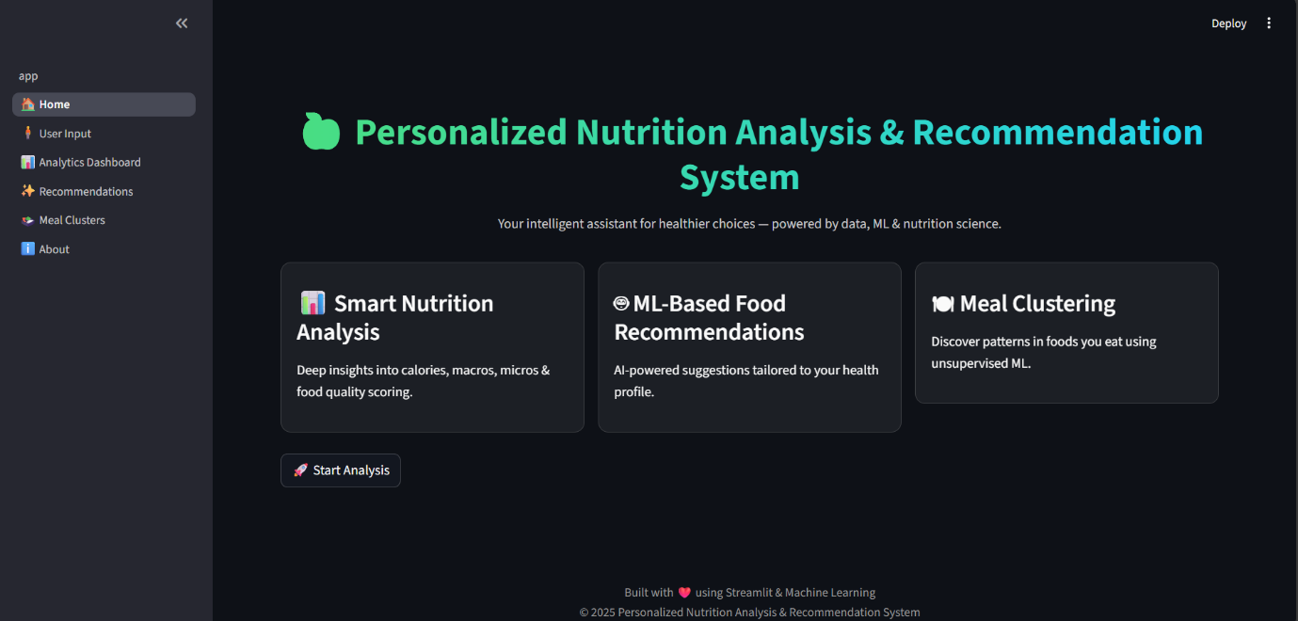

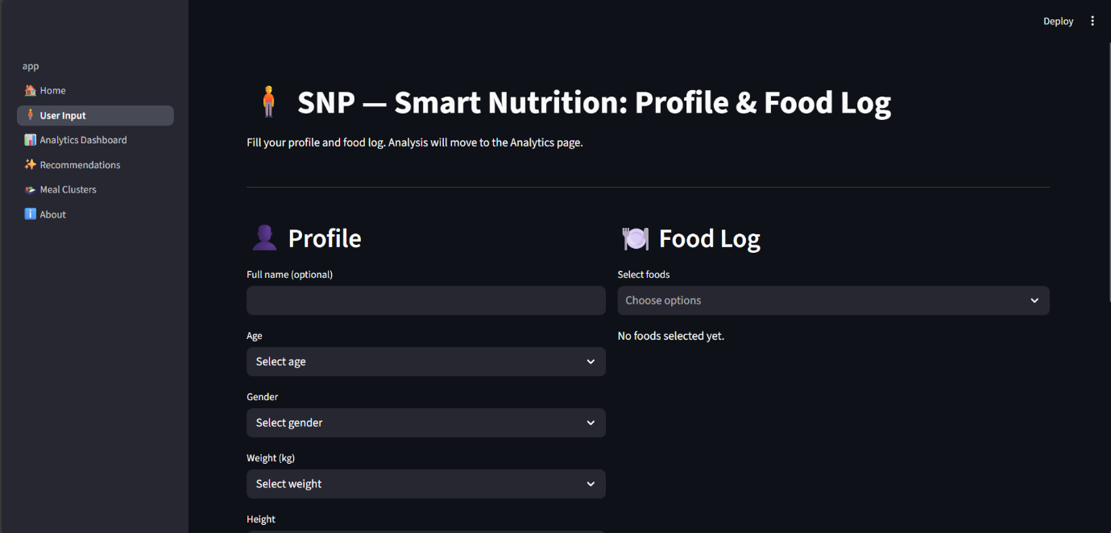
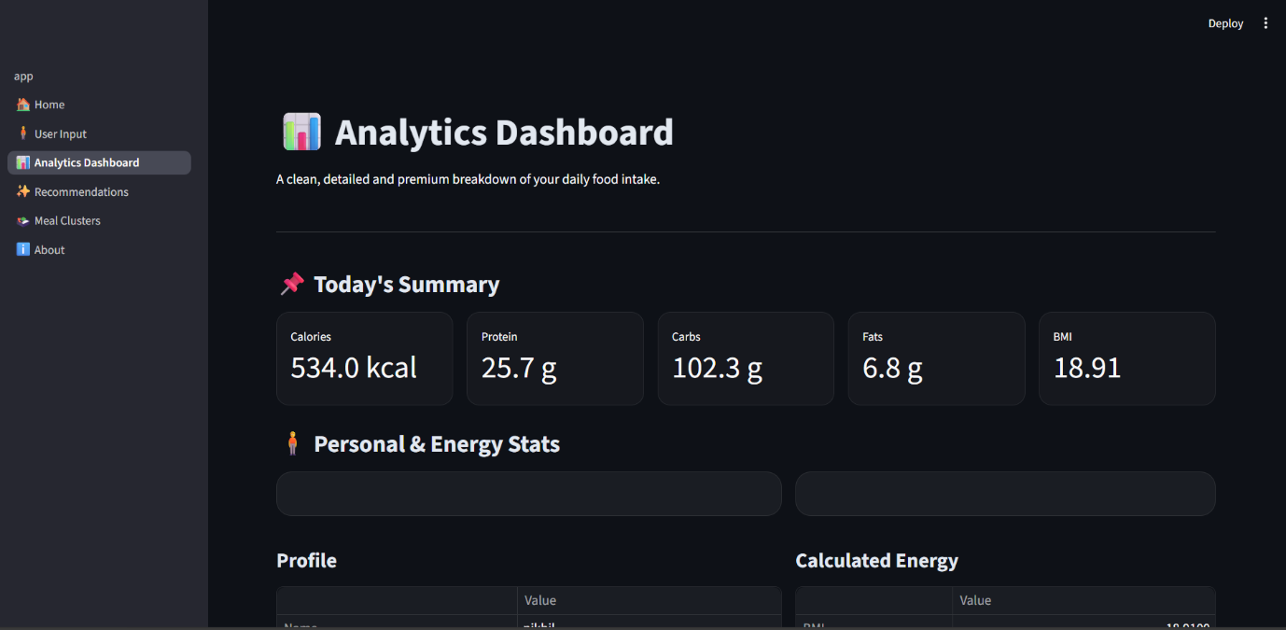

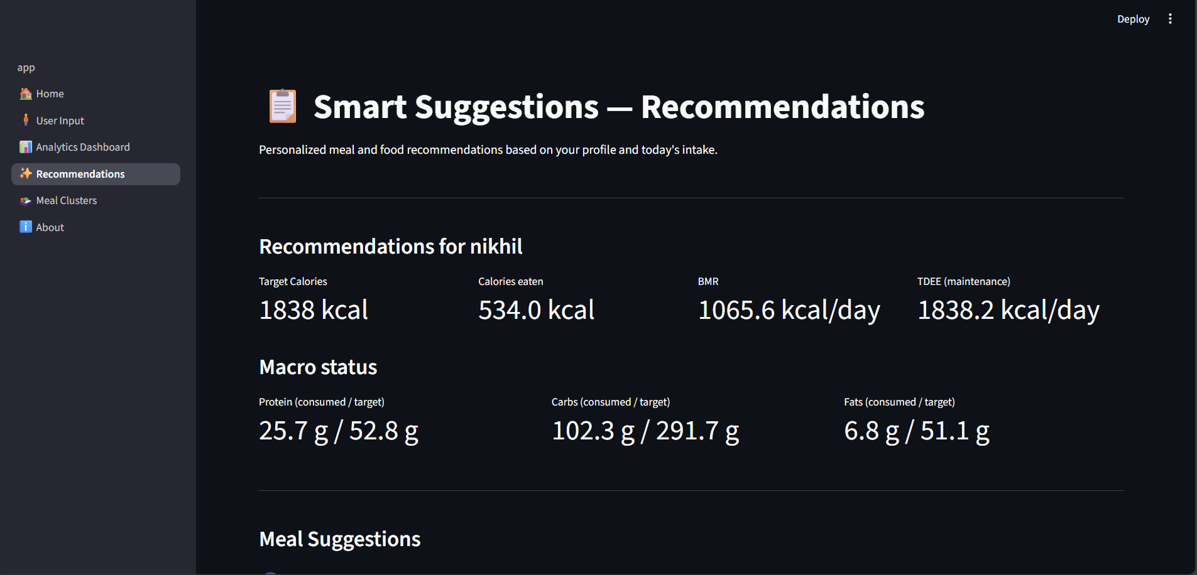
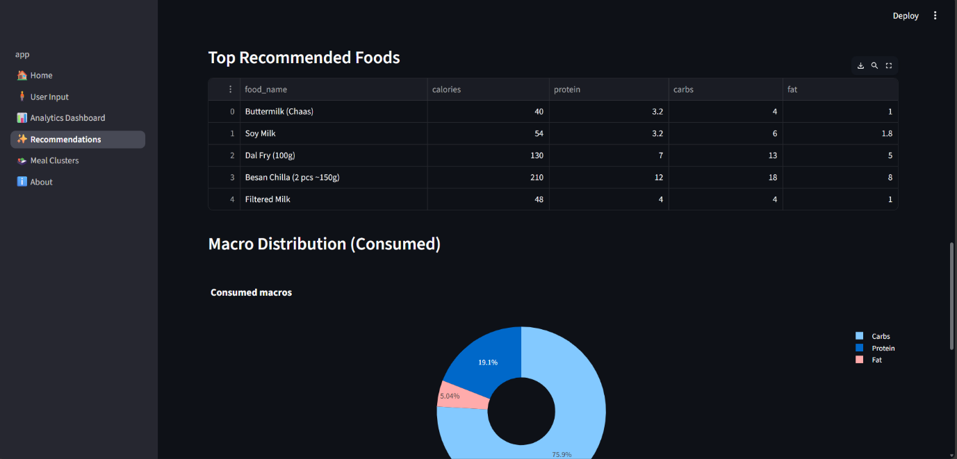

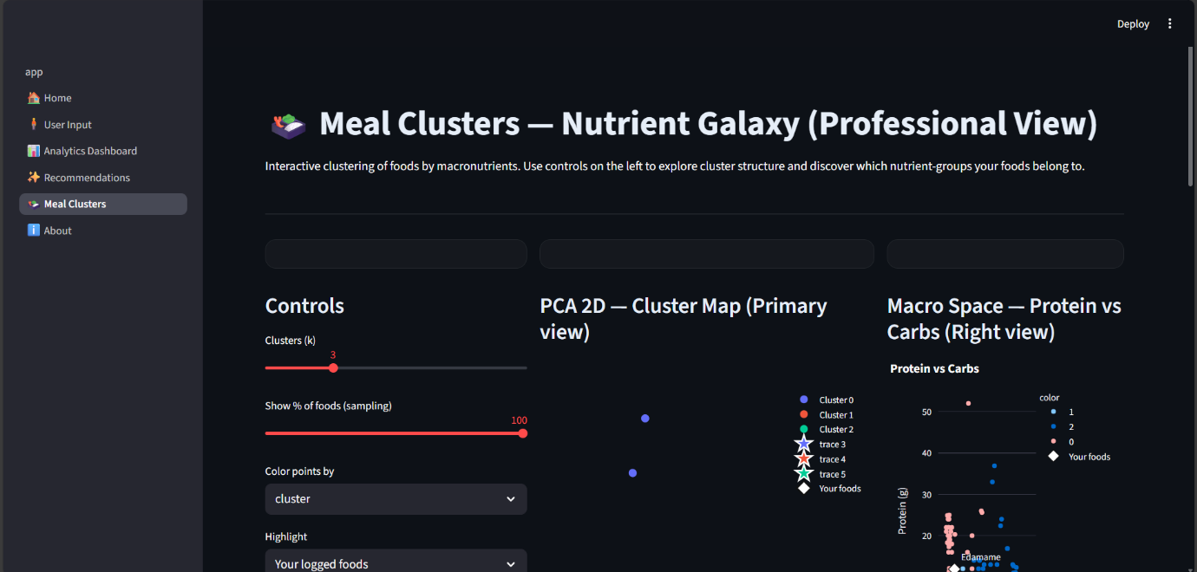

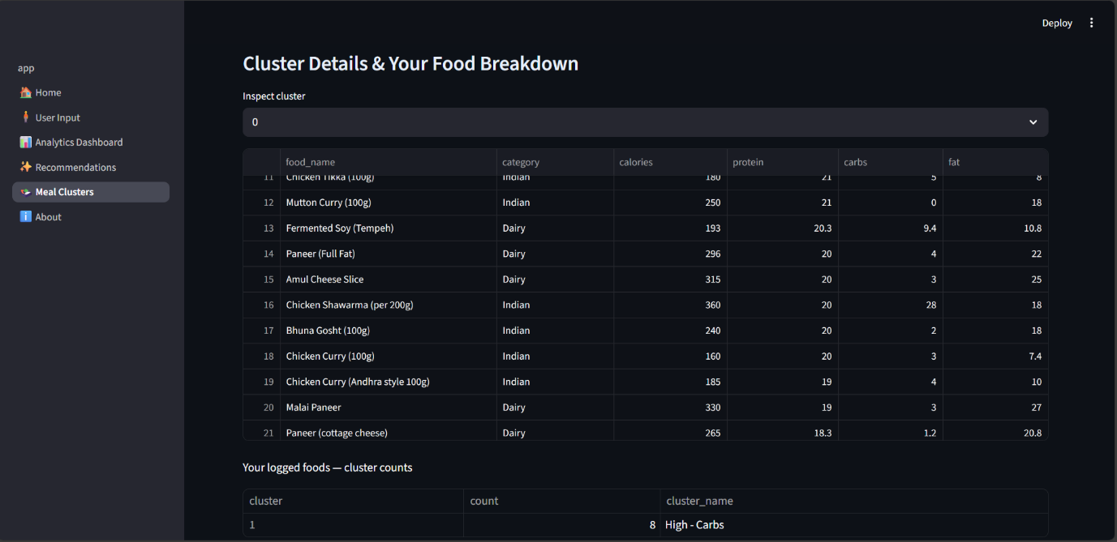

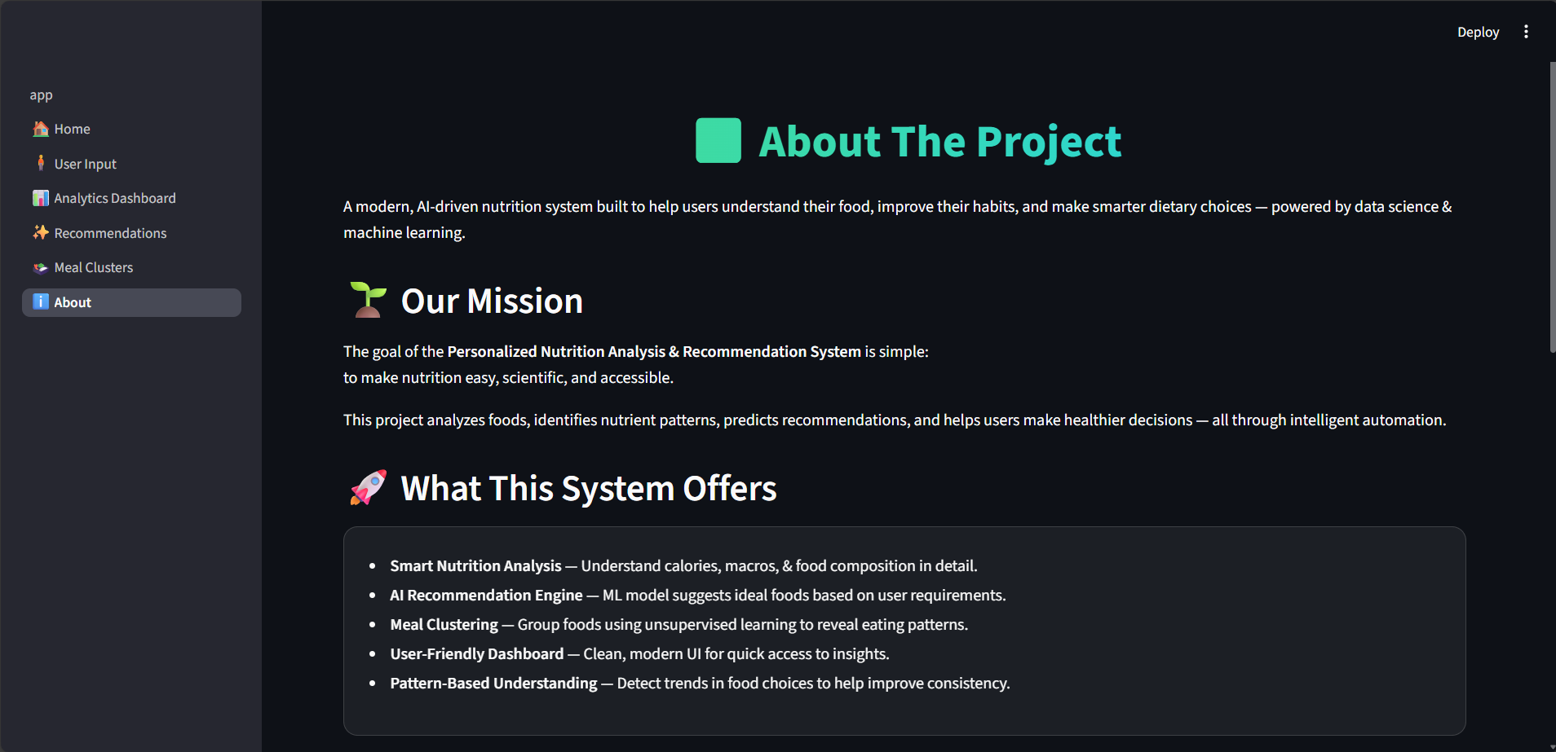

15. CONCLUSION
The Personalized Nutrition Analysis & Recommendation System (PNARS) represents a significant advancement in the application of data-driven methodologies and machine learning to the domain of personal health and nutrition. Through the systematic integration of user-specific data, scientifically validated nutritional formulas, and advanced analytical techniques, the project successfully delivers a comprehensive tool that empowers individuals to make informed dietary decisions. By bridging the gap between theoretical nutrition science and practical, everyday application, PNARS addresses a longstanding challenge faced by many: understanding and managing one’s daily nutrient intake in a precise, personalized, and actionable manner.
At the core of the system’s effectiveness is its ability to combine multiple layers of functionality into a cohesive framework. Users begin by providing personal information, including age, gender, weight, height, activity levels, dietary preferences, and fitness goals. These inputs are meticulously processed through computational modules that calculate Basal Metabolic Rate (BMR), Total Daily Energy Expenditure (TDEE), and macronutrient targets. By leveraging these scientifically grounded calculations, the system ensures that every recommendation and analysis is rooted in credible nutritional science, offering users a high degree of accuracy and reliability.
The integration of machine learning further enhances the system’s analytical capabilities. K-Means clustering identifies hidden patterns in the user’s dietary habits, highlighting tendencies toward high-protein, high-carbohydrate, or balanced meals. Content-based filtering generates personalized food suggestions that are directly aligned with observed deficiencies or surpluses, ensuring that recommendations are not generic but truly tailored to individual needs. Linear regression models provide predictive insights into potential caloric surpluses or deficits, allowing users to understand the long-term impact of their current dietary habits and make proactive adjustments. This combination of clustering, predictive modeling, and recommendation ensures that the system is not merely descriptive but also prescriptive, offering actionable guidance for healthier eating.
In addition to analytical depth, PNARS emphasizes user experience through intuitive visualization and interactivity. Interactive charts, dashboards, and graphs translate complex dietary data into easily interpretable visual insights. Users can instantly observe macro imbalances, identify problem areas, and understand the nutritional impact of individual meals. By integrating visual representation with computational intelligence, the system caters not only to health-conscious individuals but also to students, researchers, and professionals seeking a clear understanding of dietary trends and patterns.
The system’s modular architecture ensures flexibility, scalability, and maintainability. Each component, from data processing and ML analysis to visualization and recommendation, operates cohesively yet independently, allowing for easy updates, debugging, and future enhancements. Furthermore, the inclusion of PDF and CSV export functionality ensures that users can maintain records, monitor long-term progress, and share insights with nutritionists, trainers, or healthcare professionals.
Overall, PNARS demonstrates that the combination of data science, machine learning, and nutrition knowledge can produce a practical, intelligent, and user-friendly system capable of transforming how individuals approach their diet. It encourages healthier food choices, promotes awareness of macronutrient balance, and provides users with the tools necessary to achieve and maintain their personal health and fitness goals. The project not only fulfills its initial objectives but also sets a strong foundation for future innovation in the field of personalized nutrition technology.

16. FUTURE SCOPE
The potential for expanding and enhancing the Personalized Nutrition Analysis & Recommendation System is substantial, reflecting the rapid growth of technology and data-driven health solutions. One promising avenue for future development is the integration of deep learning and artificial intelligence techniques to improve the system’s predictive capabilities and recommendation accuracy. For example, deep neural networks could analyze large-scale dietary data and user behavior patterns to provide even more precise meal suggestions, identify subtle correlations between nutrient intake and physiological outcomes, and offer predictive insights about long-term health trends.
Another area for enhancement is the incorporation of image-based food recognition. By allowing users to take photos of their meals, the system could automatically identify food items, estimate portion sizes, and calculate nutritional values without manual entry. This functionality would significantly reduce the user’s workload, improve accuracy, and make the application more user-friendly, particularly for individuals with busy lifestyles or limited knowledge of food composition. Coupled with computer vision algorithms, this feature could also analyze plating patterns, meal diversity, and preparation methods, providing a holistic understanding of dietary habits.
Expanding the nutrition dataset to include micronutrients such as vitamins, minerals, amino acids, and fatty acid profiles represents another promising enhancement. While the current system primarily focuses on macronutrients, tracking micronutrients would allow for more comprehensive nutritional analysis and could support users with specific dietary needs, such as managing deficiencies, improving immunity, or optimizing metabolic health. This expansion would also open opportunities for integrating medically guided recommendations for specialized populations, including elderly individuals, athletes, and patients with chronic conditions.
Integration with fitness trackers and wearable devices offers yet another dimension of future growth. By synchronizing real-time activity data, heart rate, sleep patterns, and energy expenditure metrics, PNARS could dynamically adjust caloric and macronutrient recommendations based on actual physiological activity. This real-time feedback loop would create a more adaptive, responsive, and personalized experience, making the system not only a dietary assistant but a comprehensive wellness platform.
Furthermore, the development of a mobile application would enhance accessibility, allowing users to interact with the system anytime and anywhere. Mobile integration would also facilitate notifications, reminders, and real-time feedback, improving adherence to dietary goals and increasing user engagement. Social and gamified features could also be incorporated, such as challenges, progress tracking, and peer support, motivating users to maintain healthier eating habits.
Finally, PNARS can be expanded to support research, academic studies, and clinical applications. By anonymizing user data and analyzing aggregate trends, the system could provide valuable insights into population-level dietary patterns, the impact of lifestyle interventions, and correlations between diet and health outcomes. This dual focus on practical usability and research utility ensures that the system remains relevant and innovative as the fields of nutrition, health, and artificial intelligence continue to evolve.
In conclusion, the future scope of PNARS is broad and transformative. With enhancements in deep learning, computer vision, micronutrient analysis, wearable integration, and mobile accessibility, the system has the potential to become a fully adaptive, intelligent, and holistic nutrition and wellness platform, capable of significantly improving individual health outcomes and advancing the field of personalized nutrition technology.

17. BIBLIOGRAPHY
1. Brown, J. & Smith, L. Nutrition and Health: Principles and Applications. 3rd Edition, Pearson, 2021.
2. Willett, W. Nutritional Epidemiology. 3rd Edition, Oxford University Press, 2013.
3. Kaggle Datasets: Food Nutritional Values Dataset. Available at: https://www.kaggle.com
4. HealthifyMe and MyFitnessPal Documentation & APIs for dietary tracking and analysis.
5. Streamlit Documentation. Available at: https://docs.streamlit.io
6. Géron, A. Hands-On Machine Learning with Scikit-Learn, Keras & TensorFlow. 2nd Edition, O’Reilly Media, 2019.
7. Murphy, K. P. Machine Learning: A Probabilistic Perspective. MIT Press, 2012.
8. Research papers on K-Means clustering, content-based filtering, and linear regression in nutrition and health applications.
9. Online journals and publications on dietary analysis, BMR/TDEE calculations, and personalized nutrition recommendations.
10. Python Library References: Pandas, NumPy, Matplotlib, Seaborn, Scikit-learn.

