**CI/CD Pipeline Approach**

**Some Points to Remember Here:**

* This approach shows you how to do automation of CI/CD Pipeline for your application.
* Not necessarily you need to keep the same names of packages and connected app. You should change them according to your application. Ex- **DreamHouse** should be changed to your application name.

1. **Create and Launch Your Trailhead Playground**

* Create one Trailhead Playground.
* Launch newly created playground.

|  |  |
| --- | --- |
|  |  |

1. **Enable Dev Hub and Create a Connected App**

* Go to **Dev Hub** and Enable it.
* Also Enable Unlocked Packages and 2nd Gen Managed Packages.

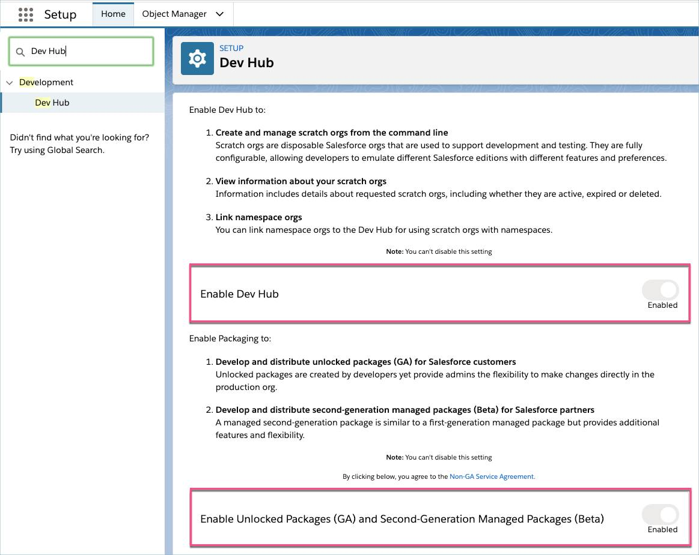

* Create Connected App with all necessary details.

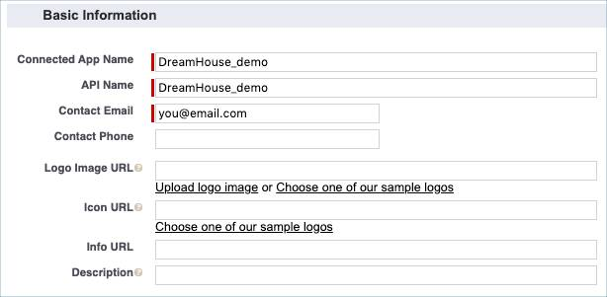

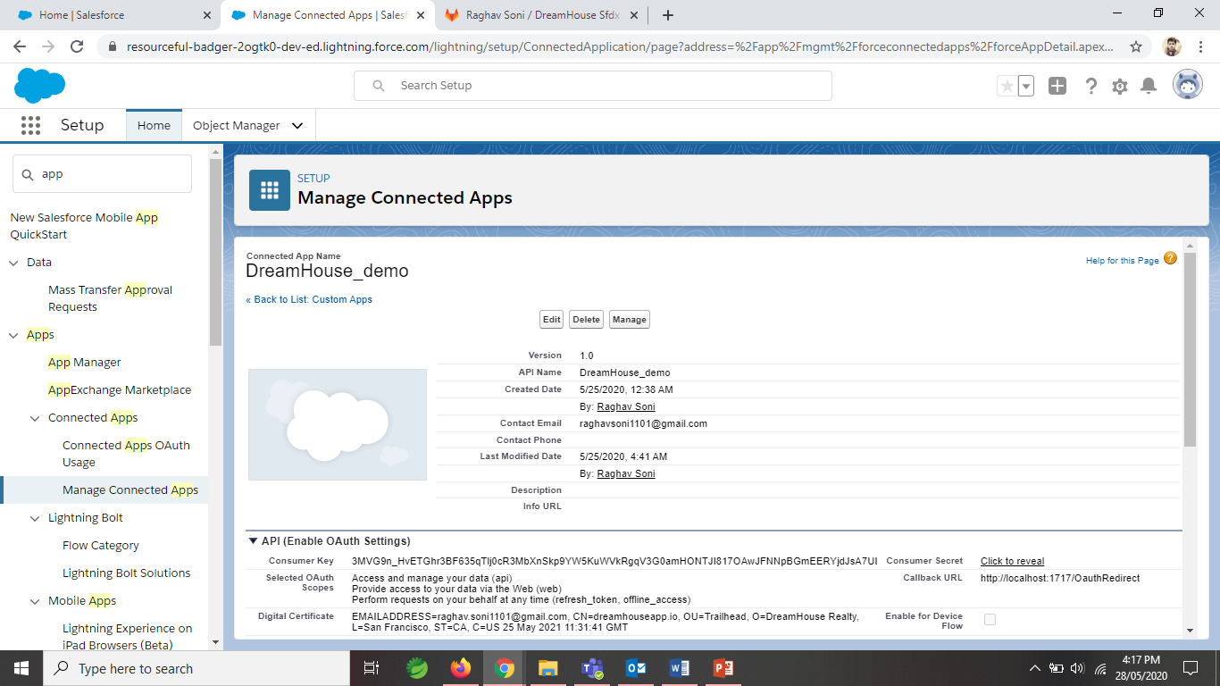

* In OAuth Section give permission to Admin approved users.

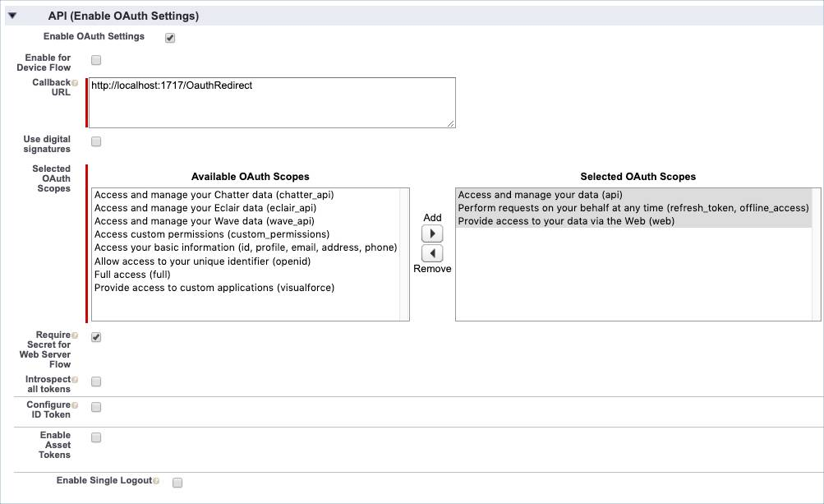

* Update admin’s permissions so the app interacts properly with GitLab in Policies section.

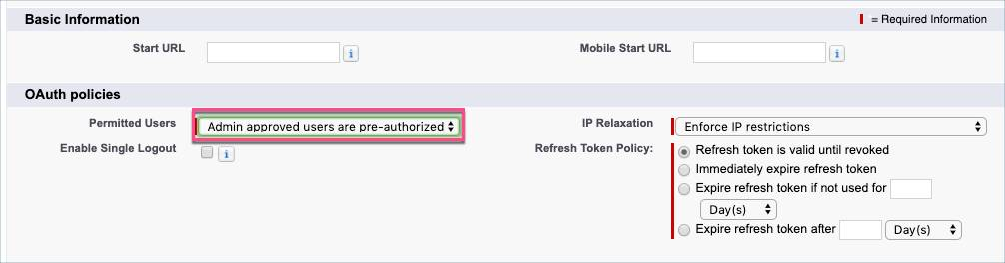

* Add Profiles Standard User & System Administrator in Profiles Section

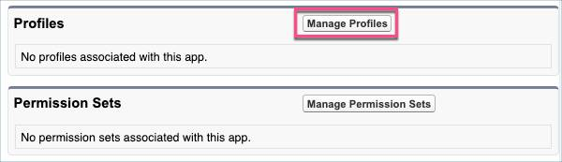

1. **Create a GitLab Project and Clone DreamHouse**

* Install Salesforce CLI for your OS.
* Install GIT for your OS and Set path in Environment Variable.
* Install OpenSSL version 1.1 for your OS and set its PATH in Environment Variables.

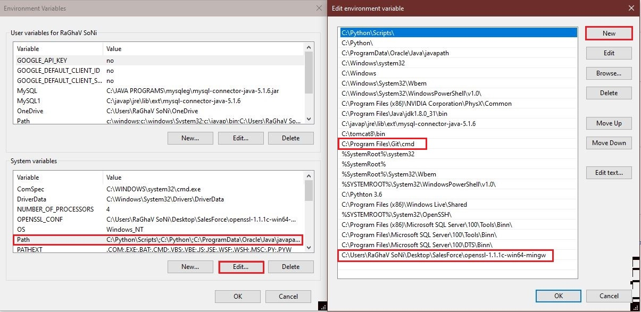

* Authenticate your Dev Hub org.

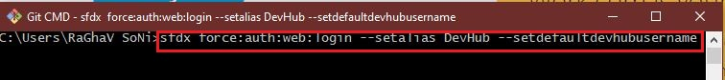

|  |  |
| --- | --- |
|  |  |

* Now log in or register for GitLab Account.

|  |  |
| --- | --- |
|  |  |

* Set Up your GitLab Project and Clone with HTTPS.
  + Go to Projects and select Your Projects.
  + Click Create a Project.
  + Then click New Project.
  + Then select Import Project.
  + Then click clone and copy the Git URL.

|  |  |
| --- | --- |
| **1** | **2** |

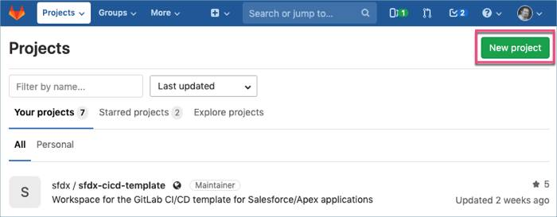

**3**

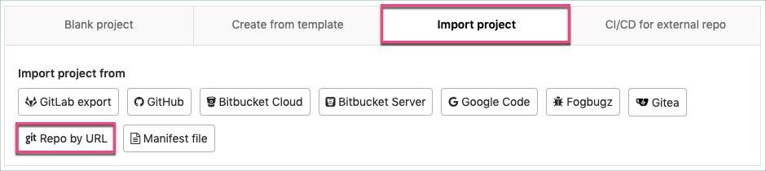

**4**

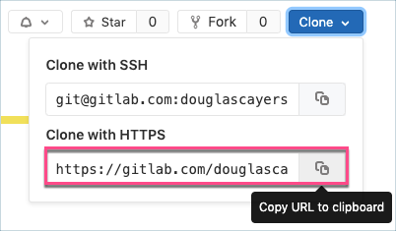

**5**

1. **Integrate with GitLab**

* Create RSA Private Key and Digital Certificate using OPENSSL.

**Note:** You can choose any password instead of **<SomePassword>** but keep password same throughout the project.

* Create key file from **server.pass.key** file.

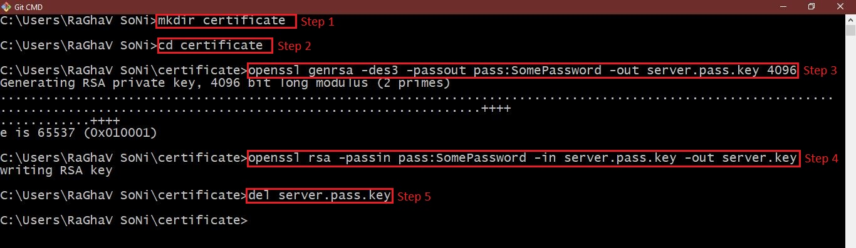

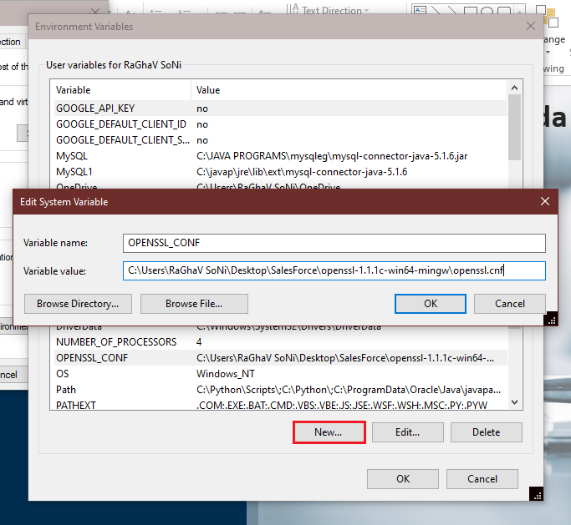

* Generate the SSL certificate and Add Digital Certificate into your Connected App.

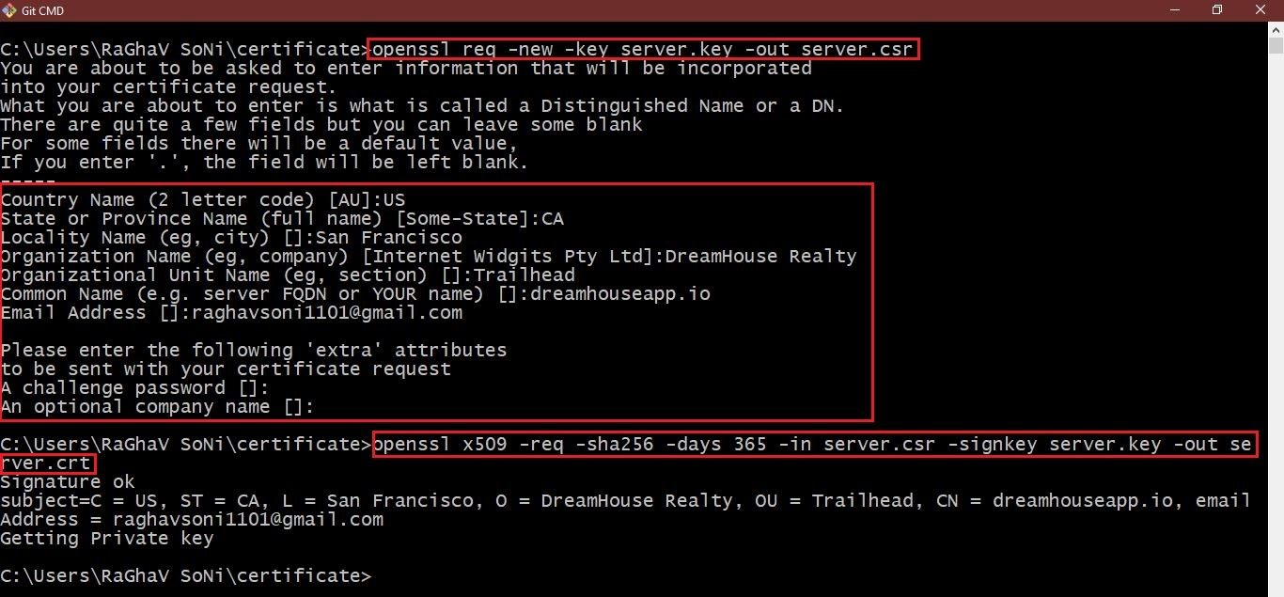

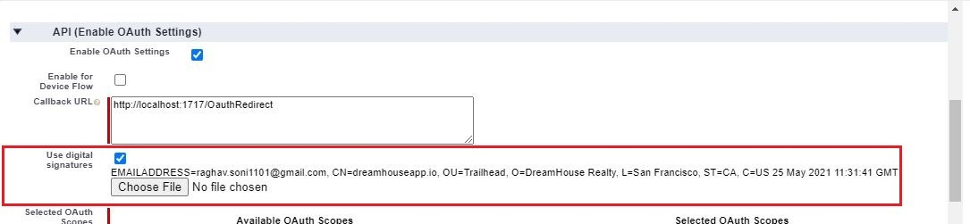

* Encrypt **server.key** file and add it into your project and push changes to GitLab.

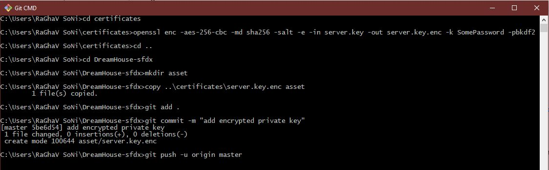

* Define the CI/CD Variables.

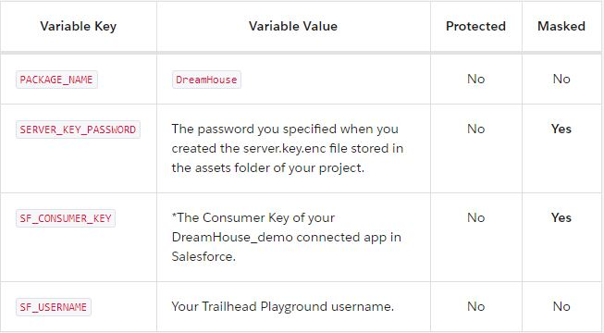

**Note:** If you don’t log out from dev hub org your JWT grant command won’t complete correctly.

* Confirm that your org is authorized via JWT and not WEB using Salesforce CLI.

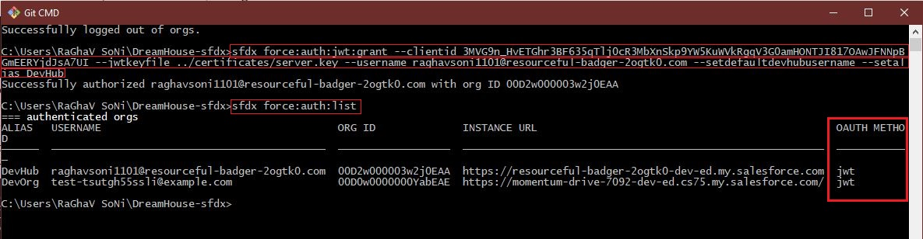

**Note:** You should see JWT listed next to your Username in the list. If you don’t repeat instructions and make sure to log out of Dev Hub org before attempting JWT grant command.

1. **Package Your App and Automate CI/CD**

* Create Unlocked Package named **DreamHouse.**
* Add JSON file to GIT and Push changes to GitLab.

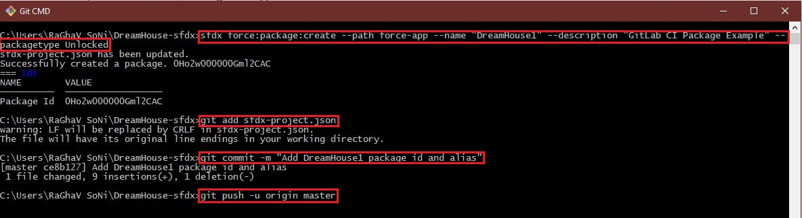

* Create YAML file in your project with required content.
  + Search your project and click on it.
  + Inside project, Go to Repository and select.
  + Now, click Web IDE.
  + And click New File.
  + Select or create file with .yml extension.
  + Now click Create File.

|  |  |
| --- | --- |
| **1** | **2** |



**3**

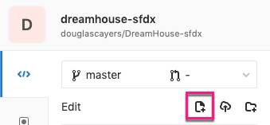

**4**

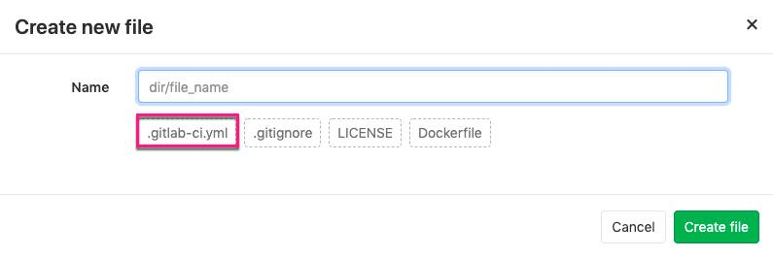

**5**

* Commit to run GitLab Pipeline.
  + Click Commit to commit your changes.
  + Again commit.
  + Finally click on Stage and Commit to run Pipeline.

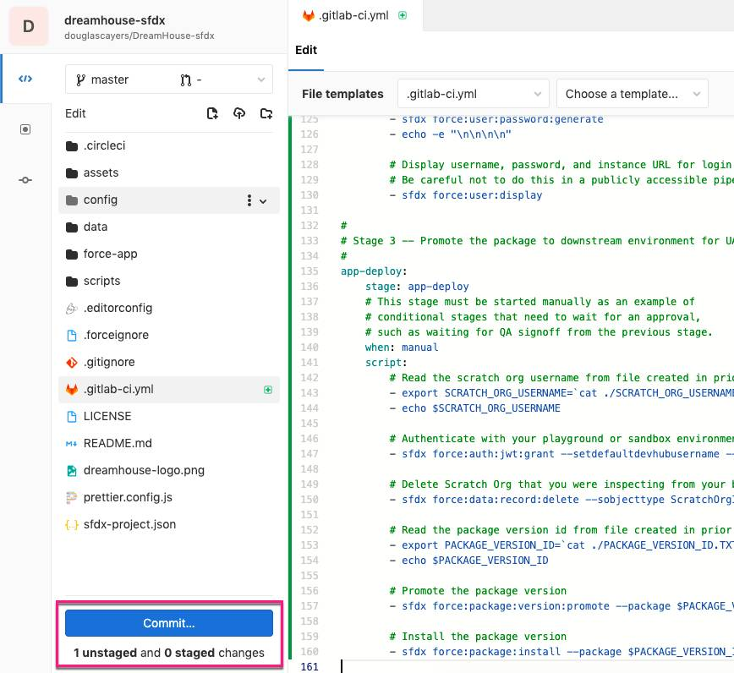

**1**

|  |  |
| --- | --- |
| **2** | **3** |

* Review the Pipeline and wait for it to complete.
  + Select your project.
  + Go to CI/CD.
  + Select Pipelines to review your pipeline.
  + Wait for it to complete.

|  |  |
| --- | --- |
| **1** | **2** |
| **3** |

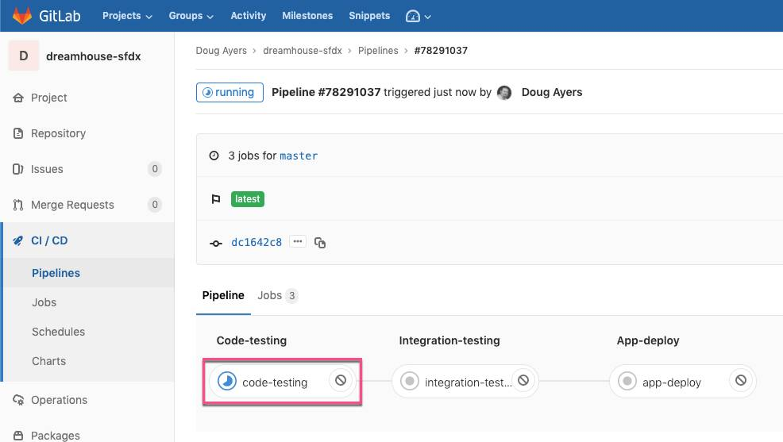

**4**

1. **Deploy to Production with CI/CD**

* **Note:** Still unable to log in because you allowed Salesforce CLI to auto delete Scratch Orgs when task is completed. So the org you are trying to log in is no more available to you.
* From latest Pipeline, click **Play** button next to **app-deploy** job. This starts the deployment stage.

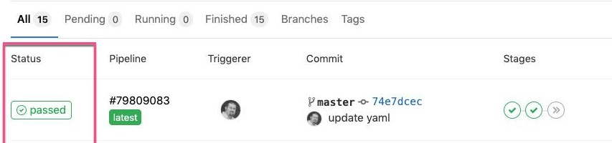

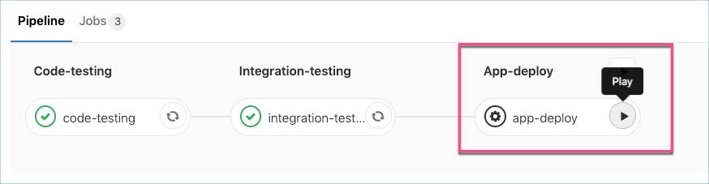

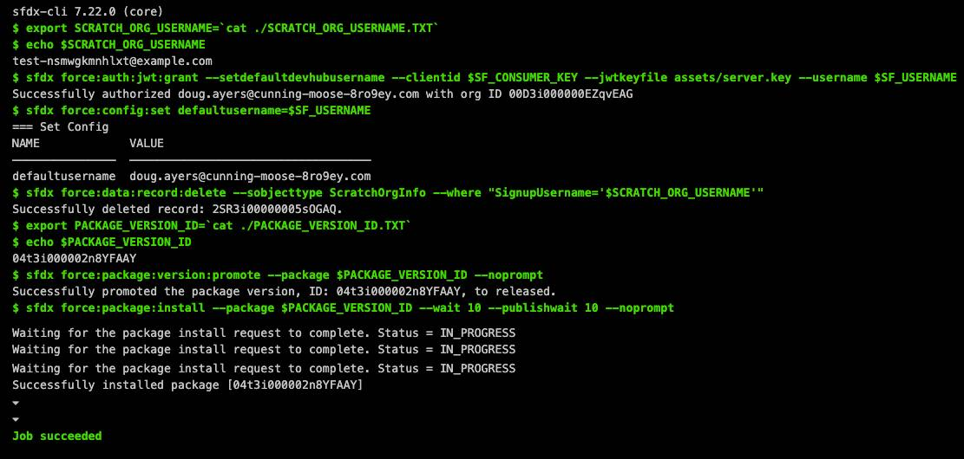

* Approve Deployment and review it.

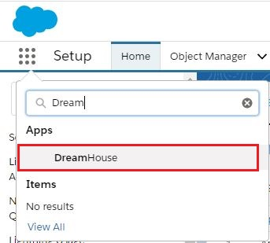

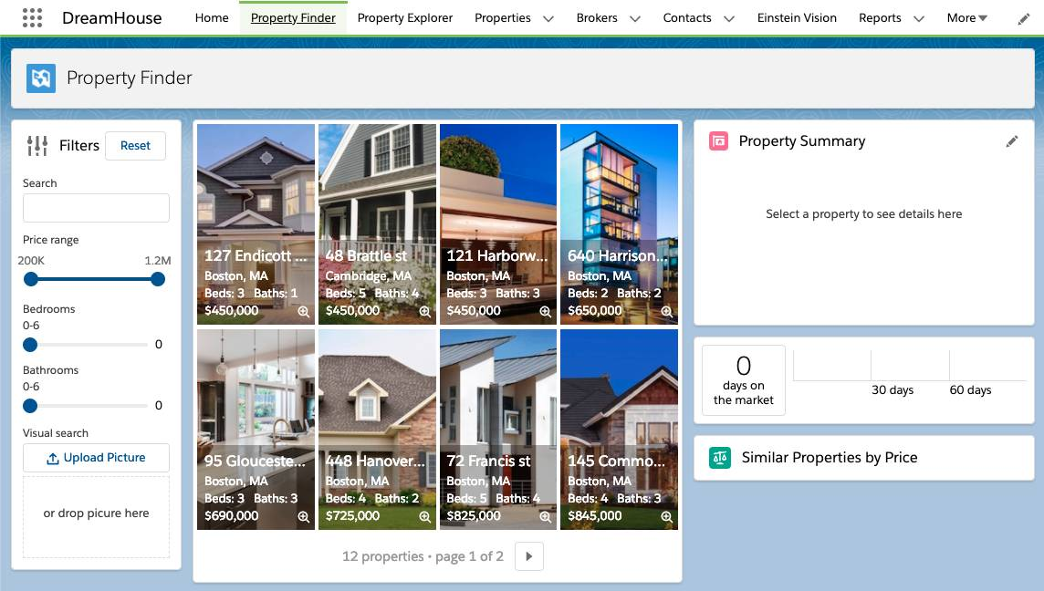

1. **Update the App with CI/CD**

* You can create new project folder to simulate another developer’s workspace.
* Create a New Scratch Org. Push local metadata to Scratch Org.

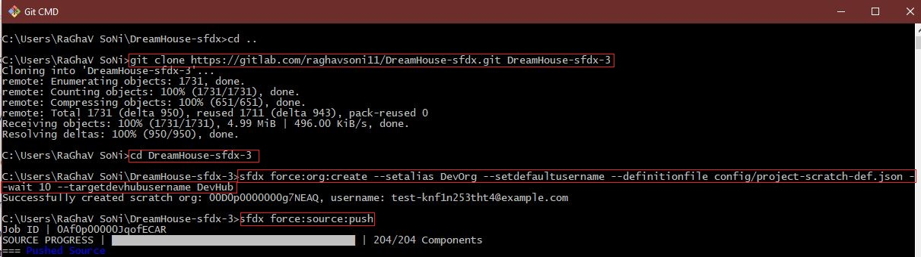

* Assign the DreamHouse permission set to Scratch Org default user.
* Load some sampled data of broker’s and properties.

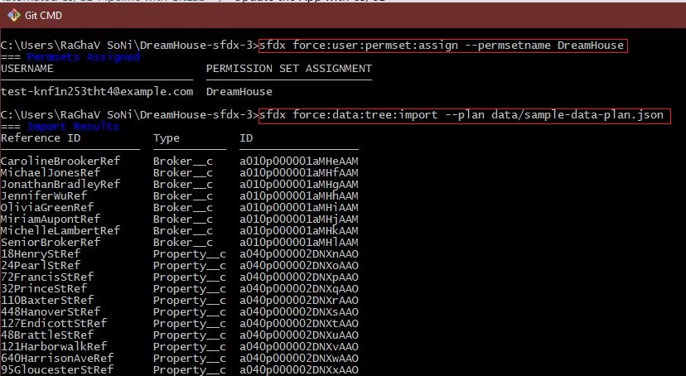

* Develop Changes in Salesforce. Pull the changes to your local project.
* Commit and Push changes to GitLab.

**Note:** If your pipeline fails with error “You must have My Domain deployed” unfortunately this means the Salesforce CLI didn’t detect that the org’s My Domain was not fully ready before attempting to deploy the metadata. You can retry the pipeline, which will retry with a new scratch org.

* Again deploy your changes.

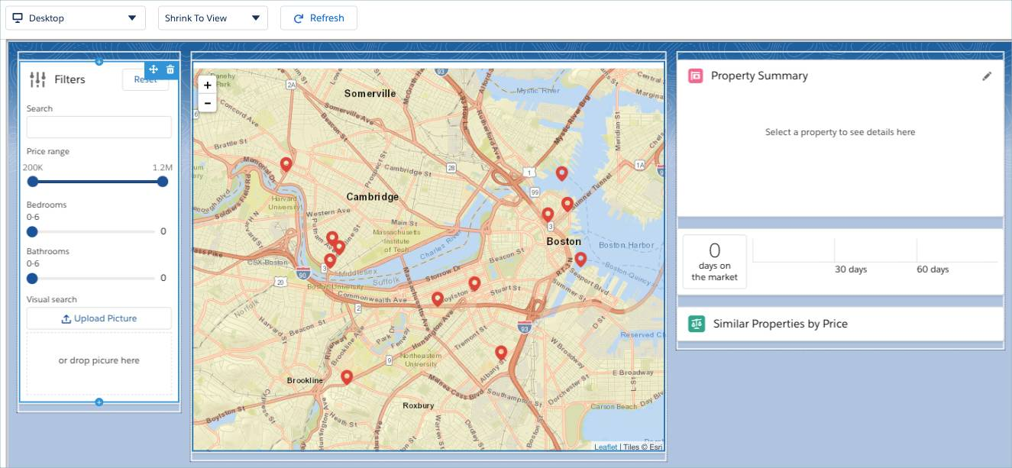



* Review it, you’ll see changes in your Playground.

