**CI/CD Pipeline FAQs**

1. **Create and Launch Your Trailhead Playground**
2. **Enable Dev Hub and Create a Connected App**
3. **Create a GitLab Project and Clone DreamHouse**

**FAQ -** Clone of the project was not being pulled from GitLab. It show "Authentication error".

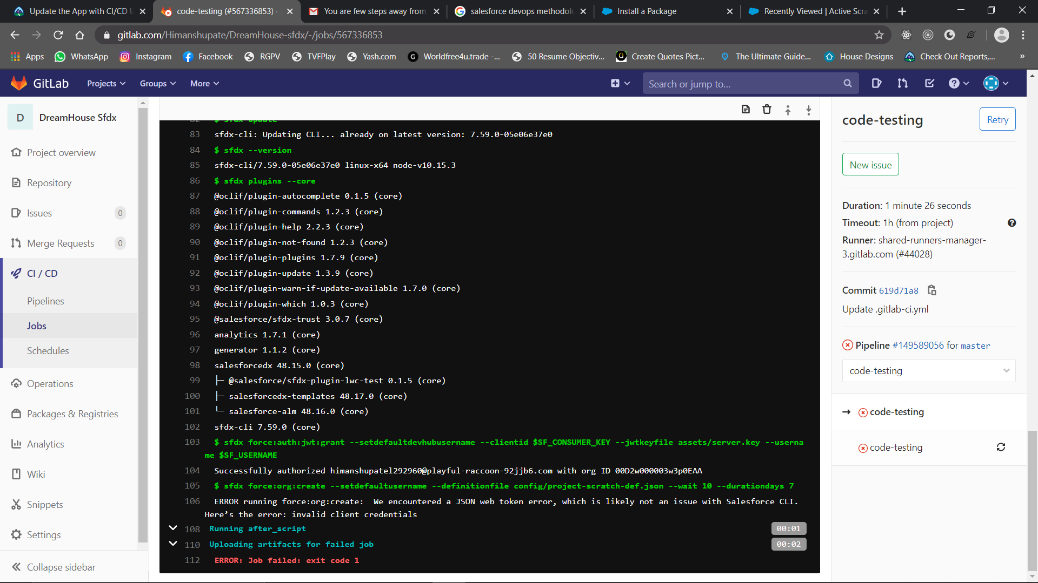

**Solution -** Just change the Git credentials. And remember one thing rather than logging via any third party application in GitLab, try registering manually. That way you’ll remember correct username and password. It’ll solve maximum problem regarding cloning.

1. **Integrate with GitLab**

**FAQ –** On Windows, if you see the error message like “Can’t open C:/Windows/System32/OpenSSL/ssl/openssl.cnf for reading. No such file or directory”.

**Solution –** Follow the earlier instructions to set the environment variable OPENSSL_CONF.

**FAQ –** Still unable to connect via JWT token.

**Solution –** Try using different Playground.

1. **Package Your App and Automate CI/CD**

**FAQ –** While creating unlocked package getting error “The package name must be unique for the namespace”.

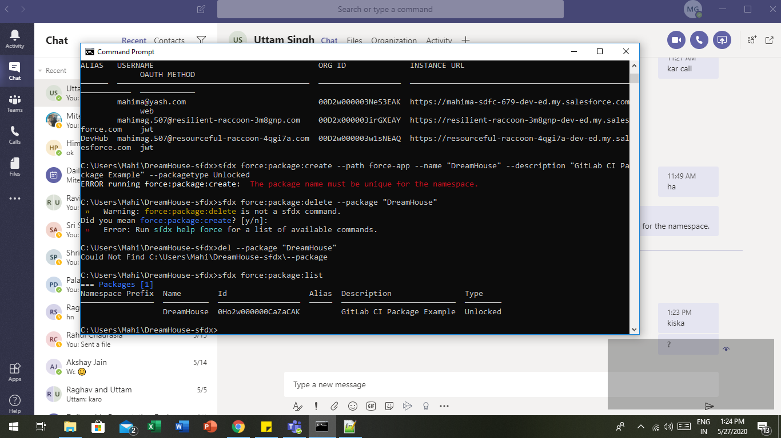

**Solution –** You already have a package with the same name e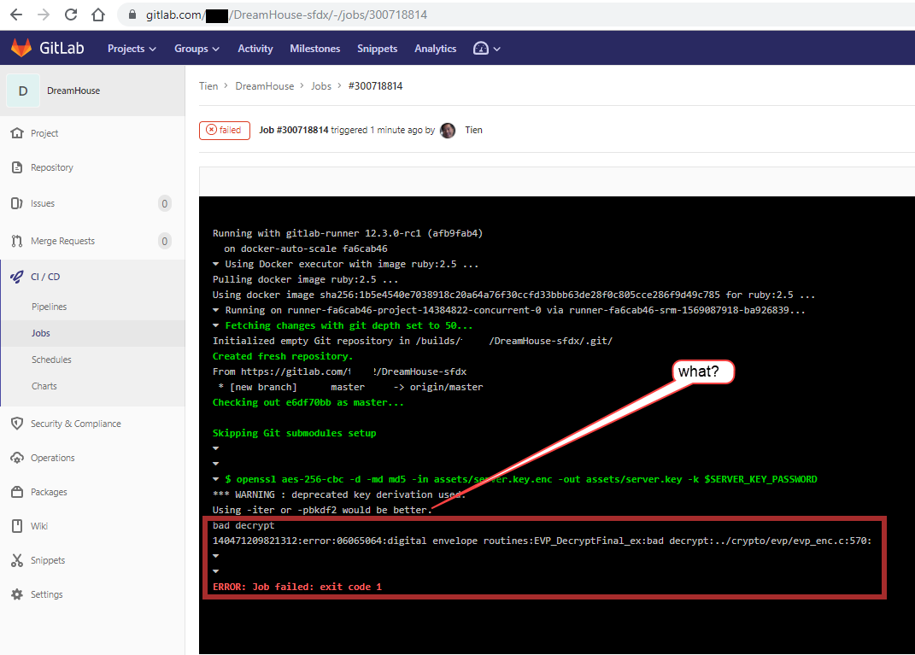ither delete the previous one and try. Or you can create new unlock package with different name.

**FAQ –** In CI/CD pipeline it was unable to pass code testing and give error bad decrypt.

**Solution –** Check the password. There can be a password mismatch.

**FAQ –** Code testing fail due to problem in encryption or decryption.

**Solution –** If you have problem in encryption & decryption it means there can be a problem in Open SSL version. Try checking latest version.

**FAQ –** In integration-testing getting error “Cannot iterate over null (null)”.

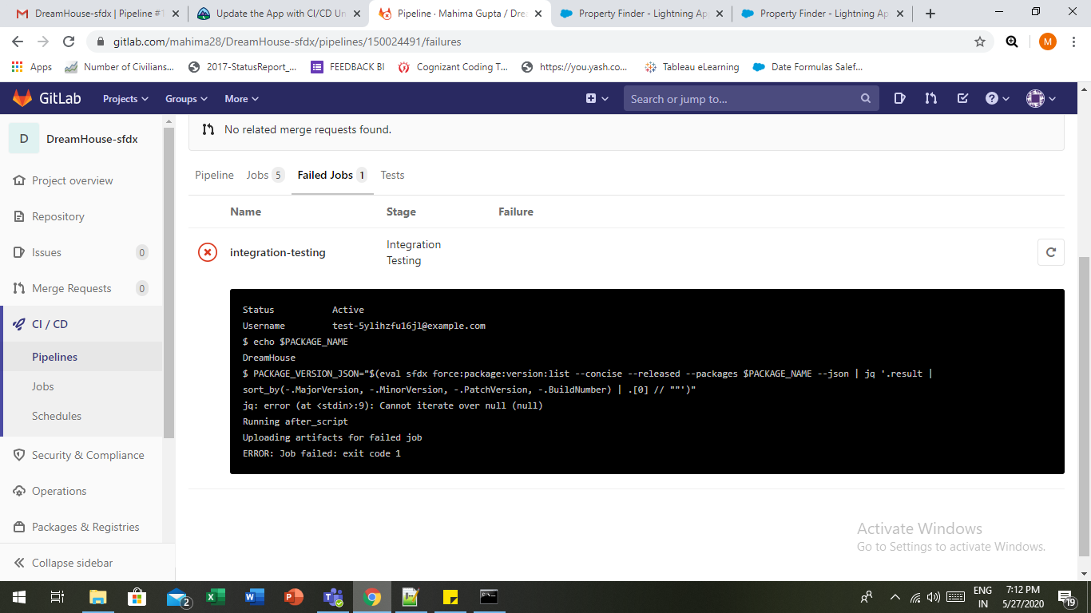

**Solution –** It means you don’t have the required data in your project. Or there was some problem while you were pulling data. So delete the current project and create another and pull data correctly this time.

**FAQ –** If the error "The signup request failed because this organization has reached its daily scratch org signup limit" comes in any job.

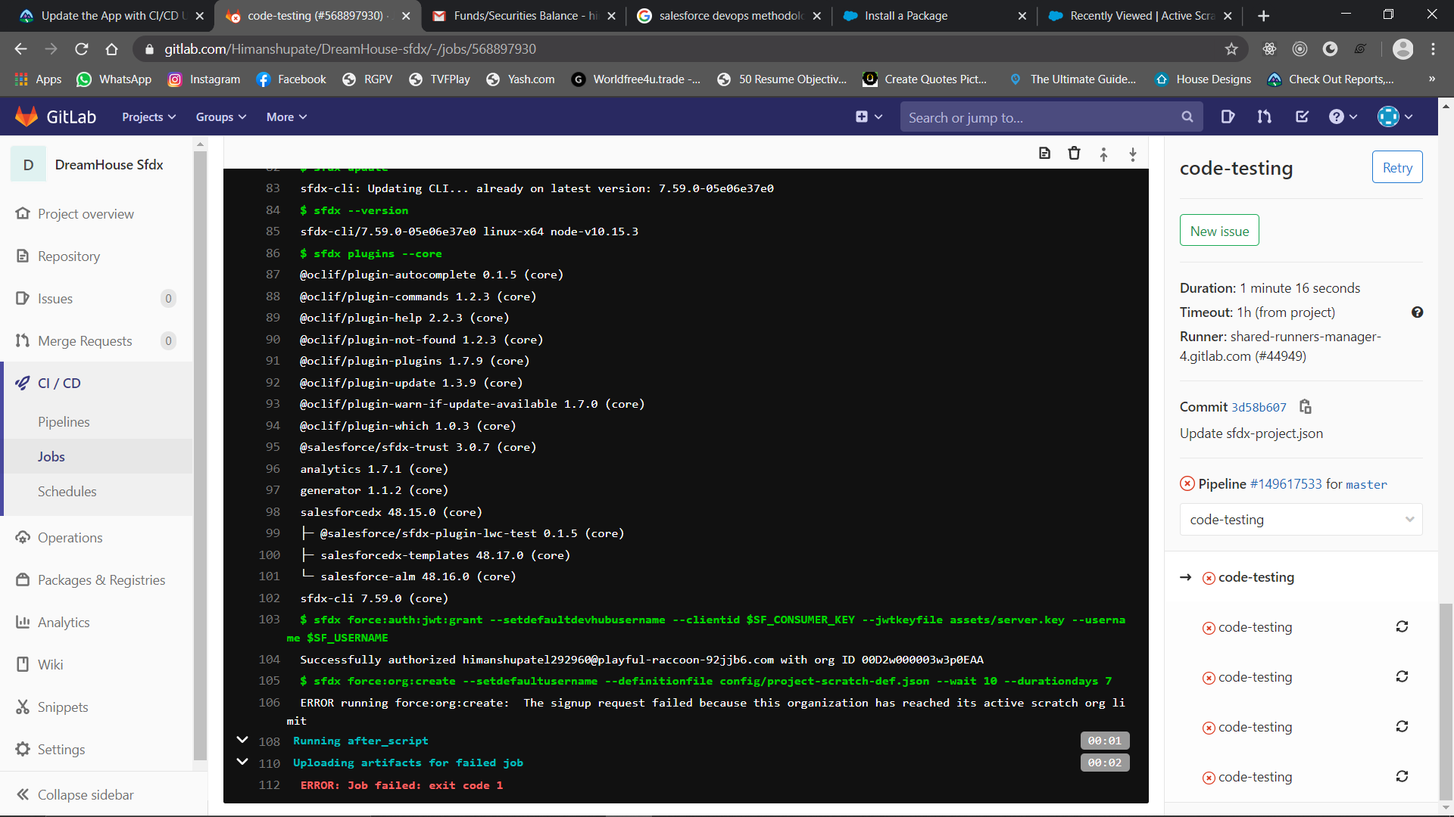

**Solution –** This error occurs because the Salesforce allows to create 3 scratch orgs only. So the solution is to delete unused orgs.

1. Login to Salesforce (with user name provided for DEV ORG).
2. Now switch to Classic.
3. Open a tab by clicking "+" button in Navigation Bar.
4. Click on Active Scratch Org.
5. Delete some old orgs.

You can do that by commands also in Salesforce CLI – **sfdx force:org:delete**

1. **Deploy to Production with CI/CD**

**FAQ –** Unable to login to Sandbox.

**Solution –** Put your Username correct and rather than using log password use **<SomePassword>** beacause log password is encrypted password of this if masking is ON.

Also remember if you are still unable to log in because you allowed Salesforce CLI to auto delete Scratch Orgs when task is completed. So the org you are trying to log in is no more available to you.

1. **Update the App with CI/CD**

**FAQ –** Unable to create Scratch Org due to “Invalid Connected Application Consumer Key provided.

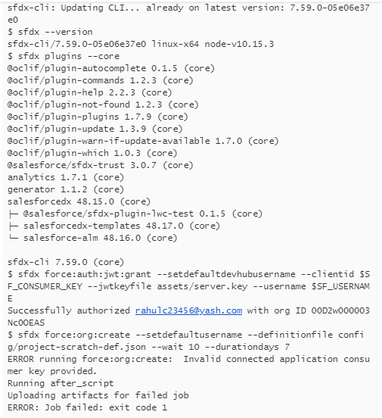

**Solution –** At first try clearing you system cache and restart the pipeline process. If still problem don’t resolve thenDelete previous Scratch Org and try creating fresh new Scratch Org from Dev Hub.

**FAQ –** While trying to open scratch org get an error “Must pass a username and/or OAuth options when creating an AuthInfo instance”.

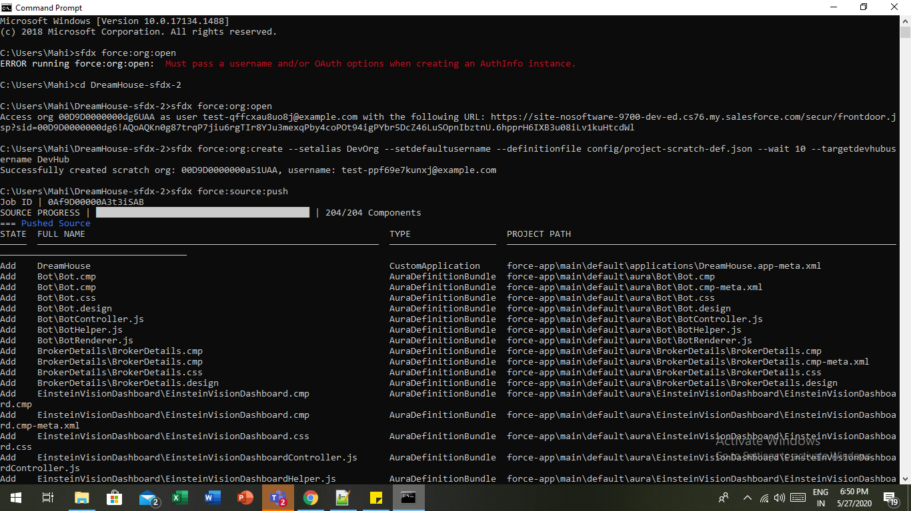

**Solution –** You are trying to open scratch org from wrong directory. Switch to project directory and re-run the command.