**Tektronix RSA 306B HowTo document**

***Script: rsa306b_samples.py***

1. This is the code to read samples from Tektronix RSA 306B and store it in a series of continuous txt files

2. The spectrum analyzer settings can be modified by opening the script in a text editor and editing it.

3. The reference level in dBm, type of trace and type of detector can be changed in this code snippet shown below.

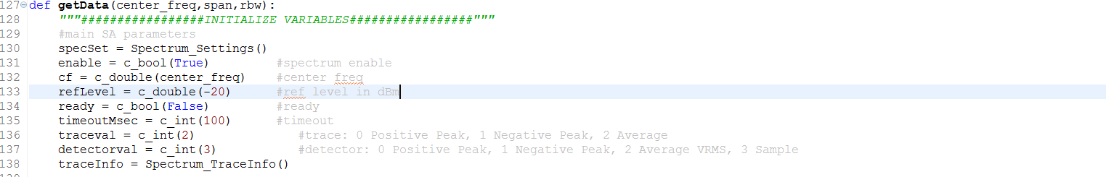

Currently, the values given are as follows.

Reference level in dBm: -20

Type of trace: 2 (Average)

Type of detector: 3 (Sample)

4. The start frequency in Hz, stop frequency in Hz, span bandwidth in Hz and resolution bandwidth in Hz can be changed in this code snippet shown below.

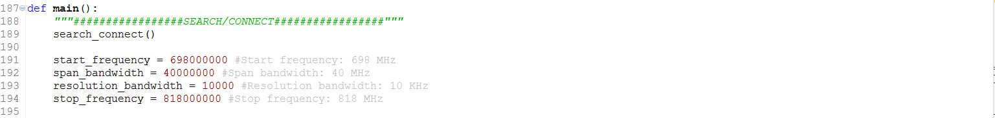

Currently, the values given are as follows.

Start frequency: 698 MHz

Stop frequency: 818 MHz

Span bandwidth: 40 MHz

Resolution bandwidth: 10 KHz

***Script: mean_std_peak_analysis.py***

1. Once the data collection is done using the script *rsa306b_samples.py*, the output txt files are stored in the format shown below.

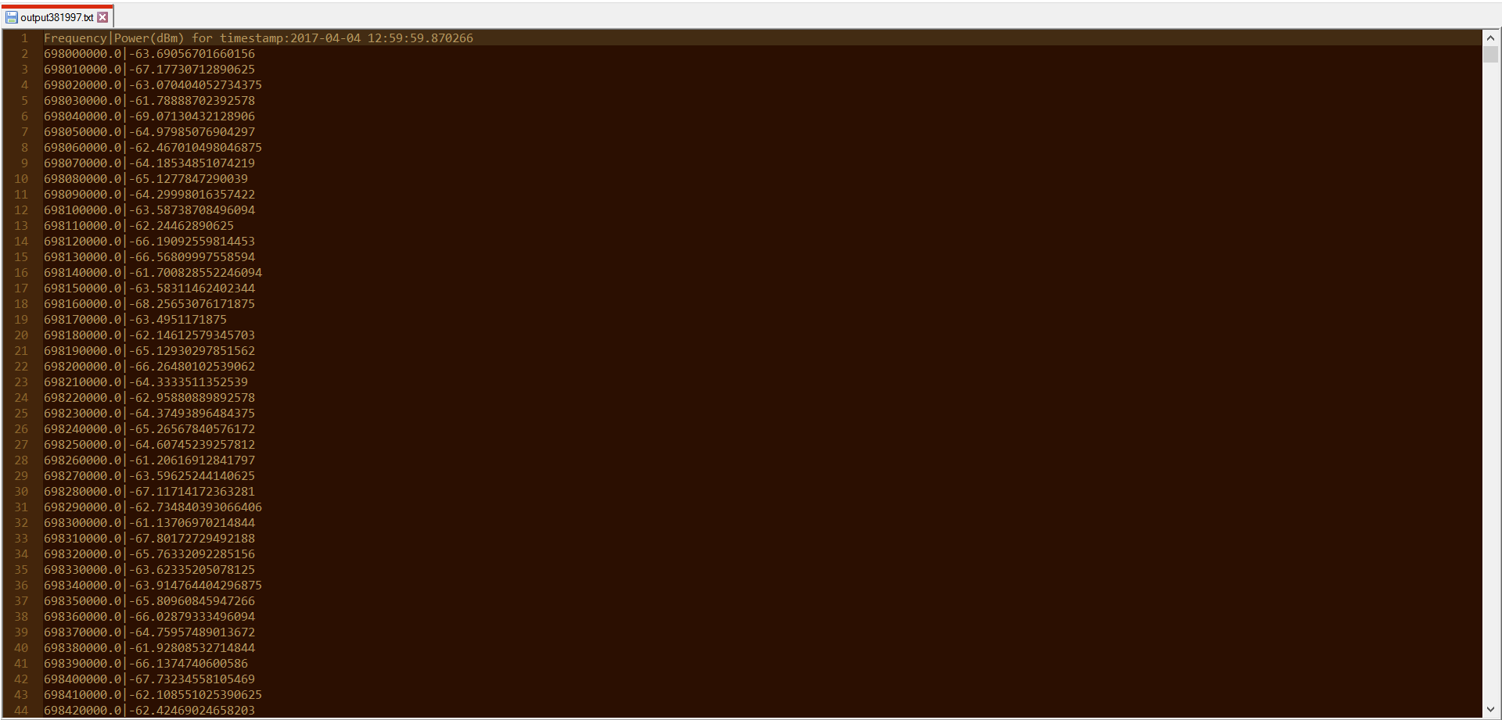

2. As observed from the screenshot above, the line 1 contains the text *‘Frequency|Power(dBm) for timestamp: <timestamp>’*. This is a header and not the actual data. This header repeats for every span bandwidth. For example, in our code, we setup the data capture for the following parameters.

Start frequency: 698 MHz

Stop frequency: 818 MHz

Span: 40 MHz

Resolution bandwidth: 10 kHz

Thus, the first header can be expected at 698 MHz + 40 MHz = 738 MHz. This occurs at line 4003 in the txt file as shown below.

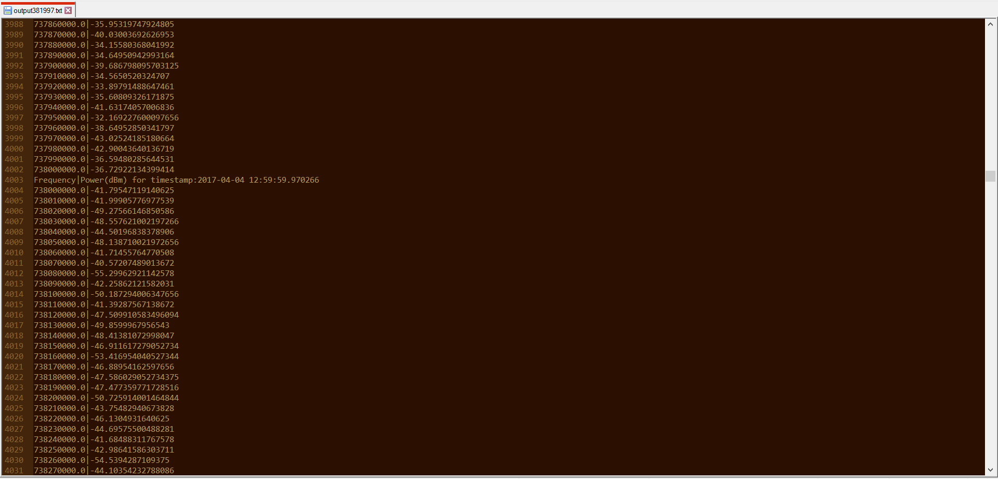

3. Additionally, in the screenshot above, the data capture for 738 MHz occurs twice, once at line 4002 and once at line 4004. Thus, one of these needs to be skipped when calculating mean, peak and standard deviation. We skip lines 1, 4003, 4004, 8005, 8006 in our code (as these lines contain either non-data values or repetitive values).

4. The code execution needs to move to the next txt file once it encounters the last line of the current txt file. The last line of the txt file is the line 12007 as shown in the screenshot below.

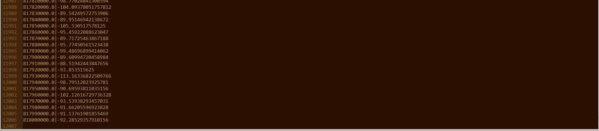

We skip the last line of 12007 in our code.

5. The start frequency in Hz, stop frequency in Hz and resolution bandwidth in Hz needs to be changed in the code snippet shown below.



6. The lines to be skipped as given in Step 3 and 4 is incorporated in the code as shown in the screenshot below.

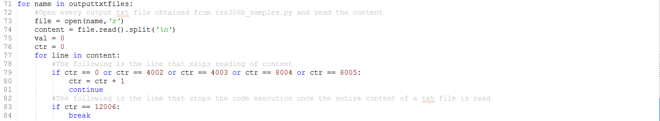

For example, we wanted to skip lines 1, 4003, 4004, 8005, 8006. The ctr values for the corresponding lines are 0, 4002, 4003, 8004, 8005 as given in the screenshot above.

For example, we also wanted to skip the last line of the txt file 12007. The ctr value for the corresponding line is 12006 as given in the screenshot above.

7. Once the code is executed, the msp.csv is obtained. The screenshot is as follows.

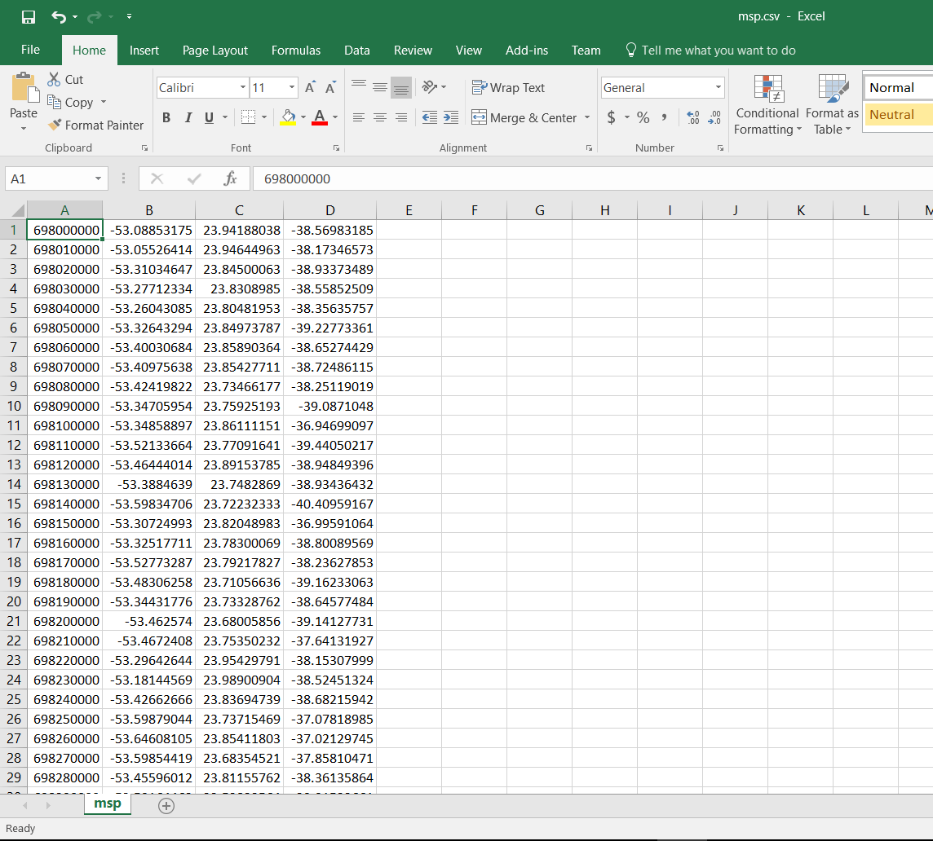

In the above screenshot, first column is frequency in Hz, second column is mean power in dBm, third column is standard deviation of power in dB, fourth column is peak power in dBm;

8. The mean power vs frequency graph obtained is as shown below.

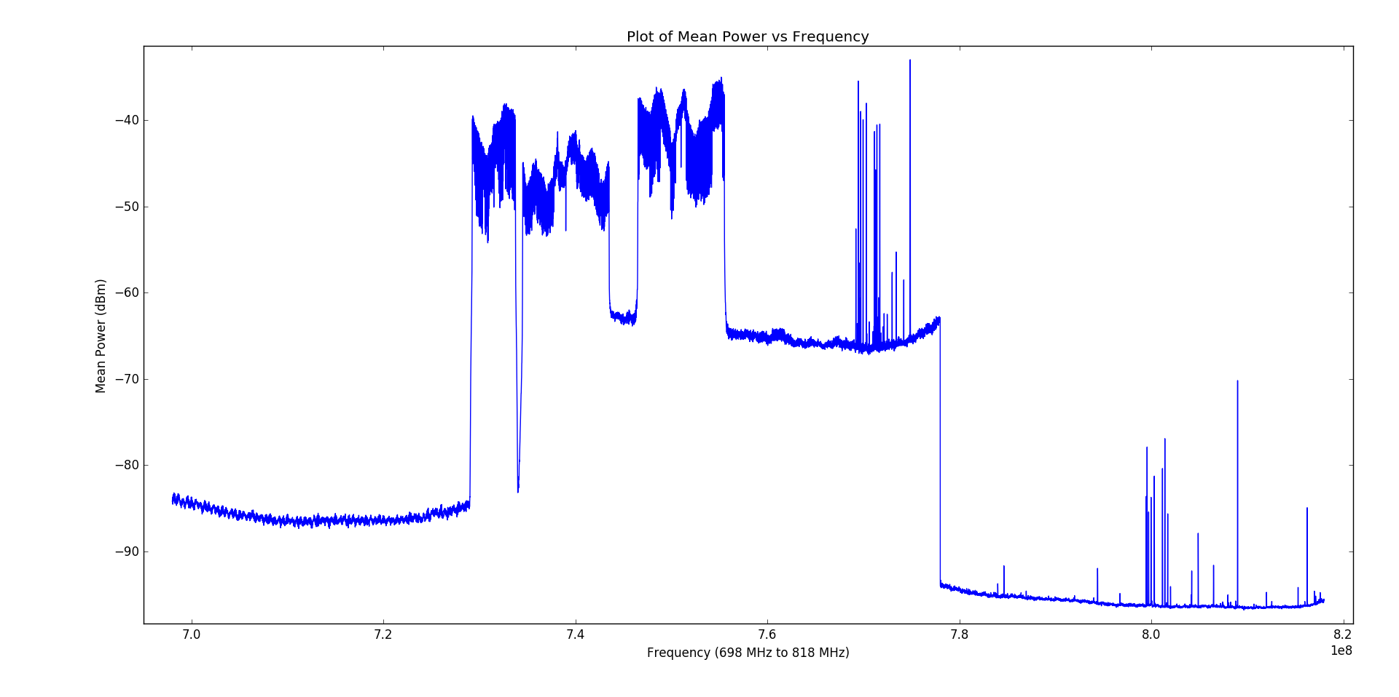

9. The standard deviation of power vs frequency graph obtained is as shown below.

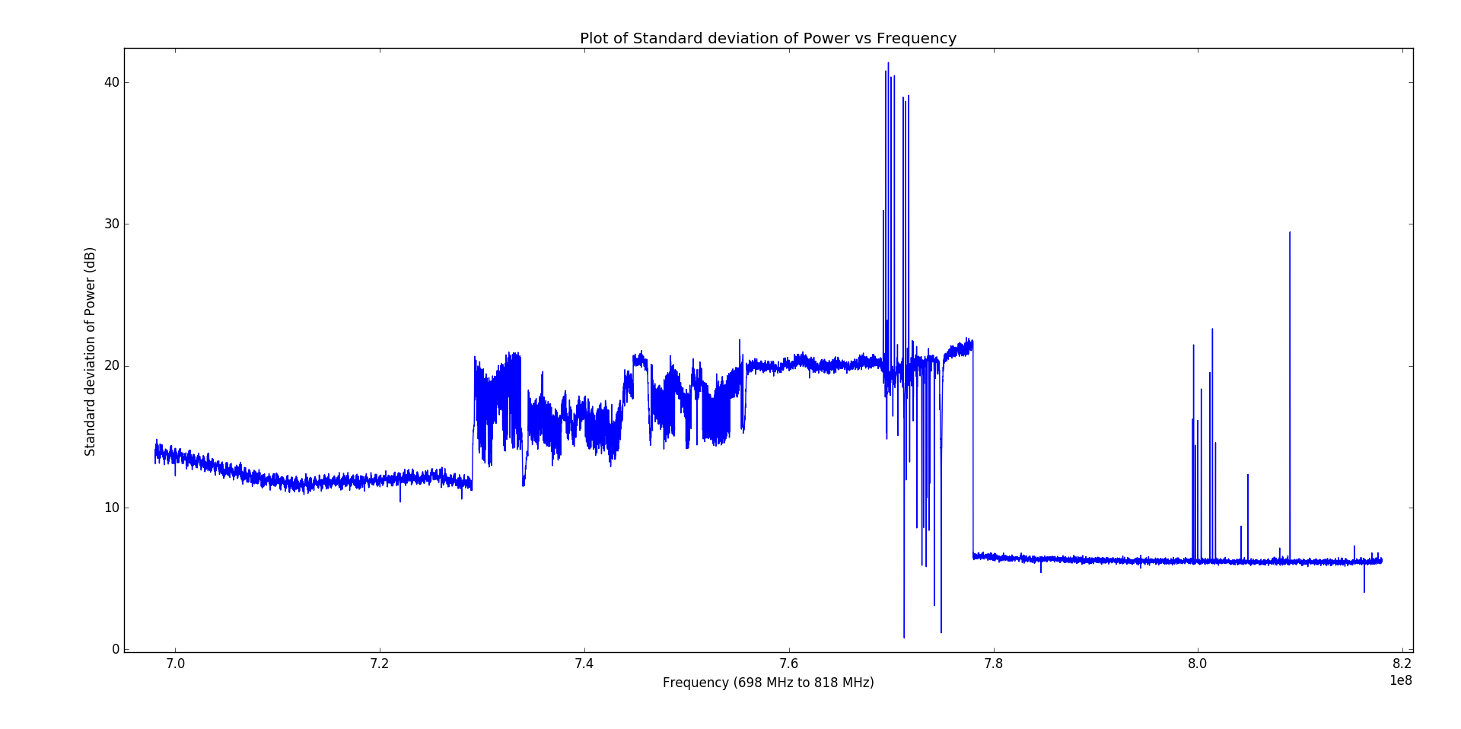

10. The peak power vs frequency graph obtained is as shown below.

