RaghavTheCyberdude

©TeraFlik | [teraflik.com](http://www.teraflik.com)

HANGMAN

Game



# Contents

Contents 2

Details 3

Synopses 3

Features 3

Execution 4

Requirements and Setup 5

System Requirements 5

Support 5

Source Code 6

Header Files 6

Classes and Objects 6

Functions 6

Code 8

Output 16

Possibilities for more 20

# Details

## Synopses

This project is an interesting game developed in the C++ language, based on the popular classic - Hangman.

User has to guess a secret word in a fixed number of guesses. He will be hanged if he cannot guess the letter in available chances.

With the option to select one level out of 5 available, the gameplay can be customized to fit the user’s wish. Help is also included in the game itself and a webpage (teraflik.com/p/hangman.html) has been developed for further assistance.

Development of this game consumed a great deal of work and dedication, but the results has proved to be fruitful.

## Features

Some features of the program are:

1. The console output of the program is presented in a neat and clean way.
2. Browsing through the user interface is easy and smooth.
3. User has the choice to select a difficulty level from: Very Easy, Easy, Moderate, Hard, and Extremely Hard.
4. The game is designed so that a word which has been asked, does not come up again, during a runtime.
5. There is a built-in help screen for users who are new to hangman.
6. Program comes bundled up with a big collection of country names.
7. User can easily add his own words and remove existing, due to the use of file handling.
8. The program uses many functions to make the transfer of control easier and hassle free.
9. The code has been written as per ANSI C++ standard, which makes it universally compatible.
10. This program is totally bug free and stable as suggested by results till date.
11. I have created a page on my website teraflik.com to provide support to this game, and also to provide updates.
12. Just visit: teraflik.com/p/hangman.html.

## Execution

The game starts with the main menu showing up where user can select his choice by entering the serial number corresponding to his choice.

If user starts the game then all the details about his level are shown, and a hidden word is displayed, asking him to input a guess. This guess is compared to the secret letters, where, if user gets it wrong, he loses a life, or if he guesses correctly, then the process is repeated again until the whole word is guessed.

From the menu, user can change his level and also see how to play the game.

# Requirements and Setup

## System Requirements

* OS - Microsoft Windows XP / 7 / 8 / 8.1 / 10
* RAM – 512 MB
* Free Hard Disk Space – 128 MB
* Internet Connection (for support, optional)

## Support

Visit <http://www.teraflik.com/p/hangman.html> for full-fledged support and to report any bugs or improvements needed.

Any kind of feedback is important for further development of program.

# Source Code

## Header Files

The following header files have been included in the program from the C++ Standard library collection. The functions used are also mentioned.



## Classes and Objects

A class named “WBank” with the following declaration has been used:



Object of the class WBank used is “Word” declared as follows:



## Functions

Several functions have been used in the program. Their prototypes are given below. Using functions makes the transfer of control easier and the same code doesn’t need to be repeated again and again in the program.



## Code

















# Output

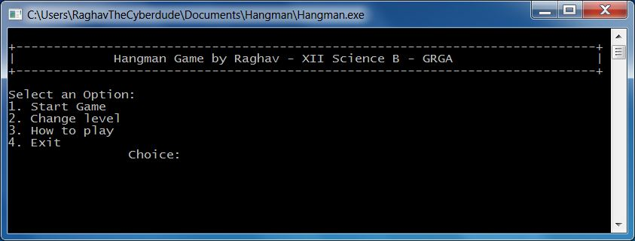

**Snapshot 1 - The Main Menu**

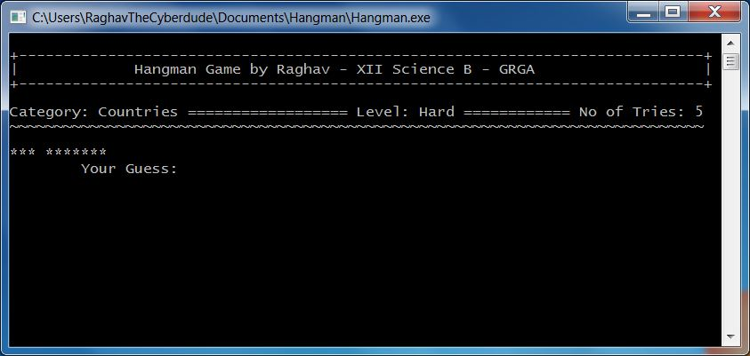

**Snapshot 2 - Starting the Game**

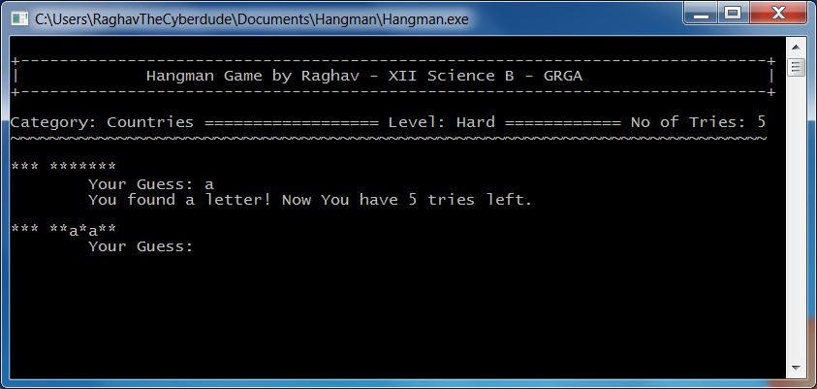

**Snapshot 3 - Guessing a letter correctly**

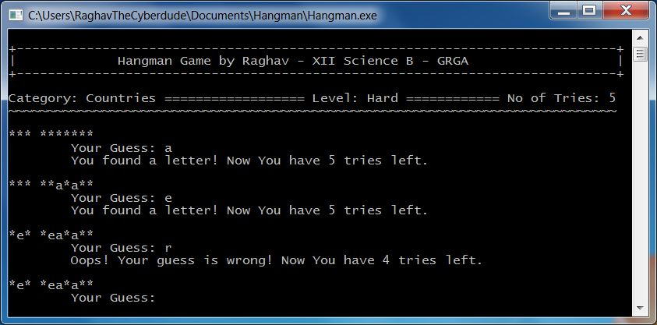

**Snapshot 4 - Guessing a letter wrong**

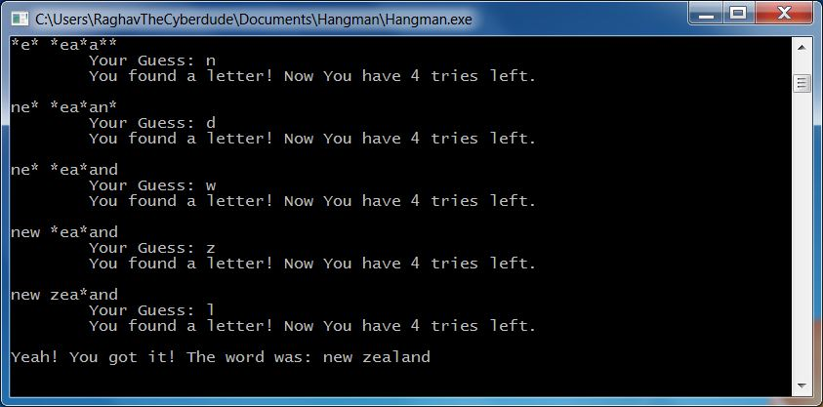

**Snapshot 5 - Finding the whole word**

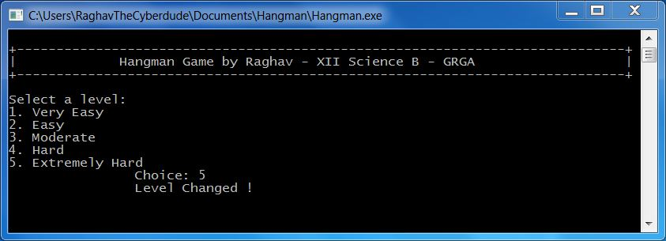

**Snapshot 6 - Selecting another level**

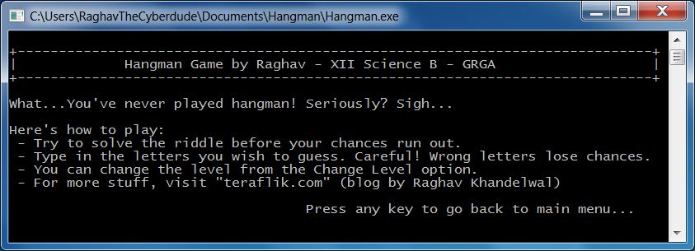

**Snapshot 7 - How to play option**

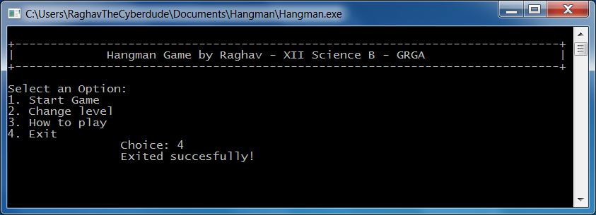

**Snapshot 8 - Exiting the game**

# Possibilities for more

Even after putting much efforts to get the game to its current level, there still remain some possibilities to do more. They can include:

* Allowing user to play the game in more categories of words.
* Displaying the characters already used up by the user.
* Using graphics to display the hangman, to make the game more appealing.

I hope to add these features in the game, in its process of further development.