Pattern Recognition and Computer Vision PROJECT
Plant Foliar Disease Diagnosis & AI Benchmarking
Comparative Evaluation of Handcrafted Features (HOG + HSV + LBP), Custom Lightweight CNN, and ResNet18 Transfer Learning on Leakage-Safe Splits

Aim:
Automated multi-class diagnosis of agricultural crop diseases from foliar photographs using classical pattern recognition (HOG, HSV color, LBP texture with RBF-SVM), custom lightweight deep learning (SmallCNN from scratch), and deep transfer learning (ResNet18) evaluated on a verified, leak-free test partition.

Objective:
To accurately detect and classify nine target plant-health conditions across five economically vital crops (Apple, Blueberry, Corn, Grape, and Bell Pepper) without cloud dependency; to eliminate optimistic test bias by preventing data leakage through perceptual hash clustering; to benchmark classification accuracy against inference latency, model parameter counts, and disk footprints on CPU hardware; and to deploy a real-time, offline multi-page Streamlit application providing visual confidence rankings and actionable agronomic disease cards.

Theory:
- Dataset Characteristics: The PlantVillage dataset contains 10,209 validated leaf images across 9 classes, representing healthy and diseased Apple, Blueberry, Corn, Grape and Pepper plants.
- Data Leakage Prevention: Perceptual hashing (pHash) identifies near-duplicate images. Similar images are grouped using Union-Find and split into training, validation and testing sets (70:15:15) to prevent data leakage.
- Feature Extraction: Images are resized to 128×128 pixels. HOG extracts edge features, HSV histograms capture colour variations, and LBP identifies texture patterns. The combined 8,232-dimensional features are standardized and reduced using PCA.
- Models Evaluated:
  - RBF-SVM: Classifies images using handcrafted features.
  - SmallCNN: Learns disease patterns through convolutional layers.
  - ResNet18: Uses ImageNet-pretrained weights and fine-tuning for classification.
- Evaluation Metrics: Models are evaluated using accuracy, precision, recall, Macro-F1, Weighted-F1, confusion matrix, inference time and model size.

Methodology:
- Virtual Environment Setup: Configured isolated Python 3.11 environment with PyTorch, Torchvision, Scikit-learn, Scikit-image, OpenCV, Pillow, Pandas, and Streamlit.
- Data Integrity Ingestion: Walked class folders, performed Pillow verify() checks, and tabulated image counts and dimensions.
- Perceptual Hash Clustering: Computed 64-bit pHash vectors, built sliding-window Hamming distance clusters (threshold ≤ 10), and assigned disjoint group IDs.
- Leakage-Free Stratified Splitting: Executed two rounds of GroupShuffleSplit to yield 7,072 Train (70%), 1,622 Validation (15%), and 1,515 Test (15%) images.
- Handcrafted Feature Extraction & Caching: Extracted HOG, HSV, and LBP descriptors, saved precomputed matrices (train_X.npy, val_X.npy, test_X.npy) to bypass repeated disk I/O.
- Data Augmentation: Applied random horizontal flip (p=0.5), vertical flip (p=0.2), random rotation (±15°), and gentle brightness/contrast jitter (0.2). Hue jitter was intentionally omitted as color is a diagnostic disease indicator.
- Traditional SVM Training: Executed 3-fold GridSearchCV over C ∈ {0.1, 1, 10, 100} and γ ∈ {scale, auto, 1e-3, 1e-4} on a 150-image/class stratified subsample; refit best estimator (C=100.0, γ=0.0001) on the full training set.
- Deep Learning Training Schedule: Optimized using Adam, Cross-Entropy Loss, ReduceLROnPlateau scheduler (patience=2, factor=0.5), and Early Stopping (patience=3). SmallCNN was trained for 8 epochs (lr=1e-3); ResNet18 was fine-tuned across 2 stages (Stage 1: head only at lr=1e-3 for 2 epochs; Stage 2: layer4 + head at lr=1e-4 for 5 epochs).
- Standardized Holdout Evaluation: Tested all three models on the identical 1,515 test images, recording accuracy, macro-F1, confusion matrices, and inference latency.
- Production Web Application: Built a multi-page Streamlit suite (Home, Detect, Models & Dataset, About) featuring real-time inference, model comparisons, and agronomic pathology cards.
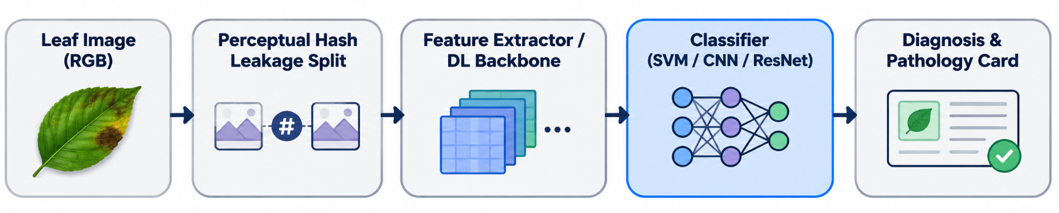
Fig. 1: End-to-end Machine Learning Pipeline: Perceptual Hash clustering for leakage prevention, dual feature branches (Handcrafted HOG+HSV+LBP vs. Deep Learning), and offline Streamlit deployment.

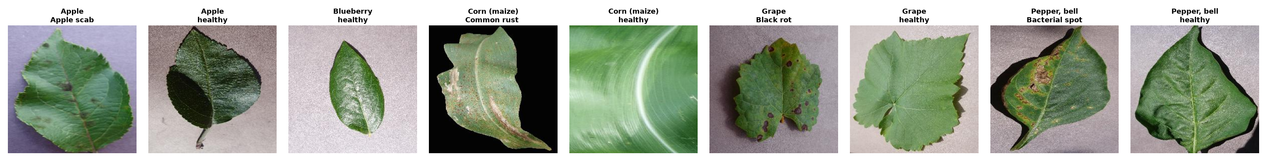
Fig. 2: Representative foliar samples from the nine target PlantVillage categories (healthy and diseased states for Apple, Blueberry, Corn, Grape, and Bell Pepper).

Real-Time Application & System Architecture:
- Model Caching & Memory Efficiency: Models are instantiated once via @st.cache_resource, enabling instantaneous switching between SVM, SmallCNN, and ResNet18 without reloading overhead.
- Unified Inference Pipeline: Reuses the identical validation transforms and normalization parameters through src.predict.predict_image(), returning predicted class, confidence, top-3 distribution, and execution latency.
- Handcrafted Feature Visualizer: Features a real-time HOG gradient map generator allowing users and students to inspect the edge orientation structures extracted from leaves during the live lab demo.
- Multi-Model Comparative Mode: Executes all three models side-by-side on a single uploaded leaf, comparing prediction consensus and confidence margins.
- Agricultural Pathology Database: Integrates app/disease_info.json containing pathogen taxonomy, visual symptomatology, chemical and cultural preventative recommendations, and educational disclaimers.

Diagnostic Application Interface:
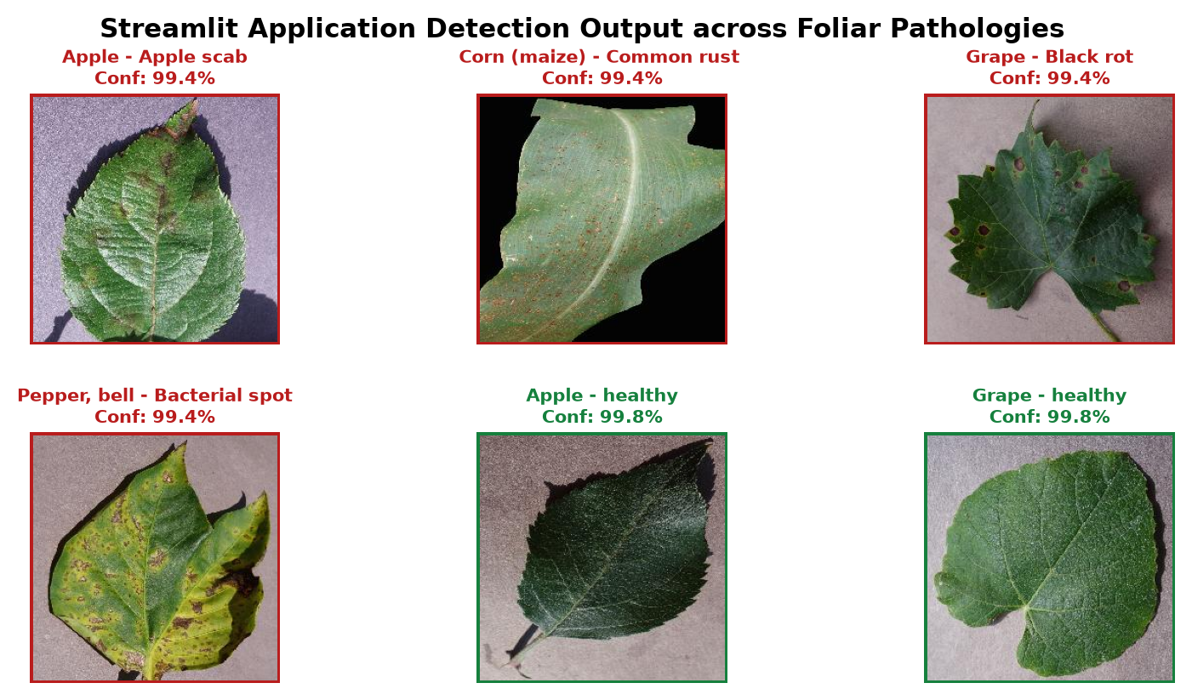
Fig. 3: Interactive Streamlit Diagnostic Interface: Real-time leaf upload, model selector (Single or 3-way comparison), confidence gauge, top-3 class distribution, and agricultural pathology advice card.

Output & Benchmark Results:
Table 1: Comprehensive benchmark results evaluated on the identical 1,515 holdout test images across all three models. Metrics reflect uncorrupted leaf images partitioned via perceptual hash clustering.
Model | Paradigm | Test Acc | Macro-F1 | Weighted-F1 | Precision | Recall | Latency | Disk Size
RBF-SVM | HOG+HSV+LBP (PCA) | 87.46% | 0.8665 | 0.8749 | 0.8687 | 0.8664 | 10.67 ms | 158.5 MB
SmallCNN | Custom CNN (Scratch) | 96.17% | 0.9630 | 0.9619 | 0.9639 | 0.9626 | 10.70 ms | 1.5 MB
ResNet18 | Two-Stage Transfer | 99.74% | 0.9967 | 0.9974 | 0.9969 | 0.9965 | 11.64 ms | 42.7 MB

Table 2: Computational complexity, parameter counts, training times, and resource profiles on local CPU hardware.
Model | Input Size | Total Parameters | Trainable Params | Training Time | Inference Latency
RBF-SVM | 128×128 (8,232-d) | 1,859 PCA components | 4,218 Support Vectors | 5.9 min (GridSearch + Fit) | 10.67 ms / image
SmallCNN | 128×128×3 RGB | 391,209 parameters | 391,209 (100%) | 7.9 min (8 epochs) | 10.70 ms / image
ResNet18 | 160×160×3 RGB | 11,181,129 parameters | 8,398,345 (Stage 2) | 8.4 min (2 + 5 epochs) | 11.64 ms / image

Diagnostic Analysis & Learning Curves:
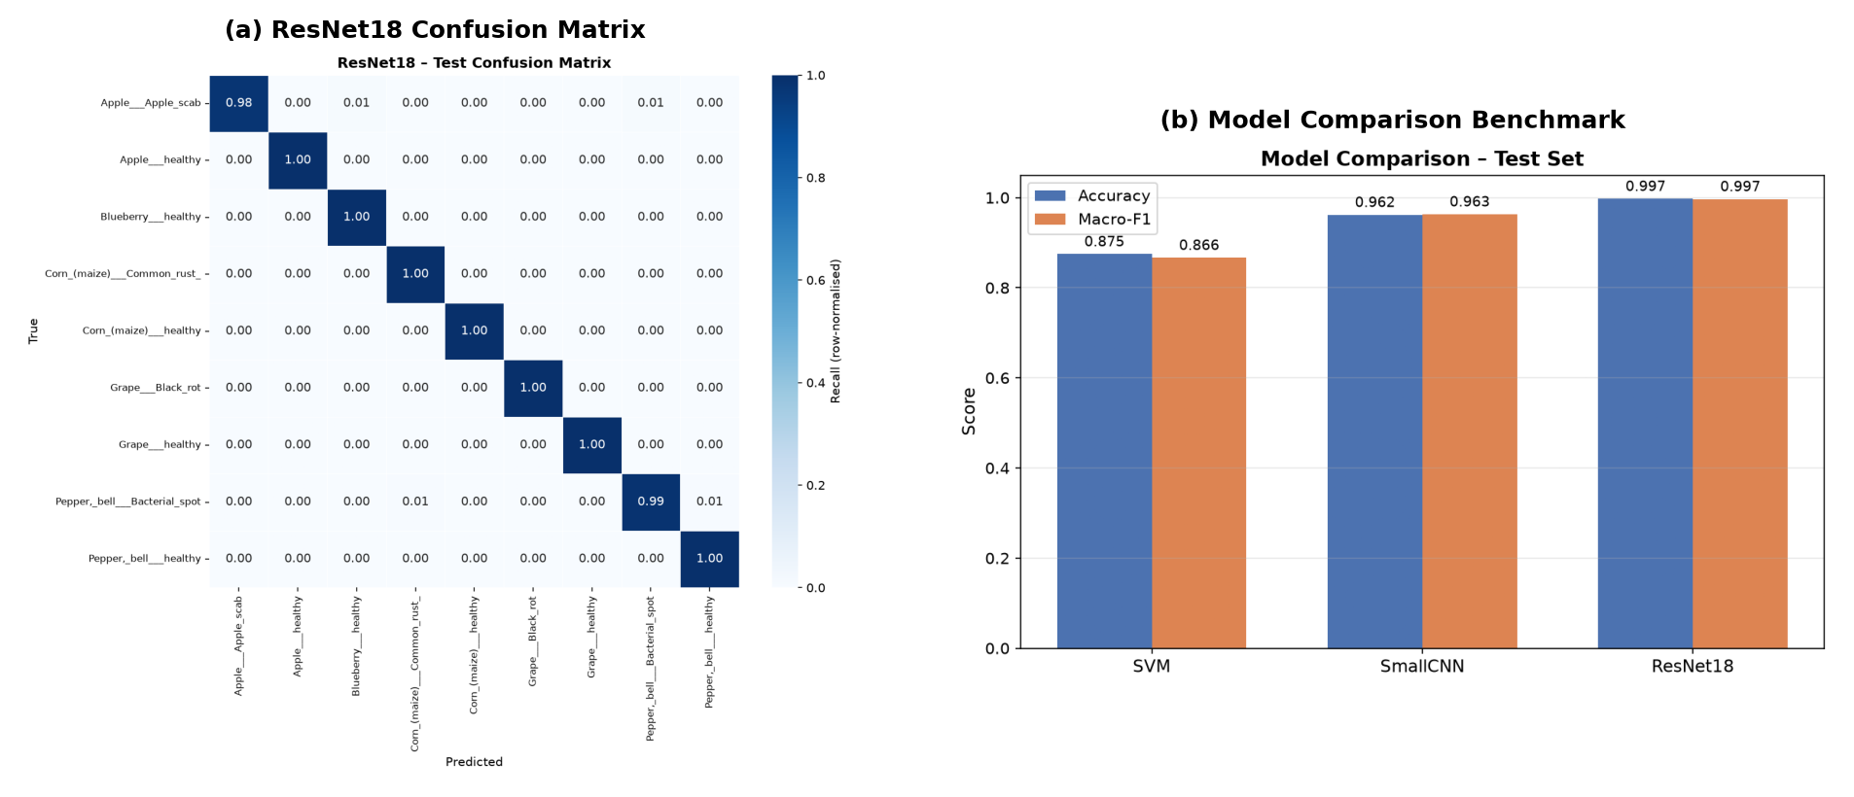
Fig. 4: Quantitative evaluation on the 1,515 test images: (Left) Accuracy and Macro-F1 comparison; (Right) Row-normalized confusion matrices for ResNet18, SmallCNN, and SVM showing classification precision across all 9 classes.
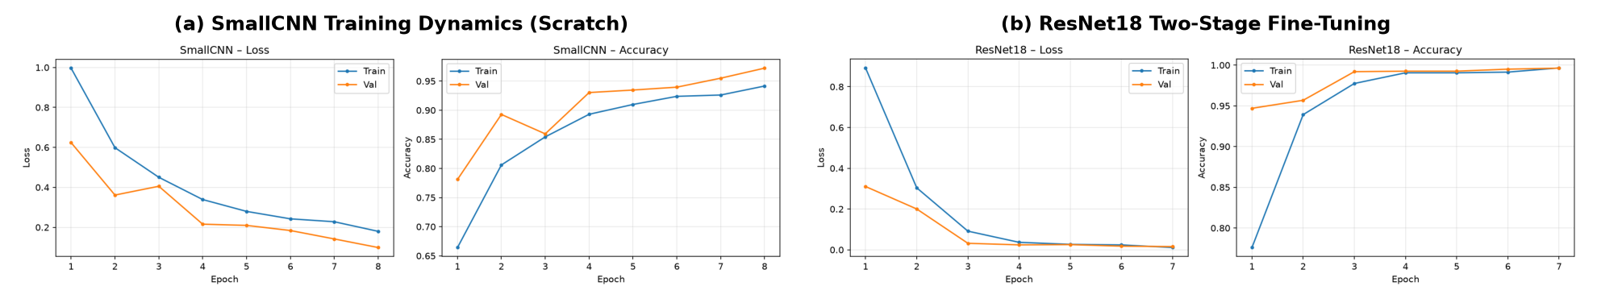
Fig. 5: Optimization dynamics across training epochs: (Left) SmallCNN trained from scratch converging steadily by epoch 8; (Right) ResNet18 two-stage fine-tuning achieving rapid validation loss reduction below 0.02.

Results & Discussion:
- Transfer Learning Dominance (ResNet18): ResNet18 achieved the best performance, with only 4 misclassifications out of 1,515 test images, resulting in 99.74% accuracy and 0.9967 macro-F1. Two-stage fine-tuning, involving classifier head warmup followed by unfreezing layer4, enabled effective adaptation to leaf disease patterns.
- Parameter Efficiency (SmallCNN): SmallCNN achieved 96.17% accuracy with just 391,209 parameters and a 1.5 MB model size. It requires 28× less storage than ResNet18 (42.7 MB) and 105× less than SVM (158.5 MB), while maintaining approximately 10.7 ms CPU inference latency, making it suitable for resource-constrained devices.
- Handcrafted Feature Performance (SVM): SVM achieved 87.46% accuracy. HOG, HSV and LBP features effectively distinguished distinct disease patterns but struggled with subtle variations, such as early Apple Scab lesions versus minor leaf abrasions.
- Training Convergence: SmallCNN showed steady improvement, with validation accuracy increasing from 78.1% (Epoch 1) to 97.2% (Epoch 8). ResNet18 converged faster, achieving 95.7% accuracy in Stage 1 (2 epochs) and 99.63% validation accuracy in Stage 2, with validation loss reaching 0.0157.

Qualitative Error Analysis & Class Distributions:
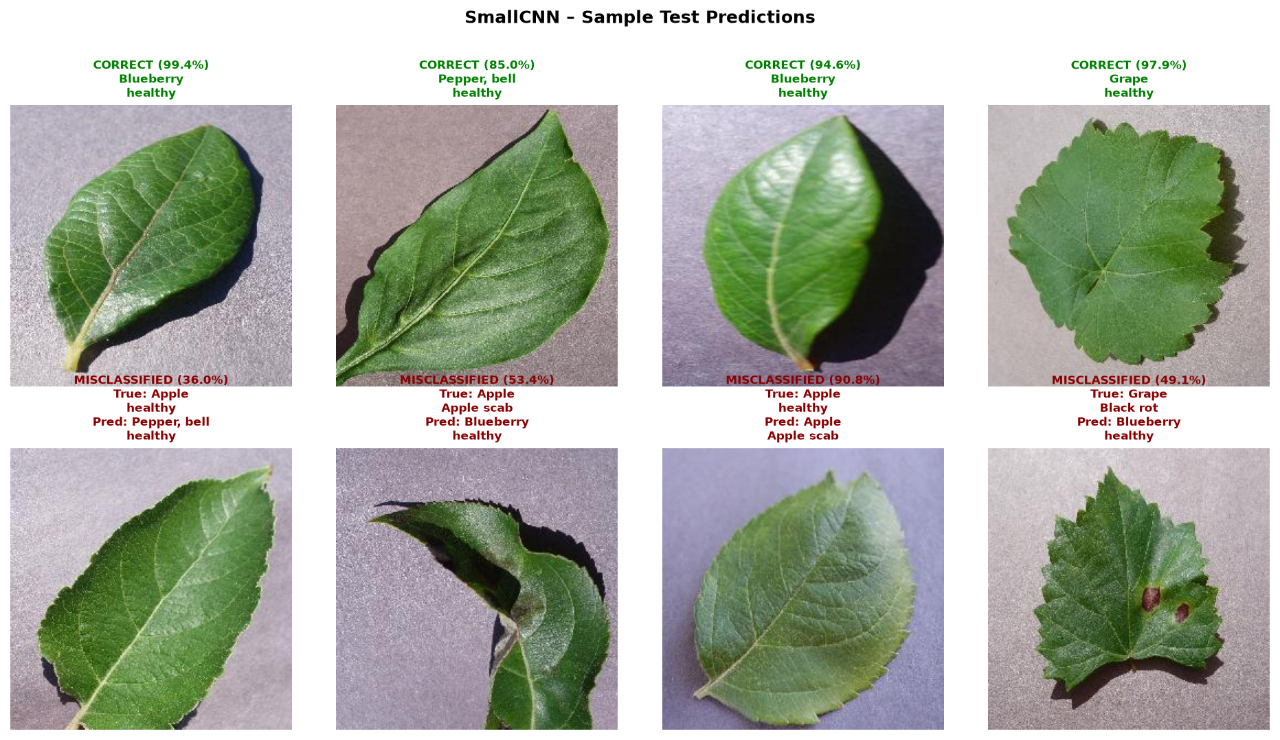
Fig. 6: Qualitative test predictions: Top row shows high-confidence correct classifications across diverse crops; Bottom row highlights edge-case misclassifications with true vs. predicted labels.
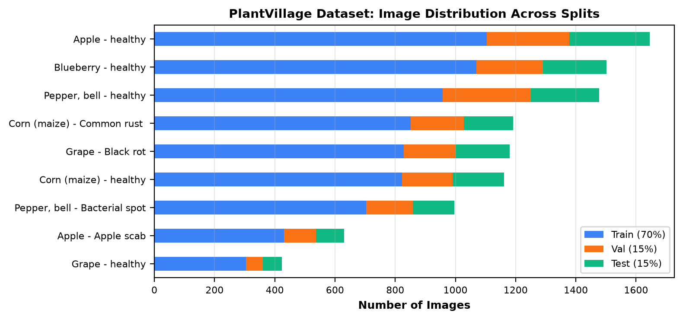
Fig. 7: Class balance and stratified split distribution across Train (70%), Validation (15%), and Test (15%) partitions with zero perceptual hash leakage.

Learning Outcomes:
- Developed an end-to-end plant disease detection system using HOG, HSV, LBP, PCA, SVM, CNN and ResNet18, including data preprocessing and model optimization.
- Prevented data leakage using pHash and Union-Find clustering; built an offline Streamlit diagnostic application with automated Pytest testing.

References:
- Hughes, D., & Salathé, M. (2015). An open access repository of images on plant health to enable mobile diagnostics. arXiv:1511.08060.
- Dalal, N., & Triggs, B. (2005). Histograms of oriented gradients for human detection. IEEE CVPR, 886-893.
- Ojala, T., et al. (2002). Multiresolution gray-scale and rotation invariant texture classification with local binary patterns. IEEE TPAMI, 24(7), 971-987.
- He, K., Zhang, X., Ren, S., & Sun, J. (2016). Deep residual learning for image recognition. IEEE CVPR, 770-778.
- Singh, D., et al. (2020). PlantDoc: A Dataset for Visual Plant Disease Detection in the Wild. ACM CoNEXT, 249-256.

