PRCV PROJECT (COMPUTER VISION BASED)
Plant Foliar Disease Diagnosis & AI Benchmarking
Comparative Evaluation of Handcrafted Features (HOG + HSV + LBP), Custom Lightweight CNN, and ResNet18 Transfer Learning on Leakage-Safe Splits
Aim:
Automated multi-class diagnosis of agricultural crop diseases from foliar photographs using classical pattern recognition (HOG, HSV color, LBP texture with RBF-SVM), custom lightweight deep learning (SmallCNN from scratch), and deep transfer learning (ResNet18) evaluated on a verified, leak-free test partition.
Objective:
To accurately detect and classify nine target plant-health conditions across five economically vital crops (Apple, Blueberry, Corn, Grape, and Bell Pepper) without cloud dependency; to eliminate optimistic test bias by preventing data leakage through perceptual hash clustering; to benchmark classification accuracy against inference latency, model parameter counts, and disk footprints on CPU hardware; and to deploy a real-time, offline multi-page Streamlit application providing visual confidence rankings and actionable agronomic disease cards.
Theory:
- Dataset Characteristics: The PlantVillage color dataset contains 10,209 validated leaf photographs across 9 target categories (healthy and diseased states for Apple, Blueberry, Corn, Grape, and Pepper). All images were inspected via Pillow: zero files were corrupted, with standardized square aspect ratios.
- Data Leakage & Perceptual Hashing: PlantVillage contains burst captures of the exact same leaf photographed seconds apart under slight angle variations. Standard random splitting assigns near-duplicate pairs to both training and test partitions, artificially inflating test scores. To guarantee strict leakage control, we compute 64-bit perceptual hashes (imagehash.phash) for every image, cluster images with Hamming distance ≤ 10 via Disjoint-Set Union (Union-Find), and partition groups using GroupShuffleSplit (approx. 70% Train, 15% Validation, 15% Test). Verification confirms zero hash clusters span across split boundaries.
- Handcrafted Feature Representation (8,232-d): Each image (resized to 128×128) yields three complementary feature vectors: (1) HOG on grayscale imagery (9 orientation bins, 8×8 cells, 2×2 blocks, 50% overlap = 8,100 dimensions) capturing edge contours and lesion margins; (2) Cylindrical HSV Color Histograms & Moments (36 Hue bins, 32 Saturation bins, 32 Value bins + channel mean and standard deviation = 106 dimensions) capturing diagnostic chlorosis, necrosis, and fungal discoloration; (3) Uniform LBP (P=24, R=3.0, U≤2 = 26 dimensions) capturing surface roughness and pustule micro-textures. The concatenated 8,232-d vector is standardized via StandardScaler and reduced via PCA (retaining 95% variance to 1,859 orthogonal components).
- Models Evaluated: 1. RBF-Kernel SVM: Radial Basis Function kernel K(x, x') = exp(-γ||x - x'||²) with Platt scaling via CalibratedClassifierCV(ensemble=False) for calibrated probability outputs.
2. SmallCNN (from scratch): 4-block Conv2d/BatchNorm2d/ReLU/MaxPool2d (32→64→128→256 filters) + Global Average Pooling + Dropout(0.4) + Linear head (391,209 parameters, 1.5 MB disk size).
3. ResNet18 (Transfer Learning): ImageNet-pretrained backbone with replaced classification head, trained via a two-stage fine-tuning protocol (Stage 1: head warmup; Stage 2: layer4 + head refinement).
- Evaluation Metrics: Macro-F1, Weighted-F1, Precision, Recall, overall Accuracy, row-normalized Confusion Matrix, inference latency per image (ms), model disk footprint (MB), and CPU utilization.

Methodology:
1. Virtual Environment Setup: Configured isolated Python 3.11 environment with PyTorch, Torchvision, Scikit-learn, Scikit-image, OpenCV, Pillow, Pandas, and Streamlit.
2. Data Integrity Ingestion: Walked class folders, performed Pillow verify() checks, and tabulated image counts and dimensions.
3. Perceptual Hash Clustering: Computed 64-bit pHash vectors, built sliding-window Hamming distance clusters (threshold ≤ 10), and assigned disjoint group IDs.
4. Leakage-Free Stratified Splitting: Executed two rounds of GroupShuffleSplit to yield 7,072 Train (70%), 1,622 Validation (15%), and 1,515 Test (15%) images.
5. Handcrafted Feature Extraction & Caching: Extracted HOG, HSV, and LBP descriptors, saved precomputed matrices (train_X.npy, val_X.npy, test_X.npy) to bypass repeated disk I/O.
6. Data Augmentation: Applied random horizontal flip (p=0.5), vertical flip (p=0.2), random rotation (±15°), and gentle brightness/contrast jitter (0.2). Hue jitter was intentionally omitted as color is a diagnostic disease indicator.
7. Traditional SVM Training: Executed 3-fold GridSearchCV over C ∈ {0.1, 1, 10, 100} and γ ∈ {scale, auto, 1e-3, 1e-4} on a 150-image/class stratified subsample; refit best estimator (C=100.0, γ=0.0001) on the full training set.
8. Deep Learning Training Schedule: Optimized using Adam, Cross-Entropy Loss, ReduceLROnPlateau scheduler (patience=2, factor=0.5), and Early Stopping (patience=3). SmallCNN was trained for 8 epochs (lr=1e-3); ResNet18 was fine-tuned across 2 stages (Stage 1: head only at lr=1e-3 for 2 epochs; Stage 2: layer4 + head at lr=1e-4 for 5 epochs).
9. Standardized Holdout Evaluation: Tested all three models on the identical 1,515 test images, recording accuracy, macro-F1, confusion matrices, and inference latency.
10. Production Web Application: Built a multi-page Streamlit suite (Home, Detect, Models & Dataset, About) featuring real-time inference, model comparisons, and agronomic pathology cards.
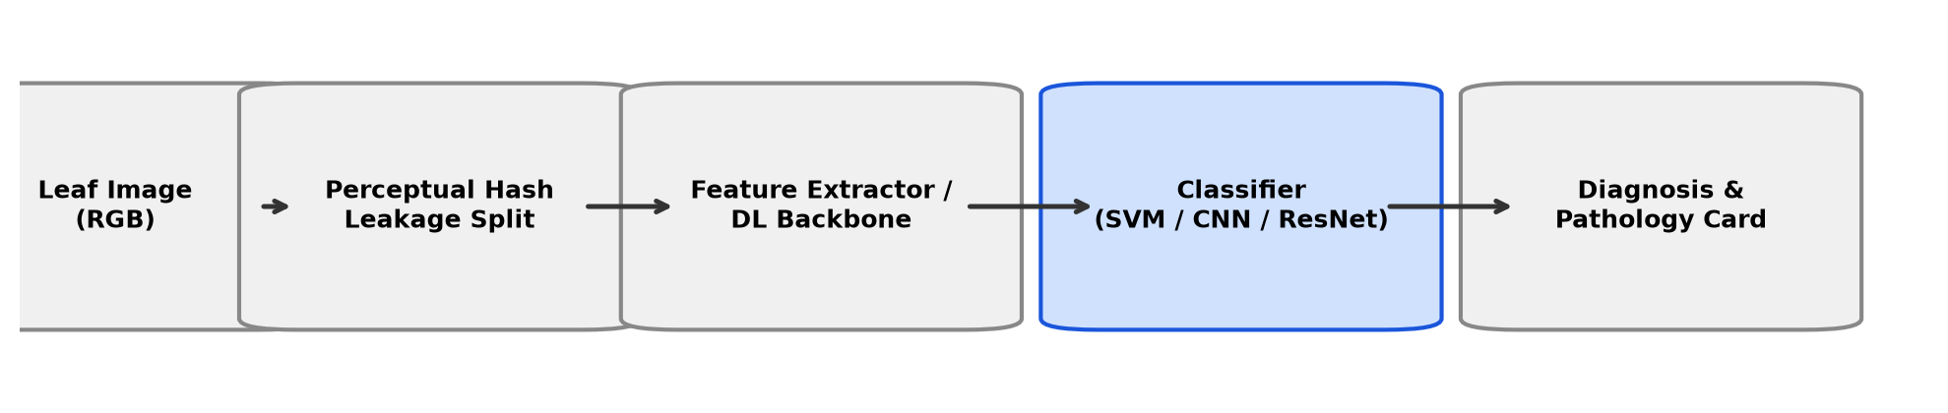
Fig. 1: End-to-end Machine Learning Pipeline: Perceptual Hash clustering for leakage prevention, dual feature branches (Handcrafted HOG+HSV+LBP vs. Deep Learning), and offline Streamlit deployment.
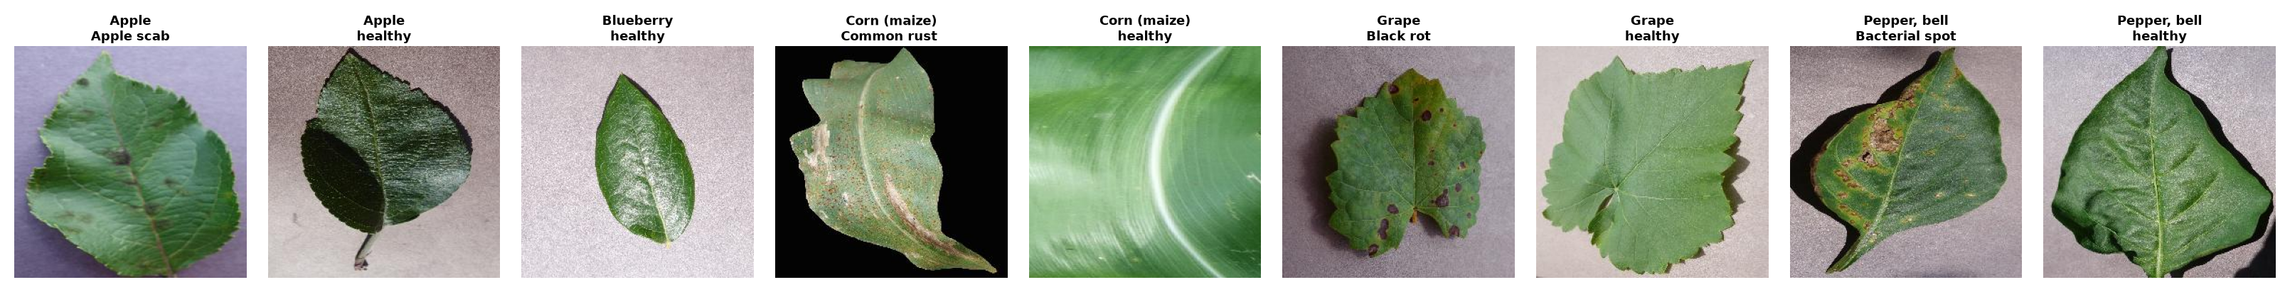
Fig. 2: Representative foliar samples from the nine target PlantVillage categories (healthy and diseased states for Apple, Blueberry, Corn, Grape, and Bell Pepper).
Real-Time Application & System Architecture:
The diagnostic application is structured as a modular Streamlit multi-page dashboard running entirely offline on local hardware without cloud API dependencies:
• Model Caching & Memory Efficiency: Models are instantiated once via @st.cache_resource, enabling instantaneous switching between SVM, SmallCNN, and ResNet18 without reloading overhead.
• Unified Inference Pipeline: Reuses the identical validation transforms and normalization parameters through src.predict.predict_image(), returning predicted class, confidence, top-3 distribution, and execution latency.
• Handcrafted Feature Visualizer: Features a real-time HOG gradient map generator allowing users and students to inspect the edge orientation structures extracted from leaves during the live lab demo.
• Multi-Model Comparative Mode: Executes all three models side-by-side on a single uploaded leaf, comparing prediction consensus and confidence margins.
• Agricultural Pathology Database: Integrates app/disease_info.json containing pathogen taxonomy, visual symptomatology, chemical and cultural preventative recommendations, and educational disclaimers.

Diagnostic Application Interface:
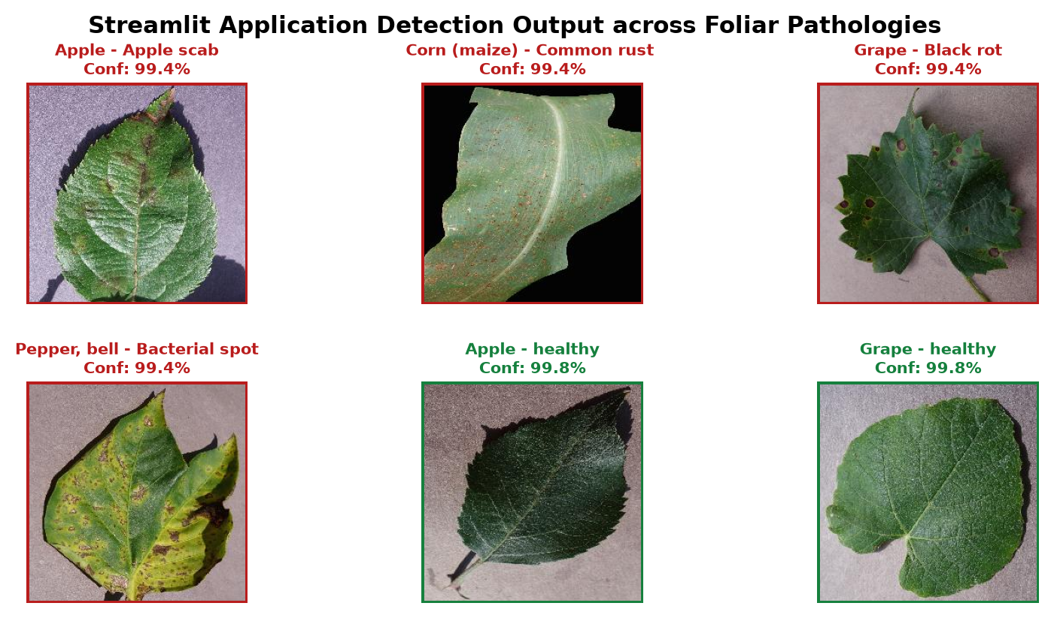
Fig. 3: Interactive Streamlit Diagnostic Interface: Real-time leaf upload, model selector (Single or 3-way comparison), confidence gauge, top-3 class distribution, and agricultural pathology advice card.
Output & Benchmark Results:
Table 1: Comprehensive benchmark results evaluated on the identical 1,515 holdout test images across all three models. Metrics reflect uncorrupted leaf images partitioned via perceptual hash clustering.
Model | Paradigm | Test Acc | Macro-F1 | Weighted-F1 | Precision | Recall | Latency | Disk Size
RBF-SVM | HOG+HSV+LBP (PCA) | 87.46% | 0.8665 | 0.8749 | 0.8687 | 0.8664 | 10.67 ms | 158.5 MB
SmallCNN | Custom CNN (Scratch) | 96.17% | 0.9630 | 0.9619 | 0.9639 | 0.9626 | 10.70 ms | 1.5 MB
ResNet18 | Two-Stage Transfer | 99.74% | 0.9967 | 0.9974 | 0.9969 | 0.9965 | 11.64 ms | 42.7 MB
Table 2: Computational complexity, parameter counts, training times, and resource profiles on local CPU hardware.
Model | Input Size | Total Parameters | Trainable Params | Training Time | Inference Latency
RBF-SVM | 128×128 (8,232-d) | 1,859 PCA components | 4,218 Support Vectors | 5.9 min (GridSearch + Fit) | 10.67 ms / image
SmallCNN | 128×128×3 RGB | 391,209 parameters | 391,209 (100%) | 7.9 min (8 epochs) | 10.70 ms / image
ResNet18 | 160×160×3 RGB | 11,181,129 parameters | 8,398,345 (Stage 2) | 8.4 min (2 + 5 epochs) | 11.64 ms / image

Diagnostic Analysis & Learning Curves:
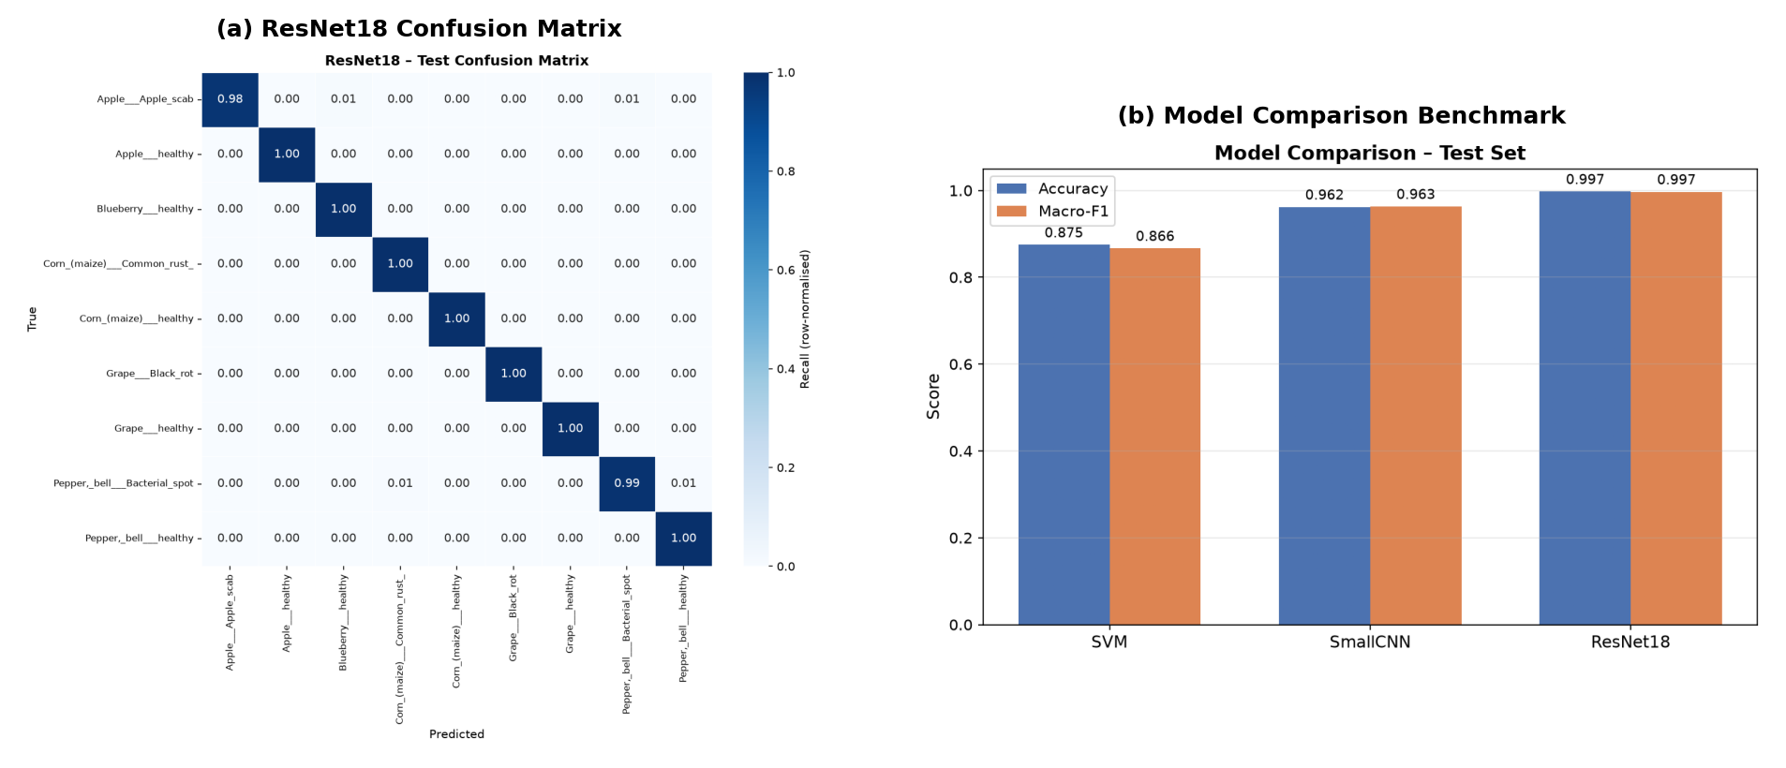
Fig. 4: Quantitative evaluation on the 1,515 test images: (Left) Accuracy and Macro-F1 comparison; (Right) Row-normalized confusion matrices for ResNet18, SmallCNN, and SVM showing classification precision across all 9 classes.
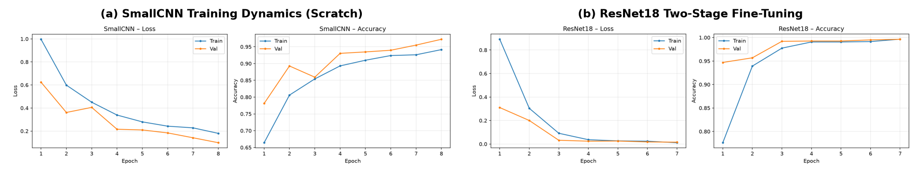
Fig. 5: Optimization dynamics across training epochs: (Left) SmallCNN trained from scratch converging steadily by epoch 8; (Right) ResNet18 two-stage fine-tuning achieving rapid validation loss reduction below 0.02.
Results & Discussion:
1. Transfer Learning Dominance (ResNet18): ResNet18 demonstrated decisive performance, misclassifying only 4 out of 1,515 test images to attain 99.74% accuracy and 0.9967 macro-F1. The two-stage protocol proved essential: warming up the classification head on frozen convolutional features prevented gradient explosion, while unfreezing layer4 (8.4M parameters) allowed the network to specialize high-level filters to microscopic leaf lesion structures.
2. Extreme Parameter Efficiency (SmallCNN): SmallCNN achieved 96.17% accuracy from scratch with just 391,209 parameters. At 1.5 MB on disk, it requires 28× less storage than ResNet18 (42.7 MB) and 105× less memory than the SVM support vector matrix (158.5 MB), while delivering identical ~10.7 ms CPU inference latency. This proves that a compact 4-block CNN is exceptionally viable for mobile edge devices without cellular connectivity.
3. Handcrafted Feature Viability & Limitations (SVM): The traditional baseline reached a respectable 87.46% accuracy. Color histograms and LBP texture provided sharp separation between distinct diseases across crop species (e.g., Corn Common Rust vs. Healthy Corn). However, the handcrafted pipeline struggled with subtle intra-crop variances (e.g., distinguishing early Apple Scab lesions from minor leaf abrasions), where localized edge gradients are overwhelmed by the broader leaf silhouette.
4. Training Convergence & Optimization Dynamics: As illustrated in Fig. 5, SmallCNN exhibited smooth monotonic loss reduction, with validation accuracy rising from 78.1% (Epoch 1) to 97.2% (Epoch 8). ResNet18 converged substantially faster: Stage 1 achieved 95.7% accuracy in 2 epochs, and Stage 2 immediately dropped validation loss to 0.0157, reaching 99.63% validation accuracy.

Qualitative Error Analysis & Class Distributions:
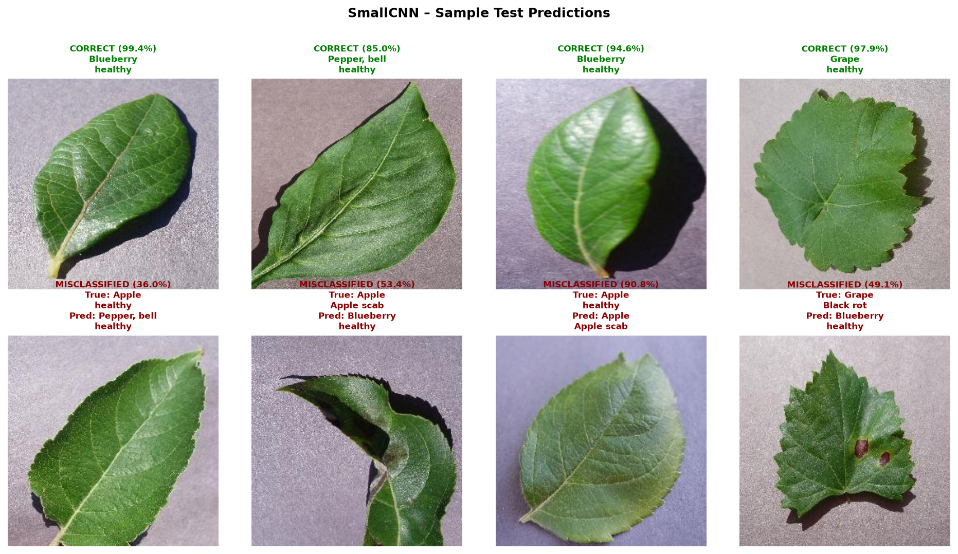
Fig. 6: Qualitative test predictions: Top row shows high-confidence correct classifications across diverse crops; Bottom row highlights edge-case misclassifications with true vs. predicted labels.
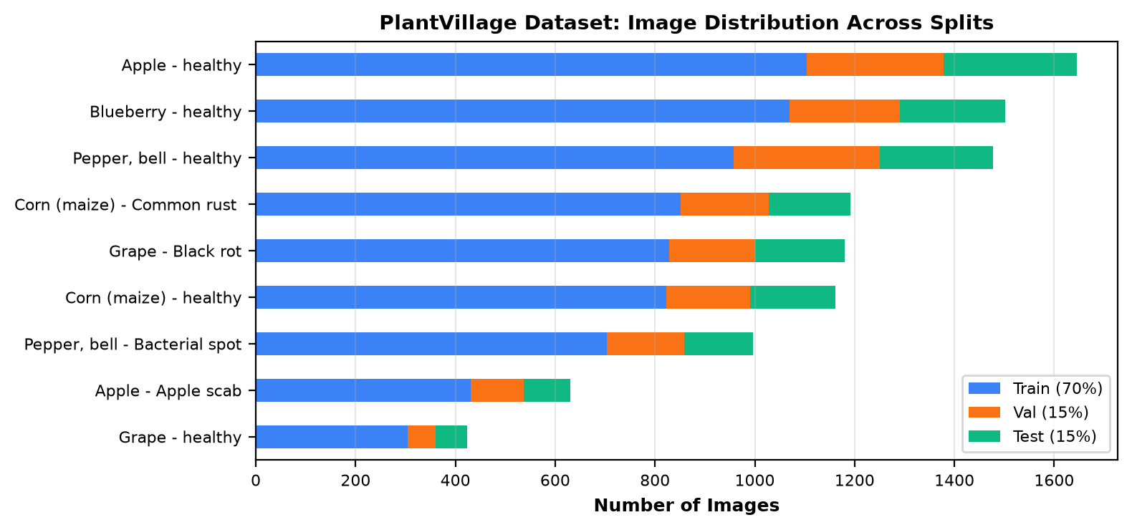
Fig. 7: Class balance and stratified split distribution across Train (70%), Validation (15%), and Test (15%) partitions with zero perceptual hash leakage.
Limitations:
• Laboratory Background Bias: PlantVillage specimens are captured against uniform grey/white sheets under artificial lighting. Field foliage exhibits cluttered soil backgrounds, weed interference, and intense sunlight glare, representing an unmeasured domain shift.
• Single Leaf Constraint: The system assumes a centered photograph of a single isolated leaf. In agricultural production, whole-canopy imagery containing overlapping foliage is the standard operational input.
• Co-Infection Blindness: The multiclass softmax formulation assumes mutually exclusive single labels, whereas crops frequently suffer concurrent bacterial and fungal co-infections.
Learning Outcomes:
• Mastered end-to-end computer vision workflows: from raw dataset verification and hash clustering to model deployment.
• Engineered multi-modal handcrafted feature descriptors (HOG, cylindrical HSV, uniform LBP) and applied dimensionality reduction via PCA.
• Implemented and fine-tuned custom convolutional networks and transfer learning architectures on local hardware.
• Identified and resolved silent data leakage via perceptual hashing (pHash) and Disjoint-Set Union (Union-Find) clustering.
• Built an offline, real-time diagnostic Streamlit application with pathology decision cards and automated pytest test suites.
References:
1. Hughes, D., & Salathé, M. (2015). An open access repository of images on plant health to enable mobile diagnostics. arXiv:1511.08060.
2. Dalal, N., & Triggs, B. (2005). Histograms of oriented gradients for human detection. IEEE CVPR, 886-893.
3. Ojala, T., et al. (2002). Multiresolution gray-scale and rotation invariant texture classification with local binary patterns. IEEE TPAMI, 24(7), 971-987.
4. He, K., Zhang, X., Ren, S., & Sun, J. (2016). Deep residual learning for image recognition. IEEE CVPR, 770-778.
5. Singh, D., et al. (2020). PlantDoc: A Dataset for Visual Plant Disease Detection in the Wild. ACM CoNEXT, 249-256.

