**IVT (Invalid Traffic) Analysis Report**

**1. Executive Summary**

* **Objective:** Analyze ad request traffic for 3 "Valid" and 3 "Invalid" apps, identify key patterns, and provide recommendations for fraud detection.
* **Dataset:** September 11-15, 2025 | Aggregated data at daily and hourly granularity, including device, IP, User-Agent, and traffic metrics.

**2. Data Preparation**

* **Loaded sheets:** Valid 1, Valid 2, Valid 3, Invalid 1, Invalid 2, Invalid 3
* **Metrics analyzed:**
  + IVT (Invalid Traffic ratio)
  + Requests per device (IDFA)
  + Impressions
  + IDFA-to-User-Agent ratio (devices per UA)
  + IDFA-to-IP ratio (devices per IP)

**3. Graphical Analysis**

**A. IVT Evolution Timeline: Valid vs Invalid Apps**

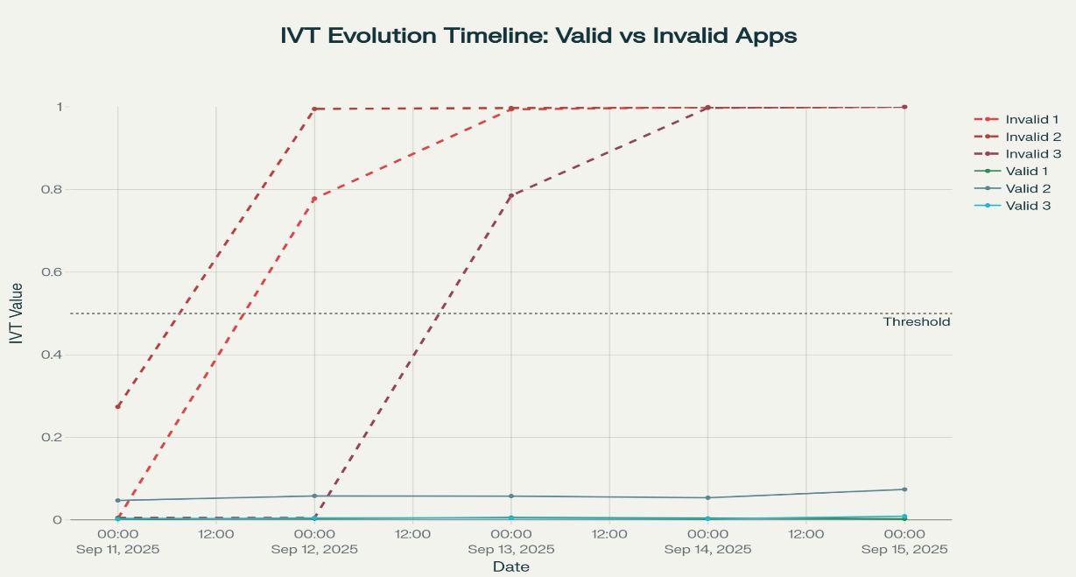

* **Observation:** Invalid apps show sudden spikes in IVT (Invalid 1&2: Sept 12, Invalid 3: Sept 13). Valid apps maintain stable, low IVT (<6%).

**B. Key Metrics Bar Comparison**

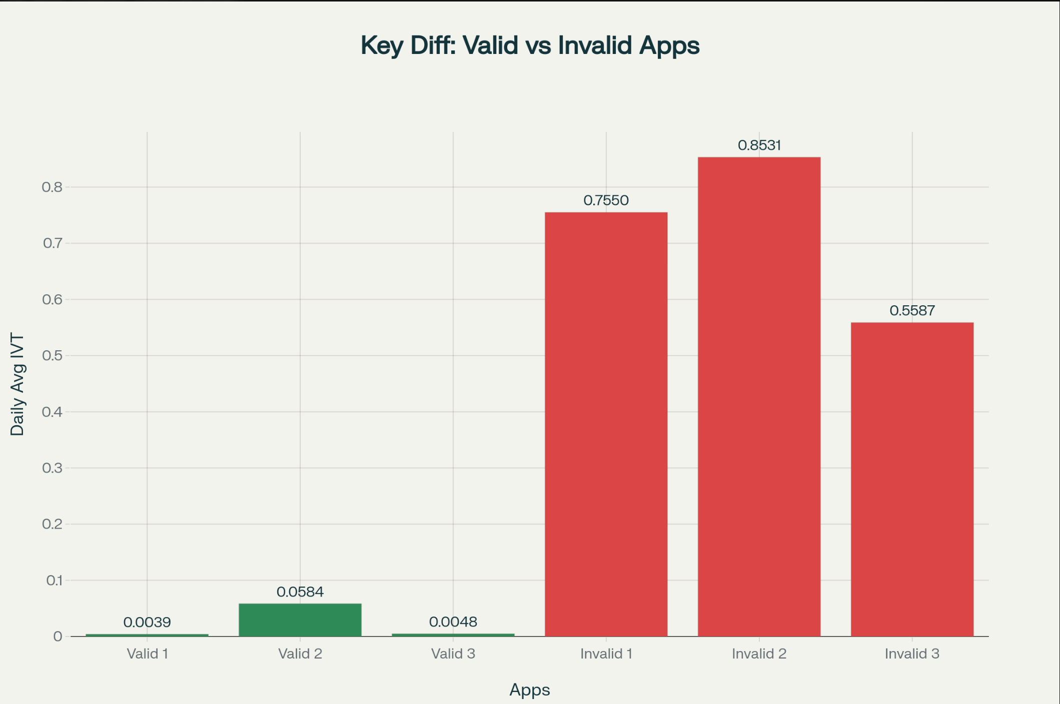

* **IVT:** Invalid apps average 72.2% IVT (vs. 2.2% for valid).
* **IDFA-to-UA ratio:** Valid apps cluster around 7,000 IDFAs/UA, invalid mostly below 700.
* **Requests per IDFA:** No significant difference between valid and invalid.

**C. IVT vs IDFA-to-UA Ratio Scatter Plot**

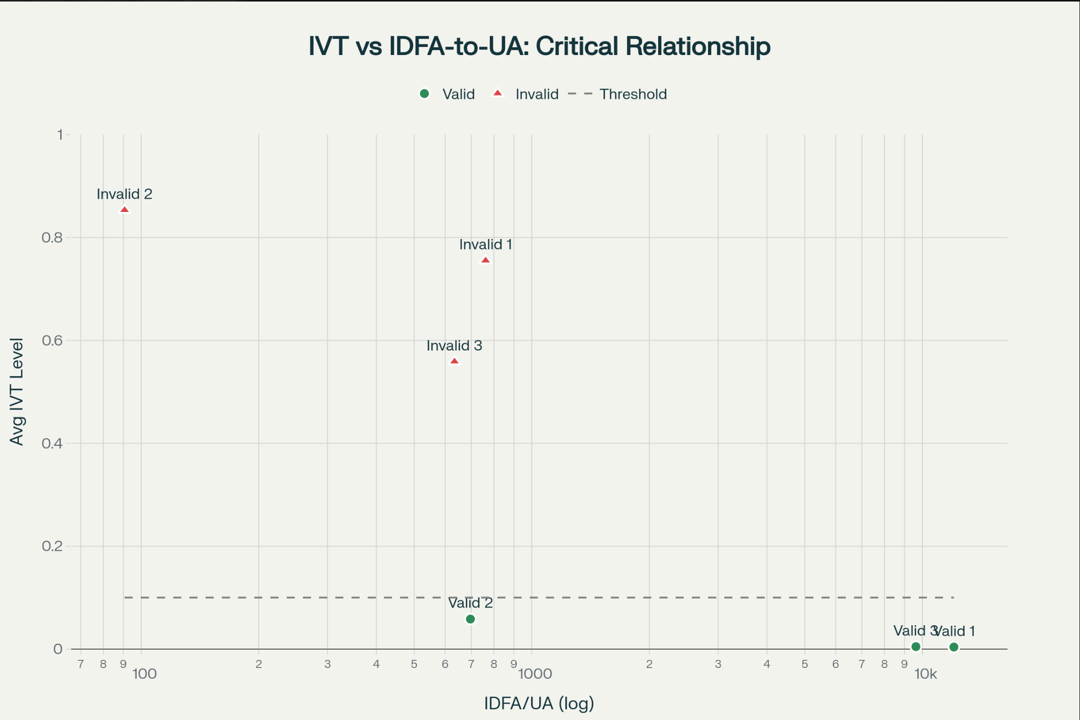

* **Key insight:** Valid apps separate clearly from invalid based on much higher device concentration per User-Agent.

**D. Invalid Apps Heatmap (Transition Days)**

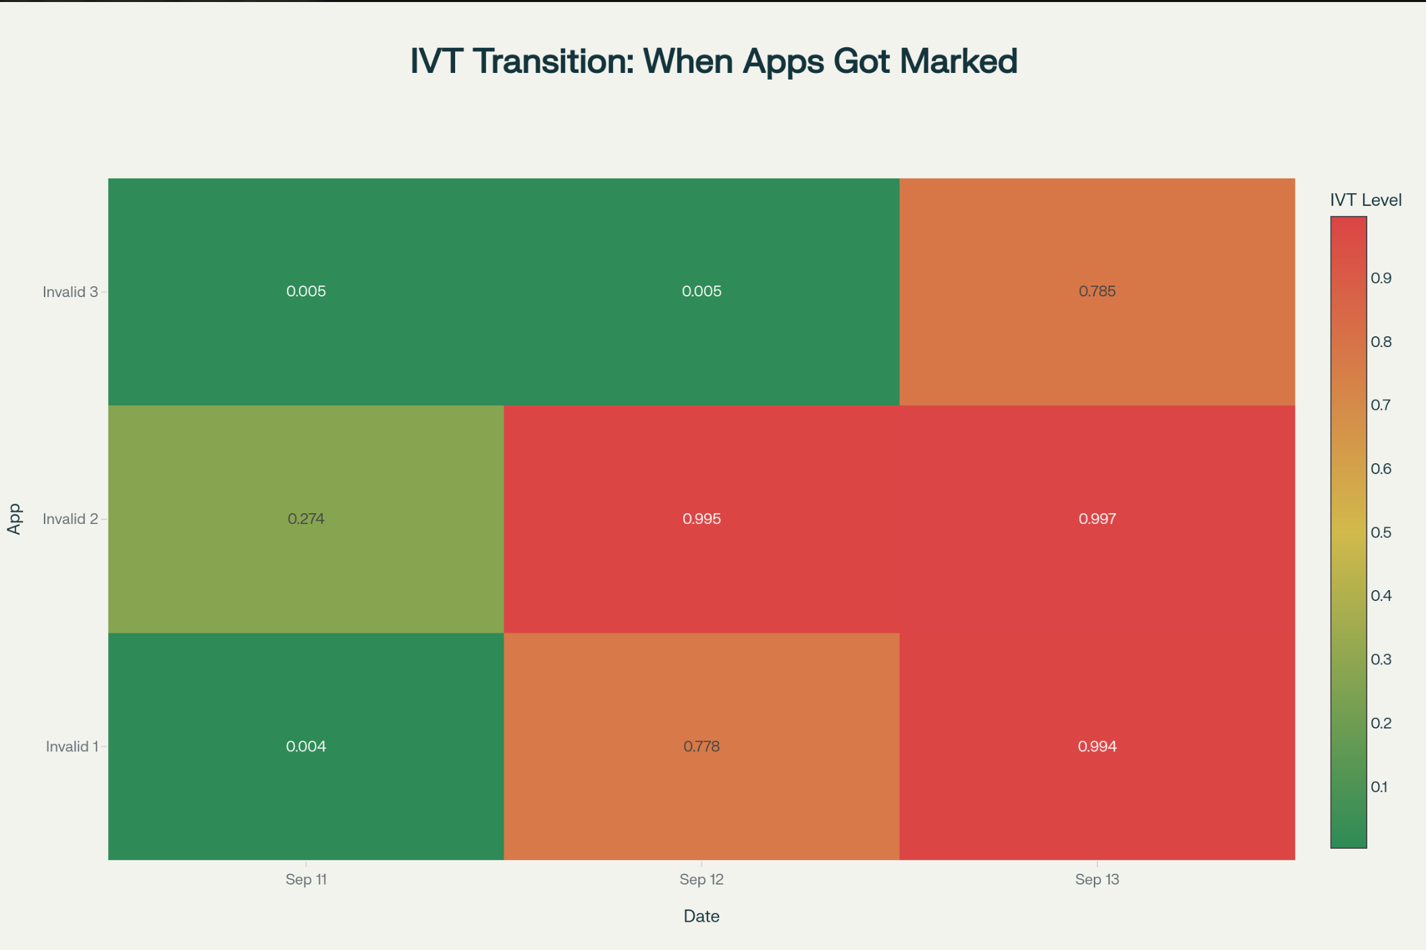

* **Interpretation:** Marking as IVT is triggered by sudden increase; sharply visible in heatmap.

**4. Summary Table**

| **Metric** | **Valid Apps** | **Invalid Apps** | **Significance** |
| --- | --- | --- | --- |
| Average IVT Level | 2.23% | 72.23% | 32.3x higher in Invalid |
| IVT Range | 0.39%-5.84% | 55.87%-85.31% | Dramatic difference |
| IDFA-to-UA Ratio | 7,455 (15x higher) | 495 | CRITICAL - Primary differentiator |
| IDFA-to-IP Ratio | 1.007 | 1.002 | Not significant |
| Requests per IDFA | 1.162 | 1.172 | Not significant |
| IVT Volatility (StdDev) | 0.012 (31x lower) | 0.383 | High volatility = fraud |
| Unique User-Agents | 22 - 266 | 262 - 1232 | Invalid 2: 1232 UAs = RED FLAG |
| Total Devices | 0.85M - 1.5M | 0.51M - 0.99M | No clear pattern |
| Total Requests | 1.0M - 1.8M | 0.59M - 1.2M | No clear pattern |
| Impressions Delivered | 0 | 0 | All blocked before impression |

**5. Major Fraud Detection Patterns**

* **Sudden IVT spike** is the clearest marking point.
* **IDFA-to-UA ratio <100** is a strong fraud signature (device spoofing).
* **User-Agent diversity** above 500 is highly suspicious for traffic below 1M devices.
* **Zero ad impressions** despite high requests suggest pre-delivery detection or SDK fraud.

**6. Recommendations**

* **Monitor IDFA/UA ratio**: Flag when below 1,000, investigate below 500, mark as IVT below 100.
* **Alert on sudden IVT increases**: Especially >50% jump day-over-day.
* **Track User-Agent diversity**: Alert if excessive.
* **Monitor IVT volatility**: High standard deviation points to inconsistent/bot traffic.
* **Investigate in real-time:** Hourly tracking can catch transition events before they dominate.

**7. Conclusion**

**IDFA-to-User-Agent Ratio is the single strongest detector of IVT/fake traffic, supported by spike patterns and UA diversity. Classic metrics (IP diversity, request rate, total volume) alone are insufficient to distinguish fraud. Zero impression rates confirm detection mechanisms are working upstream of ad delivery.**

**8. Appendix**

* Sample code and full notebook workflow provided separately.