Produce a comparative infographic of TDD, BDD, and FDD methodologies. Illustrate their unique approaches, benefits, and suitability for different software development contexts. Use visuals to enhance understanding

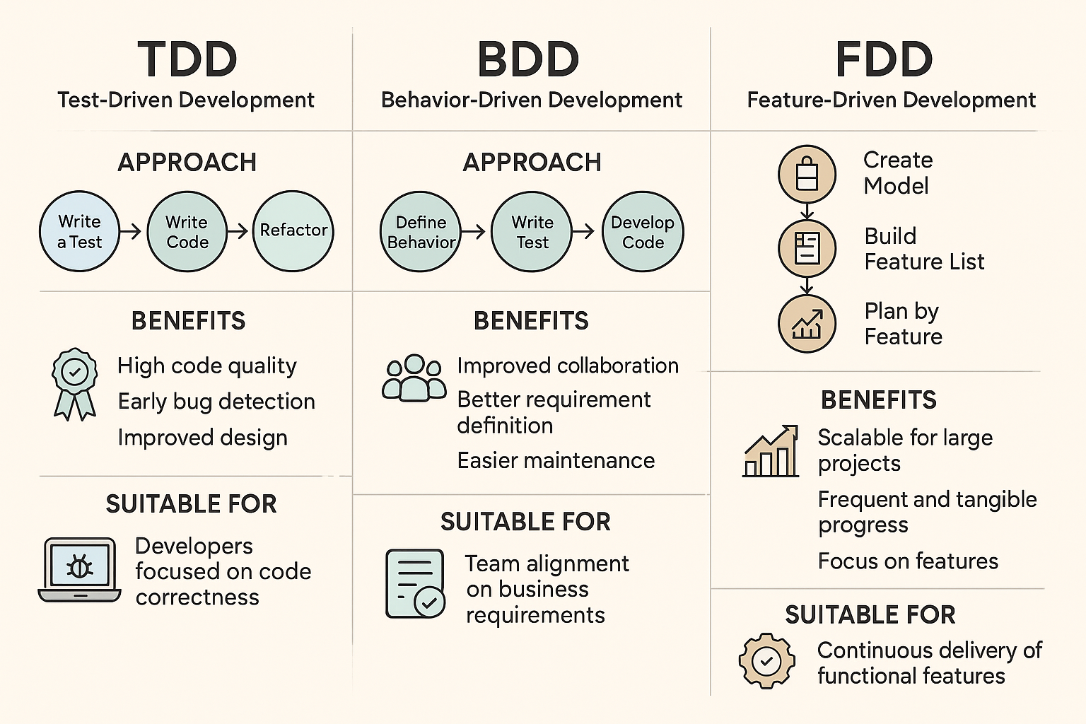

This infographic compares TDD, BDD, and FDD—three popular software development methodologies:

* **TDD (Test-Driven Development)** focuses on writing tests before code to ensure correctness and high code quality.
* **BDD (Behavior-Driven Development)** builds on TDD but emphasizes collaboration and behavior specification in plain language for better understanding across teams.
* **FDD (Feature-Driven Development)** is structured around delivering tangible, client-valued features through a model-driven and iterative process.
* TDD suits developers aiming for technical precision, BDD aligns business and tech teams, while FDD scales well for large, feature-rich projects.
* Each methodology enhances productivity, clarity, or scalability depending on the project needs.